A
ATLAS STUDIO
Complete User Guide
Admin / Operations / Developer

Advanced Tooling, Lifecycle Automation, and Security
Build smarter. Operate safer. Scale confidently.

Standalone Community Edition | Guide date: 2026-08-17

Guide scope and status legend
This guide documents the Atlas Studio repository as implemented on the guide date. It is written for the local platform owner acting in Admin, Operations, or Developer capacity. It does not treat interface placeholders or optional Compose profiles as core production capabilities.
Label | Meaning
AVAILABLE | Implemented in the current application or core Compose stack.
OPTIONAL PROFILE | Implemented but disabled until its Compose profile and configuration are enabled.
FOUNDATION / PLANNED | Visible schema, UI, or design foundation; not an active end-to-end capability.
EXPERIMENTAL | Source-integrated feature with hardware, model, or maturity constraints.

IDENTITY BOUNDARY Admin, Ops, and Developer are personas in this release. Community mode currently uses one local platform-owner session. Multi-user accounts, enforced RBAC, and Google OAuth are foundations/planned, not active controls.
DECISION INTEGRITY Agents are instructed not to invent missing facts, files, results, permissions, requirements, or preferences. When required information is missing, the agent should identify the gap, ask a direct question, and wait. Deterministic authorization policy still governs actions independently of model output.

Contents
- 1. Platform at a glance
- 2. Role-based operating model
- 3. Site map and navigation
- 4. Overview dashboard
- 5. Working with Atlas
- 6. Agents
- 7. Skills and Tool Library
- 8. Workflows
- 9. Plans and approvals
- 10. Workspace and Code
- 11. Tasks and priority
- 12. Implementation worker
- 13. QA, Sandbox, and Environments
- 14. Security
- 15. Operations and Metrics
- 16. Knowledge and Sources of Truth
- 17. Artifacts and uploads
- 18. Voice, Workers, and avatar features
- 19. Administration and configuration
- 20. Role-based use cases
- 21. Admin how-tos
- 22. Operations how-tos
- 23. Developer how-tos
- 24. Architecture and data flows
- 25. API reference
- 26. Libraries and service inventory
- 27. Troubleshooting
- 28. Known boundaries and glossary

1. Platform at a glance
Atlas Studio is a standalone, local-first multi-agent engineering control plane. Its design separates orchestration, implementation, security, persistence, and optional experience services.
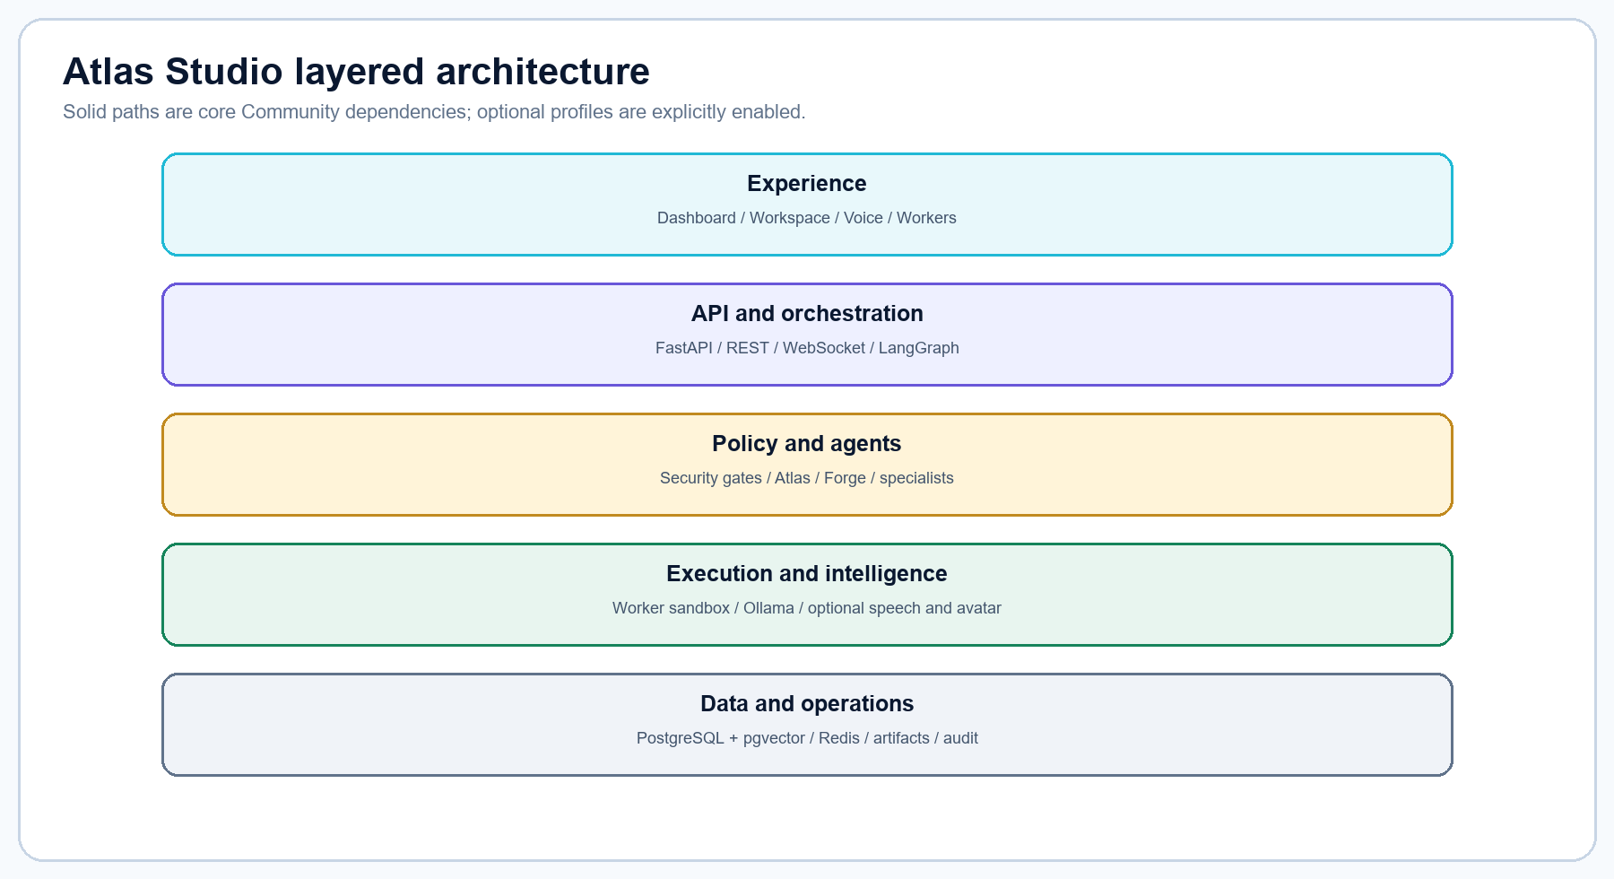
Figure 1. Implemented layered architecture.
Mode | What runs | Credentials
Community (default) | App, worker, PostgreSQL/pgvector, Redis, Ollama, local artifacts | No external key required
Integrations | Community core plus explicitly enabled adapters such as MinIO | Only the enabled adapter's local settings
Optional profiles | Web search, speech/avatar, avatar generation, avatar lab, live avatar | No paid API required; models may download separately

- Primary UI: http://localhost:8080
- API documentation: http://localhost:8080/api/docs
- Optional Gradio portal: http://localhost:8082
- Ollama API: http://localhost:11434
- OpenAvatarChat experimental UI: http://localhost:8282 when enabled

2. Role-based operating model
Persona | Primary responsibility | Typical pages | Authorization expectation
Admin | Configuration, agent/tool governance, sources, workflow registry, approvals | Settings, Agents, Tool Library, Workflows, Sources, Security | Owns local passcode and protected decisions
Operations | Availability, queue, audit, metrics, incidents, kill switch | Overview, Tasks, Activity, Metrics, Security, QA | Can stop work; should not authorize code without owner mandate
Developer | Inspect code, propose plans, use Forge, test and promote evidence | Workspace, Code, Plans, Implementation, QA, Sandbox | Requires approved plan/workspace and exact action approval

NOT RBAC These personas are operational guidance. The server does not yet authenticate separate Admin, Ops, and Developer identities.

Suggested separation of duties
- The Admin approves plans, restricted capability changes, internet research, avatar deletion, and production transitions.
- Operations observes health and evidence, manages incidents, and uses the kill switch when necessary.
- Developers prepare scoped requests and implementation evidence but do not self-approve protected actions.
- Sentinel, Quanta, Verity, and Counsel provide independent review; their output does not replace qualified human decisions.

3. Site map and navigation
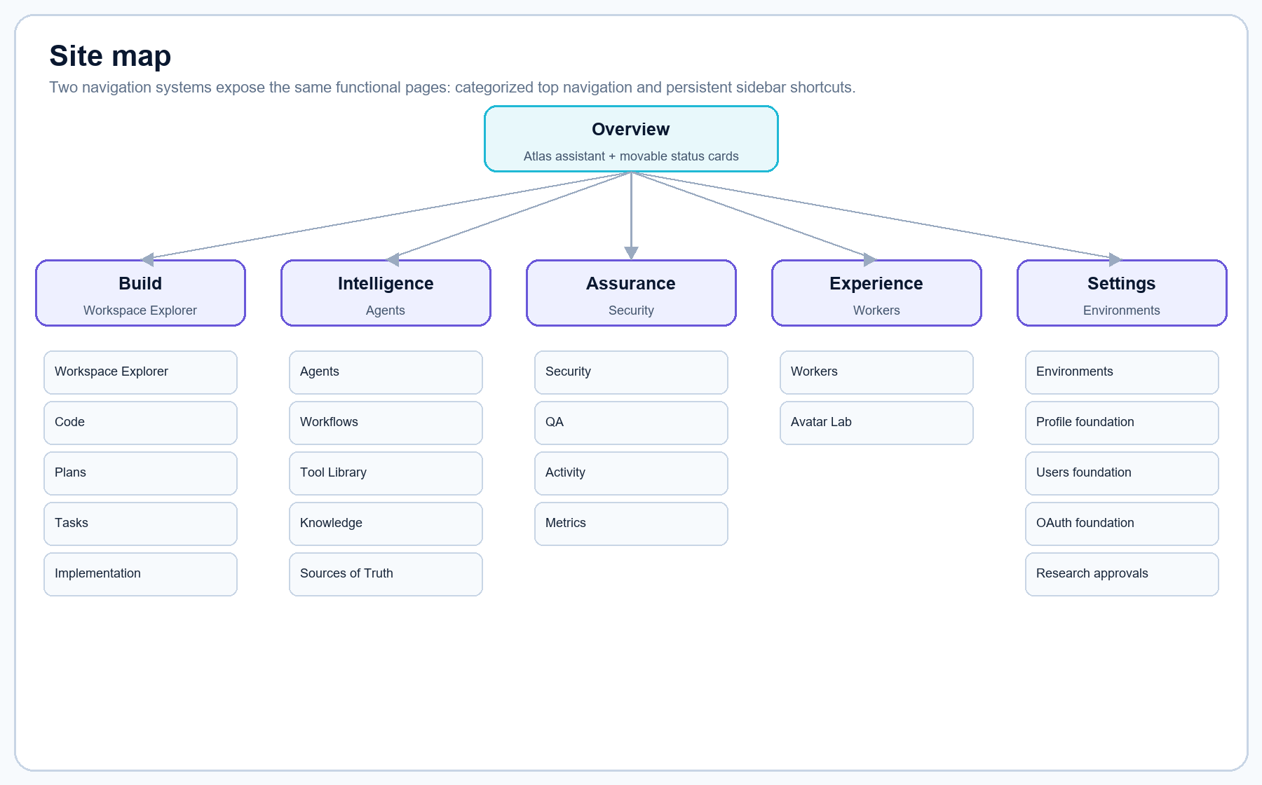
Figure 2. Current navigation and page hierarchy.
Top category | Pages | Primary audience
Overview | Assistant feed, Task Orchestrator, Active Tasks, Atlas Status | All
Build | Workspace Explorer, Code, Plans, Tasks, Implementation | Developer, Admin
Intelligence | Agents, Workflows, Tool Library, Knowledge, Sources of Truth | Admin, Developer
Assurance | Security, QA, Activity, Metrics | Operations, Admin
Experience | Workers, Avatar Lab | Admin, experience developer
Settings | Environments, profile/user foundations, research approvals, runtime config | Admin

The left sidebar provides persistent shortcuts to Dashboard, Workspace, Agents, Tools, Knowledge, Analytics, and Settings plus a live built-in-agent roster. The top navigation exposes the full category map. The profile menu links to profile/account, users/access, and Settings foundations.

4. Overview dashboard
Overview embeds the Atlas Assistant and three operational cards: Task Orchestrator, Active Tasks, and Atlas Status.

Reorganize Overview cards
- Drag a card by its header handle to a new vertical position.
- For keyboard control, focus a card header and press Ctrl (or Command) plus an arrow key.
- The order is stored in that browser's local storage.
- Select Reset card order to restore the default. The central assistant panel remains fixed.

Status interpretation
Indicator | Meaning | Response
Healthy / Online | Core dependencies and model respond | Proceed
Degraded | UI/API live but at least one dependency unavailable | Open Metrics or Activity; inspect readiness
Model unavailable | Ollama reachable but configured model absent or timed out | Pull/choose model; verify RAM and logs
Kill switch engaged | New tasks blocked; active/queued work cancelled | Investigate, then release only when safe

5. Working with Atlas
Atlas is the read-only orchestrator in the chain User → Atlas → Forge → specialist agents. Atlas may diagnose, research, investigate, read approved memory, and read workspace files. It cannot write files, execute code, run tests, deploy, or administer databases.

Ask a useful question
- State the outcome: what decision, diagnosis, plan, or artifact you need.
- Name the workspace, component, file, environment, or task when known.
- State constraints: no external access, performance target, deadline, or applicable source.
- Request evidence: files inspected, logs, tests, risks, and unresolved questions.
- If a required fact is missing, answer Atlas's clarification before authorizing action.
EXAMPLE Inspect the authentication flow in the current workspace. Identify why tool creation returns 403, cite the exact files and evidence, propose a plan, and ask before assuming any missing requirement.

Text, files, and voice
- Use the composer for text instructions and the attachment controls for supported local files.
- Uploads are validated and stored locally; attachment context is extracted where supported.
- When the speaking-avatar profile is active, the microphone transcribes locally and Atlas can synthesize a cleaned natural-language reply.
- Speech output removes code-like symbols and non-speech material where possible; the message feed remains the record.

6. Agents
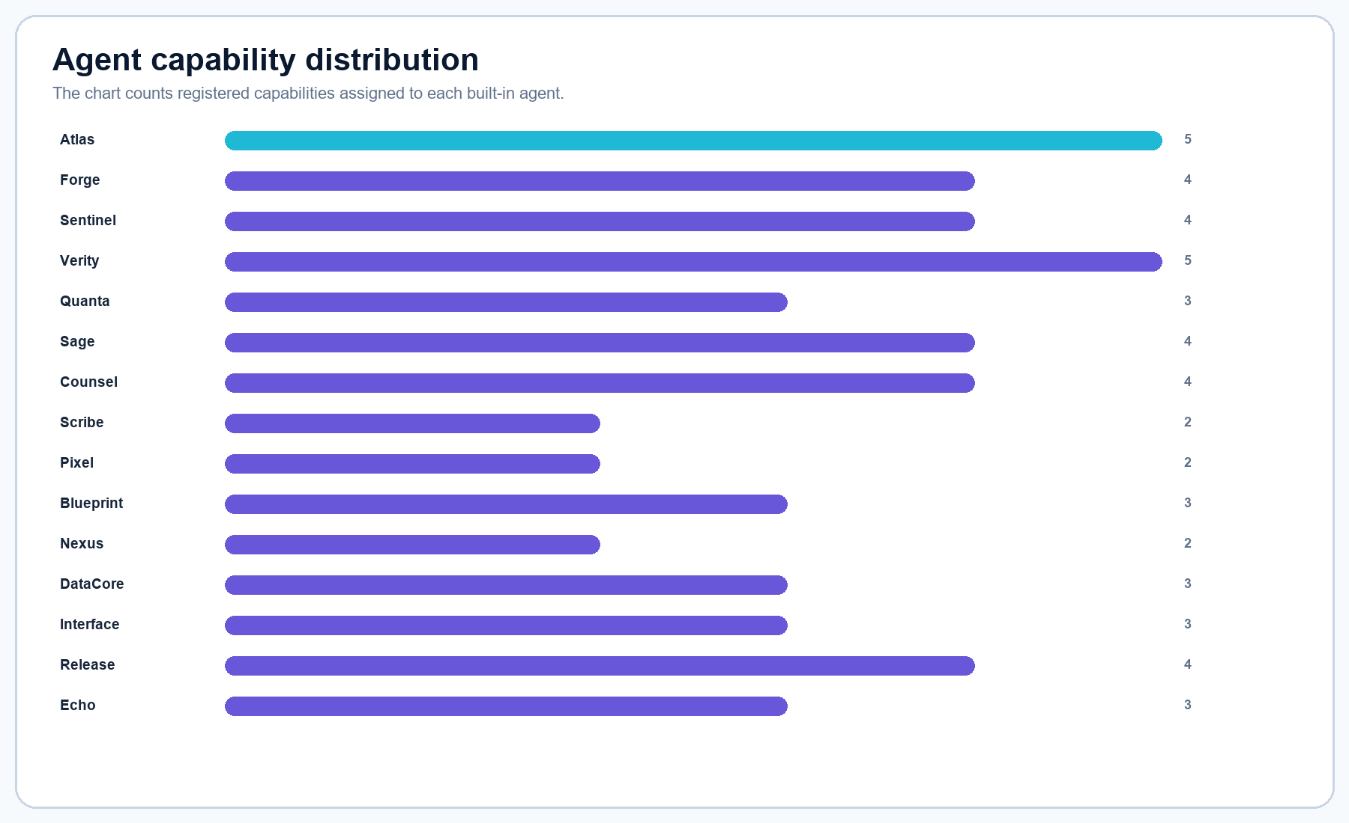
Figure 3. Approximate built-in capability assignment counts from the current agent registry.
Agent | Role | Boundary | Capabilities | Purpose
Atlas | Platform Intelligence Orchestrator | Read-only | diagnostics, research, investigation, memory read, files read | Receives direction, maintains platform awareness, coordinates approved work.
Forge | Platform Development AI | Approval required | memory read, files read/write, code execute, test execute | Primary implementation assistant inside an approved isolated workspace.
Sentinel | Security Engineering | Read-only; approval required | diagnostics, investigation, memory/files read, security scan | Threat modeling, secure-code review, dependency analysis, vulnerability triage.
Verity | GRC and Compliance | Read-only | research, investigation, memory/files read, compliance review, documents | Control mapping, governance, risk, compliance evidence.
Quanta | Quality and Test Engineering | Approval required | diagnostics, memory/files read/write, code/test execute | Test plans, authorized automated tests, release validation, regression gates.
Sage | Research and Development | Read-only | research, investigation, memory/files read, browser | Approved research, technology evaluation, experiments, recommendations.
Counsel | AI Legal Advisor | Read-only | research, memory/files read, legal review, documents | Issue spotting, licensing review, policy research; human legal review remains required.
Scribe | Document Engineering | Approval required | memory/files read/write, document generation | Technical documentation, SOPs, specifications, reports, release records.
Pixel | Image and Visual Generation | Approval required | memory/files read/write, image generation | Approved interface concepts, diagrams, product imagery, visual assets.
Blueprint | Architecture and Blueprint Generation | Read-only | research, memory/files read, document/blueprint generation | Architecture, data flow, workflow, and implementation blueprints.
Nexus | API and Integration Engineering | Approval required | memory/files read/write, code/test execute | Provider-neutral APIs, contracts, connectors, integration boundaries.
DataCore | Data Engineering | Approval required | memory/files read/write, code execute, database admin | Schemas, migrations, semantic-memory pipelines, retention, data operations.
Interface | UX and Frontend Engineering | Approval required | research, memory/files read/write, code/browser/test | Accessible UX and approved frontend implementation.
Release | DevOps and Reliability | Approval required | diagnostics, memory/files read/write, code, deployment | Build, deployment, observability, recovery, release processes.
Echo | Voice and Experience Coordinator | Read-only | speech, avatar, memory/files read | Local voice sessions and approved avatar experiences.

Add a named agent
- Open Intelligence → Agents and select Add new agent.
- Enter a unique name, role, and responsibility/boundary description.
- Select only the skills/tools required for its purpose.
- Keep Read-only selected unless implementation is necessary.
- Keep Require my authorization selected. Agents with mutating tools are rejected if authorization is disabled.
- Approve the protected creation action when prompted, then verify the card and audit event.

Modify or remove an agent
Tool changes use the same governed API boundary. Atlas cannot be given mutating tools. System agents may be protected from deletion; only delete an eligible custom agent after confirming it is not needed for active tasks or workflow ownership.

7. Skills and Tool Library
TERMINOLOGY In the current UI, “skills and tools” are the registered ToolId capabilities below. Atlas Studio does not yet provide a general package installer or execute arbitrary external skill code. Manual workflows may reference an existing skill or external resource as metadata; those references are not downloaded or executed automatically.
Capability | Category | Risk | Function
diagnostics | Observability | Low | Read service health and runtime signals.
research | Knowledge | Low | Investigate approved local or explicitly enabled sources.
investigation | Development | Low | Correlate platform, task, audit, and workspace evidence.
memory_read | Knowledge | Low | Retrieve approved workspace memory/context.
files_read | Code | Low | Read files within the active workspace boundary.
files_write | Code | Medium | Create or replace files in an authorized workspace.
code_execute | Development | High | Run approved code in the isolated worker.
browser | Development | Medium | Inspect approved browser surfaces when enabled.
speech | Automation | Low | Use configured local STT and TTS.
avatar | Automation | Low | Control local avatar presentation/state.
avatar_generate | Automation | Medium | Generate local avatar artifacts from approved images.
security_scan | Security | Low | Security inspection and dependency review.
compliance_review | Compliance | Low | Map implementations to approved controls.
legal_review | Compliance | Low | Legal and license issue spotting for human review.
test_execute | Testing | Medium | Run authorized unit, integration, and regression tests.
document_generate | Documentation | Medium | Create approved documents and reports.
image_generate | Documentation | Medium | Create approved visual assets with configured local tooling.
blueprint_generate | Documentation | Low | Produce architecture and workflow blueprints.
deployment | Cloud | Critical | Governed release/deployment; separately authorized.
database_admin | Database | Critical | Governed schema and administrative data operations.

Use the Tool Library
- Search or filter the platform registry by category.
- Open a capability to inspect provider, source, risk, data access, permissions, environments, assigned agents, and audit requirement.
- Select Request / add to record a governed access request for an agent and environment.
- Treat deployment and database_admin as restricted production capabilities requiring separate authorization.
- A request does not automatically change an agent's permissions or install software.

Request a library change
The control plane supports add, update, and remove library-change records. Record the tool identifier, name, description, reason, and action; then complete technical, security, provenance, and licensing review before any implementation.

8. Workflows
Workflow | Owner | Status | Nodes / purpose
Governed agent task | Atlas | Active | Policy → model → deterministic completion
Software feature delivery | Forge | Designed | Plan → approve → implement → QA → security → release
Security remediation | Sentinel | Designed | Verify → approve → fix → test → retest → release
Research to decision | Sage | Designed | Frame → research → compare → review → decide
R&D delivery | Sage | Designed | Sourced research through isolated prototype, validation, and decision

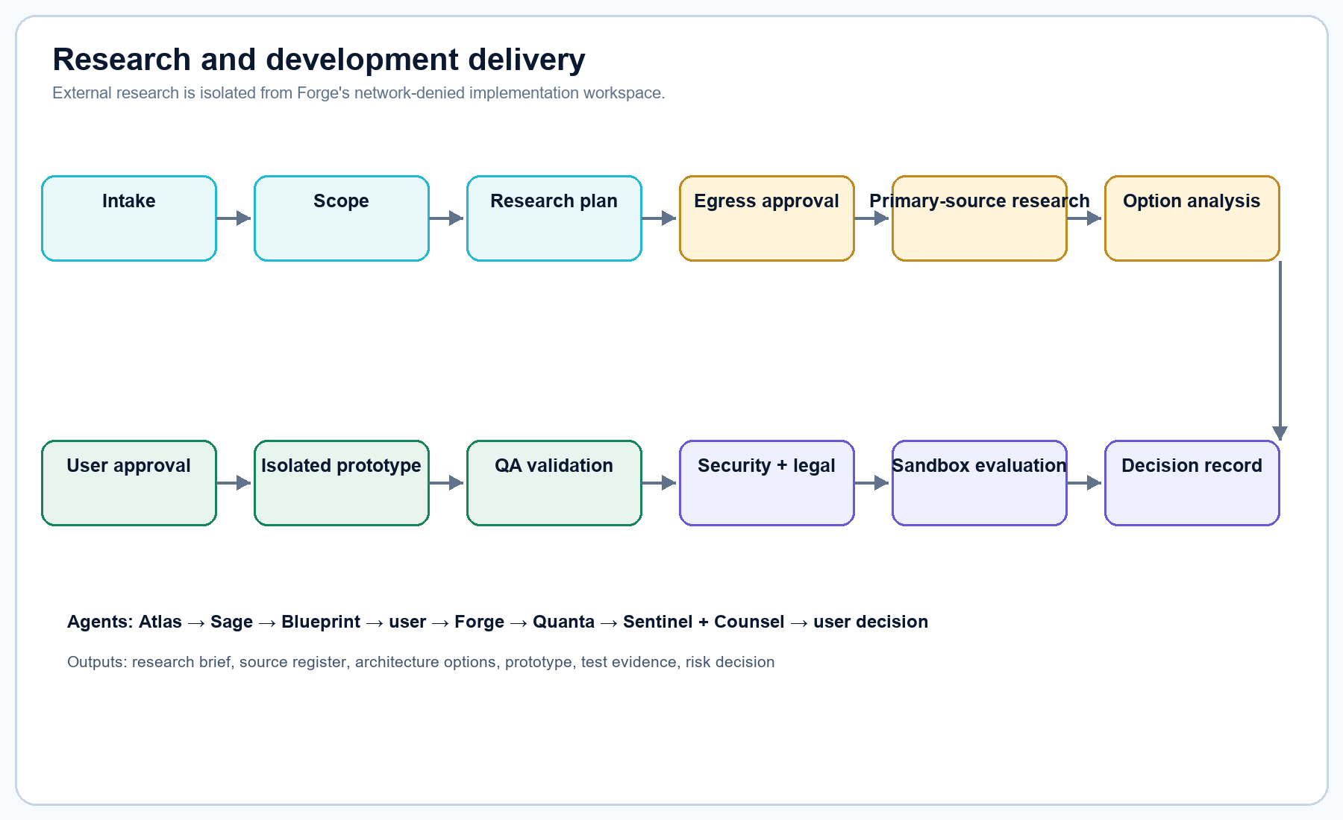
Figure 4. Built-in Research and Development delivery workflow.

Request a workflow
- Open Intelligence → Workflows.
- Under Request a workflow, enter a name, outcome/evidence goal, proposed owner, and optional local skill/library/URL references.
- Submit the request. This creates intake metadata and grants no execution authority.
- Review the proposed nodes, sources, tool needs, approvals, outputs, failure paths, and evidence before implementation.

Register a manual workflow
- Choose a stable lowercase identifier, name, owner, source type, description, and ordered node list.
- Provide the reviewed reference; external URLs remain untrusted metadata.
- Approve the exact workflow_definition action with the local passcode.
- The definition is registered pending security review; registration does not install or execute external code.

9. Plans and approvals
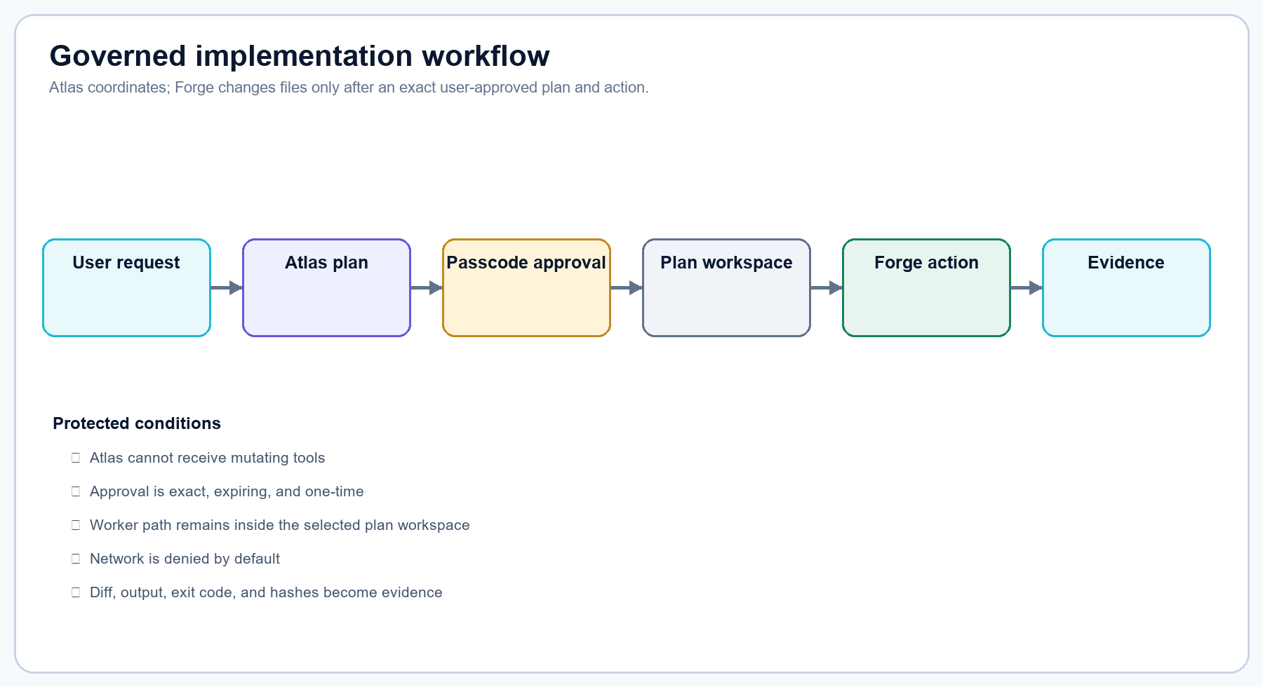
Figure 5. User-controlled implementation path.

Create and approve a plan
- Open Build → Plans and enter a title, implementation agent, priority, and requested outcome.
- Review the generated plan steps and scope. Do not approve vague paths, commands, or acceptance criteria.
- Approve with the local passcode only when the exact plan is acceptable.
- Atlas Studio creates a plan-specific workspace copy. Wait until its status is ready.
- Use that workspace for implementation tasks and worker actions. Rejecting a plan grants no authority.

Approval properties
- Exact: bound to action, target, and payload.
- Expiring: unusable after its configured lifetime.
- One-time: consumed by the approved action.
- Audited: request, decision, and consumption are recorded.
- Passcode is submitted for the decision and is not stored in the browser.
DEFAULT CREDENTIAL Change ATLAS_STUDIO_APPROVAL_PASSCODE before using write, execution, internet, avatar deletion, or production approvals.

10. Workspace Explorer and Code
The app mounts the repository at /workspace read-only. The explorer hides secrets and generated dependency folders, rejects traversal and symlink escapes, and limits previews by configuration.

Inspect a file
- Open Build → Workspace Explorer.
- Expand directories within the mounted project.
- Select a supported file. Atlas Studio audits the read and opens it in Code.
- Use line numbers and breadcrumb details for review. The Code surface is read-only.
- To edit, create/approve a plan and use Forge in Implementation rather than editing through Code.
SECRETS The explorer is a convenience boundary, not a substitute for secret hygiene. Keep credentials outside source control and avoid network exposure until authentication/TLS is implemented.

11. Tasks and priority
Tasks use a durable Redis priority queue and PostgreSQL persistence. Status flows through queued, running, completed, failed, or cancelled. WebSocket events update the UI.
Priority | Use | Behavior
Critical | Active incident or urgent security containment | Highest queue position; still requires all approvals
High | Implementation and important engineering work | Forge normal/low requests are elevated to high
Normal | Routine read-only analysis or planned work | Default
Low | Non-urgent background analysis | Lowest queue position

Add or cancel a task
- Open Build → Tasks and enter title, agent, priority, and instructions.
- Read-only agents may accept direct diagnostic/research tasks.
- Implementation-capable agents require an approved plan and ready plan workspace; direct bypass attempts are rejected.
- Watch status in Tasks, Overview, Activity, or Metrics.
- Cancel queued/running work from the task controls; the kill switch cancels all active/queued work.

12. Implementation worker
The separate worker receives narrow actions over an internal network. It has a read-only container root, no new privileges, no Linux capabilities, 512 MB memory, 1 CPU, 128 PID limit, and a plan-scoped workspace. It does not receive a generic Docker socket or internet route.
Action | Input | Evidence returned
Preview file change | Path + complete proposed content | Diff and file hashes; no write
Write approved file | Exact path + complete content + approval | Write result, diff/hashes
Run approved code | Allow-listed command arguments + approval | Output and exit code
Run approved tests | Allow-listed test arguments + approval | Test output, exit code, evidence

Run a safe Forge action
- Confirm worker health is available.
- Select Forge or another authorized implementation agent and a ready plan workspace.
- Choose Preview file change first; enter a relative workspace path and complete replacement content.
- Review the proposed diff and hashes.
- Select the intended write/execute/test action, check the exact authorization box, and continue.
- Review the passcode modal summary; approve only if action, path/command, and workspace match.
- Retain worker output as lifecycle evidence.

13. QA, Sandbox, and Environments
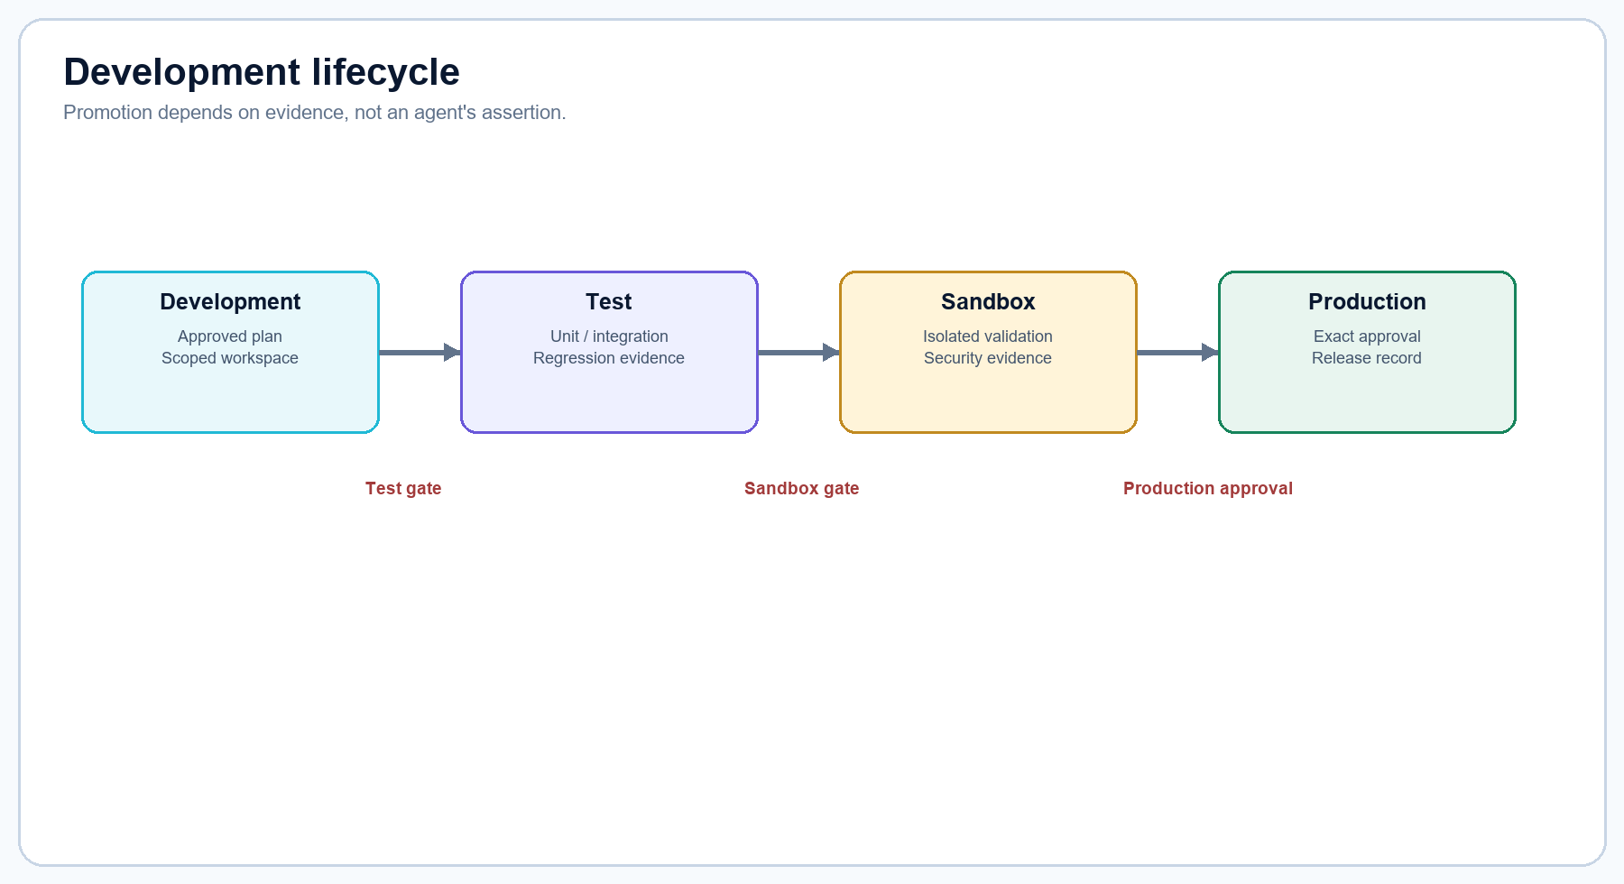
Figure 6. Evidence-gated development lifecycle.
Environment | Purpose | Default boundary | Gate
Development | Plan, inspect, implement in scoped workspace | Workspace-specific permissions | Approved plan/workspace
Test | Unit, integration, regression, security, performance checks | Authorized test execution | Completed-task evidence
Sandbox | Isolated behavior and security validation | Network none; limits; dropped capabilities | Test or security evidence
Production | Release/deployment state | Separately governed | Exact one-time production approval

Promote lifecycle evidence
- Create a lifecycle for an approved plan.
- Attach completed implementation/test evidence before requesting Test completion.
- Review Quanta results and unresolved failures.
- Move to Sandbox only with qualifying test or security evidence.
- Have Sentinel review relevant security risk and Counsel/Verity review applicable legal/compliance issues.
- Request production transition only after acceptance criteria and rollback/operational evidence are complete.
- Approve the exact production transition; record the release decision.

14. Security
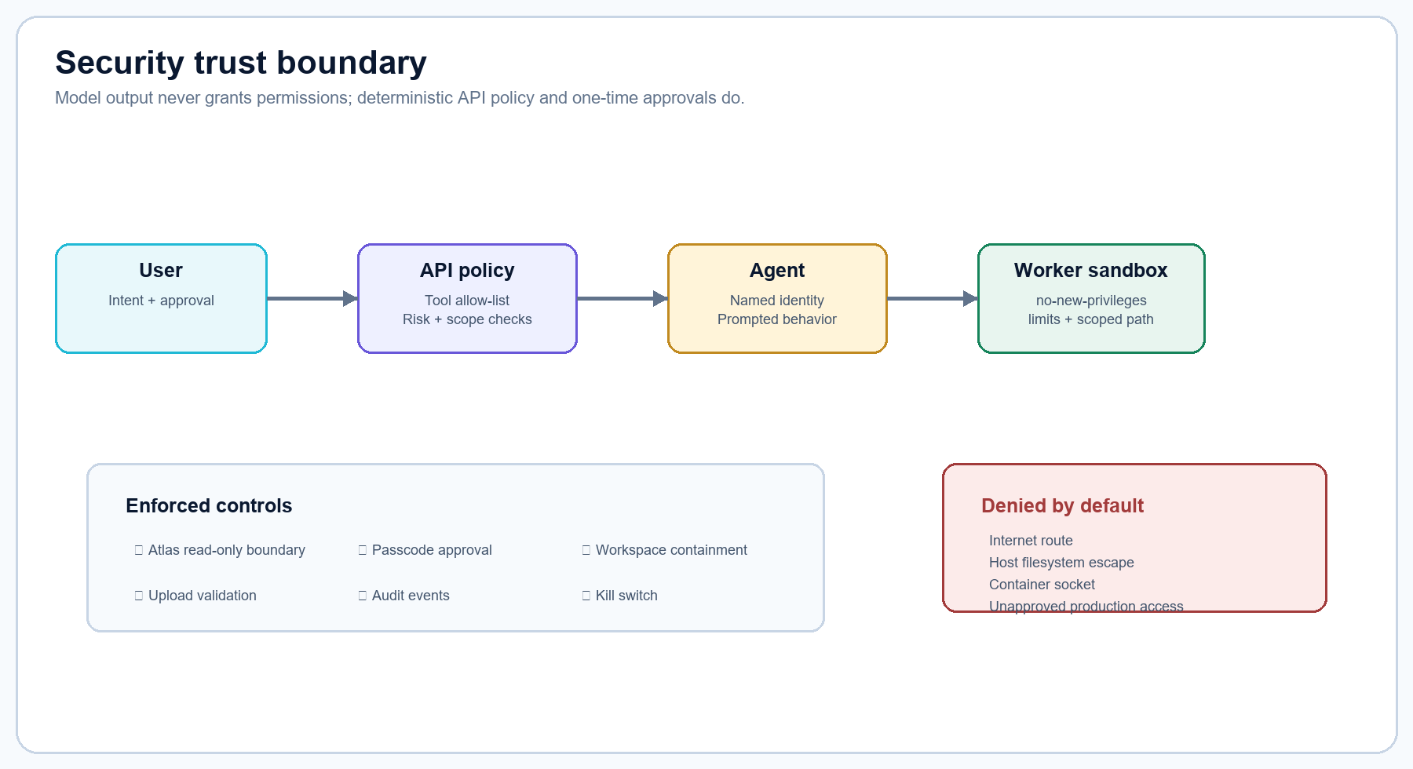
Figure 7. Security control and trust boundary.
Layer | Current state | Control
Identity/session | Planned | Authentication, session expiry, CSRF before non-loopback exposure
Agent permissions | Enforced | Server-side tool allow-lists; protected Atlas boundary
Human authorization | Enforced | Protected actions require exact approval
Workspace | Enforced | Resolved-path containment; read-only app mount
Sandbox | Enforced | Network none, limits, capabilities dropped
Uploads | Enforced | Filename, extension/type, content, and size validation
Audit/evidence | Enforced | Tasks, agents, approvals, controls, uploads, lifecycle events
Secrets/integrations | Enforced by mode | Optional integrations disabled; telemetry off in Community

Use the kill switch
- Select Stop all agents when execution must halt.
- The API blocks new tasks, removes queued work, cancels queued/running tasks, publishes a kill message, writes an audit event, and updates clients.
- Investigate service, model, worker, and audit evidence.
- Release the switch only after the unsafe or failed condition is understood.
NETWORK EXPOSURE Before exposing Atlas Studio beyond localhost, add local authentication/RBAC, CSRF protection, a TLS reverse proxy, secret rotation, backup/restore, and network policy. These are not complete today.

15. Operations and Metrics
Metric panel | What it shows | Operator question
Task performance | Status distribution, queue depth, durations, success rate | Is work flowing or failing?
Service health | API, model, worker, Postgres, Redis, speech/avatar state | Which dependency is degraded?
Model runtime | Provider, model, readiness, timeout, token ceiling | Is response latency/model availability acceptable?
Agent governance | System/custom/read-only/implementation counts | Are capabilities appropriately constrained?
Security posture | Atlas boundary, sandbox, telemetry, audit outcomes | Are controls enforced?
Runtime/storage | Process memory/load, artifacts, database/cache state | Is capacity healthy?
Recent tasks/audit | Latest activity and accountability records | What changed and who/what acted?
Tool coverage | Capability assignments | Are tools over- or under-assigned?

Daily operations checklist
- Confirm /api/health/live and /api/health/ready.
- Review degraded services and model readiness.
- Review queue depth, running task age, failures, and cancellations.
- Check kill-switch state and recent denied/failed audit events.
- Confirm artifact storage growth and persistent volume health.
- Review pending approvals and expiring research permissions.
- Validate backups before high-risk changes (backup automation remains an operator responsibility).

16. Knowledge and Sources of Truth
Knowledge search currently filters the approved local source catalog, not a full semantic-memory search service. The registered authoritative sources are README.md, SECURITY.md, and IMPLEMENTATION.md when available in the workspace.
Precedence (highest first) | Source type
1 | Applicable law and regulation
2 | Official government sources
3 | Regulators and standards organizations
4 | Organization policies and procedures
5 | Approved internal documentation
6 | Applicable compliance requirements
7 | Official vendor documentation
8 | Other verified sources
9 | General web and unverified information

Request a new source
- Open Sources of Truth and select Request source addition.
- Enter name, authority, source type, location, and optional jurisdiction/version.
- Submit for provenance review.
- The request is pending and is not authoritative until reviewed for identity, scope, currency, jurisdiction, integrity, conflicts, and approval.
- Atlas should flag unresolved source conflicts instead of silently choosing one.
SEMANTIC MEMORY PostgreSQL includes a workspace-scoped pgvector memory schema with 1,024-dimensional vectors. End-to-end embedding ingestion and user-facing semantic retrieval remain a hardening/incremental implementation item.

17. Artifacts and uploads
Artifacts use the local filesystem by default. MinIO is optional in Integrations mode. Uploads are reduced to safe basenames, checked against an allow-list, limited by size, resolved inside the artifact root, and audited.
Category | Accepted examples
Documents/data | txt, md, json, csv, pdf, rtf, odt, docx, xlsx, pptx
Images/3D/audio | png, jpg/jpeg, webp, glb/gltf, wav, mp3
Code/config | py, js, ts/tsx/jsx, html, css, yaml/yml, toml, sql, sh, ps1
Default limit | 25 MB general uploads; speech and avatar endpoints have separate limits

- Do not upload secrets, private keys, or unlicensed personal imagery.
- Confirm permission before avatar image processing.
- An uploaded file is context, not executable authority.
- Executable extensions and path traversal names are rejected.

18. Voice, Workers, and avatar features
Feature | Status | Use / constraint
Workers by delos | Available UI | Local GLB/WebGL worker identities; Atlas image and source references included
Local speech | Optional profile | Whisper-compatible STT; Kokoro/Piper American female TTS defaults
Image-to-3D | Optional profile | TripoSR + Blender; front image drives geometry; not a production human rig
Speaking avatar | Optional profile | TalkingHead/Three.js foundation; requires rig/morph-compatible character
EchoMimic V2 | Experimental GPU lab | CUDA/NVIDIA and official model weights required
LiteAvatar/OpenAvatarChat | Experimental | Large first-start downloads; CPU path may be slow; hardware dependent

Local voice how-to
- Start the speaking-avatar profile and wait for speech health.
- Open the Atlas chat surface and grant microphone permission.
- Press the microphone, speak, and stop/submit the turn as shown.
- Verify the transcript before relying on it for an implementation decision.
- Atlas text appears in the feed; synthesized audio plays through the browser when local TTS succeeds.
- If audio fails, inspect speech service health and the X-Atlas-Voice-Backend response header.
LIFELIKE BOUNDARY The repository includes experimental/open-source avatar paths, but it does not currently deliver a turnkey photorealistic, full-body, low-latency neural avatar on CPU-only hardware.

19. Administration and configuration
Configuration area | Default | Admin action
Mode | community | Use integrations only for explicitly enabled local adapters
Model | Ollama / qwen3:8b | Pull model separately; select a smaller manifest when hardware constrained
Artifacts | filesystem / 25 MB | Enable MinIO only with profile and changed credentials
Sandbox | docker; network none; 512m; 1 CPU; 128 PIDs | Keep deny-by-default; tune only with evidence
Telemetry | false | Keep disabled unless an explicit local policy permits it
Approval passcode | development default | Change before protected actions or exposure
OAuth | disabled | Foundation only; do not treat as active sign-in

Start and verify the core
- Copy .env.example to .env and change local passwords/passcode.
- Run docker compose up -d --build.
- Pull the configured Ollama model separately.
- Run docker compose ps until core services are healthy.
- Open http://localhost:8080 and inspect Metrics.
- Call /api/health/live and /api/health/ready for precise component state.

20. Role-based use cases
ID | Persona | Goal | Primary path | Outcome
UC-A1 | Admin | Create a least-privilege custom agent | Agents → add → choose tools → approve | Named audited agent
UC-A2 | Admin | Register a reviewed workflow | Workflows → manual definition → passcode | Pending-security-review definition
UC-A3 | Admin | Approve external research | Settings → query/purpose/domains → passcode | One-time 15-minute route
UC-A4 | Admin | Add a source candidate | Sources → request → provenance review | Pending, not authoritative
UC-O1 | Ops | Diagnose degradation | Metrics → readiness → logs | Identified dependency/failure
UC-O2 | Ops | Stop unsafe execution | Stop all agents → audit → investigate | Tasks cancelled; execution locked
UC-O3 | Ops | Review task performance | Metrics/Activity/Tasks | Queue and failure evidence
UC-D1 | Developer | Diagnose a code problem | Atlas → Workspace/Code → plan | Evidence-backed plan
UC-D2 | Developer | Implement a feature | Plan → approve → Forge preview/write → test | Scoped change + evidence
UC-D3 | Developer | Promote a release | QA → Sandbox → Production approval | Traceable lifecycle decision
UC-D4 | Developer | Evaluate technology | R&D workflow → approved research → prototype | Sourced recommendation

21. Admin how-tos

Change an agent's tools
- Open Agents and select the named agent.
- Compare requested capability with the Tool Library risk/data-access details.
- Remove unnecessary tools; never assign mutating tools to Atlas.
- Approve protected changes when required.
- Verify the refreshed card and audit event.

Approve internet research
- Start the web-search profile if the local broker is required.
- In Settings, enter the exact query, business purpose, and optional allowed domains.
- Review the passcode modal and approve.
- Run the search before the 15-minute expiry.
- Confirm the approval was consumed and retain sources in the research record.

Govern a source
- Request the source with authority, type, location, jurisdiction, and version.
- Validate ownership, currency, integrity, applicability, and conflicts.
- Do not treat the submitted item as authoritative until the review process is implemented/completed.
- Record the decision and update dependent workflows/documentation.

Safely enable an optional profile
- Review license, model, hardware, port, storage, and privacy requirements.
- Set only the documented environment values.
- Build/start that profile without changing Community dependencies.
- Wait for its health check and review logs.
- Disable it if degraded; core Atlas should continue operating.

22. Operations how-tos

Investigate a slow or timed-out response
- Check Metrics → Model runtime and Service health.
- Confirm Ollama health and that the configured model is present.
- Review task duration, timeout, model token ceiling, host RAM/CPU, and competing optional services.
- Stop resource-heavy experimental profiles if core work is affected.
- Use a smaller local model only after confirming quality needs.

Recover from degraded core services
- Use readiness to identify Postgres, Redis, Ollama, or worker failure.
- Inspect the specific service logs and container state.
- Restore the dependency; avoid deleting persistent volumes during diagnosis.
- Confirm readiness, queue recovery, and task/audit consistency.
- Document incident cause and corrective action.

Handle an unsafe or runaway task
- Engage Stop all agents.
- Verify queued/running tasks become cancelled and new task creation is locked.
- Inspect audit, task, worker, and workspace evidence.
- Correct permissions, plan scope, command allow-list, or service condition.
- Release the switch and use a low-risk diagnostic task before resuming.

Monitor storage
- Review Metrics → Runtime & storage.
- Inspect artifact and model volume growth.
- Back up Postgres and required artifacts/models according to local policy.
- Use governed deletion for generated avatar artifacts; do not manually remove unknown volume data.

23. Developer how-tos

Diagnose before changing code
- Ask Atlas for evidence and exact file references.
- Browse the mounted workspace and open relevant files in Code.
- Request clarification for missing requirements or environment facts.
- Create a plan with acceptance criteria, test scope, risk, and rollback expectations.
- Do not jump directly to Forge for mutating work.

Implement a change with Forge
- Approve the plan and wait for a ready plan workspace.
- Use Preview file change with a relative path and complete content.
- Review diff and hashes.
- Approve and execute the exact file write.
- Run targeted tests through the worker.
- Attach output and exit code to lifecycle evidence.

Run R&D
- Frame a decision question, constraints, evaluation criteria, and required sources.
- Let Sage prepare the research plan; approve egress only if needed.
- Have Blueprint compare architectural options.
- Approve only a bounded prototype.
- Forge builds it without internet; Quanta validates; Sentinel and Counsel review.
- Record the user-owned adopt/reject/iterate decision.

Add a workflow from a library or skill
- Review the local library/skill documentation and license outside the execution path.
- Create a workflow request with desired outcome and reference.
- Translate it into named nodes, owners, inputs, outputs, gates, failure states, and evidence.
- Register the definition with passcode approval.
- Complete security review before activation; external code is not auto-installed.

24. Architecture and data flows
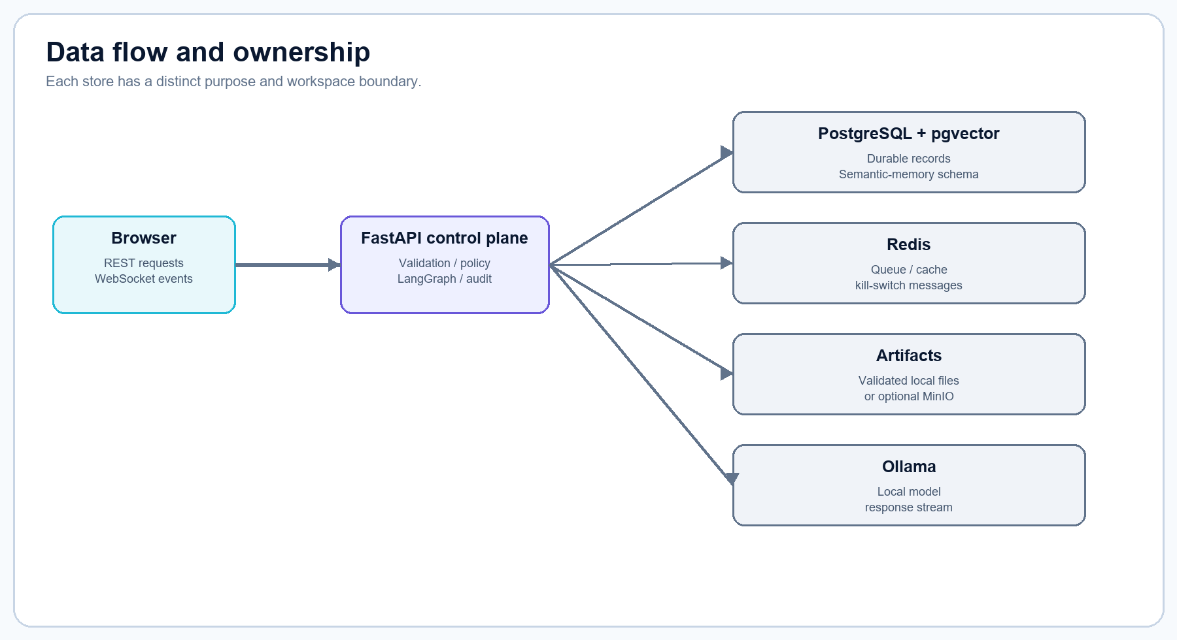
Figure 8. Runtime data flow and store ownership.
Store | Durability | Data
PostgreSQL | Durable | Workspaces, agents, tasks, plans, lifecycles, workflow runs/steps/approvals/events, audit, artifact metadata, memory schema
pgvector | Durable extension | Workspace-scoped 1,024-dimensional semantic-memory vectors
Redis | Durable queue + transient | Priority queue, task snapshots, cache, coordination, kill messages
Filesystem | Durable volume | Default uploaded/generated artifacts
MinIO | Optional durable | S3-compatible artifacts in Integrations profile
Plan workspace volume | Durable until archived | Isolated implementation copies bound to approved plans
Ollama volume | Durable | Separately downloaded local model weights

Task event flow
- Browser submits REST request.
- API validates agent, kill switch, plan/workspace, tools, risk, and authorization.
- Task persists to PostgreSQL and priority is queued in Redis.
- LangGraph policy node runs before the model node.
- Ollama streams local output; the API emits WebSocket deltas/progress.
- Terminal state and audit evidence persist; the UI reconciles task status.

25. API reference
Area | Endpoints | Use
Health/config | GET /api/health/live; /ready; /config | Service diagnosis and UI configuration.
Agents | GET/POST /api/agents; PATCH/DELETE /api/agents/{id} | List, add, change permitted tools, or remove eligible agents.
Tasks | POST/GET /api/tasks; POST /api/tasks/{id}/cancel | Queue, observe, and cancel governed work.
Plans | GET/POST /api/plans; POST /api/plans/{id}/decision | Create and approve/reject implementation plans.
Lifecycle | GET/POST /api/lifecycles; POST /api/lifecycles/{id}/transition | Track test, sandbox, and production gates.
Worker | GET /api/worker/health; POST /api/worker/actions | Preview/write files and run allow-listed commands.
Workflows | GET /api/workflows; POST /requests; POST /api/workflows | Inspect, request, and register governed definitions.
Approvals | POST /api/approvals; decision; external approvals | Exact, expiring, one-time passcode decisions.
Research | POST /api/research/search | Consume approved search authorization through isolated broker.
Library | GET /api/tool-library; changes; tool access requests | Inspect registry and request controlled changes/access.
Knowledge | GET /api/sources; /content; POST /requests | View approved internal sources or request provenance review.
Workspace | GET /api/workspace/tree; /file | Read-only contained explorer and code preview.
Operations | GET /api/security/posture; /audit; /metrics | Security and operational evidence.
Control | POST /api/control/kill-switch | Stop/release agent execution.
Artifacts | POST /api/artifacts | Validated local uploads and context extraction.
Speech | POST /api/speech/transcribe; /synthesize | Local microphone transcription and voice output.
Avatar | POST/GET/DELETE /api/avatar-generations | Optional local avatar generation and governed deletion.
Progress | WebSocket /api/ws | Connected, task progress, avatar, and kill-switch events.

API SECURITY The API is designed for localhost Community use. Do not treat the current local-owner session as sufficient authentication for LAN or internet exposure.

26. Libraries and service inventory

Application libraries
Library | Role
FastAPI / Uvicorn | REST, WebSocket, validation hosting
Pydantic Settings | Validated environment configuration
HTTPX | Local provider/service calls
asyncpg | PostgreSQL persistence
redis-py | Queue/cache/control messages
LangGraph + PostgreSQL checkpointer | Policy-first agent workflow and durable checkpoints
python-multipart | Uploads
Gradio | Optional portal
pypdf / python-docx / openpyxl / python-pptx / Pillow | Local document and image context handling

Container services
Service | Profile | Port | Purpose
app | Core | 8080 | FastAPI, UI, REST, WebSocket, policy and orchestration
worker | Core | internal 8092 | Allow-listed implementation actions in scoped workspaces
postgres | Core | internal 5432 | Durable records plus pgvector schema
redis | Core | internal 6379 | Priority queue, cache, transient state, kill messages
ollama | Core | 11434 | Default local open-weight model runtime
portal | Optional UI | 8082 | Legacy/holographic Gradio portal
research-worker + SearXNG | web-search | internal | Approved, single-purpose internet research route
minio | integrations | 9000/9001 | Optional S3-compatible artifact storage
avatar3d | avatar-local | internal 8090 | Local TripoSR plus Blender generation
speech | speaking-avatar | internal 8091 | Local Whisper-compatible STT and Kokoro/Piper TTS
headtts | speaking-avatar | 8882 | Optional TalkingHead/Kokoro presentation service
echomimic | avatar-lab | 7861 | GPU-oriented EchoMimic V2 laboratory
openavatarchat | live-avatar | 8282 | OpenAvatarChat + LiteAvatar experimental live runtime

Model/provider boundary
Ollama is the default native provider. An OpenAI-compatible protocol adapter supports self-hosted llama.cpp, vLLM, and compatible Transformers servers. No vendor SDK is required. Model manifests reference suggested Qwen general/coder models and TripoSR; weights are not bundled.

27. Troubleshooting
Symptom | Likely cause | Action
localhost:8080 refused | App container stopped or port unavailable | docker compose ps; inspect app logs; restart core
UI unchanged after rebuild | Old image/container or browser cache | Rebuild/recreate app; Ctrl+F5
Ollama 404 | Configured model not pulled | ollama list; pull exact configured model
Model timeout | Model too large, host contention, or timeout | Inspect resources; stop optional profiles; use smaller model or tune timeout
Task 403/409 | Missing authorization, plan, or ready workspace | Approve plan; select its ready workspace; retry exact action
Worker unavailable | worker service unhealthy/token mismatch | Check worker health/logs and shared token
Speech 503 | Speaking profile disabled/unhealthy | Start speech profile; inspect /health and app TTS/STT URLs
No browser audio | Autoplay/permission or invalid TTS response | Interact with page; inspect status/header; test synthesized WAV
Avatar service unhealthy | Model bootstrap/hardware/build failure | Review profile logs and requirements; disable without affecting core
OpenAvatarChat starting/unhealthy | Large model initialization or resource pressure | Follow logs; wait for downloads; confirm RAM/GPU constraints
Docker API 500 | Docker Desktop engine/config issue | Restart Docker Desktop; verify engine; retry pull/compose
Card reorder not visible | Old static bundle/cache | Rebuild app and hard refresh; drag card header handle

Diagnostic commands
docker compose ps
docker compose logs --tail 100 app
docker compose logs --tail 100 worker
docker compose exec ollama ollama list
Invoke-RestMethod http://localhost:8080/api/health/live
Invoke-RestMethod http://localhost:8080/api/health/ready

28. Known boundaries and glossary

Known implementation boundaries
- Community mode is a single local-owner workspace; multi-user authentication and enforced RBAC are not active.
- Google OAuth is disabled and foundational only.
- Knowledge search filters registered local sources; complete semantic-memory ingestion/retrieval is not exposed end to end.
- Manual workflow registration stores definitions; only the governed-agent-task graph is active universally. Designed workflows require further execution-node implementation.
- Generic Docker socket execution is intentionally absent; a narrow Docker action broker remains future work.
- Production deployment and database administration are restricted capabilities, not a general self-service production control plane.
- Avatar services are optional/experimental and do not guarantee photorealistic, low-latency full-body behavior on current hardware.
- Local-first does not automatically mean encrypted, authenticated, backed up, or safe for network exposure; those controls must be implemented and operated explicitly.

Glossary
Term | Meaning
Approval | Exact, time-limited, single-use user decision for a protected action.
Artifact | Validated uploaded or generated local file.
Community mode | No-required-key, local core deployment.
Evidence | Recorded diff, hash, test result, exit code, source, audit event, or decision supporting a gate.
Forge | Primary implementation agent; requires user authorization.
LangGraph | OSS workflow engine used for policy-first orchestration.
Plan workspace | Isolated workspace copy bound to one approved plan.
Source of Truth | Reviewed authority with provenance, version, jurisdiction, and applicability.
Tool / skill | Registered capability that can be assigned to a named agent.
Workspace | Mounted project boundary visible read-only to the app/Atlas.

OPERATING PRINCIPLE Build smarter. Operate safer. Scale confidently. Keep Atlas read-only, keep implementation scoped to Forge and approved agents, demand evidence at every gate, and ask the user when a decision lacks required information.

