Kibana Visualize
Dans ce tutoriel nous allons explorer la page Visualize.

Cette page contient les composants suivants :

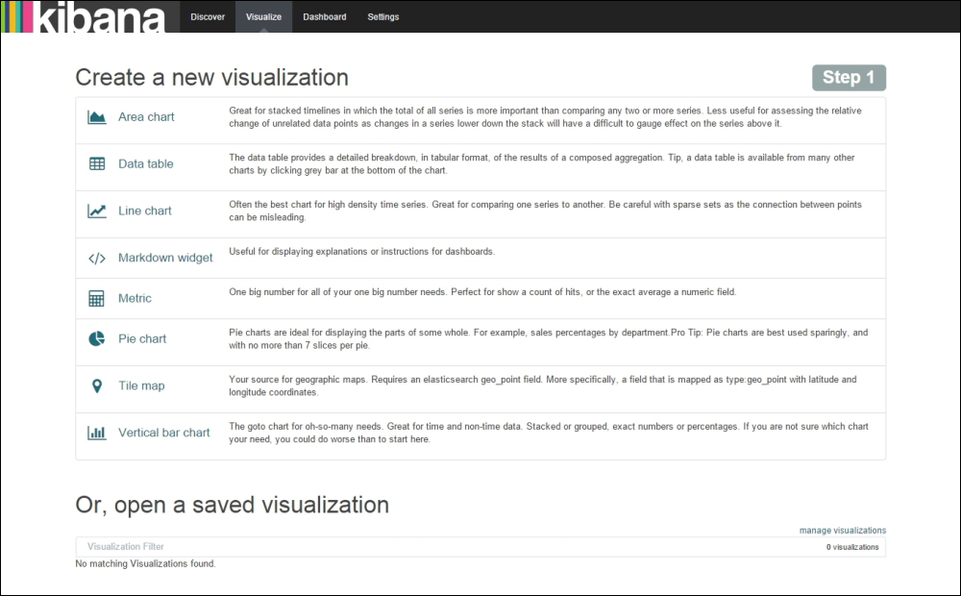

Data Table
Objectif : Show the top languages along with a count of each language's retweets in the ranges of 0 to 10 and 10 to 20.

Tout d’abord trouvons le top 5 des langues.
Cliquer sur Data Table

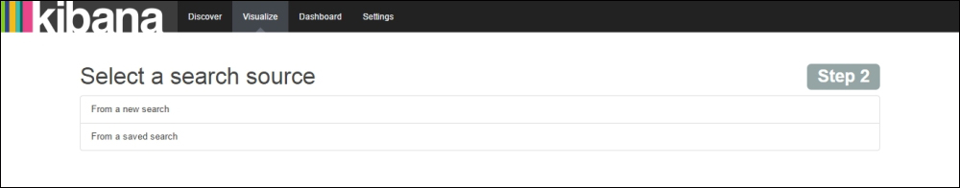

Cliquer sur From a new search

Select Metric count

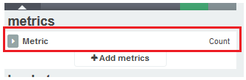

Dans la partie buckets cliquez sur Split Rows

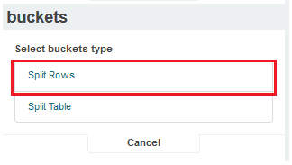

Maj les champs suivants:

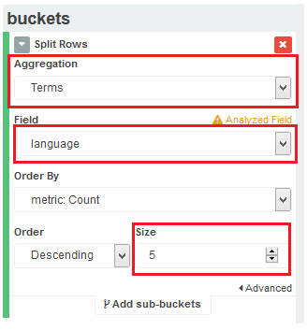

Tester

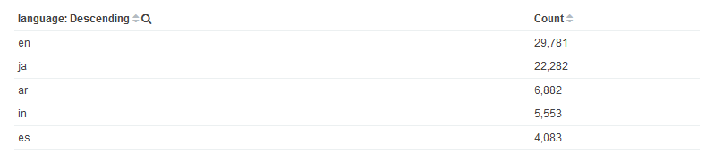

Maintenant : count of each language's retweets in the ranges of 0 to 10 and 10 to 20

Cliquer sur Add sub-buckets

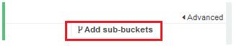
Select

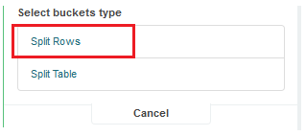

Ajuster les champs comme suit :

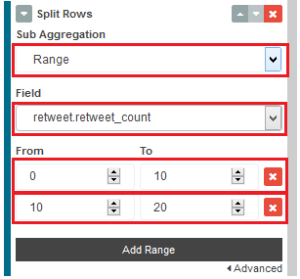

Tester

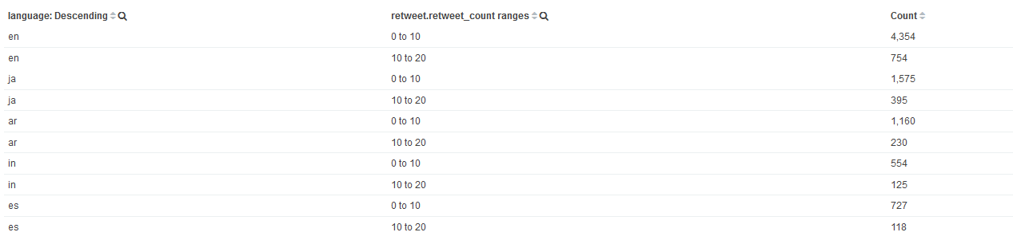

Line Chart

Objectif : Show the comparison of top languages in which users tweeted, along with the retweet count for those languages over a period of time.

Solution : we will split the chart on the basis of top languages, split the area on the basis of retweet.retweet_count, and the X-axis will contain the period of time

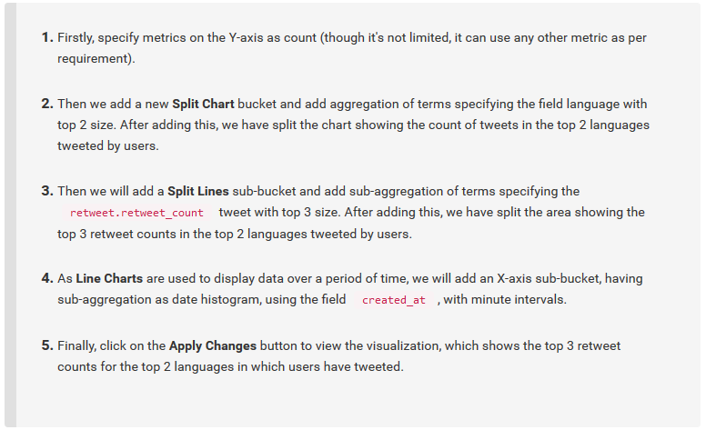

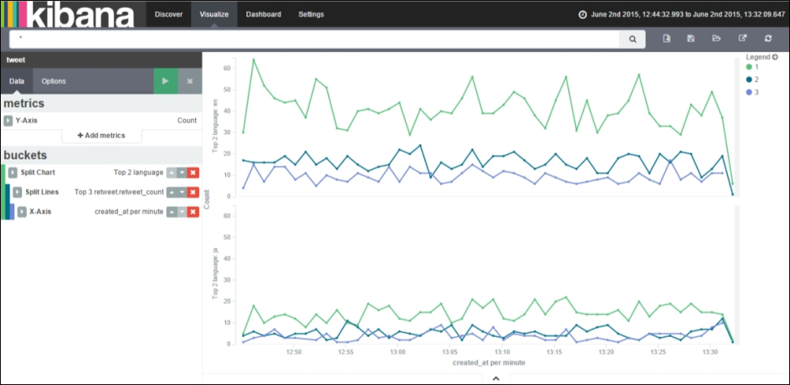

Sauvegarder sous le nom : LineChart
There is a new variation to Line Charts known as Bubble Charts. Bubble Charts are used to display data points as bubbles.
You can convert a Line Chart visualization to a Bubble Chart visualization by using the following steps:
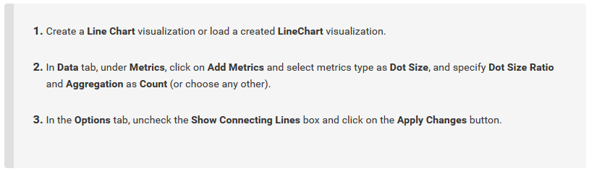

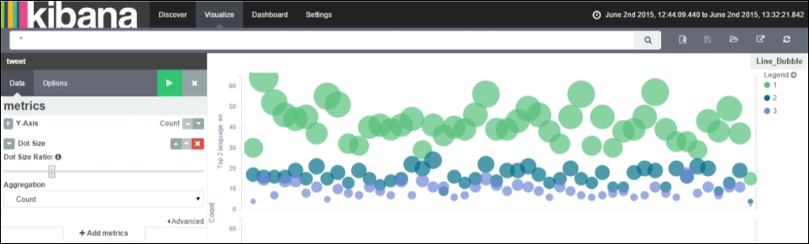

Sauvegarder sous le nom : Line_Bubble

Markdown widget
Zone de texte pour ajouter des commentaires …

Metric

Metric visualization is used to display a single number for various metric aggregations.

Objectif : Let's create a very interesting Metric visualization to calculate the unique hashtags in the data set and determine the preferred length of hashtag for Twitter. For this we would require the following inputs

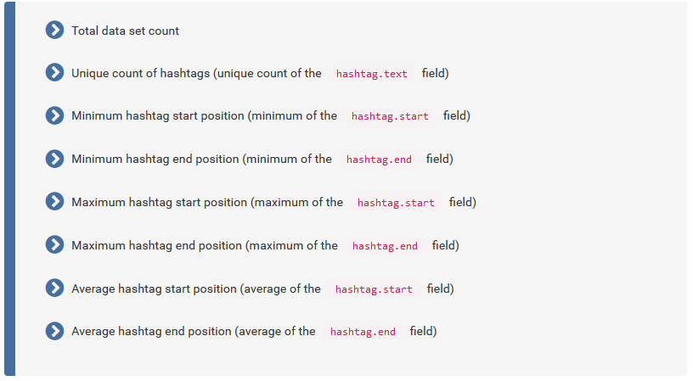

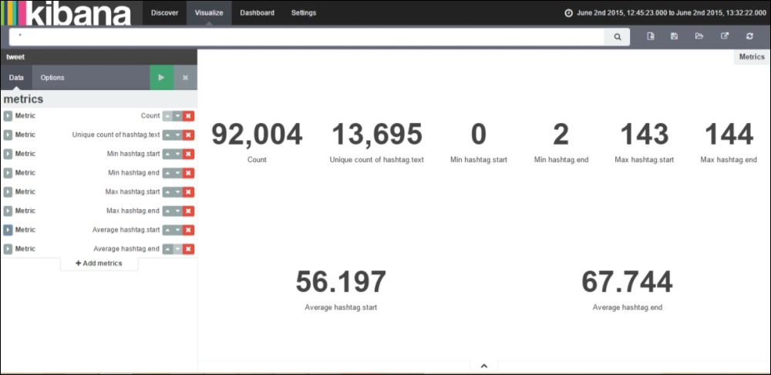

Sauvegarder le chart sous le nom Metrics

Pie Chart
This is used to display each source's contribution to the total.

Objectif : The chart that we would like to create would show comparison of top languages in which users tweeted, along with top country code for those languages over a period of time.

In this we will split the chart on the basis of created_at, split slices on the basis of top languages, and split slices on the basis of top country code. In Pie Charts, Split Charts are generally used before Split Slices:

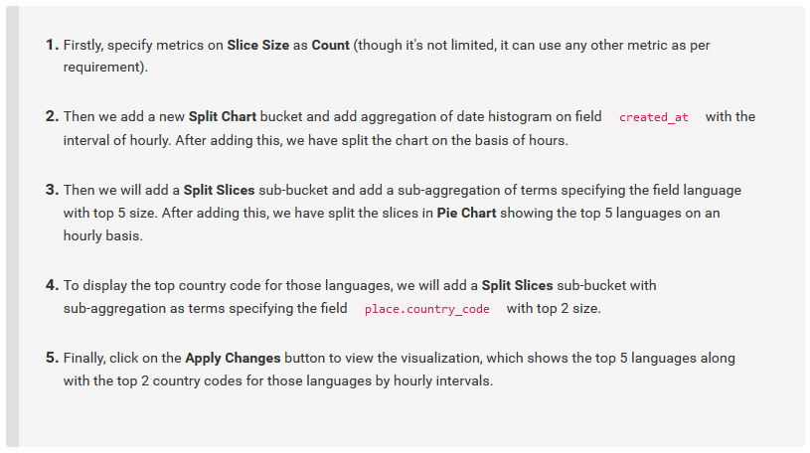

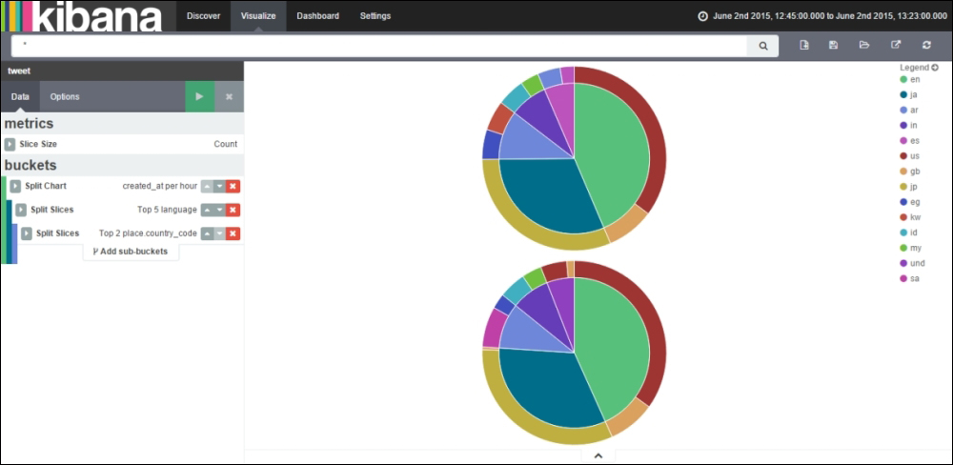

Sauvegarder le chart sous le nom PieChart

In the Options tab there are view options that alter the following behavior of pie charts:

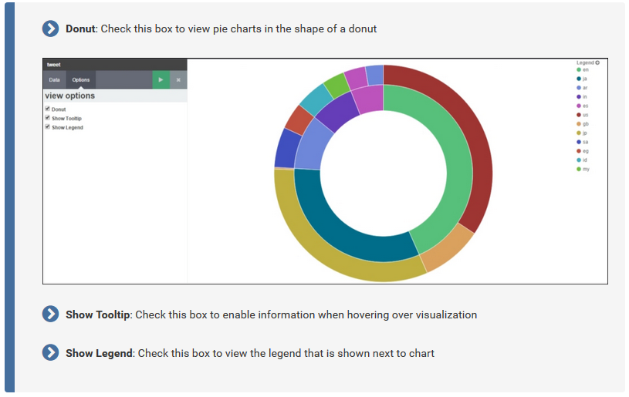

Vertical Bar Chart
This acts as a general-purpose chart suited to both time-based data and non-time-based data.
- The bar chart can be displayed either as stacked, percentage, or grouped.
- In this type of chart, every X-axis value will have its own corresponding bar where the size of every bar signifies the metric aggregation.

Objectif : The chart that we would like to create will show the comparison of the top languages in which users tweeted, along with the retweet count for those languages over a period of time.

In this, we will split the bars on the basis of the top languages, split the chart on the basis of retweet.retweet_count, and the X-axis will contain the period of time

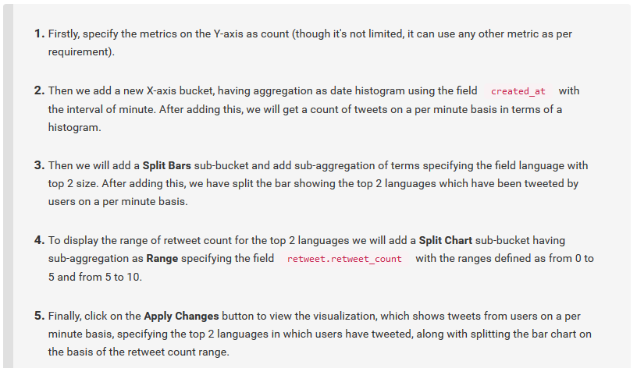

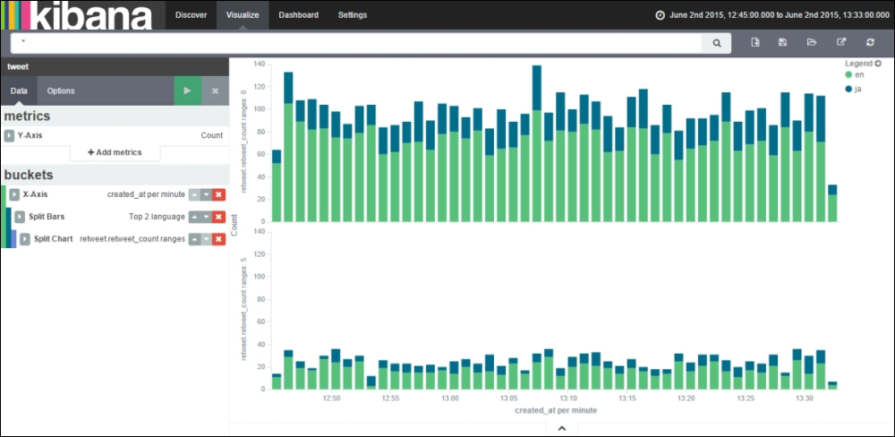

Area Chart
This is used to display areas below the lines and is similar to Line Charts. It is also used to display data over a period of time.
Objectif : The chart that we would like to create would show a comparison of top languages in which users tweeted, along with the retweet count for those languages over a period of time.
In this we will split the chart on the basis of top languages, split the area on the basis of retweet.retweet_count, and the X-axis will contain the period of time
