Aggregation Test-Drive

Lancez ElasticSearch.
Ouvrir Marvel Sense

Préparation

Insertion de données

DELETE /movies+

PUT /movies
{
"mappings": {
"_default_": {
"dynamic_templates": [
{
"strings": {
"match_mapping_type": "string",
"path_match": "*",
"mapping": {
"type": "string",
"fields": {
"original": {
"type": "string",
"index": "not_analyzed"
}
}
}
}
}
]
}
}
}

PUT /movies/movie/1
{
"title": "The Godfather",
"director": "Francis Ford Coppola",
"year": 1972,
"genres": ["Crime", "Drama"]
}

POST /movies/movie/_search
{
"query": {
"constant_score": {
"filter": {
"term": { "director.original": "Francis Ford Coppola" }
}
}
}
}

PUT /movies/movie/2
{
"title": "To Kill a Mockingbird",
"director": "Robert Mulligan",
"year": 1962,
"genres": ["Crime", "Drama", "Mystery"]
}

PUT /movies/movie/3
{
"title": "Lawrence of Arabia",
"director": "David Lean",
"year": 1962,
"genres": ["Adventure", "Biography", "Drama"]
}

PUT /movies/movie/4
{
"title": "Apocalypse Now",
"director": "Francis Ford Coppola",
"year": 1979,
"genres": ["Drama", "War"]
}

PUT /movies/movie/5
{
"title": "Kill Bill: Vol. 1",
"director": "Quentin Tarantino",
"year": 2003,
"genres": ["Action", "Crime", "Thriller"]
}

PUT /movies/movie/6
{
"title": "The Assassination of Jesse James by the Coward Robert Ford",
"director": "Andrew Dominik",
"year": 2007,
"genres": ["Biography", "Crime", "Drama"]
}

POST /movies/movie/_search
{
"query": {
"constant_score": {
"filter": {
"term": {
"genres.original": "Drama"
}
}
}
},
"aggregations": {
"directors": {
"terms": {
"field": "director.original"
}
}
}
}

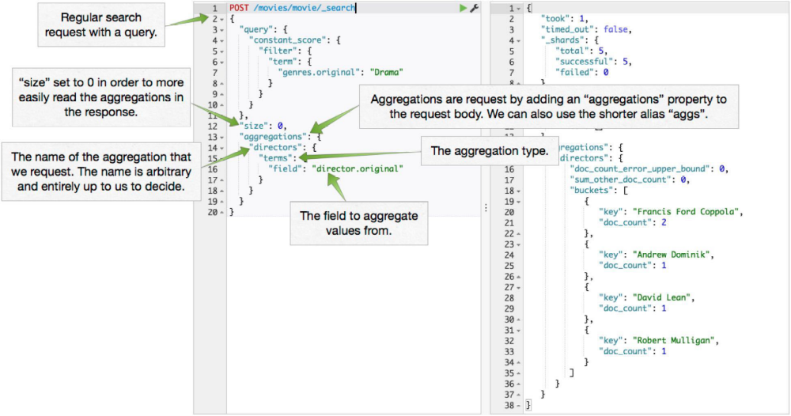

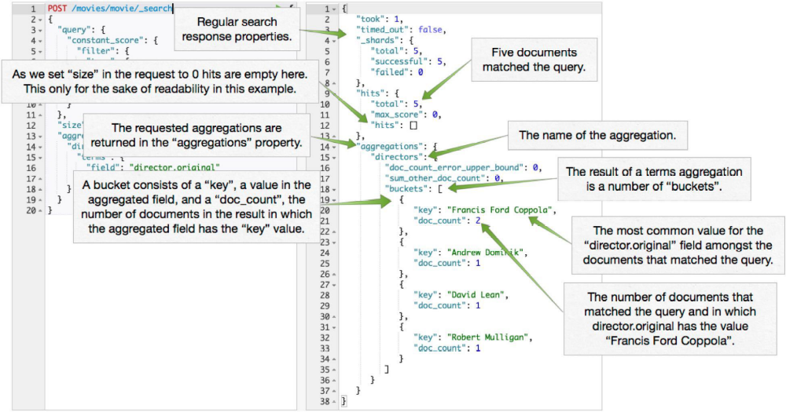

POST /movies/movie/_search
{
"aggregations": {
"directors": {
"terms": {
"field": "director.original"
}
},
"genres": {
"terms": {
"field": "genres.original"
}
}
}
}

POST /movies/movie/_search
{
"query": {
"filtered": {
"query": {
"match_all": {}
},
"filter": {
"term": {
"director.original": "Francis Ford Coppola"
}
}
}
},
"aggregations": {
"directors": {
"terms": {
"field": "director.original"
}
},
"genres": {
"terms": {
"field": "genres.original"
}
}
}
}

POST /movies/movie/_search
{
"post_filter": {
"term": {
"director.original": "Francis Ford Coppola"
}
},
"aggregations": {
"directors": {
"terms": {
"field": "director.original"
}
},
"genres": {
"terms": {
"field": "genres.original"
}
}
}
}

Mapping for KIBANA

PUT /movies/movie/_mapping
{
"movie": {
"properties": {
"director": {
"type": "multi_field",
"fields": {
"director": {
"type": "string"
},
"original": {
"type" : "string",
"index" : "not_analyzed"
}
}
},
"year" : { "type" : "integer" }
}
}
}

