Encore des opérateurs

Etape 1 : Chargement de la base
On peut exécuter un fichier .js(Javascript) directement dans mongodb.

Format: en ligne de commande dos

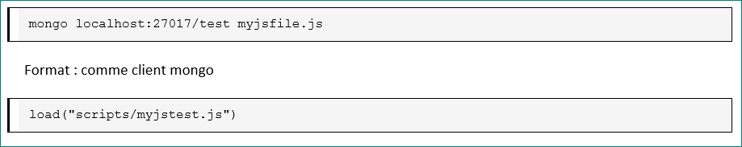

Le chemin vers le fichier peut être en relatif/absolue

Exécuter le script data.js (fournit)

Etape 2 : Writing
Insertion

//------------------------------------- update

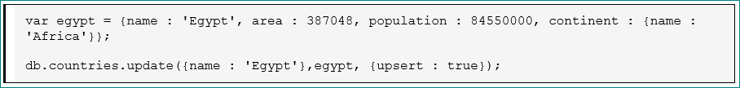

// get a document, change it, save it

var panama = db.countries.findOne( {name : 'Panama'} );
panama.continent = {name : 'South America'}
db.countries.save(panama);

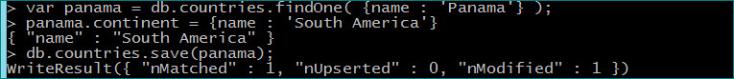

//update a document by setting a property

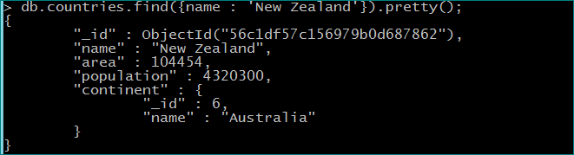

db.countries.update( {name : 'New Zealand'},{$set : {area : 104464 }} );

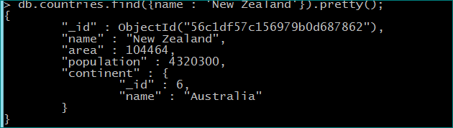

// increment a value in multiple documents

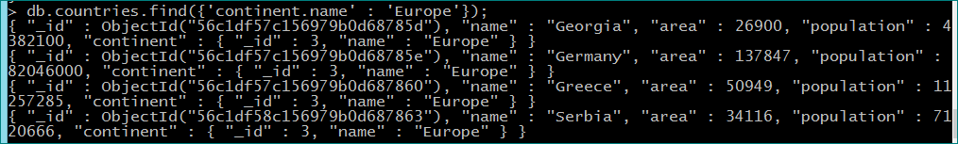

// rename and remove field

// only set field when inserting

//------------------------------------- remove

// remove one

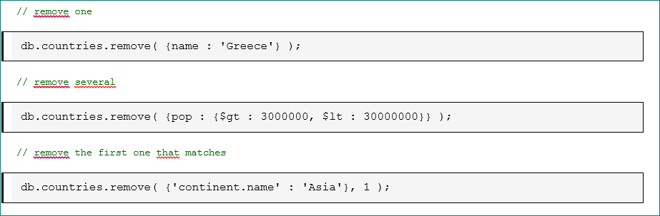

Etape 3 : Reading

Exécuter le script data.js (fournit)

Lancer un client mongo et taper les commandes suivantes :

> db.continents.findOne()
{ "_id" : 1, "name" : "Africa" }
> db.continents.find().pretty()
{ "_id" : 1, "name" : "Africa" }
{ "_id" : 2, "name" : "Asia" }
{ "_id" : 3, "name" : "Europe" }
{ "_id" : 4, "name" : "North America" }
{ "_id" : 5, "name" : "South America" }
{ "_id" : 6, "name" : "Australia" }
{ "_id" : 7, "name" : "Antarctica" }
>

findOne
Get the first document and print it as json



find

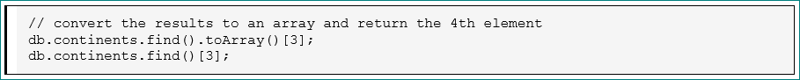



// display all documents from cursor

var continents = db.continents.find();
while ( continents.hasNext() ) printjson( continents.next() );

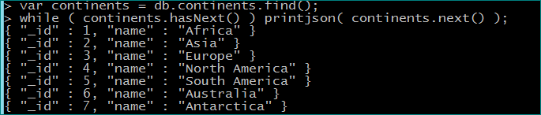

var ctryCursor = db.countries.find();
ctryCursor.forEach(printjson);

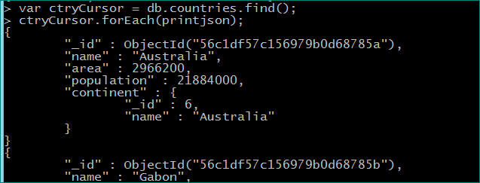
…

// a batch of 20 is returned if not assigned to variable
db.countries.find();

// get the next batch
it

// change the batch size
DBQuery.shellBatchSize = 10

queries

// return documents where area > 120000

skip & limit

// ignore the first 2 then return the next 3

sort

// 1 = ascending, -1 = descending

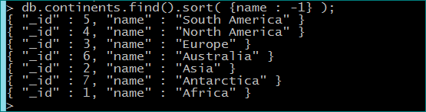

projection

// return the country name and the nested city name and population fields
db.megacities.find( {}, {_id : 0, name : 1, 'cities.name' : 1, 'cities.population' : 1} );

/* Return countries which have at least one city with a growth rate of 2%.
* All the cities for that country are returned. */

/* Return countries which have at least one city with a growth rate of 2%.
* Only those cities with growth rate of 2% are returned. */

combination

// query, projection, sort and limit

Etape 4 :
Lancer un client mongo et taper les commandes suivantes :

> db.countries.findOne()
{
"_id" : ObjectId("560e790fecd2d575d0e3c4b7"),
"name" : "Australia",
"area" : 2966200,
"population" : 21884000,
"continent" : {
"_id" : 6,
"name" : "Australia"
}
}

- Trouver un document (countries) avec ‘area’ = 26900.

- Trouver l’ensemble des documents (countries) qui ont le champ ‘area’ != 26900

- Trouver l’ensemble des documents (countries) qui ont le champ ‘area’ <= 50000

- Trouver l’ensemble des documents (countries) qui ont le champ ‘area’ compris entre 10000 et 80000

- Trouver l’ensemble des documents (countries) qui ont le champ ‘population’ > 10000000 et le champ ‘area’ < 100000

- Trouver l’ensemble des documents (countries) qui ont le champ ‘population’ > 10000000 ou le champ ‘area’ < 100000

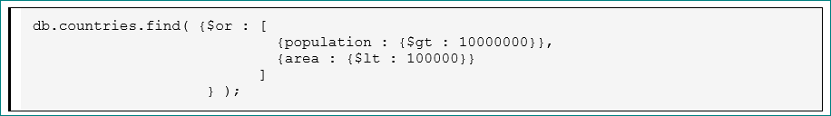

- //----------------------------------------------- and / or

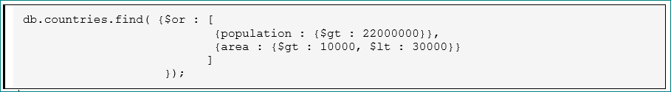

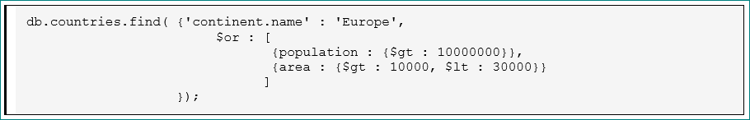

- //----------------------------------------------- in list

db.countries.find( {name : {$in : ['Ghana','Gambia','Gabon']}} );

- //----------------------------------------------- regular expression

db.countries.find( {name : {$regex : 'G[ae].*'}} );

- //----------------------------------------------- subdocument

db.countries.find( {'continent.name' : 'Europe'} );

