Python with Selenium Automated Testing

Code

from selenium import webdriver

from selenium.webdriver.chrome.service import Service

from selenium.webdriver.common.by import By

import time

class Test:

def __init__(self):

self.s = Service(r"C:\Users\Sreelekshmi\Downloads\chromedriver.exe")

browser = webdriver.Chrome(service=self.s)

url = 'https://www.urbanladder.com/'

time.sleep(5)

browser.get(url)

time.sleep(5)

browser.maximize_window()

time.sleep(5)

browser.find_element(By.XPATH, "//*[@id='header']/div[1]/div/section[3]/ul/li[2]/span").click()

time.sleep(5)

browser.find_element(By.LINK_TEXT, "Log In").click()

time.sleep(7)

browser.find_element(By.XPATH, "/html/body/div[6]/div/div[1]/div/div[2]/div[3]/form/div/input").send_keys(

"abc1111@gmail.com")

time.sleep(2)

browser.find_element(By.XPATH, "/html/body/div[6]/div/div[1]/div/div[2]/div[3]/form/div/div/div/input"). \

send_keys("Fk#mM!wGS9jvx4Z")

browser.find_element(By.ID, "ul_site_login").click()

print("Login successful")

browser.find_element(By.XPATH, "//*[@id='topnav_wrapper']/ul/li[3]/span").click()

time.sleep(2)

browser.find_element(By.LINK_TEXT, "Beds with Storage").click();

time.sleep(2)

print("Navigated to Beds with Storage");

browser.find_element(By.XPATH, "//*[@id='filters-form']/div[1]/div/div/ul/li[6]").click()

time.sleep(2)

browser.find_element(By.ID, "filters_brand_name_By_Urban_Ladder").click()

print("Sorted brand by urban ladder ")

time.sleep(6)

browser.find_element(By.XPATH, "//*[@id='filters-form']/div[1]/div/div/ul/li[1]").click()

time.sleep(2)

browser.find_element(By.ID, "price_limit_9299-24999").click()

print("Sorted by price")

time.sleep(5)

time.sleep(5)

browser.execute_script("window.scroll(0, 0);")

time.sleep(2)

browser.find_element(By.XPATH, "//*[@id='head-alert']/div/div/div").click()

time.sleep(2)

browser.find_element(By.XPATH, "//*[@id='topnav_wrapper']/ul/li[3]/span").click()

time.sleep(2)

browser.close()

ob1 = Test()

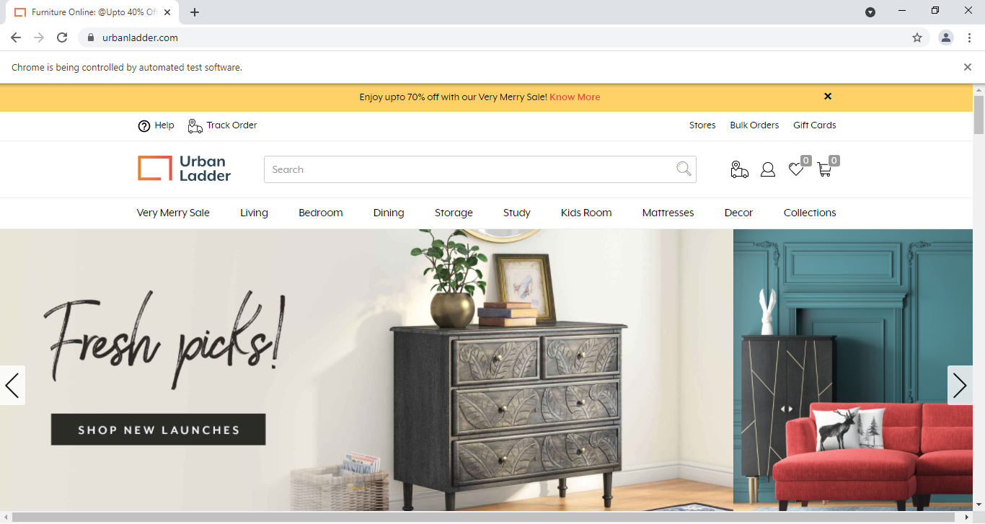**RESULTS**

