1. Write a program to reverse the String (use char[] or String built in method)
2. Write programs to depict the usage of contains(), length(), replace(), concat(), equals()

Write a program to reverse the String (use char[] or String built in method)

**package** com.ust.test;

**import** java.io.*;

**import** java.util.Scanner;

**public** **class** StringReverse {

**public** **static** **void** main (String[] args) {

String str= "Jerome", rev="";

**char** ch;

System.***out***.print("Original word: ");

System.***out***.println("Jerome");

**for** (**int** i=0; i<str.length(); i++)

{

ch= str.charAt(i);

rev= ch+rev;

}

System.***out***.println("Reversed word: "+ rev);

}

}

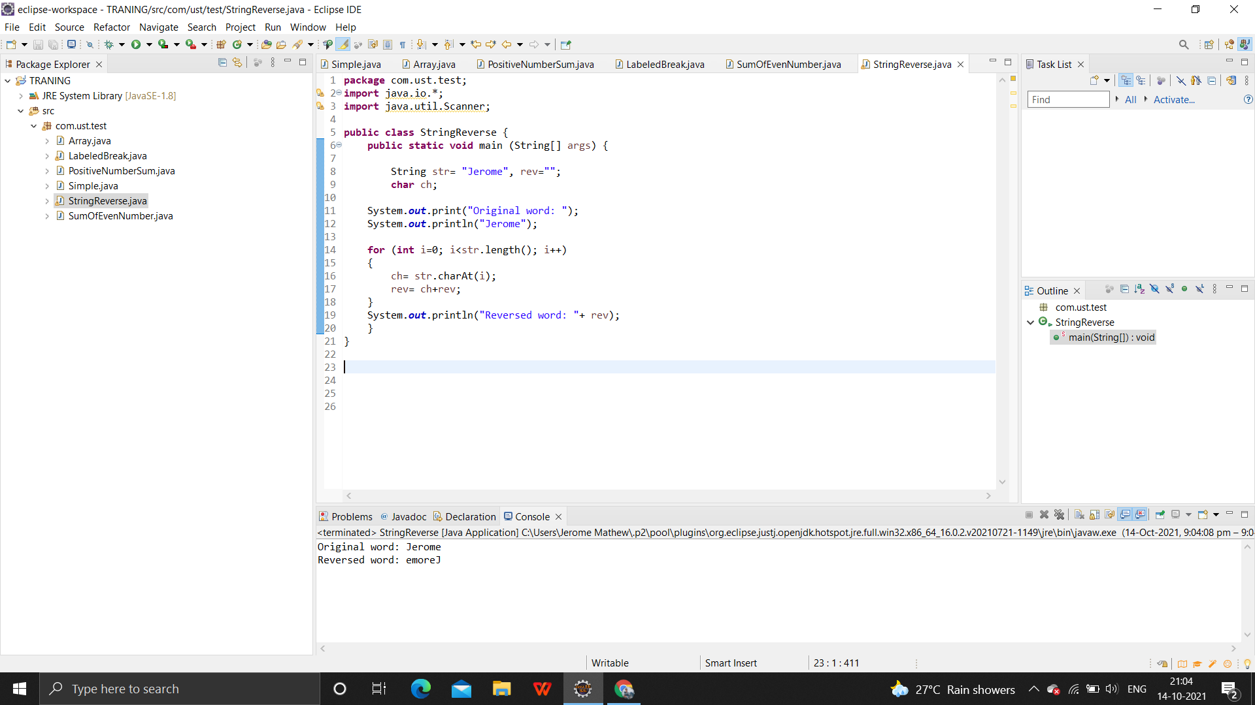

Write programs to depict the usage of contains(), length(), replace(), concat(), equals()

**package** com.ust.test;

**public** **class** Contain {

**public** **static** **void** main(String args[])

{

String s1 = "Hello Friends";

System.***out***.println(s1.contains("Hello"));

System.***out***.println(s1.contains("people"));

}

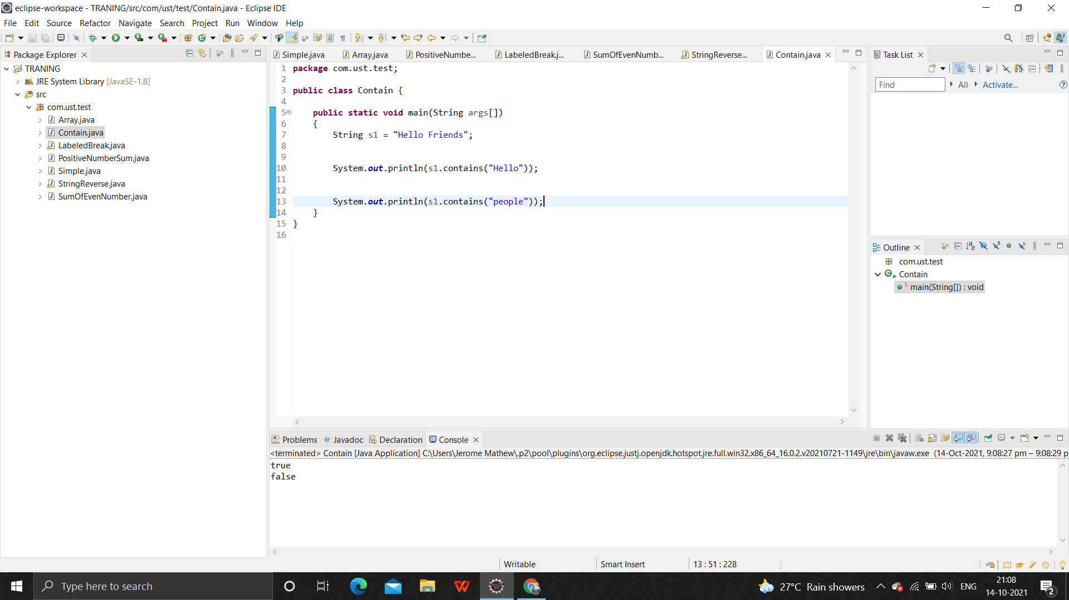}

**length()**

**package** com.ust.test;

**public** **class** Length {

**public** **static** **void** main(String[] args)

{

**int**[] array = **new** **int**[4];

System.***out***.println("The size of the array is "

+ array.length);

String str = "Good morning";

System.***out***.println("The size of the String is "

+ str.length());

}

}

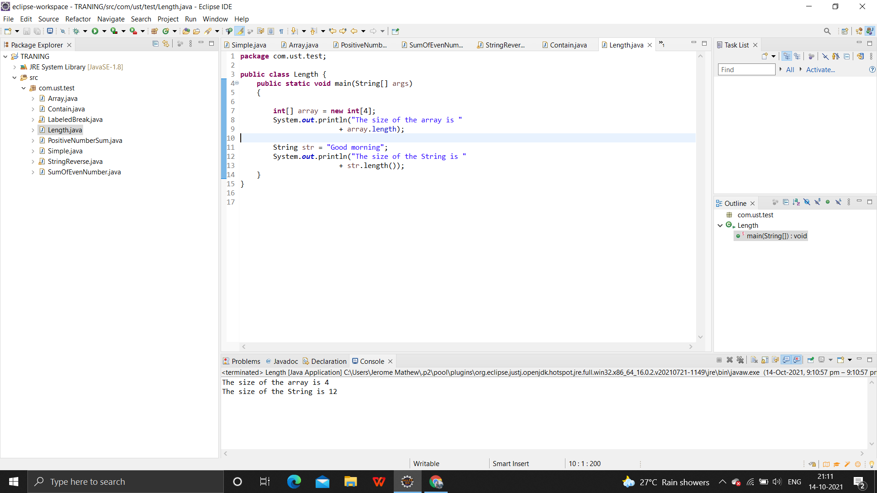

**replace()**

**package** com.ust.test;

**public** **class** Replace{

**public** **static** **void** main(String args[]){

String s1="Helloeveryone";

String replaceString=s1.replace('e','c');

System.***out***.println(replaceString);

}}

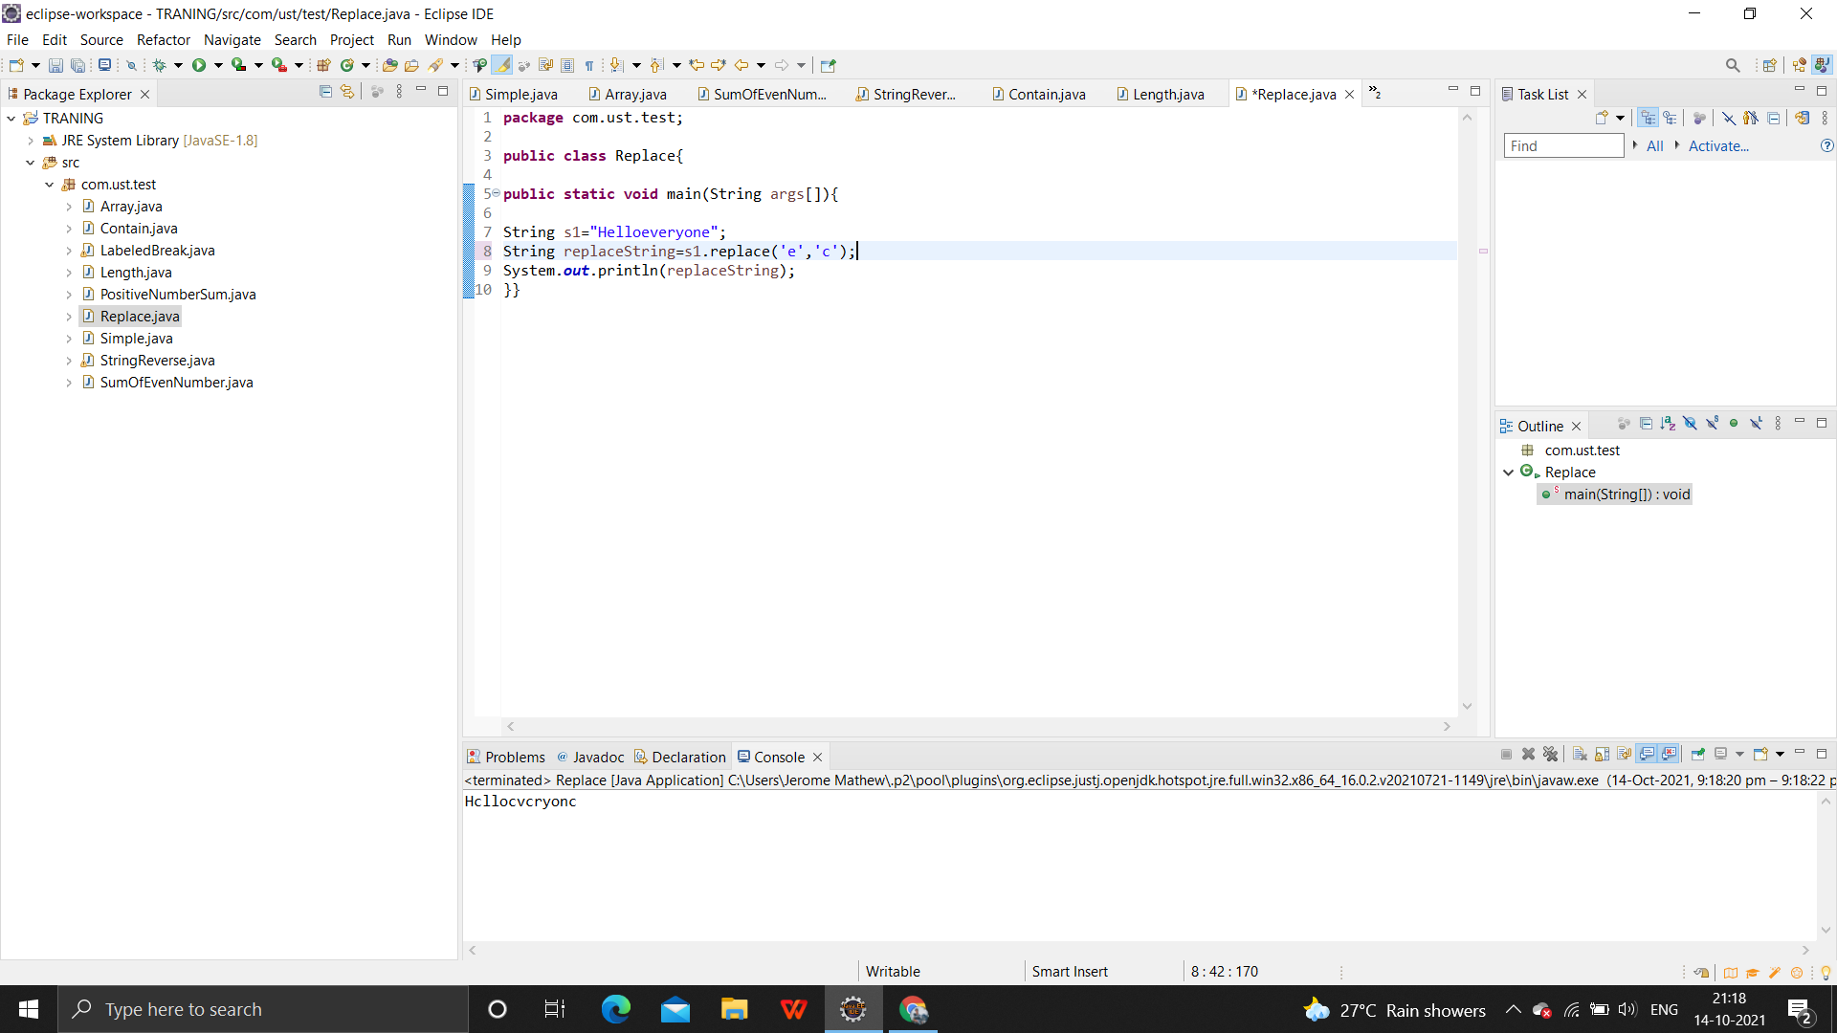

**concat()**

**package** com.ust.test;

**public** **class** Concat {

**public** **static** **void** main(String args[])

{

String s = "Hello ";

s = s.concat("Everyone");

System.***out***.println(s);

}

}

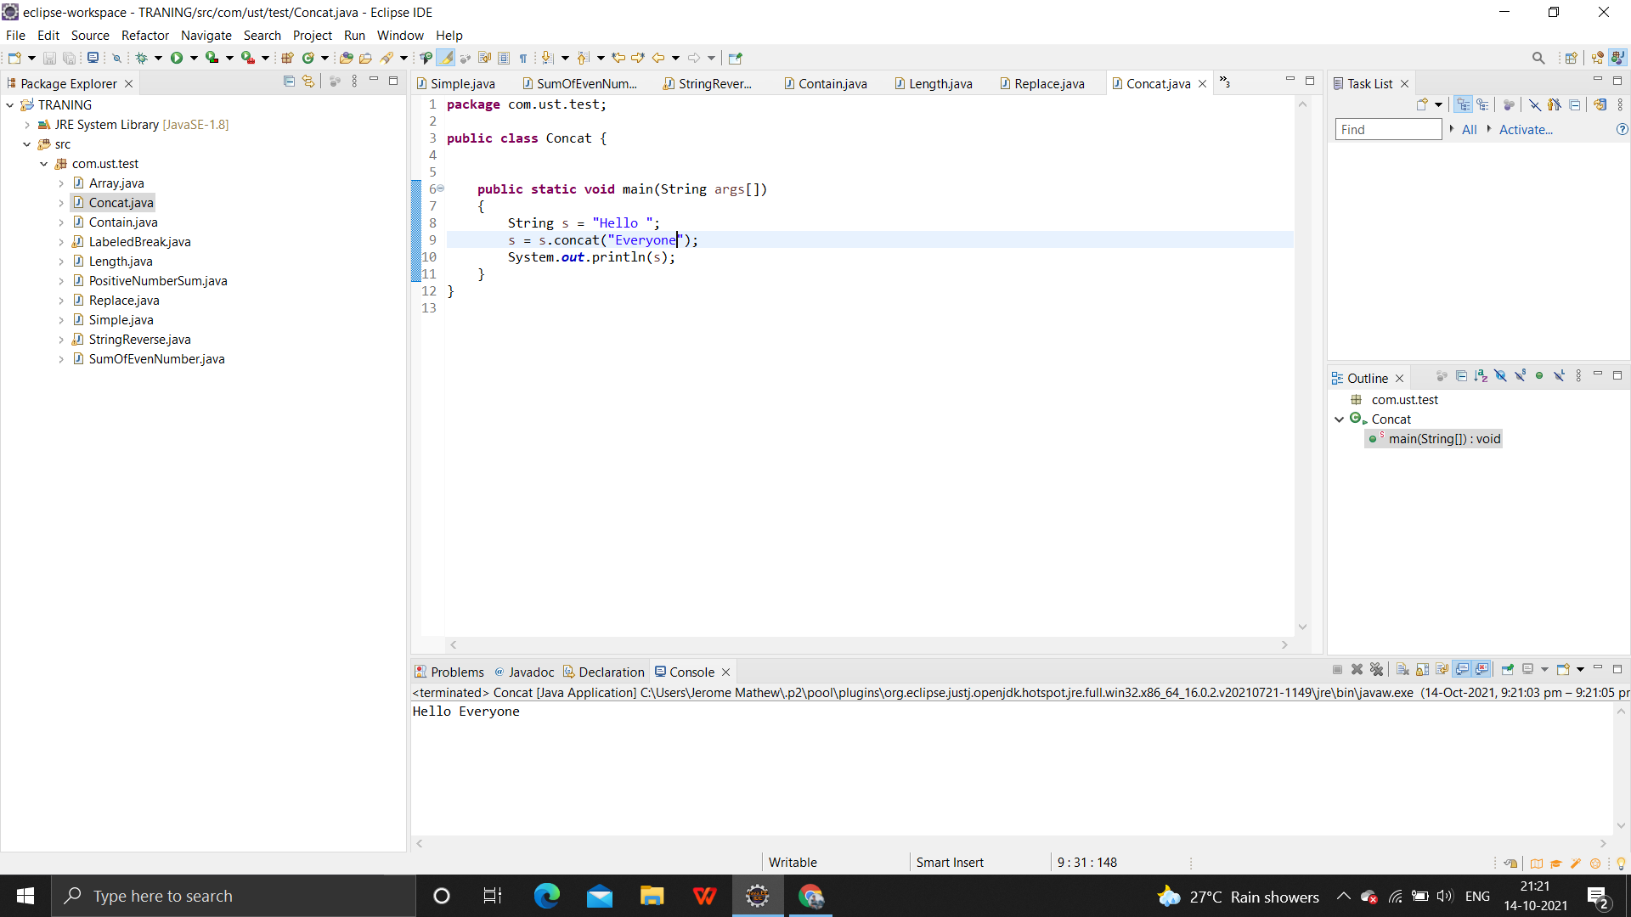

**equals()**

**package** com.ust.test;

**public** **class** Equals{

**public** **static** **void** main(String args[]){

String s1="HELLO";

String s2="hello";

String s3="world";

String s4="HELLO";

System.***out***.println(s1.equals(s2));

System.***out***.println(s1.equals(s3));

System.***out***.println(s1.equals(s4));

}}

