**Miles Front-end Challenge**

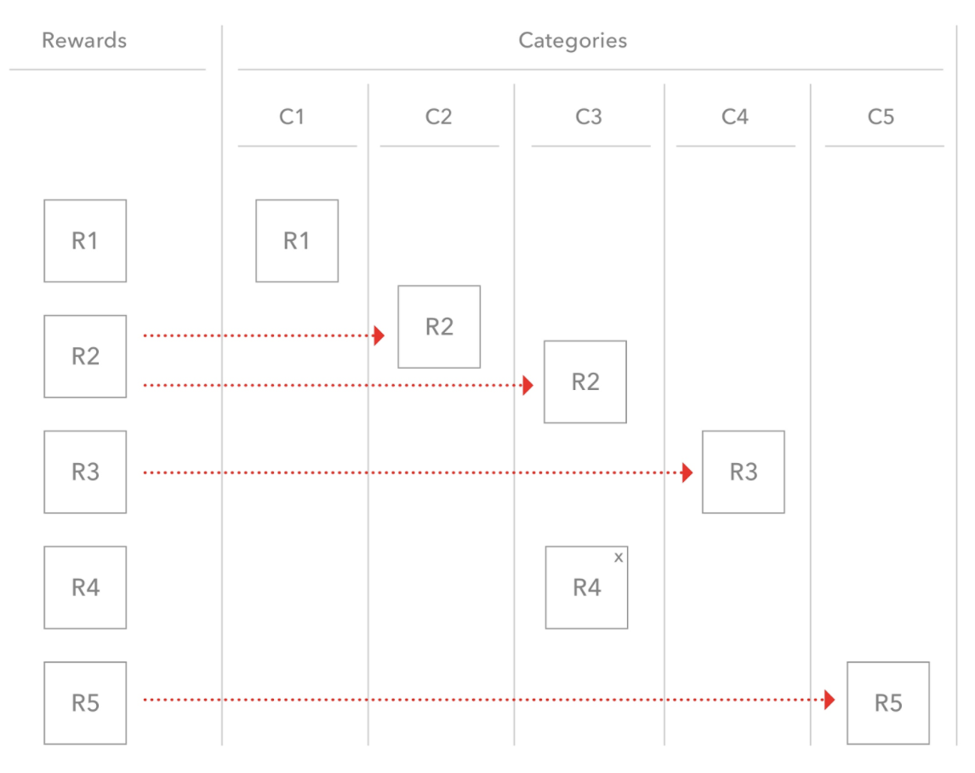

**Objective:** Map the Rewards with the Categories

Consider a reward related company like "Groupon" which have several rewards like R1, R2, R3, R4 and R5 that are categorized between categories like C1, C2, C3, C4, and C5.

**Requirements:**

1. A reward can be a part of multiple categories.

Eg:

R1 -> C1

R2 -> C2, C3 and so on...

You can drag a reward to achieve this functionality shown by red dotted lines.

2. A reward can be removed from any category. You have a cross on the reward R4 which helps to remove the reward from that category only.

3. A reward can also be dragged between the swimlanes. In such a case, the reward gets removed from the former swimlane.

4. The reward should always stay in the reward swimlane so that you can keep dragging in one or more categories.

5. Once you have completed the challenge, deploy on the cloud of your choice and give us the link to evaluate. We will require the source code for the technical phone screen.

**Note:** You can achieve this functionality by any framework/technology of your choice. You can use any external library as well.

#### **Extra points**

If you feel like you want to overachieve, pick these:

* Undo/redo button
* Permalink URLs
* Save to simple backend / or local storage