JT-GPS Demo
JT-GPS Demo is a small managed application that illustrates how to read NMEA 0183 data from a GPS receiver, and display the GPS position fix on a map.
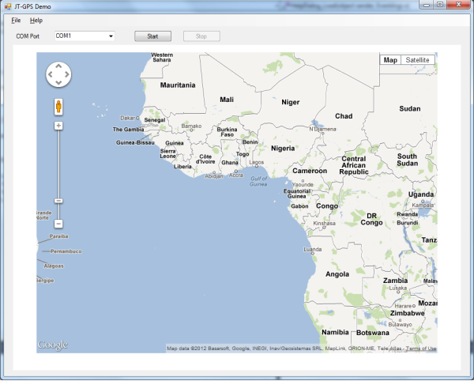
To use JT-GPS Demo, first ensure that your GPS receiver is connected to your PC. If your GPS receiver uses a connection other than a serial cable (e.g. Bluetooth, or USB to Serial converter), it can only be used with the application is a Virtual Com Port is assigned to your device. Consult your documentation to determine what COM port to use.
If your COM port isn't listed in the drop down of available COM ports, then unfortunately your GPS device cannot be used with JT-GPS Demo. In the future we may consider beefing up the search for COM ports, allowing entering of COM port manually, or allowing connections other than COM ports directly without the use of virtual COM ports. But since this is just a demo, it's only going to work with COM ports available in the drop down.

There are no COM port configuration settings to tweak in this demo. We're assuming the COM settings follow the NMEA-0183 protocol:
- 4800 baud
- 8 data bits
- No parity
- 1 stop bit
Once you select the appropriate COM port for your GPS receiver, click the start button to open the port and start reading data. If your GPS receiver transmits the GLL NMEA 0183 sentence and your GPS receiver is locked onto enough satellites to obtain a fix, then a red marker will be displayed on the map.
The map is a Google Map, so the user interface is the same as if you opened Google maps in a web browser. In fact, the Google Map in the demo application is actually inside an embedded browser, served up from an embedded web server.
Clicking the stop button will close the COM port, and stop reading of GPS data.
You can terminate the application without clicking stop if you wish. The COM port will be automatically closed.

