**Regular Expressions**

We are going to use the regex101.com website to learn some Regular Expressions.

Before we start, please ensure that the REGEX flags on the website have global and multi-line turned on as shown in the screenshot below:

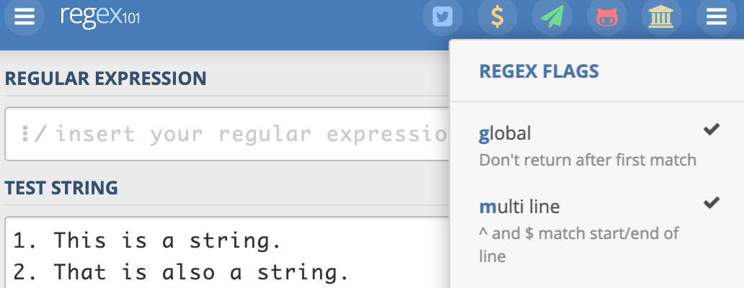

We will use the following text for our practice:

1. This is a string.

2. That is also a string.

3. This is an illusion.

4. THIS IS LOUDER Than you.

that isn't thus

bob this is bob

bob bob_ ralph_ bobbobbobbybobbob

ababababab

6. tHiS iS CoFu SEd

777. THIS IS 100%-THE-BEST!!!

8888. this_is_a_fiiile.py

hidden bob

**Exact Match**

You will need to copy the text above and paste it into the website.

First, we try to match the string bob. This is intended to be an exact match, i.e. the text must strictly match this expression. Note: this is case sensitive.

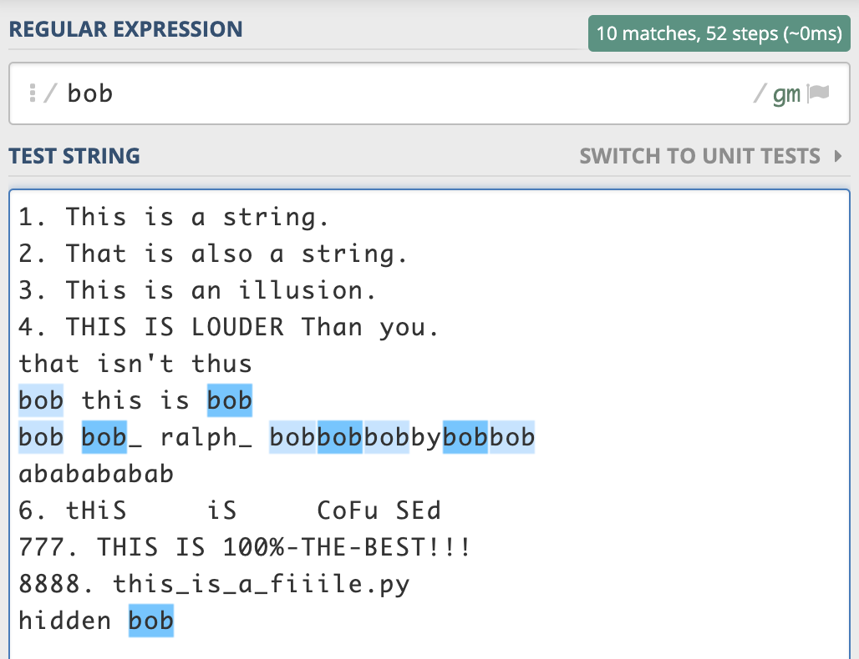 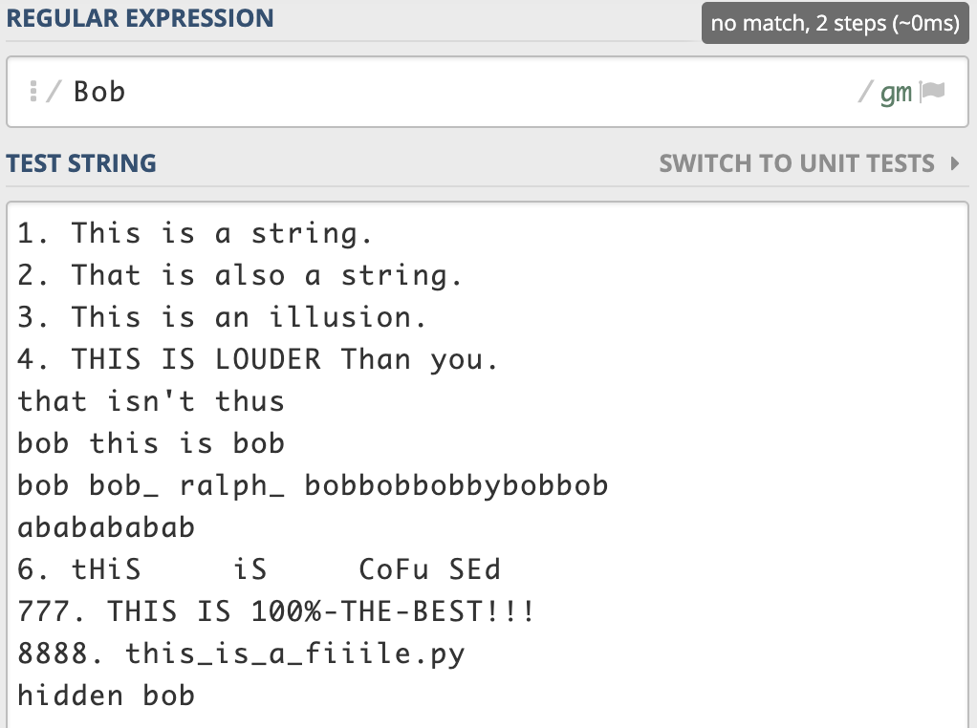

**Character Class**

Next, we will try to match single vowels.

Note: there are no commas. If you do include commas, then the comma(s) will be part of what you are trying to match. As before, this is case-sensitive. It will only match single characters of lower-case vowels. We can include AEIOU if we want to match both lower and upper-case vowels.

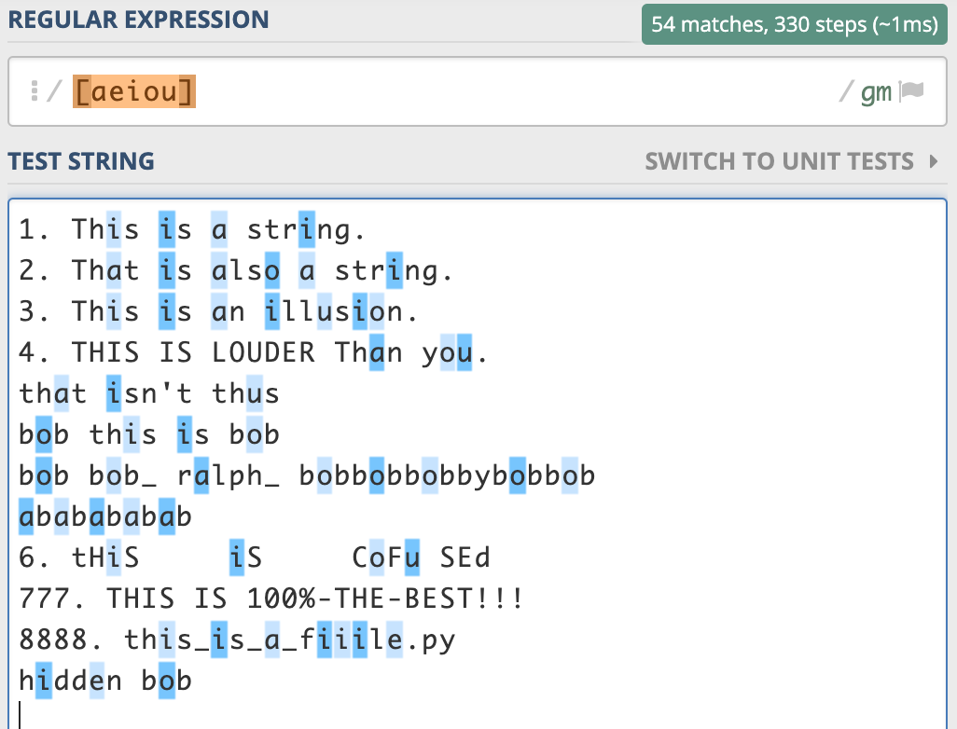 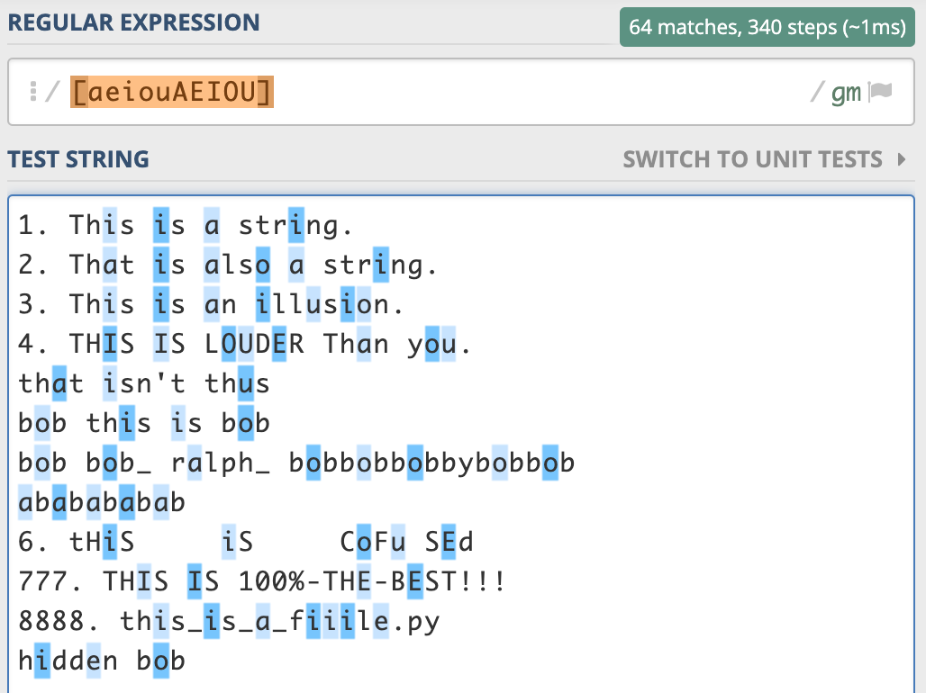

The screenshot below shows how we can match either this or thus in the text. The explanation of the regular expression is shown on the right-hand panel.

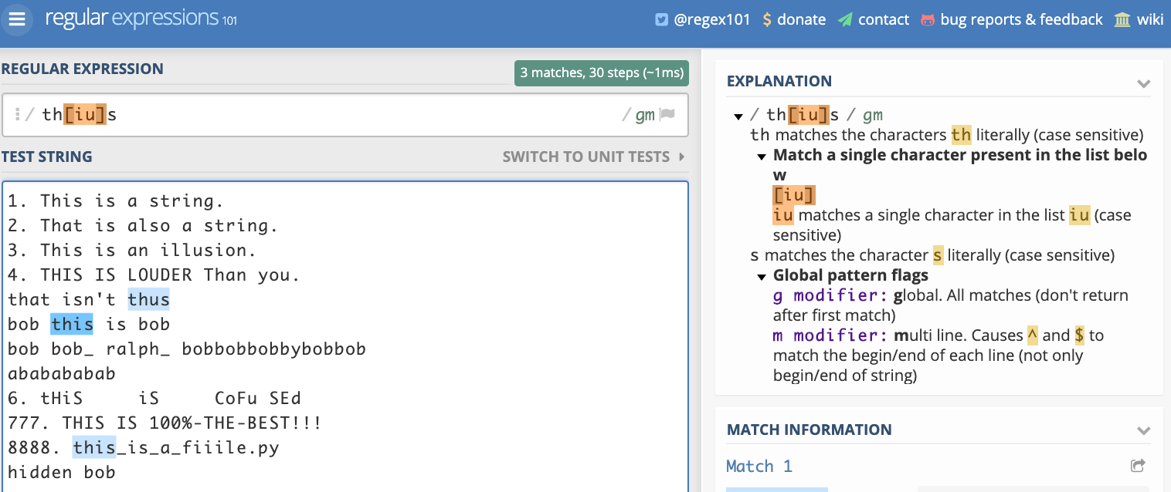

If we want to match either This or Thus or this or thus, we will write the regular expression as shown in the following screenshot.

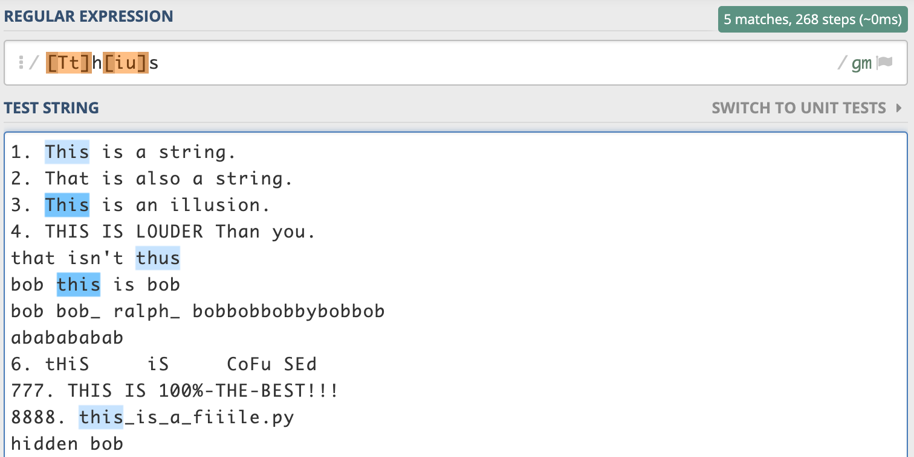

Clearly, we will not enjoy typing in numerous alphabets just to match them. Instead we can put in a range of alphabets as shown in the following screenshot:

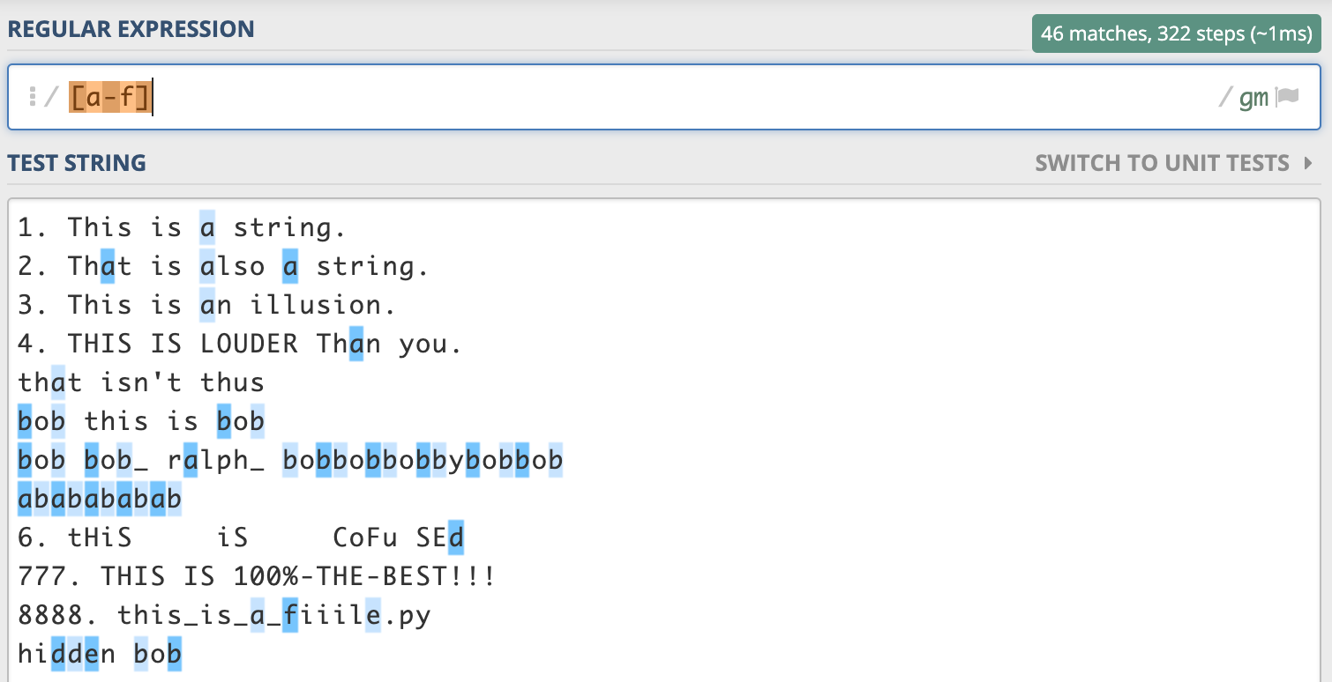

We can also use the concept of using ranges for numbers as shown in the screenshot below:

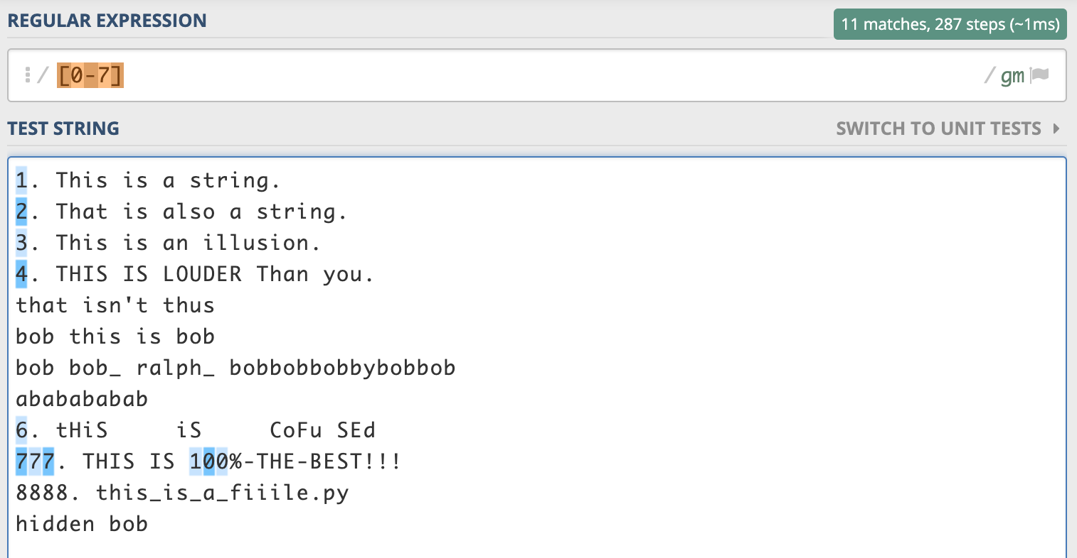

We can also use [A-z] to make the matching case-insensitive. However, please note that this way of writing the regular expression make also (unexpectedly) match the underscore ( _ ) characters.

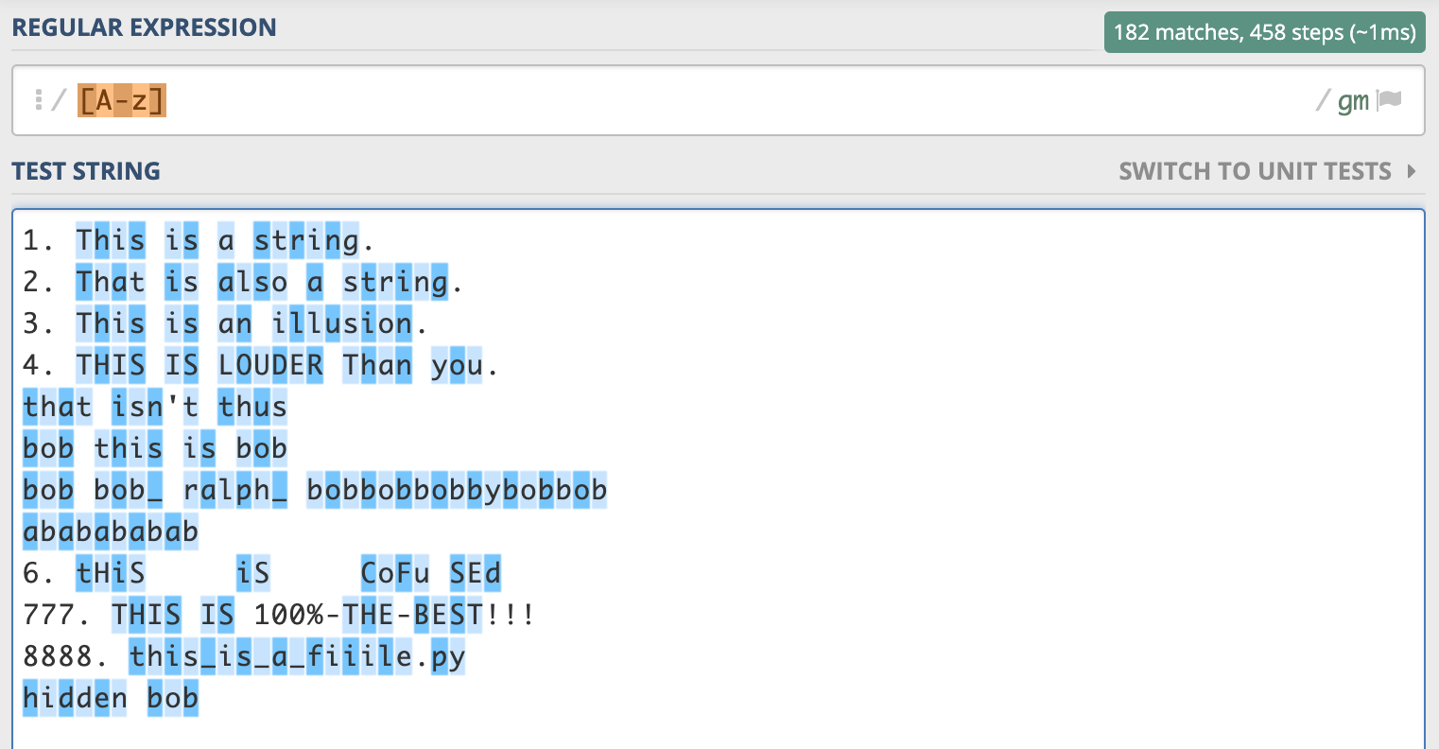

To match only the case-insensitive alphabets and exclude the underscore characters, we use the regular expression as shown below:

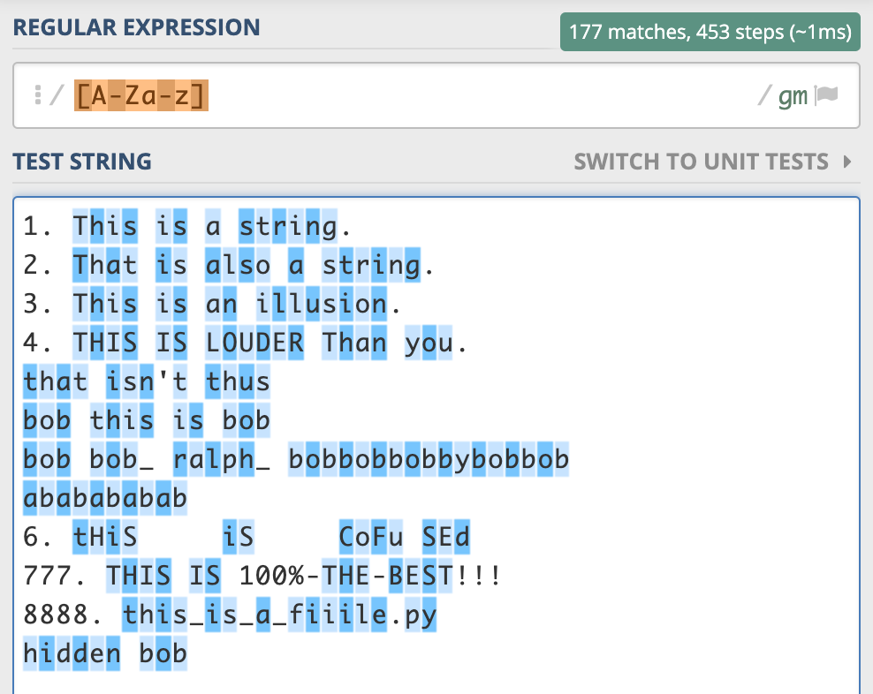

To include matching for numbers, we use the regular expression as shown below:

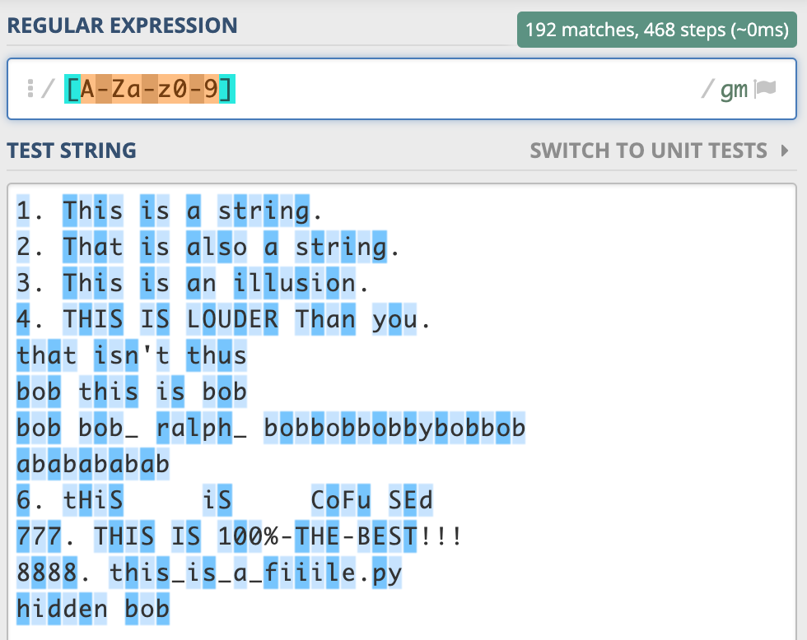

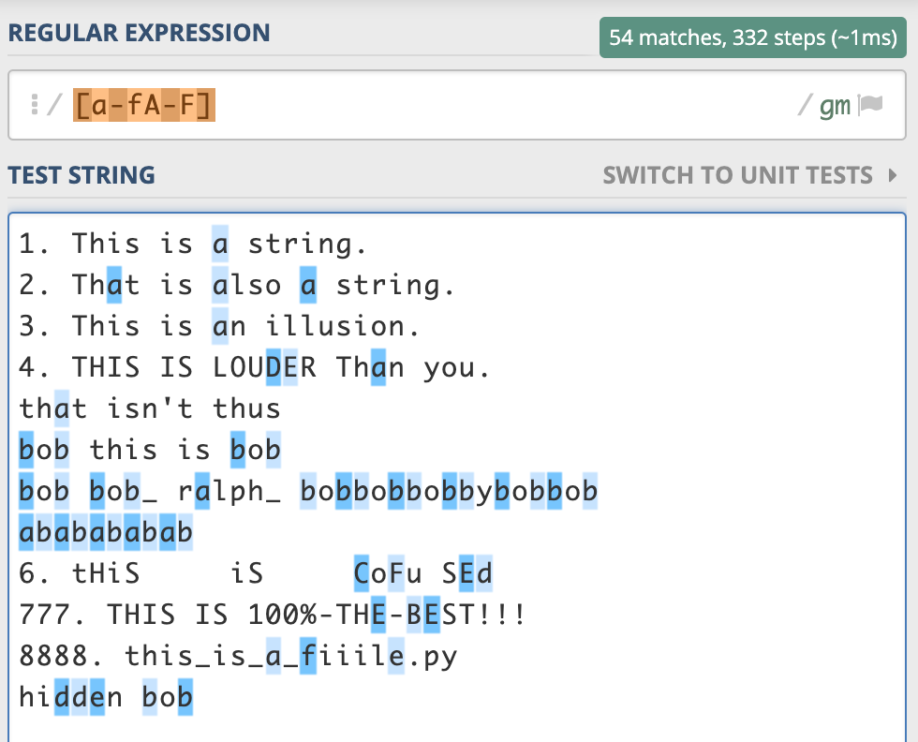

**Quantifiers**

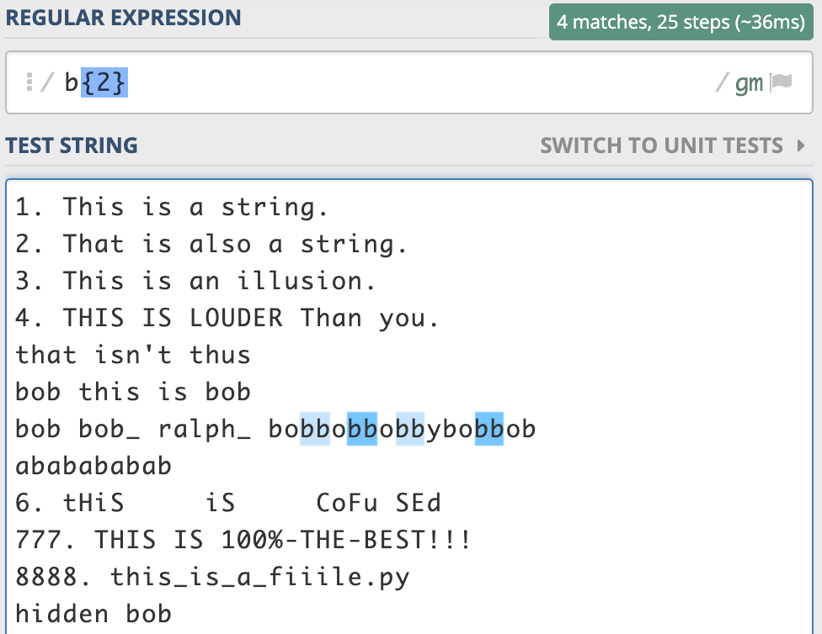

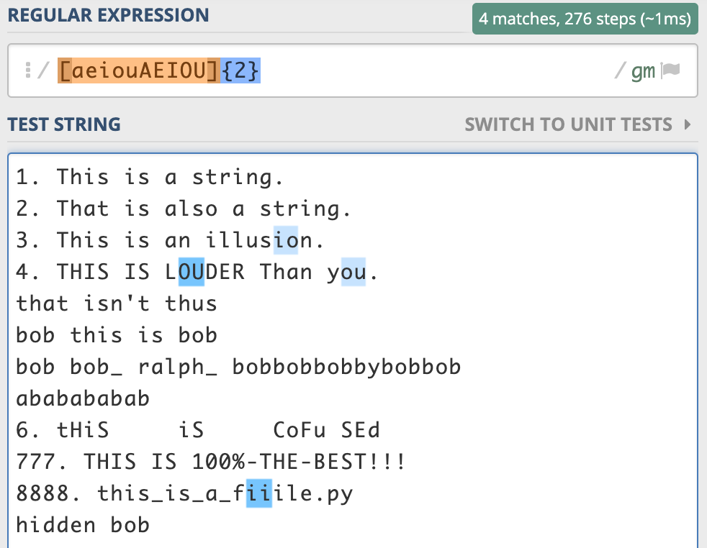

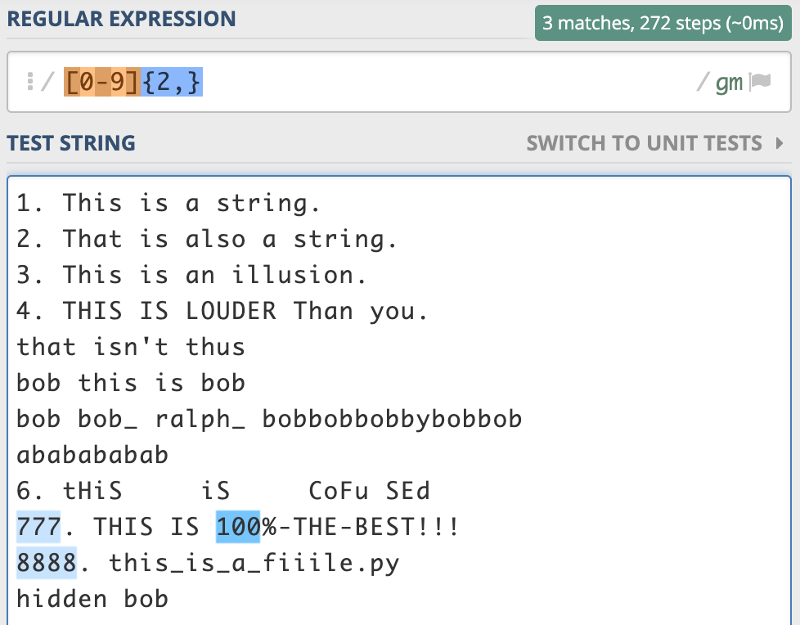

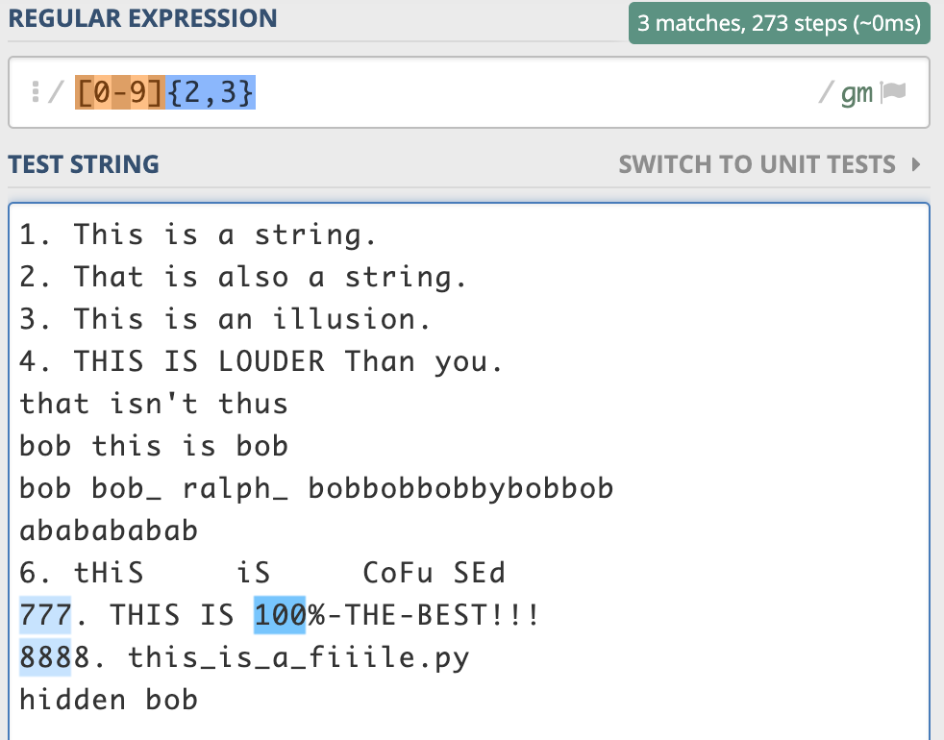

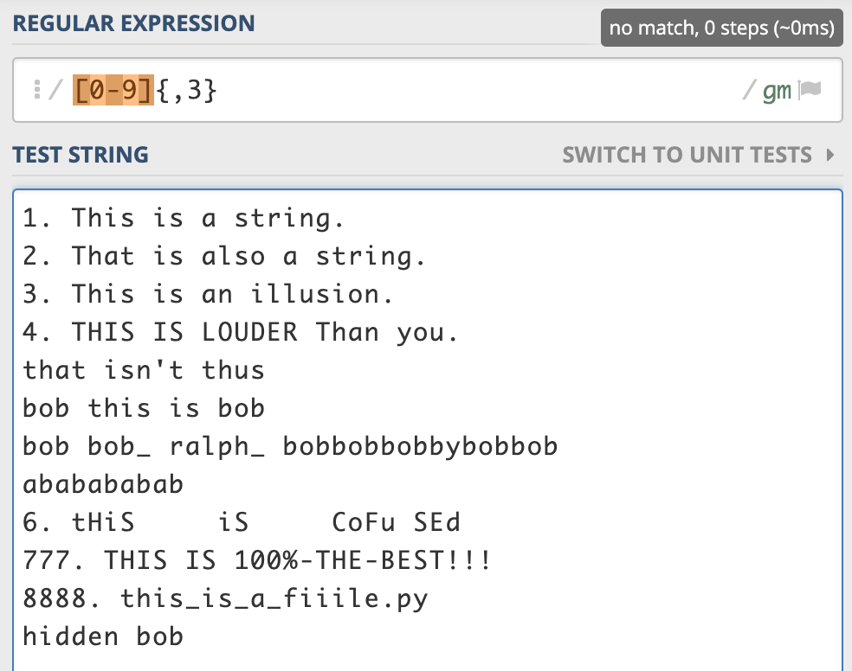

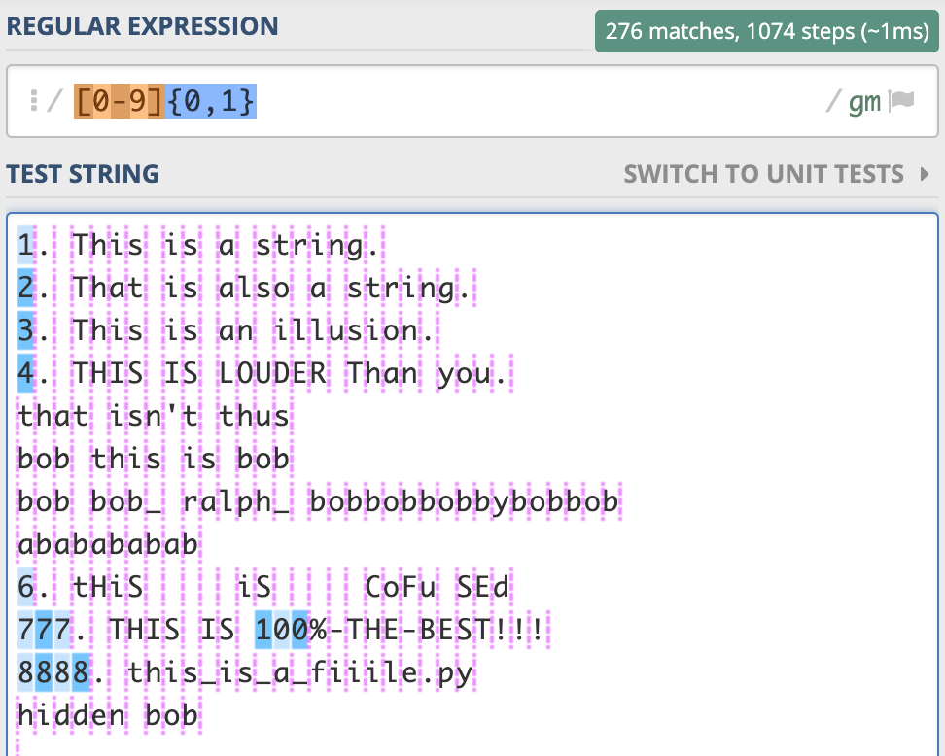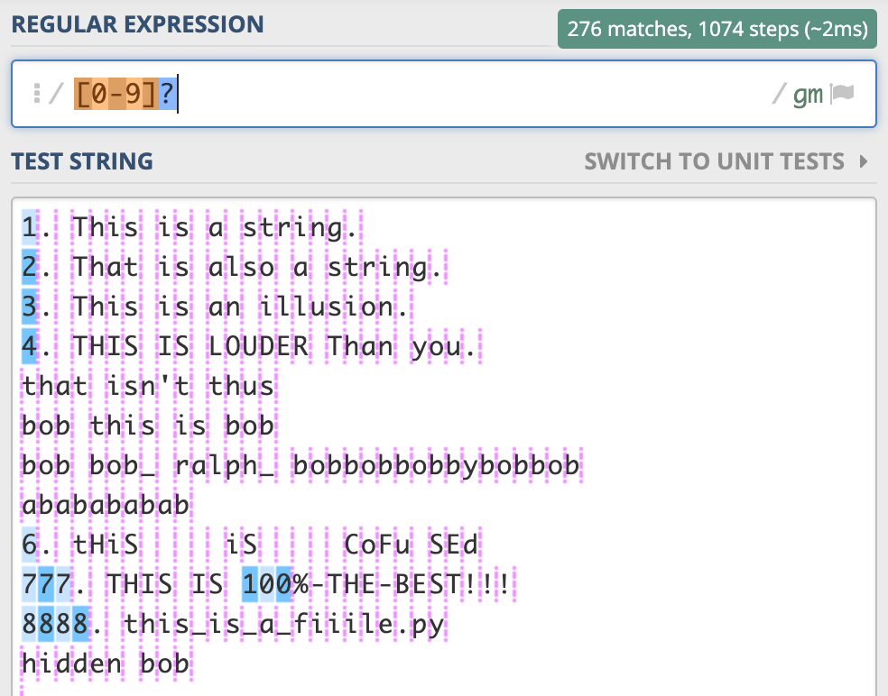

{0,1} is the same as a ?

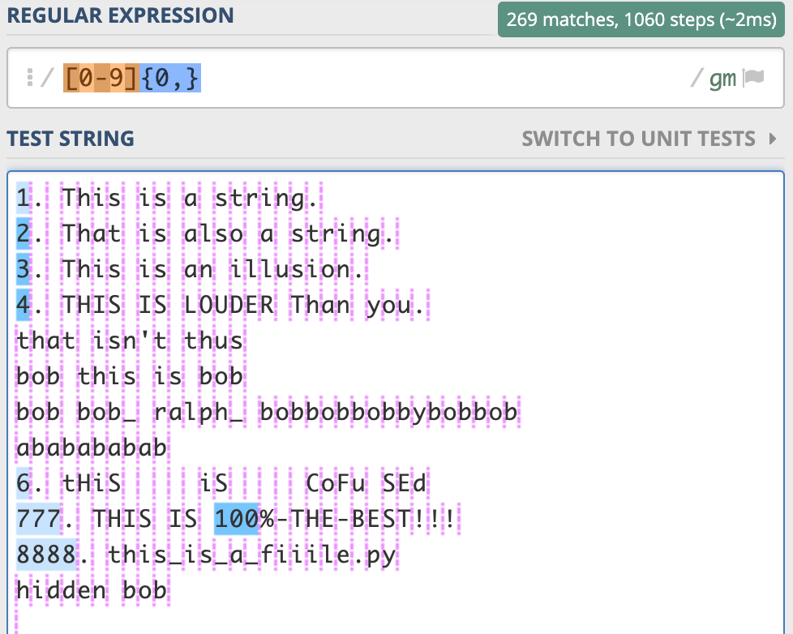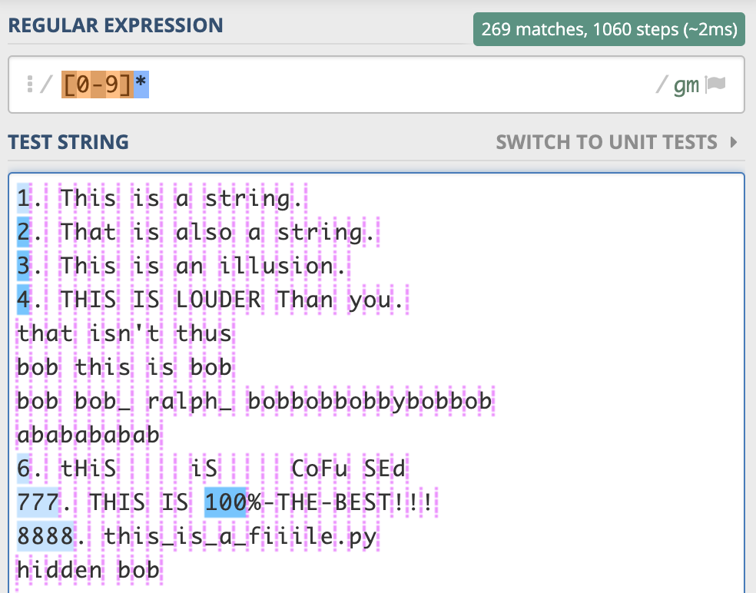

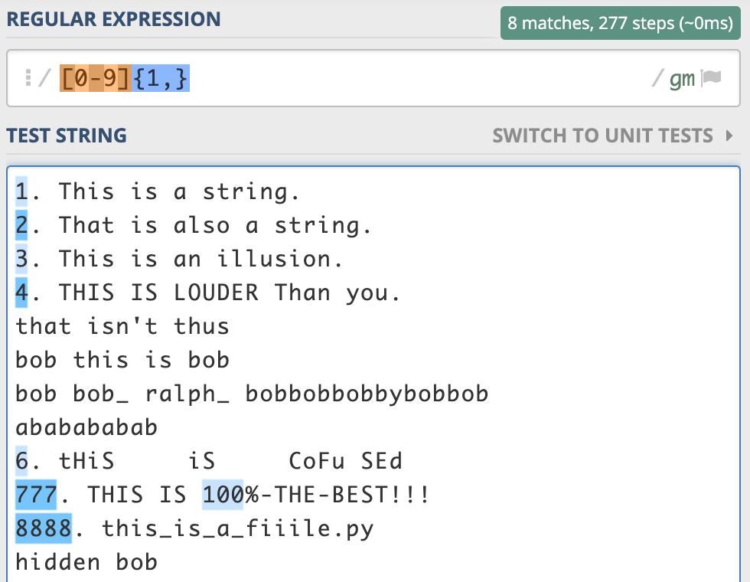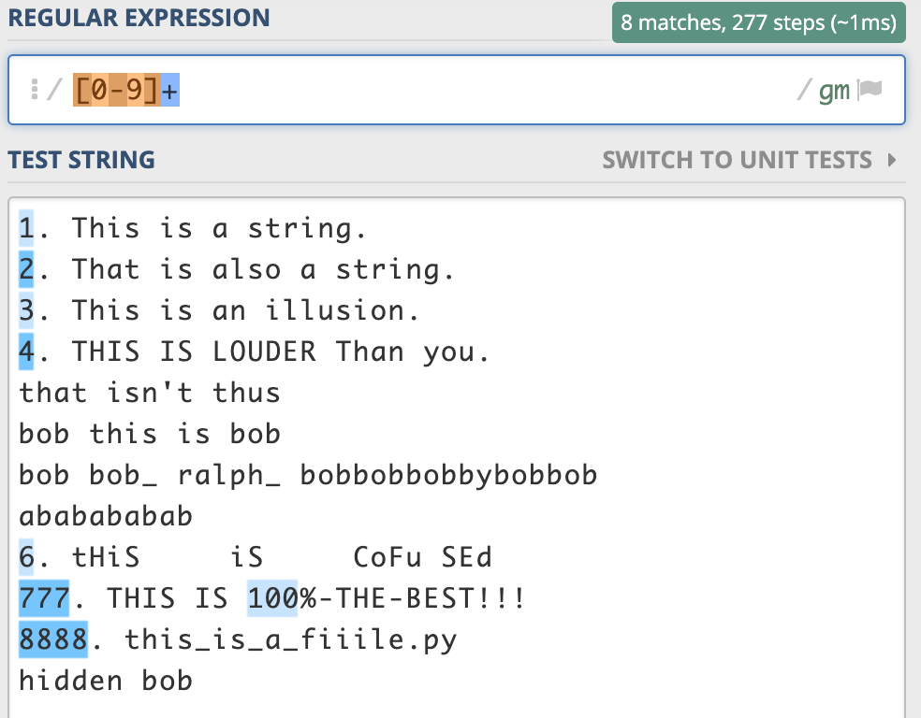

For the subsequent steps, we will use the following text:

CH4

H20

HCl

C3H8

ClF3

Cl2O7

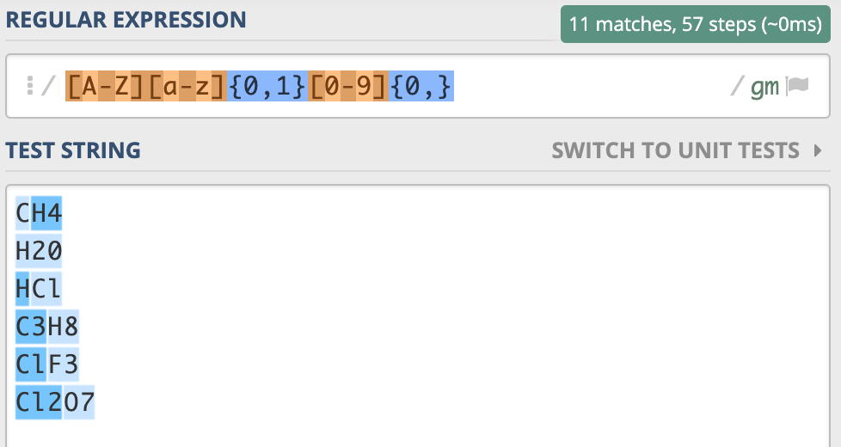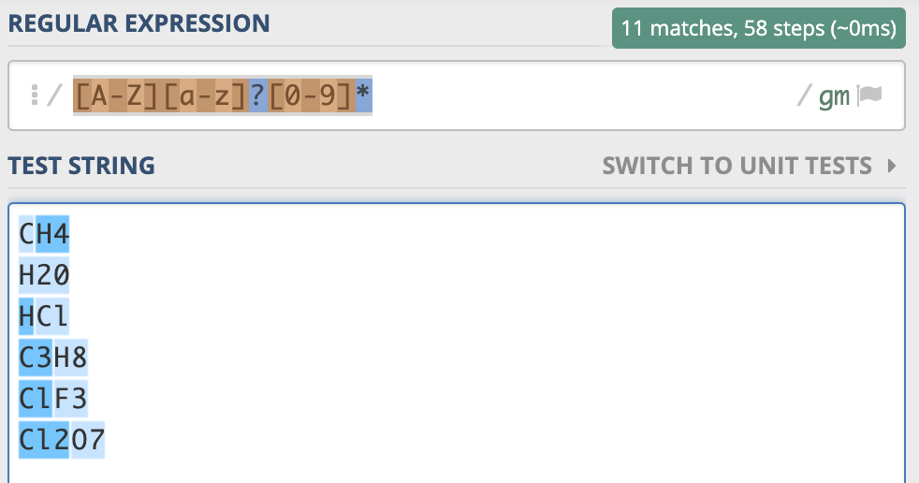

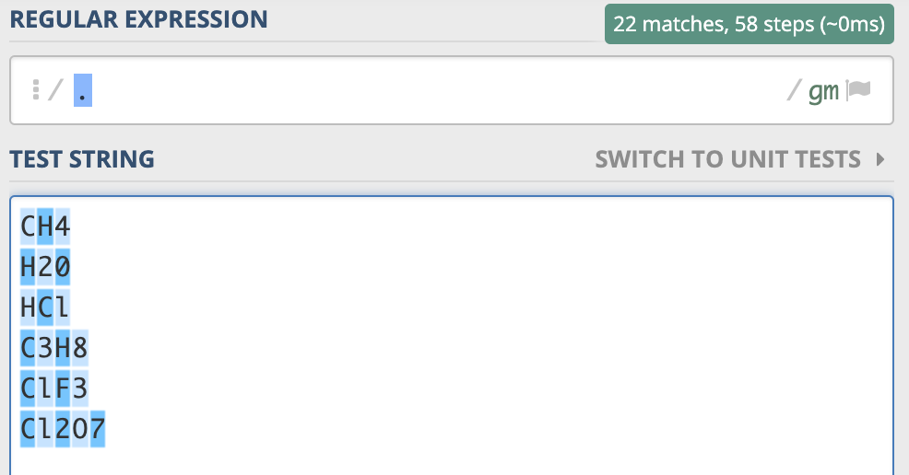

Matches any character.

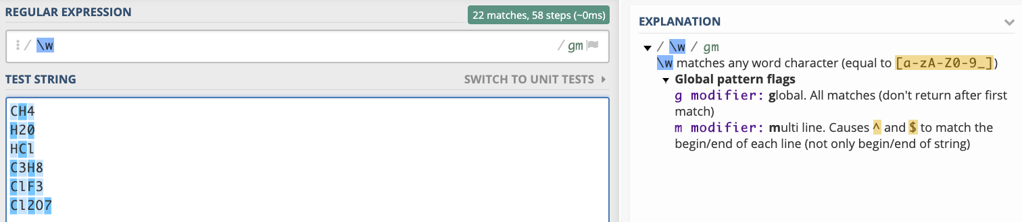

Matches any alphanumeric character.

