Axis笔记

Axis1.4必须的jar

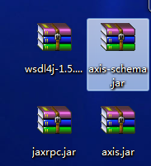

Axis2.1.5必须的jar

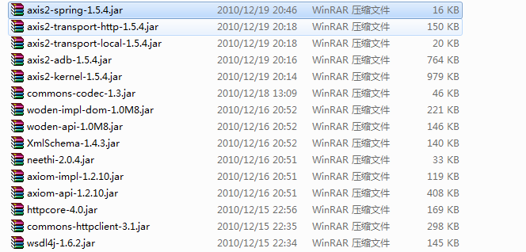

查看可用服务

http://localhost/jrmApp/services/listServices