# **Project Plan Report Template**

# **Team Name: Team Correct**

**Project Plan**

**1. Vision**

* **What are you doing?**

This website is built to verify the authenticity of the English news around the world to come to an understanding that if the news is real or fake by comparing with the existing database of the news websites or with other genuine sites.

* **Why are you doing it?**

This helps in reducing the spread of rumoured news which in turn helps in protection against business or personal damage caused due to fake news. As the news spreads like wildfire, this tool / website would help in reducing the issues faced because of such media.

* **Who will use it?**

1. Various social media users who read news on a daily or hourly basis on social media would find this tool very helpful.
2. Regular English language news readers.
3. Other teams or organisations who are working on such bigger projects and who can integrate this portion into their system.

* **How will they use it? (Example use case)**

The website will be developed in such a way that a user would have a search bar to enter the URL needed to be checked and there can be two possible outcomes for this particular check i.e., if the URL exists in the database or not.

If the URL exists in our database, then the database is searched for more details related to the URL and then it returns the rating, header, content, image etc. and displays authenticity of article as result.

If the URL does not exist in our database then the web scraping is done to obtain the website content and checks are done on the website and the data is updated to database and send back to the user.

## **2. Minimum Viable Product**

## **System Design**

## 

* **Front-end:**

A two-page web application using Django.

First page will contain:

* A Search Bar

Search bar lets user enter a url related to some news article and return back the details and rating associated with it.

* Top 10 credible and fake news

This feature that is added to the page will help display the high scored and low scored news article in the database.

Second page will contain:

* The news headlines
* Image and first paragraph of news article (if credible)
* News rating as evaluated from backend

The data will be sent from backend in json format.

* **Backend:**

Scrap the news collected from the data sources to the database and evaluate the data

Evaluation of the data

1. Domain Filtering

The domain filtering is done on the source url of the articles and this is compared to the domain url that we have on our database.

1. Grammar Check

Most fake websites does not check grammatical errors and this can be used as a measure to check news editor credibility and we will be using <https://textgears.com/api/> to check grammatical errors.

1. Check structure of the content to credible news

All credible news sources follow particular structure in their news, this can be identified by taking into account Paragraph count, word count in paragraph as similar settings.

1. Check suburl and advertisement in the news article

Advertisements are main source of revenue for news sites and these urls and sub urls in ad can be be used as tool to filter and categorize news.

1. Content mapping to other related news in the same time period

Real news always have similar content posted at the same time and this can be used to check the validity of the news.

Backend Structure

* Using postgresql as database system.

Version - postgresql-9.4

* Use Django to create Rest Api.

Version - Django 1.11.2

* **Data Sources**

1. News api for credible news

<https://newsapi.org/sources>

1. Fake news sites that have updated content every day (Custom list prepared by group).

<https://github.com/ucd-nlmsc-teamproject/Correct-Repo/blob/master/Team_Correct_App/FakeWebsites.json>

1. Url domain filtering using news type - <https://github.com/BigMcLargeHuge/opensources/blob/master/sources/sources.json>

* **How will you evaluate your system? (Initial ideas)**

1. Discrimination Evaluation: The website will be evaluated on accuracy level in distinguishing news’ types, compared with other similar websites like <http://realorsatire.com/>.
2. Interaction Evaluation: Turnaround time for each request is calculated for content that is in our database and content that is new. This data is used to evaluated with respect to other credibility checking sites like <http://realorsatire.com/>
3. User evaluation: At regular intervals users will be presented two different news article and asked to rate which news is more credible. Users would be informed how the website differentiate the type of news.

* **How will the evaluation inform your future development?**

1. This data collected from user will be used to improve the algorithm that scores the news articles credibility.
2. If the user feels a fake news is more credible we will collect the characteristics that made it to score high in check and make changes.
3. If the features are less to distinguish the credibility more features can be added which can be used to distinguish the type of news (e.g. content comparison).
4. Users can navigate based on the click through rates, buttons on the page would be arranged more logically and more in line with users’ expectations.

**3. Project Management**

* **How will you run your project?**
* **Planning**

Project manager will provide a list of tasks, each one will be assigned into sections to be compared with the team skills, this will help to assign the number of members to the tasks also providing realistic due dates.

Project management tool called Freed camp will be used to deliver the tasks which will form into three parts (drag and drop)

1) Task List

2) In progress

3) Completed

This service will give daily notification of tasks to the assigned member, and allow them to upload completed tasks.

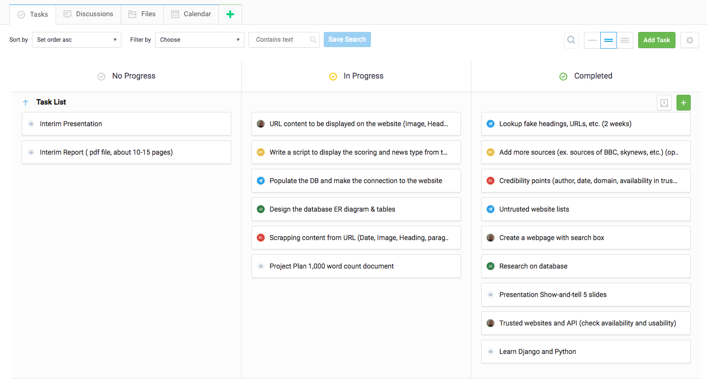

Our Freedcamp account

* **Communication**

The group will meet up twice a week, Tuesday to review the submitted tasks and then

reconvene on Friday for a stand-up deliverable for each member to speak about their progress, what problems they might be facing and what you plan to do next.

We will also use google hangout for meeting to review deliverables before the due dates.

* **Troubleshooting**

We hope to prevent any massive error by using the agile approach

1) Plan: Do the tasks with the highest risk first

2) Build: Complete before the time frame to allow for changes

3) Test: Constantly

4) Review: Compare the progress with the plan

* **Predictions**

Allow each task time to change for any issues that may arise by assigning due date

earlier than expected.

Discussion on each task with the project manager and the group member who is apportioned the task to provide another route if the existing task doesn’t meet

expectations.