# Info

Opcodes can be divided in the following sections

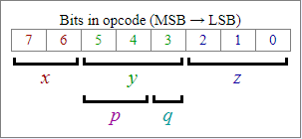

Using these sections you can easily decode the opcodes

|  |  |
| --- | --- |
| 15 … 8 | 7 … 0 |
| A | F (flags) |
| B | C |
| D | E |
| H | L |
| SP (Stack Pointer) | |
| PC (Program Counter) | |

Flag Register (F) bits

|  |  |  |  |  |  |  |  |
| --- | --- | --- | --- | --- | --- | --- | --- |
| 7 | 6 | 5 | 4 | 3 | 2 | 1 | 0 |
| Z | N | H | C | 0 | 0 | 0 | 0 |

Z – Zero Flag

N – Subtract Flag

H – Half Carry Flag

C – Carry Flag

0 – Not Used, always zero

Other relevant info:

Instruction **STOP** has according to manuals opcode **10 00** and thus is 2 bytes long. Anyhow it seems there is no reason for it so some assemblers code it simply as one byte instruction **10**.  
Flags affected are always shown in **Z H N C** order. If flag is marked by "**0**" it means it is reset after the instruction. If it is marked by "**1**" it is set. If it is marked by "**-**" it is not changed. If it is marked by "**Z**", "**N**", "**H**" or "**C**" corresponding flag is affected as expected by its function.  
  
**d8** means immediate 8 bit data  
**d16** means immediate 16 bit data  
**a8** means 8 bit unsigned data, which are added to $FF00 in certain instructions (replacement for missing **IN** and **OUT** instructions)  
**a16** means 16 bit address  
**r8** means 8 bit signed data, which are added to program counter  
  
**LD A,(C)** has alternative mnemonic **LD A,($FF00+C)**  
**LD C,(A)** has alternative mnemonic **LD ($FF00+C),A**  
**LDH A,(a8)** has alternative mnemonic **LD A,($FF00+a8)**  
**LDH (a8),A** has alternative mnemonic **LD ($FF00+a8),A**  
**LD A,(HL+)** has alternative mnemonic **LD A,(HLI)** or **LDI A,(HL)**  
**LD (HL+),A** has alternative mnemonic **LD (HLI),A** or **LDI (HL),A**  
**LD A,(HL-)** has alternative mnemonic **LD A,(HLD)** or **LDD A,(HL)**  
**LD (HL-),A** has alternative mnemonic **LD (HLD),A** or **LDD (HL),A**  
**LD HL,SP+r8** has alternative mnemonic **LDHL SP,r8**

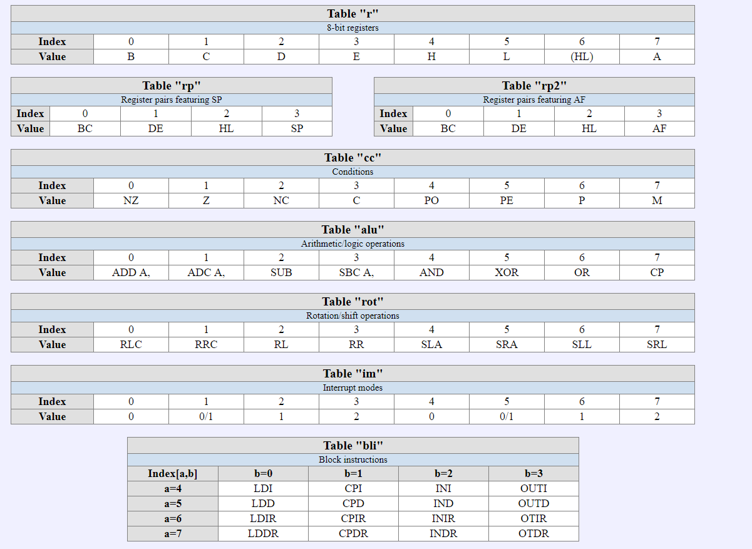

# Unprefixed Opcodes

|  |
| --- |
| For X= 0 |
| |  |  |  |  |  |  |  |  |  |  |  |  | | --- | --- | --- | --- | --- | --- | --- | --- | --- | --- | --- | --- | | Z = 0 | |  |  |  | | --- | --- | --- | |  | Y=0 **NOP** | Y=3 **JP** *r8* | |  | Y=1 **LD** *(a16),SP* | Y=4..7 **JP** *cc[Y-4], r8* | |  | Y=2 **STOP** |  | | Nop, stop, write stackpointer  And relatitive jumps | | Z = 1 | |  |  |  |  | | --- | --- | --- | --- | | Q=0 | **LD** *rp[p], d16* |  |  | | Q=1 | **ADD *HL,*** *rp[p]* |  |  | | 16-bit load immediate/add | | Z = 2 | |  |  |  | | --- | --- | --- | | Q=0 | P=0 **LD** *(BC), A* | P=2 **LDI** *HL, A* | |  | P=1 **LD** *(DE), A* | P=3 **LDD** *HL, A* |  | | Q=1 | P=0 **LD** *A, (BC)* | P=2 **LDI** *A, HL* |  | |  | P=1 **LD** *A, (DE)* | P=3 **LDD** *A, HL* |  | | Indirect loading | | Z = 3 | |  |  |  | | --- | --- | --- | | Q=0 | **INC** *rp[p]* |  | | Q=1 | **DEC** *rp[p]* |  | | 16-bit INC/DEC | | Z = 4 | |  |  |  |  | | --- | --- | --- | --- | |  | **INC** *r[Y]* |  |  | | 8-bit INC | | Z = 5 | |  |  |  |  | | --- | --- | --- | --- | |  | **DEC** *r[Y]* |  |  | | 8-bit DEC | | Z = 6 | |  |  |  |  | | --- | --- | --- | --- | |  | **LD** *r[Y], n* |  |  | | 8-bit load immediate into *r[y]* | | Z = 7 | |  |  |  | | --- | --- | --- | |  | Y=0 **RLCA** | Y=4 **DAA** | |  | Y=1 **RRCA** | Y=5 **CPL** | |  | Y=2 **RLA** | Y=6 **SCF** | |  | Y=3 **RRA** | Y=7 **CCF** | | Assorted operations on accumulator/flags | |
| For x= 1 |
| |  |  |  |  |  |  |  | | --- | --- | --- | --- | --- | --- | --- | | Z = 6 | |  |  |  |  | | --- | --- | --- | --- | |  | Y=6 **HALT** |  |  | | Power down cpu until interrupt occurs | | others | |  |  |  |  | | --- | --- | --- | --- | |  | **LD** *r[Y], r[Z]* |  |  | | 8-bit load *r[z]* into *r[y]* | |
| For x= 2   |  |  |  |  |  |  |  | | --- | --- | --- | --- | --- | --- | --- | |  | |  |  |  |  | | --- | --- | --- | --- | |  | ***Alu[y]*** *r[Z]* |  |  | | Operate on accumulator and register/memory location | |
| For x= 3 |
| |  |  |  |  |  |  |  |  |  |  |  |  |  |  |  | | --- | --- | --- | --- | --- | --- | --- | --- | --- | --- | --- | --- | --- | --- | --- | | Z = 0 | |  |  |  | | --- | --- | --- | | Q=0 | P=0**RET** *NZ* | P=2**LDH** *(a8), A* | |  | P=1**RET** *NC* | P=3**LDH** *A,(a8)* | | Q=1 | P=0**RET** *Z* | P=2**ADD** *SP, r8* | |  | P=1**RET** *C* | P=3**LD** *HL, SP+r8* | | Conditional returns & and various others | | Z = 1 | |  |  |  | | --- | --- | --- | | Q=0 | **POP** *rp2[P]* |  | | Q=1 | P=0 **RET** | P=2 **JP** *(HL)* | |  | P=1 **RETI** | P=3 **LD** *SP, HL* | | POP & various ops | | Z = 2 | |  |  |  | | --- | --- | --- | | Q=0 | P=0**JP** *NZ, a16* | P=2 **LD** *(C), A* | |  | P=1**JP** *NC, a16* | P=3**LD** *A, (C)* | | Q=1 | P=0**JP** *Z, a16* | P=2**LD** *a16, A* | |  | P=1**JP** *C, a16* | P=3**LD** *A, a16* | | Jumps and 16-bit loads | | Z = 3 | |  |  |  | | --- | --- | --- | |  | Y=0 **JP** *a16* | Y=6 **DI** | |  | Y=1 (CB prefix) | Y=7 **EI** | | Assorted operations | | Z = 4 | |  |  |  |  | | --- | --- | --- | --- | |  | **CALL** *cc[Y]* |  |  | | Conditional call | | Z = 5 | |  |  | | --- | --- | | Q=0 | **PUSH** *rp2[p]* | | Q=1 | **CALL** *a16* | | (the call is only for Q=1, P=0. P>0 are all unused) | | Z = 6 | |  |  |  | | --- | --- | --- | |  | ***Alu[Y]****, d8* |  | | Operate on accumulator and immediate operand | | Z = 7 | |  |  |  |  | | --- | --- | --- | --- | |  | **RST** *Y*8* |  |  | | restart | |

# CB-Prefixed Opcodes

|  |  |  |
| --- | --- | --- |
| X=0 | **ROT[Y]** *r[Z]* | Roll/shift register or memory location |
| X=1 | **BIT** *Y, r[Z]* | Test bit |
| X=2 | **RES** *Y, r[Z]* | Reset bit |
| X=3 | **SET** *Y, r[Z]* | Set bit |

# Sources

Decoding method from: <http://www.z80.info/decoding.htm#intro>

Table of Gameboy opcodes: <http://www.pastraiser.com/cpu/gameboy/gameboy_opcodes.html>