A little about Darkorbit

This program is design to help Darkorbit gamers to build their skill trees. Darkorbit.com is an internet game in which you are a space pilot that mines for materials and kill ships N.P.C. (Non-player character) and P.V.P player verses player. The skill tree allows you to increase your ability to fight and collect the four main skills you want to increase are Evasive maneuvers 2, luck 2, bounty hunter, and alien hunter. If you are new to the game you might want to upgrade luck2 and any other skill to help you to collect better. Uridum is the most valuable and rare currency in the game so keep that in mind were credits not worth allocating piolet points just focus on attack defense and Uridum collection. You may have only 50 Pilot points to use so use them wisely. resetting them will cost a lot of resources.

Using my program

When you run my code, you it is recommended to have [www.darkskill.info](http://www.darkskill.info) open as well or your skill tree in the game open. This is what my program will look like when you are building the skill tree. The program should be more or pretty self-explanatory

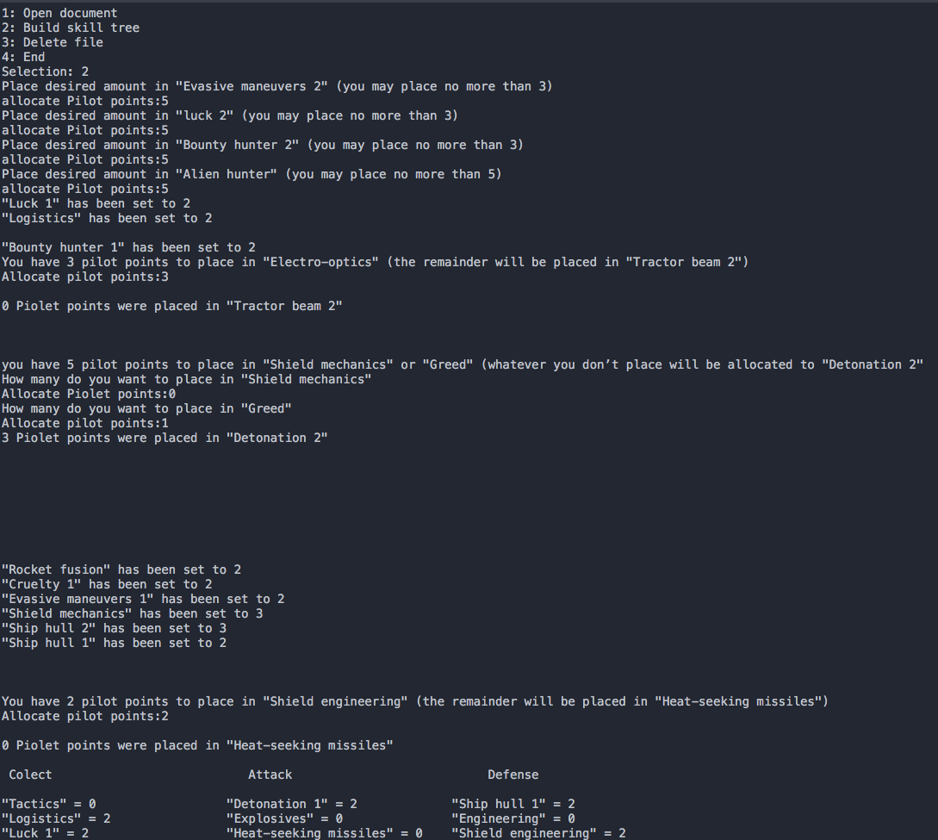

hover over the item that corresponds with the item you are thinking of allocating points to on the website [www.darkskill.info](http://www.darkskill.info) the website should look like this.

