STANDARD OPERATING PROCEDURE (SOP)
Microwave (MW)-Assisted CO₂ Adsorption–Desorption on Monoliths and Powders
Feed | 15 % CO₂ / 85 % N₂, 100 mL/min. Desorption gas: N₂, 100 mL/min.
Measured | CO₂ at the outlet (MS, m/z 44) and sample temperature (IR camera).
Version | Prepared: Shayan Gul. Reviewed: Prof. Reyes Mallada.

How to use: Learn the set-up (Sections 1–3), then follow Stages 0–7.

1. The experiment in one table
Stage | What happens | Why
0–2 | Prepare, load sample, start gas software | Correct mass and flows
3 | Start MS with N₂ (bypass) | MS stable before any CO₂
4 | Tune the MW cavity | MW energy goes into the sample
5 | Dry the sample: N₂ + MW → vent, then cool | Remove water; keep it away from the MS
6a | Baseline: CO₂/N₂ mixture → MS (bypass) | Reference signal C₀
6b | Adsorption: mixture through the sample (≈10 min) for monolith and (≈22 min) for Zeolite 13X Powder | Sample takes up CO₂
6c | Desorption: N₂ through sample + MW ON (≈5 min) with power (≈10W and reach upto 200 ºC) and check when the signal of CO2 reaches to 0 then turn off the MW to cool down the system to room temp. | CO₂ released
×3 | Repeat 6a–6c three times | Average of 3 cycles
7 | Shutdown | Off every gas flow and MS software properly

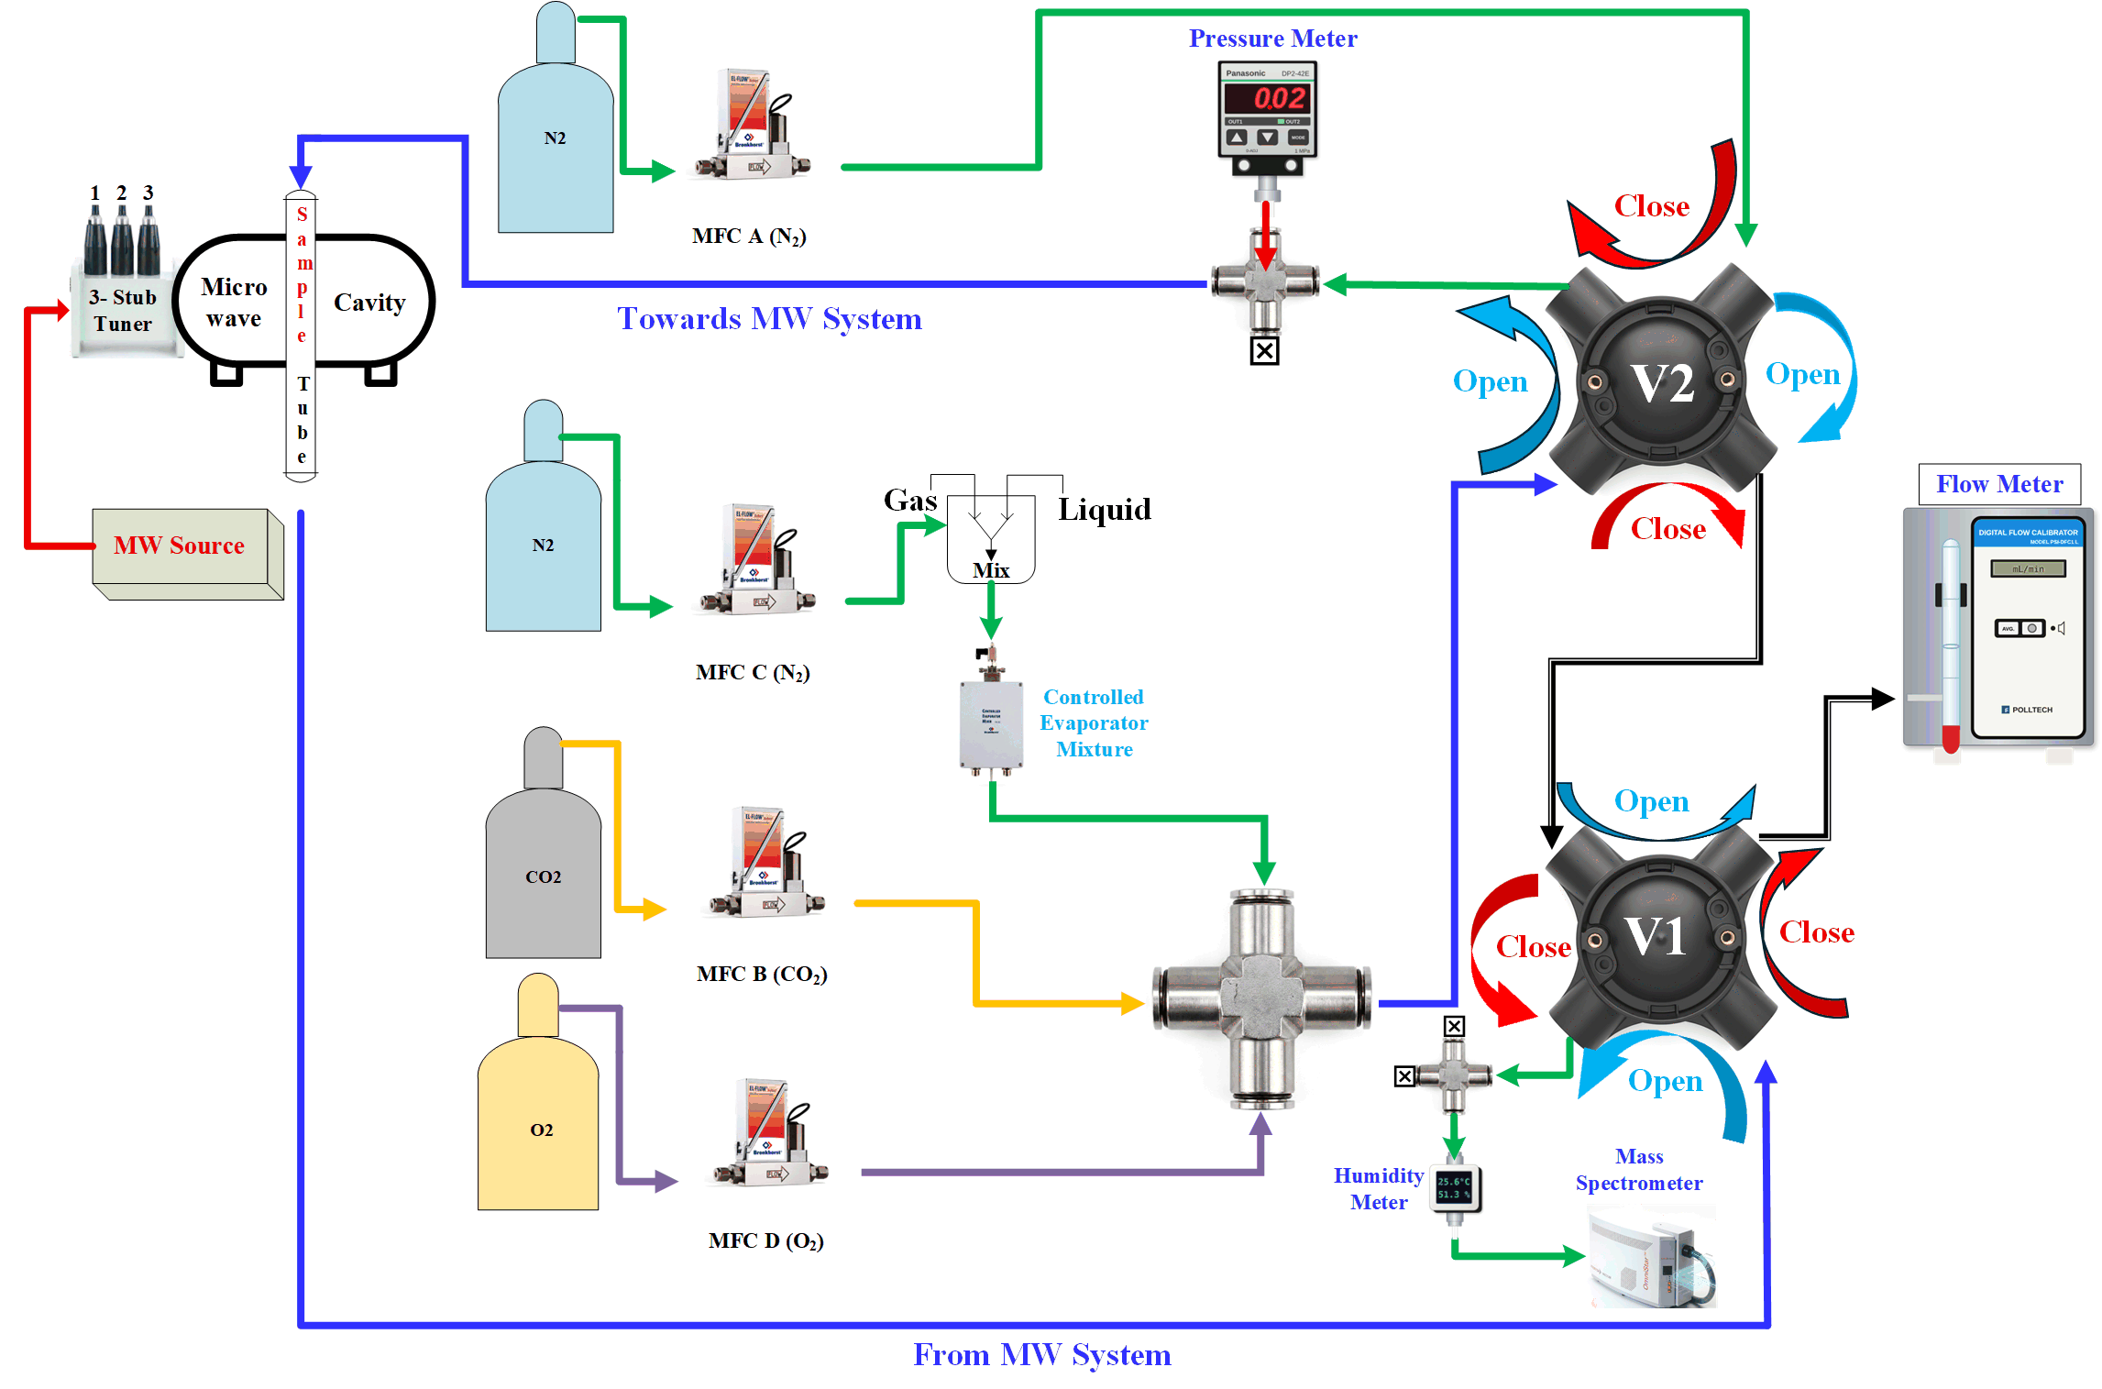
2. The set-up
Figure 1. Gas-flow MW Assisted CO₂ Adsorption Desorption set-up.
# | Part | What it does
1–2 | Cylinders + MFCs A–D | A = N₂ (purge/desorption), B = CO₂, C = N₂ of the feed, D = O₂ (off). Set in LabVIEW “Quimisorción” (Table 2).
3–4 | CEM + mixing cross | N₂ (C) passes the Controlled Evaporator Mixture (CEM) and meets CO₂ (B) → 15/85 feed.
5 | Valve V2 | Chooses which gas goes through the sample (Section 3).
6 | Pressure meter | Panasonic DP2-42E (0–1 MPa) at the tube inlet.
7 | Sample tube in MW cavity | Quartz tube; gas in at the top, out at the bottom.
8 | MW source + 3-stub tuner | Tune cavity with help of tuner dials.
9 | Valve V1 | Chooses which gas goes to the MS (Section 3).
10 | Humidity meter | T (°C) and RH (%) of the gas entering the MS.
11 | Mass spectrometer | Pfeiffer, QUADSTAR 32-bit. CO₂ = m/z 44.
12 | Flow meter | Polltech PSI-DFC1 L bubble flow meter on the vent: real flow in mL/min.
13 | IR camera / VNA | Optris (PI Connect) for temperature; NanoVNA for tuning (MW OFF only).

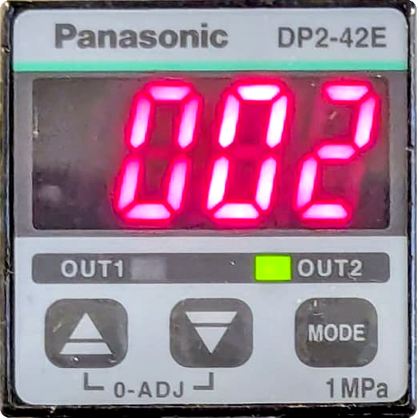  (a) pressure meter (6) | 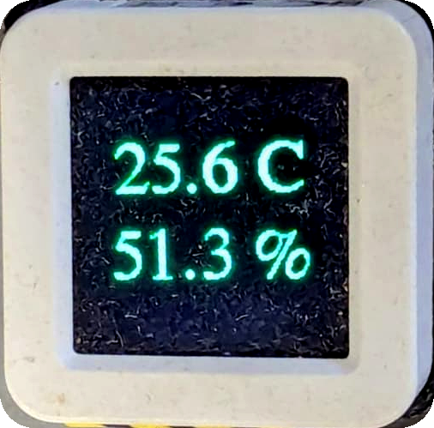  (b) humidity meter (10) | 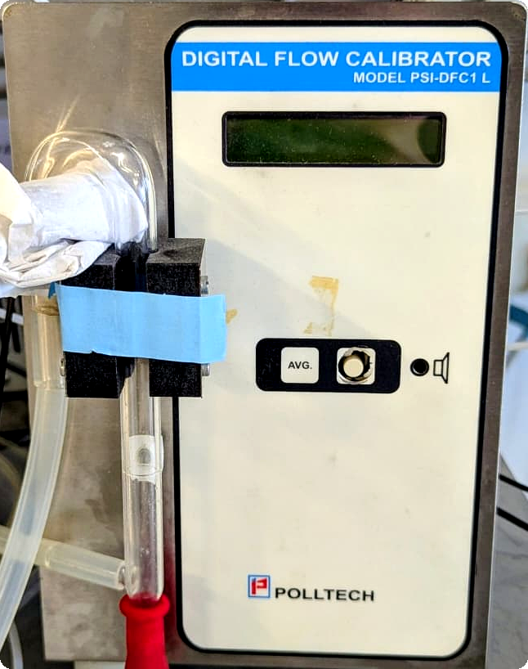  (c) flow meter (12)
Figure 2. Measuring devices on the gas lines.
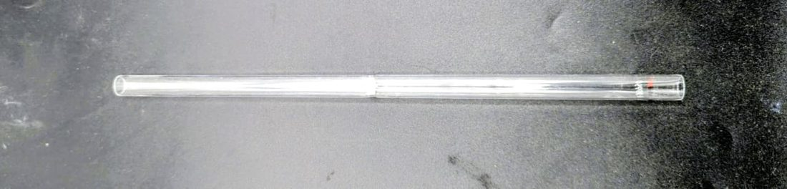  (a) quartz sample tube | 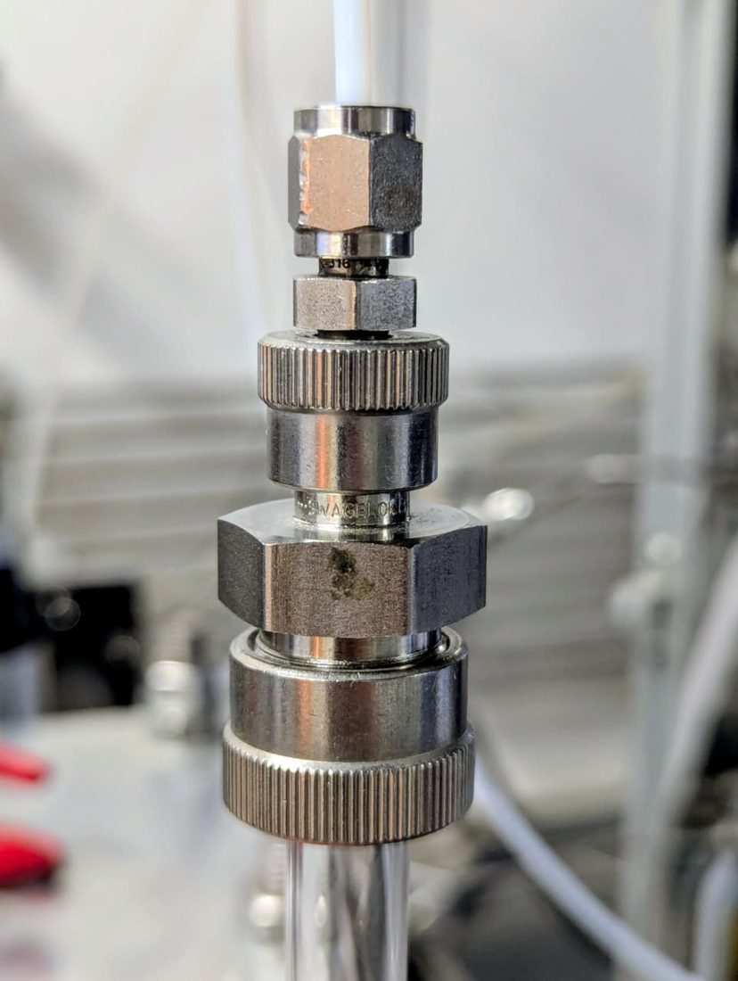  (b) tube fitting
Figure 3. Sample tube and its fitting.

3. The two valves
V2 = what goes through the sample | Open: CO₂/N₂ mixture → sample (N₂ A → bypass)  Closed: N₂ A → sample (mixture → bypass)
V1 = what goes to the MS | Open: gas from the sample → MS (bypass → flow meter)  Closed: bypass → MS (gas from the sample → flow meter)

Table 1. Valve positions per stage
Stage | V2 | V1 | MW | Through the sample | To the MS | Time (minutes) for each experiment
3–4 MS start, tuning | Open | Closed | OFF | (nothing) | N₂ via bypass | 20
5 Drying + cooling | Closed | Closed | ON → OFF | N₂ → flow meter/vent | bypass | 20
6a Baseline (start MS recording cycles) | Closed | Closed | OFF | N₂ → flow meter/vent | mixture via bypass | 10
6b Adsorption | Open | Open | OFF | mixture → MS | gas from sample | 15 for Monoliths  25 for Powder
6c Desorption | Closed | Open | ON | N₂ → MS | gas from sample | 15
Then Repeat the steps 6 (a, b, and c) for more 2 time.
Baseline → adsorption: turn V2 and V1 together. Adsorption → desorption: turn only V2 and MW ON.
Table 2. MFC set points (type X as “% MFC”; Y = real flow)
MFC | Gas | Calibration | Flow | X =
A | N₂ | Y = 3.3735 X + 2.2795 | 100 mL/min | 29.0
B | CO₂ | Y = 0.4077 X − 0.5881 | 15 mL/min | 38.2
C | N₂ | Y = 2.2661 X + 0.8288 | 85 mL/min | 37.1

Procedure

Stage 1. Weigh and load the sample
# | Do this
1 | Weigh the sample (i.e: 0.290-400 mg). Write sample code and mass.
2 | Monolith: slide it into the tube cavity centre.
3 | Powder: At the same position, add the powder, tap to a bed of monolith height aprox.15mm.
4 | Insert the tube vertically in the cavity; connect inlet at the top, outlet at the bottom (Figure 3). Tighten properly to avoid leaks.
5 | Point and focus the IR camera on the sample.

Stage 2. Start the gas software (LabVIEW “Quimisorción”, PC 1)
# | Do this
1 | PC 1: double-click “Quimisorción” on the desktop.
2 | Tick “Si usado” for MFC = COM6 and EURO = COM3 only. OK (Figure 4a).
3 | Main screen shows “Listo para comenzar”. Click Manual (Figure 4b).
4 | In “Choose or Enter Path of File”: My Documents › LabVIEW Data › your folder; type the file name (Figure 5a).
5 | In “Introduzca los flujos de gas” type % MFC: GAS A = A, GAS B = B, CEM = C, GAS D = D (Figure 5b). For Stage 3: A = 29.0, B = 0, CEM = 0, D = 0.

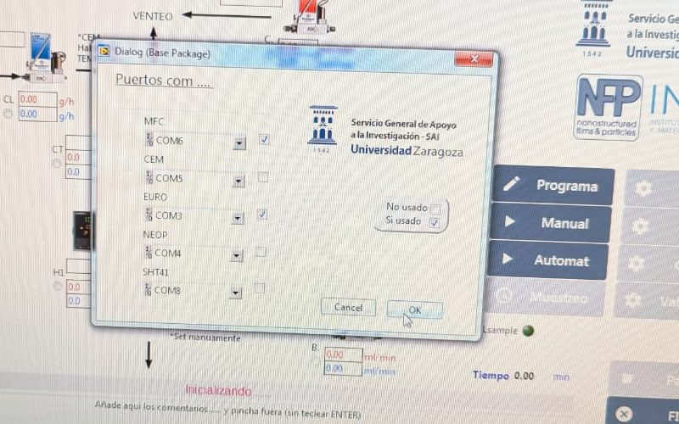  (a) COM ports | 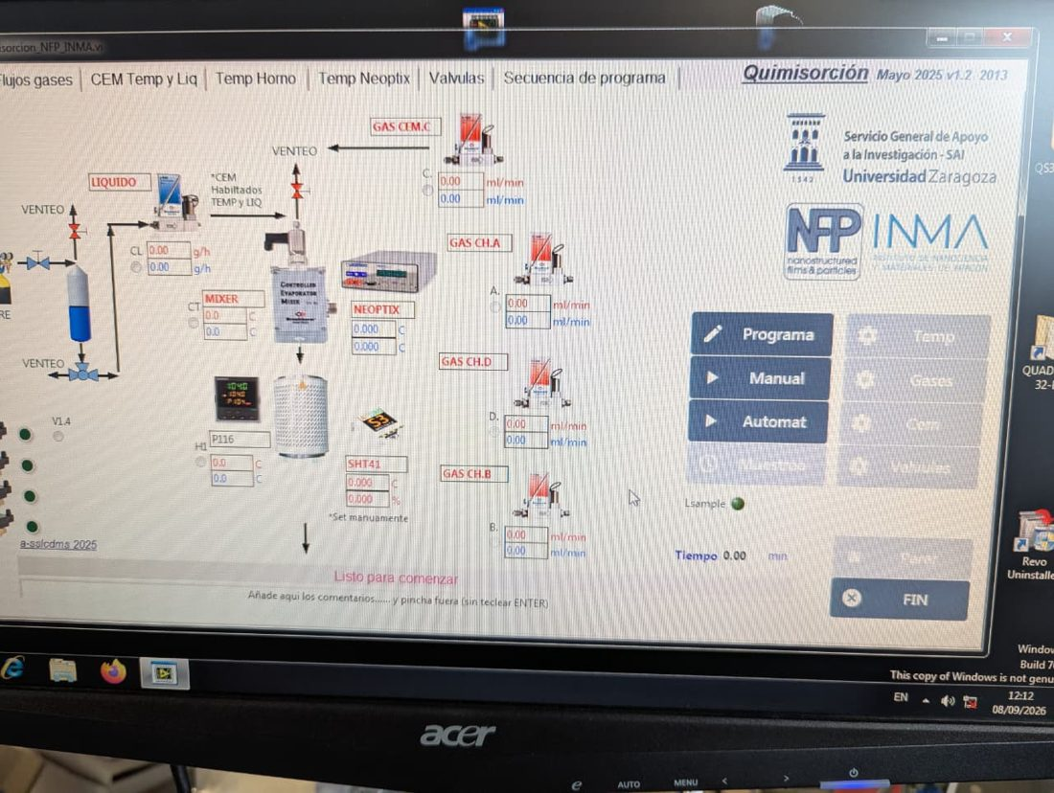  (b) main screen
Figure 4. Starting “Quimisorción”.

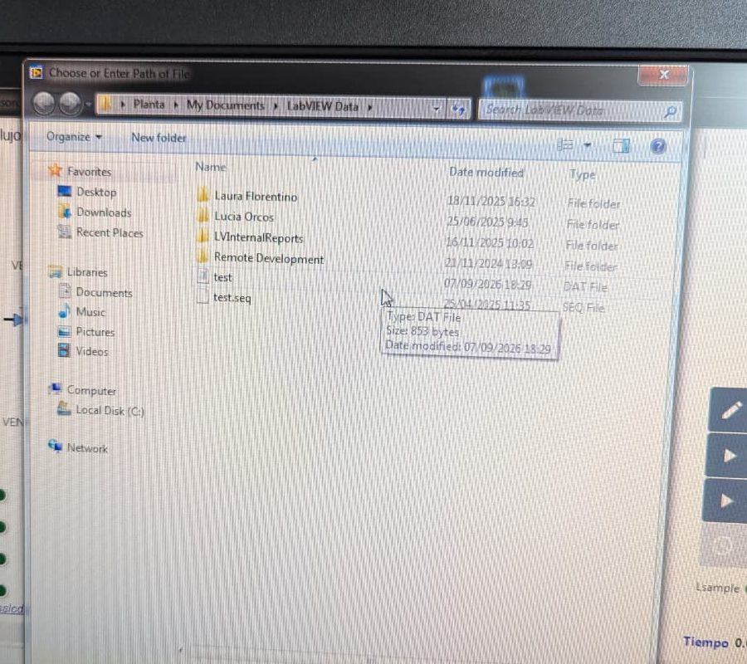  (a) data file | 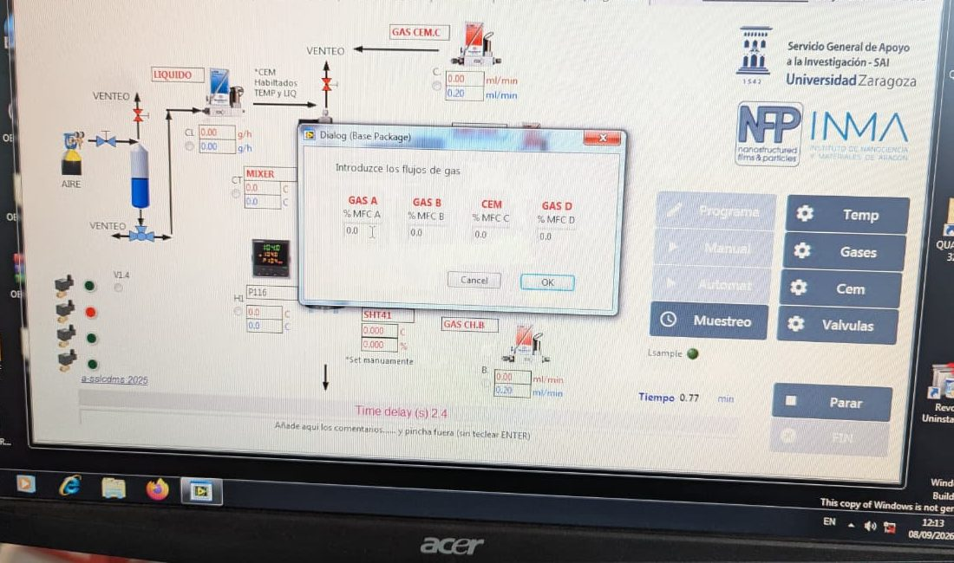  (b) flow set points (% MFC)
Figure 5. Data file and flows in “Quimisorción”.

Stage 3. Start the mass spectrometer with N₂ (bypass)
V2: Open | V1: Closed | MW: OFF | N₂ (MFC A = 29.0) goes straight to the MS through the bypass. B = C = 0.

# | Do this
 | Read the pressure (program Service)
1 | Set the valves and MFC A.
2 | Read the humidity meter: T and % RH of the N₂ going to the MS. Write both in the notes.
3 | PC 2: desktop folder “QUADSTAR 32-Bit” → Service (Figure 6).
4 | Measure › Total Pressure (Figure 7a). Stable ≈ 1 × 10⁻⁸ mbar (Figure 7b).
5 | Manual › DI/DO…; double-click DO 0 and DO 1 until both are green; OK (Figure 8)
6 | Setup › SEM/Emission Control…; tick Emission and SEM; OK (Figure 9).
7 | Open Measure; open AIRDEMO.MIP; select MID › Versus Time (Figure 10).
8 | Wait until all lines are flat (N₂ baseline).

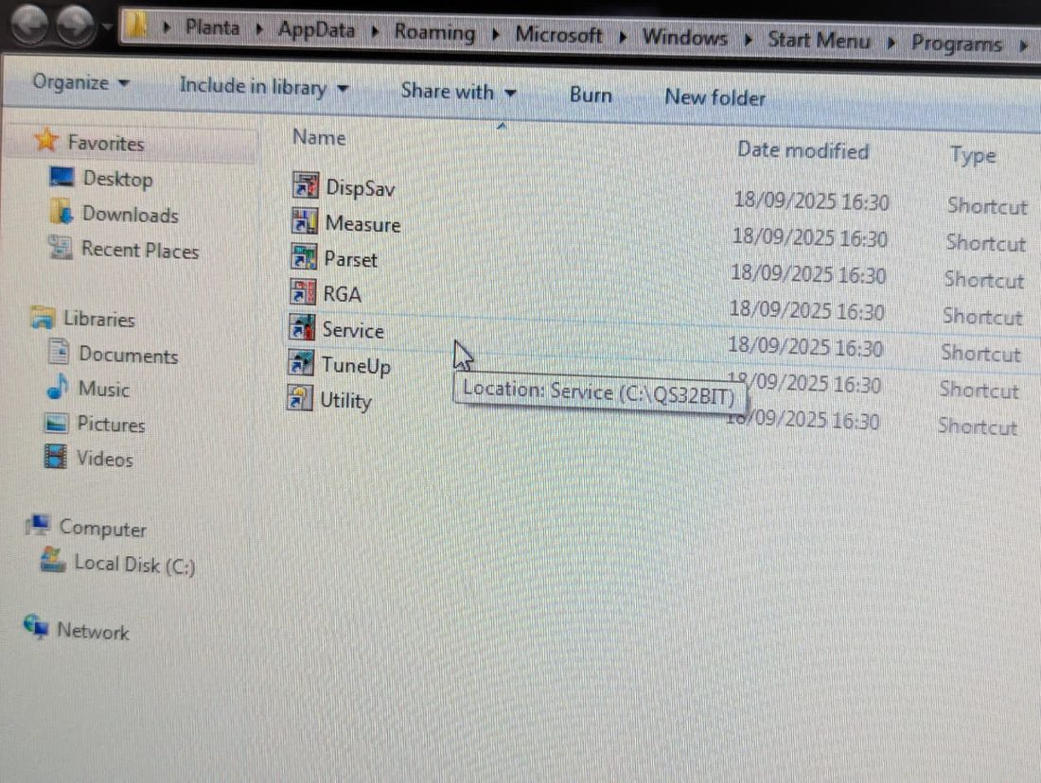
QUADSTAR programs (C:\QS32BIT)
Figure 6. Service starts the MS; Measure records the data.

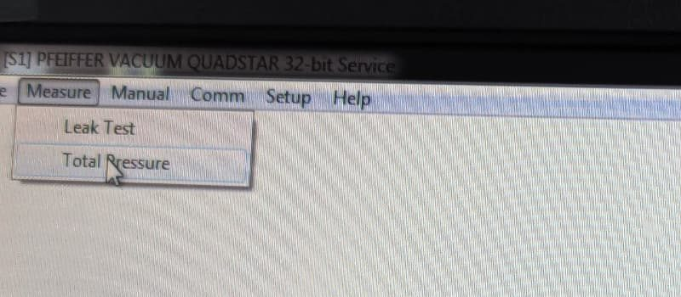  (a) Measure › Total Pressure | 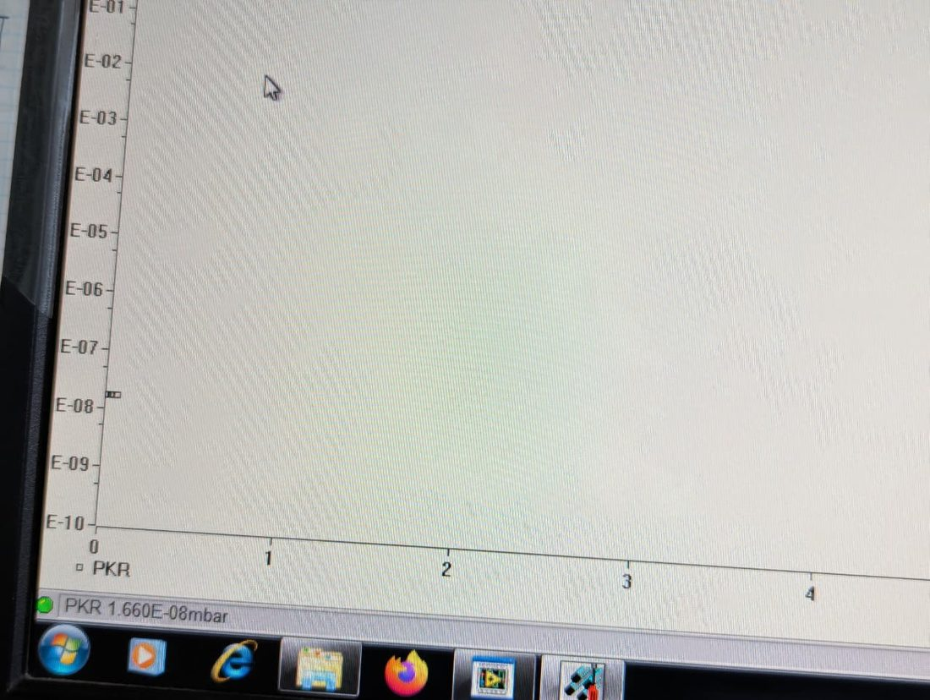  (b) PKR 1.66 × 10⁻⁸ mbar
Figure 7. Total pressure before opening the inlet.

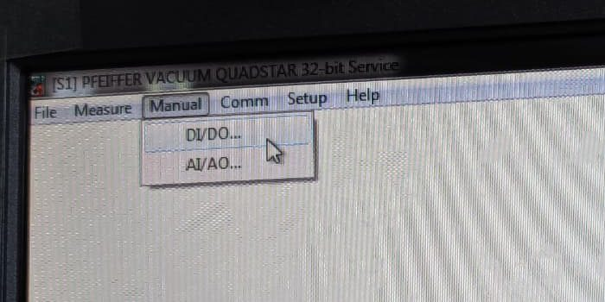  (a) Manual › DI/DO | 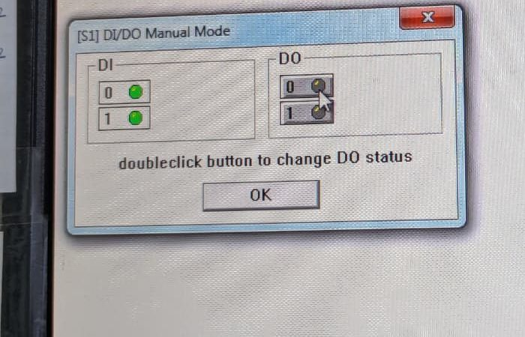  (b) grey = closed | 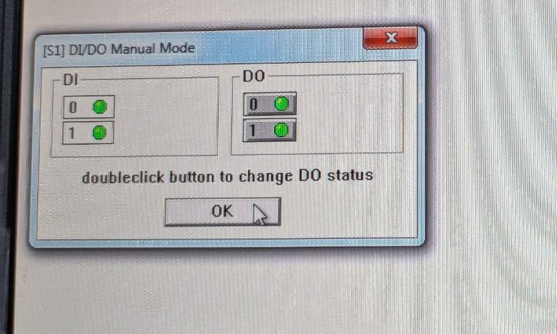  (c) green = open
Figure 8. Opening the MS inlet (double-click DO 0 and DO 1).

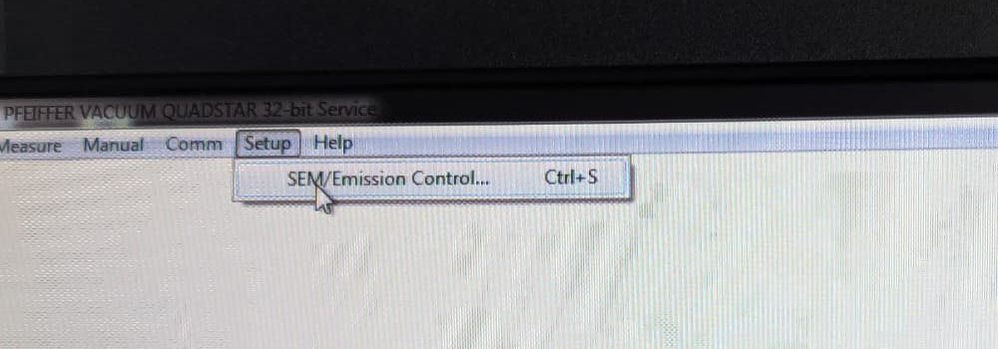  (a) Setup › SEM/Emission | 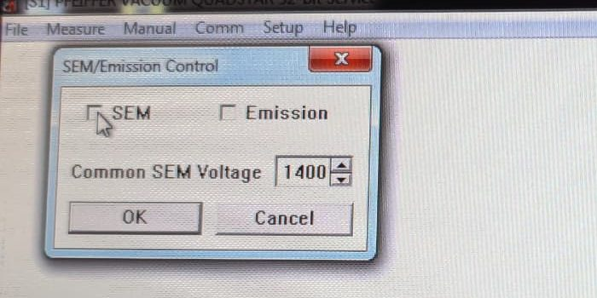  (b) off | 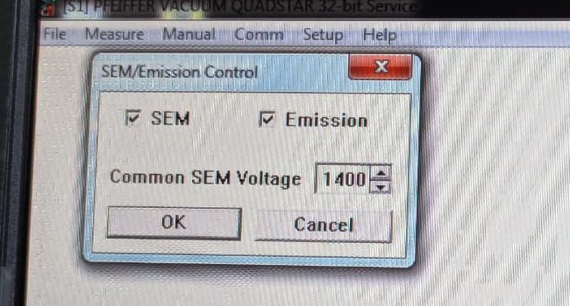  (c) on, 1400 V
Figure 9. Filament (Emission) and SEM detector on.

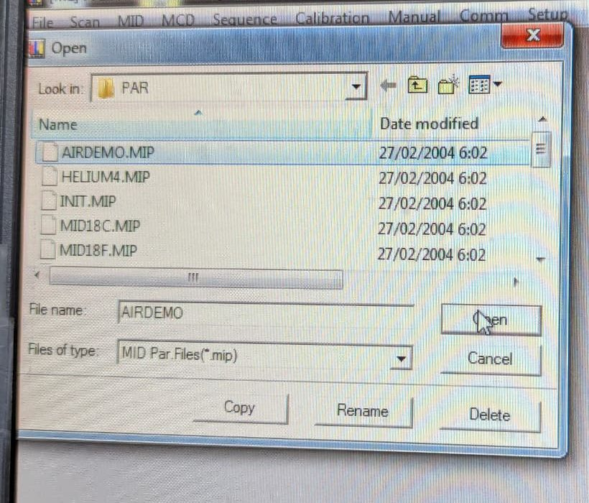  (a) open AIRDEMO.MIP | 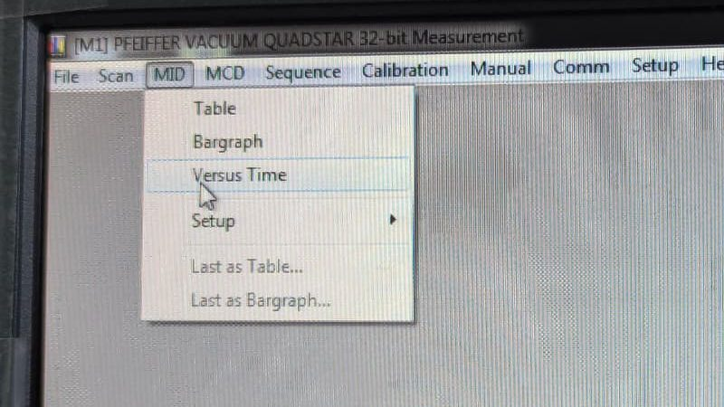  (b) MID › Versus Time
Figure 10. Starting the MID measurement.

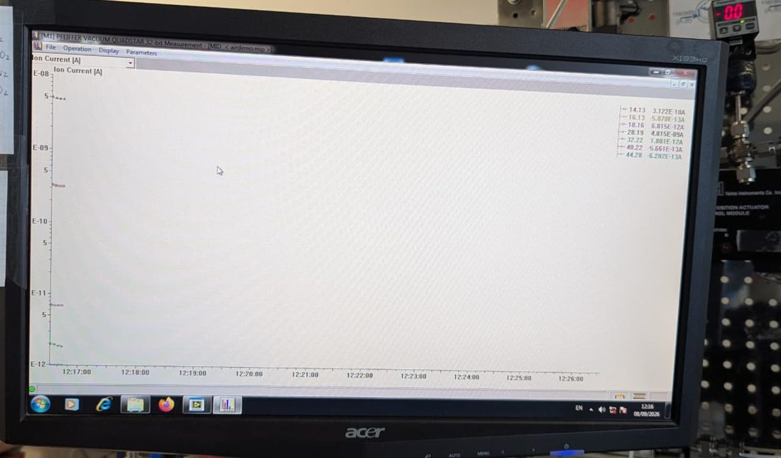
ion current (A) vs time
Figure 11. MID “Versus Time” display.

Stage 4. Tune the MW cavity (MW OFF)
V2: Open | V1: Closed | MW: OFF

# | Do this | Check / you should see
1 | Connect the VNA cable to port. | MW source OFF.
2 | VNA: Trace 2 → back → S11 → SWR. Range 2.43–2.47 GHz. Usually set at 2.461 GHz.
3 | Turn the 3 stubs one at a time to make the SWR as low as possible. | SWR is never below 1.0 (1.0 = perfect). Aim ≤ example 1.167 at 2.461 GHz (Figure 12).
4 | Write down frequency, SWR and all 3 stub dials (turns + division, Figure 13). | Use them as start values next time; re-check when the sample changes.
5 | Disconnect the VNA; reconnect the MW line.

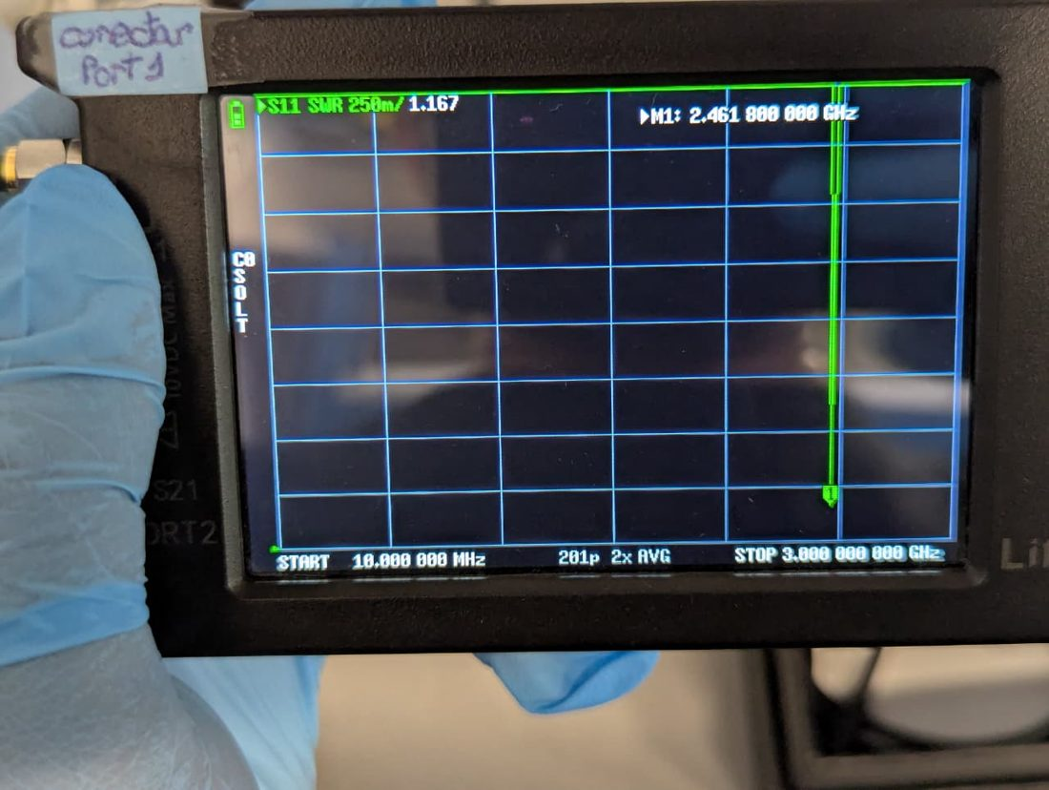
SWR 1.167 at 2.461 GHz
Figure 12. VNA after tuning (S11, SWR format).

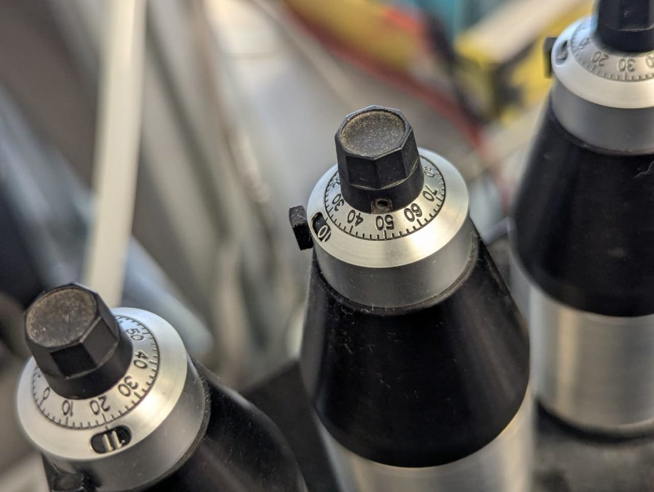  (a) stub dials | 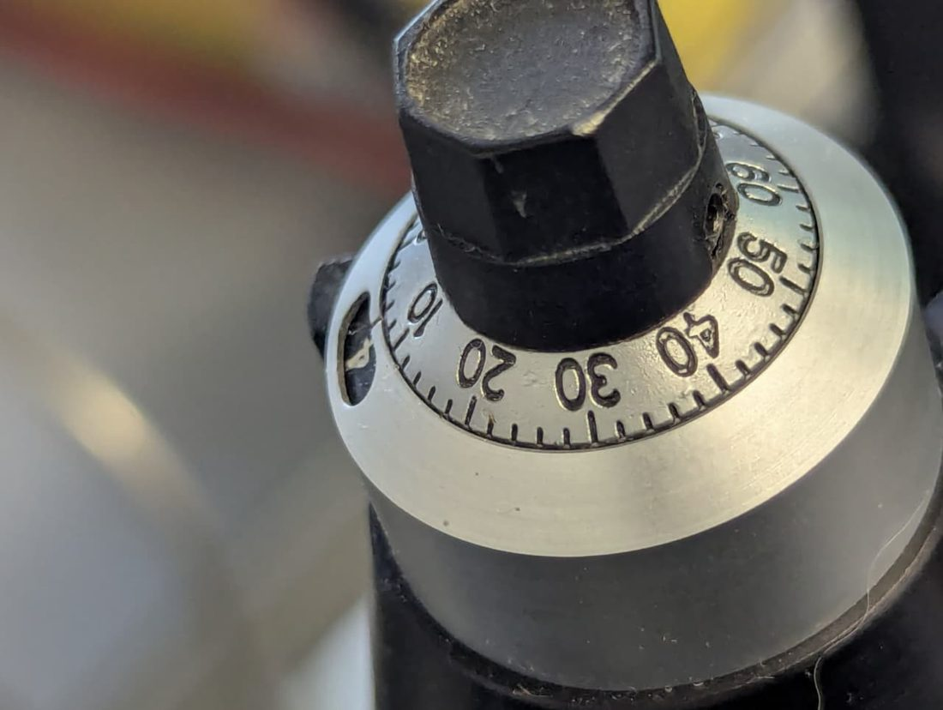  (b) scale 0–60 + turn counter
Figure 13. Stub tuner dials: write down all three.

Stage 5. Activate (dry) the sample, then cool
V2: Closed |  | V1: Closed | MW: ON → OFF | N₂ (A = 29.0 with flow 100ml/min) through the sample → vent, so the water never reaches the MS. Stay for 20 Minutes.
# | Do this |  |  |  | Check / you should see
1 | Set valves; flow N₂ at room temperature.
2 | Flow check: all N₂ that passed the sample now goes to the flow meter. |  |  |  | Reading = MFC A flow (100 mL/min).
3 | Read the pressure meter and write it down. |  |  |  | This is the normal inlet pressure for this sample (reference for later).
6 | Heat to 200 °C for 20 min; watch the IR image. |  |  |  | Temperature rises (166 °C example, Figure 14b).
7 | MW OFF; keep N₂; cool to the start temperature [e.g. 24 ± 1 °C]. |  |  |  | IR temperature stable.
8 | In Measure start the data recording (“Cycle Data”); write file name and time.
 | How to measure with the flow meter: Switch it on. Squeeze the red bulb once so a soap film rises in the glass tube; the instrument times the film and shows the flow in mL/min. Press AVG. to average several readings. Write the value in the notes.
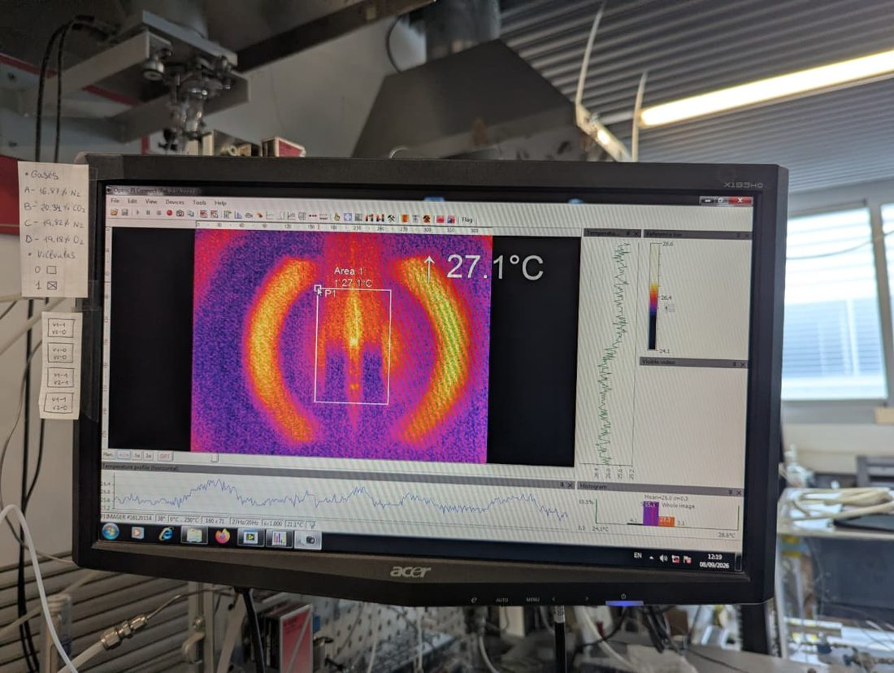  (a) before heating, 27.1 °C |  | 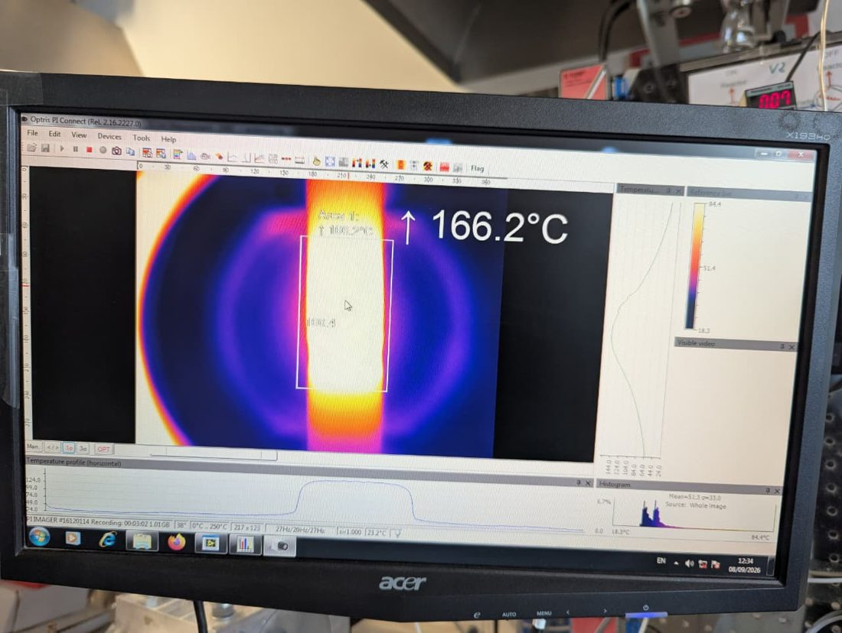  (b) MW heating, 166.2 °C
Figure 14. Optris PI Connect image of the sample.

Stage 6. Adsorption–desorption cycles (do 3 cycles)
6a. Baseline (before every cycle ≈ 10 minute)
V2: Closed | V1: Closed | MW: OFF | Mixture → MS via bypass. N₂ (A) keeps the sample under N₂ → vent.

# | Do this
1 | Set MFC B = 38.2 (15 mL/min CO₂), C = 37.1 (85 mL/min N₂); keep A = 29.0.
2 | Wait until m/z 44 is flat. Write C₀ and the time.

6b. Adsorption (≈15 min for monoliths and ≈ 25 for powder)
V2: Open | V1: Open | MW: OFF | Turn V2 and V1 together. Mixture through the sample → MS; N₂ (A) → vent.

# | Do this | Check / you should see
3 | Turn both valves; write the time (t = 0). | m/z 44 first drops (CO₂ taken up), then rises back.
4 | Keep ≈10 min, until m/z 44 is back at C₀. | Sample saturated. IR shows a temperature rise (exotherm).
5 | Glance at the pressure meter. | About the same as in Stage 5.

6c. MW desorption (≈15 min)
V2: Closed | V1: Open | MW: ON | Turn only V2. N₂ (A) through the sample → MS; mixture → vent.

# | Do this | Check / you should see
6 | Turn V2 and at the same moment MW ON at 10W at beginning RP is more about 2-3W but with time it will goes to 0W. | m/z 44 peak (CO₂ released); IR temperature rises. Pressure stays close to the Stage 5 value; if it keeps rising, MW OFF.
7 | After ≈15 min MW OFF | Almost all CO₂ desorb in 1st 5 minutes remaining 10 minutes used for regeneration of the monolith and then off MW to cool down to room temp for other 2 adsorption desorption cycles.
8 | Keep N₂ until m/z 44 is back to zero and the sample is back at the start temperature. | Then turn V1 → Closed: back to 6a.

Repeat: 6a → 6b → 6c three times in total.

Stage 7. Shutdown
# | Do this
1 | MW OFF; let the tube cool.
2 | Off all running flows MFC B → 0, then C → 0; N₂ (A) → 0. (Close the cylinders as well)
3 | Stop and save MS, IR and LabVIEW files; copy to name folder (Shayan—shortcut on desktop)
4 | QUADSTAR: untick Emission and SEM; then close valve DO 0 and 1.

