CCNA CAPSTONE PROJECT

NEXORA NETWORK INFRASTRUCTURE INITIATIVE
Company: Nexora Technologies LTD
Project: Nexora Network Infrastructure Initiative
Prepared by: KIBET JEROP ANNETTE
Date: October 2026
1. OVERVIEW
Nexora Technologies LTD is a mid-sized technology and digital solutions company operating from a Head Office in Nairobi and a Branch Office in Eldoret. This document describes the final design, configuration, and security implementation of Nexora's enterprise network, built and verified in Cisco Packet Tracer. The network implements VLAN segmentation, inter-VLAN routing, OSPF, HSRP, EtherChannel, DHCP, ACLs, port security, DHCP snooping, STP, and SSH-based device management.
2. TOPOLOGY SUMMARY
Two sites: Head Office and Branch Office, each with an HSRP router pair (NEX-HQ-R1/R2, NEX-BR-R1/R2) and an EtherChannel-bonded switch pair (NEX-HQ-SW1/2, NEX-BR-SW1/2). Each router single-homes to one local switch via an 802.1Q trunk (router-on-a-stick); the two switches at each site share all VLANs across their EtherChannel trunk. A single WAN link (NEX-HQ-R1 to NEX-BR-R1) connects the two sites, routed with OSPF.
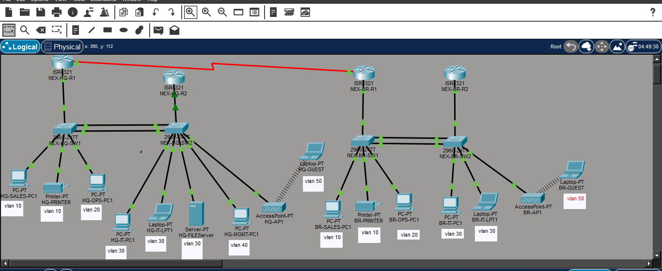
Final topology in Packet Tracer: two offices, each with a router pair and a switch pair, joined by one WAN link, with a guest access point at each office.
3. VLAN PLAN
VLAN | Network Segment | Purpose | HSRP Gateway (virtual IP) | DHCP Range
VLAN 10 | Sales | Sales employees | 10.10.10.1 / 10.20.10.1 | 10.10.10.4-14 / 10.20.10.4-14
VLAN 20 | Operations | Operations employees | 10.10.20.1 / 10.20.20.1 | 10.10.20.4-14 / 10.20.20.4-14
VLAN 30 | IT | IT and network administrators | 10.10.30.1 / 10.20.30.1 | 10.10.30.5-14 (HQ, .4 reserved for server) / 10.20.30.4-14
VLAN 40 | Management | Management users (Head Office only) | 10.10.40.1 | 10.10.40.4-6
VLAN 50 | Guest | Visitors and temporary users (wireless) | 10.10.50.1 / 10.20.50.1 | 10.10.50.4-6 / 10.20.50.4-6
VLAN 99 | Network Management | Management of network infrastructure | 10.10.99.1 / 10.20.99.1 | 10.10.99.4-6 / 10.20.99.4-6 (switch SVIs only)

Departments were separated into VLANs so that each functions as its own broadcast domain, thus keeping departments logically separated. A dedicated Network Management VLAN, distinct from the Management business department, was created specifically to carry switch and router management interfaces, so that remote access could be restricted to IT staff through a single, consistent mechanism.
4. IP ADDRESSING TABLE
Addressing scheme: 10. <site>. <VLAN ID>.0, where the second octet identifies the site (10 = Head Office, 20 = Branch) and the third octet matches the VLAN ID. Subnets were sized by VLSM: /28 (14 usable addresses) for Sales, Operations, and IT, and /29 (6 usable addresses) for Management, Guest, and Network Management, based on actual device counts plus headroom for growth. Within every subnet, .1 is reserved for the HSRP virtual gateway, .2 for the active router's real interface, and .3 for the standby router's real interface, so the pattern is identical and predictable across all eleven subnets. The WAN link uses its own /30 block (10.0.0.0/30), separate from the site/VLAN pattern, since a point-to-point link only ever needs two usable addresses.

Device | Interface | IP Address | Subnet Mask | VLAN | Notes
HQ Routers (R1/R2) | G0/0.10 | 10.10.10.1 / .2 / .3 | 255.255.255.240 | 10 | Sales
HQ Routers (R1/R2) | G0/0.20 | 10.10.20.1 / .2 / .3 | 255.255.255.240 | 20 | Operations
HQ Routers (R1/R2) | G0/0.30 | 10.10.30.1 / .2 / .3 | 255.255.255.240 | 30 | IT
HQ Routers (R1/R2) | G0/0.40 | 10.10.40.1 / .2 / .3 | 255.255.255.248 | 40 | Management
HQ Routers (R1/R2) | G0/0.50 | 10.10.50.1 / .2 / .3 | 255.255.255.248 | 50 | Guest
HQ Routers (R1/R2) | G0/0.99 | 10.10.99.1 / .2 / .3 | 255.255.255.248 | 99 | Network Management
Branch Routers (R1/R2) | G0/0.10 | 10.20.10.1 / .2 / .3 | 255.255.255.240 | 10 | Sales
Branch Routers (R1/R2) | G0/0.20 | 10.20.20.1 / .2 / .3 | 255.255.255.240 | 20 | Operations
Branch Routers (R1/R2) | G0/0.30 | 10.20.30.1 / .2 / .3 | 255.255.255.240 | 30 | IT
Branch Routers (R1/R2) | G0/0.50 | 10.20.50.1 / .2 / .3 | 255.255.255.248 | 50 | Guest
Branch Routers (R1/R2) | G0/0.99 | 10.20.99.1 / .2 / .3 | 255.255.255.248 | 99 | Network Management
HQ-SW1 | VLAN 99 | 10.10.99.4 | 255.255.255.248 | 99 | Switch management
HQ File Server | FastEthernet0 | 10.10.30.4 | 255.255.255.240 | 30 | File server
HQ-RTR1 | Serial0/1/0 | 10.0.0.1 | 255.255.255.252 |  | WAN connection
Branch-RTR1 | Serial0/1/0 | 10.0.0.2 | 255.255.255.252 |  | WAN connection

5. END DEVICE INVENTORY
Each department has one representative device per type, with spare subnet capacity deliberately reserved for future growth. It consists of 13 devices in the entire network.
Site | VLAN / Department | Device Name | Type
Head Office | Sales (10) | NEX-HQ-Sales-PC1 | PC
Head Office | Sales (10) | NEX-HQ-Shared Printer | Printer
Head Office | Operations (20) | NEX-HQ-Ops-PC1 | PC
Head Office | IT (30) | NEX-HQ-IT-PC1 | PC
Head Office | IT (30) | NEX-HQ-IT-LT1 | Laptop
Head Office | IT (30) | NEX-HQ-Fileserver | Server
Head Office | Management (40) | NEX-HQ-Mgmt-PC1 | PC
Head Office | Guest (50) | NEX-HQ-Guest-1 | Laptop (wireless, via NEX-HQ-AP1)
Branch Office | Sales (10) | NEX-BR-Sales-PC1 | PC
Branch Office | Sales (10) | NEX-BR-Shared Printer | Printer
Branch Office | Operations (20) | NEX-BR-Ops-PC1 | PC
Branch Office | IT (30) | NEX-BR-IT-PC1 | PC
Branch Office | Guest (50) | NEX-BR-Guest-1 | Laptop (wireless, via NEX-BR-AP1)

6. REDUNDANCY DESIGN
- HSRP: configured on every VLAN sub-interface at both sites. The active router (R1) holds priority 110 with preempt enabled; the standby router (R2) uses the default priority. If the active router fails, the standby takes over the shared gateway IP within seconds, and recovers it automatically once the active router returns.
HSRP FAILOVER
NEX-HQ-R2 takes over as Active on every group while NEX-HQ-R1 is shut down.

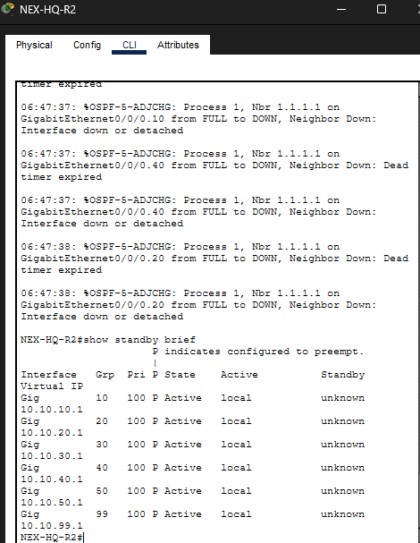
After NEX-HQ-R1 is restored, it takes the Active role back on every group (preempt).
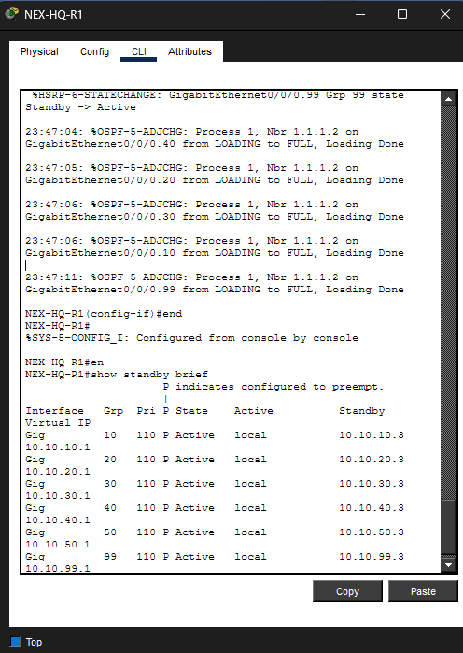
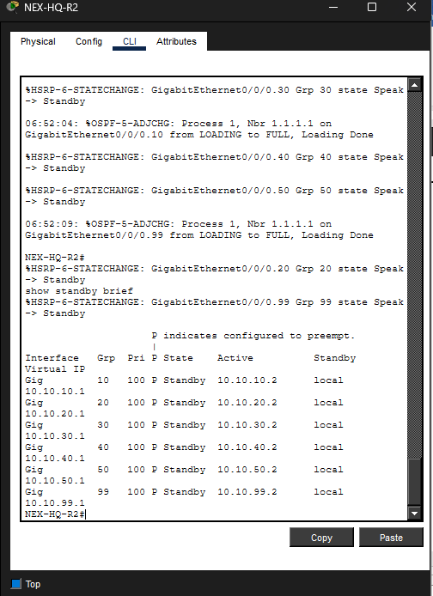
NEX-HQ-R2 returns to Standby
- EtherChannel: two physical links between each site's switch pair, bundled via LACP (channel-group 1 mode active) into a single logical trunk (Port-channel 1). This avoids a Spanning Tree-blocked link and allows both cables to carry traffic simultaneously, with no service interruption if one fails.
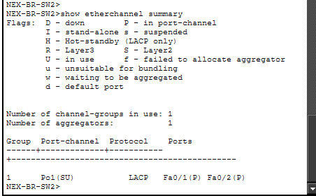
Port-channel 1 is in use (SU) with Fa0/1 and Fa0/2 both bundled (P) using LACP.
7. ACL DESIGN AND REASONING
Two access control lists were implemented:
- GUEST-ISOLATION
Extended ACL, applied inbound on each router's VLAN 50 sub-interface: denies traffic from the Guest subnet to any internal 10.0.0.0/8 network, while explicitly permitting Guest devices to reach their own subnet (for DHCP renewal and local gateway access) and permitting all other traffic. This enforces that visitors can use the network for basic connectivity but cannot reach any department's data, directly protecting against unauthorized access to internal resources from an untrusted or unmanaged device.
A ping from the guest laptop to 10.10.10.4, the shared printer at HQ, is blocked.
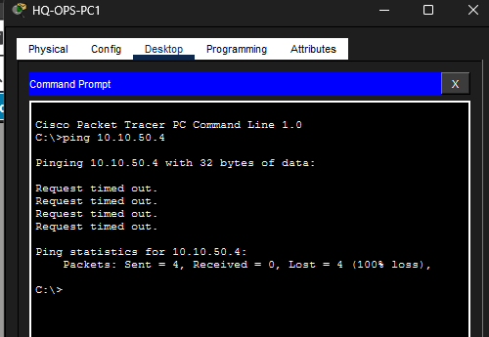
From an Operations PC, pinging the Guest laptop also fails, so isolation works in both directions.
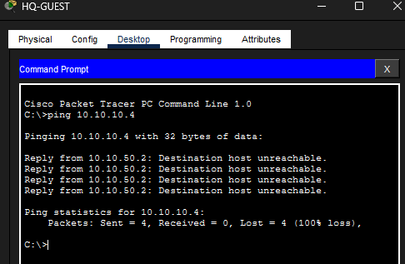
- SSH-restricted-to-IT
Standard ACL 10, applied to the VTY lines on all four routers and all four switches: permits only the IT (VLAN 30) and Network Management (VLAN 99) subnets at both sites, denying all other sources. This is what actually restricts remote device management to IT staff, protecting against unauthorized configuration changes from any other department.
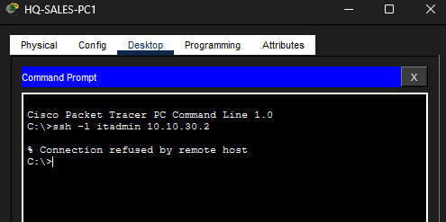
SSH from a Sales PC is refused because of the restriction.
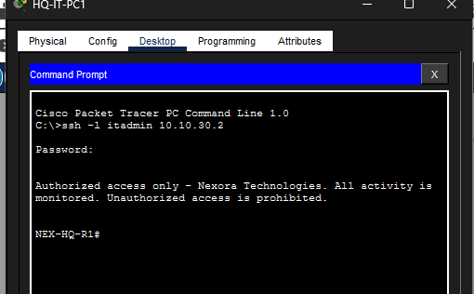
SSH from an IT PC shows the login banner and lands in privileged mode on NEX-HQ-R1.

8. SECURITY FEATURES
- Port security (all access ports, maximum 1 MAC address, sticky learning, violation mode restricts): protects against an unauthorized device being plugged into a port that was provisioned for a specific, known device. The port continues operating but drops traffic from any second MAC address and logs the violation.
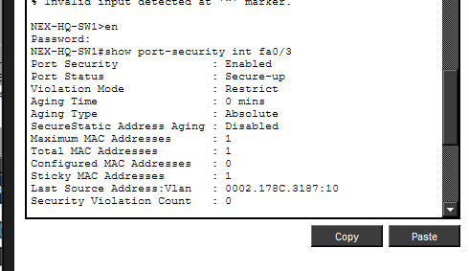
port security is enabled on Fa0/3 with one sticky MAC address learned and a violation count of 0.

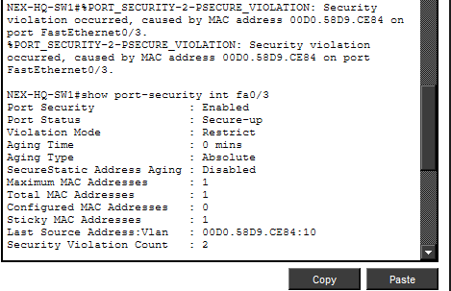
After a different PC was plugged into Fa0/3, the violation count rose to 2 and the port stayed up in Restrict mode.

- DHCP snooping (enabled on NEX-HQ-SW1 and NEX-BR-SW1, with Gi0/1 and the EtherChannel member ports trusted): protects against a rogue DHCP server being connected to the network and handing out false gateway or DNS information to unsuspecting devices. Only ports leading toward the legitimate DHCP server (NEX-HQ-R1 / NEX-BR-R1) are trusted to relay DHCP server messages.
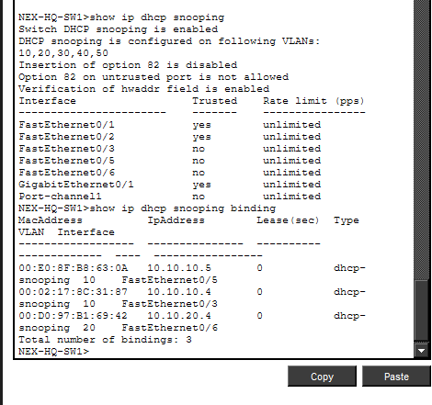
NEX-HQ-SW1: DHCP snooping is on for VLANs 10 to 50, the uplink and EtherChannel ports are trusted, and three leases are recorded.
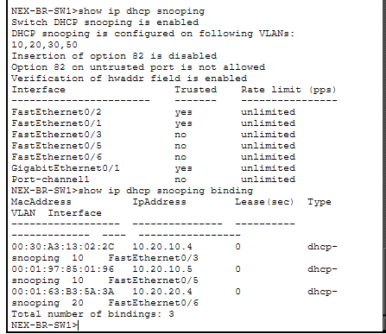
NEX-BR-SW1: the same setup for VLANs 10, 20, 30 and 50, with three leases recorded.
- SSH-only management: protects against credentials and configuration data being sent in plaintext.
- Encrypted passwords (service password-encryption, enable secret) and a login banner: protects stored passwords from being read directly out of the configuration file, and the banner provides a documented legal notice that access is monitored and unauthorized access is prohibited.
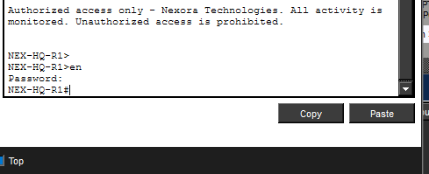
The login banner appears on connection, then the enable password is required to reach privileged mode.

- Spanning Tree Protocol (enabled by default on all switches, verified with show spanning-tree): protects against Layer 2 broadcast storms that would occur if a switching loop existed.
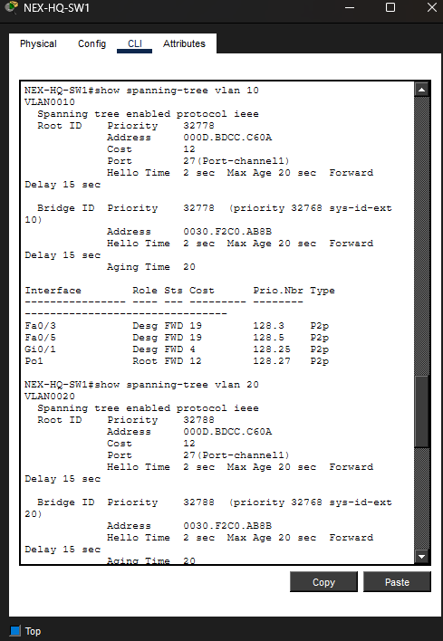
show spanning-tree on NEX-HQ-SW1: every port is forwarding and the root bridge is reached through Port-channel 1, so there is no loop.

9. TESTING AND VERIFICATION
VLAN AND TRUNK VERIFICATION
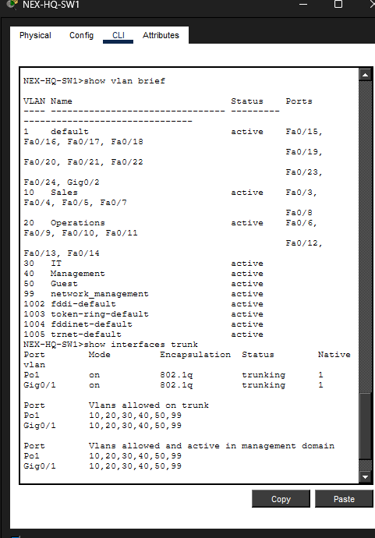
NEX-HQ-SW1: all six VLANs exist, and Gi0/1 and Po1 trunk VLANs 10, 20, 30, 40, 50 and 99.

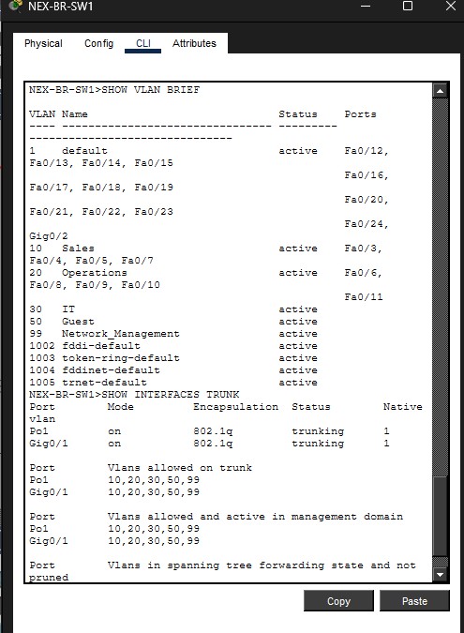
NEX-BR-SW1: five VLANs (no VLAN 40 at Branch), with Gi0/1 and Po1 trunking.
OSPF NEIGHBOR VERIFICATION
NEX-HQ-R1 OSPF neighbors: its HQ partner on each VLAN plus the Branch router across the WAN (Serial0/1/0).
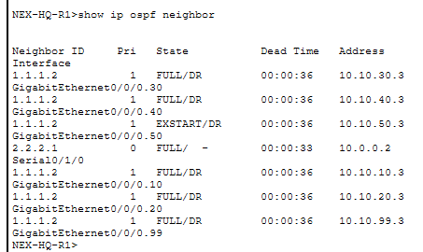

DHCP CONFIGURATION
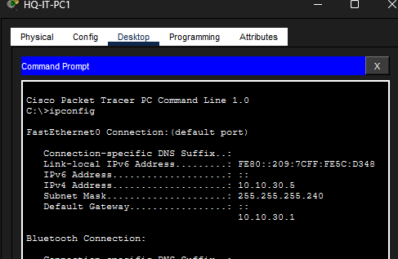
HQ-IT-PC1 received 10.10.30.5/28 with gateway 10.10.30.1 by DHCP.

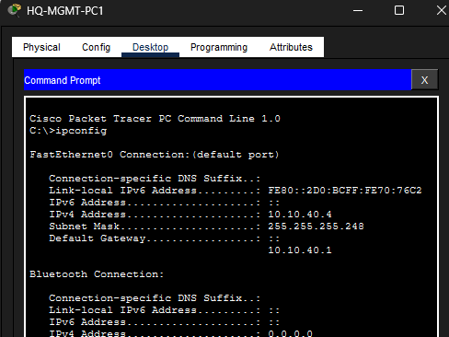
HQ-MGMT-PC1 received 10.10.40.4/29 with gateway 10.10.40.1 by DHCP.

INTER-SITE CONNECTIVITY
PINGING FROM BRANCH OPERATIONS TO HQ OPERATIONS (same VLAN number, other office) AND HQ SALES (different VLAN).

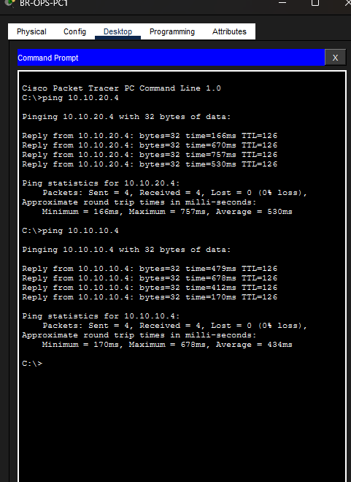

PINGING FROM THE HQ IT PC TO A BRANCH SALES PC (different VLAN) AND A BRANCH IT PC (same VLAN number, other office)

