**Minutes for Meeting 2**

**Date**: Friday 04/09/2015

**Attendees**: Jeremy (PM), Nabilah, Shu Wen, Zhi Hui, Darren  
**Time**: 11:30am – 2:50pm

**Venue**: Library GSR 4-11

**Agenda**

* ERD
* Set-up Environment
* Functions into Schedule
* SD for Bootstrap

|  |  |  |  |  |
| --- | --- | --- | --- | --- |
| S/N | Agenda (In details) | Brief Details: | Action By: | Due Date |
| 1 | Planning of Schedule | Refer to appendix A. | Info | - |
| 2 | ERD Drawing (Database) | Refer to appendix B.  Pair 1 (Darren and Shu Wen) to do further research on ERD Drawing | Pair 1 | 12/9/15 |
| 3 | SD for BootStrap | Refer to appendix C.  Pair 2 (Nabilah and Zhi Hui) to do further work on the SD diagram | Pair 2 | 12/9/15 |
| 4 | Update PP Log | Updated the PP Log with details for work (Points 2 and 3) for the week. | Info |  |
| 5 | Agenda and Date of next Meeting | Refer to Point 1.   1. PM Changeover: Zhi Hui 2. Reassign Pair Teams 3. Pair 1 to show ERD Diagram work (Discussion) 4. Pair 2 to show SD Bootstrap   (Discussion)   1. Set up relations between Git and Netbeans (Action next week) 2. Begin Iteration 1: Week 4-5   (Time boxing, 2 weeks cycle)   1. Pair 1: Bootstrap Implementation 2. Pair 2: JSON Interaction 3. Prepare for Supervisor Meeting (Week 5)   Next Meeting Scheduled at 12/09/15, 1630 onwards. | Jeremy (PM) |  |

The meeting was adjourned at 2.50pm. These minutes will be circulated and adopted if there are no amendments reported in the next 24 hours.

Prepared by,

Darren Tay

Vetted and edited by,

Jeremy Ong

1. TIME SCHEDULE

|  |  |  |
| --- | --- | --- |
| Weeks: | Important Matters | Project Manager |
| 2 | Planning (Diagrams) – Use Case, Domain | Jeremy |
| 3 | Pair 1: [ERD]  Pair 2: [SD for bootstrap (as model)] |
| 4 | Pair 1: [Bootstrap]  Pair 2: [JSON Interaction] | Zhi Hui |
| 5 | Pair 1: [Bootstrap]  Pair 2: [JSON interaction] |
| 6 | Pair 1:[CRUD Location data]  Pair 2:[Login/Logout] [Generate Basic App Usage Report] | Nabilah |
| 7 | Pair 1:[CRUD Location data]  Pair 2:[Login/Logout] [Generate Basic App Usage Report]  *PM Review* |
| 8 | Pair 1:[Smartphone usage heatmap]  Pair 2:[Top-k usage report]  *-Break Week-* | Darren |
| 9 | Pair 1:[Smartphone usage heatmap]  Pair 2:[Smartphone overuse report] |
| 10 | Pair 1:[Social activity report]  Pair 2: [Integration crew] | Shu Wen |
| 11 | Pair 1:[Social activity report]  Pair 2: [Integration crew] |
| 12 | UAT | Jeremy |
| 13 | Sunday (End): Submission of SE Project |

1. ER DIAGRAMS

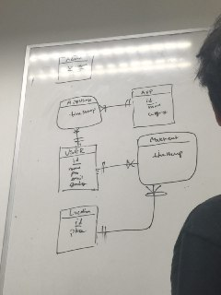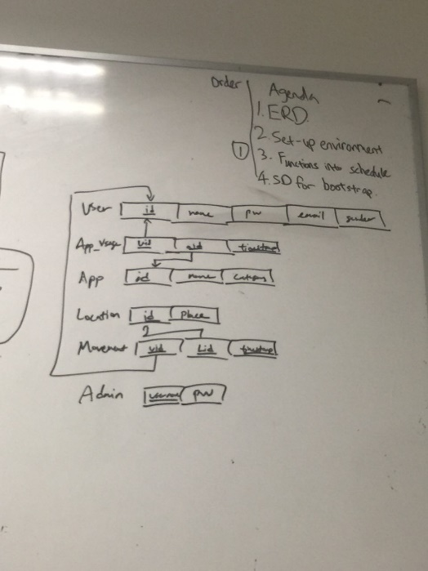

ER Diagram Logical Diagram

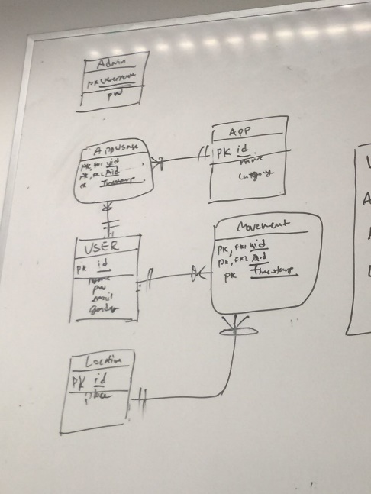

Our idea of the ERD

1. SD for Bootstrap

