Jerry Jones
CSD325-Advanced Python
Module 4.2 Assignment
October 2026

Step 4: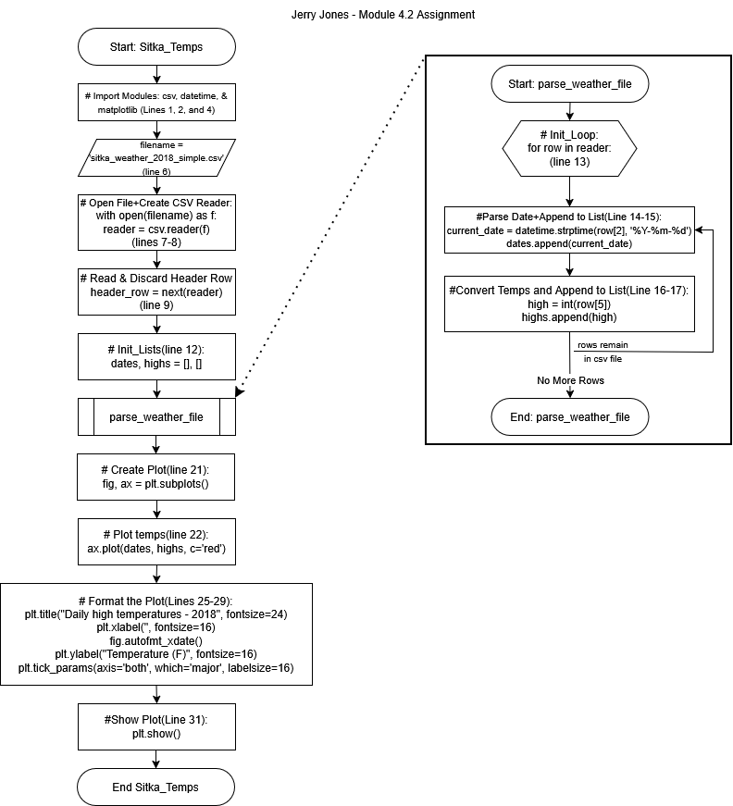
Step 6:
- Added opening menu and choice input
- Added {lows} list
- Read low temps from CSV file
- Created while loop to format and control which graph displays
Step 7:
