Low Level Design Template

DMT/AD06/TMP

Project Code | Group - 02
Project Name | Expense Management System (Project Code Module)

Prepared/Modified by | Role | Date of Preparation
Harshita Gupta | Analyst | 04/12/2018
Reviewed by | Role | Date of Review
Deepa Suryawanshi | Analyst | 05/12/2018
Approved by | Role | Date of Approval
Circulation List | Deepa.suryawanshi@capgemini.com,  Shreya.pawar@capgemini.com,  Ankita.nayak@capgemini.com,  Ujwala.bedarkar@capgemini.com,  Vaibhav.gade@capgemini.com,  Harshita.b.gupta@capgemini.com,  Prashant.borkar@capgemini.com ,  hitesh.prithiani@capgemini.com,  inderpreet.b.kaur@capgemini.com | Version Number of the template:1.0
Version Number | <1.0 >

Table of Contents

1. Description Of The Unit 3
2. References 4
3. Dependencies / Assumptions 5
4. Class Diagrams 6
5. Sequence Diagrams 7
6. Design Components 8
6.1 List Of UI Components 8
6.2 List Of Design Classes 8
7. Re-Usable Routines/Components 9
8. Messages 10
9. Configuration Files 11
10. Crud Matrix Table 12
11. Data Mapping Matrix 13
12. Action Flow Matrix 14
13. Stored Procedures 15
14. Program Specification / Pseudo Code 16
REVISION HISTORY OF THE WORK PRODUCT 17

Description Of The Unit

The add project module allows the user to add new projects into the database. This module can be used only by the user of the application.

We are required to give the Project description, project start date, project end date to the postman in the form of JSON. Then, the link of the addDetails function (in the Ems controller) is given to the postman using the POST method.

After entering all the project details, the details are inserted into the database on clicking the send button in the postman.

References
Reference | Description
Repository reference | https://github.com/jerry-143/ProjectCodeModule
Class Diagram | /Project Documents/Design Documents/HLD/Class Diagrams
URS | /Project Documents/Requirements/Case Study/ExpenseManagementSystemCaseStudy.doc
UTP | /Project Documents/Test Plan/UTP/Test Cases/AddProject /UTP_AddModule.xlsm
DB Design | /Project Documents/Design Documents/HLD/DB Design

Dependencies / Assumptions

Dependencies:
The user should be logged in.

Assumptions:
The project details are stored in the database.

Class Diagrams

Sequence Diagrams

Sequence Diagram
NA

Design Components

List Of UI Components

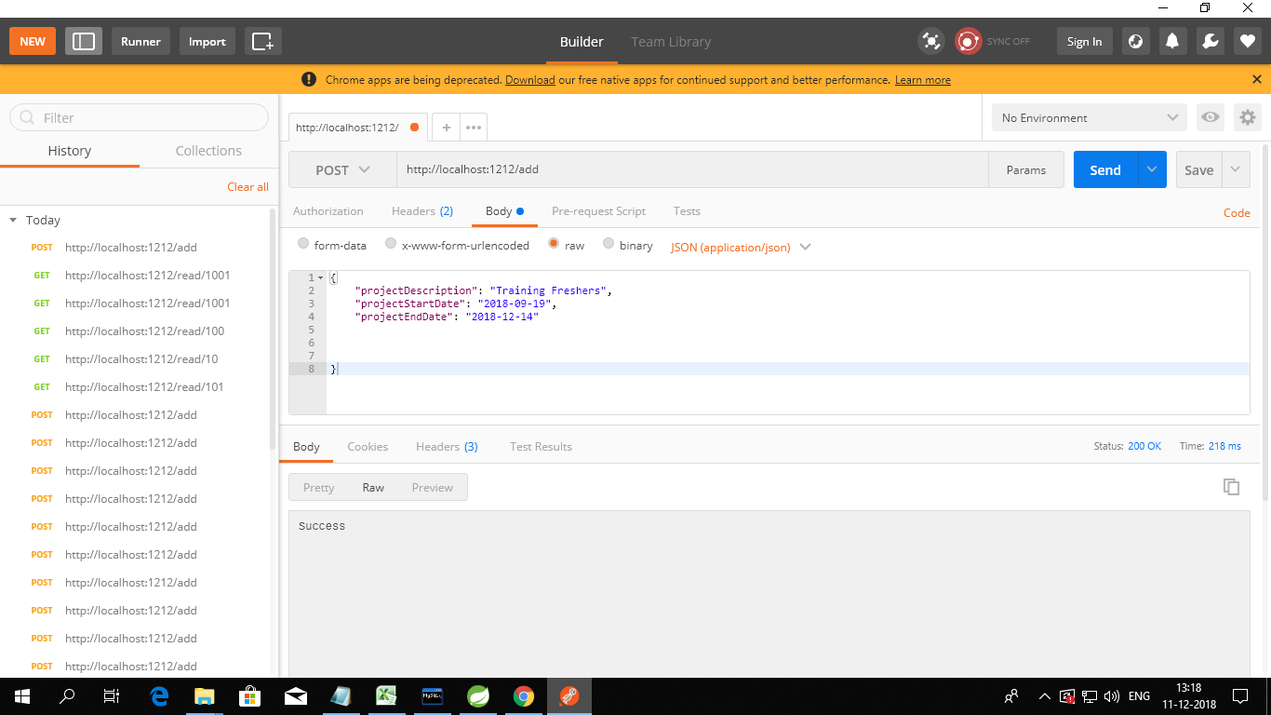

6.2 List Of Design Classes

Sr. No. | LLD Name | Class Name | Method Name | Method Description
1 | Add Project Module | ProjectCodeModule | Appropriate getters and setters methods | Getters retrieve the property values and setters set the property values
2 | Add Project Module | EmsController | addDetails(@RequestBody @Valid ProjectCodeModule pcm) : String | Calls addDetails() of ProjectCodeServiceImpl class. It returns a message “success” when the values are inserted successfully.
3 | Add Project Module | ProjectCodeServiceImpl | addDetails(ProjectCodeModule pcm) : void | Calls save() of IProjectRepository interface.

Re-Usable Routines/Components

Re-Usable Routines/Components

- ProjectCodeException class
- GlobalExceptionProjectCode class

Messages

#. | Type | Message Text
M1 | Error Message | Enter a valid project description
M2 | Error Message | Enter a valid date
M3 | Error Message | Enter a valid date

Configuration Files

File Name | Path | Description
application.yml | /Development/Source | To configure database connection.
pom.xml | /Development/Source | To configure the dependencies.

Crud Matrix Table

# | Table Name | Create | Read | Update | Delete
1. | Project_code | Y | N | N | N

Data Mapping Matrix

Sr. No. | Screen Label | Field Source | Field Type | Data Type | Max Length | Data Flow | Mandatory
1 | Project Id | project_id | NA | int | 11 | UI→D | Yes
2 | Project Description | project_description | NA | Varchar | 255 | UI→D | Yes
3 | Project Start Date | project_start_date | NA | date | NA | UI→D | No
4 | Project Start Date | project_end_date | NA | date | NA | UI→D | No

Legend
D → UI (Database to User Interface)
UI → D (User Interface to Database)
UI (User Interface Only)

Action Flow Matrix

Sr. No. | Action | Description | Process
1 | On click of Send button of Postman after giving the details in Json form and making the method as POST | Project Details are inserted | The project description, start date and end date are inserted.

Stored Procedures

# | Stored Procedure Name  (with Description) | Input/Out Parameters | Type | Size
1. | NA | NA | NA | NA

Program Specification / Pseudo Code

14. 1 ACTION: On click of Send button of Postman after giving the details in Json form and making the method as POST

Pseudo Code:
- Client Side Scripting:
None

- Server Side Scripting:
The project description, start date and end date are inserted.

REVISION HISTORY OF THE WORK PRODUCT
# | Date | Version # | Section Changed | Details of changes made | Approved By
1 | 04/12/2018 | 1.0 | LLD prepared | N/A | Harshita Gupta
2 | 04/12/2018 | 1.1 | Reusable components,  Pseudo code | Reusable components added.  The pseudo code is modified as per the specified flow. | Harshita Gupta
3 | 05/12/2018 | 1.2 | Reusable components,  References,  Data Mapping Matrix. | Reusable Components added.  File name with relative path is added in the references section.  The name of text boxes(screen label is changed). | Harshita Gupta
4 | 05/12/2018 | 1.3 | Configuration files,UI Components | Paths of the configuration files is updated and UI components(Screen Shots) added. | Harshita Gupta

