Android JSON Parser Tutorial with Examples

1. What is JSON?
2. JSON & Java Object
3. Quickly generate a project to work with JSON
4. Java Beans classes
5. Example, read JSON data transferred into a Java object
6. Example of converting a Java object into JSON data
7. Read JSON from URL

## **1. What is JSON?**

**JSON (JavaScript Object Notation)** is a data exchange format. It stores data in key and value pair. Compared to **XML**, **JSON**is more simple and easier to read.

Hãy xem một ví dụ đơn giản của **JSON**:

{

"name" : "Tran",

"address" : "Hai Duong, Vietnam",

"phones" : [0121111111, 012222222]

}

Key-value pairs can be nested:

{

"id": 111 ,

"name":"Microsoft",

"websites": [

"http://microsoft.com",

"http://msn.com",

"http://hotmail.com"

],

"address":{

"street":"1 Microsoft Way",

"city":"Redmond"

}

}

In **Java**, there are very many open source code libraries which help manipulate with **JSON**documents, for example:

* JSONP
* json.org
* Jackson
* Google GSON
* json-lib
* javax json
* json-simple
* json-smart
* flexjson
* fastjson

**Android** provides available supports for the library to work with **JSON**, you don't need to declare any other libraries. In this manual, I will instruct you how to work with the **JSON** using the**JSON API**available in the operating system of **Android**.

## **2. JSON & Java Object**

The following illustration describes the relationship between **JSON** and **Java** classes.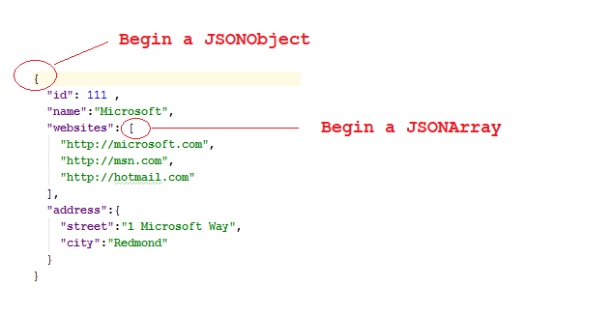

## **3.   Quickly generate a project to work with JSON**

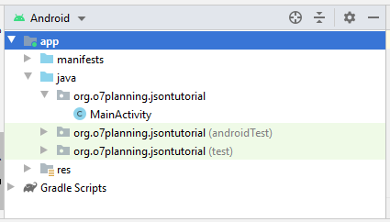

Create a ***raw*** folder:

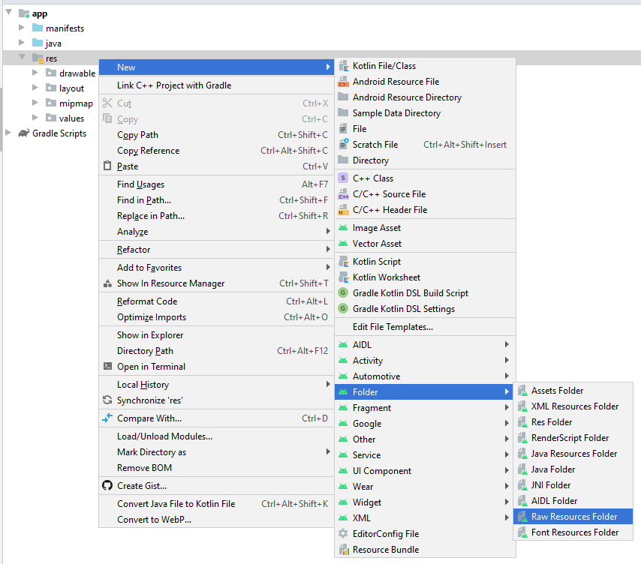

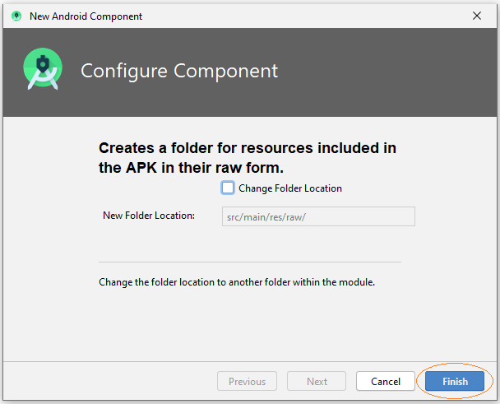

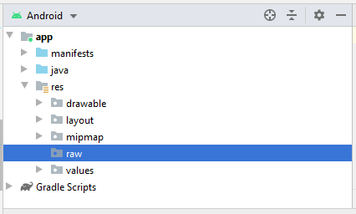

I create some **json**files in the **'raw'** folder, which will be involved in the examples in this document.

*The sources of providing****JSON****data can be from files or****URLs****, etc. At the end of the document you can see the example of taking****JSON****data from****URL****, analyzed and displayed on an****Android****application.*

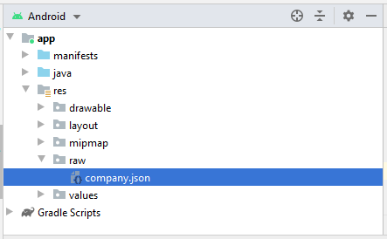

company.json

{

"id": 111 ,

"name":"Microsoft",

"websites": [

"http://microsoft.com",

"http://msn.com",

"http://hotmail.com"

],

"address":{

"street":"1 Microsoft Way",

"city":"Redmond"

}

}

Design **activity_main.xml**:

<?xml version="1.0" encoding="utf-8"?>

<**androidx.constraintlayout.widget.ConstraintLayout**

xmlns:android="http://schemas.android.com/apk/res/android"

xmlns:app="http://schemas.android.com/apk/res-auto"

xmlns:tools="http://schemas.android.com/tools"

android:layout_width="match_parent"

android:layout_height="match_parent"

tools:context=".MainActivity">

<**EditText**

android:id="@+id/editText"

android:layout_width="0dp"

android:layout_height="220dp"

android:layout_marginStart="16dp"

android:layout_marginLeft="16dp"

android:layout_marginTop="16dp"

android:layout_marginEnd="16dp"

android:layout_marginRight="16dp"

android:ems="10"

android:inputType="none|textMultiLine"

app:layout_constraintEnd_toEndOf="parent"

app:layout_constraintStart_toStartOf="parent"

app:layout_constraintTop_toTopOf="parent" />

<**Button**

android:id="@+id/button"

android:layout_width="wrap_content"

android:layout_height="wrap_content"

android:layout_marginTop="39dp"

android:text="Running the Example"

app:layout_constraintEnd_toEndOf="parent"

app:layout_constraintStart_toStartOf="parent"

app:layout_constraintTop_toBottomOf="@+id/editText" />

</**androidx.constraintlayout.widget.ConstraintLayout**>

## **4. Java Beans classes**

Some classes participated in the examples:

Address.java

**package** org.o7planning.jsontutorial.beans;

**public** **class** **Address** {

**private** String street;

**private** String city;

**public** **Address**() {

}

**public** **Address**(String street, String city) {

this.street = street;

this.city = city;

}

**public** String **getStreet**() {

**return** street;

}

**public** **void** **setStreet**(String street) {

this.street = street;

}

**public** String **getCity**() {

**return** city;

}

**public** **void** **setCity**(String city) {

this.city = city;

}

@Override

**public** String **toString**() {

**return** street + ", " + city;

}

}

**Company.java**

**package** org.o7planning.jsontutorial.beans;

**public** **class** **Company** {

**private** int id;

**private** String name;

**private** String[] websites;

**private** Address address;

**public** int **getId**() {

**return** id;

}

**public** **void** **setId**(int id) {

this.id = id;

}

**public** String **getName**() {

**return** name;

}

**public** **void** **setName**(String name) {

this.name = name;

}

**public** String[] getWebsites() {

**return** websites;

}

**public** **void** **setWebsites**(String[] websites) {

this.websites = websites;

}

**public** Address **getAddress**() {

**return** address;

}

**public** **void** **setAddress**(Address address) {

this.address = address;

}

@Override

**public** String **toString**() {

StringBuilder sb = **new** **StringBuilder**();

sb.append("\n id:" + this.id);

sb.append("\n name:" + this.name);

**if** (this.websites != null) {

sb.append("\n website: ");

**for** (String website : this.websites) {

sb.append(website + ", ");

}

}

**if** (this.address != null) {

sb.append("\n address:" + this.address.toString());

}

**return** sb.toString();

}

}

## **5. Example, read JSON data transferred into a Java object**

In this example, we will read the **JSON** data file and transfer it into a **Java** object.

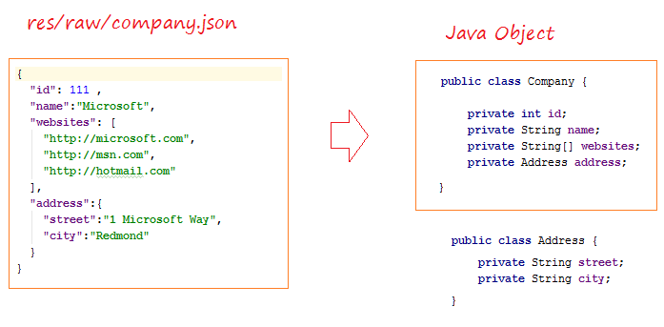

**ReadJSONExample.java**

**package** org.o7planning.jsontutorial.json;

**import** android.content.Context;

**import** org.json.JSONArray;

**import** org.json.JSONException;

**import** org.json.JSONObject;

**import** org.o7planning.jsontutorial.R;

**import** org.o7planning.jsontutorial.beans.Address;

**import** org.o7planning.jsontutorial.beans.Company;

**import** java.io.BufferedReader;

**import** java.io.IOException;

**import** java.io.InputStream;

**import** java.io.InputStreamReader;

**public** **class** **ReadJSONExample** {

// Read the company.json file and convert it to a java object.

**public** **static** Company **readCompanyJSONFile**(Context context) **throws** IOException,JSONException {

// Read content of company.json

String jsonText = readText(context, R.raw.company);

JSONObject jsonRoot = **new** **JSONObject**(jsonText);

int id= jsonRoot.getInt("id");

String name = jsonRoot.getString("name");

JSONArray jsonArray = jsonRoot.getJSONArray("websites");

String[] websites = **new** **String**[jsonArray.length()];

**for**(int i=0;i < jsonArray.length();i++) {

websites[i] = jsonArray.getString(i);

}

JSONObject jsonAddress = jsonRoot.getJSONObject("address");

String street = jsonAddress.getString("street");

String city = jsonAddress.getString("city");

Address address= **new** **Address**(street, city);

Company company = **new** **Company**();

company.setId(id);

company.setName(name);

company.setAddress(address);

company.setWebsites(websites);

**return** company;

}

**private** **static** String **readText**(Context context, int resId) **throws** IOException {

InputStream is = context.getResources().openRawResource(resId);

BufferedReader br= **new** **BufferedReader**(**new** **InputStreamReader**(is));

StringBuilder sb= **new** **StringBuilder**();

String s= null;

**while**(( s = br.readLine())!=null) {

sb.append(s);

sb.append("\n");

}

**return** sb.toString();

}

}

**MainActivity.java**

**package** org.o7planning.jsontutorial;

**import** androidx.appcompat.app.AppCompatActivity;

**import** android.os.Bundle;

**import** android.view.View;

**import** android.widget.Button;

**import** android.widget.EditText;

**import** org.o7planning.jsontutorial.beans.Company;

**import** org.o7planning.jsontutorial.json.ReadJSONExample;

**public** **class** **MainActivity** **extends** **AppCompatActivity** {

**private** EditText outputText;

**private** Button button;

@Override

**protected** **void** **onCreate**(Bundle savedInstanceState) {

super.onCreate(savedInstanceState);

setContentView(R.layout.activity_main);

this.outputText = (EditText)this.findViewById(R.id.editText);

this.button = (Button) this.findViewById(R.id.button);

this.button.setOnClickListener(**new** **View**.OnClickListener() {

@Override

**public** **void** **onClick**(View view) {

runExample(view);

}

});

}

**public** **void** **runExample**(View view) {

**try** {

Company company = ReadJSONExample.readCompanyJSONFile(this);

outputText.setText(company.toString());

} **catch**(Exception e) {

outputText.setText(e.getMessage());

e.printStackTrace();

}

}

}

Run the example:

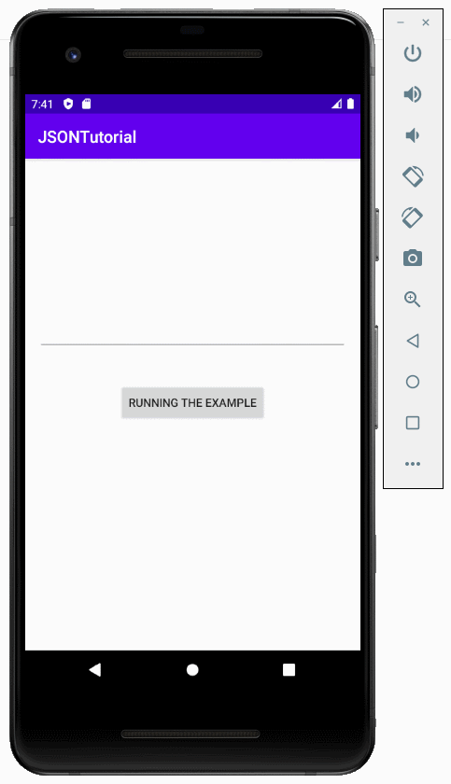

## **6. Example of converting a Java object into JSON data**

The following example converts a **Java**object into a **JSON**data.

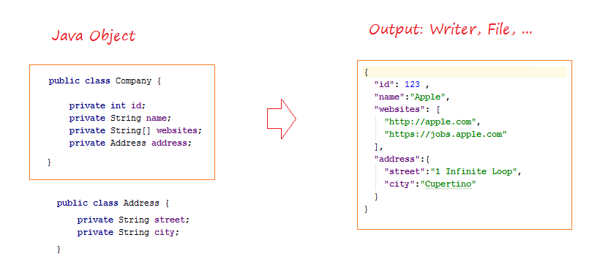

**JsonWriterExample.java**

**package** org.o7planning.jsontutorial.json;

**import** android.util.JsonWriter;

**import** org.o7planning.jsontutorial.beans.Address;

**import** org.o7planning.jsontutorial.beans.Company;

**import** java.io.IOException;

**import** java.io.Writer;

**public** **class** **JsonWriterExample** {

**public** **static** **void** **writeJsonStream**(Writer output, Company company ) **throws** IOException {

JsonWriter jsonWriter = **new** **JsonWriter**(output);

jsonWriter.beginObject();// begin root

jsonWriter.name("id").value(company.getId());

jsonWriter.name("name").value(company.getName());

String[] websites= company.getWebsites();

// "websites": [ ....]

jsonWriter.name("websites").beginArray(); // begin websites

**for**(String website: websites) {

jsonWriter.value(website);

}

jsonWriter.endArray();// end websites

// "address": { ... }

jsonWriter.name("address").beginObject(); // begin address

jsonWriter.name("street").value(company.getAddress().getStreet());

jsonWriter.name("city").value(company.getAddress().getCity());

jsonWriter.endObject();// end address

// end root

jsonWriter.endObject();

}

**public** **static** Company **createCompany**() {

Company company = **new** **Company**();

company.setId(123);

company.setName("Apple");

String[] websites = { "http://apple.com", "https://jobs.apple.com" };

company.setWebsites(websites);

Address address = **new** **Address**();

address.setCity("Cupertino");

address.setStreet("1 Infinite Loop");

company.setAddress(address);

**return** company;

}

}

MainActivity.java (2)

**package** org.o7planning.jsontutorial;

**import** androidx.appcompat.app.AppCompatActivity;

**import** android.os.Bundle;

**import** android.view.View;

**import** android.widget.Button;

**import** android.widget.EditText;

**import** org.o7planning.jsontutorial.beans.Company;

**import** org.o7planning.jsontutorial.json.JsonWriterExample;

**import** java.io.StringWriter;

**public** **class** **MainActivity** **extends** **AppCompatActivity** {

**private** EditText outputText;

**private** Button button;

@Override

**protected** **void** **onCreate**(Bundle savedInstanceState) {

super.onCreate(savedInstanceState);

setContentView(R.layout.activity_main);

this.outputText = (EditText)this.findViewById(R.id.editText);

this.button = (Button) this.findViewById(R.id.button);

this.button.setOnClickListener(**new** **View**.OnClickListener() {

@Override

**public** **void** **onClick**(View view) {

runExample(view);

}

});

}

**public** **void** **runExample**(View view) {

**try** {

StringWriter output = **new** **StringWriter**();

Company company = JsonWriterExample.createCompany();

JsonWriterExample.writeJsonStream(output, company);

String jsonText = output.toString();

outputText.setText(jsonText);

} **catch**(Exception e) {

outputText.setText(e.getMessage());

e.printStackTrace();

}

}

}

Running the example:

