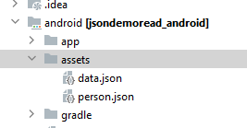

{  
 "items": [  
 {  
 "id": "1",  
 "name": "Apple",  
 "description": "An apple is an edible fruit produced by an apple tree (Malus domestica). Apple trees are cultivated worldwide and are the most widely grown species in the"  
 },  
 {  
 "id": "2",  
 "name": "Banana",  
 "description": "banana is an elongated, edible fruit - botanically a berry - produced by several kinds of large herbaceous flowering plants in the genus Musa."  
 },  
 {  
 "id": "3",  
 "name": "Grape",  
 "description": "The grapefruit (Citrus × paradisi) is a subtropical citrus tree known for its relatively large, sour to semi-sweet, somewhat bitter fruit."  
 },  
 {  
 "id": "4",  
 "name": "Mango",  
 "description": "A mango is an edible stone fruit produced by the tropical tree Mangifera indica which is believed to have originated from the region between northwestern "  
 },  
 {  
 "id": "5",  
 "name": "Orange",  
 "description": "An orange is a fruit of various citrus species in the family Rutaceae ); it primarily refers to Citrus × sinensis, which is also called sweet orange"  
 }  
 ]  
}

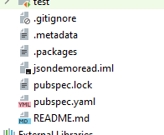

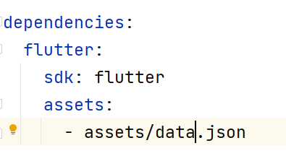

Main.dart

import 'package:flutter/material.dart';  
import 'dart:async';  
import 'dart:convert';  
import 'package:flutter/services.dart';  
  
void main() => runApp(new MyApp());  
class MyApp extends StatelessWidget {  
 @override  
 Widget build(BuildContext context) {  
 return new MaterialApp(  
 title: 'Flutter JSON Demo',  
 theme: new ThemeData(  
 primarySwatch: Colors.*blue*,  
 ),  
 home: new LocalJsonScreen(apiRoot: 'http://api.flutter.institute/'),  
 );  
 }  
}  
  
class LocalJsonScreen extends StatefulWidget {  
 const LocalJsonScreen({Key key, String apiRoot}) : super(key: key);  
  
 @override  
 State<LocalJsonScreen> createState() => _LocalJsonScreenState();  
}  
  
class _LocalJsonScreenState extends State<LocalJsonScreen> {  
 List jsonData = [];  
  
 *// Fetch content from the json file* Future<void> readJson() async {  
 final String response = await rootBundle.loadString('assets/person.json');  
 final data = await json.decode(response);  
 setState(() {  
 jsonData = data["items"];  
 });  
 }  
  
 @override  
 Widget build(BuildContext context) {  
 return Scaffold(  
 appBar: AppBar(  
 centerTitle: true,  
 title: const Text(  
 'Read Data From Local Json',  
 ),  
 ),  
 body: Padding(  
 padding: const EdgeInsets.all(25),  
 child: Column(  
 mainAxisAlignment: MainAxisAlignment.center,  
 children: [  
 Center(  
 child: ElevatedButton(  
 child: const Text('Load Fruit Data'),  
 onPressed: readJson,  
 ),  
 ),  
  
 *// Display the data loaded from data.json* jsonData.isNotEmpty  
 ? Expanded(  
 child: ListView.builder(  
 itemCount: jsonData.length,  
 itemBuilder: (context, index) {  
 return Card(  
 margin: const EdgeInsets.all(10),  
 child: ListTile(  
 leading: CircleAvatar(  
 child: Text(jsonData[index]["id"])),  
 title: Text(jsonData[index]["name"]),  
 subtitle: Text(jsonData[index]["description"]),  
 ),  
 );  
 },  
 ),  
 )  
 : const SizedBox()  
 ],  
 ),  
 ),  
 );  
 }  
}