# From: 2016 General Election: Trump vs. Clinton

<https://elections.huffingtonpost.com/pollster/2016-general-election-trump-vs-clinton>

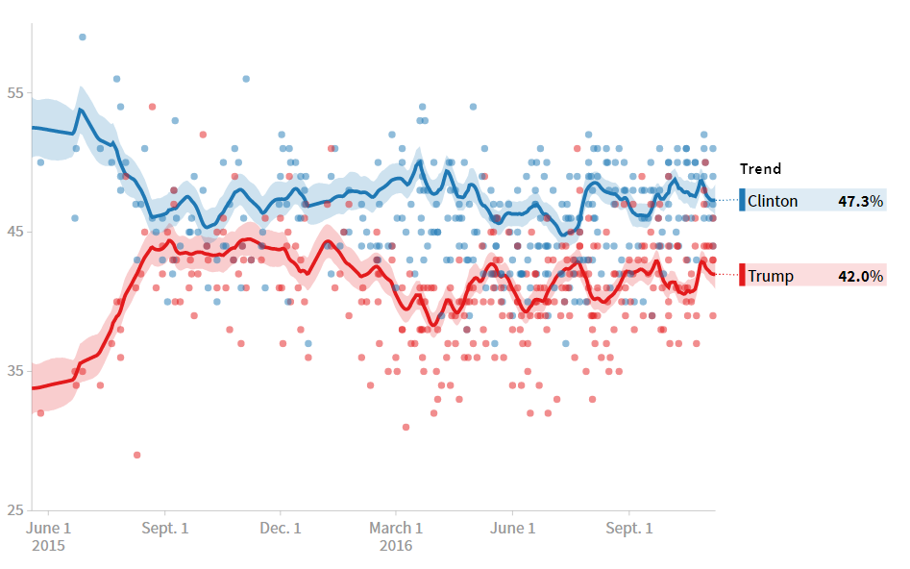

The chart show Hilary is ahead of Trump more than 5 points. But the result is Trump won the election with 306 : 232

The chart is misleading since the media did not get the poll data with truly randomized data, when people interviewed, they tend not to show the opinion was socially undesirable. The media clearly show its preference, then a poll from that media will get a high biased result, no matter how it design or equalize the sample.