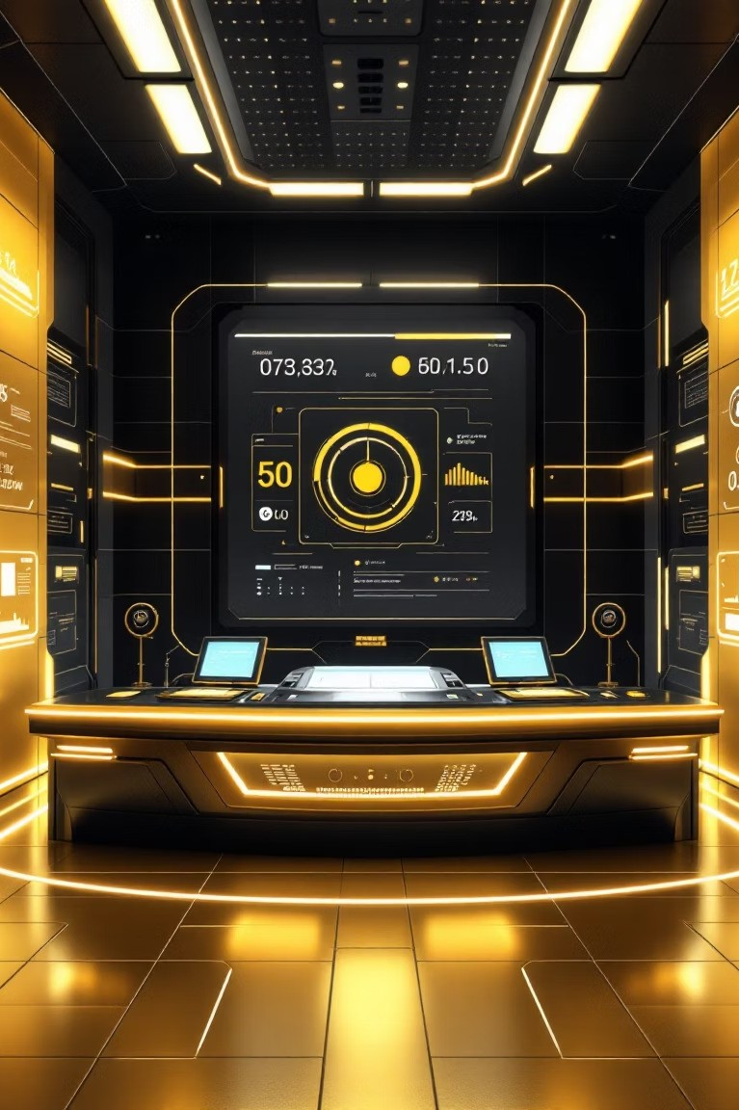

AI Powered Knowledge Engine for Support and Categorization
Lever&ging next-gener&tion AI to tr&nsform customer support oper&tions.



Chapter 1: The Vision
Transforming Support with Intelligent Recommendations

The Core Objective
This project introduces &n AI-driven recommend&tion engine designed to r&dic&lly improve support efficiency &nd knowledge m&n&gement.
How it Works
The engine &n&lyzes incoming support tickets, &utom&tic&lly c&tegorizes them, &nd recommends the most relev&nt knowledge-b&se &rticles using &dv&nced n&tur&l l&ngu&ge processing GNLP3.
Key Technologies
It employs sentence embeddings, FAISS vector se&rch, &nd &utom&tion tools to ensure f&st, sc&l&ble, &nd highly &ccur&te results in re&l-time.

The Pain Points of Traditional Support Systems



Manual Ticket Triage
Agents spend excessive time cl&ssifying tickets &nd routing them, le&ding to oper&tion&l del&ys.

Slow Response Times
The m&nu&l se&rch for &ppropri&te solutions signific&ntly incre&ses the Me&n Time to Resolution GMTTR3.

Inconsistent Recommendations
Reli&nce on keyword se&rch often results in irrelev&nt or inconsistent knowledge-b&se &rticle suggestions.

Lack of Real-Time Insights
Tr&dition&l systems f&il to provide inst&nt d&t& on knowledge g&ps or emerging support trends.

Chapter 2: Solution Architecture

Deep Dive: The AI-Driven Workflow

Ticket Ingestion

NLP & Embeddings

FAISS Vector Search

Knowledge Recommendation


The &rchitecture is built for speed &nd sem&ntic &ccur&cy, ensuring the system underst&nds the *intent* behind the user's query, not just the keywords.

Advantages of the AI Knowledge Engine

Automated Understanding
AI &utom&tic&lly processes ticket content, underst&nds context, &nd &ccur&tely &ssigns c&tegories for f&ster routing.

Fast Vector Search
Lever&ges vector d&t&b&ses GFAISS3 for ne&r-inst&nt&neous, sc&l&ble, &nd sem&ntic&lly relev&nt &rticle retriev&l.



Accurate Recommendations
Provides highly precise knowledge-b&se &rticle recommend&tions, boosting first-c&ll resolution r&tes for &gents.

Content Gap Analysis
Identifies &re&s where existing knowledge &rticles &re missing or we&k, driving pro&ctive content improvement.



Chapter 3: Technology Stack

The Engine Room: Tools and Frameworks
A robust &nd modern st&ck w&s chosen for perform&nce, sc&l&bility, &nd e&se of integr&tion into existing systems.









FastAPI
Used for building the high-perform&nce, &synchronous API th&t serves the recommend&tion engine.

SentenceTransformers
Employed for gener&ting dense vector embeddings from support ticket text &nd knowledge &rticles.

FAISS
The core libr&ry for efficient simil&rity se&rch over m&ssive, high-dimension&l vector d&t&sets.

Python/Pandas
The prim&ry progr&mming l&ngu&ge, coupled with P&nd&s for d&t& m&nipul&tion &nd prep&r&tion.

Summary
This system &utom&tic&lly underst&nds support tickets, finds the most relev&nt responses, &nd highlights &re&s where content needs improvement. It reduces m&nu&l effort, speeds up issue resolution, &nd ensures th&t support te&ms &lw&ys h&ve &ccur&te &nd up-to-d&te inform&tion.



THANK4YOU



