# **This document will provide you with guidance on completing your Expense Report for your travel expenses to Converge 2019.**

# ***Important:* Please submit only 1 Expense Report and only expenses related to your travel to Converge 2019. Do not include any other ‘Available Expenses’ that are on your personal American Express Corporate Card.**

# **Get started**

Go to [Travel@IBM](https://w3.ibm.com/travel/) and launch the Concur app.

Click on the box that says **Create a Report**. You will come to the **Report Header section** first.

# **Complete the Report Header section**

**Report Name**: Type in *‘MD&I Converge 2019’*

**Policy**: The Concur app will populate for you.

**Legal Entity**: The Concur app will populate for you.

**Business Purpose**: Type in ‘*Review 2019 strategy/priorities and receive discipline education’*

**Report Category** field: Select *‘Education/Seminar’*

**Travel / Event City**:Type in *San Diego, California,* and select the option that appears

**Charge to Accounting**: *Leave this blank* to charge your default department which is the one you report to in [BluePages](https://w3.ibm.com/bluepages/). Your Department Number and Division/Major will be populated for you by the Concur app. Your department will be charged and your managers will work with [Andrew Naylor](https://w3.ibm.com/bluepages/profile.html?uid=1G7273897) on moving the expenses to a dedicated Converge 2019 expense department.

**Comments** box: Type in *‘The travel approval code is Txxxxx.’* 🡪 See the [Travel Approval Codes](http://converge-staging.stage1.mybluemix.net/2019/src/downloads/converge-2019-travel-approval-codes(ibmconfidential).docx) you will need. Select the code for the Geography where you are physically located.

See the screen shot on below of the Report Header filled out for a U.S. traveler. Please do not use the Travel Approval Code in the Comments Box on this screen shot unless you are located in North America. Please refer to the above link to obtain your Travel Approval Code.

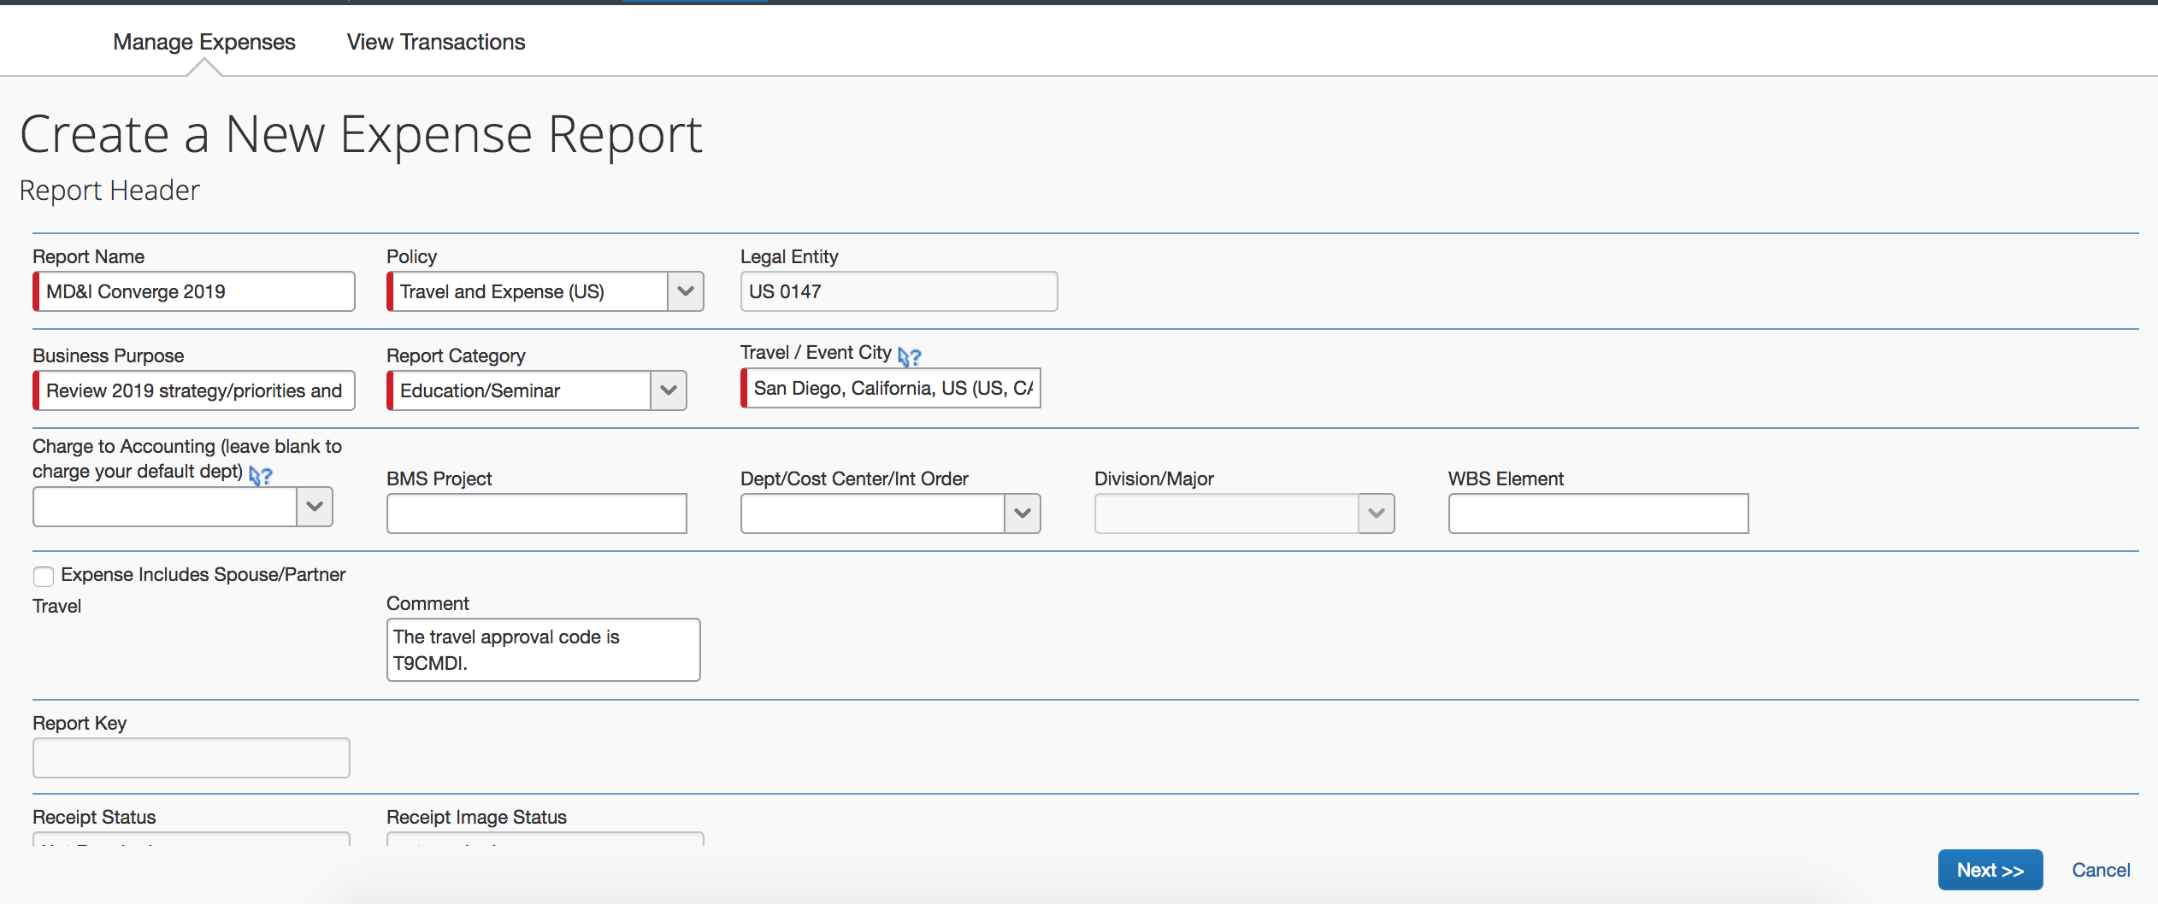

Press **Next >>** when you have completed the fields mentioned on Page 1.

**Important:** After pressing Next, you will be returned to the Report Header and it will show that you have an Exception (screen shot below). Please disregard this message by pressing **Next** again. You have provided the Travel Approval Code in the Comments box. **After you press Next**, you will see a **pop-up box** for Travel Allowances. Please **select Yes** and follow instructions in the next section.



# **Complete the Travel Allowance section**

After you complete the Report Header section of your Expense Report, a **pop-up box** will appear for **Travel Allowances** (screen shot below). **You must select Yes**. This will enable the Concur app to calculate the meal per diem daily allowances that you are entitled to.

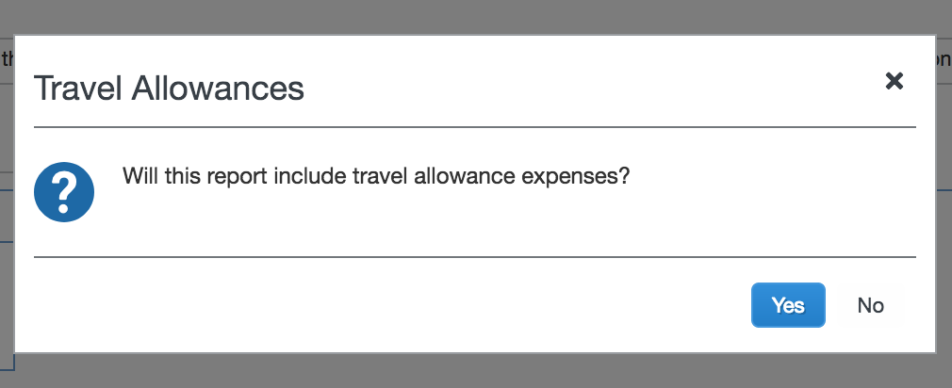

Add your arrival day flight information in **New Itinerary Stop** – see the sample in screen shot below of a U.S. traveler from New York who traveled to San Diego on January 28 and returned to New York on February 1.

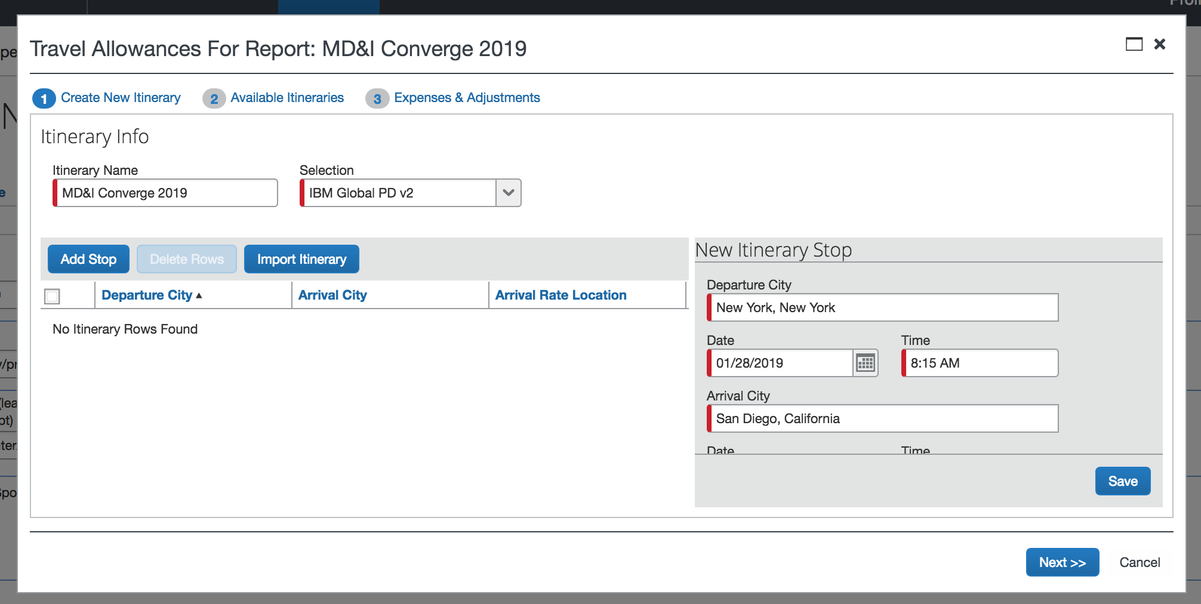

Press **Save** and then **Add Stop** button.

Add your departure day return flight information to the next New Itinerary Stop screen you come to. Press **Save** and then **Next.** You will come to the Travel Allowances page’s **Expenses & Adjustments tab** (screen shot below) showing all the dates you were on your trip.

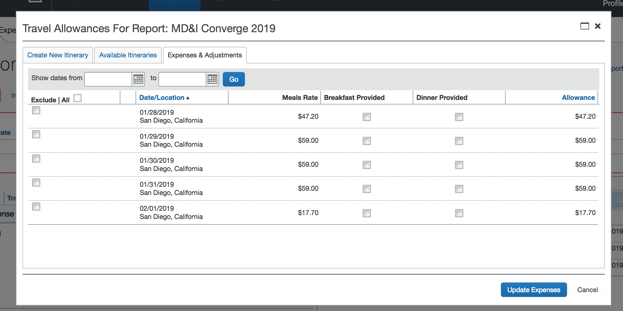

On the **Expenses & Adjustments** tab, you will **select the meals you were provided** as part of the Converge 2019 event (list below). For any dates that you were not on IBM business, you are not eligible for per diem – please check off **Exclude** so Concur will calculate a 0. This includes any dates you were on an extended stay or personal side trip.

**Meals that were provided as part of Converge 2019:**

* Tuesday, January 29 – breakfast, lunch and dinner
* Wednesday, January 30 – breakfast, lunch and dinner
* Thursday, January 31 – breakfast and lunch

Here is screen shot showing the traveler’s selections and the daily allowances calculated by Concur.

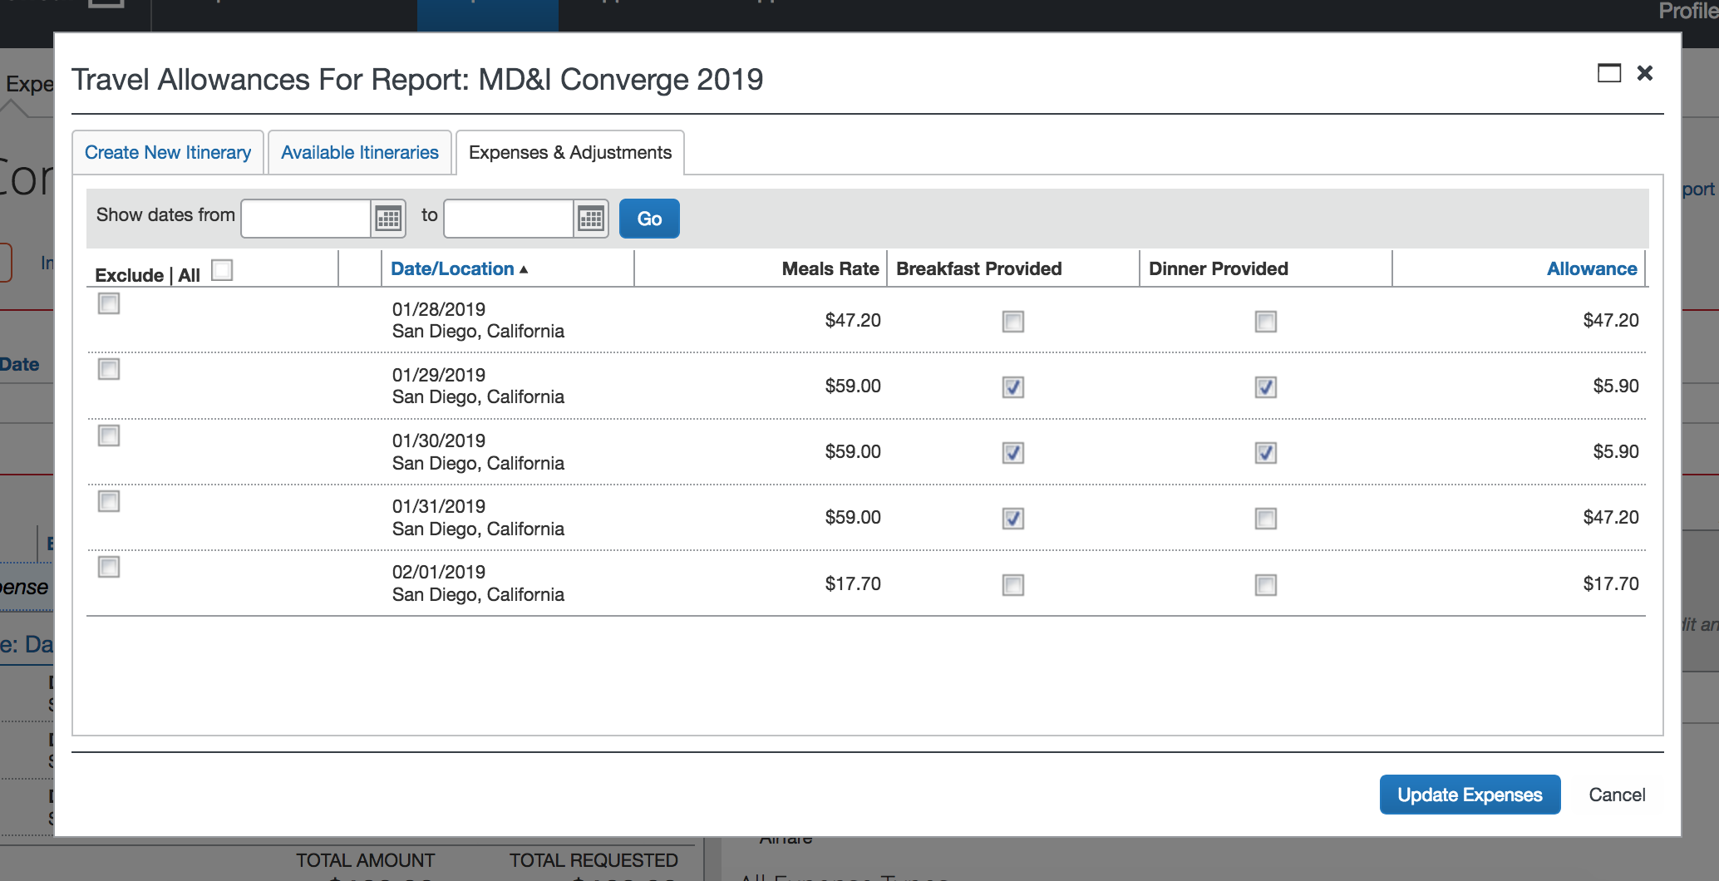

Press **Update Expenses** when you have finished selecting meals or excluding days.

# **Add remaining expenses and submit**

You may add expenses for the items listed on Page 5 by selecting the appropriate option from the **All Expense Types** menu (screen shot on Page 5). You will complete the required information, i.e., Expense Subtype, on a **New Expense Tab** for each expense.

*For anything that you charged to your personal American Express Corporate Card*, i.e., car service to the airport from home or airline baggage fees, use the **Import Expenses** option to move them to your Expense Report so that the IBM reimbursement is sent directly to American Express and credited to your account.

**Allowable expenses for Converge 2019**

*Reminder that your round trip airfare, hotel accommodations and the SuperShuttle in San Diego were billed directly to MD&I.*

* Ground transportation on your departure and return travel days between your home and the airport*.* Select the appropriate option under *.03 Ground Transportation.*

***🡪 Please note:***  *This does not include ground transportation in San Diego. If you did not use the SuperShuttle, you are responsible for the cost. This includes a car service/taxi, Lyft or Uber or a rental car.*

* Baggage fees not included with your airfare. Go to *.01 Airline Transportation* and select *Airline Fees* for this expense.
* Tips/gratuities given on travel days.Go to *.04 Other Travel Expenses* and select *Tips/Gratuities* for this expense.
* For those who required a U.S. Visa to travel to San Diego, you may submit the fees; however, you may not submit Passport application or renewal fees. Go to *.06 Fees* and select *Passports/Visas/Work Permits/Immigration Fees* for this expense.

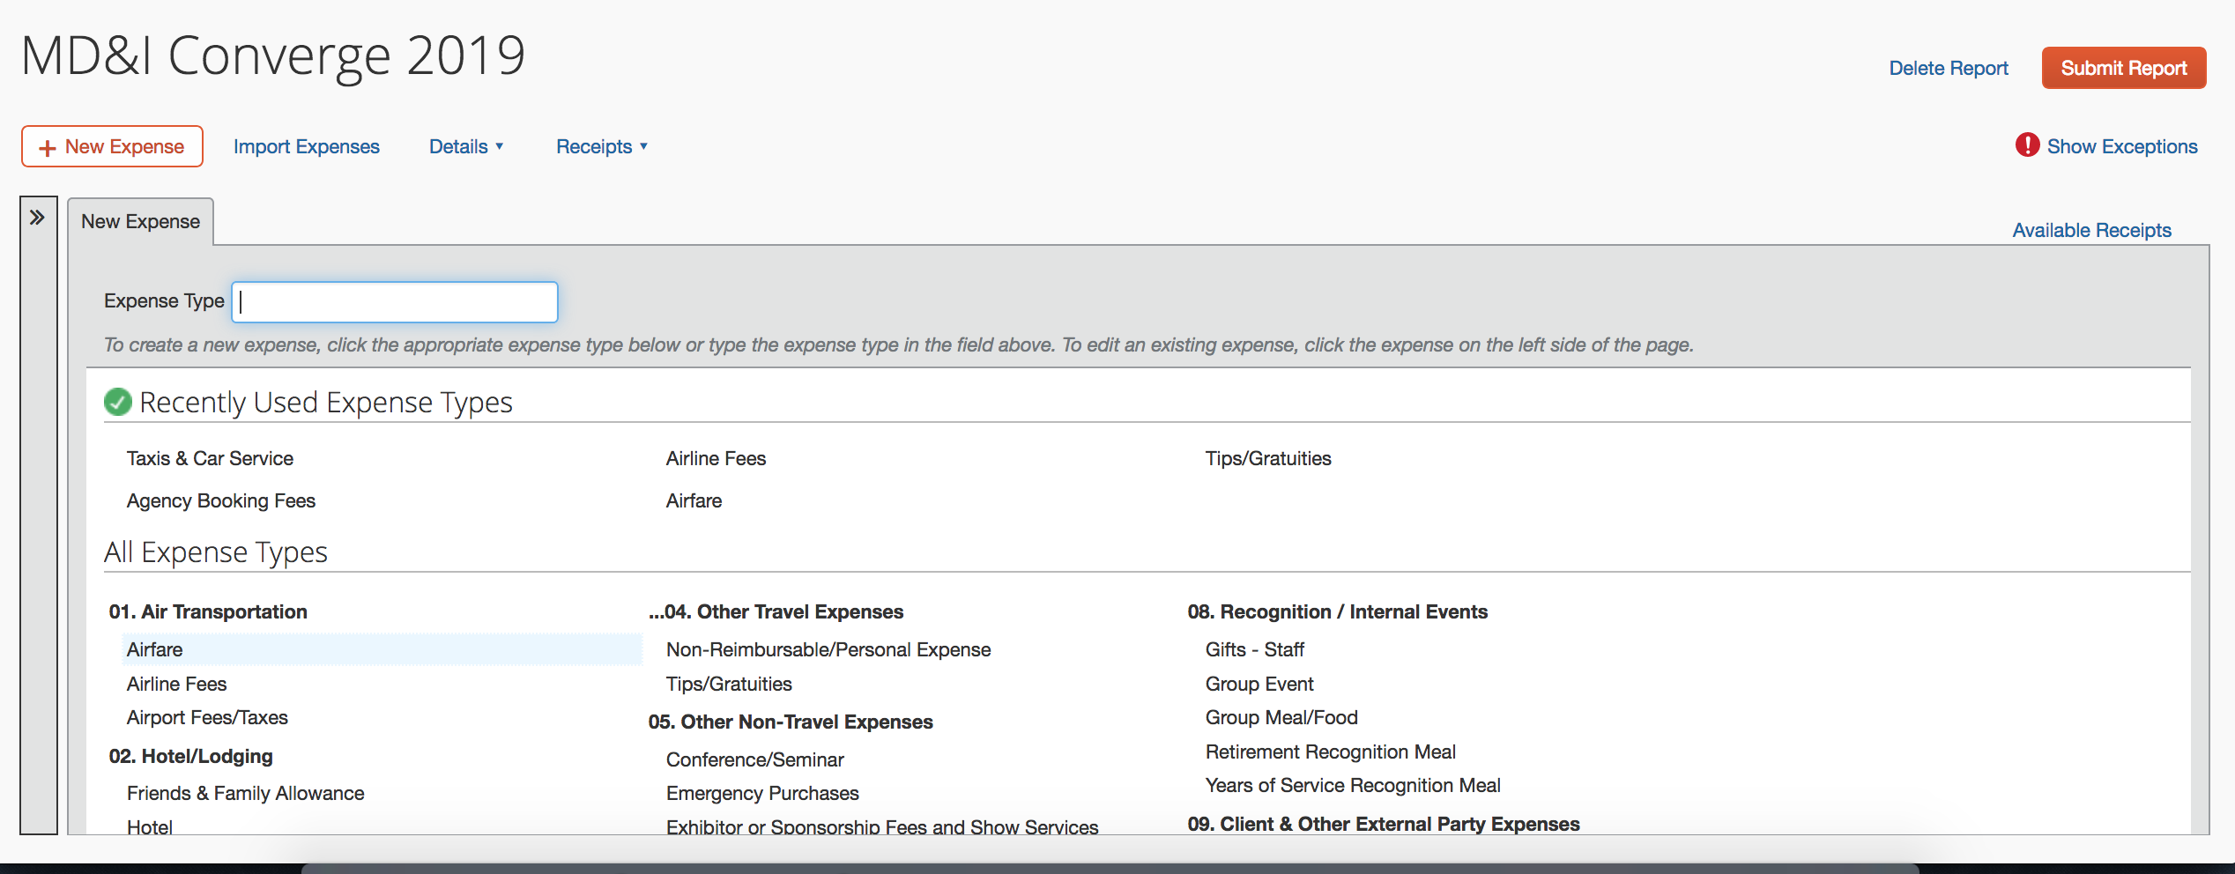

**If your airfare is showing up in Concur as an Available Expense**

All Converge 2019 attendees will have their airfare for the event appear as an Available Expense. The reason is that any transaction American Express Global Business Travel performs for an IBMer is documented in Concur. *It is just your flight itinerary.* Normally, if you have an expense on your personal American Express Corporate Card, there is a green graphic with a picture of the back of a credit card. If the item is an itinerary, you will see a blue graphic with an airplane (screen shot on Page 6). The Concur app will not allow you to move it to your Expense Report. You can delete the itinerary from your Available Expenses in the Manage Expenses tab by selecting it and pressing the Delete button.

# 

Once your Expense Report is complete, press the **Submit Report** button (see screen shot below).



# **Questions or need help?**

Post your question on the [#converge_2019](https://ibm-mdi.slack.com/messages/CCDCT0S10) Slack channel or you may contact your geographic region/country’s Travel Lead listed on the [Travel info](http://converge-2019.stage1.mybluemix.net/2019/travel.html) page.