**The Travel Approval Codes you will need for your Expense Report can be found in the table below. Please select the code for the Geography where you are *physically located*.**

|  |  |
| --- | --- |
| **Geography** | **Travel Approval Code** |
| Asia Pacific – *includes India* | T9AMDI |
| Europe – *includes the UK/Ireland* | T9EMDI |
| Greater China Group (GCG) | T9QMDI |
| Japan | T9JMDI |
| Latin America | T9LMDI |
| Middle East & Africa (MEA) | T9MMDI |
| North America | T9CMDI |

**You will enter the Travel Approval Code in the Comments box within your Expense Report Header below section. See screen shot example below for a *North America* submitter.**

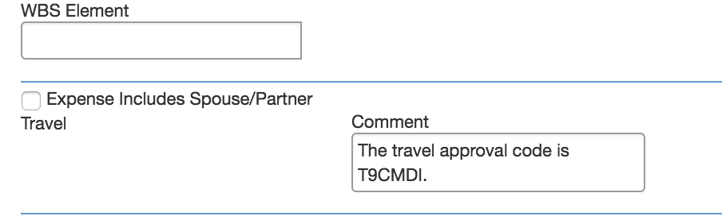

**Please disregard this Exception notice in the Report Header asking for pre-approval documentation.**

