Change Detection For High-Resolution
Satellite Images By Using Gaussian Mixture Model

Shijie Li, Tianpei Xia, ​Jingjuan Deng, Zhiren Lu, Zifan Nan, Rui Liu

Abstract— In modern times, human civilization’s settlement landscapes and patterns are changing rapidly because of the growth of human population, acceleration of urbanization and the application of varied technologies. Keep detecting and assessing these changes and mastering the accurate information are quite important for civilized human development. High resolution images provided by satellites are good resource to use to identify and quantify landscapes changes. We explore a detection method to identify landscape changes using high resolution satellite images. This grid based method is helpful in Bi-temporal change detection. By given two satellite images from the same area, it can identify changes accurately.
Keywords: Change Detection, Satellite Images, Gaussian Mixture Model

Introduction
Rapid urbanization has dramatically rebuilt the earth’s landscape from its previous shape. Satellite images provide many valuable information about human settlements. Our objective in this study is to present an ongoing algorithmic research on change detection for high resolution satellite images. Change detection can be defined as the process of identifying differences in the state of an object or phenomenon by observing it at different times. There are different methods for the detection: Pixel-based method and Object-based method. On pixel level, change detection for high resolution satellite images is computationally expensive and sensitive to the geo-registration errors between images. High resolution satellite images are very elaborate, which causes objects cannot be presented by single pixel purely, each object is presented by multiple neighboring pixels with strong spatial correlation. The grid-based change detection, a sub-method of object-based, could reduce the computational cost and enhance the robustness to pixel level geo-registration errors by dividing the high-resolution images into grid blocks. The difference between temporal images can be quantified by using some distance measurements. There are various divergence and distance measures readily available from the literature. In our experiment we use Kullback-Leibler (KL) divergence since it has better performance than many other notable measures [1]. However, KL divergence is not a distance matrix and not scaled between 0 and 1, so we fit a Gaussian Mixture Model (GMM) to the KL divergence data, which is a good option since Gaussian Mixture Model has good property to model objects in grids.

Related work and your contributions
When using Pixel-based approach, the high resolution satellite images’ changing detection, the computation will be expensive, and these images are sensitive to the geo-registration errors. High resolution satellite images are very elaborate, which causes objects cannot be presented by single pixel purely, each object is presented by multiple neighboring pixels with strong spatial correlation. We propose a Grid-based approach to identify changes which could reduce the computational cost and enhance the robustness to pixel level geo-registration errors by dividing the high-resolution images into grid blocks.

Methodology
To process the image data, we use the Python library including numpy and scipy as well as the OpenCV APIs, since every image can be decomposed into RGB values of real numbers. And the Gaussian Mixture Model algorithm is implemented in Python. For the human labeled images, we evaluate the results by the accuracy of change detection.
To divide the image into grids, we need to choose the right size of grids. The size of grids determines the quality and computational cost of the algorithm. It should not be too large since that may result in poor change detection: larger grids may contain more than a single object, therefore the Gaussian distribution fitted to the grid may not have a single peak. On the other hand, the time costs of computation will drastically reduce with increases in grid size. If the grid size is too small it would increase the computational cost, and may also cause model parameter estimation and matrix inversion problems. In our experiment, we use 50 pixel as the grid size.
We model the image data in each grid. All multi-dimensional feature vectors from each pixel in the grid, are generated by a multi-variate Gaussian distribution described in the following equation:

P(x|y_{j}) = 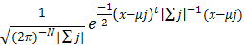

The standard multi-variate Gaussian distribution is described by the parameters mean (μ) and covariance matrix (Σ). These parameters are estimated for each grid separately from the corresponding image data.

Experiments and Results

This section defines experimental setup; datasets used; preprocessing done; analysis of the results; comparison with competing methods; and show why your method worked (or didn’t work).

Conclusions and future directions
Summarize your experience (list all key elements). Based on experience gained, state what can be done in future.

Acknowledgment
We would like to thank our professor Dr. Ranga Raju Vatsavai and graduate teaching assistant Zexi Chen for various suggestions and feedbacks to our project study.

References

- Vatsavai, R. Graesser, J. 2012. “Probabilistic Change Detection Framework for Analyzing Settlement Dynamics Using Very High-resolution Satellite Imagery. ICCS: 907-916.
- Goldberger, Jacob, Shiri Gordon, and Hayit Greenspan. "An efficient image similarity measure based on approximations of KL-divergence between two Gaussian mixtures." Computer Vision, 2003. Proceedings. Ninth IEEE International Conference on. IEEE, 2003.
- Beecks, Christian, et al. "Modeling image similarity by gaussian mixture models and the signature quadratic form distance." 2011 International Conference on Computer Vision. IEEE, 2011.
- Hershey, John R., and Peder A. Olsen. "Approximating the Kullback Leibler divergence between Gaussian mixture models." 2007 IEEE International Conference on Acoustics, Speech and Signal Processing-ICASSP'07. Vol. 4. IEEE, 2007.

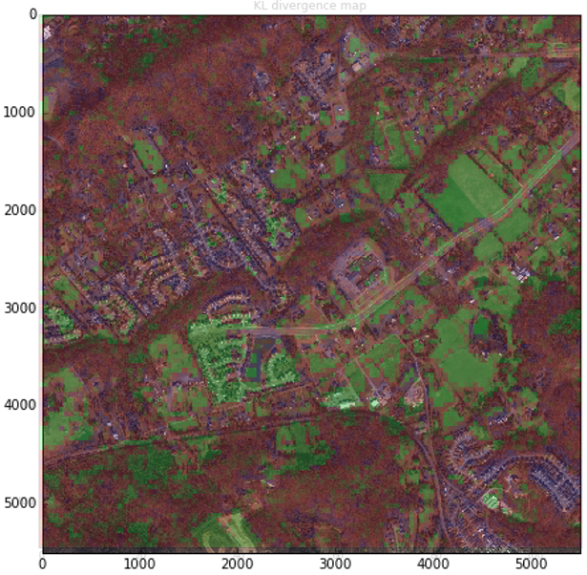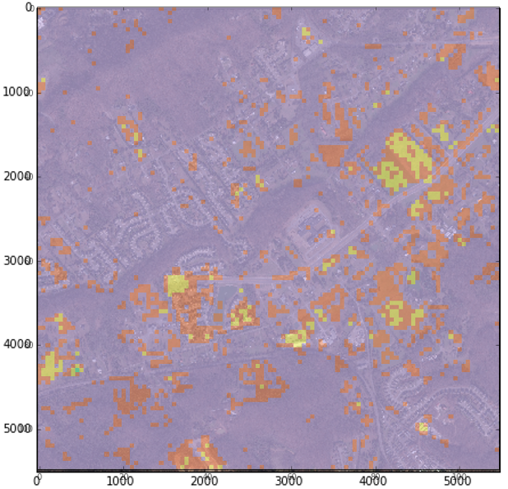
- KL map with coordinate info (LEFT), Change map with coordinate info (RIGHT)
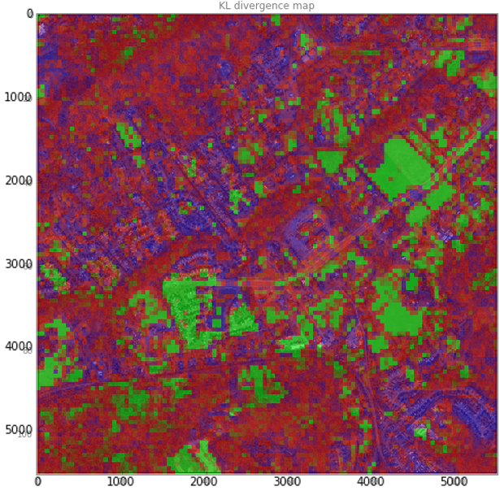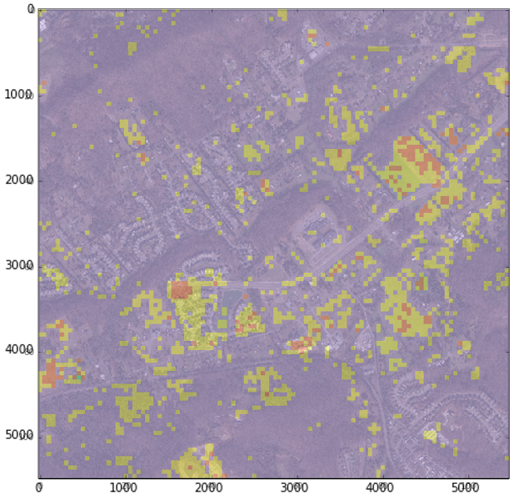
- KL map without coordinate info (LEFT), Change map without coordinate info (RIGHT)

