Proposal for UTC Leeds

Sean O’Callaghan

Learner number:

Occupational Specialism

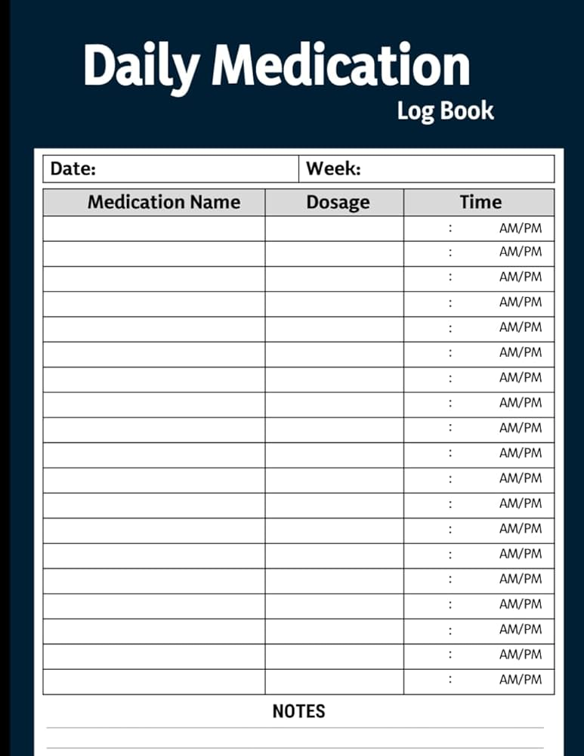

Table of Contents
Proposal for company name 1
Organisation overview 3
Problem overview 4
User groups 5
Empathy maps 6
User stories 7
Laws and Guidance 8
Alternative systems 9
Risks 10
Decomposition 11
User Acceptance Criteria 12
Functional and Non-Functional Requirements 13
Key Performance Indicators 14
Description of proposed solution 15

Organisation overview
UTC Leeds is a STEM school that teaches students from year 10 to year 13. It has an emphasis on the employability of its students and strives to make their students as employable as possible. They invest considerable amounts of money and time getting students in contact with employers and instilling values and qualities that employers value into each of their students. They teach a range of A-levels in the STEM field such as: Geography, maths, further maths, biology, chemistry and physics. They also run T-levels in the digital and engineering sectors. They also house a large number of nut-allergic students and therefore require that the school accommodates for that. This means that there will be a large number of students with medication related to their allergies

Problem overview
Most schools in England rely entirely on staff tracking these medications and ther

User groups

Empathy maps

User stories

Laws and Guidance

Alternative systems

Risks

Decomposition

User Acceptance Criteria

Functional and Non-Functional Requirements

Key Performance Indicators

Description of proposed solution

