Provide two functions which are AQI to Concentration of PM2.5 and Concentration of PM2.5 to AQI

To use the wind-bearing parameter, we firstly to calculation the azimuth between zip-code location and three closest sites.

For example, two location A (latA, longA) and B (latB, longB)

Degrees to Radians:

$$latA=latA÷180×π$$

$$latB=latB÷180×π$$

Projection on Cartesian Coordinate

$$\left\{\begin{aligned}X_{A}=R*\cos\left(latA\right)*cos⁡(longA) \\ Y_{A}=R*\cos\left(latA\right)*sin⁡(longA) \\ Z_{A}=R*\sin\left(latA\right)\end{aligned}\right.$$

where $R=6371.3km$ is the average radius of the earth.

Then do the similar calculation for B.

Central angle for each arc:

$$∠AOB=\arccos\left(\frac{X_{A}∙X_{B}+Y_{A}∙Y_{B}+X_{A}∙X_{B}}{R^{2}}\right)$$

$$∠AOC=90-latA$$

$$∠BOC=90-latB$$

$$p=\frac{∠AOB+∠AOC+∠BOC}{2}$$

According to half-angle formula:

$$∠CAB=2×arccos⁡(\sqrt{\frac{sinp∙sin⁡(p-∠BOC)}{sin⁡(∠AOC)∙sin⁡(∠AOB)}})$$

which is the B’s azimuth compared to A.

The dominant pollutant, particularly PM2.5 in haze population, is epidemiologically associated with the risk of deleterious health effects on cardiovascular and lung disease.

SO2, O3 have too many NA values. We mainly predict PM2.5 in the model. Instead, those two pollution use average AQI for prediction.

In this model, we select three closest monitoring sites A, B, C, to calculate the specific zip-code location. (calculate and sort distance based on latitude and longitude)

Low wind speeds over a source region allows for pollutants to accumulate

High wind speeds ventilate a source region preventing local emission from accumulating. And we use azimuths to determine whether the wind gives a positive or negative effect on transportation.

To calculate the PM2.5 concentration of location D

$$C_{D}=C_{A}*\left(ω_{AD}-\frac{δ∙I∙ω_{AD}}{ω_{AD}+ω_{BD}}\right)+C_{B}*\left(ω_{BD}-\frac{δ∙I∙ω_{BD}}{ω_{AD}+ω_{BD}}\right)+C_{C}*\left(ω_{CD}+δ∙I\right)$$

where $ω_{AD}+ω_{BD}+ω_{CD}=1$, $I$ denotes the wind speed.

$δ$ is a constant and it takes value of 0.03 in this model. ( $δ=0.1$ in the paper based on China’s pollution situation)

Normalized inverse distance weights (IDW) for the three closest monitoring site

simplest weighting function is inverse power

$$w\left(d\right)=\frac{1}{d^{p}}$$

Here we use $p=2$.(The most common choice)

Assumption:

Residence time refers to the time span between the PM2.5 emission and its removal from the atmosphere.

Residence time determines the range of impact of PM2.5

PM2.5 sulfates reside 3-5 days in the atmosphere

On the average, PM2.5 particles are transported 1000 or more km from the source.

The PM2.5 residence time increased with height

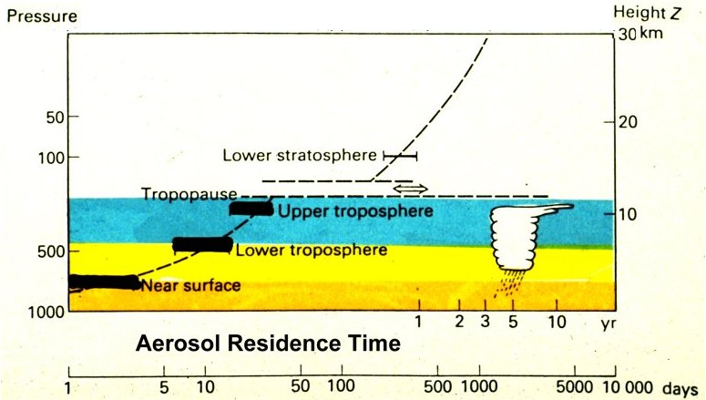

Within the atmospheric boundary layer(the lowest 1-2 km), the residence time is 3-5 days

Assume here residence time is uniformly distributed

$$residence time\sim Unif(3, 5)$$

If lifted to 1-10 km, they are transported for weeks and many thousand miles before removal

$$residence time= \sqrt{45×elevation}$$

The residence time determines the range of transportation. And the range of transportation determines the region of influence of PM2.5. Thus, the residence time determines the number of future days in prediction model

Reference:

Xiao Feng, Qi Li, Artificial neural networks forecasting of PM2.5 pollution using air mass trajectory based geographic model and wavelet transformation, *Atmospheric Environment*, April 2015, volume 107: 118-128