**第0002讲 进程原理及系统调用**

**1、进程有两种特殊的形式：没有用户虚拟地址空间的进程叫内核线程，共享用户虚拟地址空间的进程叫用户线程。共享同一个用户虚拟地址空间的所有用户线程叫线程组。**

**C语言标准库进程 Linux内核进程**

包括多个线程的进程 线程组

只有一个线程的进程 任务或进程

线程 共享用户虚拟地址空间的进程

**2、Linux内核提供API函数来设置进程的状态：**

1. TASK_RUNNING（可运行状态或者可就绪状态）；
2. TASK_INTERRUPTIBLE（可中断睡眠状态，又叫浅睡眠状态）；
3. TASK_UNINTERRUPTIBLE（不可中断状态，又叫深度睡眠状态）；我们可以通过ps命令查看被标记为D状态的进程。
4. __TASK_STOPPED（终止状态）；
5. EXIT_ZOMBIE（僵尸状态）；

3、Linux内核进程描述符task_struct数据结构，源码分析如下：

// 进程描述符 task_struct

struct task_struct {

#ifdef CONFIG_THREAD_INFO_IN_TASK

    /*

     * For reasons of header soup (see current_thread_info()), this

     * must be the first element of task_struct.

     */

    struct thread_info      thread_info;

#endif

    /* -1 unrunnable, 0 runnable, >0 stopped: */

    volatile long           state; // 进程的状态标志

    /*

     * This begins the randomizable portion of task_struct. Only

     * scheduling-critical items should be added above here.

     */

    randomized_struct_fields_start

    void                *stack; // 指向内核栈

    refcount_t          usage;

    /* Per task flags (PF_*), defined further below: */

    unsigned int            flags;

    unsigned int            ptrace;

#ifdef CONFIG_SMP

    struct llist_node       wake_entry;

    int             on_cpu;

#ifdef CONFIG_THREAD_INFO_IN_TASK

    /* Current CPU: */

    unsigned int            cpu;

#endif

    unsigned int            wakee_flips;

    unsigned long           wakee_flip_decay_ts;

    struct task_struct      *last_wakee;

    /*

     * recent_used_cpu is initially set as the last CPU used by a task

     * that wakes affine another task. Waker/wakee relationships can

     * push tasks around a CPU where each wakeup moves to the next one.

     * Tracking a recently used CPU allows a quick search for a recently

     * used CPU that may be idle.

     */

    int             recent_used_cpu;

    int             wake_cpu;

#endif

    int             on_rq;

    /* 下面这个四是进程调度策略和优先级*/

    int             prio;

    int             static_prio;

    int             normal_prio;

    unsigned int            rt_priority;

    const struct sched_class    *sched_class;

    struct sched_entity     se;

    struct sched_rt_entity      rt;

#ifdef CONFIG_CGROUP_SCHED

    struct task_group       *sched_task_group;

#endif

    struct sched_dl_entity      dl;

#ifdef CONFIG_UCLAMP_TASK

    /* Clamp values requested for a scheduling entity */

    struct uclamp_se        uclamp_req[UCLAMP_CNT];

    /* Effective clamp values used for a scheduling entity */

    struct uclamp_se        uclamp[UCLAMP_CNT];

#endif

#ifdef CONFIG_PREEMPT_NOTIFIERS

    /* List of struct preempt_notifier: */

    struct hlist_head       preempt_notifiers;

#endif

#ifdef CONFIG_BLK_DEV_IO_TRACE

    unsigned int            btrace_seq;

#endif

    unsigned int            policy;

    int             nr_cpus_allowed;

    const cpumask_t         *cpus_ptr; // 此成员允许进程在那个CPU上运行

    cpumask_t           cpus_mask;

#ifdef CONFIG_PREEMPT_RCU

    int             rcu_read_lock_nesting;

    union rcu_special       rcu_read_unlock_special;

    struct list_head        rcu_node_entry;

    struct rcu_node         *rcu_blocked_node;

#endif /* #ifdef CONFIG_PREEMPT_RCU */

#ifdef CONFIG_TASKS_RCU

    unsigned long           rcu_tasks_nvcsw;

    u8              rcu_tasks_holdout;

    u8              rcu_tasks_idx;

    int             rcu_tasks_idle_cpu;

    struct list_head        rcu_tasks_holdout_list;

#endif /* #ifdef CONFIG_TASKS_RCU */

    struct sched_info       sched_info;

    struct list_head        tasks;

#ifdef CONFIG_SMP

    struct plist_node       pushable_tasks;

    struct rb_node          pushable_dl_tasks;

#endif

    // 这个两指针指向内存描述符。进程：mm和active_mm指向同一个内存描述符。内核线程：mm是空指针，

    // 当内核线程运行时，active_mm指向从进程借用内存描述符

    struct mm_struct        *mm;

    struct mm_struct        *active_mm;

    /* Per-thread vma caching: */

    struct vmacache         vmacache;

#ifdef SPLIT_RSS_COUNTING

    struct task_rss_stat        rss_stat;

#endif

    int             exit_state;

    int             exit_code;

    int             exit_signal;

    /* The signal sent when the parent dies: */

    int             pdeath_signal;

    /* JOBCTL_*, siglock protected: */

    unsigned long           jobctl;

    /* Used for emulating ABI behavior of previous Linux versions: */

    unsigned int            personality;

    /* Scheduler bits, serialized by scheduler locks: */

    unsigned            sched_reset_on_fork:1;

    unsigned            sched_contributes_to_load:1;

    unsigned            sched_migrated:1;

    unsigned            sched_remote_wakeup:1;

#ifdef CONFIG_PSI

    unsigned            sched_psi_wake_requeue:1;

#endif

    /* Force alignment to the next boundary: */

    unsigned            :0;

    /* Unserialized, strictly 'current' */

    /* Bit to tell LSMs we're in execve(): */

    unsigned            in_execve:1;

    unsigned            in_iowait:1;

#ifndef TIF_RESTORE_SIGMASK

    unsigned            restore_sigmask:1;

#endif

#ifdef CONFIG_MEMCG

    unsigned            in_user_fault:1;

#endif

#ifdef CONFIG_COMPAT_BRK

    unsigned            brk_randomized:1;

#endif

#ifdef CONFIG_CGROUPS

    /* disallow userland-initiated cgroup migration */

    unsigned            no_cgroup_migration:1;

    /* task is frozen/stopped (used by the cgroup freezer) */

    unsigned            frozen:1;

#endif

#ifdef CONFIG_BLK_CGROUP

    /* to be used once the psi infrastructure lands upstream. */

    unsigned            use_memdelay:1;

#endif

    unsigned long           atomic_flags; /* Flags requiring atomic access. */

    struct restart_block        restart_block;

    pid_t               pid;  // 全局的进程号

    pid_t               tgid; // 全局的线程组标识符

#ifdef CONFIG_STACKPROTECTOR

    /* Canary value for the -fstack-protector GCC feature: */

    unsigned long           stack_canary;

#endif

    /*

     * Pointers to the (original) parent process, youngest child, younger sibling,

     * older sibling, respectively.  (p->father can be replaced with

     * p->real_parent->pid)

     */

    /* Real parent process: */

    struct task_struct __rcu    *real_parent; // 指向真实的父进程

    /* Recipient of SIGCHLD, wait4() reports: */

    struct task_struct __rcu    *parent; // 指向父进程

    /*

     * Children/sibling form the list of natural children:

     */

    struct list_head        children;

    struct list_head        sibling;

    struct task_struct      *group_leader; // 指向线程组的组长

    /*

     * 'ptraced' is the list of tasks this task is using ptrace() on.

     *

     * This includes both natural children and PTRACE_ATTACH targets.

     * 'ptrace_entry' is this task's link on the p->parent->ptraced list.

     */

    struct list_head        ptraced;

    struct list_head        ptrace_entry;

    /* PID/PID hash table linkage. */

    struct pid          *thread_pid;

    struct hlist_node       pid_links[PIDTYPE_MAX]; // 进程号，进程组标识符和会话标识符

    struct list_head        thread_group;

    struct list_head        thread_node;

    struct completion       *vfork_done;

    /* CLONE_CHILD_SETTID: */

    int __user          *set_child_tid;

    /* CLONE_CHILD_CLEARTID: */

    int __user          *clear_child_tid;

    u64             utime;

    u64             stime;

#ifdef CONFIG_ARCH_HAS_SCALED_CPUTIME

    u64             utimescaled;

    u64             stimescaled;

#endif

    u64             gtime;

    struct prev_cputime     prev_cputime;

#ifdef CONFIG_VIRT_CPU_ACCOUNTING_GEN

    struct vtime            vtime;

#endif

#ifdef CONFIG_NO_HZ_FULL

    atomic_t            tick_dep_mask;

#endif

    /* Context switch counts: */

    unsigned long           nvcsw;

    unsigned long           nivcsw;

    /* Monotonic time in nsecs: */

    u64             start_time;

    /* Boot based time in nsecs: */

    u64             start_boottime;

    /* MM fault and swap info: this can arguably be seen as either mm-specific or thread-specific: */

    unsigned long           min_flt;

    unsigned long           maj_flt;

    /* Empty if CONFIG_POSIX_CPUTIMERS=n */

    struct posix_cputimers      posix_cputimers;

    /* Process credentials: */

    /* Tracer's credentials at attach: */

    const struct cred __rcu     *ptracer_cred;

    /* Objective and real subjective task credentials (COW): */

    const struct cred __rcu     *real_cred; // 此成员指向主体和真实客体证书

    /* Effective (overridable) subjective task credentials (COW): */

    const struct cred __rcu     *cred; // 指向有效客体证书

#ifdef CONFIG_KEYS

    /* Cached requested key. */

    struct key          *cached_requested_key;

#endif

    /*

     * executable name, excluding path.

     *

     * - normally initialized setup_new_exec()

     * - access it with [gs]et_task_comm()

     * - lock it with task_lock()

     */

    char                comm[TASK_COMM_LEN]; // 进程名称

    struct nameidata        *nameidata;

// 下面这两个成员用于UNIX系统：信号量和共享内存

#ifdef CONFIG_SYSVIPC

    struct sysv_sem         sysvsem;

    struct sysv_shm         sysvshm;

#endif

#ifdef CONFIG_DETECT_HUNG_TASK

    unsigned long           last_switch_count;

    unsigned long           last_switch_time;

#endif

    /* Filesystem information: */

    struct fs_struct        *fs; // 此成员文件系统信息，主要是进程的根目录和当前工作目录

    /* Open file information: */

    struct files_struct     *files;  //  打开文件表

    /* Namespaces: */

    struct nsproxy          *nsproxy; // 命名空间

    // 下面这个块的成员主要是用于：信号处理

    /* Signal handlers: */

    struct signal_struct        *signal;

    struct sighand_struct __rcu     *sighand;

    sigset_t            blocked;

    sigset_t            real_blocked;

    /* Restored if set_restore_sigmask() was used: */

    sigset_t            saved_sigmask;

    struct sigpending       pending;

    unsigned long           sas_ss_sp;

    size_t              sas_ss_size;

    unsigned int            sas_ss_flags;

    struct callback_head        *task_works;

#ifdef CONFIG_AUDIT

#ifdef CONFIG_AUDITSYSCALL

    struct audit_context        *audit_context;

#endif

    kuid_t              loginuid;

    unsigned int            sessionid;

#endif

    struct seccomp          seccomp;

    /* Thread group tracking: */

    u64             parent_exec_id;

    u64             self_exec_id;

    /* Protection against (de-)allocation: mm, files, fs, tty, keyrings, mems_allowed, mempolicy: */

    spinlock_t          alloc_lock;

    /* Protection of the PI data structures: */

    raw_spinlock_t          pi_lock;

    struct wake_q_node      wake_q;

#ifdef CONFIG_RT_MUTEXES

    /* PI waiters blocked on a rt_mutex held by this task: */

    struct rb_root_cached       pi_waiters;

    /* Updated under owner's pi_lock and rq lock */

    struct task_struct      *pi_top_task;

    /* Deadlock detection and priority inheritance handling: */

    struct rt_mutex_waiter      *pi_blocked_on;

#endif

#ifdef CONFIG_DEBUG_MUTEXES

    /* Mutex deadlock detection: */

    struct mutex_waiter     *blocked_on;

#endif

#ifdef CONFIG_DEBUG_ATOMIC_SLEEP

    int             non_block_count;

#endif

#ifdef CONFIG_TRACE_IRQFLAGS

    unsigned int            irq_events;

    unsigned long           hardirq_enable_ip;

    unsigned long           hardirq_disable_ip;

    unsigned int            hardirq_enable_event;

    unsigned int            hardirq_disable_event;

    int             hardirqs_enabled;

    int             hardirq_context;

    unsigned long           softirq_disable_ip;

    unsigned long           softirq_enable_ip;

    unsigned int            softirq_disable_event;

    unsigned int            softirq_enable_event;

    int             softirqs_enabled;

    int             softirq_context;

#endif

#ifdef CONFIG_LOCKDEP

# define MAX_LOCK_DEPTH         48UL

    u64             curr_chain_key;

    int             lockdep_depth;

    unsigned int            lockdep_recursion;

    struct held_lock        held_locks[MAX_LOCK_DEPTH];

#endif

#ifdef CONFIG_UBSAN

    unsigned int            in_ubsan;

#endif

    /* Journalling filesystem info: */

    void                *journal_info;

    /* Stacked block device info: */

    struct bio_list         *bio_list;

#ifdef CONFIG_BLOCK

    /* Stack plugging: */

    struct blk_plug         *plug;

#endif

    /* VM state: */

    struct reclaim_state        *reclaim_state;

    struct backing_dev_info     *backing_dev_info;

    struct io_context       *io_context;

#ifdef CONFIG_COMPACTION

    struct capture_control      *capture_control;

#endif

    /* Ptrace state: */

    unsigned long           ptrace_message;

    kernel_siginfo_t        *last_siginfo;

    struct task_io_accounting   ioac;

#ifdef CONFIG_PSI

    /* Pressure stall state */

    unsigned int            psi_flags;

#endif

#ifdef CONFIG_TASK_XACCT

    /* Accumulated RSS usage: */

    u64             acct_rss_mem1;

    /* Accumulated virtual memory usage: */

    u64             acct_vm_mem1;

    /* stime + utime since last update: */

    u64             acct_timexpd;

#endif

#ifdef CONFIG_CPUSETS

    /* Protected by ->alloc_lock: */

    nodemask_t          mems_allowed;

    /* Seqence number to catch updates: */

    seqcount_t          mems_allowed_seq;

    int             cpuset_mem_spread_rotor;

    int             cpuset_slab_spread_rotor;

#endif

#ifdef CONFIG_CGROUPS

    /* Control Group info protected by css_set_lock: */

    struct css_set __rcu        *cgroups;

    /* cg_list protected by css_set_lock and tsk->alloc_lock: */

    struct list_head        cg_list;

#endif

#ifdef CONFIG_X86_CPU_RESCTRL

    u32             closid;

    u32             rmid;

#endif

#ifdef CONFIG_FUTEX

    struct robust_list_head __user  *robust_list;

#ifdef CONFIG_COMPAT

    struct compat_robust_list_head __user *compat_robust_list;

#endif

    struct list_head        pi_state_list;

    struct futex_pi_state       *pi_state_cache;

    struct mutex            futex_exit_mutex;

    unsigned int            futex_state;

#endif

#ifdef CONFIG_PERF_EVENTS

    struct perf_event_context   *perf_event_ctxp[perf_nr_task_contexts];

    struct mutex            perf_event_mutex;

    struct list_head        perf_event_list;

#endif

#ifdef CONFIG_DEBUG_PREEMPT

    unsigned long           preempt_disable_ip;

#endif

#ifdef CONFIG_NUMA

    /* Protected by alloc_lock: */

    struct mempolicy        *mempolicy;

    short               il_prev;

    short               pref_node_fork;

#endif

#ifdef CONFIG_NUMA_BALANCING

    int             numa_scan_seq;

    unsigned int            numa_scan_period;

    unsigned int            numa_scan_period_max;

    int             numa_preferred_nid;

    unsigned long           numa_migrate_retry;

    /* Migration stamp: */

    u64             node_stamp;

    u64             last_task_numa_placement;

    u64             last_sum_exec_runtime;

    struct callback_head        numa_work;

    /*

     * This pointer is only modified for current in syscall and

     * pagefault context (and for tasks being destroyed), so it can be read

     * from any of the following contexts:

     *  - RCU read-side critical section

     *  - current->numa_group from everywhere

     *  - task's runqueue locked, task not running

     */

    struct numa_group __rcu     *numa_group;

    /*

     * numa_faults is an array split into four regions:

     * faults_memory, faults_cpu, faults_memory_buffer, faults_cpu_buffer

     * in this precise order.

     *

     * faults_memory: Exponential decaying average of faults on a per-node

     * basis. Scheduling placement decisions are made based on these

     * counts. The values remain static for the duration of a PTE scan.

     * faults_cpu: Track the nodes the process was running on when a NUMA

     * hinting fault was incurred.

     * faults_memory_buffer and faults_cpu_buffer: Record faults per node

     * during the current scan window. When the scan completes, the counts

     * in faults_memory and faults_cpu decay and these values are copied.

     */

    unsigned long           *numa_faults;

    unsigned long           total_numa_faults;

    /*

     * numa_faults_locality tracks if faults recorded during the last

     * scan window were remote/local or failed to migrate. The task scan

     * period is adapted based on the locality of the faults with different

     * weights depending on whether they were shared or private faults

     */

    unsigned long           numa_faults_locality[3];

    unsigned long           numa_pages_migrated;

#endif /* CONFIG_NUMA_BALANCING */

#ifdef CONFIG_RSEQ

    struct rseq __user *rseq;

    u32 rseq_sig;

    /*

     * RmW on rseq_event_mask must be performed atomically

     * with respect to preemption.

     */

    unsigned long rseq_event_mask;

#endif

    struct tlbflush_unmap_batch tlb_ubc;

    union {

        refcount_t      rcu_users;

        struct rcu_head     rcu;

    };

    /* Cache last used pipe for splice(): */

    struct pipe_inode_info      *splice_pipe;

    struct page_frag        task_frag;

#ifdef CONFIG_TASK_DELAY_ACCT

    struct task_delay_info      *delays;

#endif

#ifdef CONFIG_FAULT_INJECTION

    int             make_it_fail;

    unsigned int            fail_nth;

#endif

    /*

     * When (nr_dirtied >= nr_dirtied_pause), it's time to call

     * balance_dirty_pages() for a dirty throttling pause:

     */

    int             nr_dirtied;

    int             nr_dirtied_pause;

    /* Start of a write-and-pause period: */

    unsigned long           dirty_paused_when;

#ifdef CONFIG_LATENCYTOP

    int             latency_record_count;

    struct latency_record       latency_record[LT_SAVECOUNT];

#endif

    /*

     * Time slack values; these are used to round up poll() and

     * select() etc timeout values. These are in nanoseconds.

     */

    u64             timer_slack_ns;

    u64             default_timer_slack_ns;

#ifdef CONFIG_KASAN

    unsigned int            kasan_depth;

#endif

#ifdef CONFIG_FUNCTION_GRAPH_TRACER

    /* Index of current stored address in ret_stack: */

    int             curr_ret_stack;

    int             curr_ret_depth;

    /* Stack of return addresses for return function tracing: */

    struct ftrace_ret_stack     *ret_stack;

    /* Timestamp for last schedule: */

    unsigned long long      ftrace_timestamp;

    /*

     * Number of functions that haven't been traced

     * because of depth overrun:

     */

    atomic_t            trace_overrun;

    /* Pause tracing: */

    atomic_t            tracing_graph_pause;

#endif

#ifdef CONFIG_TRACING

    /* State flags for use by tracers: */

    unsigned long           trace;

    /* Bitmask and counter of trace recursion: */

    unsigned long           trace_recursion;

#endif /* CONFIG_TRACING */

#ifdef CONFIG_KCOV

    /* See kernel/kcov.c for more details. */

    /* Coverage collection mode enabled for this task (0 if disabled): */

    unsigned int            kcov_mode;

    /* Size of the kcov_area: */

    unsigned int            kcov_size;

    /* Buffer for coverage collection: */

    void                *kcov_area;

    /* KCOV descriptor wired with this task or NULL: */

    struct kcov         *kcov;

    /* KCOV common handle for remote coverage collection: */

    u64             kcov_handle;

    /* KCOV sequence number: */

    int             kcov_sequence;

#endif

#ifdef CONFIG_MEMCG

    struct mem_cgroup       *memcg_in_oom;

    gfp_t               memcg_oom_gfp_mask;

    int             memcg_oom_order;

    /* Number of pages to reclaim on returning to userland: */

    unsigned int            memcg_nr_pages_over_high;

    /* Used by memcontrol for targeted memcg charge: */

    struct mem_cgroup       *active_memcg;

#endif

#ifdef CONFIG_BLK_CGROUP

    struct request_queue        *throttle_queue;

#endif

#ifdef CONFIG_UPROBES

    struct uprobe_task      *utask;

#endif

#if defined(CONFIG_BCACHE) || defined(CONFIG_BCACHE_MODULE)

    unsigned int            sequential_io;

    unsigned int            sequential_io_avg;

#endif

#ifdef CONFIG_DEBUG_ATOMIC_SLEEP

    unsigned long           task_state_change;

#endif

    int             pagefault_disabled;

#ifdef CONFIG_MMU

    struct task_struct      *oom_reaper_list;

#endif

#ifdef CONFIG_VMAP_STACK

    struct vm_struct        *stack_vm_area;

#endif

#ifdef CONFIG_THREAD_INFO_IN_TASK

    /* A live task holds one reference: */

    refcount_t          stack_refcount;

#endif

#ifdef CONFIG_LIVEPATCH

    int patch_state;

#endif

#ifdef CONFIG_SECURITY

    /* Used by LSM modules for access restriction: */

    void                *security;

#endif

#ifdef CONFIG_GCC_PLUGIN_STACKLEAK

    unsigned long           lowest_stack;

    unsigned long           prev_lowest_stack;

#endif

    /*

     * New fields for task_struct should be added above here, so that

     * they are included in the randomized portion of task_struct.

     */

    randomized_struct_fields_end

    /* CPU-specific state of this task: */

    struct thread_struct        thread;

    /*

     * WARNING: on x86, 'thread_struct' contains a variable-sized

     * structure.  It *MUST* be at the end of 'task_struct'.

     *

     * Do not put anything below here!

     */

};

4、进程优先级如下

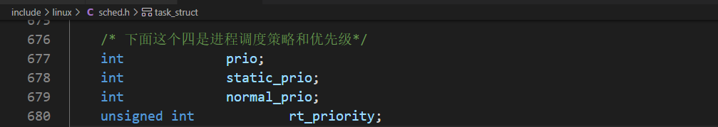

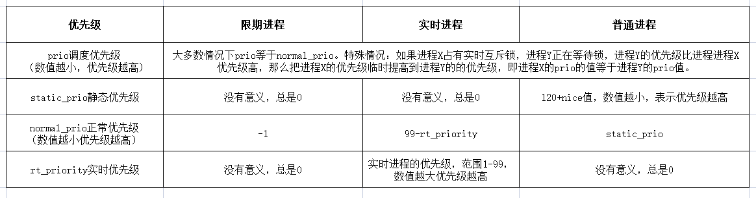

5、系统调用

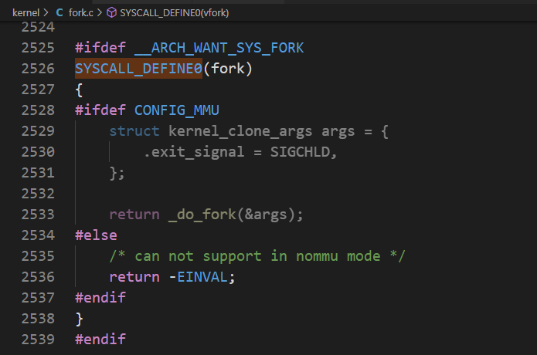

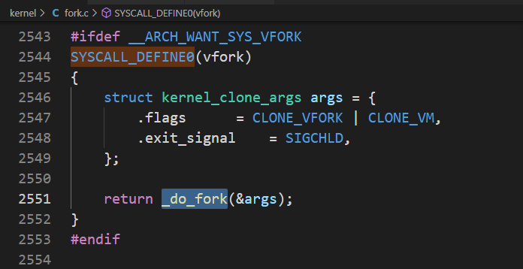

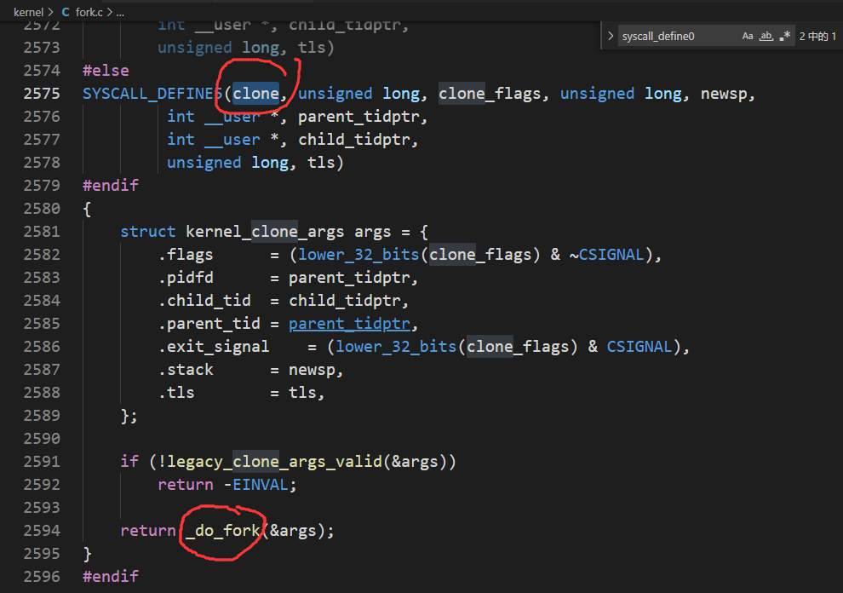

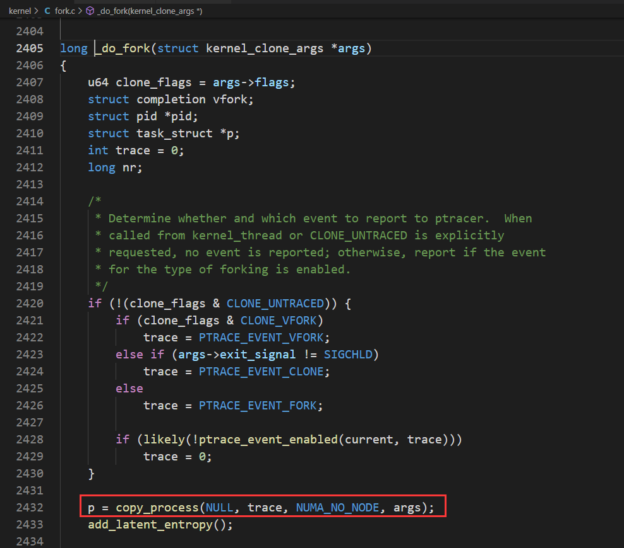

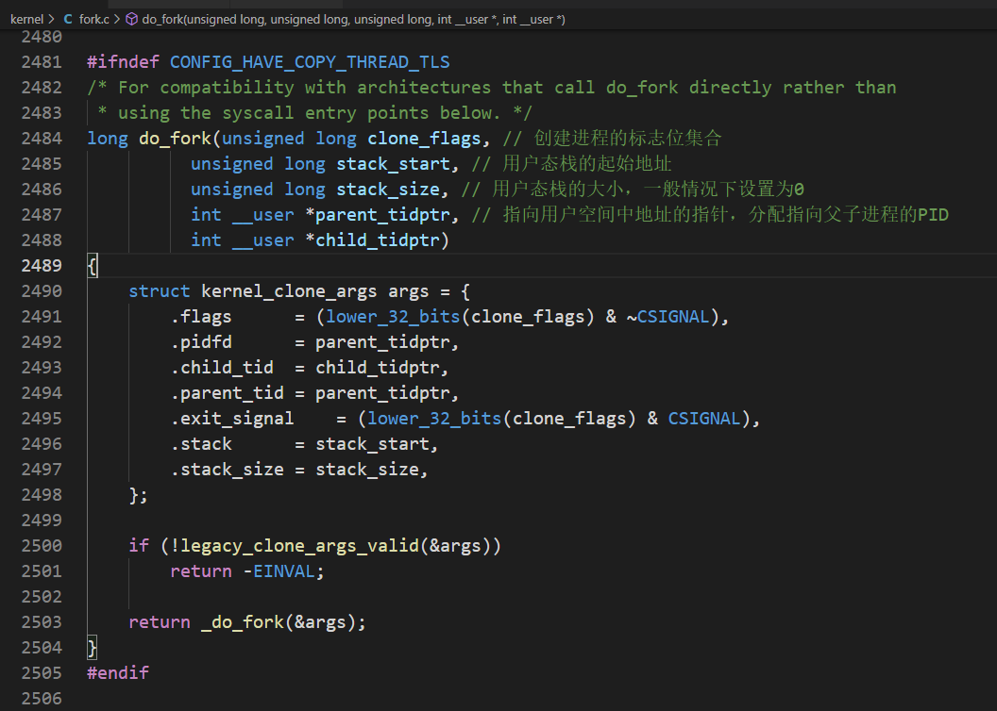

6、内核线程

它是独立运行在内核空间的进程，与普通用户进程区别在于内核线程没有独立的进程地址空间。task_struct数据结构里面有一个成员指针mm设置为NULL，它只能运行在内核空间。

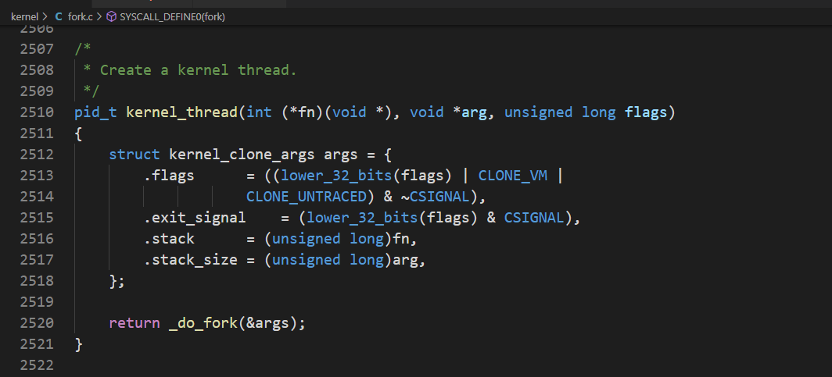

7、退出进程

进程主动终止：从main()函数返回，链接程序会自动添加到exit()系统调用；主动调用exit()系统函数。

进程被动终止：进程收到一个自己不能处理的信号；进程收到 SIGKILL等终止信息。

