# 创建docker镜像并提交到dockerhub中

root@jerry-virtual-machine:/home/jerry/Documents/c/day03# ls

Dockerfile hello.c

root@jerry-virtual-machine:/home/jerry/Documents/c/day03# cat Dockerfile

FROM ubuntu:focal

RUN sed -i 's/noble/focal/g' /etc/apt/sources.list

RUN apt-get update && apt-get install -y gcc

COPY hello.c /usr/src/hello.c

RUN gcc -o /usr/src/hello /usr/src/hello.c

CMD ["/usr/src/hello"]

root@jerry-virtual-machine:/home/jerry/Documents/c/day03# cat hello.c

#include<stdio.h>

int main(int argc,char *argv[]){

printf("hello world!\n");

return 0;

}

root@jerry-virtual-machine:/home/jerry/Documents/c/day03#

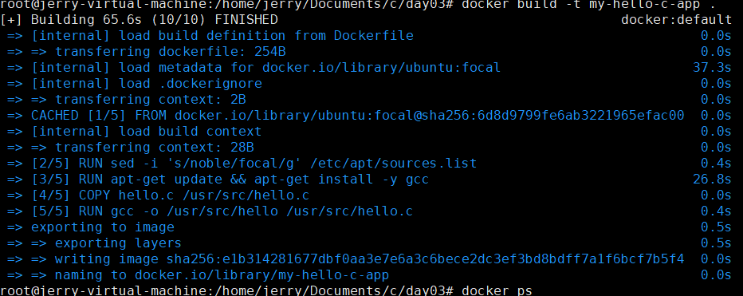

##注意一定要重新设置时区

##下一步：登录docker

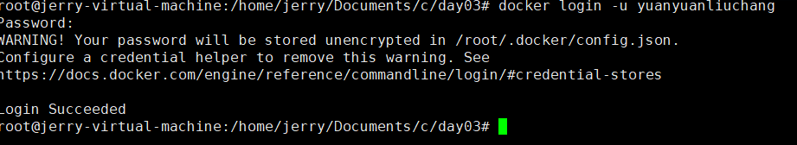

##提交：

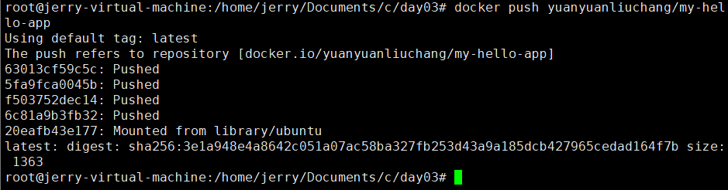

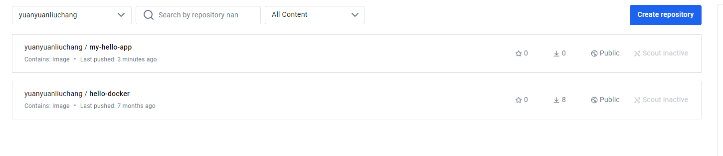

# 下拉操作：

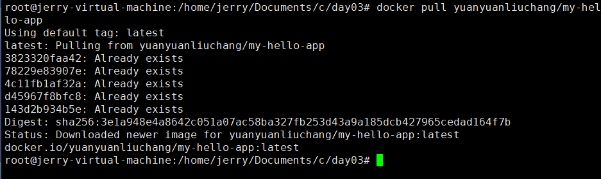

运行：

