**Frequency distribution table for the feature ‘highest_education’**

|  |  |  |
| --- | --- | --- |
| Response | Frequency | Percentage(%) |
| Bachelor | 231 | 65.44 |
| Master | 79 | 22.38 |
| Doctorate | 42 | 11.90 |
| Diploma | 1 | 0.28 |

**Bar chart visualizing repayment status with respect to discipline of study**

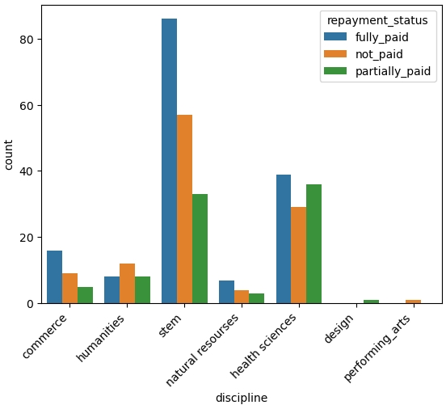

**Machine learning pipeline**

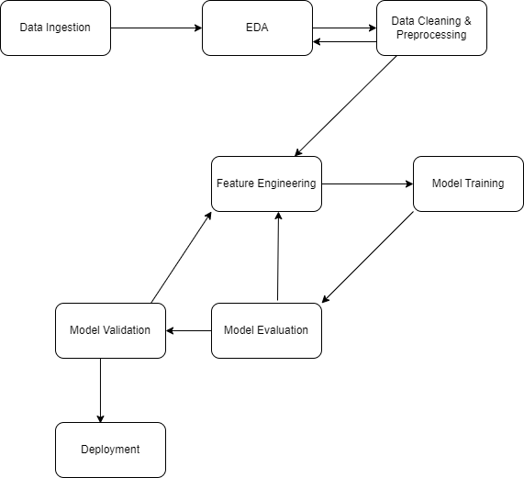

**Model deployment plan**

