Backup

System backup is supported by the app shrink-backup.
- Launch Thunar and navigate to the folder /home/orangepi/.shrink-backup
- Right-click an open area > Open terminal here
- Use the file exclude.txt to specify what you do not want backed up
- You will need to know the location (usually external, as in /media or /mount) and the name of the image you want to create or update
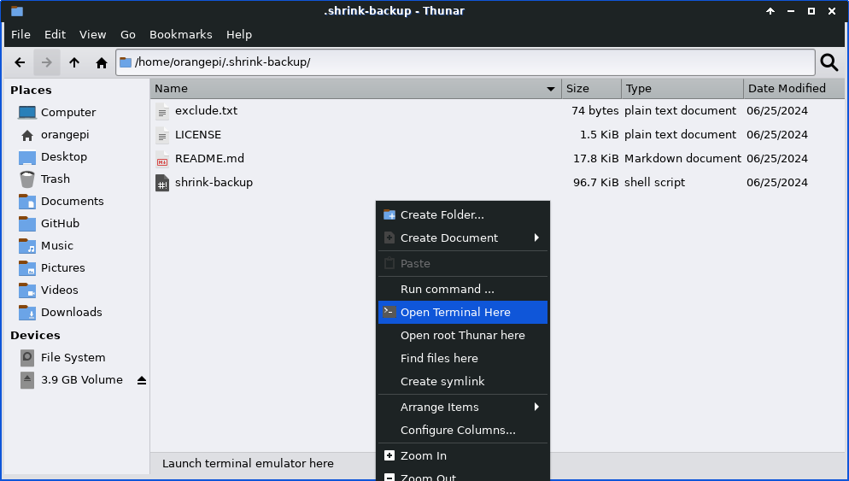

Image creation
To create a new backup img using recommended size, use the -a option and the path to the new file.
General: sudo shrink-backup -a /path/to/backup.img
Real example: sudo shrink-backukp -a /media/orangepi/4020-31F7/mxop_240702.img
Image update
To update an existing img file simply use the -U option and the path to an existing img file.
Example: sudo shrink-backup -U /path/to/backup.img
Image restoration
To restore a backup, simply "burn" the img file to the device using MX Live USB or a similar app.
------------------------
Detailed help
https://github.com/UnconnectedBedna/shrink-backup/blob/main/README.md

v. 240703

