

HELP

MX Remix for Orange Pi 5

Default User: Orangepi
Default Password (MX): demo

MX-23 Orange Pi Respin unites the released version of Debian 12 (Bookworm) for Orange Pi 5 (=OPi5) and the flagship Xfce version of MX Linux. It was developed and tested on an earlier (Jan 2023) and a later (Jan 2024) version of the device.

First things first
- Use MX User Manager or Menu > Orangepi Config to change the user password (highly recommended)
- Use MX Date & Time or Orangepi Config to set correct time format and change “Local” to “UTC” on the Hardware Clock tab.
- Use MX Locale to get a detailed setup (and to remove unneeded packages).
- Right-click the clock > Properties to change the format (e.g., %H:%M to %I:%M for US)
- Reboot.

Resources
Use the MX Forum and the Users Manual (Alt + F1) for questions about the MX desktop environment. HINT: Be sure to launch Menu > MX Tools to become familiar with this signature feature of the distro.
Use Menu > Orange Pi Config for handy access to common settings. Detailed and authoritative information can be found in the Orange Pi 5 Wiki. Both are accessible from the Menu.
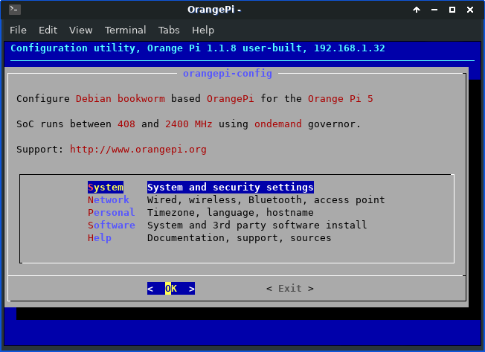Main screen of Orange Pi Config

Software
MX-23 Orange Pi Respin ships with basic apps installed but leaves to the user the decision to add other software such as email client, favorite music app, full office suite, etc. The convenient MX Package Installer > “Popular Applications” tab is highly recommended for speed, functionality and safety; other packages can be installed on the “Enabled Repos” tab of that same app.
Available upgrades will be signaled by the empty box outline in the systray (AKA system tray, notification area) turning green and the appearance of a visual notification on the desktop. Left-click the box to start the upgrade process; right-click to review options and preferences. More detailed package operations are available using Synaptic.
NOTE: be very careful about adding software from outside the default repositories to avoid package failure or even system instability.

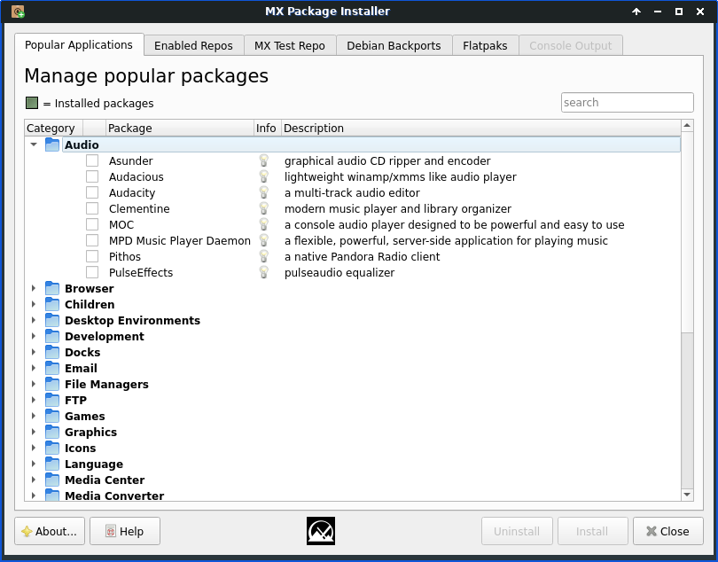Selecting an audio device

Wifi
In our testing only the more recent OPi5 devices had wifi capability without added hardware. MX Linux comes preconfigured (NetworkManager) to auto-detect a WiFi card, and in most cases your card will be found and set up automatically.
- Left-click the network connection icon in the systray
- Select the network you want to join, providing any necessary security information
- Once joined, you will see the familiar wifi icon in the systray
- Normally, you will be reconnected to that same network whenever you log in
Troubleshooting:
--MX Network Assistant allows you to identify connection problems, from network card to web issues.
--Advanced Network Configuration provides access to many connection details. A common "no network" issue experienced in some PC usage is resolved by double-clicking the network name and checking the box for "All users may connect to this network" on the "General" tab.

Bluetooth
Only more recent OPi5s have BT functionality if a good-quality external adapter (I use an ASUS USB-BT500 dongle) is present. To enable Bluetooth:
- Left-click the icon in the systray
- Choose if you want Bluetooth to be enabled automatically on boot (recommended)
- Make your device discoverable, if necessary
- Launch Menu > Bluetooth Manager and click the "Search" button
- Right-click the icon of your device > Pair, or use the button bar
- Right-click again > Trust, or use the button bar
- If it immediately disconnects, left-click the icon to reconnect, use the Bluetooth Manager or simply log out and back in. If not, right-click your device's icon in Bluetooth Manager > Connect
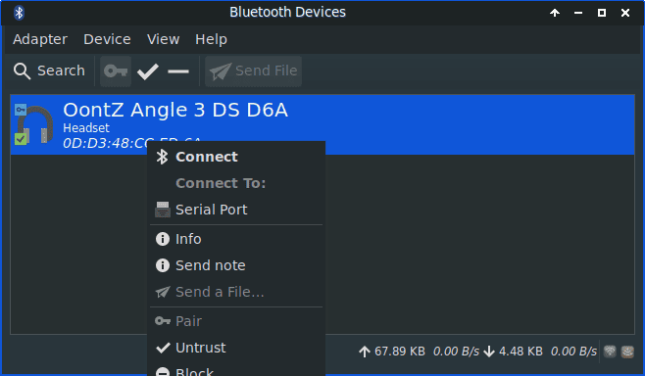A Bluetooth speaker has been found, paired and trusted--ready to connect.

Sound
The system is set up by default for routing sound through the hdmi connection. To change that:
1. Headphones
- Left-click the speaker icon in the systray and use the pull-down menu to change to ES8388
2. External speaker
- Confirm that an external speaker is on and enabled
- Left-click the speaker icon in the systray and use the pull-down menu to change to the speaker.
- Test by playing a streaming site, an installed music app such as audacious or another source
- Adjust volume by scrolling up or down while holding the cursor over the speaker icon
- If problems arise, left-click the speaker icon again and click "Audio mixer." Start a music source, and click on the mixer's “Output Devices” or “Playback” tab to change settings.
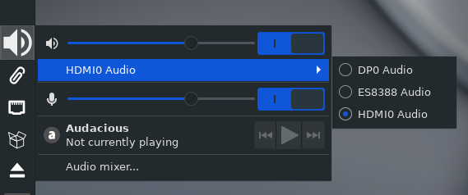Ready to select the headphones (ES8388)

Screen
Use Menu > Display to easily change screen traits such as resolution, orientation, selection etc. Changing orientation will affect both the desktop and the mouse.
Blanking. NeitherXfce’s Power or any other mechanism worked in our testing.
Suspend/Sleep. Click Menu > Power Manager, "Display" tab. Confirm that "Display Power Manager" is enabled, then move the top (“Blank after etc.) and bottom (“Switch off”) sliders to zero/never before adjusting the middle slider named "Put to sleep etc" to the number of minutes desired. We were not able to recover the screen when using the Exit Buttons > Sleep.

Browser
The default browser is Chromium (chromium-browser); others are available from Package Installer.
To get rid of the pop-up on reopening Chromium saying that it did not close properly and asking if you want to restore tabs: open ~/.config/chromium/Default/Preferences, search for exit_type and change "Crashed" to "Normal." Save and exit.

MX Versions
You can easily install a different official version of MX Linux:
- Launch MX Package Installer
- Click "Desktop Environments" and select KDE, or "Window Managers" for Fluxbox. Then click "Install."
- Log out, and use the icon in the center of the login page's top bar to select the new option.
- Short how-to video demonstrated on a Raspberry Pi 5: https://youtu.be/T19Hy93kEHg
NOTE: you will see other desktop environments and window managers available in Package Installer; these are not MX versions but simply default configurations.

Miscellaneous
- To set desktop localization, use MX Tools > System keyboard or Orange Pi Config, "Localization" tab.
- To center screens click Menu > Window Management Tweaks, "Placement" tab, and move the "Minimum size" slider over to about 75%.
- A future upgrade of Orange Pi 5 may overwrite the MX splash. To revert to the MX version, run as root <find name, add to uip list>

V: 240528

