

HELP

MX RPi Openbox Remix

Default User: mxob
Default Password: mxob

This unofficial MX-23 OpenBox Respin unites the MX-23 Official Raspberry Pi Respin based on Debian 12 (Bookworm), Openbox and various apps developed for the Fluxbox version of MX Linux.

This OS requires Xorg as display server (=default).
It will not work under Wayland.

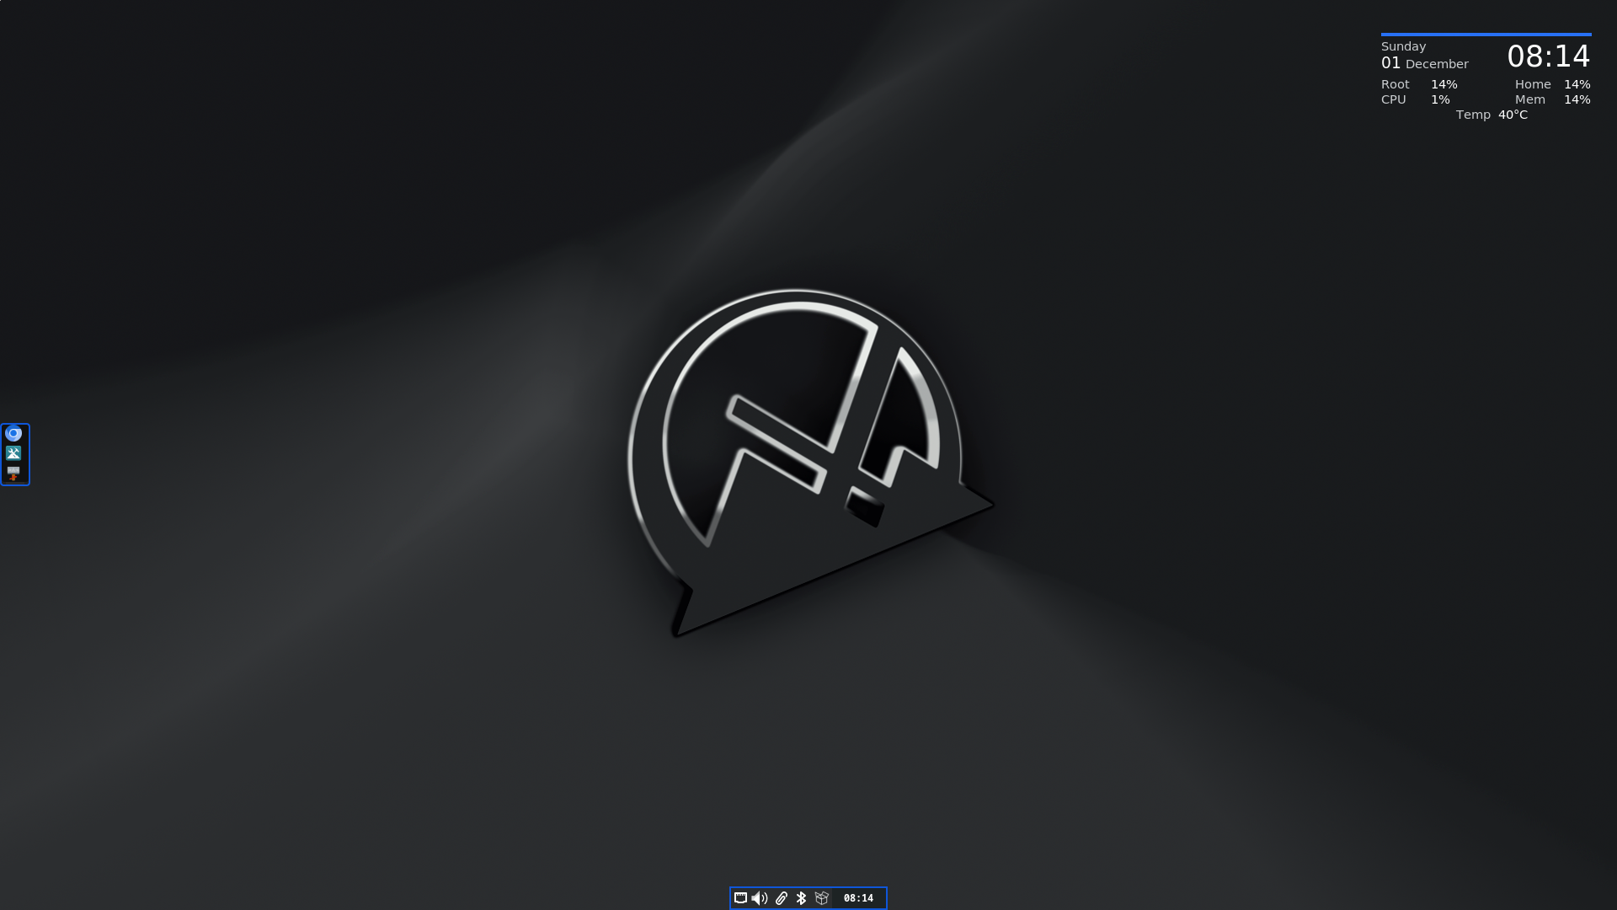Default desktop

- Left center: dock (tint2)
- Right top: desktop system information (conky)
- Bottom center: notification area, with a systray (stalonetray) and clock (tdc)
TO START: right-click anywhere on the desktop to access the root menu (hereafter: “Menu”).

Basic openbox configuration (~/.config/openbox/)
- autostart: programs to be started at the beginning of a session are listed in this flat file that is easily understood and directly edited by clicking Menu > Settings > Autostart.
- menu.xml: this static menu of user-selected applications is conveniently managed with Menu > Settings > Menus > Desktop Menu (obmenu2). See below for other menus.
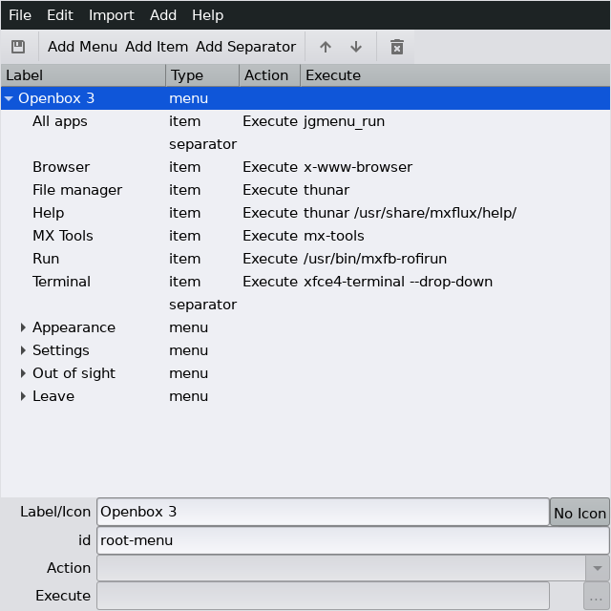The menu editor with menu.xml open

- rc.xml: this is the main configuration file for Openbox settings and behavior. It includes keys (AKA shortcuts, keybindings), that may be easily managed with Menu > Settings > Keys (obkey).
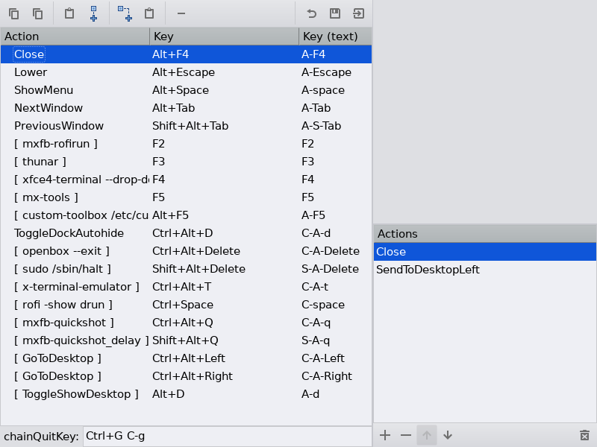The keys management tool ready to use

Desktop icons
Desktop icons can be set up and managed by iDesktool, a tool adapted and modernized from an earlier app by MX Linux Devs and users: Menu > Appearance > Desktop icons. This tool greatly facilitates the use of desktop icons on window managers such as Openbox. It is very straightforward, should raise few questions and is supported by a detailed Help file.
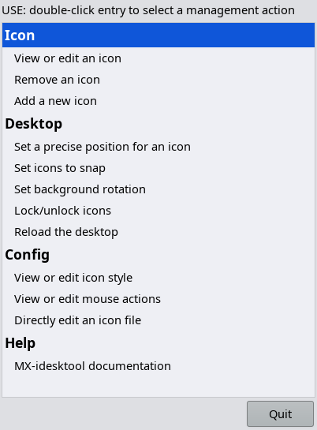Main screen of iDesktool

Dock
The default dock is provided by tint2. Settings: Menu > Settings > Dock. Press the “Config” button to open the graphical editor. Click on basic-dock-tint2rc and then on “Launcher” in the left column. Use the arrows in the middle column to add, remove and reposition selected applications.
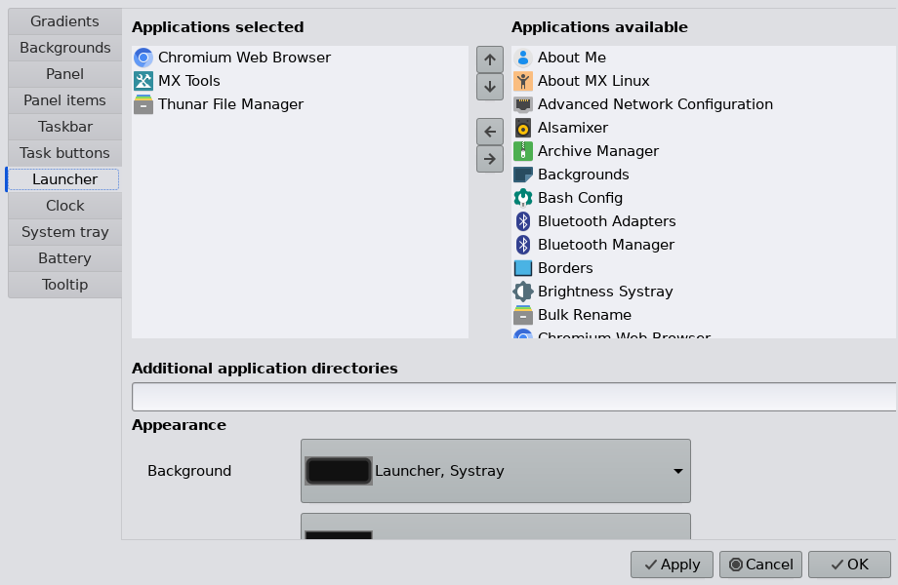Dock manager, showing app options

Menus
In addition to the static menu, two other menus are included to allow for differing user preferences:
- All apps (jgmenu), the top entry on the static root menu, provides easy access to installed applications organized by categories. To find an app directly, click the top search box (the word “Search” remains visible) and type in the name or a descriptive term. Settings: Menu > Settings > Menus > All apps (jgmenu_run). Details in the jgmenu overview.
- Rofi is conveniently accessed with the key: Ctrl + Space. It is used here primarily as an app launcher, though it has other functions as well. It is structured alphabetically but brings frequently used apps to the top of the list. Settings: Menu > Settings > Menus > Rofi (mx-rofi-manager). Details in the MX Wiki.

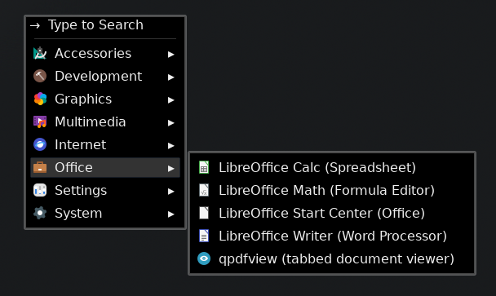The All Apps menu, showing a subcategory
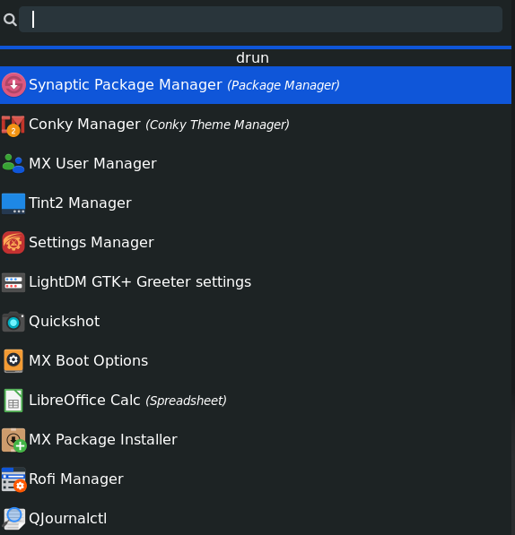The Rofi menu (dmenu)

Localization
- Static menu. The default static menu will be delivered in translation generated by DeepL if an appropriate one for the user’s locale exists in /usr/share/mxob/menu-translations.
- All apps and Rofi menus. Localization of Name and Comment depends on the individual desktop files in /usr/share/applications.

Notification area
Two separate stand-alone apps are used to create the Notification area: stalonetray and tdc. They can be separately hidden (Menu > Out of sight > Notification area) or even removed (from Autostart). The settings for these apps can be adjusted by clicking Menu > Settings > Notification area.
HINTS: 1) a left-click on the clock brings up a calendar (gsimplecal), and a second click or Alt + F4 closes it; 2) the order of icons in the systray sometimes shifts without apparent reason.

Configuration

First things first
Basic setup can be modified by using Raspberry Pi’s convenient app: Menu > Settings > Raspberry Pi > Basic setup (rc_gui).
- Change the user password. For advanced changes use MX User Manager.
- Set correct time format. For advanced changes use MX Date & Time.
- Set desktop localization. For advanced changes use MX System keyboard or MX Locales.
Log out and back in when done.

Software
This unofficial MX-23 Openbox Respin ships with basic apps installed but leaves to the user the decision to add other software such as email client, favorite music app, video player, full office suite, etc. The convenient MX Package Installer > “Popular Applications” tab is highly recommended for speed, functionality and safety. More detailed package operations are available using Synaptic.
NOTE: be very careful about adding software from outside the default repositories to avoid package failure or even system instability.
Available package upgrades will be signaled by the wire box in the systray turning from white to green as well as the appearance of a visual notification on the desktop. Right-click the box to view or change preferences and options, left-click the box to start the upgrade process.
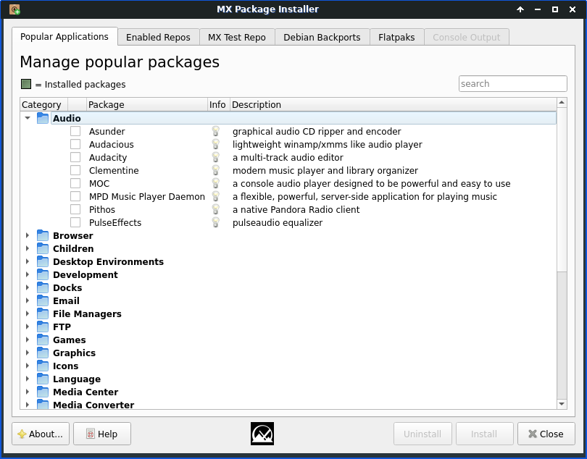Package Installer with an audio device selected

Wifi
MX Linux comes preconfigured (Network Manager) to auto-detect a Wifi card and in most cases you will simply need to click the icon in the systray and select the access point you want.
Troubleshooting:
- MX Network Assistant allows you to identify connection problems, from network card to web issues.
- Advanced Network Configuration provides access to many connection details.

Bluetooth
To enable Bluetooth (if an internal or external bluetooth adapter is present):
- Make your device discoverable, if necessary.
- Left-click the icon in the systray to launch Bluetooth Manager.
- Click the "Search" button to find your device.
- Right-click the icon of your device > Pair, or use the button bar.
- Right-click again > Trust, or use the button bar.
- If it immediately disconnects, left-click the icon to reconnect, use the Bluetooth Manager or simply log out and back in. If that doesn’t work, right-click your device's icon in Bluetooth Manager > Connect.
- When you next log in your device should be automatically connected as soon as it is turned on. If not, right-click the systray icon to enable a recent connection.

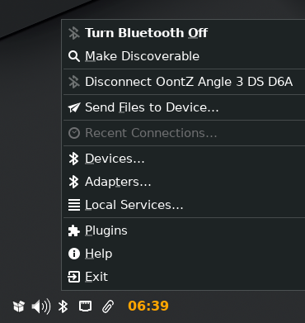The right-click menu of the systray icon
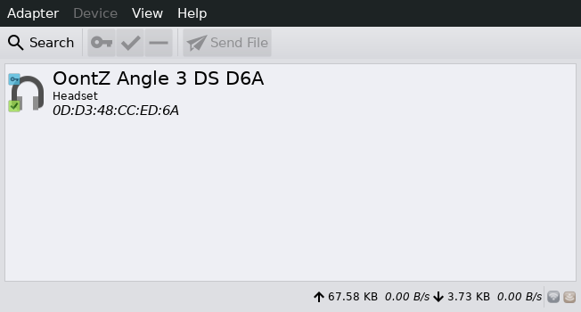A device has been found, paired and trusted

Sound
- Confirm that the speaker (or headphones) is powered on and enabled.
- Left-click the speaker icon in the systray and use the pull-down menu to change to the speaker.
- Test by playing a streaming site, an installed music app such as audacious or another source
- Adjust volume by scrolling up or down while holding the cursor over the speaker icon.
- You may also have to right-click the speaker icon > Open mixer (pavucontrol), then click on the Playback tab and use the pull-down menu to change the output (when using Chromium, for instance).

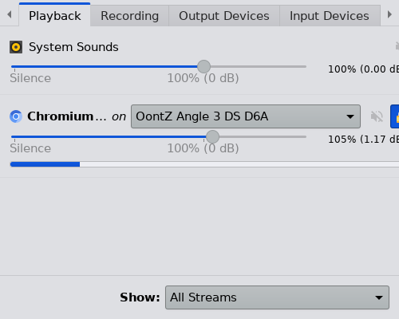Changing the playback in the mixer

Screen
Settings. Use Menu > Settings > Display (raindrop). For details, consult the Raspberry Pi documentation.
Blanking. Setting up blanking with Raspberry Pi Config did not work in our testing, so we make use of xset.. To change the number of seconds of inactivity before the screen blanks (default: 600), click Menu > Settings > Autostart and find the entry that begins with “xset -dpms…”
For instant screen blanking, press F12; any keyboard action restores the screen.

MX Tools
This signature collection of tools developed by MX Linux is easily accessed from Menu > MX Tools or with the key F5. For description and details of the tool collection, click Menu > Help > Users Manual (or Shift + F1) and go to Section 3.2.

Users are advised to become familiar with these unique and helpful apps.

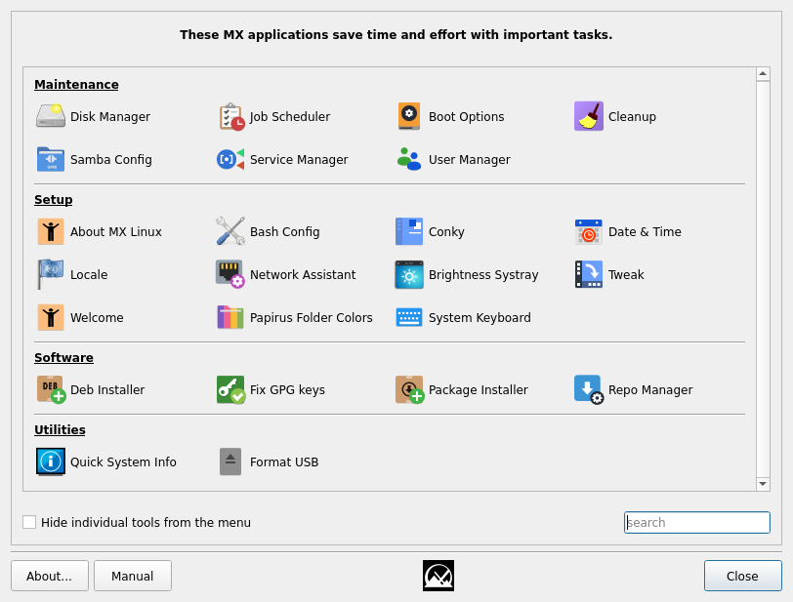The MX Tools dashboard

Miscellaneous
- A running system can be copied with the app SD Card Copier. To create an *.img file instead, a handy set of tools has been developed by RPi Forum user RonR.
- Resources
  - MX Openbox version: Use the MX Forum and consult the Users Manual (Shift + F1) for questions about the MX programs. HINT: Be sure to launch Menu > MX Tools and Menu > Settings Manager in order to become familiar with signature features of MX Linux.
  - Original Openbox version (3.7): Consult the much deprecated but still valuable OpenBox home page. Be aware that many links are broken and some of the apps listed there (e.g., obamenu) may no longer exist or be installable.

V: 20241205

