Problem1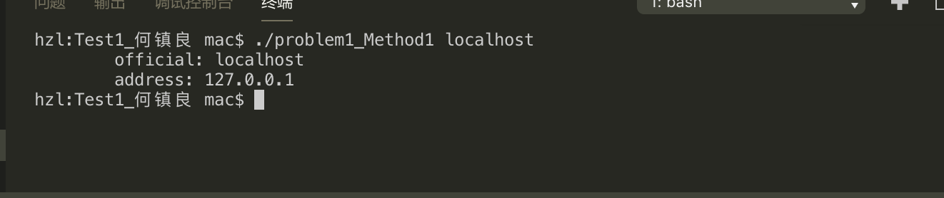

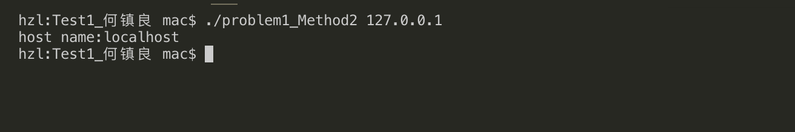

Problem2

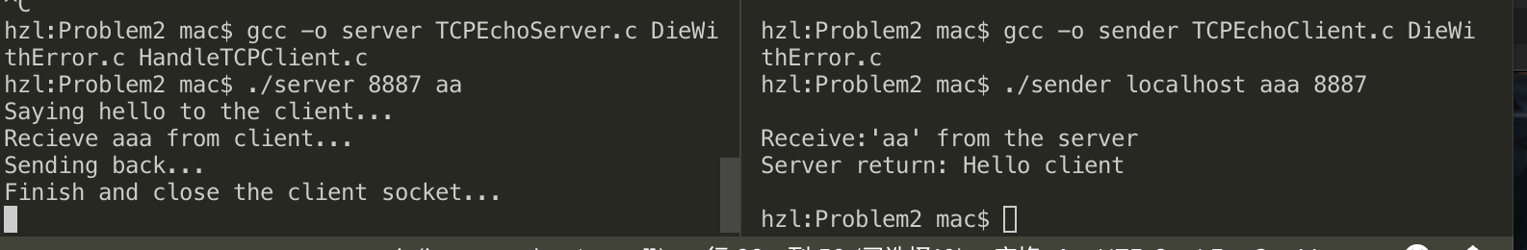

Problem3

