OFFICIAL

New User Onboarding Application

High Level Design Document

Department of Human Services
Identity & Access Management — Digital Transformation

Document Version | 1.0 — Draft
Date | March 2026
Classification | OFFICIAL — Not for Distribution
Prepared by | HR Operations — IAM Team
Status | For Management Review

1. Executive Summary
This document presents the high-level design for a new user onboarding application that will automate and streamline the identity provisioning process for new employees. The application replaces the current manual process with a secure, end-to-end digital workflow that covers the full lifecycle from HR submission through to user account provisioning in the department's IAM systems.

The solution uses a magic link authentication model — a candidate receives a uniquely signed email link, authenticates via the backend, and is presented with a pre-populated onboarding form drawn from Supabase attribute storage. Upon submission, the completed identity record is automatically written to the IAM Source of Truth database, where the downstream IAM Solution (e.g. Microsoft Identity Manager) imports and provisions the user's accounts.

The design prioritises security, simplicity for the candidate, and auditability for the HR team — with full notification flows, link expiry management, and an in-app status dashboard.

2. Scope & Objectives
This design covers the following in-scope components:
- HR Team portal — onboarding request submission, status dashboard, and magic link reissue.
- Candidate-facing portal — magic link authentication, pre-populated onboarding form, and confirmation screen.
- App backend — magic link generation and validation, Supabase attribute retrieval, IAM DB record insertion, and notification dispatch.
- IAM integration — automated import of identity records by the IAM Solution (e.g. Microsoft Identity Manager) from the Source of Truth database.

The following are out of scope for this design phase:
- Manager approval workflows (not required — form auto-submits to IAM DB on completion).
- Internal IAM provisioning logic within the IAM Solution.
- Off-boarding and de-provisioning workflows.

3. System Participants
Actor | Component | Responsibility
HR Team | Onboarding admin | Initiates onboarding requests; monitors status dashboard; reissues expired magic links; receives dual notification on completion.
App Backend | Onboarding application | Generates and validates magic links; fetches candidate attributes from Supabase; renders pre-populated form; writes identity records to IAM DB; dispatches all email and in-app notifications.
Supabase | Auth & attribute store | Stores candidate attributes and manager details embedded in the magic link. Returns an attributes token to the App backend upon request following successful link validation.
Candidate | New hire | Receives onboarding email; authenticates via magic link; reviews and completes the pre-populated onboarding form; submits the form.
IAM DB | Identity Source of Truth | Central identity database that receives the completed identity record upon form submission. Acts as the authoritative source for all downstream IAM provisioning.
IAM Solution | Provisioning engine | Imports identity records from the IAM DB and provisions user accounts across all connected systems. Operates independently from the onboarding app (e.g. Microsoft Identity Manager, SCIM).

4. System Overview
The diagram below illustrates the high-level component architecture and the relationships between system participants. The onboarding application acts as the central orchestrator, interfacing with the HR team portal on one side, the candidate portal on the other, and the identity backend (Supabase, IAM DB, IAM Solution) beneath.

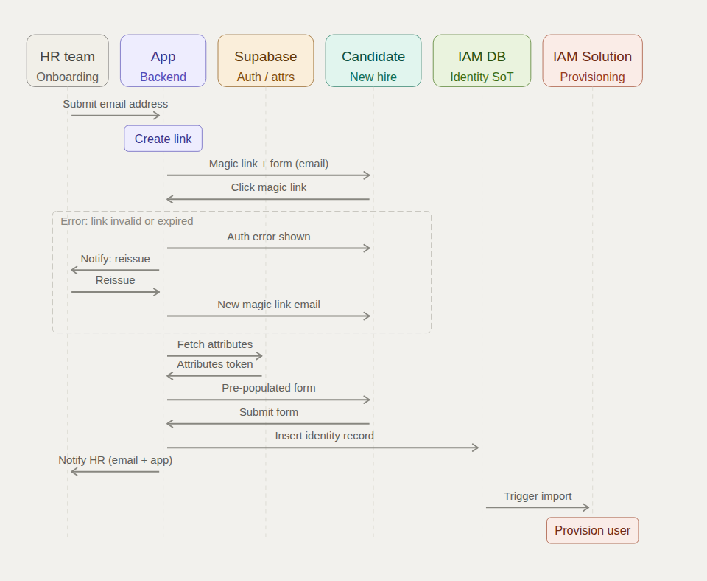
Figure 1 — Sequence diagram: end-to-end onboarding interaction flow

5. Interaction Flow

5.1 Happy Path
Step | From | To | Description
1 | HR Team | App | HR team submits the candidate email address via the onboarding portal.
2 | App (internal) | — | App backend generates a magic link containing a signed payload with the candidate email, manager details, and onboarding attributes.
3 | App | Candidate | App sends an onboarding email containing the magic link and access to the online onboarding form.
4 | Candidate | App | Candidate clicks the magic link. App backend validates the link signature and expiry. On success, flow continues.
5 | App | Supabase | App requests candidate attributes from Supabase using the identity embedded in the validated magic link.
6 | Supabase | App | Supabase returns an attributes token containing the candidate profile (name, role, manager, division, etc.).
7 | App | Candidate | App renders the onboarding form pre-populated with token attributes. Candidate reviews and completes any remaining fields.
8 | Candidate | App | Candidate submits the completed onboarding form.
9 | App | IAM DB | App inserts the completed identity record into the IAM Source of Truth database.
10 | App | HR Team | App notifies HR team via email and in-app notification that the candidate has completed onboarding.
11 | IAM DB | IAM Solution | IAM Solution imports the identity record from IAM DB and triggers user account provisioning across connected systems.

5.2 Error Path — Magic Link Failure
If the magic link has expired or is invalid, the following alternative flow is triggered:

Step | From | To | Description
4a | App | Candidate | App displays an authentication error to the candidate — link is invalid or expired.
4b | App | HR Team | App notifies the HR team that the magic link has failed and a reissue is required.
4c | HR Team | App | HR team triggers a reissue of the magic link via the onboarding portal.
4d | App | Candidate | App generates a new magic link and sends a fresh onboarding email. Flow resumes from Step 4.

6. Key Design Decisions
Design Decision | Rationale
App backend validates magic link | Validation is handled by the App backend — not delegated to Supabase. This keeps the authentication logic centralised and auditable, and limits Supabase's role to attribute storage and retrieval.
Attributes token flows via backend | The Supabase attributes token flows from Supabase to the App backend, which then renders the pre-populated form. The token is never exposed directly to the candidate browser, reducing risk of token interception.
No manager approval required | Manager details are embedded in the magic link by the HR team at the point of submission. On form completion, the record is auto-submitted to the IAM DB — no separate approval gate is required.
IAM Solution imports independently | The onboarding app writes to the IAM DB (Source of Truth) only. The IAM Solution (e.g. MIM, SCIM) imports from the IAM DB autonomously. This decouples the onboarding app from provisioning logic.
Dual HR notification on completion | The HR team receives both an email notification and an in-app notification when a candidate completes the onboarding form, ensuring visibility across both channels.
72-hour magic link expiry | Magic links expire after 72 hours (configurable). Expired links trigger an automatic alert to HR for reissue. HR can configure validity periods of 24 hours, 72 hours (recommended), or 7 days.

7. Screen Designs (UI Mockups)
The following screens represent the UI design for the onboarding application, presented in government / public sector visual style. All screens are navigable in the accompanying interactive HTML prototype.

7.1 HR Team — Submit Email Screen
The primary data-entry screen for the HR/onboarding coordinator. The form captures candidate personal details, employment information, and manager details. Manager details are embedded in the generated magic link payload. A contextual side panel explains the workflow and displays the 72-hour link expiry notice.

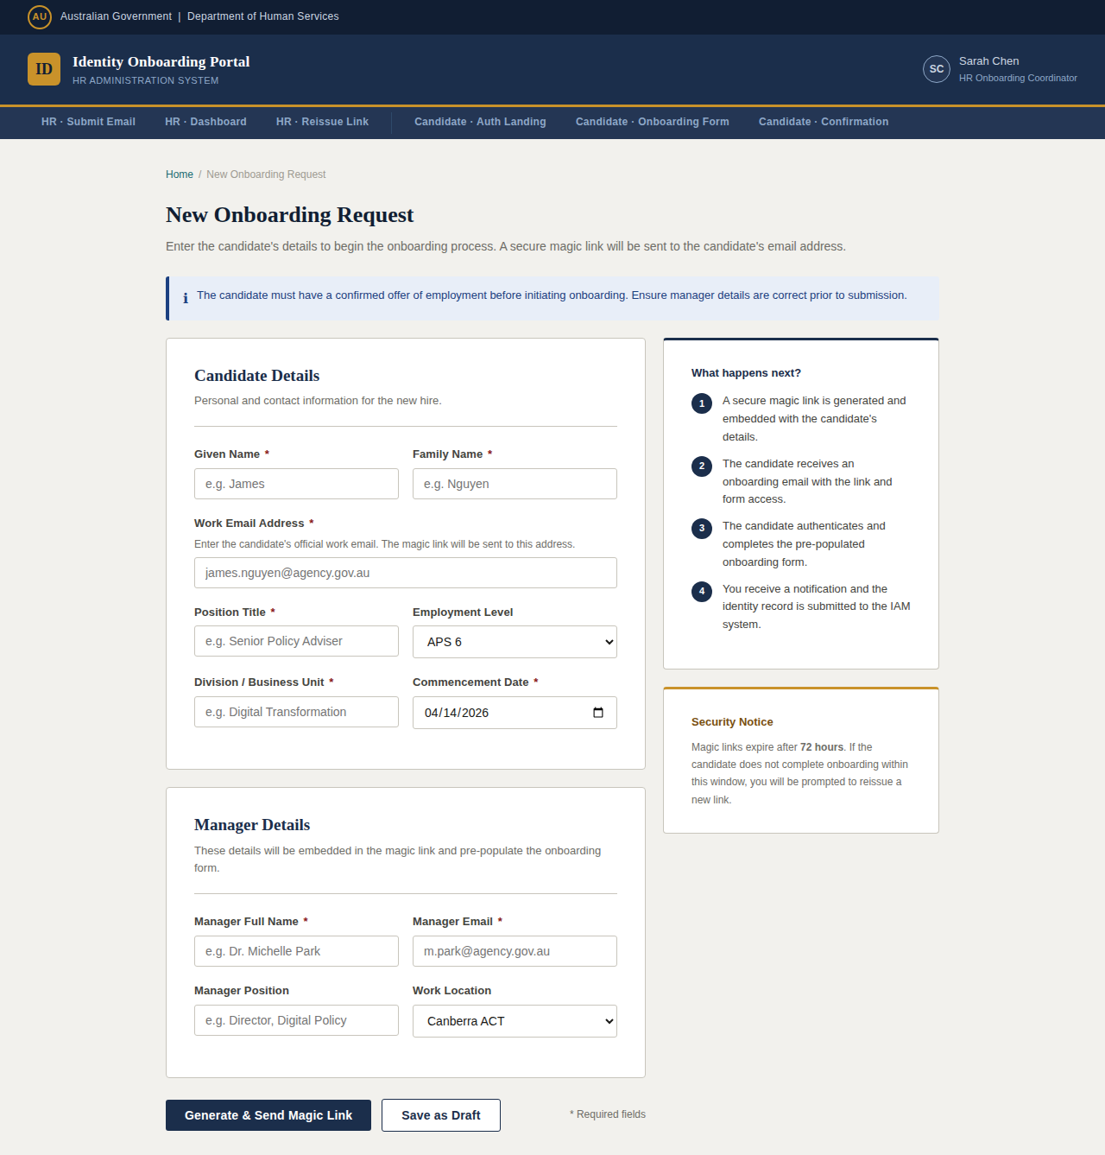
Figure 2 — HR Team: Submit Email / New Onboarding Request

7.2 HR Team — Notification & Status Dashboard
The dashboard provides the HR coordinator with a real-time view of all onboarding requests. Summary statistics are displayed at the top (pending, completed, expired, quarterly total). The request table shows candidate name, position, link sent date, expiry, current status, and quick action buttons. The notifications panel on the right surfaces unread events including form completions and link expirations.

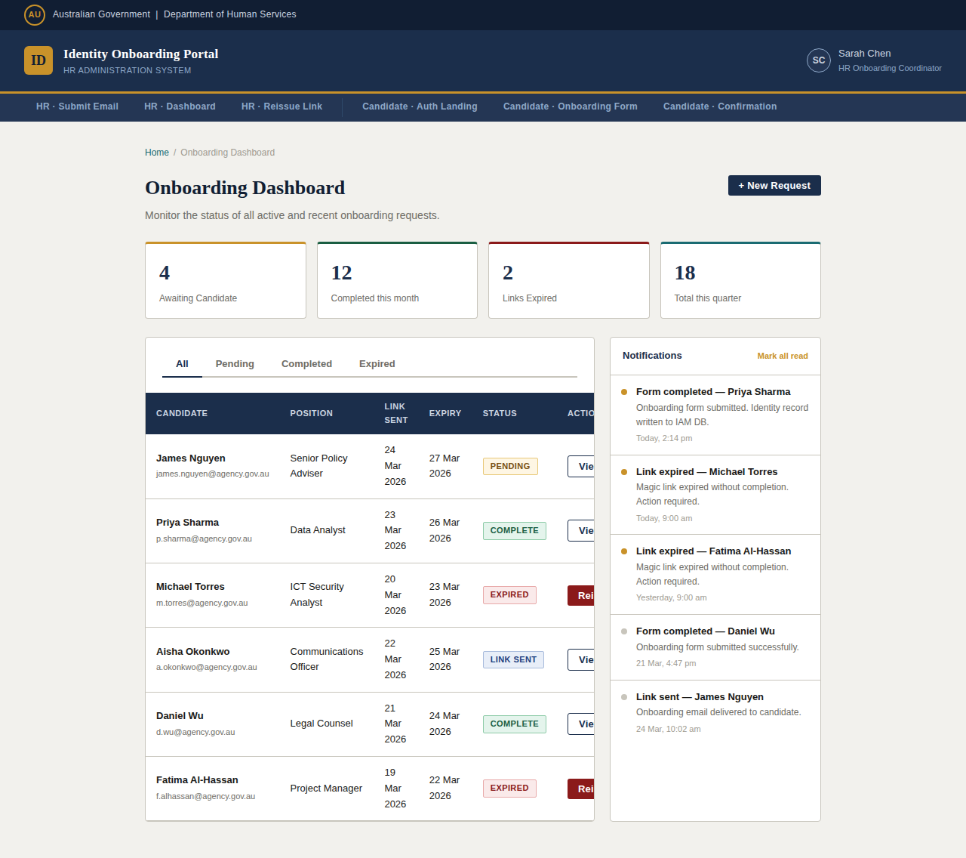
Figure 3 — HR Team: Notification & Status Dashboard

7.3 HR Team — Reissue Magic Link Screen
Triggered when a magic link has expired without the candidate completing onboarding. The screen presents a clear error alert, a read-only summary of the candidate and manager record for verification, and a reissue settings panel where the coordinator can configure the validity period, record the reason for reissue, and add an internal note. Previous link history is displayed for audit purposes.

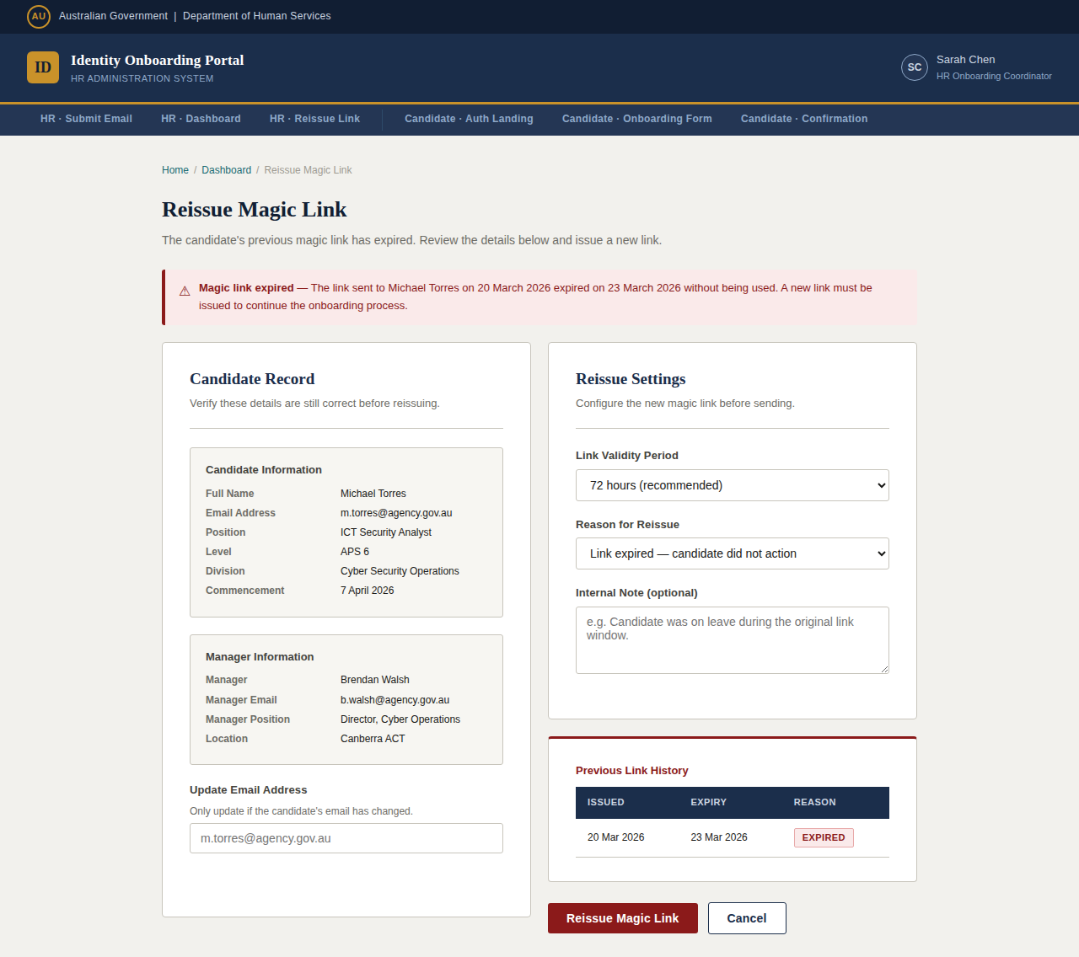
Figure 4 — HR Team: Reissue Magic Link

7.4 Candidate — Magic Link Authentication Screen
The candidate-facing authentication landing page. Displayed when the candidate clicks the magic link from their onboarding email. The candidate confirms their work email address and enters the one-time invitation code included in their email. On successful validation, the candidate proceeds to the pre-populated onboarding form. A statutory footer references the Privacy Act 1988 and the Public Service Act 1999.

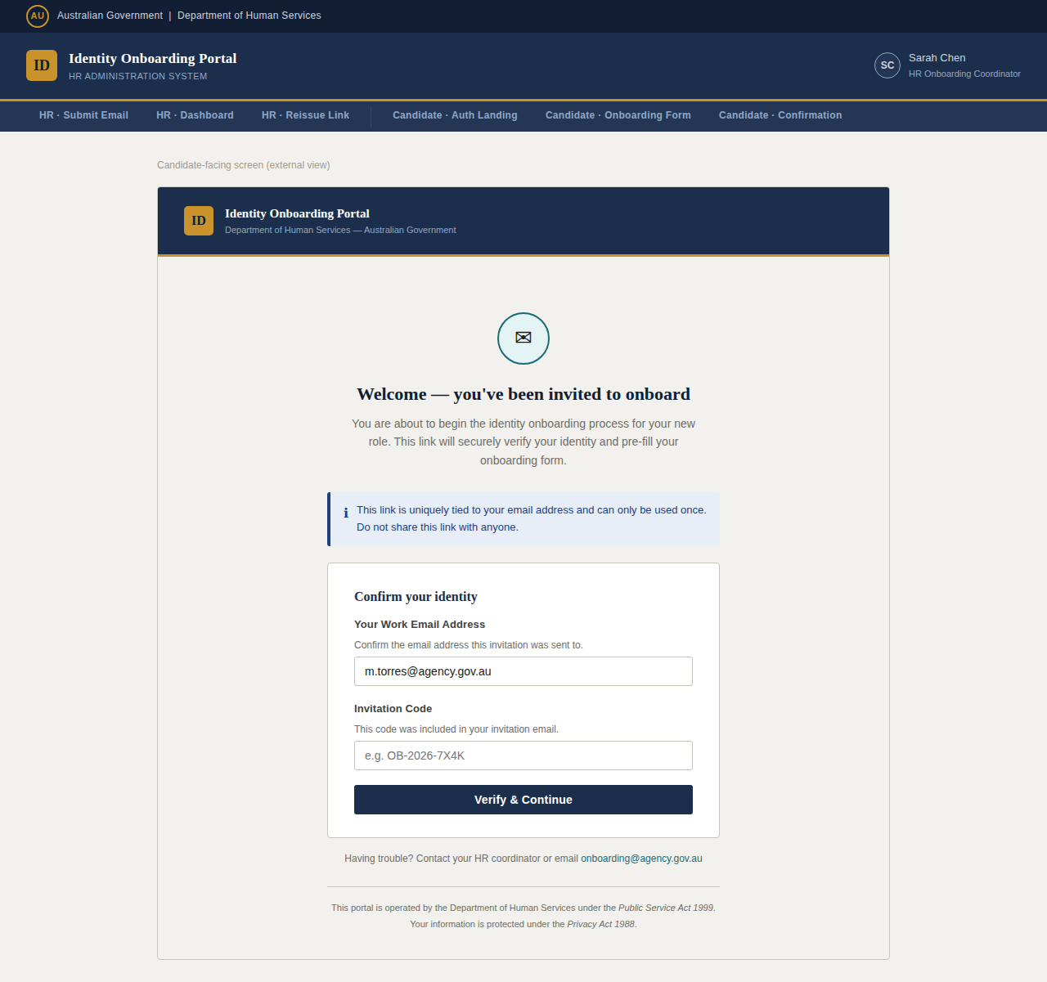
Figure 5 — Candidate: Magic Link Authentication Landing

7.5 Candidate — Pre-populated Onboarding Form
Following successful authentication, the candidate is presented with the onboarding form pre-populated from the Supabase attributes token. Pre-filled fields (name, position, level, division, manager, commencement date, work location) are visually distinguished with a shaded background and a "Pre-filled from employment record" indicator. The candidate completes the remaining fields (preferred name, date of birth, emergency contact, TFN, bank account details). A progress stepper at the top tracks the four-stage onboarding process.

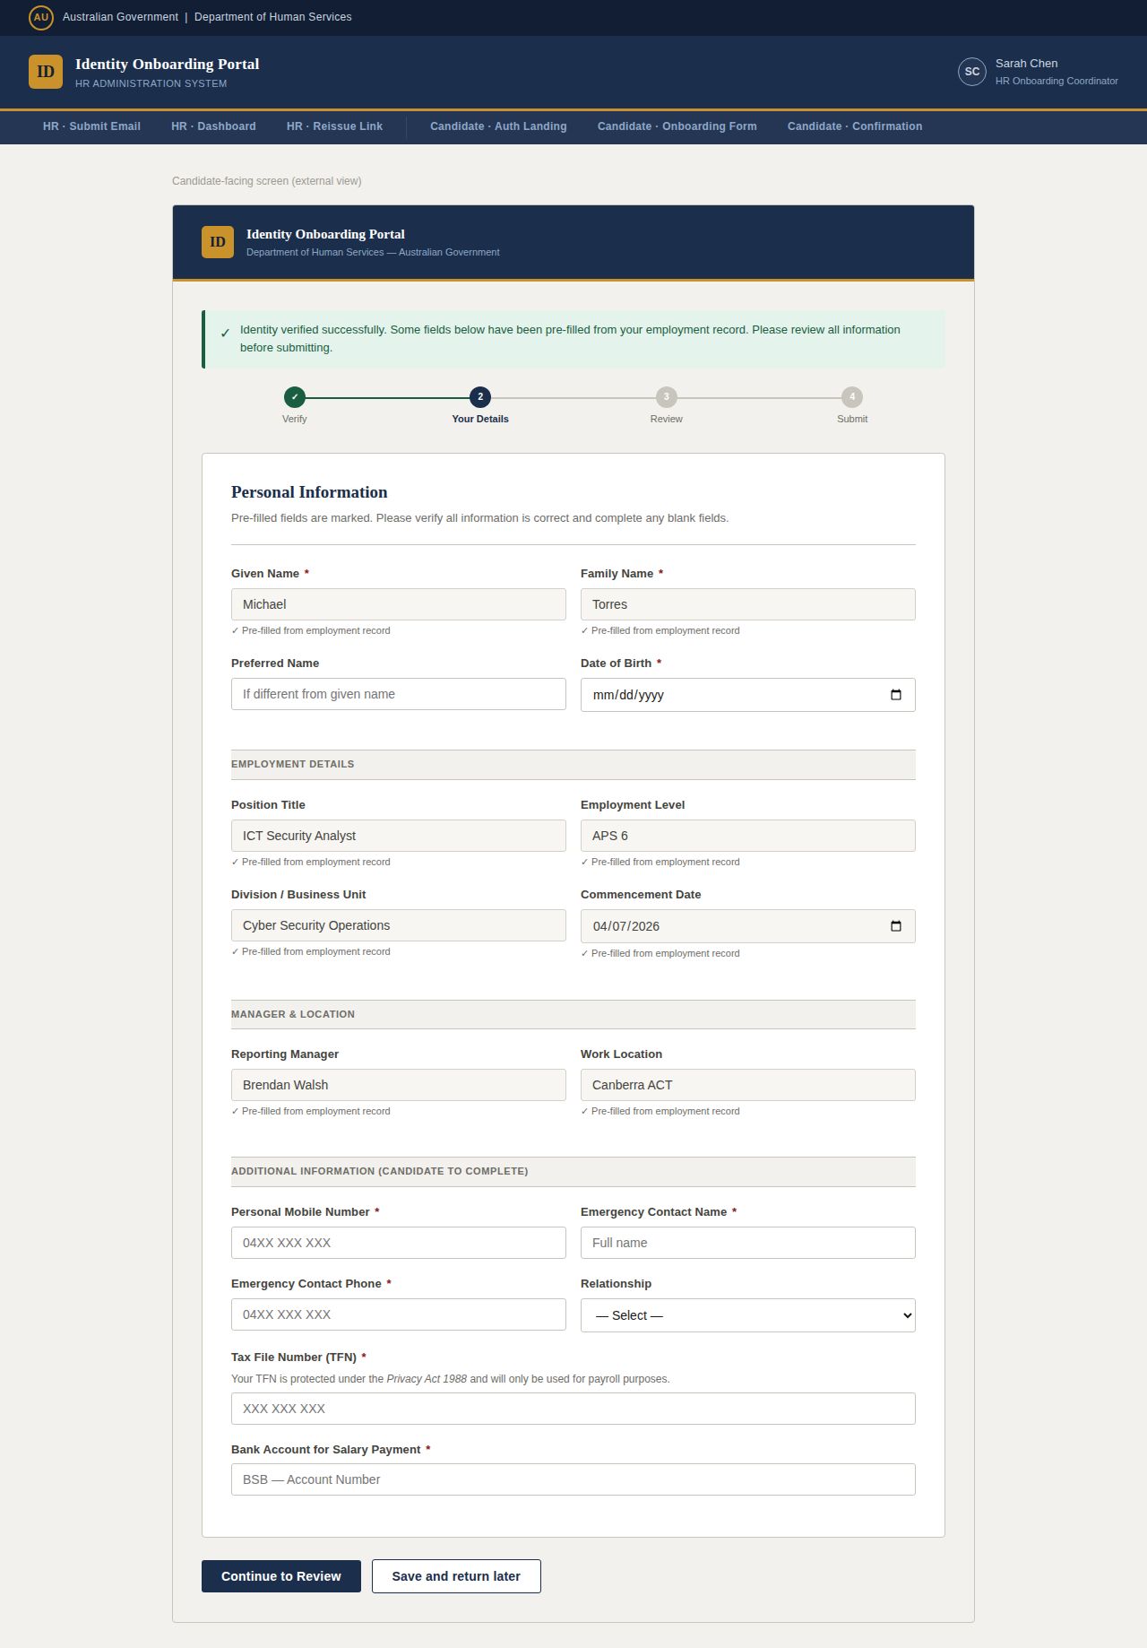
Figure 6 — Candidate: Pre-populated Onboarding Form

7.6 Candidate — Form Submission Confirmation
The final screen displayed to the candidate upon successful form submission. A large success indicator, a unique reference number, and a submission summary are presented. A "What happens next" section explains the provisioning timeline, advises the candidate of their commencement date, and provides a contact address for follow-up queries.

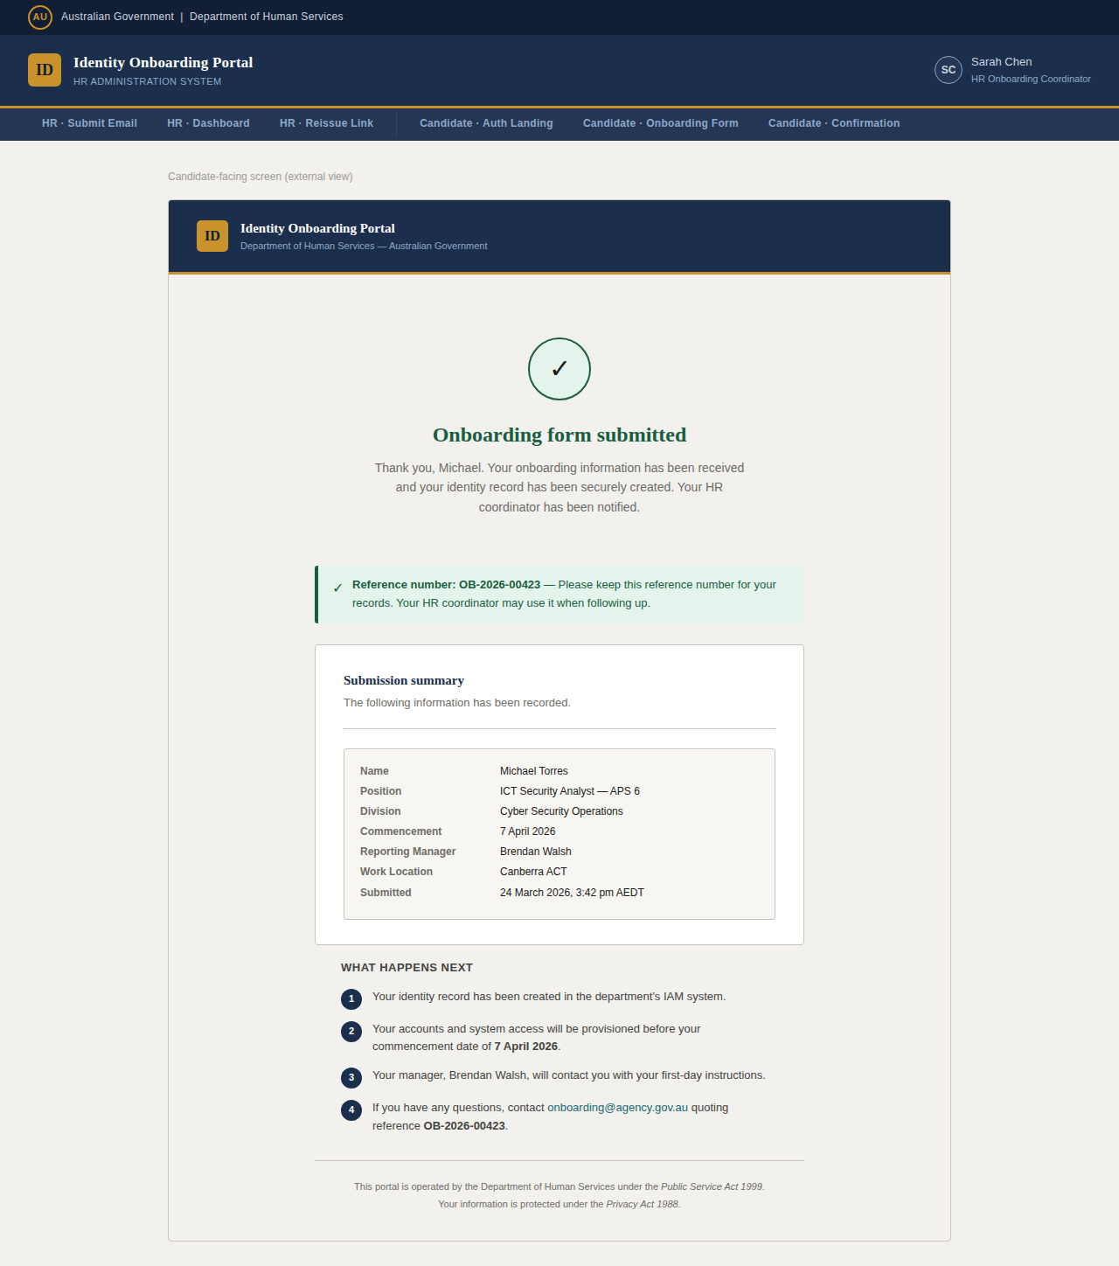
Figure 7 — Candidate: Form Submission Confirmation

8. Security Considerations
- Magic links are signed with a server-side secret and carry an embedded expiry timestamp. Signature validation occurs in the App backend before any Supabase call is made.
- Links are single-use — once validated, the link is invalidated server-side to prevent replay attacks.
- The Supabase attributes token is never exposed to the candidate browser. All attribute retrieval occurs server-to-server.
- TFN and bank account data submitted in the onboarding form must be transmitted over TLS and stored encrypted at rest, in compliance with the Privacy Act 1988.
- All reissue events are recorded with reason, timestamp, and HR coordinator identity for audit trail purposes.
- The design should be assessed against the ISM (Information Security Manual) and PSPF (Protective Security Policy Framework) controls applicable to OFFICIAL data classification.

9. Next Steps
# | Action | Owner | Target Date
1 | Management review and sign-off on this HLD | Management | April 2026
2 | Tech stack selection and detailed component design | IAM Team | April 2026
3 | Security review: magic link signing algorithm, token expiry policy, and Supabase access controls | Cyber Security | April 2026
4 | Privacy Impact Assessment (PIA) for TFN and sensitive attribute handling | Privacy Officer | April 2026
5 | Detailed Low Level Design (LLD) including API specifications and data schema | IAM Team | May 2026
6 | Development sprint planning and MVP scope definition | Project Manager | May 2026
7 | IAM DB schema design and MIM import connector configuration | IAM Team | May 2026

10. Appendix — Document History
Version | Date | Author | Changes
1.0 | March 2026 | HR Operations — IAM Team | Initial draft for management review.

