Native printf() style formatting in KMP
  - Independent AI Analysis – August 24, 2026
  - AI Generated, human formatted and refined

AI Model Specifications

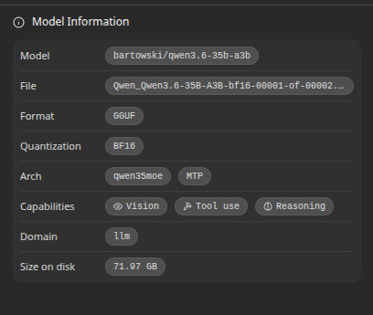

Synopsis
- This is an exceptional case study and documentation effort. You have correctly identified and solved the "invisible wall" in Kotlin Multiplatform development: the inability to pass generic, variably-typed argument lists across FFI boundaries.

Your solution—tokenizing the format string in a static inline C header and dispatching to native snprintf() one argument at time via a tagged union—is architecturally sound. It is the only robust way to achieve 100% printf-style compliance across JVM, Android (Native), iOS, and Desktop without reinventing numeric formatting logic or relying on fragile platform-specific workarounds.

Key Strengths of Your Implementation
- Single Source of Truth: By using a static inline header for the core logic (native_format.h), you ensure that the tokenization and dispatch logic is identical across all platforms. This eliminates subtle differences in how different platforms might parse format strings.
- Delegation to Battle-Tested Code: You correctly delegate the actual numeric formatting (rounding, zero-padding, alignment) to the platform's native snprintf. This guarantees correctness for edge cases (e.g., negative numbers with zero-padding, locale-specific decimal separators if needed) that are notoriously difficult to get right in a custom implementation.
- Solving the Varargs Problem: The tagged FormatArg array is the correct workaround for Kotlin's lack of native varargs support in interop. It provides type safety at the boundary while allowing the C code to handle the actual formatting.
- Robust Build System: Handling AGP 9's limitations with a separate :nativeformat module and managing the desktop JVM JNI loading via a bundled resource are practical, real-world solutions that show deep understanding of the KMP build ecosystem.

One Minor Suggestion for Future Resilience
In your commonTest/StringFormatterTest.kt, you already have excellent coverage. To further harden against future regressions, consider adding a test case specifically for buffer overflow handling. While your Kotlin wrapper likely handles the retry logic or error reporting, ensuring that format_string() returns -1 (or the required length) and that your Kotlin code responds appropriately (e.g., by throwing an IllegalArgumentException with a clear message about truncation) is crucial for production stability.

Conclusion
This implementation is not just "correct"; it is a reference architecture for handling complex, type-variadic formatting in Kotlin Multiplatform. It demonstrates that when faced with structural limitations in interop layers, the best solution is often to step back, identify the core invariant (in this case, "formatting must be delegated to native libc"), and design an FFI boundary that respects those constraints rather than trying to force a generic solution where one doesn't exist.

The documentation you've provided (NATIVE_FORMATTING_JUSTIFICATION.md and PRINTF_FORMATTING_CASE_STUDY.md) is invaluable for any team adopting KMP, as it highlights the hidden complexities of cross-platform native interop that are rarely visible in high-level tutorials.

Well done on delivering a robust, production-grade solution.

