# Android Device

## Android Device Visual Design



## Android Device Pseudocode Design

### Initialize GUI

* Create text inputs for IP username and password
* Create button for connection
* if user enters valid IP and username/password
  + call Retrieve user information

### Retrieve user information

* Retrieve user IP address, username, and password from text inputs
* Store into variables
* Create socket for server connection
* call Retrieve user location

### Retrieve user location

* Get the users current location
* if user location has changed or first time getting location
  + call send data

### Send user data

* Send data to the server
* call Retrieve user location

# Server

## Server Visual Design



## Server Pseudocode Design

### Initialize TCP socket

* create TCP socket
* allow other sockets to bind to this port, unless there is an active listening socket bound to the port already.
* bind socket
* listen for a maximum of 20 connection
* While the Server is active
  + Wait for Incoming Data

### Accept New Client

* Accept the client from the listening socket
* Add the client to the list of clients connected
* Create a file dedicated to that client with read/write privileges to store all new GPS data.

### Wait for Incoming Data

* Wait for data to arrive on socket
* Determine which socket has data
* If the listening socket has data, Accept New Client
* If a connected socket has data, Collect New Connected Client data

### Collect New Connected Client data

* Receive the new data arriving on the client’s pre-connected socket.
* Connect to the MYSQL database
* Write the user’s coordinates to the table
* Disconnect from the database

# Website Design

## Website Visual Display

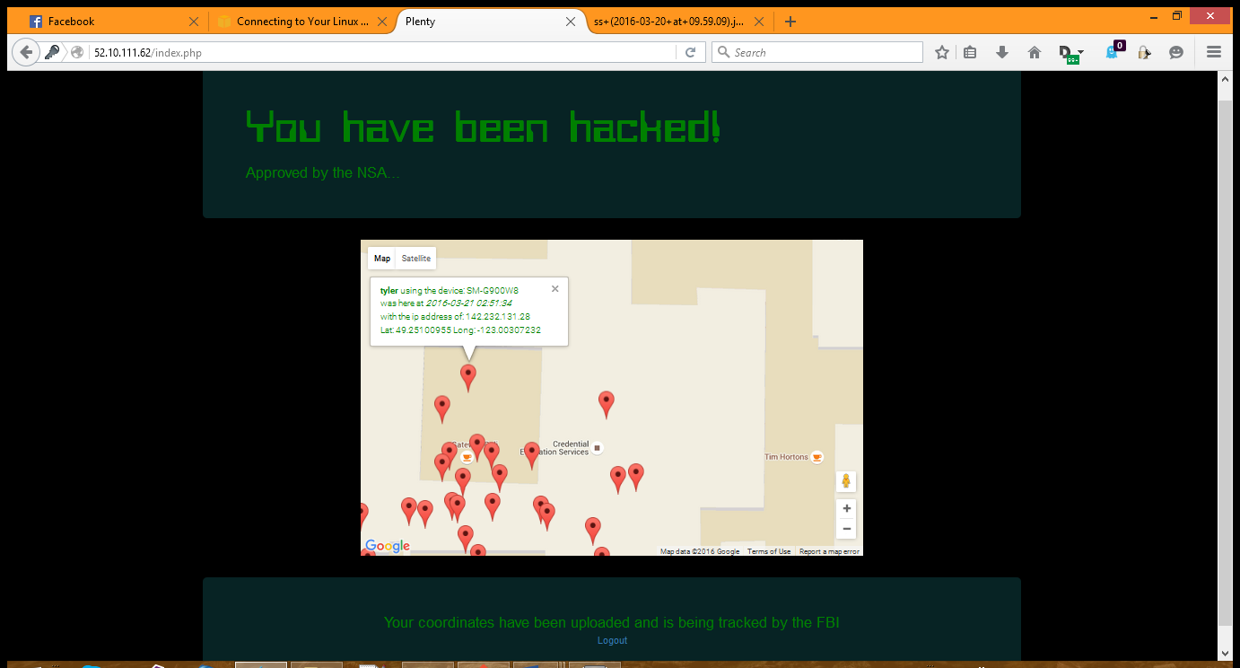

## Website Pseudocode Design

### Display Webpage

* Acquire the user’s login information
* Authenticate the user, denying any invalid credentials
* Display the initial landing page.
* In a continuous loop
  + Pull from the database the user’s coordinates.
  + Place any new coordinates into the Map
  + Update the map with the new markers