GPSD Reader
Assignment 3
Test Documentation

Contributors:
Ruoqi Jia
Jaegar Sarauer
Test # | Description | Test | Expected Results | Pass/Fail | Supporting Details
1 | Curses GUI display | Program startup | Expect all the required parameters for the curses GUI are displayed. (Time stamp (UTC), Latitude/Longitude, PRN , Elevation o Azimuth, SNR, Used flag (Y or N)) | Pass | See Figure.1
2 | opening the device | Ensure that the GPS device is properly opened | If it failed, prompt for error message and terminate the program | Pass | See Figure.2
3 | Reading from GPS | Ensure that the program is running in an outside environment where there is nothing blocking the sky. | Corresponding values for the GUI parameters will be updated on the program. | Pass | See Figure.3
4 | Disconnecting from the device | Enter Ctrl^C | Display message and terminate the program | Pass | See Figure.4
5 | Displaying longitude and latitude | Ensure there are more than 2 satellites detected | Corresponding values are displayed properly. If there are no fixes, display “n\a” | Pass | See Figure.5 for lack of satellites, See figure. 3 for sufficient satellites.
6 | Unplugging the satellite dongle | Unplug the dongle while reading satellites. | The error window will display a problem reading satellites. | Pass | See Figure 6.

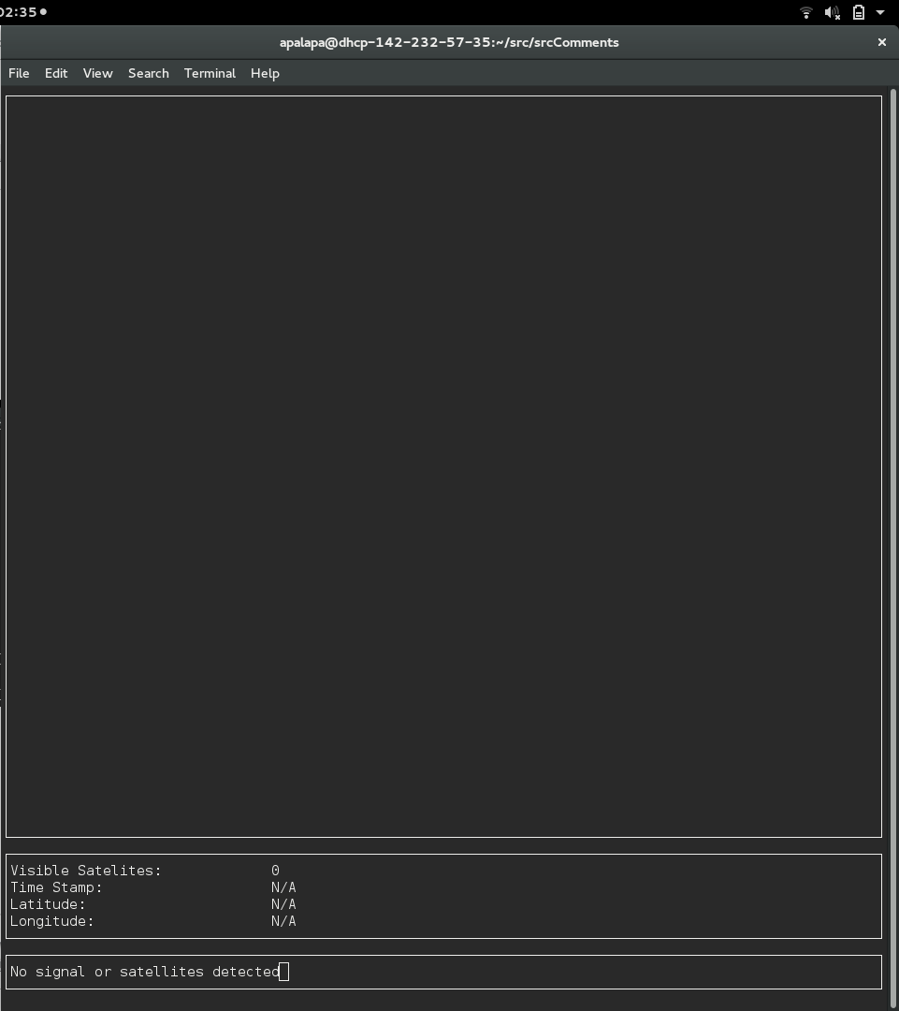
Figure 1:Figure 2:
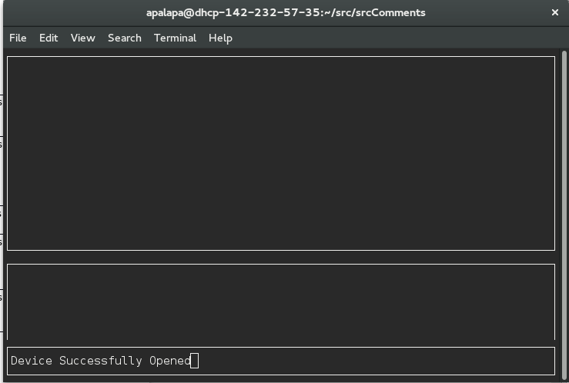
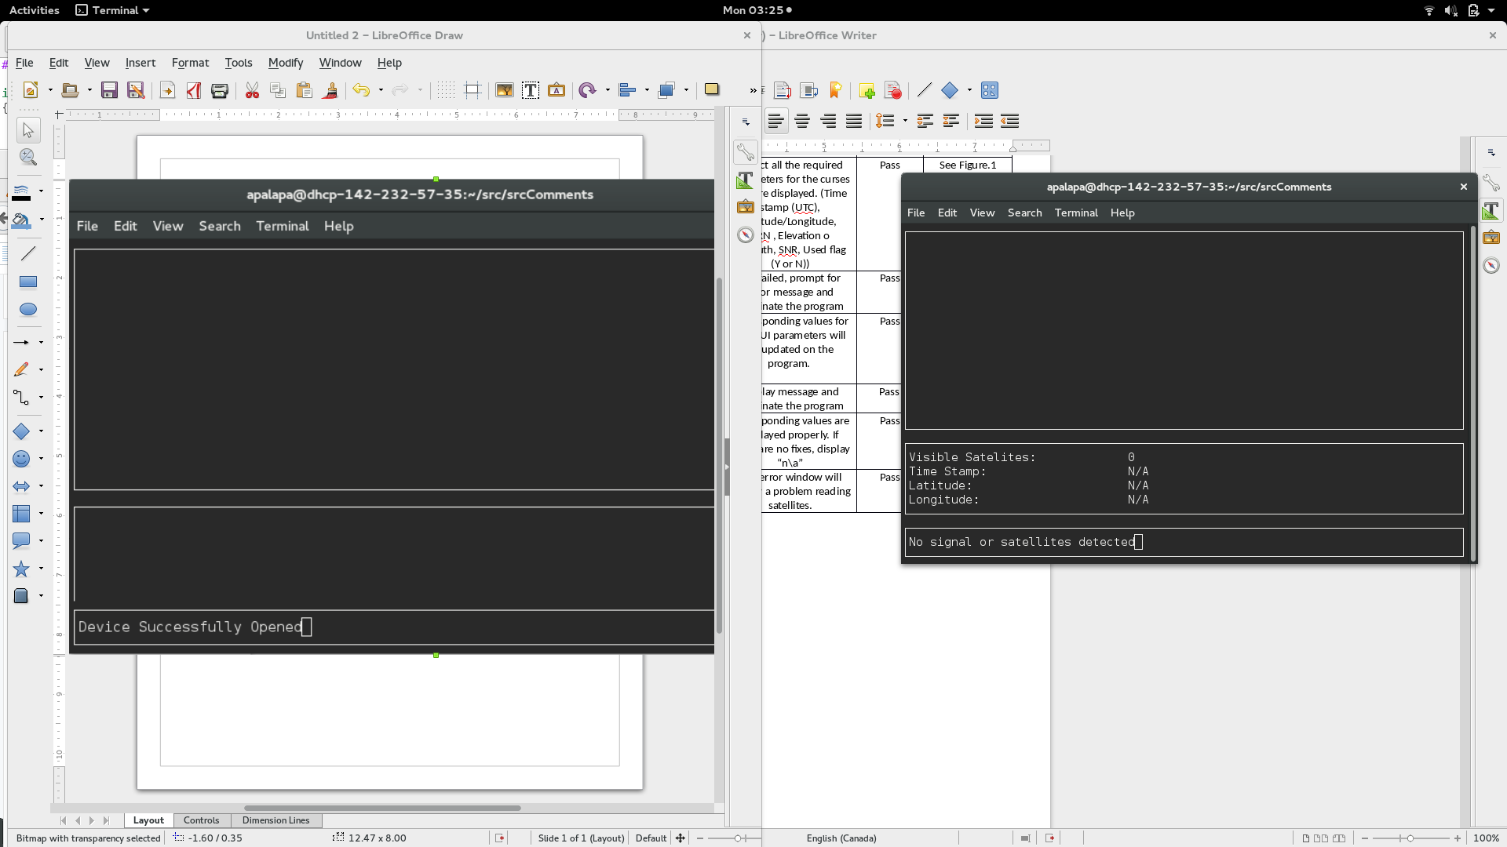
Figure 3:
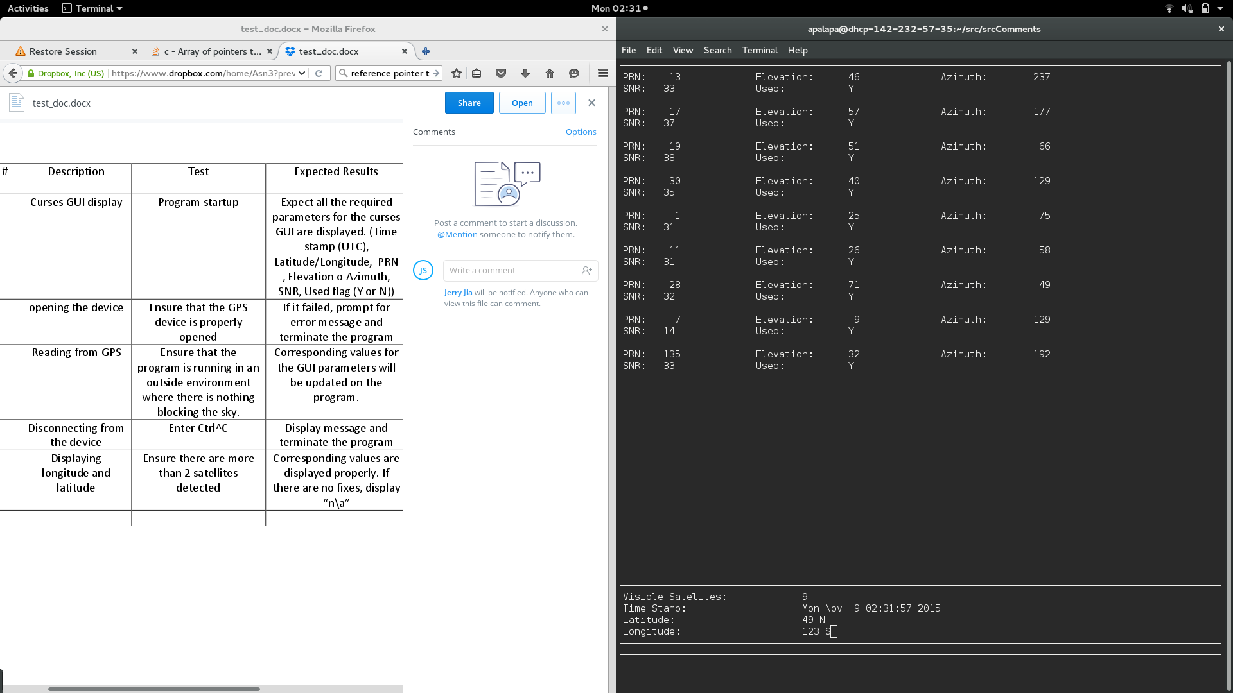
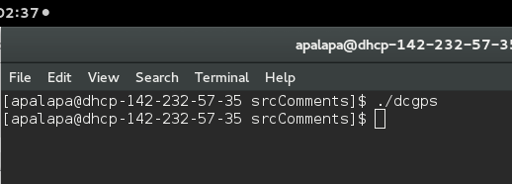
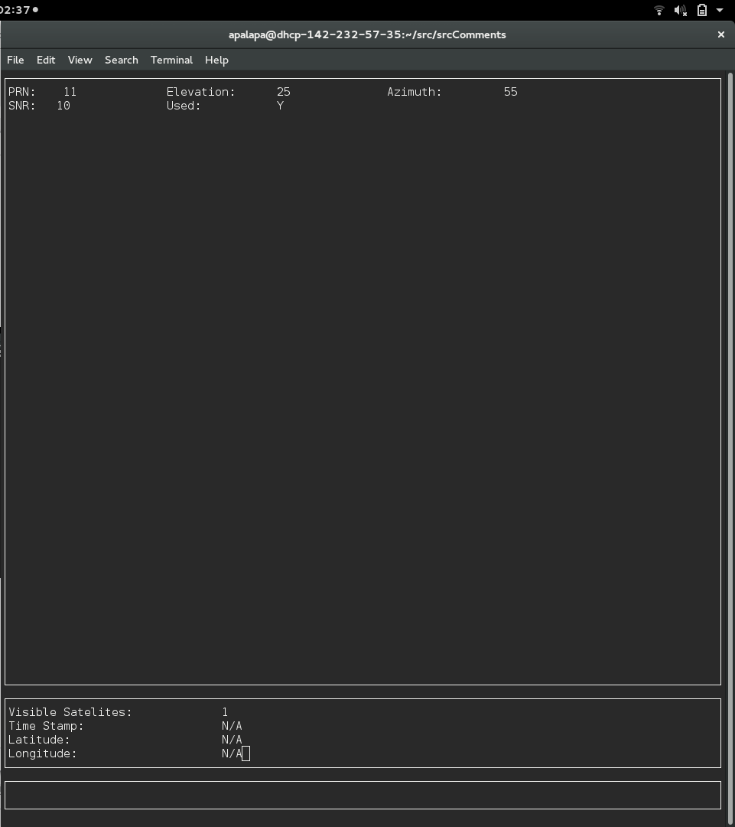
Figure 4:
Figure 5:Figure 6:
