GPSD Reader

Assignment 3

Test Documentation

Contributors:

Ruoqi Jia

Jaegar Sarauer

|  |  |  |  |  |  |
| --- | --- | --- | --- | --- | --- |
| Test # | Description | Test | Expected Results | Pass/Fail | Supporting Details |
| 1 | Curses GUI display | Program startup | Expect all the required parameters for the curses GUI are displayed. (Time stamp (UTC), Latitude/Longitude, PRN , Elevation o Azimuth, SNR, Used flag (Y or N)) | Pass | See Figure.1 |
| 2 | opening the device | Ensure that the GPS device is properly opened | If it failed, prompt for error message and terminate the program | Pass | See Figure.2 |
| 3 | Reading from GPS | Ensure that the program is running in an outside environment where there is nothing blocking the sky. | Corresponding values for the GUI parameters will be updated on the program. | Pass | See Figure.3 |
| 4 | Disconnecting from the device | Enter Ctrl^C | Display message and terminate the program | Pass | See Figure.4 |
| 5 | Displaying longitude and latitude | Ensure there are more than 2 satellites detected | Corresponding values are displayed properly. If there are no fixes, display “n\a” | Pass | See Figure.5 for lack of satellites, See figure. 3 for sufficient satellites. |
| 6 | Unplugging the satellite dongle | Unplug the dongle while reading satellites. | The error window will display a problem reading satellites. | Pass | See Figure 6. |

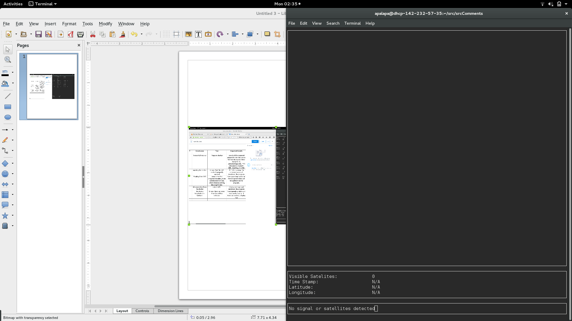

Figure 1:Figure 2:

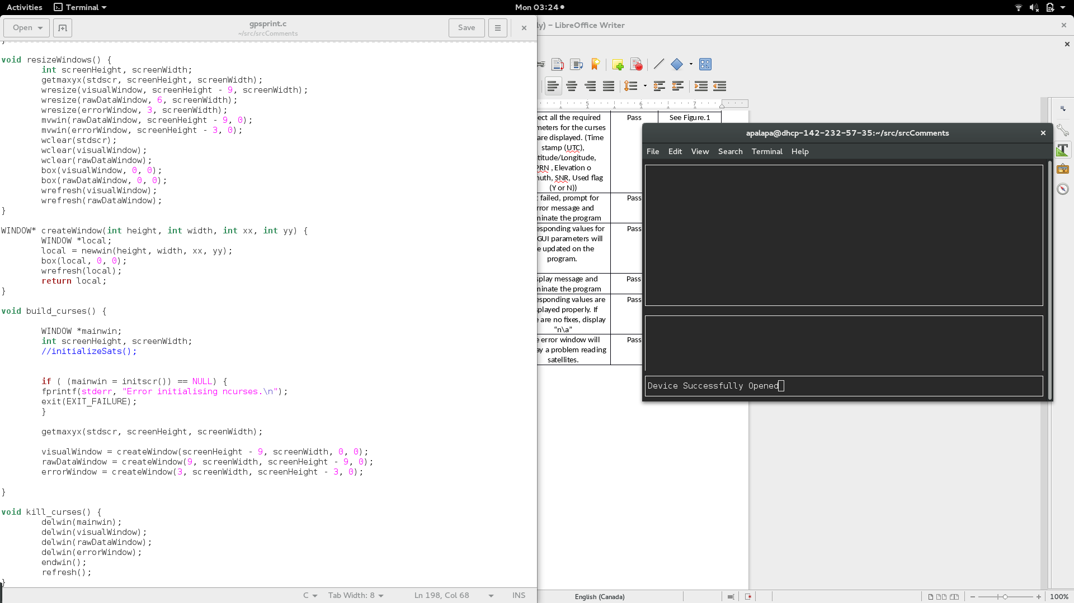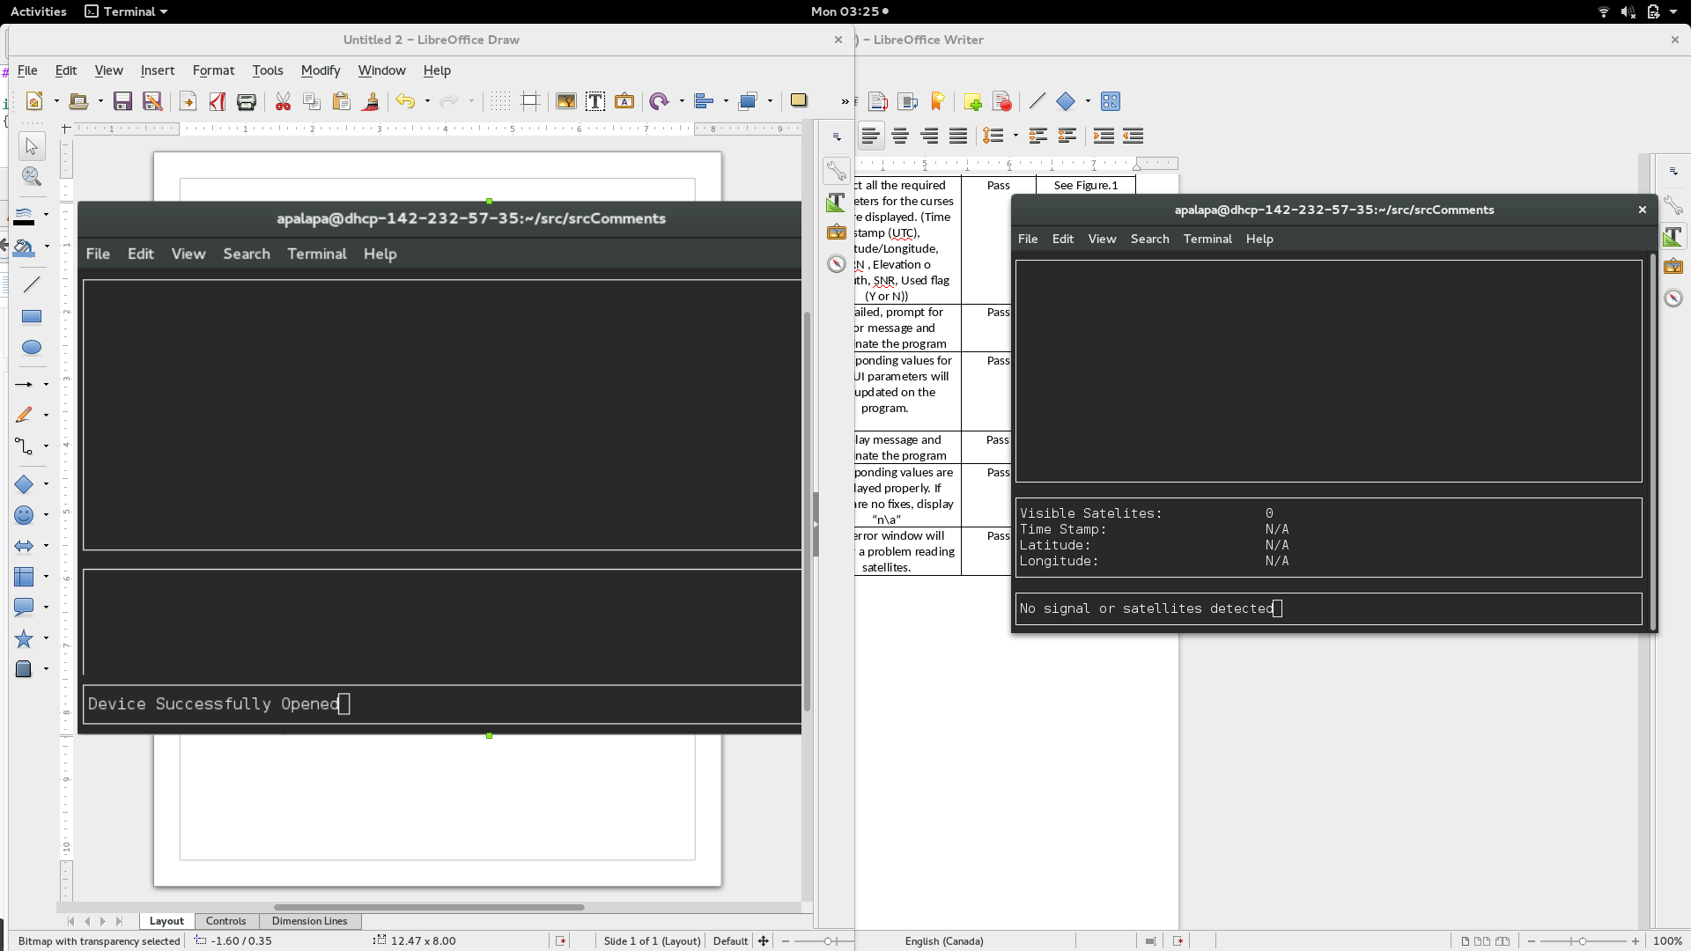

Figure 3:

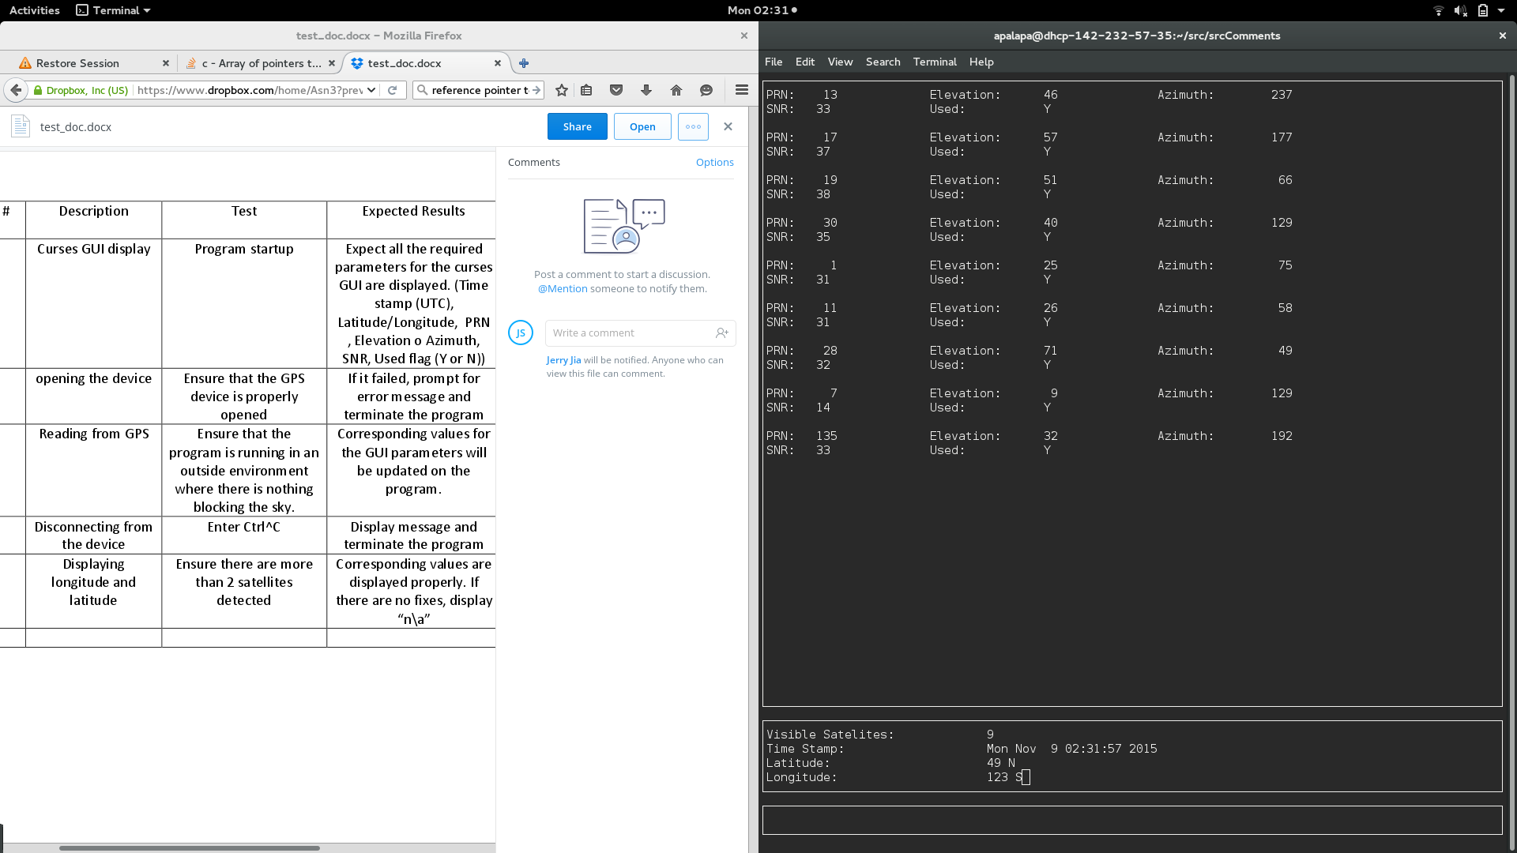

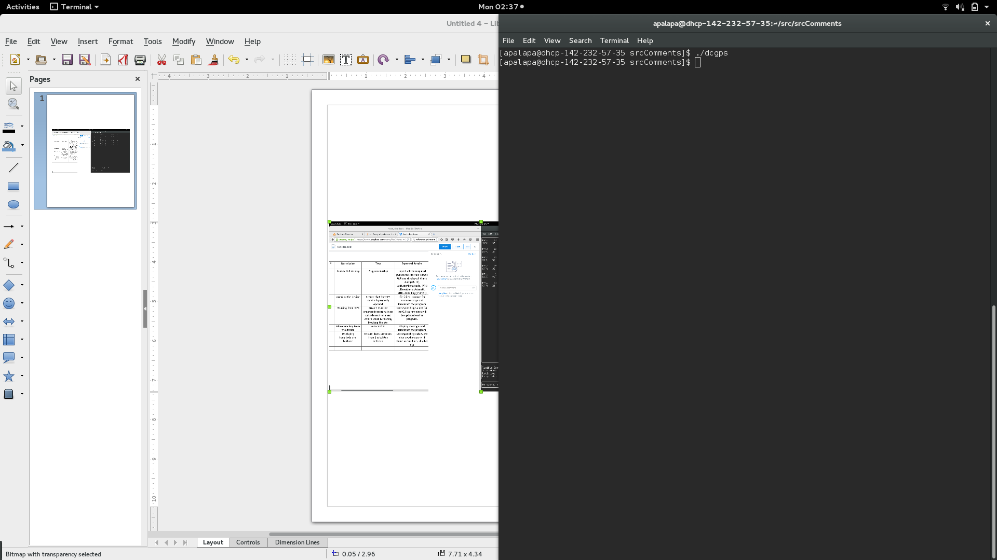

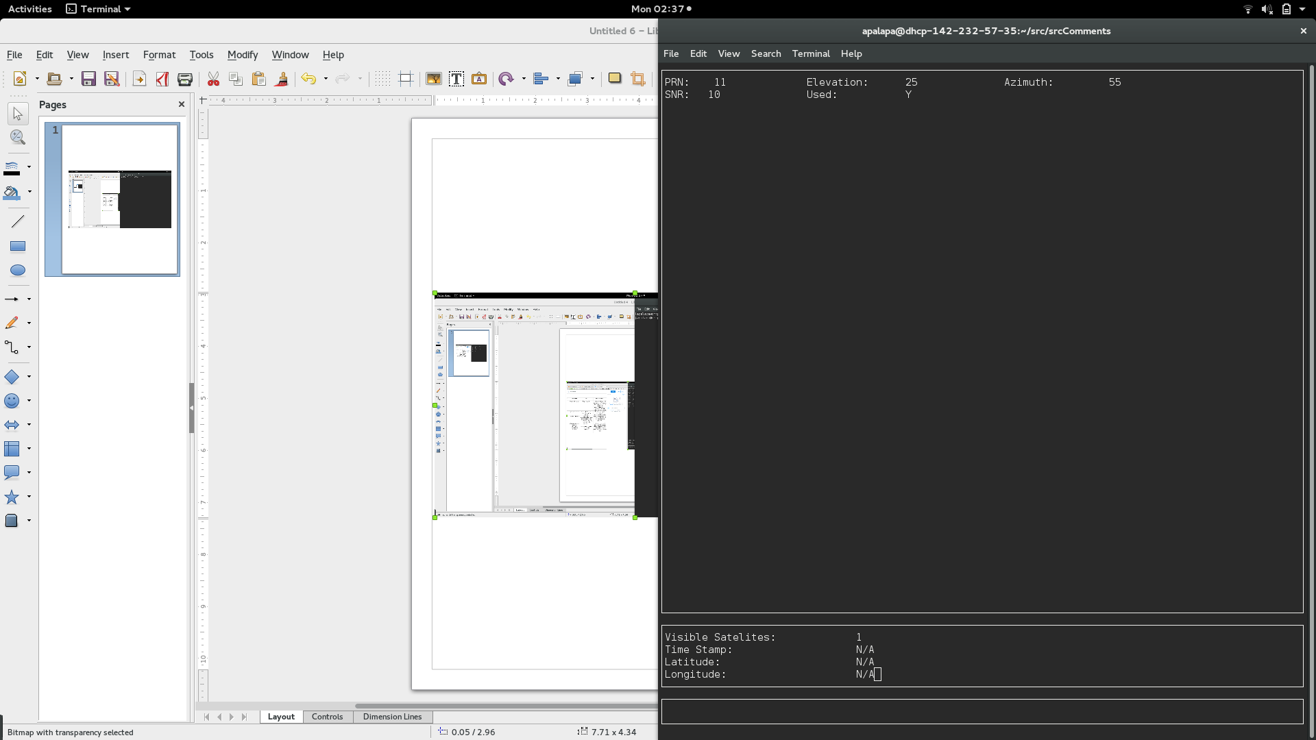Figure 4:

Figure 5:Figure 6:

