COMP 3980 DCGPS

Assignment 3 User Manual

2015

Administrator

Ruoqi Jia, Jaegar Sarauer

11/8/2015

**Overview**

DCGPS is a GPS tracking system developed by Ruoqi Jia and Jaegar Sarauer. The program is a Linux-based implementation using the Open Source GPSD utility, and it is powered by the terminal GUI library Curses. The intent of this manual is to focus on running the program on a Raspberry Pi (a mini computer) by either remotely SSH from a computer or connected to a monitor and keyboard.

**Usage**

Before you begin make sure the following minimum requirements are met:

* Have a working wireless adaptor connected to the Pi and a network
* Have Putty installed and successfully SSH into the Pi terminal
* Have a working GPS dongle connected to the Pi
* Be in an area that is not blocking the sky view.

**Section 1:**

*#gpsd/dev/ttyUSB0 –F/var/run/gpsd.sock*

*#sudo KillAll gpsd*

* **Type then**

**to restart any running gpsd before testing the program**

* **To run the application, type**

*#./gpsd*

**Section 2:**

* **Once the device is opened properly, it will start searching for available satellites to be found. (Figure 1)**
  + - **If an error occurred while trying to establish a connection with the daemon the program will terminate. (Figure 1.1)**
* **Information/values of each satellite will be displayed in a list when they are detected by the application, and the fixed location of the GPS. (Figure 2)**
  + - **Longitude and latitude will be displayed as “n\a” if the GPS signal is poor (Figure 2.1)**

**Section 3:**

* **To terminate/close the application, type**

*#ctrl^c*

**Figure 1**

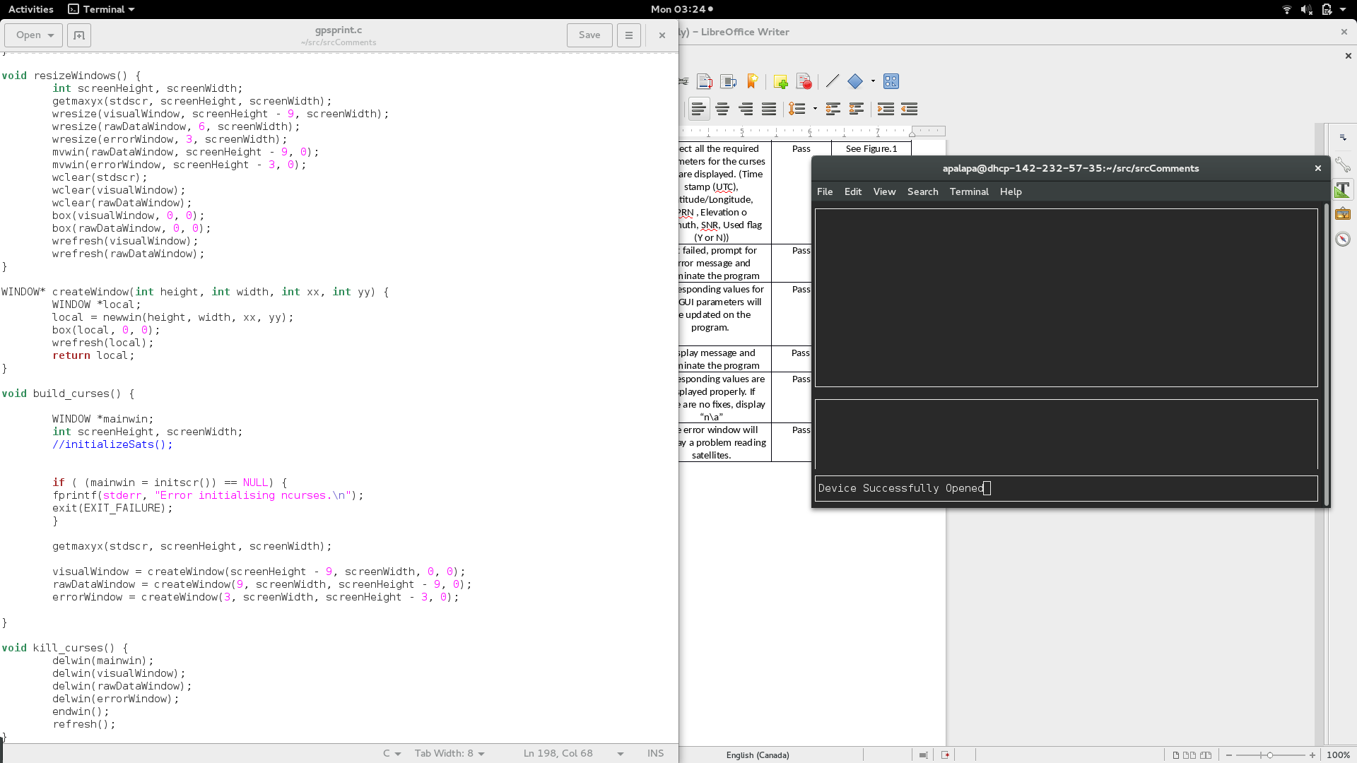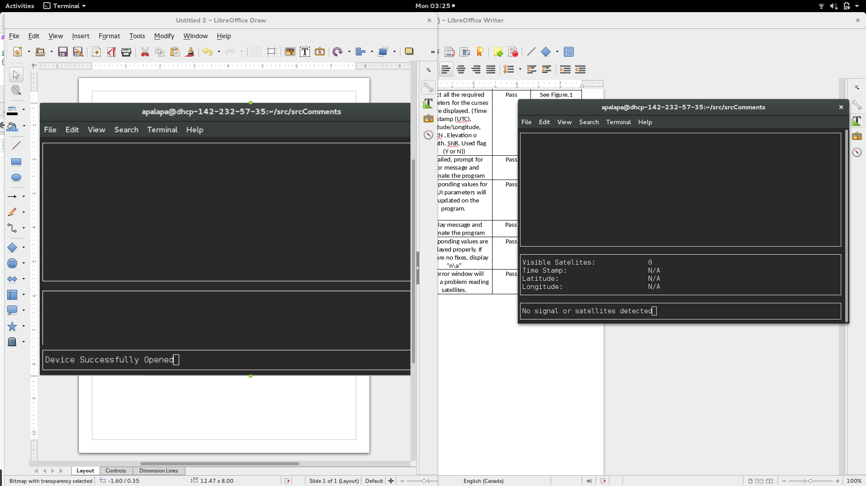

**Figure 1.1**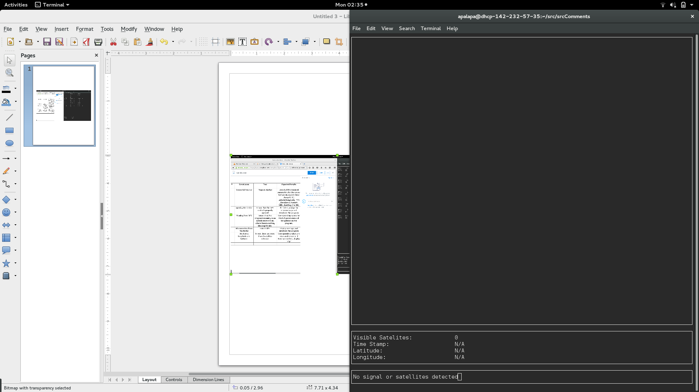

**Figure 2**

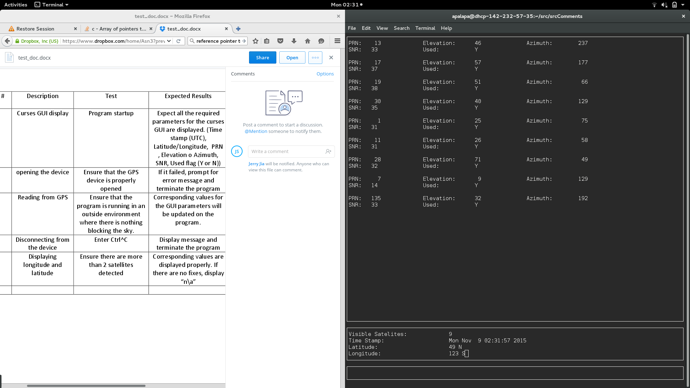

**Figure 2.1**

