USER MANUAL

COMP 4981 Linux Terminal Simulator

Table of Contents

1 Intro to Linux Terminal Simulator 2

2 Process Creation 2

3 Program Flow | Functionality 3

# Intro to Linux Terminal Simulator

This application is a basic terminal process simulator for Linux to demonstrate the practical use of creating processes, communicating with pipes, and handling signals. To make the program interesting and interactive, we will be using user inputs to communicate between the processes and terminating them.

* typing 'E' will send the input to the other process to be interpreted
* typing 'T' will quit the program
* typing 'K'will remove all characters preceding it
* typing 'X'will remove the previous character
* all 'a' characters will be replaced with 'z' characters in the output

# Process Creation

When the program is first launched, it will generate a default process to the application,which we will call it input. The input process will create a child process with the fork() API call, called the output process. After that it will create another child process, called the translate process.

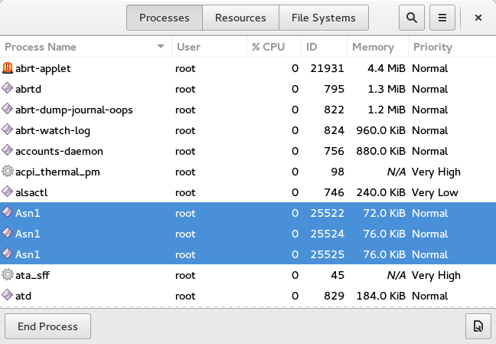

# Program Flow | Functionality

Now we have the processes ready to go, let’s get into the flow of the program and its functionality.

* First of all, all terminal signals will be disabled, which means that ^C, ^Z, enter, and any input echoing will be turned off
* Let’s try typing something into the terminal

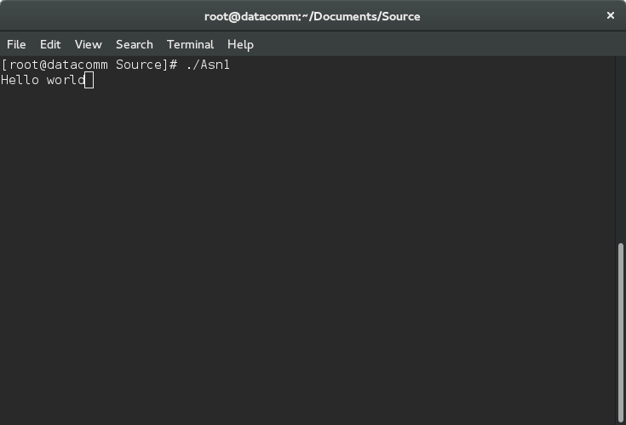

(*Note that the characters displayed is being echoed out by the output process)

* If we press ‘E’ after the input, it will be sent off to the translate process and echoed by the output after the translation

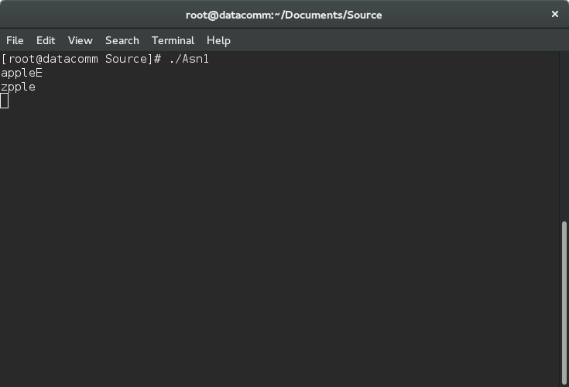

(* Note that the ‘a’ is translated to ‘z’)

* Entering ‘X’ will delete the previous character

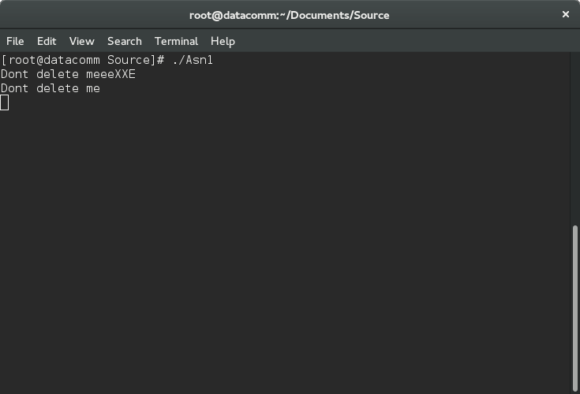

* Entering ‘K’ will delete all preceding characters

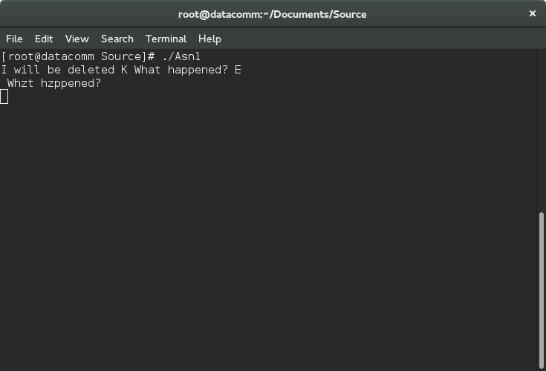

# Terminating

Since all terminal processes are disabled, we assigned the key “^K” and “T” to terminate the program.

