TEST DOCUMENTATION

COMP 4981 Terminal Processor

|  |  |  |  |  |
| --- | --- | --- | --- | --- |
| **Test #** | **Description** | **Test Steps** | **Expected Result** | **Pass / Fail** |

|  |  |  |  |  |
| --- | --- | --- | --- | --- |
| 1 | Normal terminal processes disabled | 1. Start Program 2. Type ^C, Enter, and ^Z | No changes will occur. | **Pass** |

|  |  |  |  |  |
| --- | --- | --- | --- | --- |
| 2 | Three processes running | 1. Start Program 2. Open system monitor 3. Look for the process Asn1 | Should display 3 processes | **Pass** |

**Test Case 2 | Screenshot**

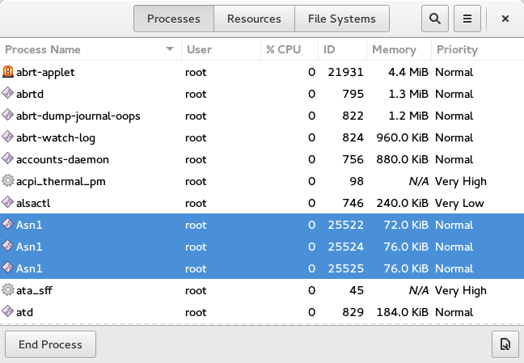

|  |  |  |  |  |
| --- | --- | --- | --- | --- |
| 3 | Each character from keyboard input is echoed on the screen | 1. Start Program 2. Type “Hello world” | “Hello world” should echoed on the screen | **Pass** |

***Test Case 3 | Screenshot***

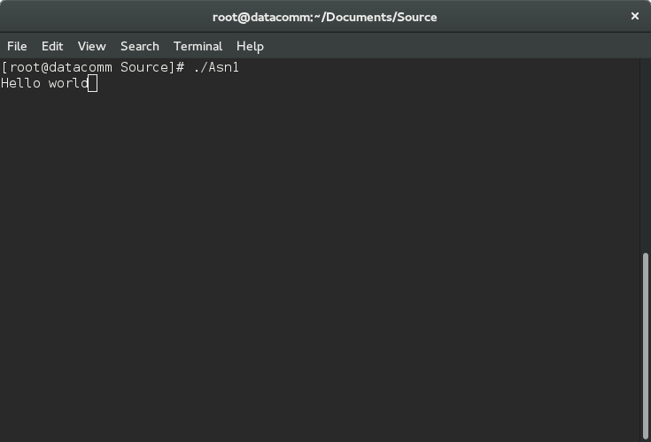

|  |  |  |  |  |
| --- | --- | --- | --- | --- |
| 4 | Abnormal termination | 1. Start Program 2. Type “^K” | Exists all three processes and give core dump error | **Pass** |

***Test Case 4 | Screenshot***

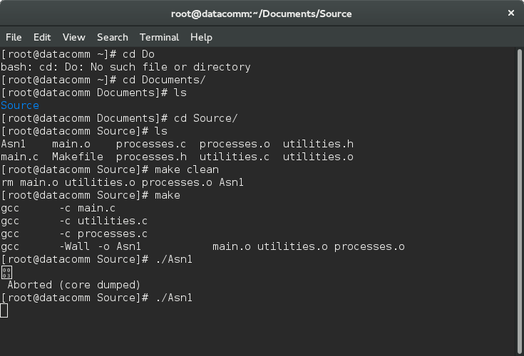

|  |  |  |  |  |
| --- | --- | --- | --- | --- |
| 5 | Translate from ‘a’ to z | 1. Start Program 2. Type “apple E” | Displays “zpple” | **Pass** |

***Test Case 5 | Screenshot***

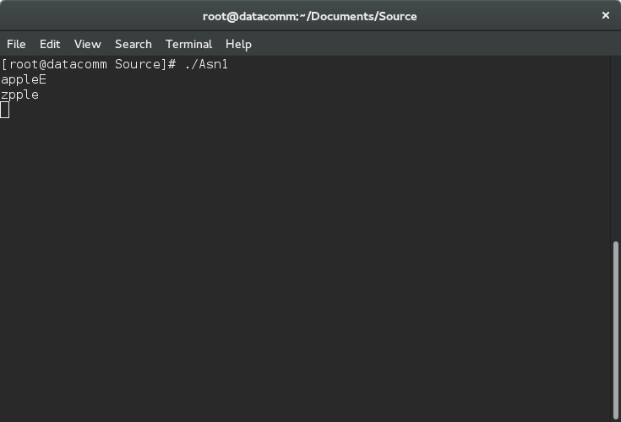

|  |  |  |  |  |
| --- | --- | --- | --- | --- |
| 6 | Delete character with ‘X’ | 1. Start Program 2. Type “Don’t delete meeeXXE” | Displays “Don’t delete me” | **Pass** |

***Test Case 6 | Screenshot***

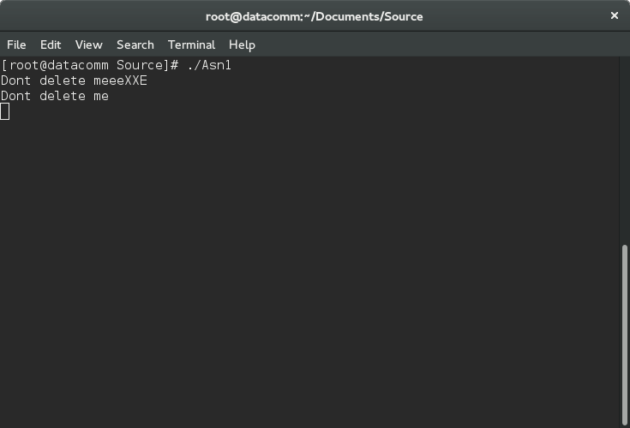

|  |  |  |  |  |
| --- | --- | --- | --- | --- |
| 7 | Line kill with ‘K’ | 1. Start Program 2. Type “I will be deleted K What happened? E” | Displays “Whzt happened?” | **Pass** |

***Test Case 7 | Screenshot***

