USER MANUAL

COMP 4981 Windows Socket

Table of Contents

1 Intro to Windows socket 2

2 User Interface Overlook 2

3 Program Flow | Functionalities 3

# Intro to Windows socket

This is a basic Win32 application created using Visual Studio in Windows. The purpose is to demonstrate the basic WniSock 2 API database lookup calls. The functionalities of the program are driven by the GUI user interface provided, which allow users to:

* Lookup IP Addresses, Alias and Hostname by passing in a web URL
* Lookup Host Name / Alias by passing in the IP address
* Lookup Service Name by passing in the Port Number and Protocol Type
* Lookup Port Number by passing in the Service Name and Protocol Type

*Note: All of the error handling and test cases will be provided in the test documentation, this is a general flow of success cases*

# User Interface Overlook

A general overview of the user interface when the program first started contains:

* A dropdown list that contains the type of input they would like to enter
* An input field for corresponding option selected from the dropdown box
* An input field for the type of protocol service
* A button that would start the database lookup, which takes the string from the input field
* A text field that displays the result of the database lookup. Also for displaying error messages.

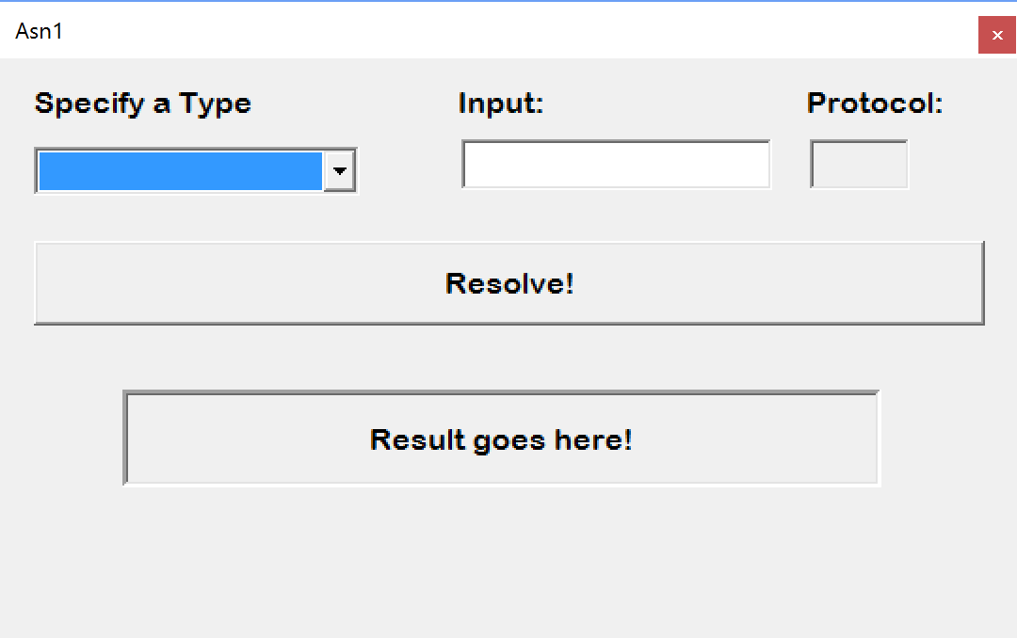

# Program Flow | Functionalities

Now we have the basic elements ready to go, let’s get into the flow of the program and its functionality.

**Host Name to IPs**

* Select the Host Name from the drop down list *(Note: the text on the button is updated!)*
* Enter <google.com> into the input field

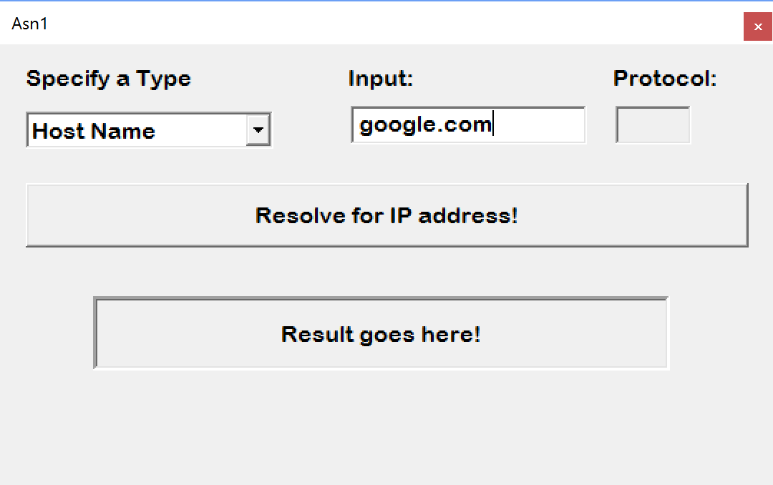

* Click on the “Resolve for IP address button”
* Voila! Two drop down lists appear before your eyes, along with the result text field updated with the Host Name

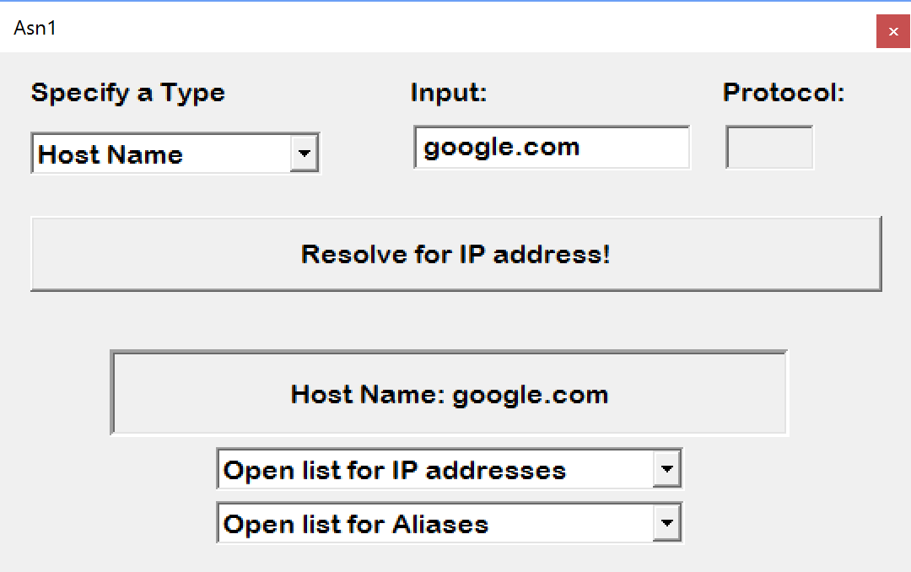

* Let’s open the IP address list

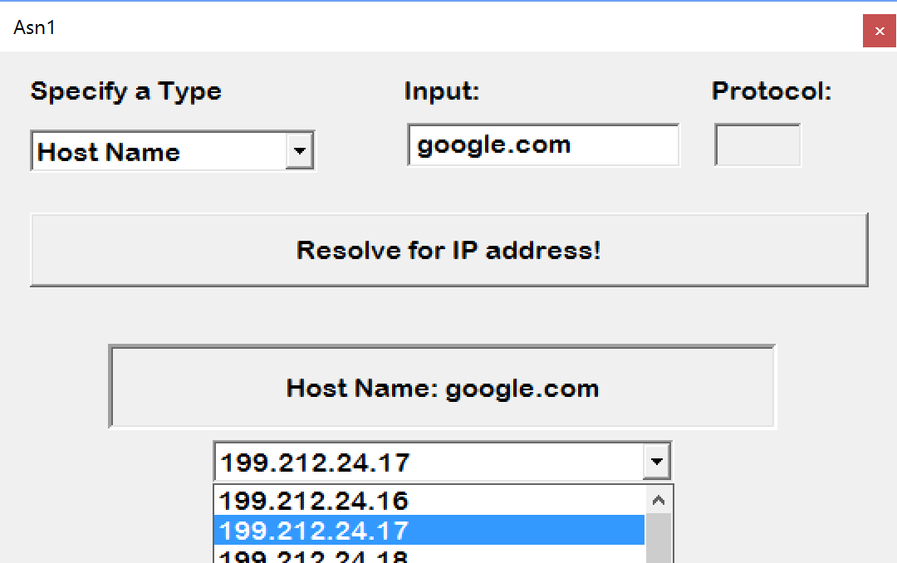

* Since there are no alias for <google.com>, we will use <http://www.milliways.bcit.ca> instead

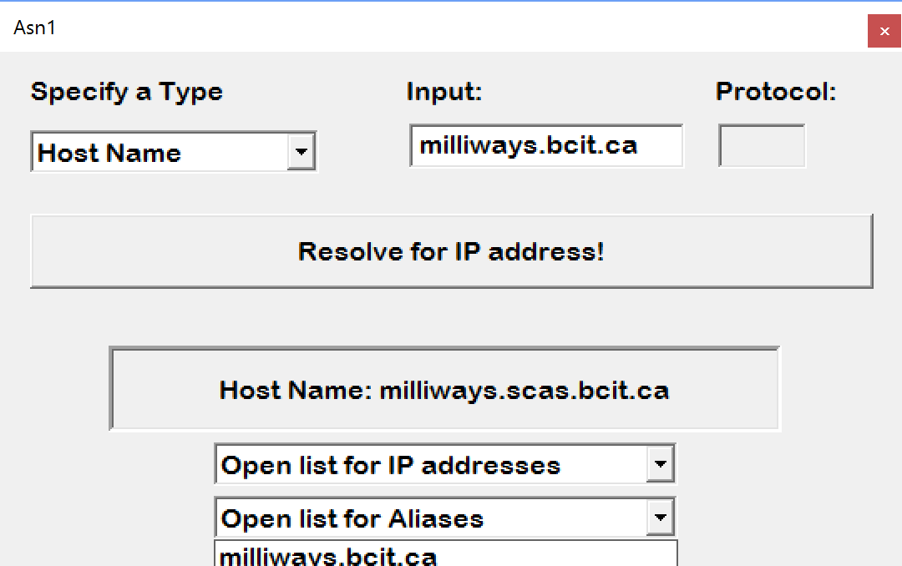

**IP to Host Name**

* Select Host Name from the drop down list (*Note: the text on the button is updated!)*
* Enter <8.8.8.8> (Google’s IP address) into the input field
* Click the “Resolve for host name!” button

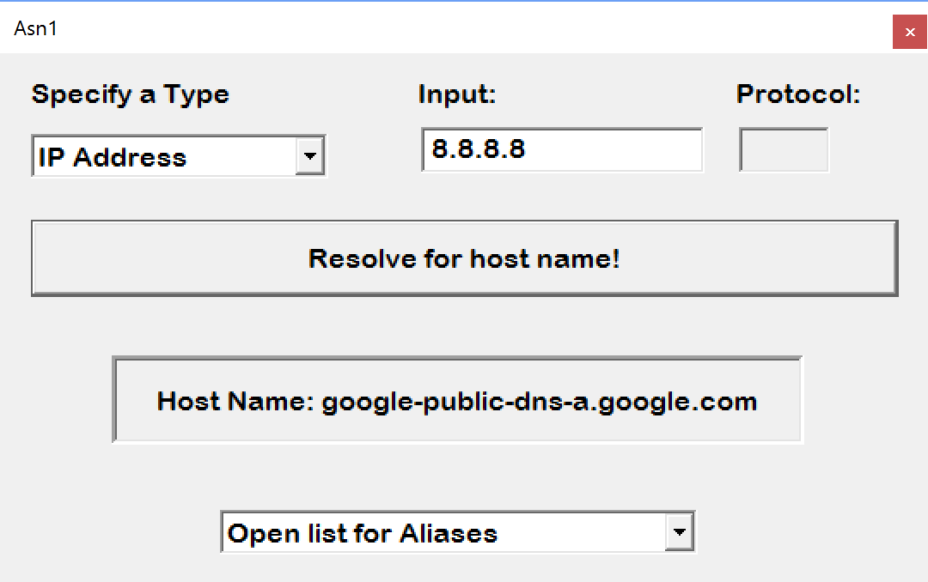

**Port Number to Service Name**

* Select Port Number from the drop down list *(Note: the protocol input field is now editable)*

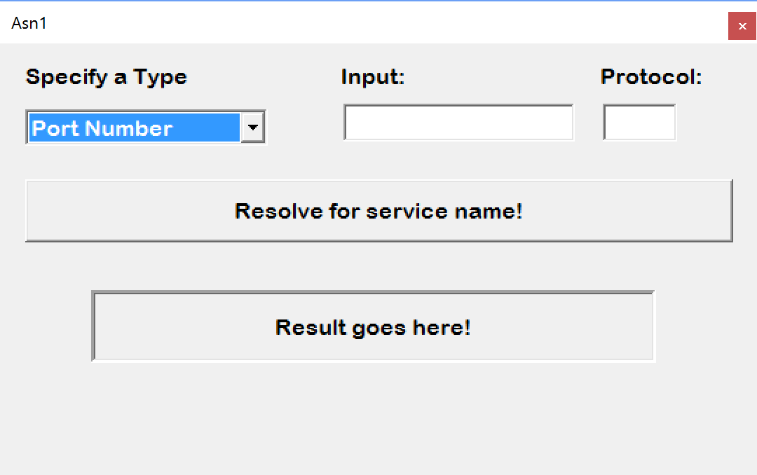

* Enter “20” into the input field
* Enter “tcp” into the input field
* Click on “Resolve for service name!” button

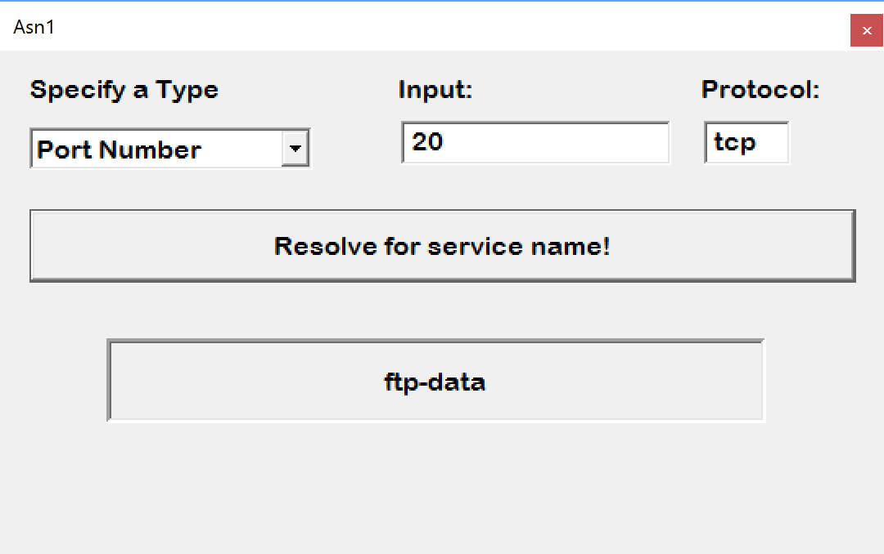

* An dup protocol lookup:

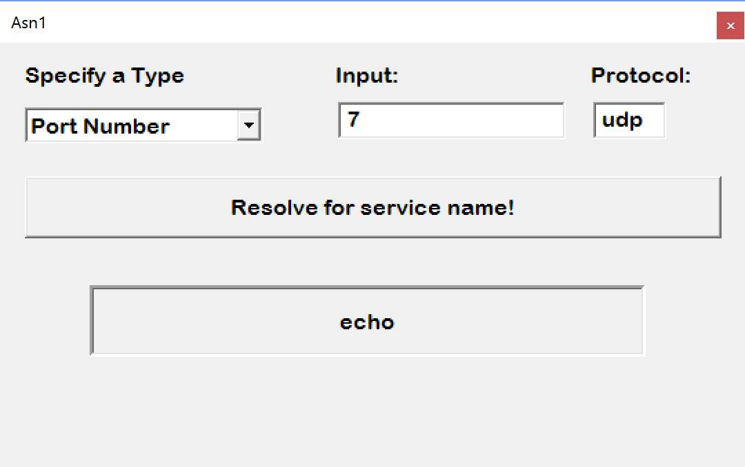

**Service Name to Port Number**

* Select Service Name from the drop down list *(Note: the protocol input field is now editable)*
* Enter “http” into the input field
* Enter “tcp” as the protocol type
* Click on “Resolve for port number!” button

