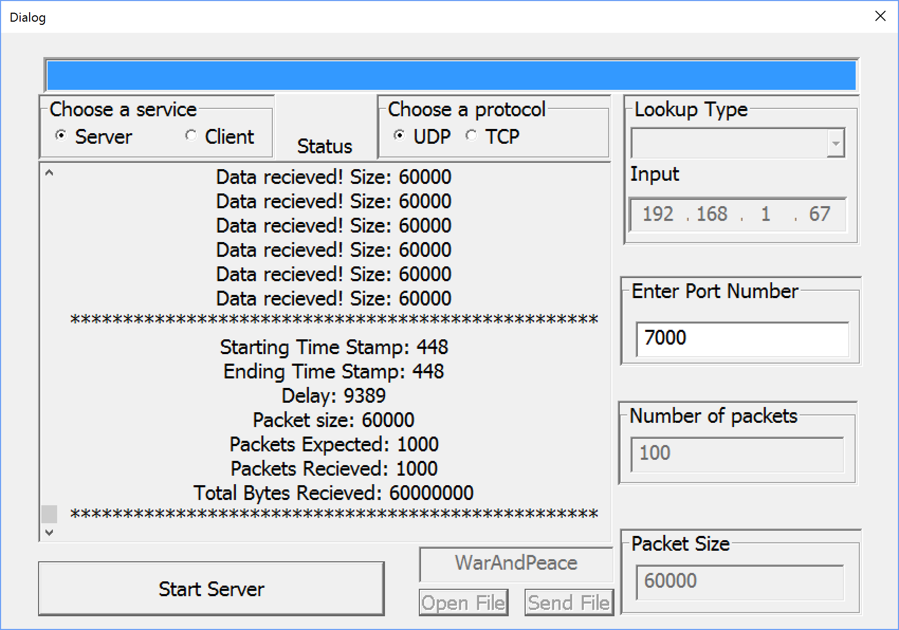

TEST DOCUMENTATION

COMP 4985 Protocol Analyzer

[Notes]

Testing Parameters:

Port Number: 7000

IP Address: 192.168.1.67

Network Type:

Local Area Network

|  |  |  |  |  |
| --- | --- | --- | --- | --- |
| **Test #** | **Description** | **Test Steps** | **Expected Result** | **Pass / Fail** |

|  |  |  |  |  |
| --- | --- | --- | --- | --- |
| 1 | Initialize TCP Server | 1. Start Program 2. Select Server 3. Select TCP 4. Fill in testing parameters 5. Select Connect | Display “TCP Server Initialized” | **Pass** |

**Test Case 1 | Screenshot TCP Server**

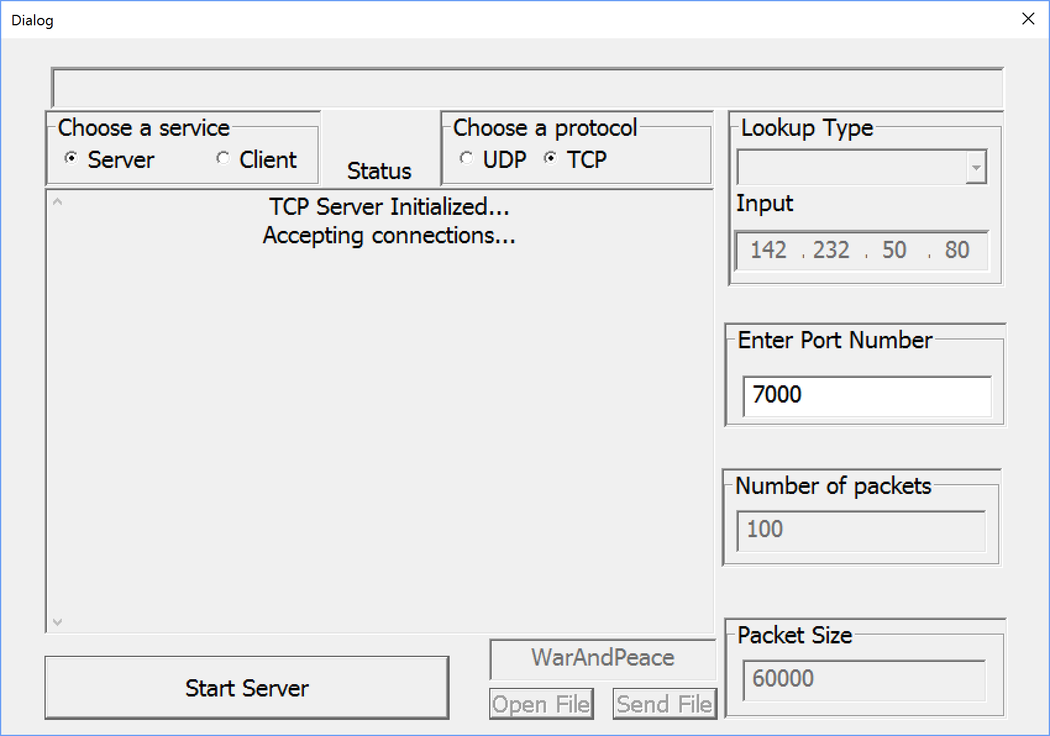

|  |  |  |  |  |
| --- | --- | --- | --- | --- |
| 2 | Initialize TCP Server | 1. Start Program 2. Select Server 3. Select UDP 4. Fill in testing parameters 5. Select Connect | Display “UDP Server Initialized” | **Pass** |

**Test Case 2 | Screenshot TCP Server**

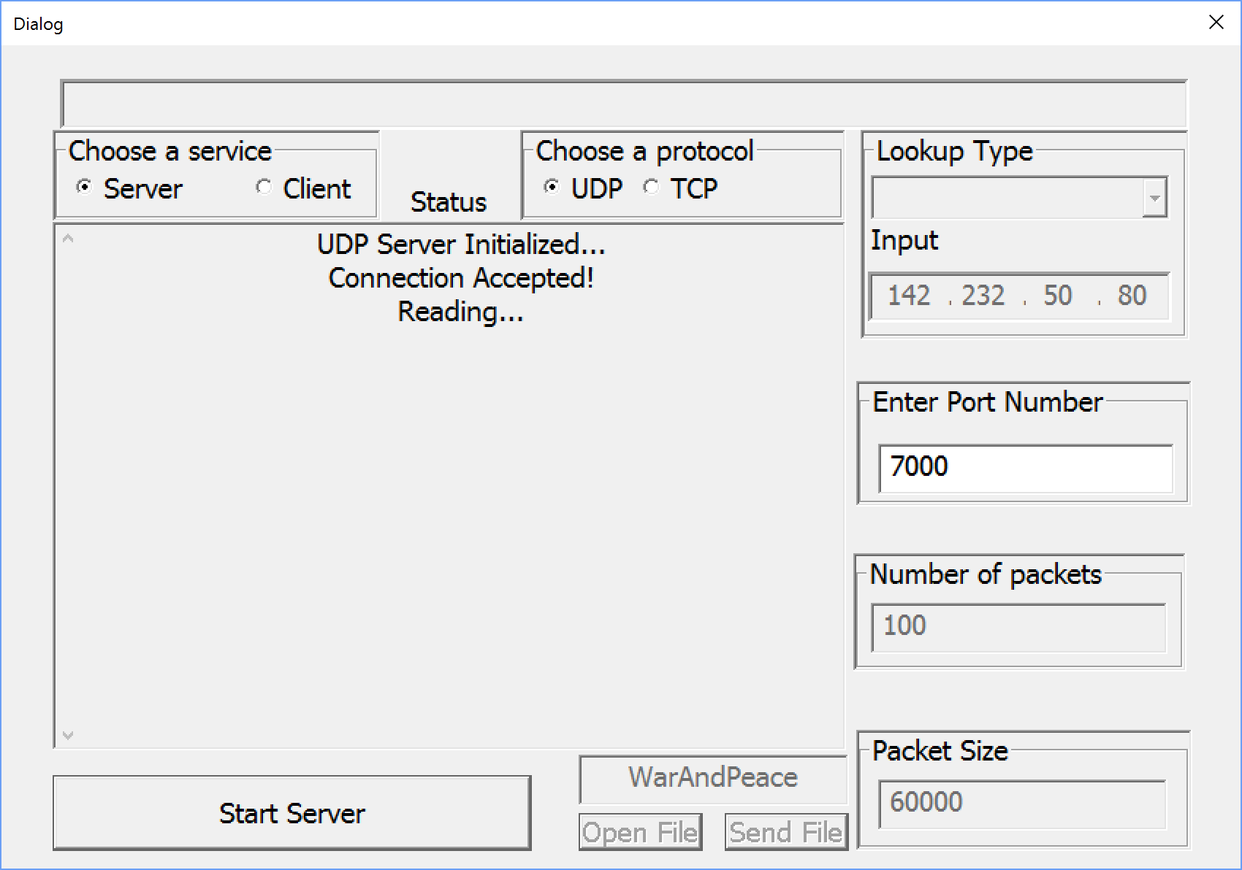

|  |  |  |  |  |
| --- | --- | --- | --- | --- |
| 3 | Initialize control message successfully sent and received | **Client**   1. Start Program 2. Select Client 3. Select TCP 4. Fill in testing parameters 5. Packet size 1024, send times 1 6. Select Connect   **Server**   1. Start Program 2. Select Server 3. Select TCP 4. Fill in testing parameters 5. Select Connect | **Client**  Display server port number, IP address, and size of packet sent every time  **Server**  Display “Expected packet size: 1024, Expected number of packets: 1” | **Pass** |

***Test Case 3 | Screenshot TCP Client***

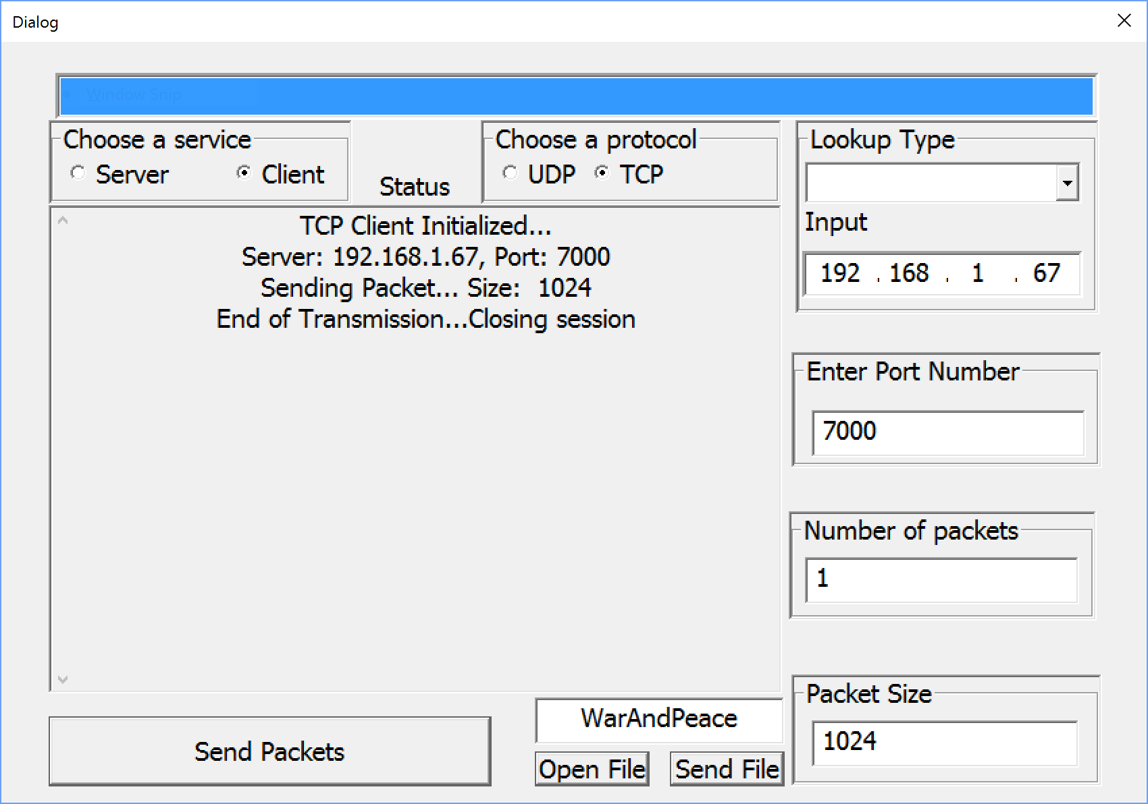

**Test Case 3 | Screenshot TCP Server**

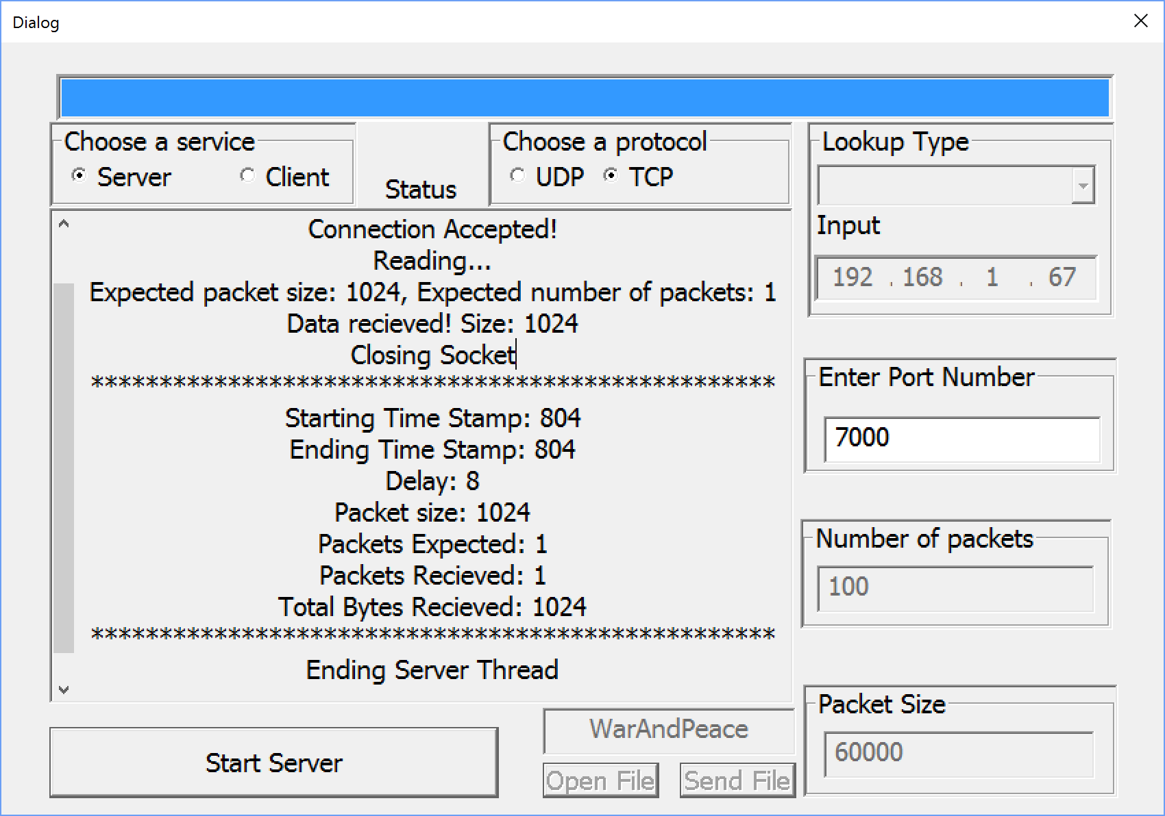

|  |  |  |  |  |
| --- | --- | --- | --- | --- |
| 4 | Send and receive 1024 size packets 10 times | **Client**   1. Start Program 2. Select Client 3. Select TCP 4. Fill in testing parameters 5. Packet size 1024, send times 10 6. Select Connect   **Server**   1. Start Program 2. Select Server 3. Select TCP 4. Fill in testing parameters 5. Select Connect” | **Client**  Display server port number, IP address, and size of packet sent every time  **Server**  Display “Expected packet size: 1024, Expected number of packets: 10”  Display “packets received” every time a packet is read  Display transmission information, which receives all the packets | **Pass** |

***Test Case 4 | Screenshot TCP Client***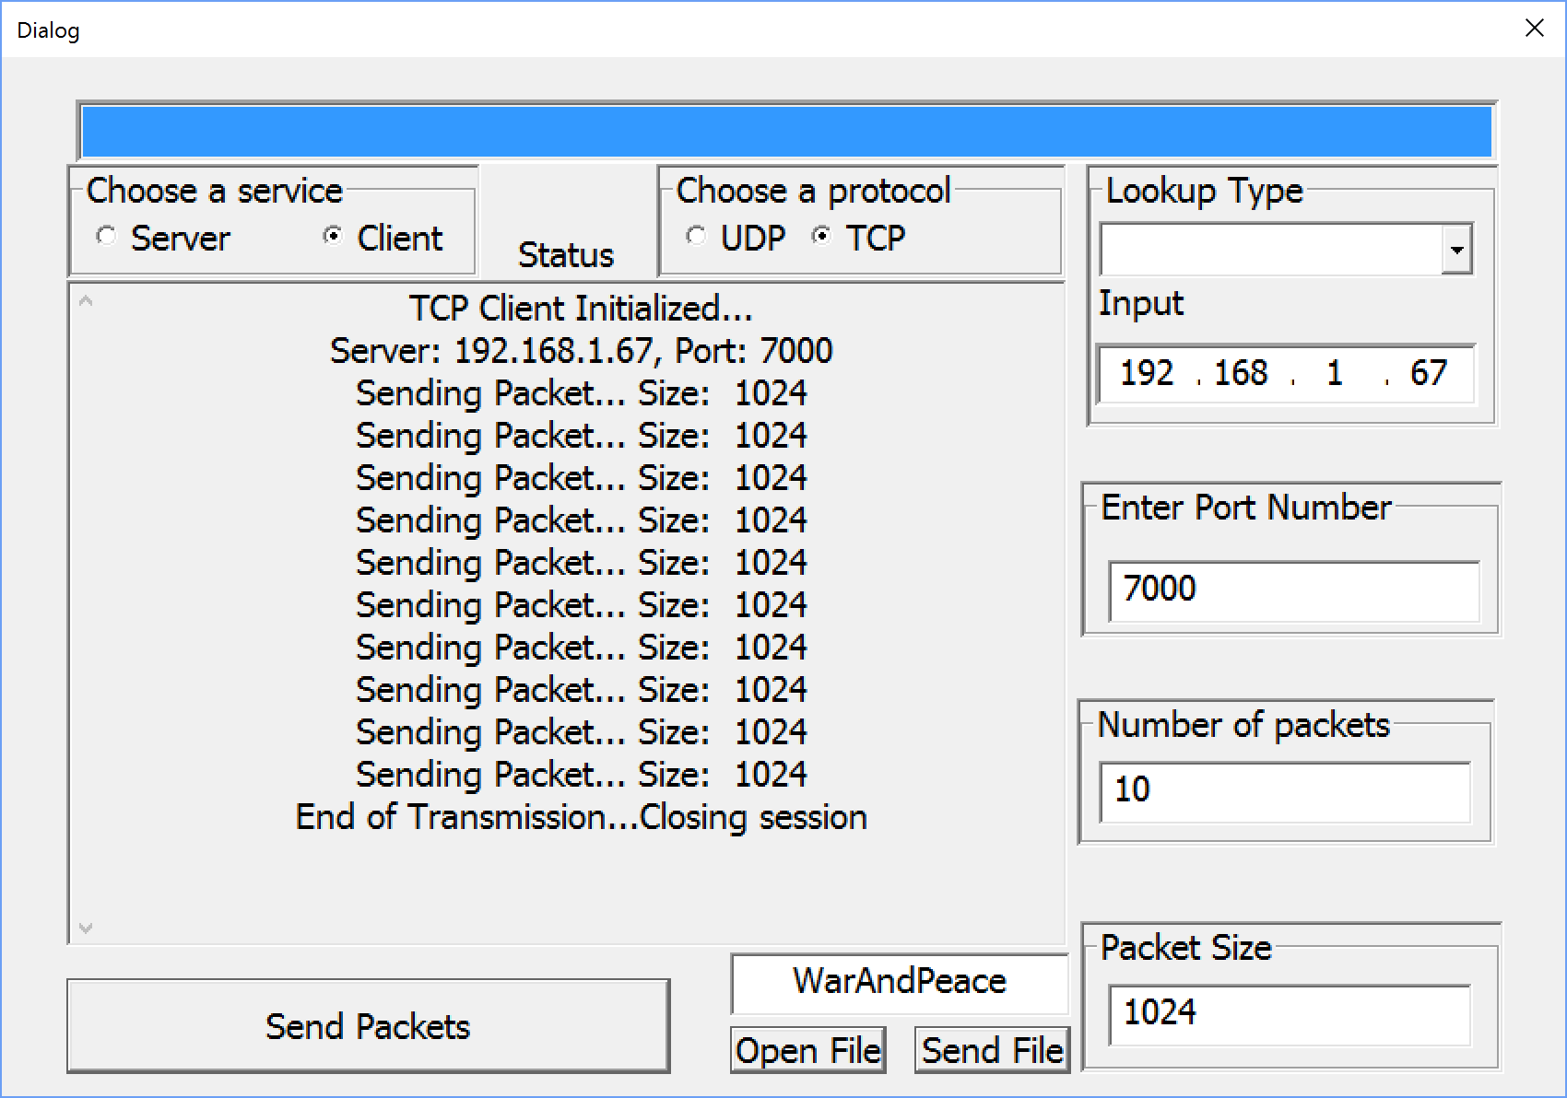

***Test Case 4 | Screenshot TCP Server***

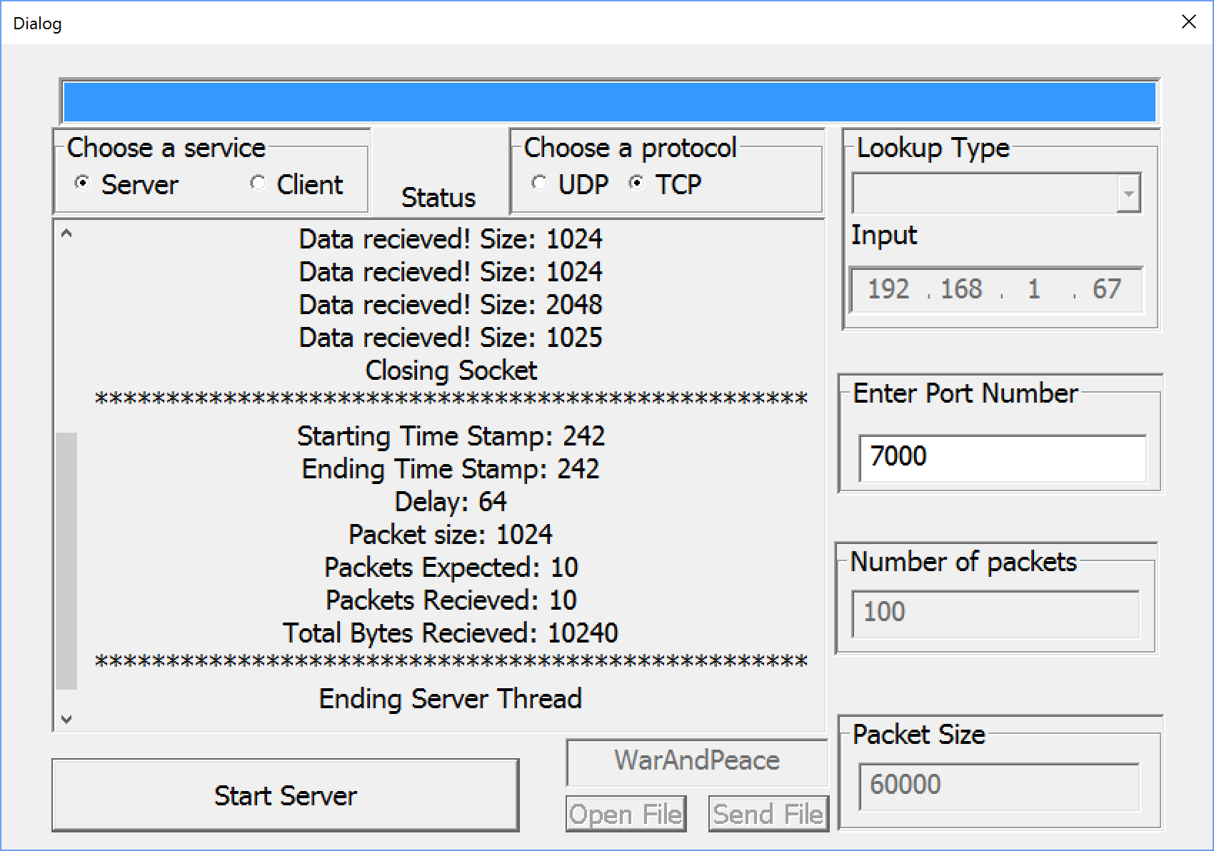

|  |  |  |  |  |
| --- | --- | --- | --- | --- |
| 5 | Send and receive 1024 size packets 100 times | **Client**   1. Start Program 2. Select Client 3. Select TCP 4. Fill in testing parameters 5. Packet size 1024, send times 100 6. Select Connect   **Server**   1. Start Program 2. Select Server 3. Select TCP 4. Fill in testing parameters 5. Select Connect” | **Client**  Display server port number, IP address, and size of packet sent every time  **Server**  Display “Expected packet size: 1024, Expected number of packets: 100”  Display “packets received” every time a packet is read  Display transmission information, which receives all the packets | **Pass** |

***Test Case 5 | Screenshot TCP Client***

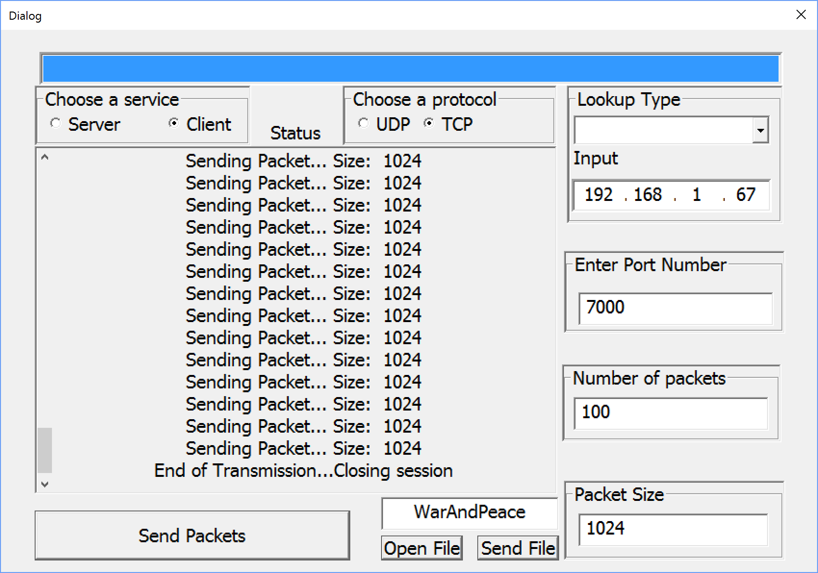

***Test Case 5 | Screenshot TCP Server***

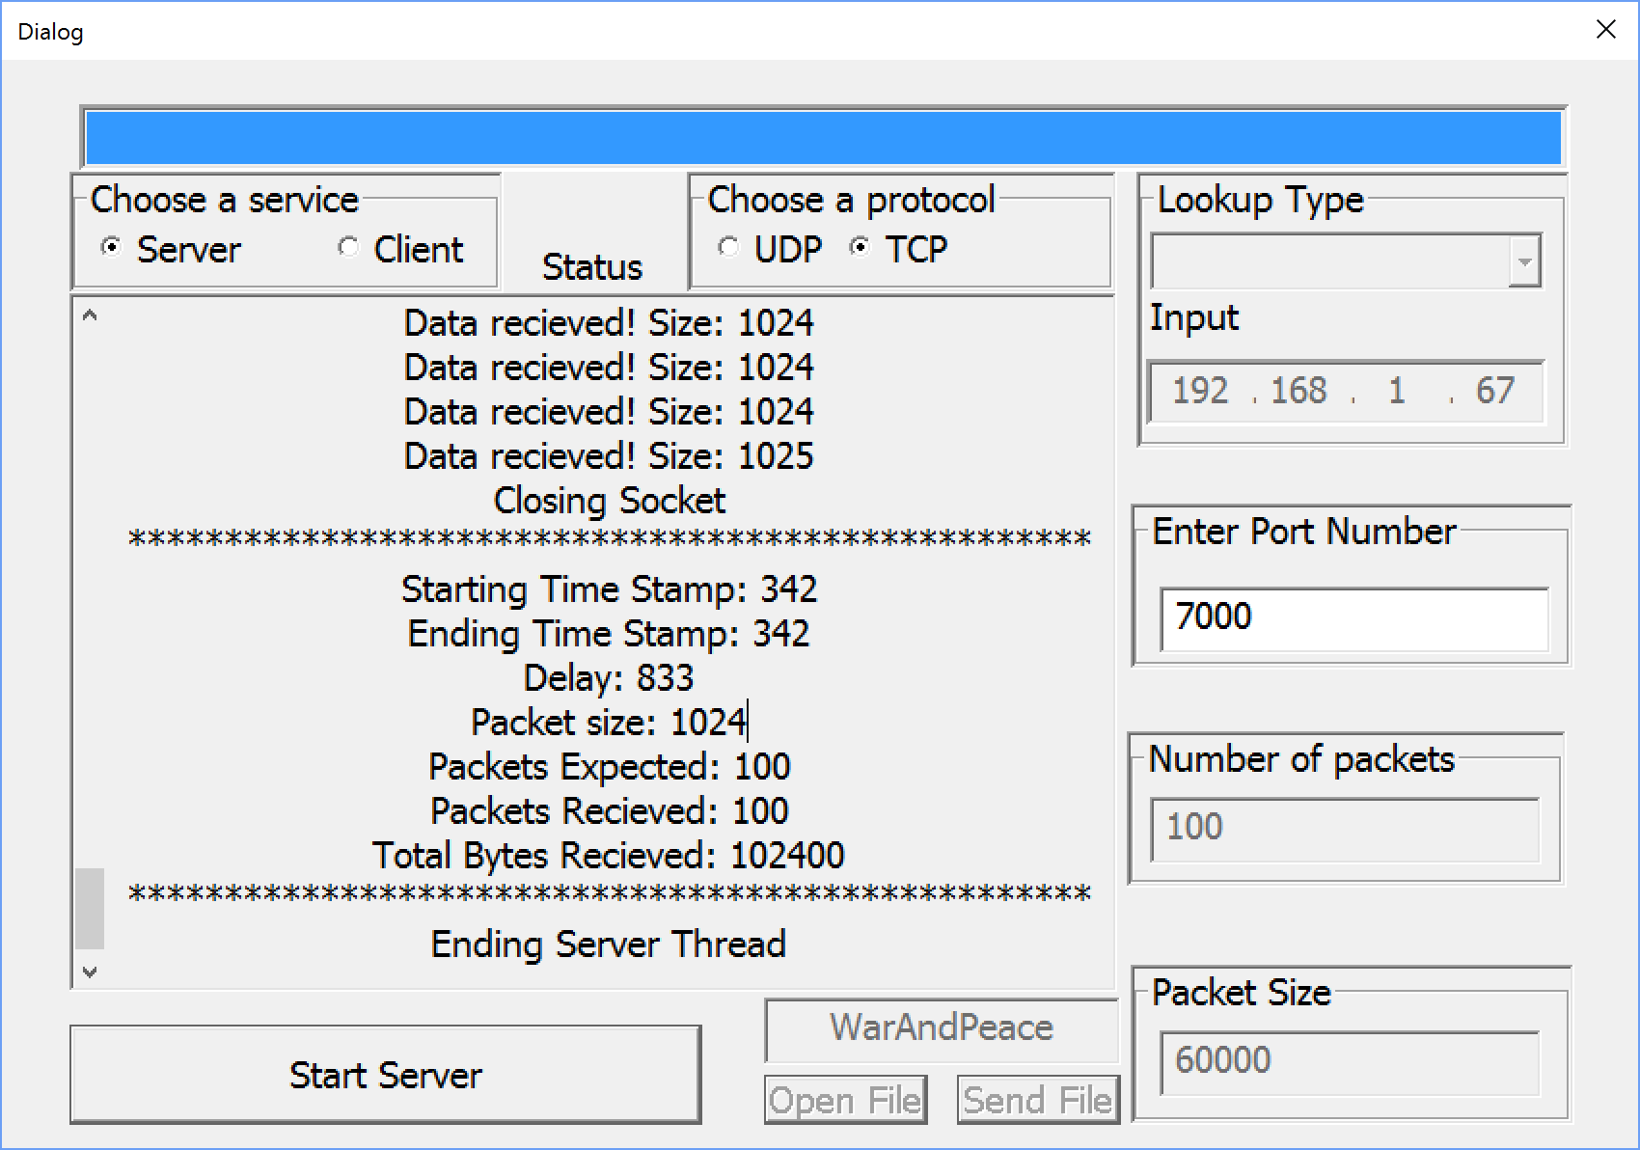

|  |  |  |  |  |
| --- | --- | --- | --- | --- |
| 6 | Send and receive 4096 size packets 10 times | **Client**   1. Start Program 2. Select Client 3. Select TCP 4. Fill in testing parameters 5. Packet size 1024, send times 10 6. Select Connect   **Server**   1. Start Program 2. Select Server 3. Select TCP 4. Fill in testing parameters 5. Select Connect” | **Client**  Display server port number, IP address, and size of packet sent every time  **Server**  Display “Expected packet size: 4096, Expected number of packets: 10”  Display “packets received” every time a packet is read  Display transmission information, which receives all the packets | **Pass** |

***Test Case 6 | Screenshot TCP Client***

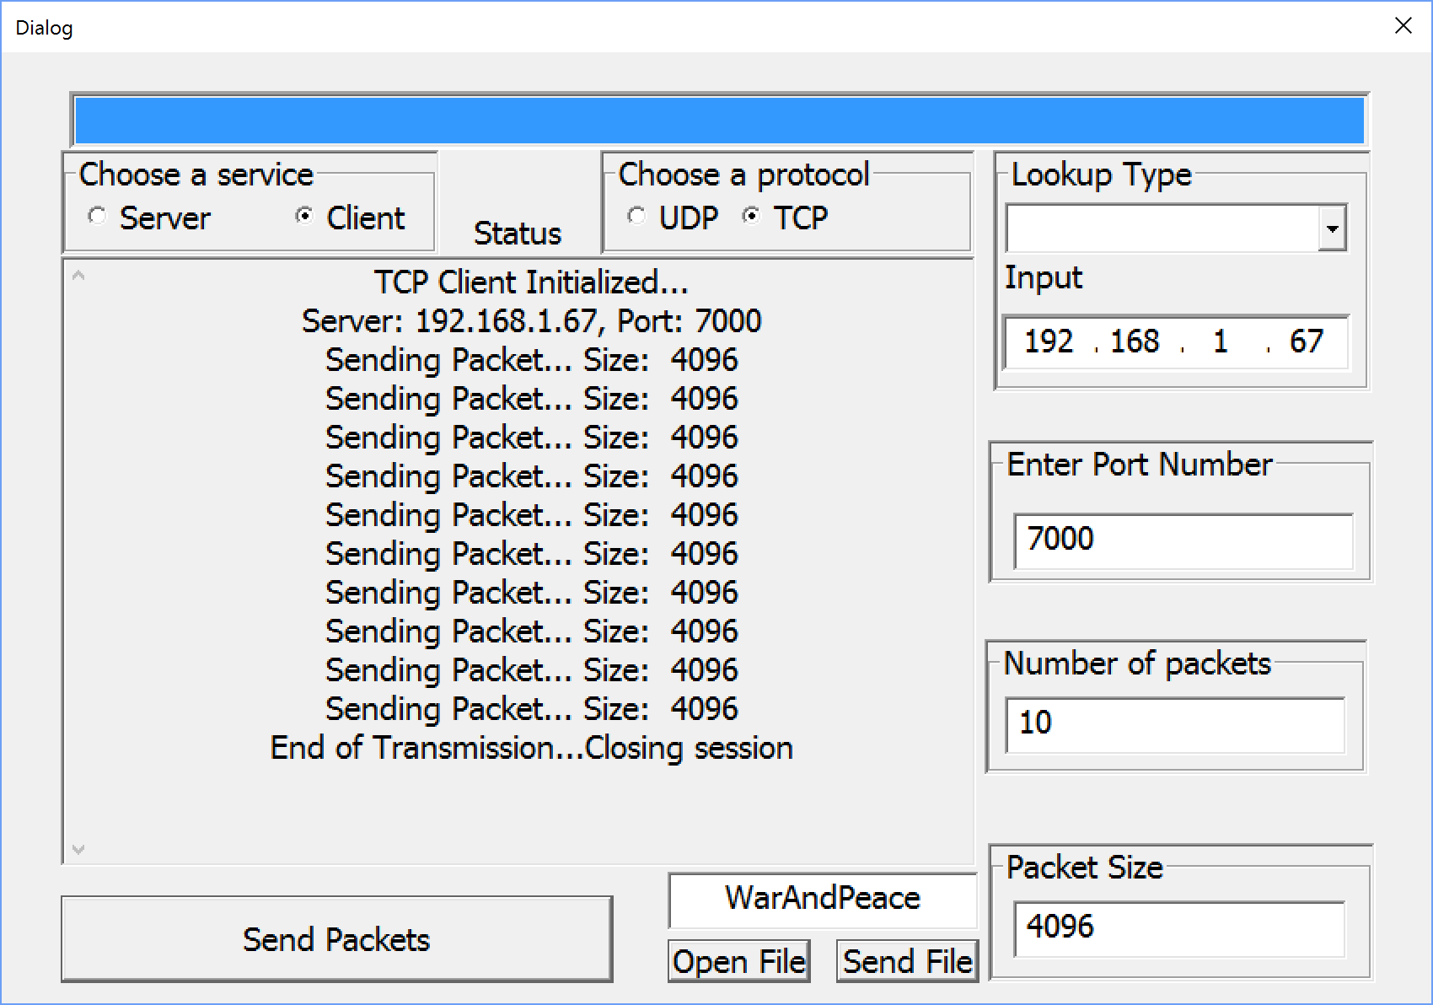

***Test Case 6 | Screenshot TCP Server***

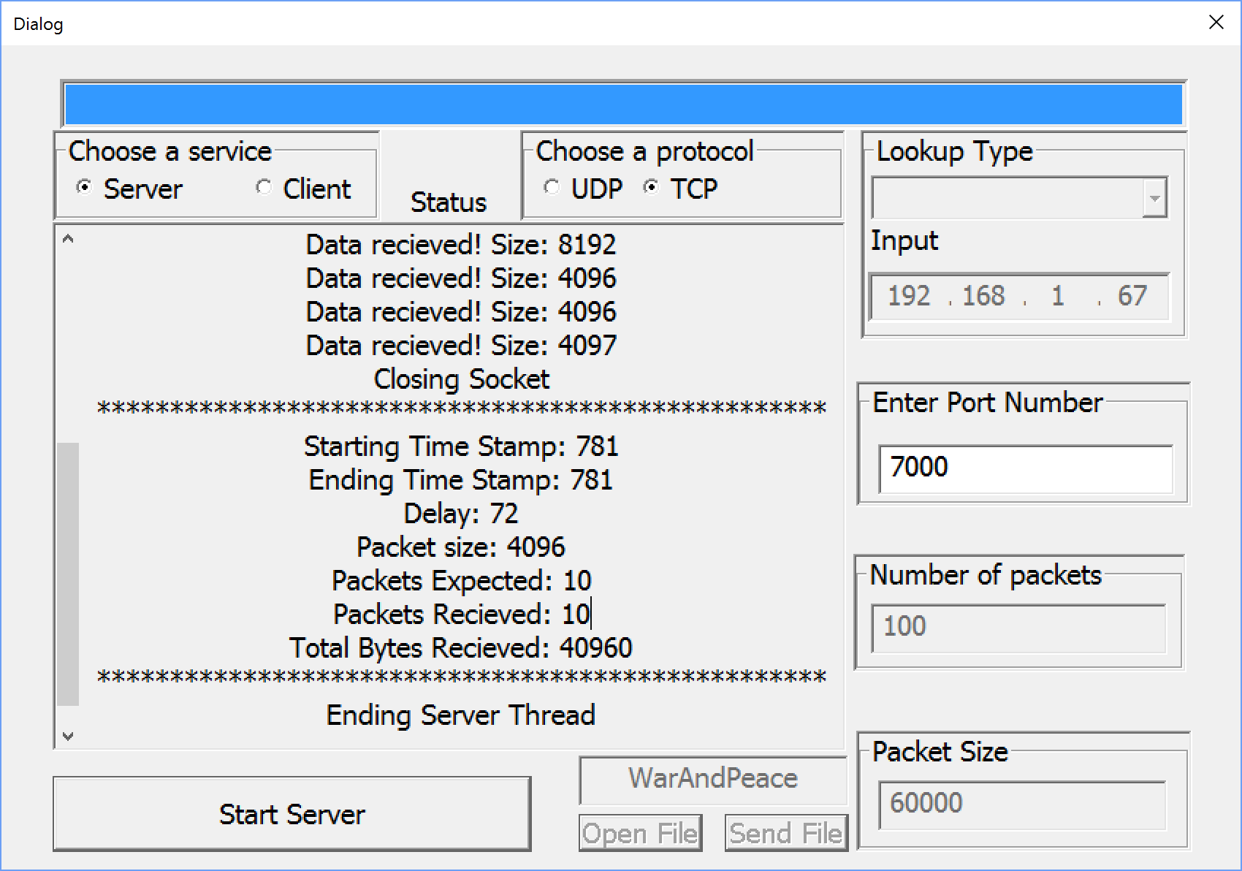

|  |  |  |  |  |
| --- | --- | --- | --- | --- |
| 7 | Send and receive 4096 size packets 100 times | **Client**   1. Start Program 2. Select Client 3. Select TCP 4. Fill in testing parameters 5. Packet size 1024, send times 100 6. Select Connect   **Server**   1. Start Program 2. Select Server 3. Select TCP 4. Fill in testing parameters 5. Select Connect” | **Client**  Display server port number, IP address, and size of packet sent every time  **Server**  Display “Expected packet size: 4096, Expected number of packets: 100”  Display “packets received” every time a packet is read  Display transmission information, which receives all the packets | **Pass** |

***Test Case 7 | Screenshot TCP Client***

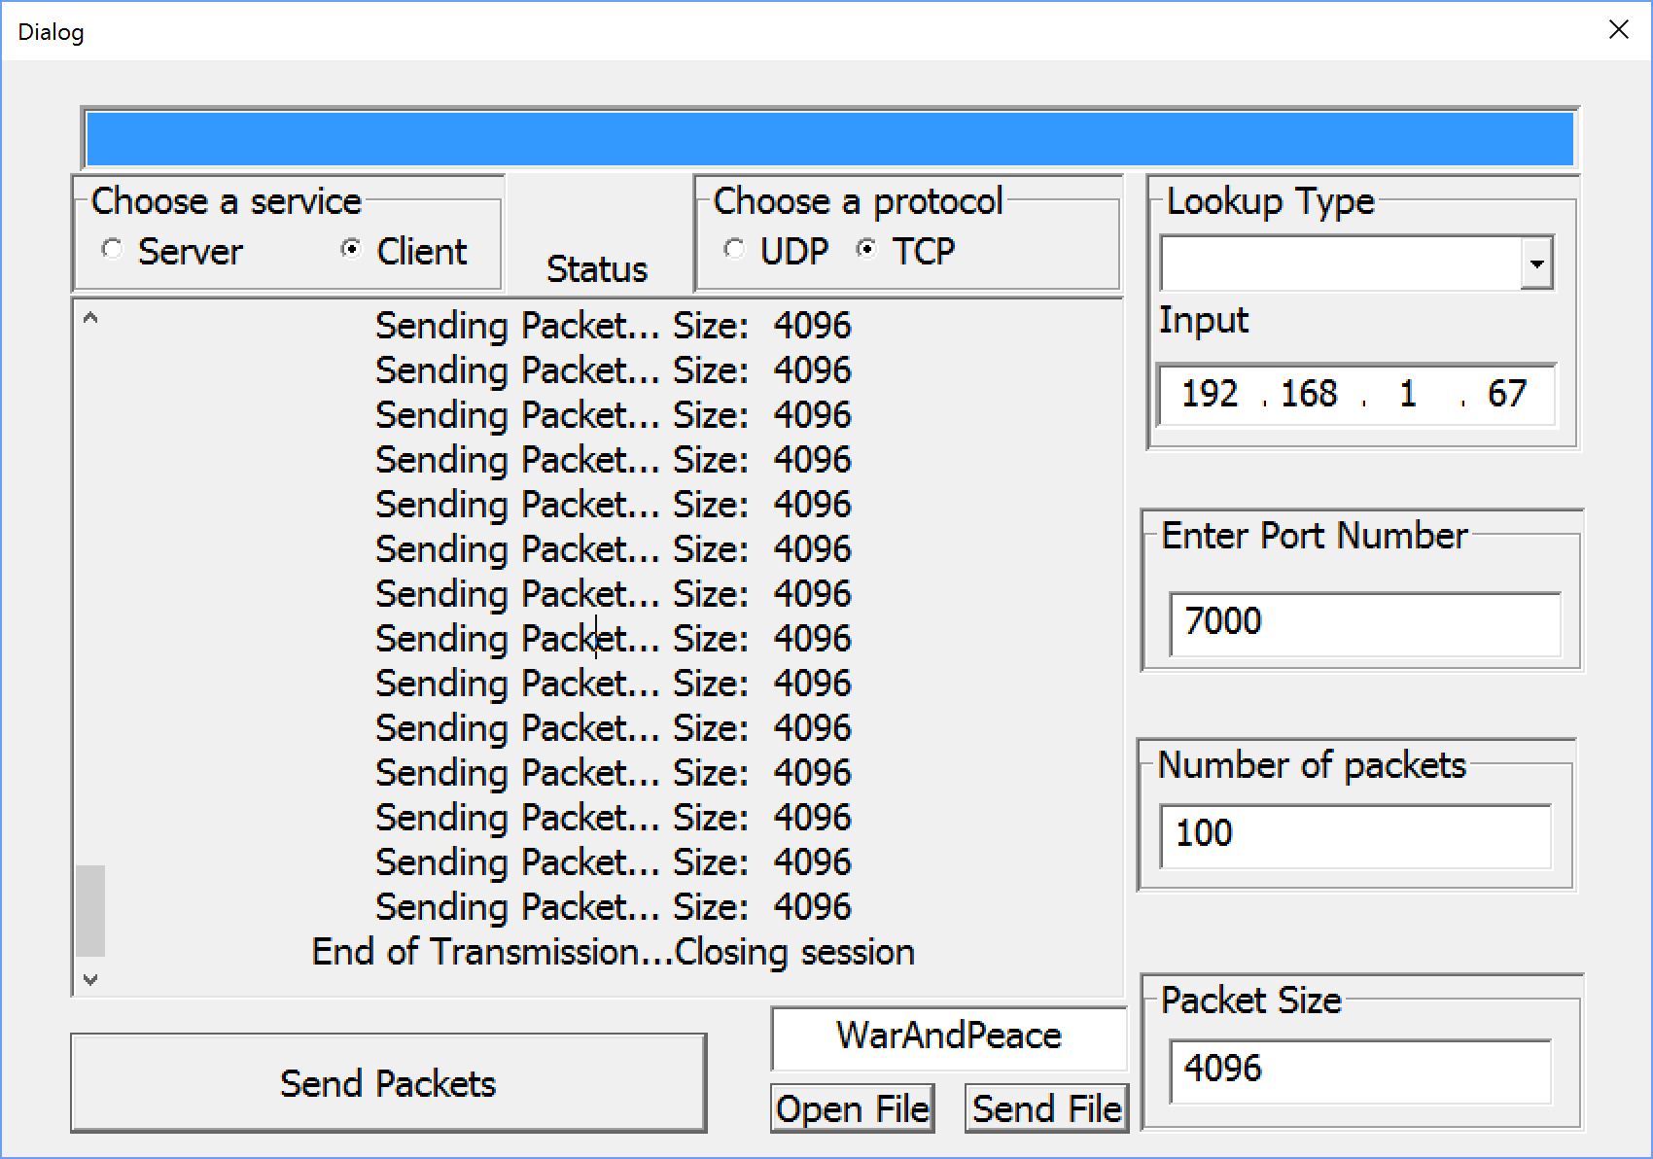

***Test Case 7 | Screenshot TCP Server***

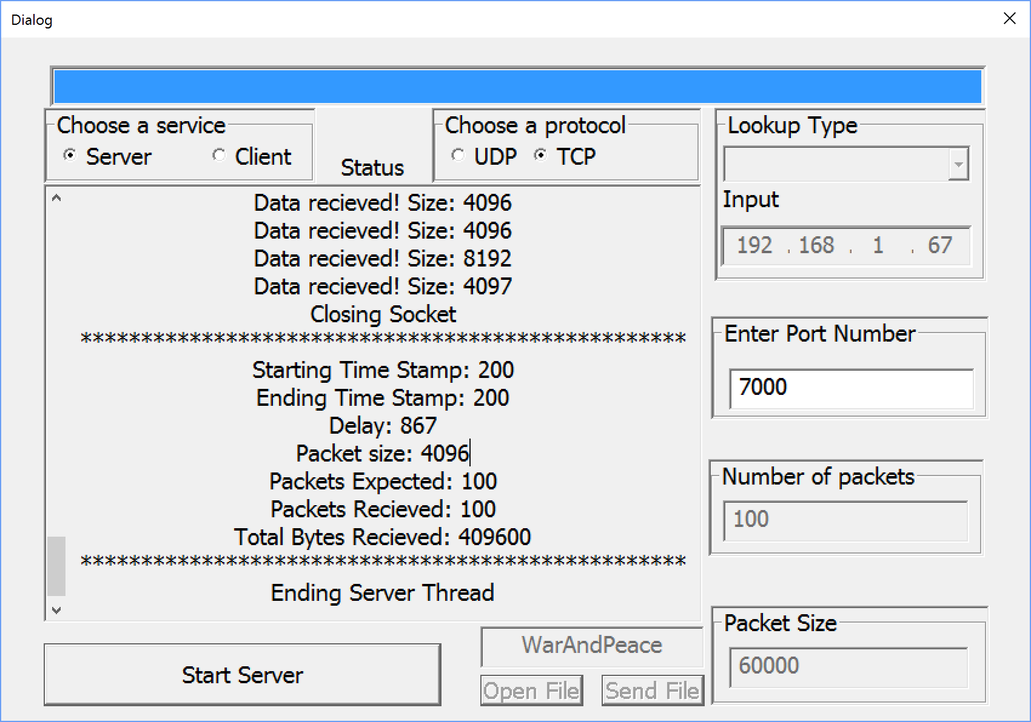

|  |  |  |  |  |
| --- | --- | --- | --- | --- |
| 8 | Send and receive 20000 size packets 10 times | **Client**   1. Start Program 2. Select Client 3. Select TCP 4. Fill in testing parameters 5. Packet size 20000, send times 10 6. Select Connect   **Server**   1. Start Program 2. Select Server 3. Select TCP 4. Fill in testing parameters 5. Select Connect” | **Client**  Display server port number, IP address, and size of packet sent every time  **Server**  Display “Expected packet size: 20000, Expected number of packets: 10”  Display “packets received” every time a packet is read  Display transmission information, which receives all the packets | **Pass** |

***Test Case 8 | Screenshot TCP Client***

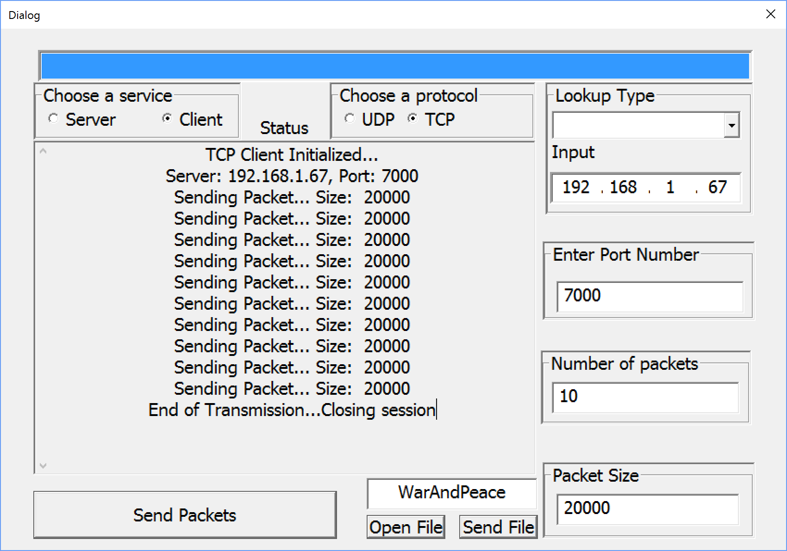

***Test Case 8 | Screenshot TCP Server***

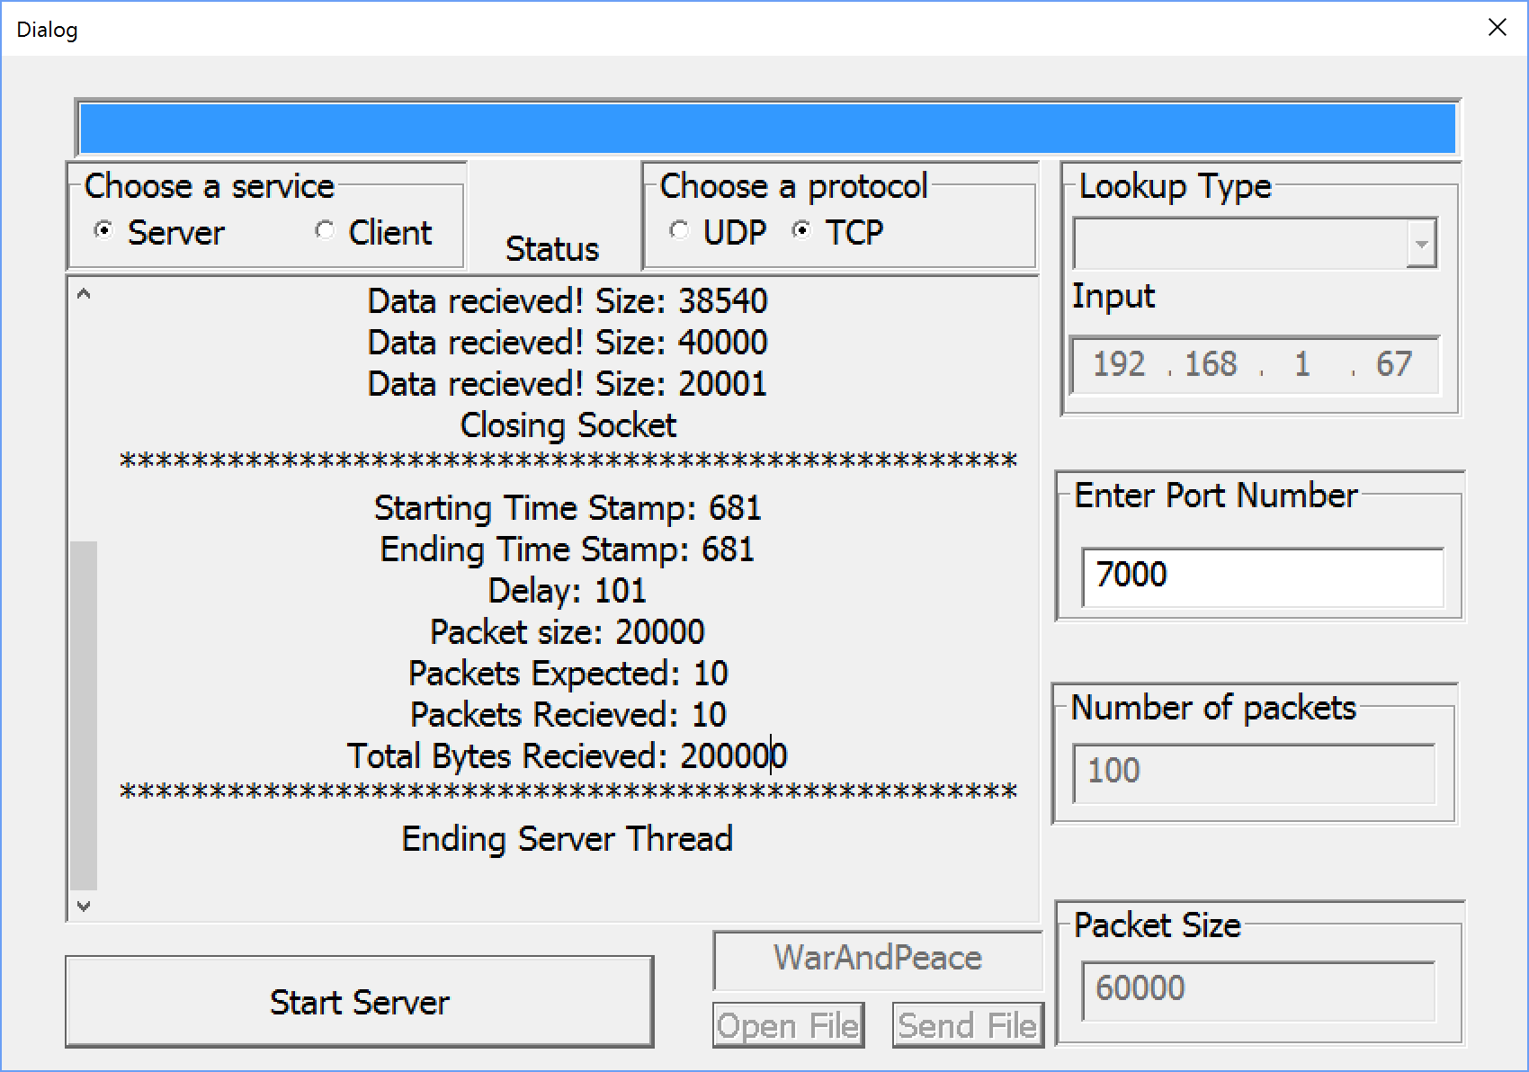

|  |  |  |  |  |
| --- | --- | --- | --- | --- |
| 9 | Send and receive 20000 size packets 100 times | **Client**   1. Start Program 2. Select Client 3. Select TCP 4. Fill in testing parameters 5. Packet size 20000, send times 100 6. Select Connect   **Server**   1. Start Program 2. Select Server 3. Select TCP 4. Fill in testing parameters 5. Select Connect” | **Client**  Display server port number, IP address, and size of packet sent every time  **Server**  Display “Expected packet size: 20000, Expected number of packets: 100”  Display “packets received” every time a packet is read  Display transmission information, which receives all the packets | **Pass** |

***Test Case 9 | Screenshot TCP Client***

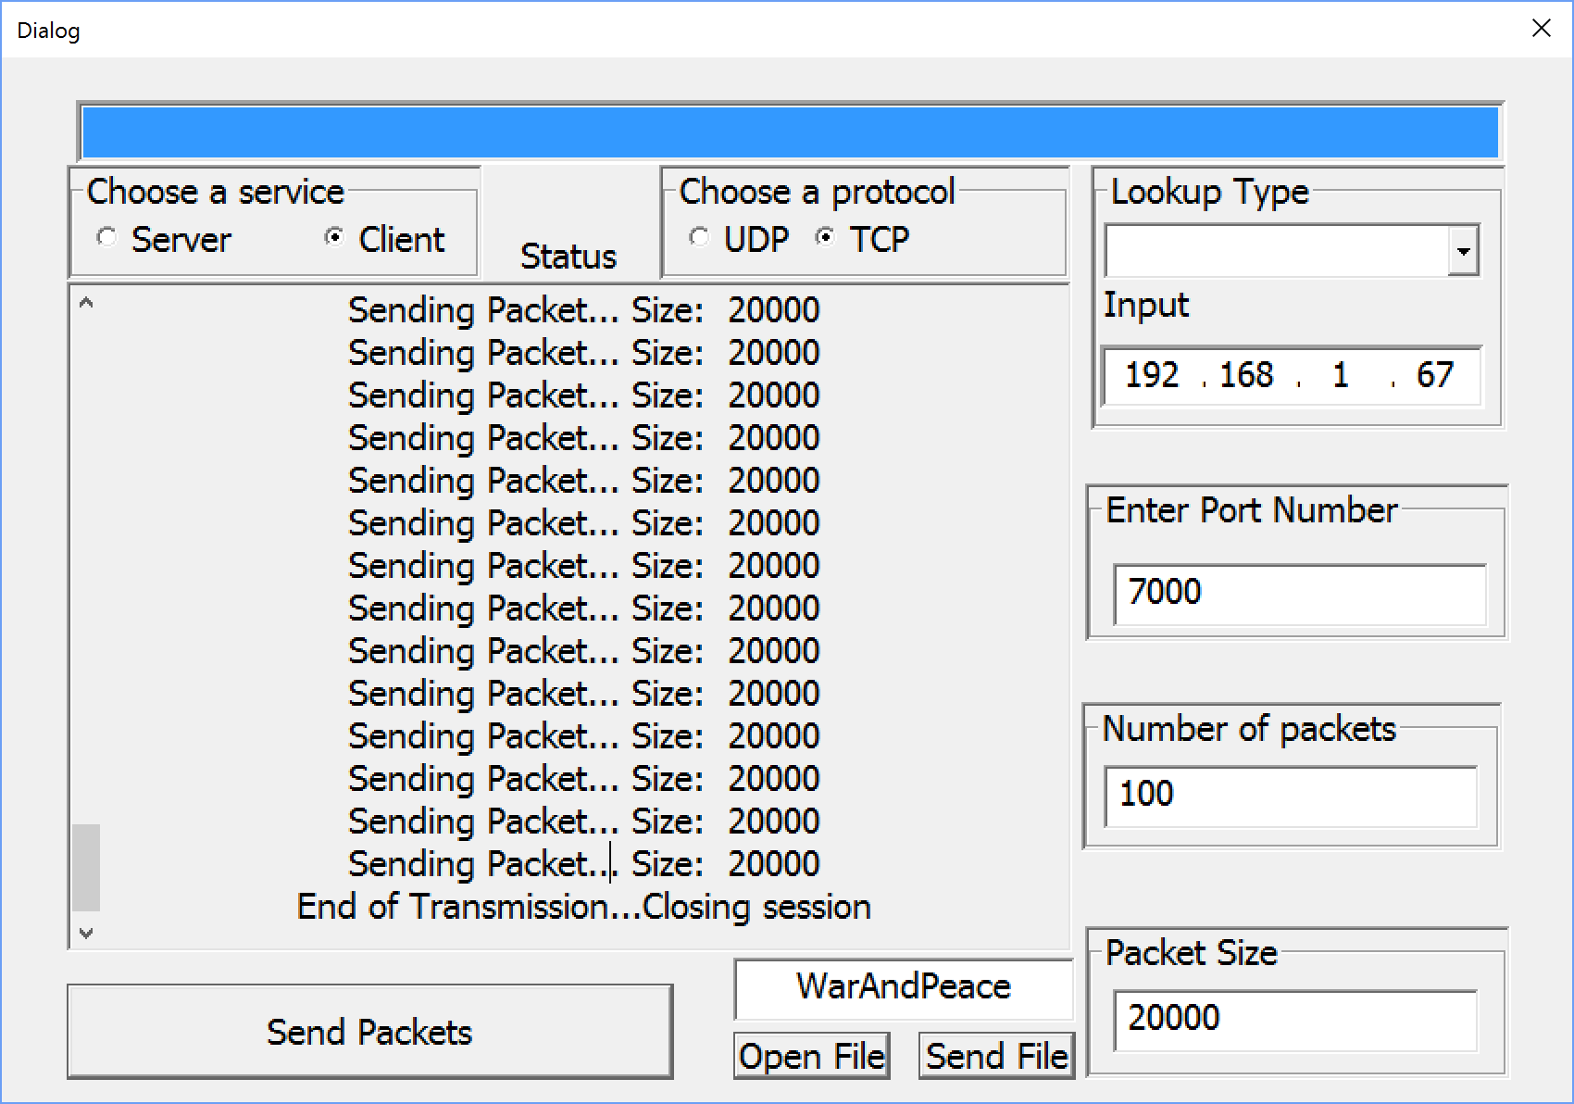

***Test Case 9 | Screenshot TCP Server***

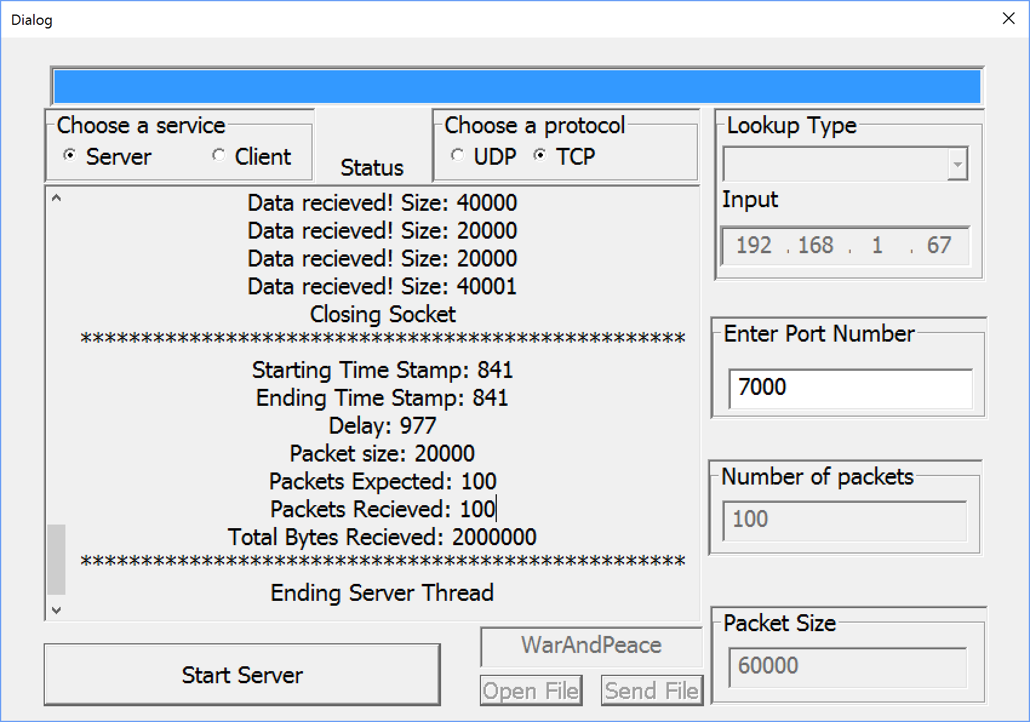

|  |  |  |  |  |
| --- | --- | --- | --- | --- |
| 10 | Send and receive 60000 size packets 10 times | **Client**   1. Start Program 2. Select Client 3. Select TCP 4. Fill in testing parameters 5. Packet size 60000, send times 10 6. Select Connect   **Server**   1. Start Program 2. Select Server 3. Select TCP 4. Fill in testing parameters 5. Select Connect” | **Client**  Display server port number, IP address, and size of packet sent every time  **Server**  Display “Expected packet size: 60000, Expected number of packets: 10”  Display “packets received” every time a packet is read  Display transmission information, which receives all the packets | **Pass** |

***Test Case 10 | Screenshot TCP Client***

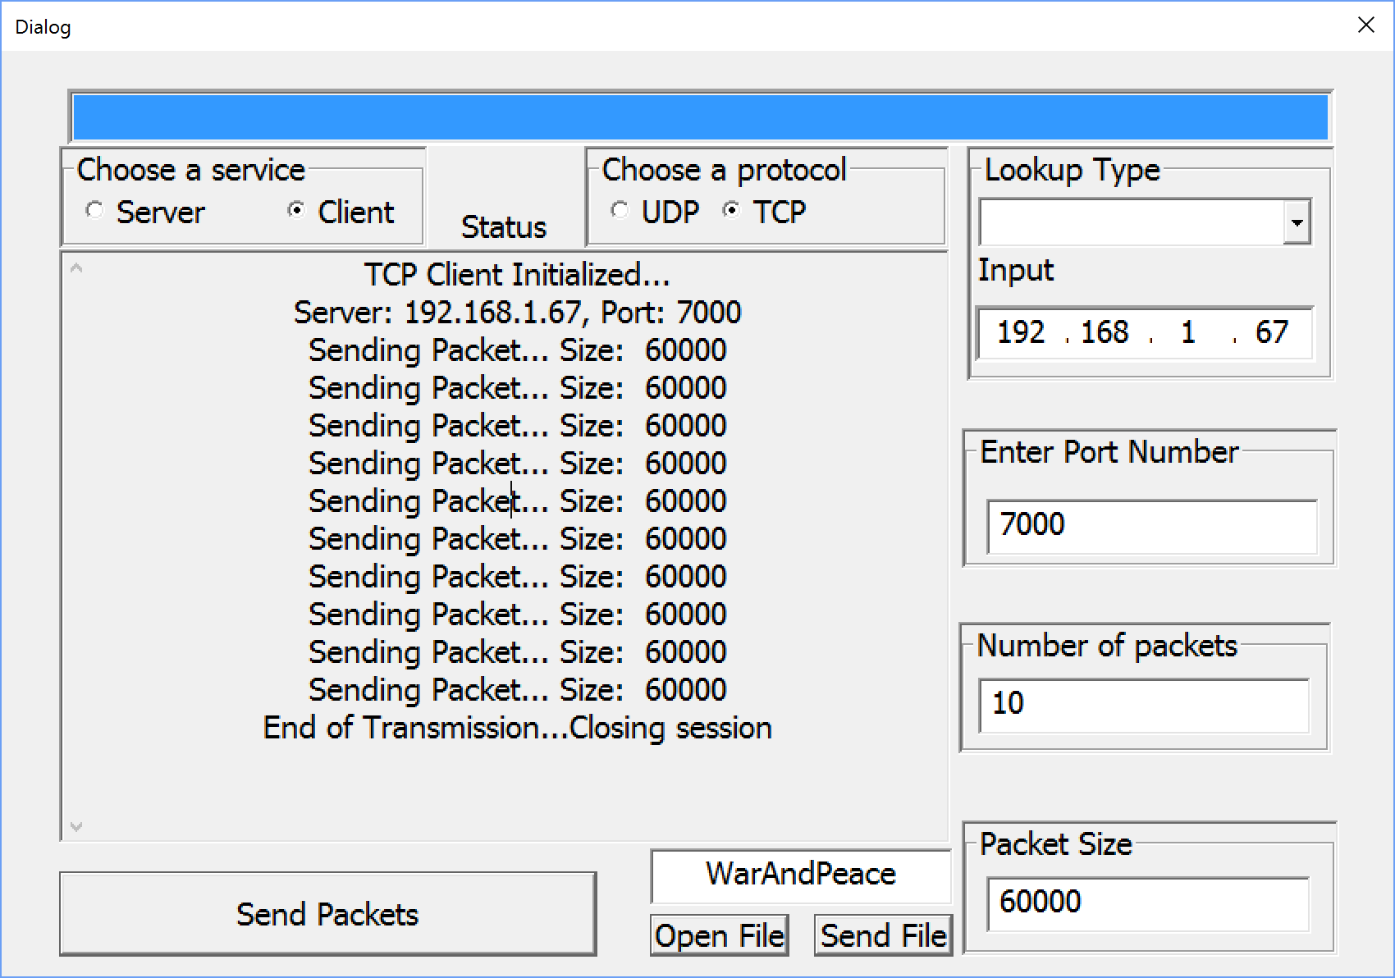

***Test Case 10 | Screenshot TCP Server***

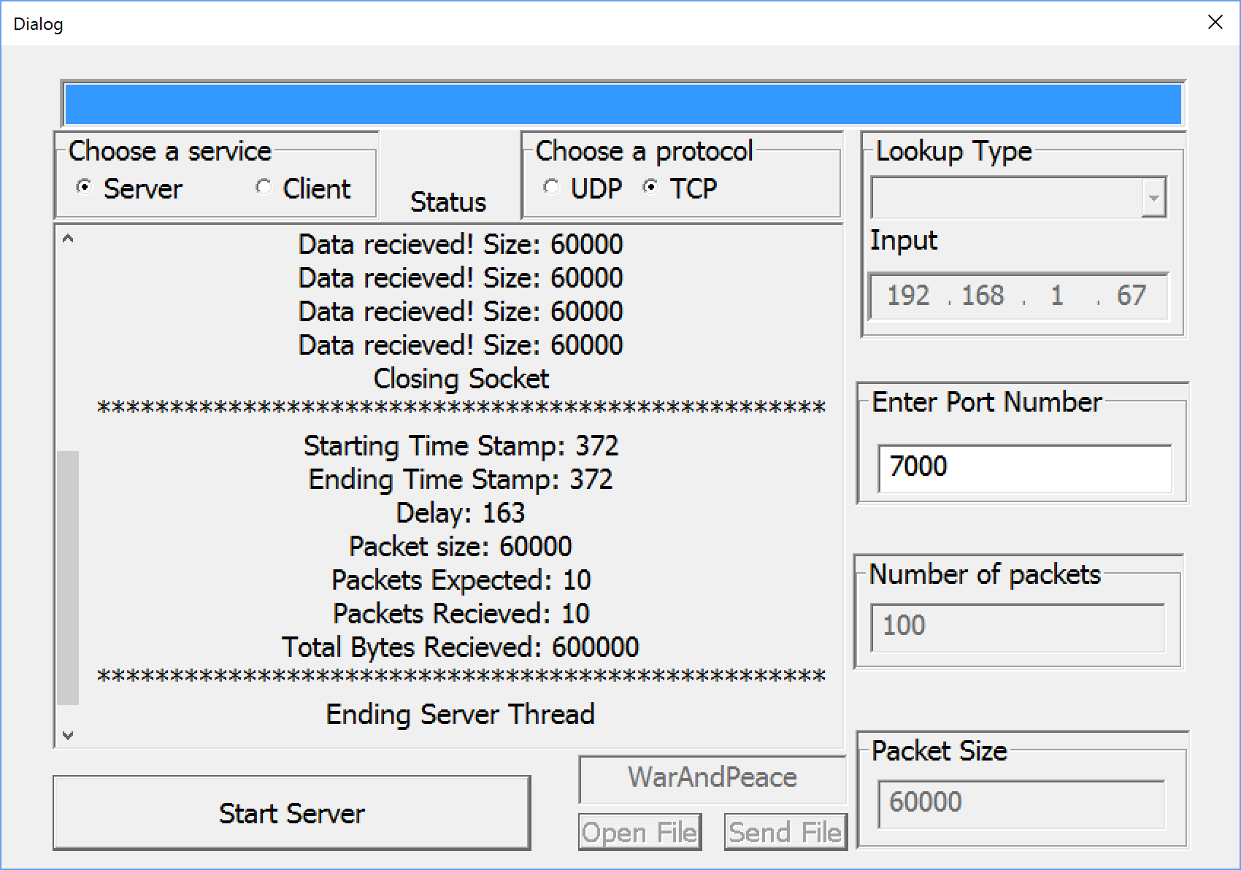

|  |  |  |  |  |
| --- | --- | --- | --- | --- |
| 11 | Send and receive 60000 size packets 100 times | **Client**   1. Start Program 2. Select Client 3. Select TCP 4. Fill in testing parameters 5. Packet size 60000, send times 100 6. Select Connect   **Server**   1. Start Program 2. Select Server 3. Select TCP 4. Fill in testing parameters 5. Select Connect” | **Client**  Display server port number, IP address, and size of packet sent every time  **Server**  Display “Expected packet size: 60000, Expected number of packets: 100”  Display “packets received” every time a packet is read  Display transmission information, which receives all the packets | **Pass** |

***Test Case 11 | Screenshot TCP Client***

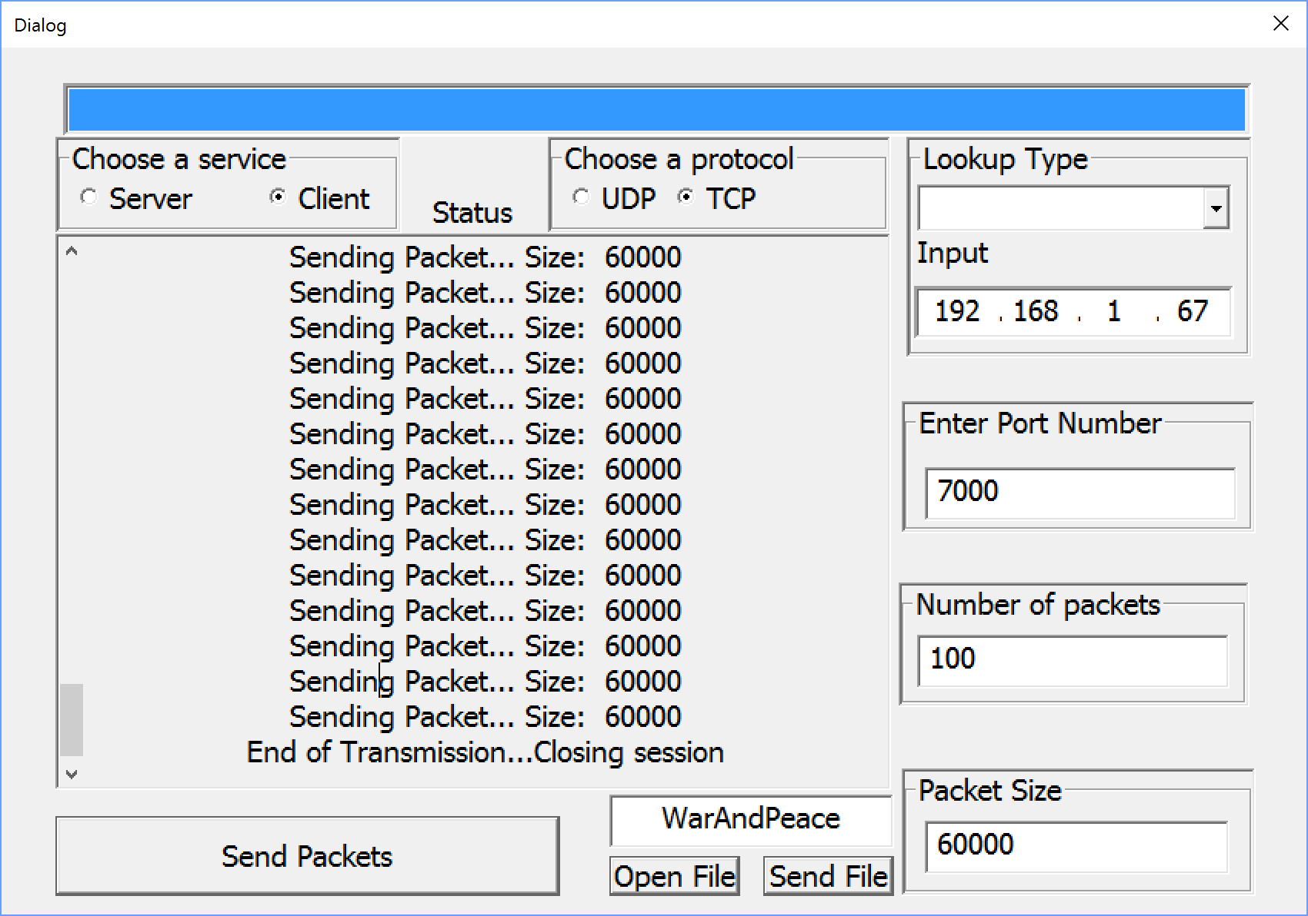

***Test Case 11 | Screenshot TCP Server***

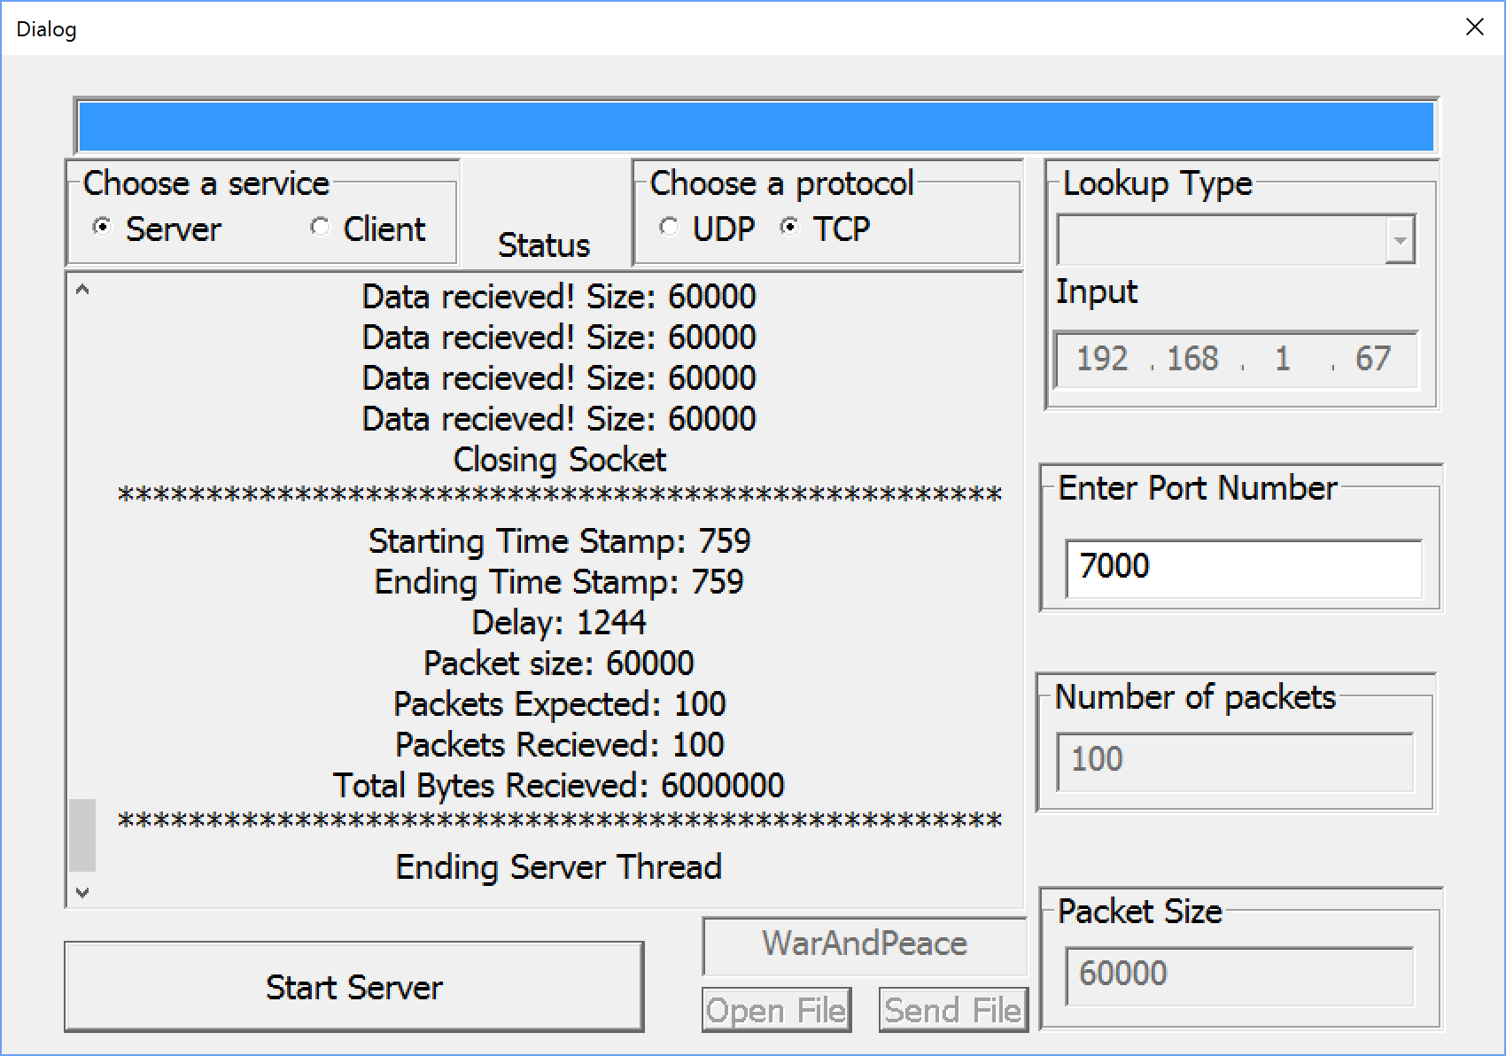

|  |  |  |  |  |
| --- | --- | --- | --- | --- |
| 12 | Send and receive 1024 size packets 10 times | **Client**   1. Start Program 2. Select Client 3. Select UDP 4. Fill in testing parameters 5. Packet size 1024, send times 10 6. Select Connect   **Server**   1. Start Program 2. Select Server 3. Select UDP 4. Fill in testing parameters 5. Select Connect” | **Client**  Display server port number, IP address, and size of packet sent every time  **Server**  Display “Expected packet size: 1024, Expected number of packets: 10”  Display “packets received” every time a packet is read  Display transmission information, which receives all the packets | **Pass** |

***Test Case 12 | Screenshot UDP Client***

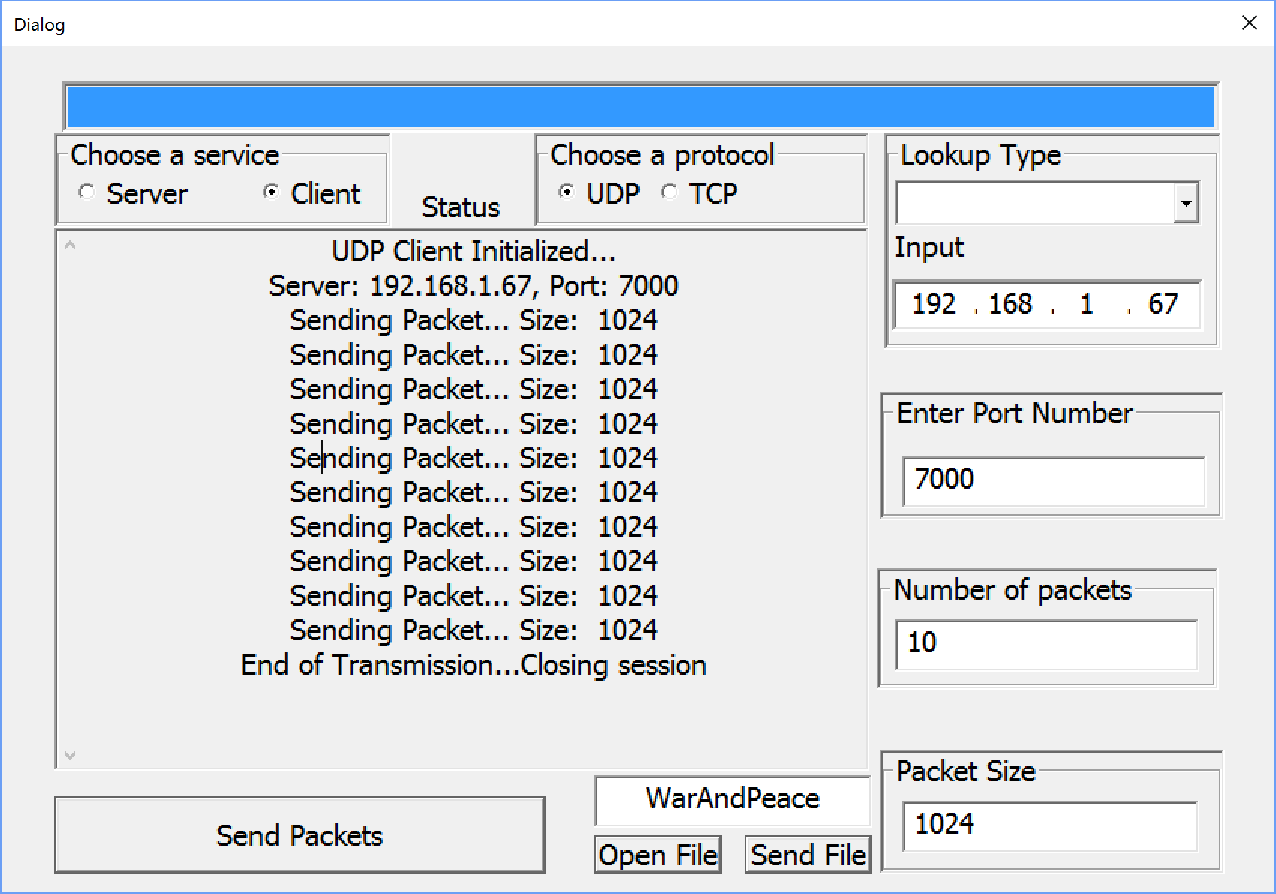

***Test Case 12 | Screenshot UDP Server***

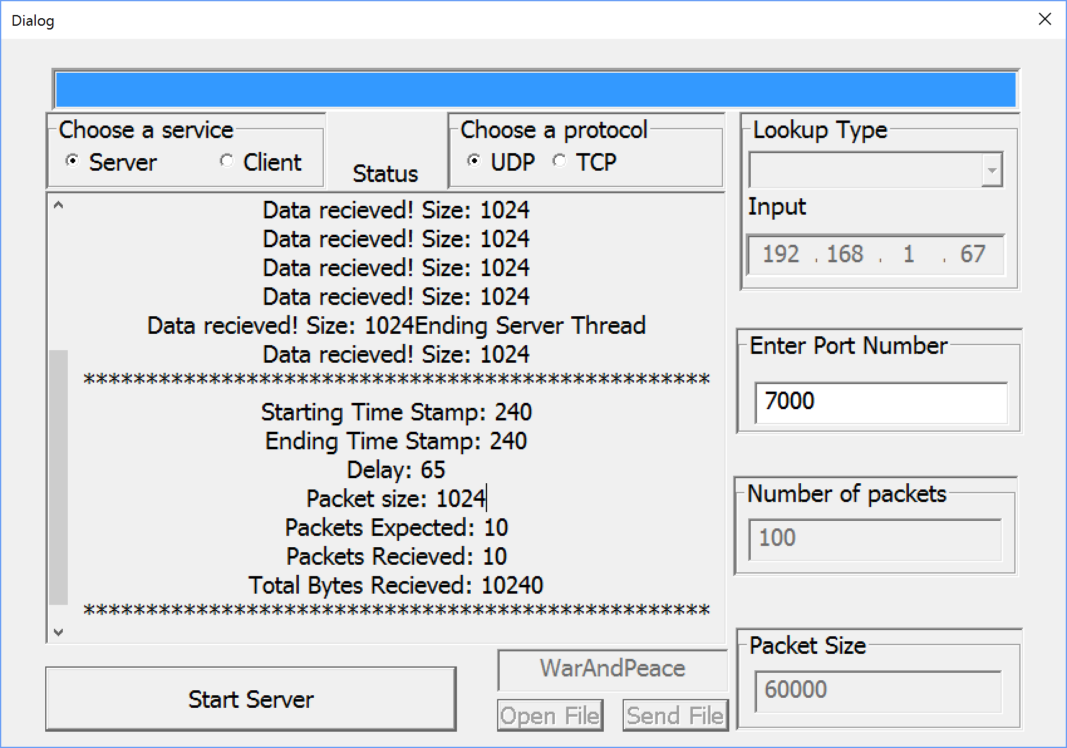

|  |  |  |  |  |
| --- | --- | --- | --- | --- |
| 13 | Send and receive 1024 size packets 100 times | **Client**   1. Start Program 2. Select Client 3. Select UDP 4. Fill in testing parameters 5. Packet size 1024, send times 100 6. Select Connect   **Server**   1. Start Program 2. Select Server 3. Select UDP 4. Fill in testing parameters 5. Select Connect” | **Client**  Display server port number, IP address, and size of packet sent every time  **Server**  Display “Expected packet size: 1024, Expected number of packets: 100”  Display “packets received” every time a packet is read  Display transmission information, which receives all the packets | **Pass** |

***Test Case 13 | Screenshot UDP Client***

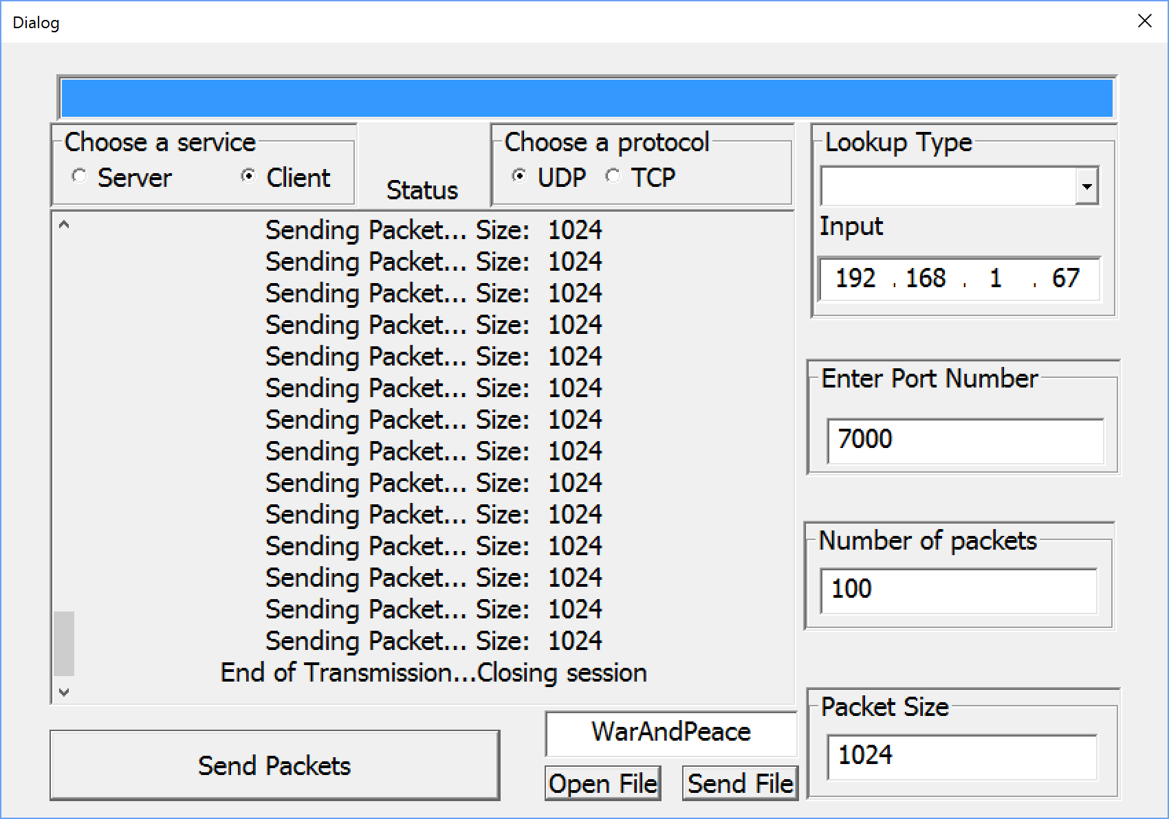

***Test Case 13 | Screenshot UDP Server***

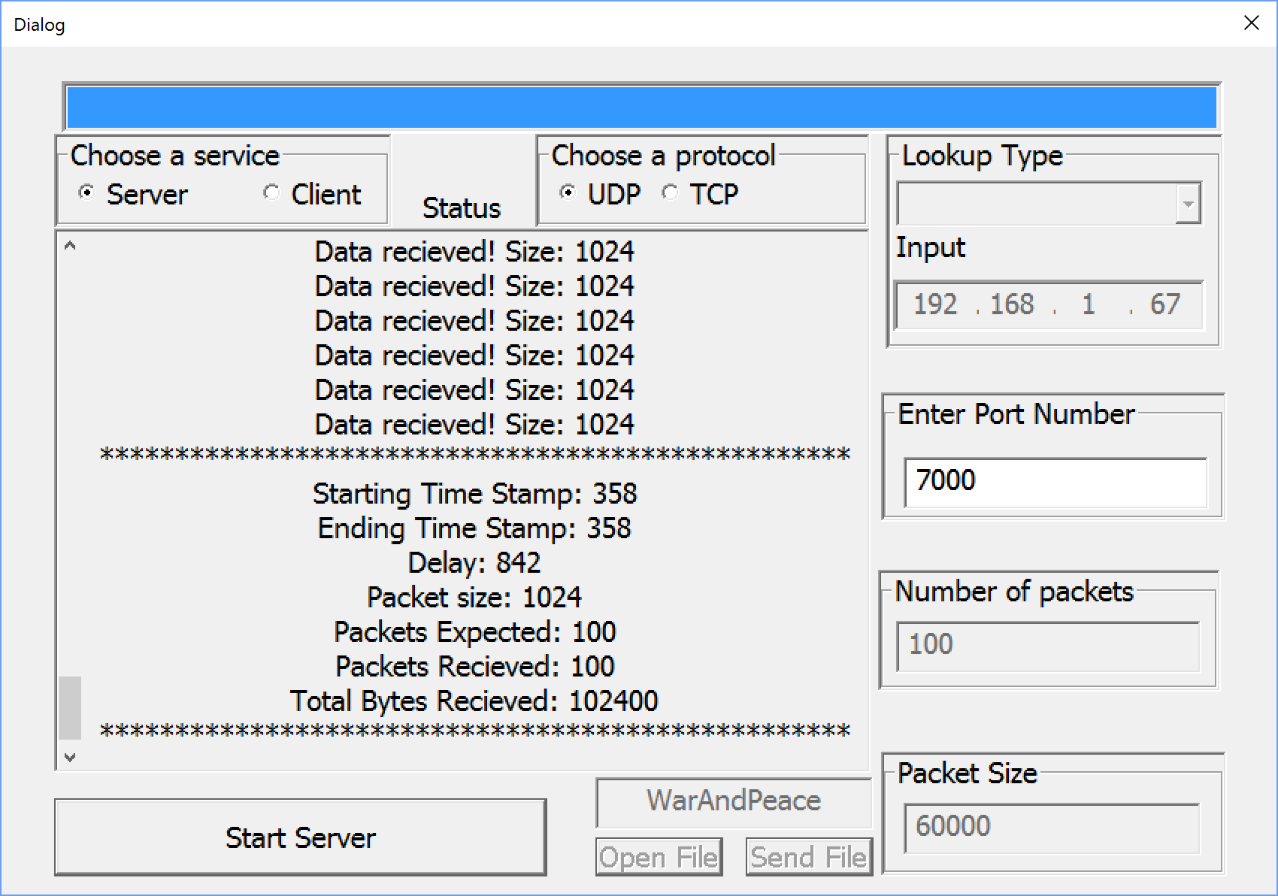

|  |  |  |  |  |
| --- | --- | --- | --- | --- |
| 14 | Send and receive 4096 size packets 10 times | **Client**   1. Start Program 2. Select Client 3. Select UDP 4. Fill in testing parameters 5. Packet size 1024, send times 10 6. Select Connect   **Server**   1. Start Program 2. Select Server 3. Select UDP 4. Fill in testing parameters 5. Select Connect” | **Client**  Display server port number, IP address, and size of packet sent every time  **Server**  Display “Expected packet size: 4096, Expected number of packets: 10”  Display “packets received” every time a packet is read  Display transmission information, which receives all the packets | **Pass** |

***Test Case 14 | Screenshot UDP Client***

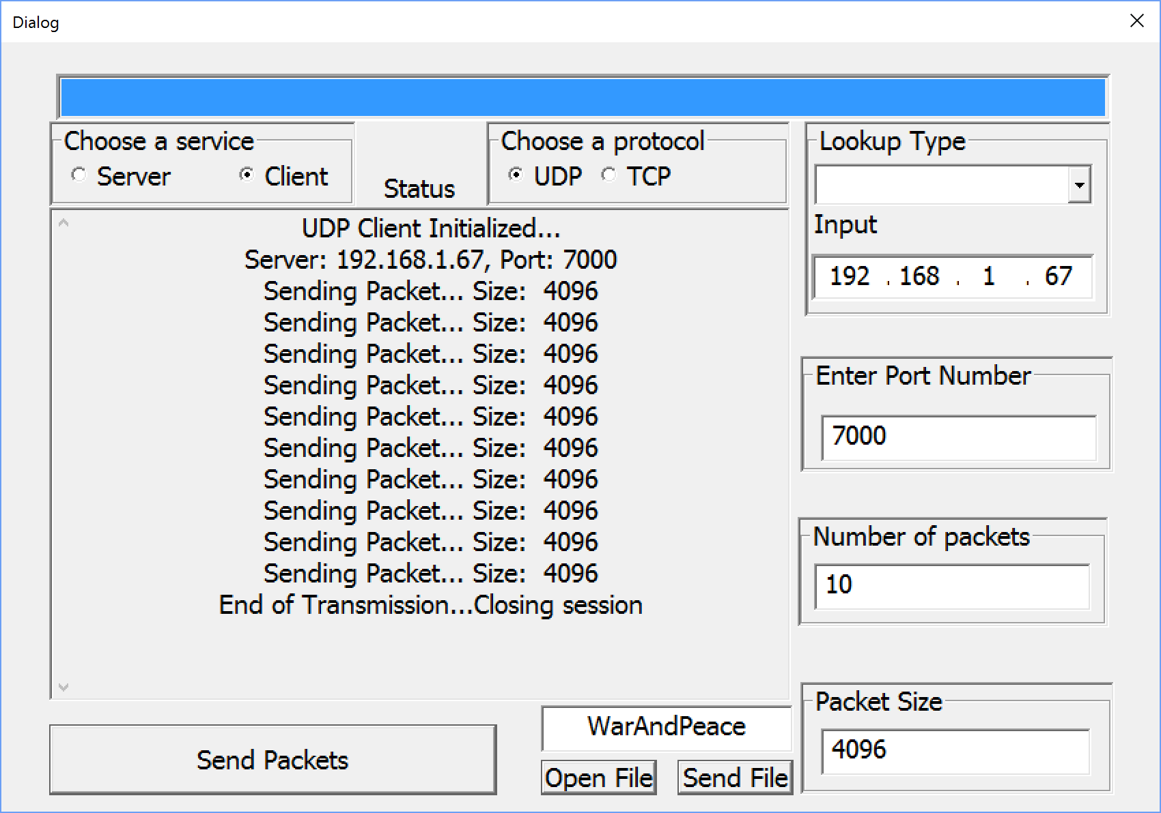

***Test Case 14 | Screenshot UDP Server***

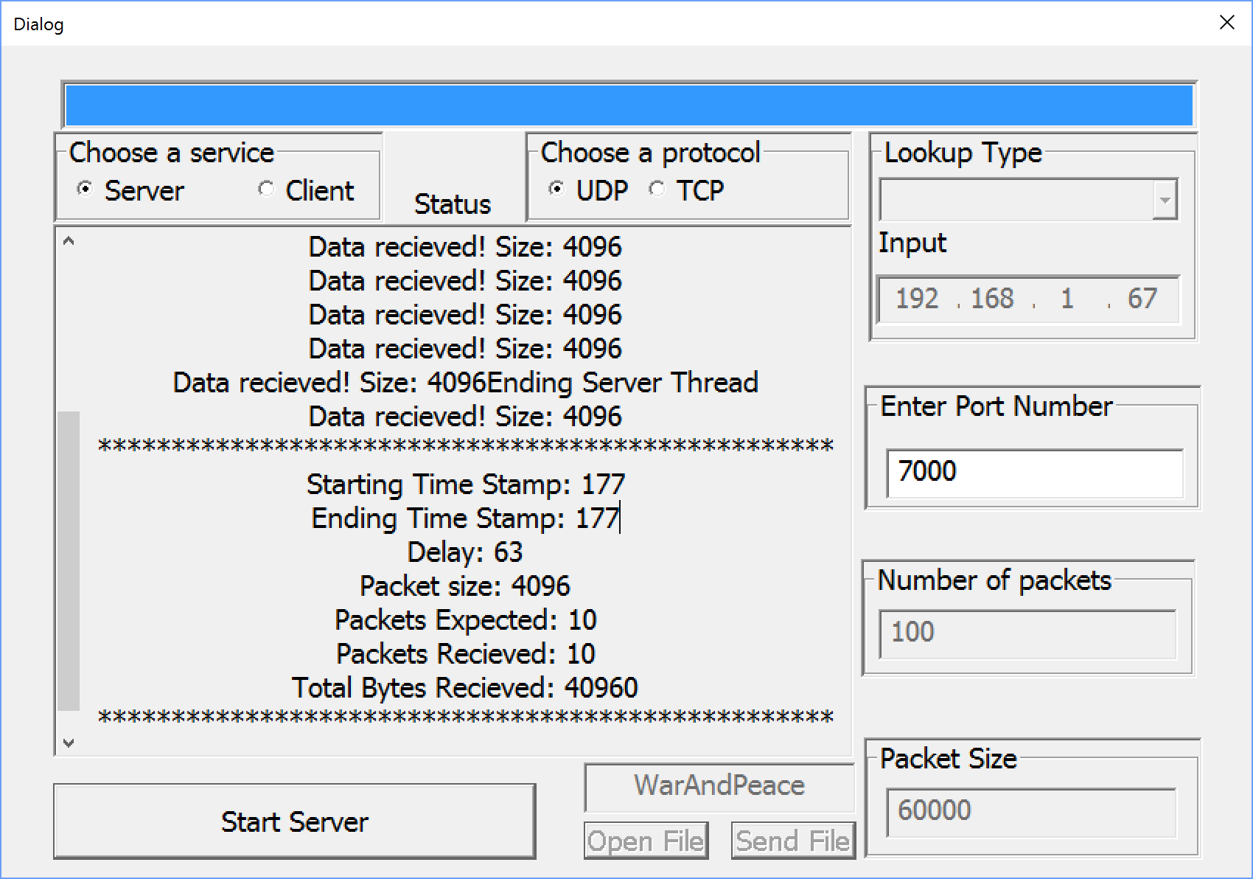

|  |  |  |  |  |
| --- | --- | --- | --- | --- |
| 15 | Send and receive 4096 size packets 100 times | **Client**   1. Start Program 2. Select Client 3. Select UDP 4. Fill in testing parameters 5. Packet size 1024, send times 100 6. Select Connect   **Server**   1. Start Program 2. Select Server 3. Select UDP 4. Fill in testing parameters 5. Select Connect” | **Client**  Display server port number, IP address, and size of packet sent every time  **Server**  Display “Expected packet size: 4096, Expected number of packets: 100”  Display “packets received” every time a packet is read  Display transmission information, which receives all the packets | **Pass** |

***Test Case 15 | Screenshot UDP Client***

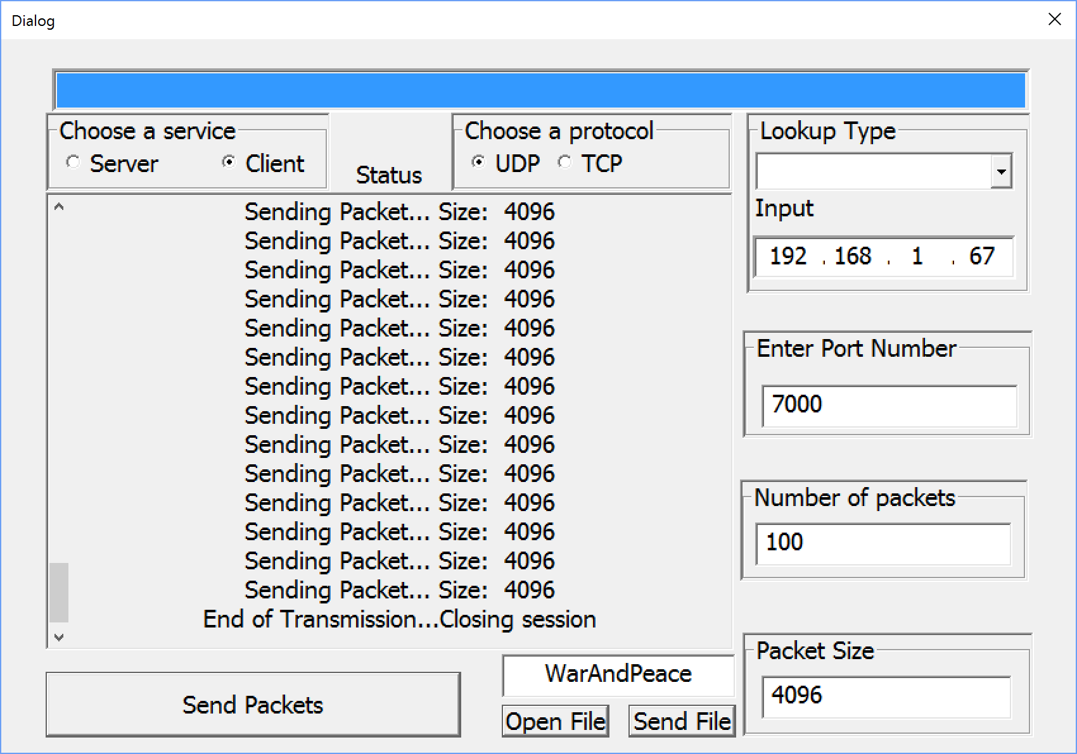

***Test Case 15 | Screenshot TCP Server***

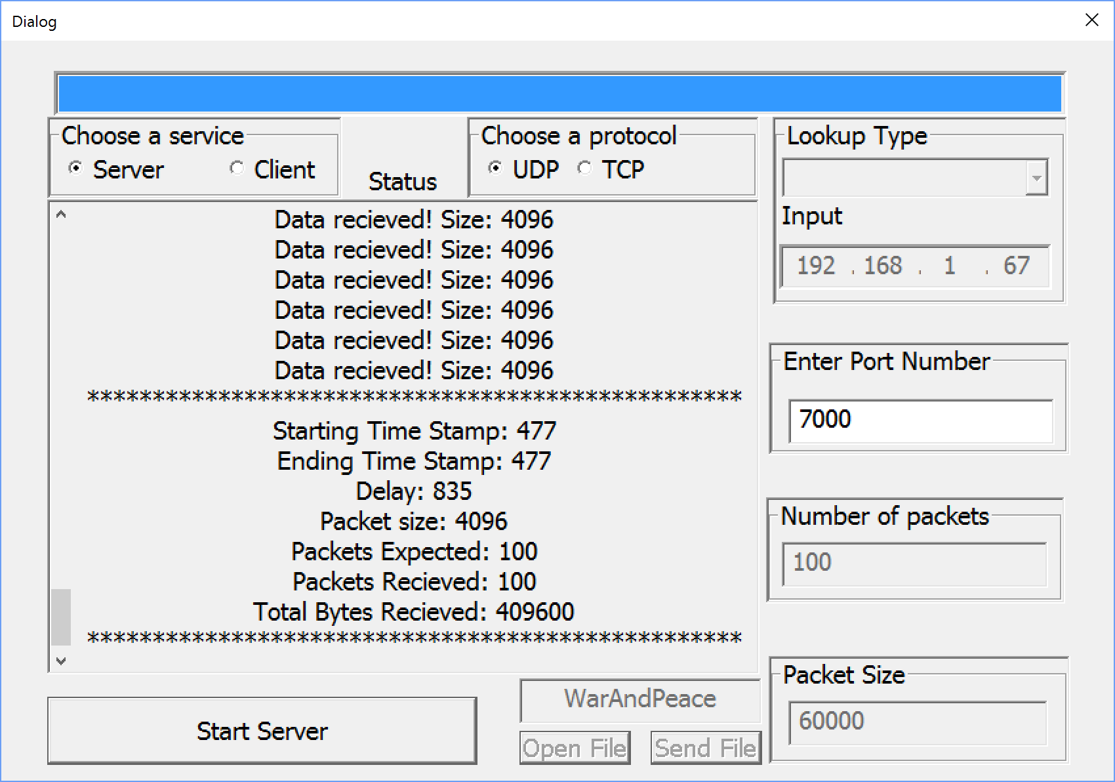

|  |  |  |  |  |
| --- | --- | --- | --- | --- |
| 16 | Send and receive 20000 size packets 10 times | **Client**   1. Start Program 2. Select Client 3. Select UDP 4. Fill in testing parameters 5. Packet size 20000, send times 10 6. Select Connect   **Server**   1. Start Program 2. Select Server 3. Select UDP 4. Fill in testing parameters 5. Select Connect” | **Client**  Display server port number, IP address, and size of packet sent every time  **Server**  Display “Expected packet size: 20000, Expected number of packets: 10”  Display “packets received” every time a packet is read  Display transmission information, which receives all the packets | **Pass** |

***Test Case 16 | Screenshot UDP Client***

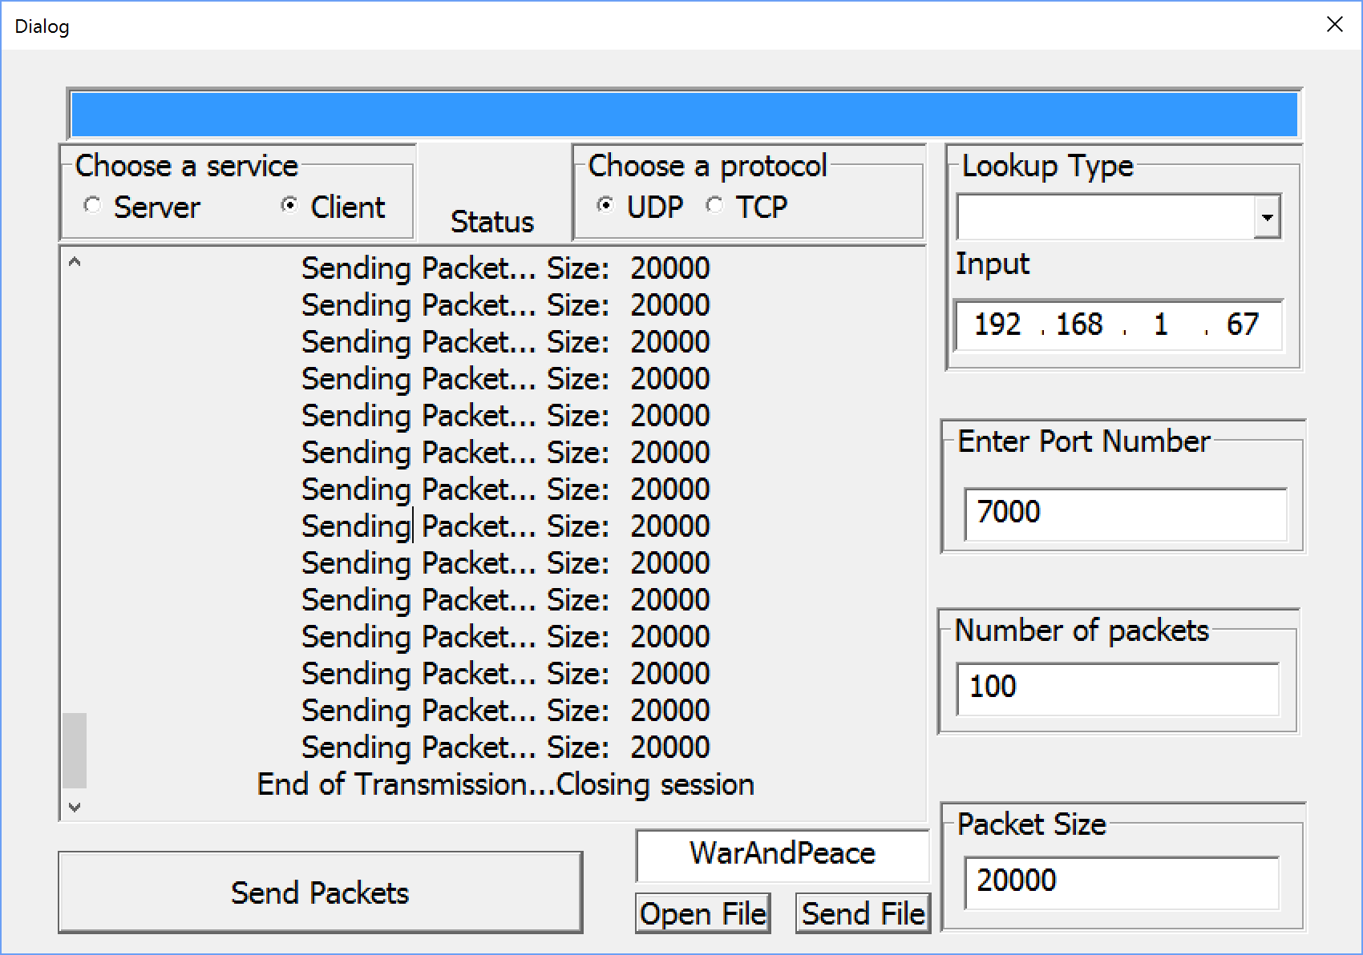

***Test Case 16 | Screenshot UDP Server***

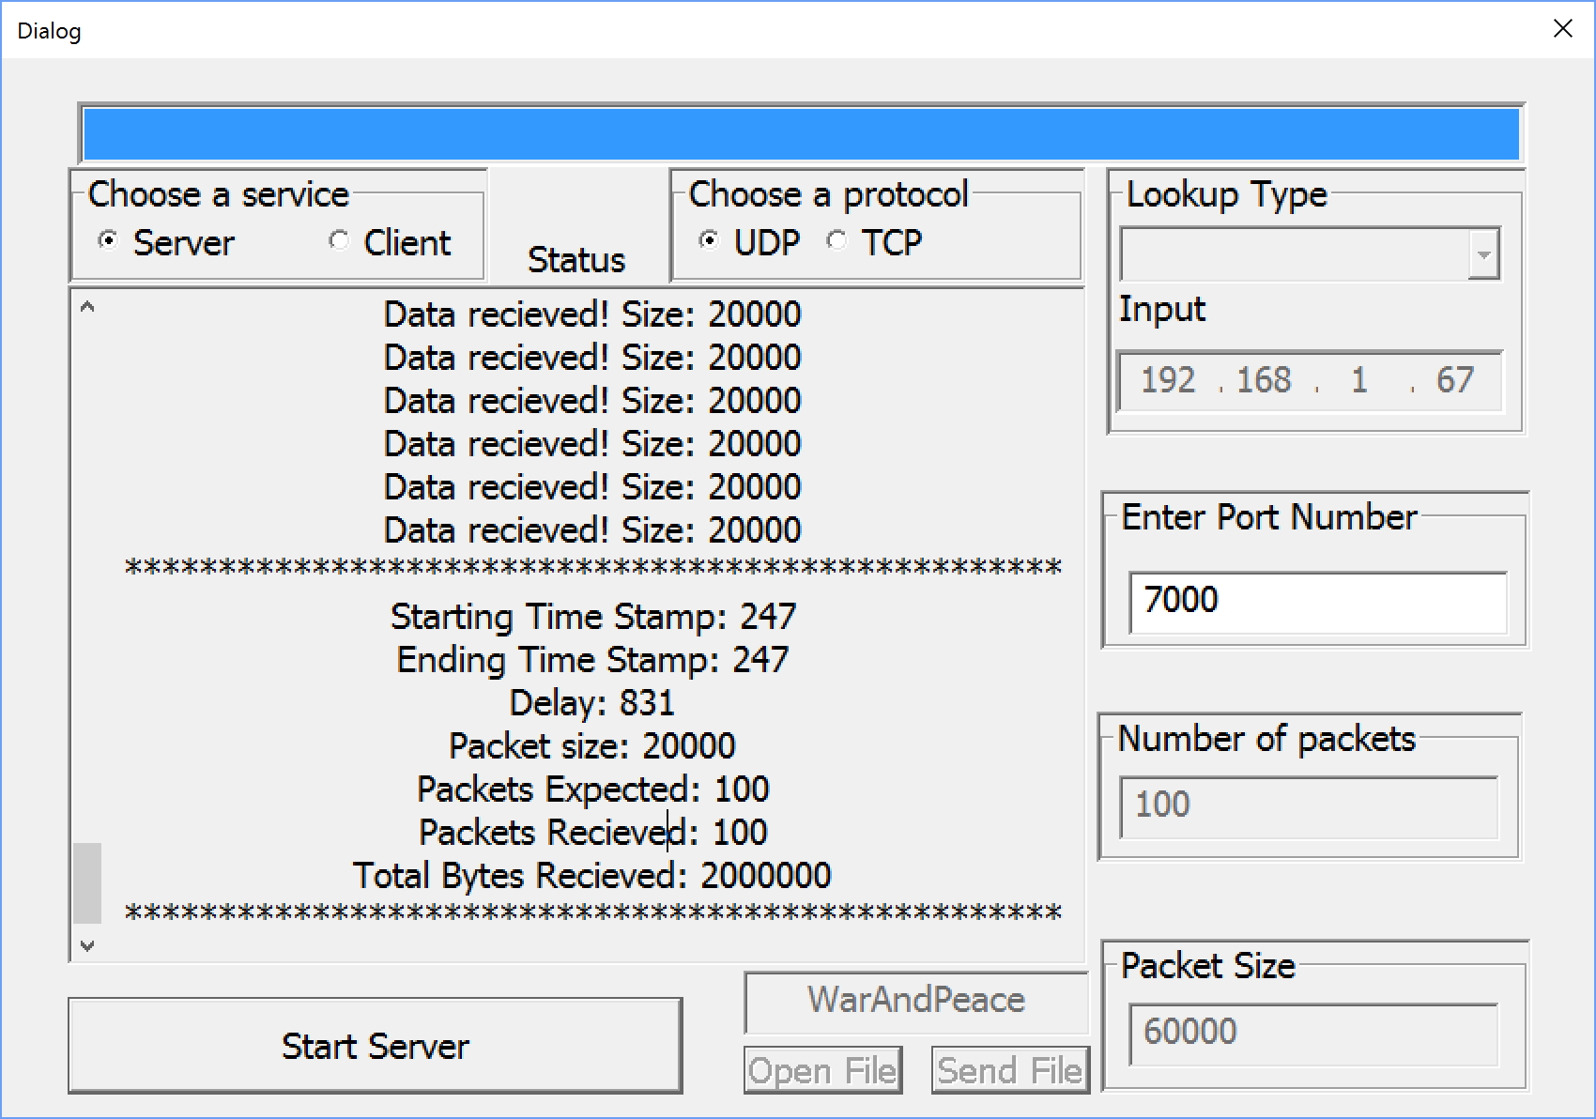

|  |  |  |  |  |
| --- | --- | --- | --- | --- |
| 17 | Send and receive 20000 size packets 100 times | **Client**   1. Start Program 2. Select Client 3. Select UDP 4. Fill in testing parameters 5. Packet size 20000, send times 100 6. Select Connect   **Server**   1. Start Program 2. Select Server 3. Select UDP 4. Fill in testing parameters 5. Select Connect” | **Client**  Display server port number, IP address, and size of packet sent every time  **Server**  Display “Expected packet size: 20000, Expected number of packets: 100”  Display “packets received” every time a packet is read  Display transmission information, which receives all the packets | **Pass** |

***Test Case 17 | Screenshot UDP Client***

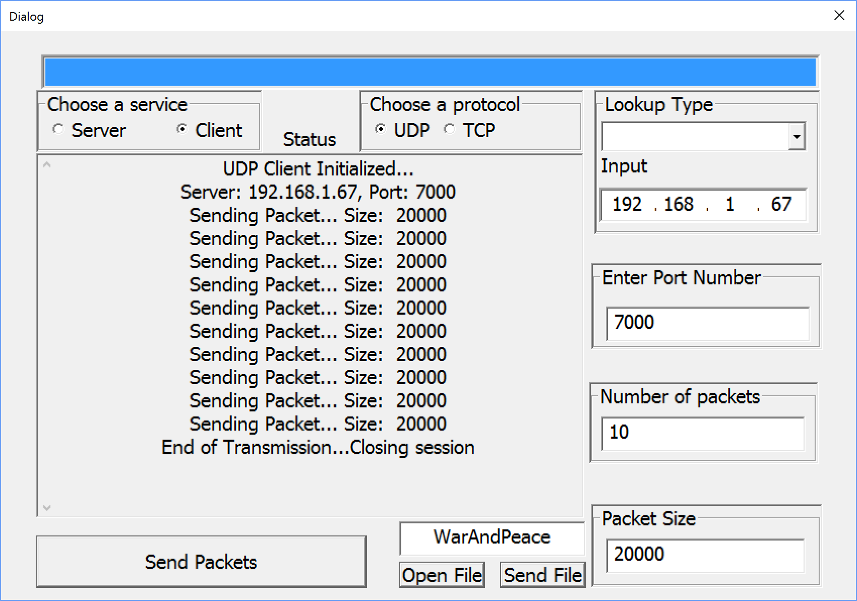

***Test Case 17 | Screenshot UDP Server***

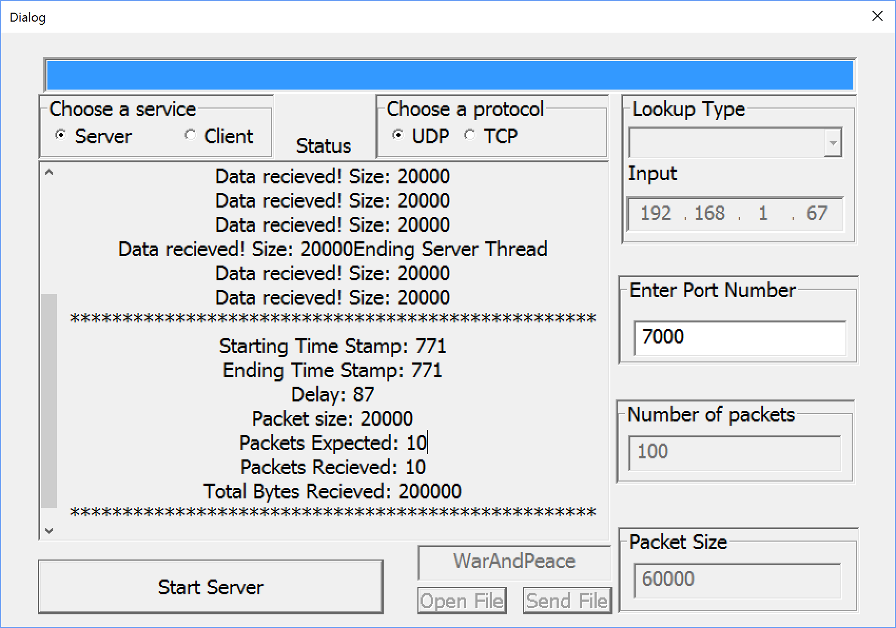

|  |  |  |  |  |
| --- | --- | --- | --- | --- |
| 18 | Send and receive 60000 size packets 10 times | **Client**  1.Start Program   1. Select Client 2. Select UDP 3. Fill in testing parameters 4. Packet size 60000, send times 10 5. Select Connect   **Server**   1. Start Program 2. Select Server 3. Select UDP 4. Fill in testing parameters 5. Select Connect” | **Client**  Display server port number, IP address, and size of packet sent every time  **Server**  Display “Expected packet size: 60000, Expected number of packets: 10”  Display “packets received” every time a packet is read  Display transmission information, which receives all the packets | **Pass** |

***Test Case 18 | Screenshot UDP Client***

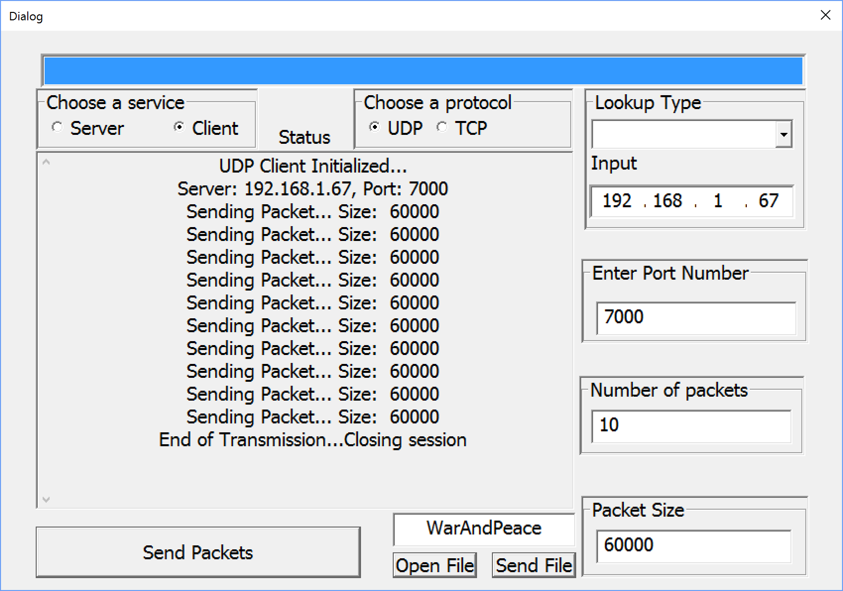

***Test Case 18 | Screenshot UDP Server***

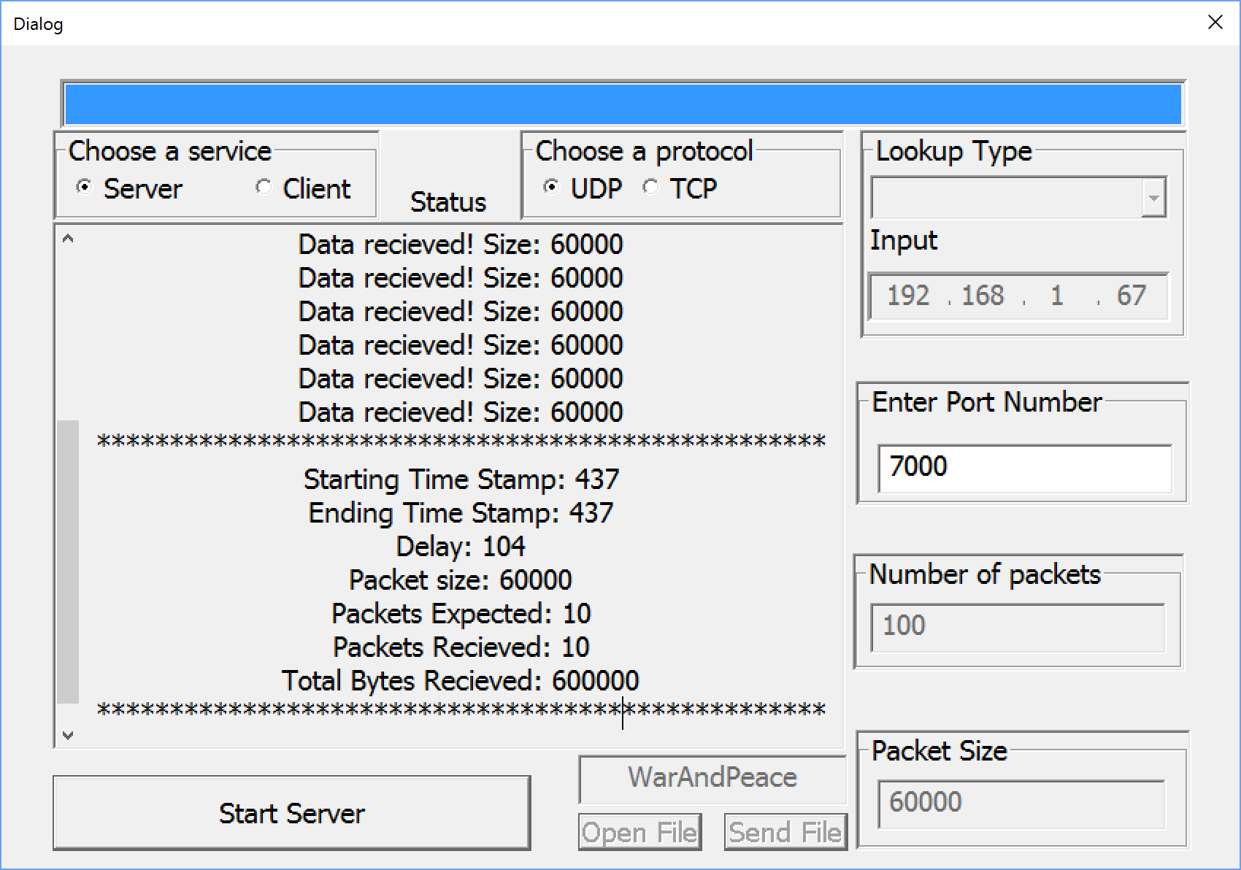

|  |  |  |  |  |
| --- | --- | --- | --- | --- |
| 19 | Send and receive 60000 size packets 100 times | **Client**   1. Start Program 2. Select Client 3. Select UDP 4. Fill in testing parameters 5. Packet size 60000, send times 100 6. Select Connect   **Server**   1. Start Program 2. Select Server 3. Select UDP 4. Fill in testing parameters 5. Select Connect” | **Client**  Display server port number, IP address, and size of packet sent every time  **Server**  Display “Expected packet size: 60000, Expected number of packets: 100”  Display “packets received” every time a packet is read  Display transmission information, which receives all the packets | **Pass** |

***Test Case 19 | Screenshot UDP Client***

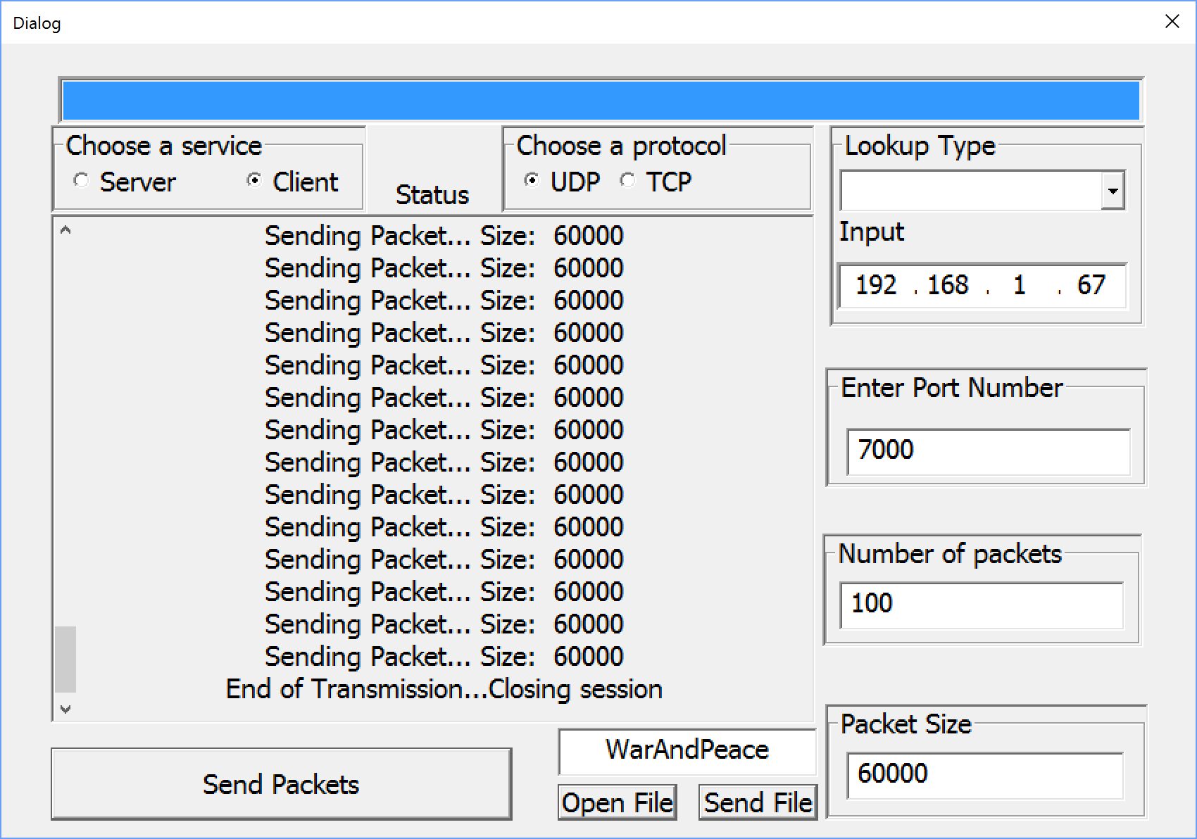

***Test Case 19 | Screenshot TCP Server***

