TEST DOCUMENTATION

WIRELESS PROTOCOL

Table of Contents

1 Test Cases 2

2 GUI Tests 2

3 Sending 6

4 Protocol 7

# Test Cases

|  |  |  |  |  |
| --- | --- | --- | --- | --- |
| **Test #** | **Description** | **Test Steps** | **Expected Result** | **Pass / Fail** |

# GUI Tests

|  |  |  |  |  |
| --- | --- | --- | --- | --- |
| 1 | Minimize Window | 1. Start Program 2. Minimize screen using ‘-‘ 3. Open program again by hitting the tab on the windows toolbar | Program remains the same. Minimizing and showing window works properly. Content is not changed. | **Pass** |

|  |  |  |  |  |
| --- | --- | --- | --- | --- |
| 2 | Communication dialog is functional | 1. Start Program | A Communication dialog appears and user is allowed to enter in comm parameters. | **Pass** |

**Test Case 2 | Screenshot**

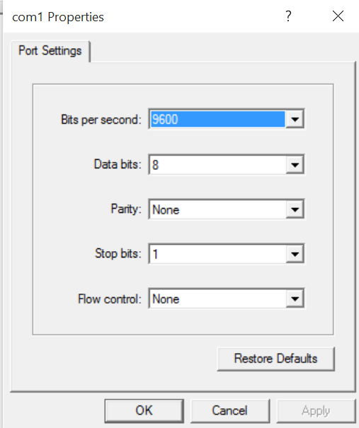

|  |  |  |  |  |
| --- | --- | --- | --- | --- |
| 3 | User can open a file. | 1. Start Program 2. Press Open 3. See expected results | An Open file dialog appears. | **Pass** |

***Test Case 3 | Screenshot***

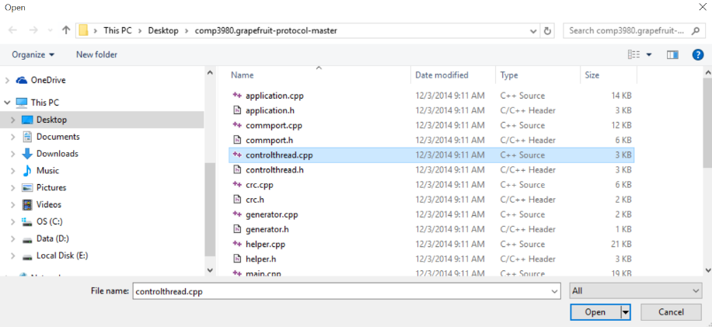

|  |  |  |  |  |
| --- | --- | --- | --- | --- |
| 4 | User can select any text file and content is displayed on the left window. | 1. Start Program 2. Press Open 3. Choose a text file (.cpp, .txt, .c. , .h etc) 4. Match file’s content with content on the left window. 5. See Expected Results | Content on the left window matches content in text file. | **Pass** |

Test Case **4** | Screenshot

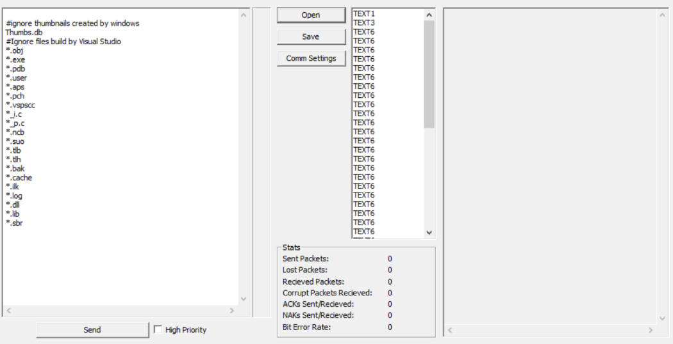

|  |  |  |  |  |
| --- | --- | --- | --- | --- |
| 5 | Statistics are updated live | 1. Start Program 2. Press Open and select a file 3. Click Send 4. Observe statistics box | Statistics are updated live according to what was sent and received. | **Pass** |

|  |  |  |  |  |
| --- | --- | --- | --- | --- |
| 6 | Sending one packet. (516 bytes) | 1. Start Program 2. Press open and select a file that has size 516 bytes 3. Click Send 4. See Expected Results | One packet is successfully read on other device. | **Pass** |

|  |  |  |  |  |
| --- | --- | --- | --- | --- |
| 7 | Opening a file while we are reading | 1. Start Program 2. Open a file and send it over to the receiver 3. Go on receiver’s application and open a file while it is receiving | Reader can still open a file while it is still reading | **Pass** |

|  |  |  |  |  |
| --- | --- | --- | --- | --- |
| 8 | Ability to save a file and send it. | 1. Start Program 2. Type into the left window and click save 3. Click Send | Program can save a file inputted by the user | **Pass** |

|  |  |  |  |  |
| --- | --- | --- | --- | --- |
| 9 | Clearing left window. (local) | 1. Start Program 2. Click open and select a file 3. Press Clear (local) | Left window text is cleared when clear button is pressed. | **Pass** |

Test Case **9** | Screenshots

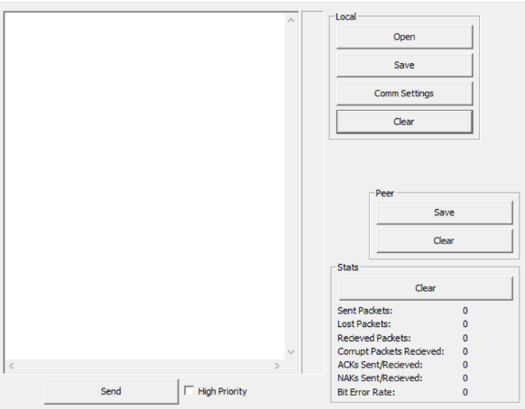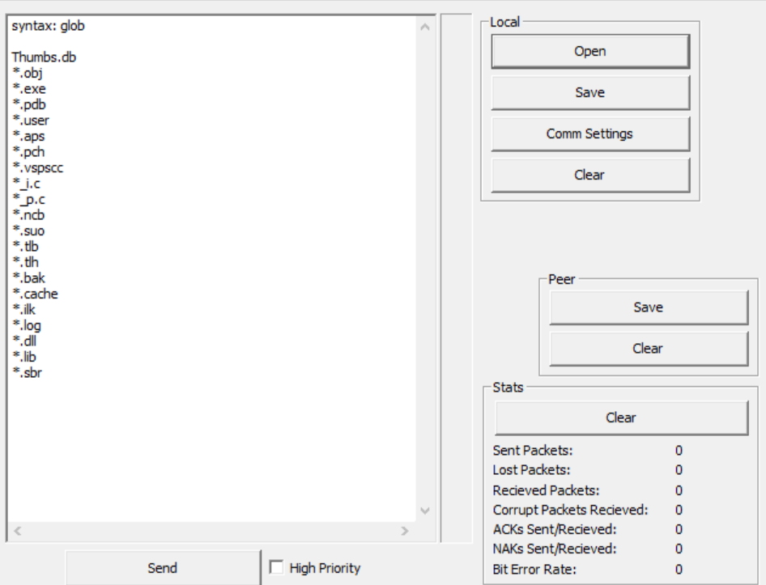

# Sending

|  |  |  |  |  |
| --- | --- | --- | --- | --- |
| 10 | Sending a small file (2000 bytes) | 1. Start program 2. Press open and select a file where the size is 2000 bytes 3. Click Send 4. See Expected Results | The receiver reads a small file correctly displaying the correct results. | **Pass** |

|  |  |  |  |  |
| --- | --- | --- | --- | --- |
| 11 | Sending a large file (30000 bytes) | 1. Start program 2. Press open and select a file where the size is 30,000 bytes 3. Click Send 4. See Expected Results | The receiver reads a large file correctly displaying the correct results. | **Pass** |

|  |  |  |  |  |
| --- | --- | --- | --- | --- |
| 12 | Sending at the same time | 1. Start program 2. Open and select the same file on both computers 3. Click Send at the same time 4. See Expected Results | Devices should alternate sending/receiving and read correct results on both sides | **Pass** |

|  |  |  |  |  |
| --- | --- | --- | --- | --- |
| 13 | Sending while other is already sending. | 1. Start program 2. Open and select the same file on both computers 3. Click Send on one computer 4. Click Send on the other computer while the other side is sending 5. See Expected Results | Devices should alternate sending/receiving and read correct results on both sides | **Pass** |

# Protocol

|  |  |  |  |  |
| --- | --- | --- | --- | --- |
| 14 | Sending a file to another group’s code to test the protocol. | 1. Start Program 2. Insure no one else is sending over the modem 3. Open a file and send it over to the receiver (other group) 4. Confirm if the other group receives the file | Other group’s application reads our file successfully without losing any packets. | **Pass** |

|  |  |  |  |  |
| --- | --- | --- | --- | --- |
| 15 | Receiving a file to another group’s code to test the protocol. | 1. Start Program 2. Insure no one else is sending over the modem 3. Wait until other group sends a file 4. Confirm if file is received and displayed on the right window | Other group’s application can write successfully to our application without losing any packets. | **Pass** |

|  |  |  |  |  |
| --- | --- | --- | --- | --- |
| 16 | Sending a small file while receiving a large file. | 1. Start Program 2. Open a large file (5000 bytes) and click send 3. Go to receiver and open a small file (26 bytes) and click send 4. Observe results | Both computers should receive the correct file. The smaller size file should be read first and the larger file should be read afterwards. | **Fail** |

|  |  |  |  |  |
| --- | --- | --- | --- | --- |
| 17 | Sending a large file while receiving a large file. | 1. Start Program 2. Open a large file (5000 bytes) and click send 3. Go to receiver and open a large file (5000 bytes) and click send 4. Observe results | Both computers should receive the correct file. Since file sizes are the same, both computers should receive the files around the same time. | **Pass** |