USER MANUAL

WIRELESS PROTOCOL

Table of Contents

1 Intro to Wireless Protocol Application 2

2 Setting up SSRT-24 Modems 2

3 Launching Application 3

4 Sending a file 4

5 Receiving a file 4

6 Statistics 5

# Intro to Wireless Protocol Application

Our application is a basic driver for a simple half-duplex wireless protocol which transfers files between devices. The devices are both connected via a serial cable to a wireless modem (SSRT-24). For the transferring to be successful, the sender must bid for a line by sending an ENQ to the receiver. If the receiver is ready to receive it will send an ACK back to the sender. The sender proceeds to send a packet (516 size) at a time until EOT is reached.

# Setting up SSRT-24 Modems

Set up two **workstations** that are able to use serial ports.

WARNING: INSURE MODEM ATENNAS ARE SCREWED ON BEFORE PLUGGING IN THE POWER

1. Insert (*female end*) serial cable in both computers (*male end*) shown in the pictures below.

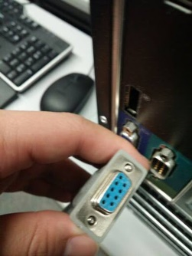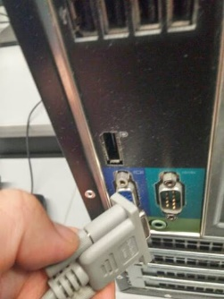

1. Attach **antennas** onto the wireless modems

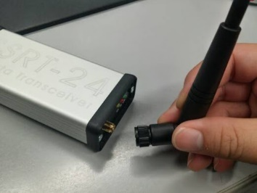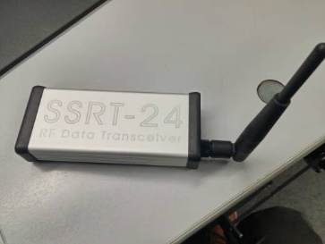

1. Connect the serial cables with the modem and the desktop

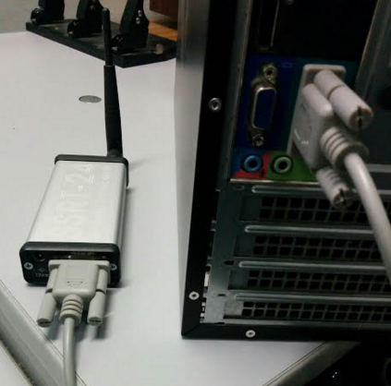

1. Plug in the power to the modem, the modem should have a GREEN LED that turns on.

# Launching Application

1. Launch the application by running the executable provided.
2. A Communication settings dialog appear and needs to be set.
   1. For consistent settings, click on **Restore Defaults** and click **OK**

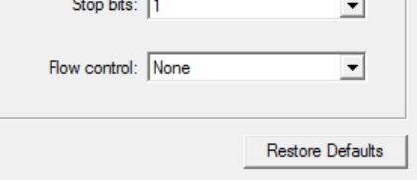

# Sending a file

1. To **open a file**, simply press on the open button located in the middle of the application.

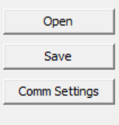

1. 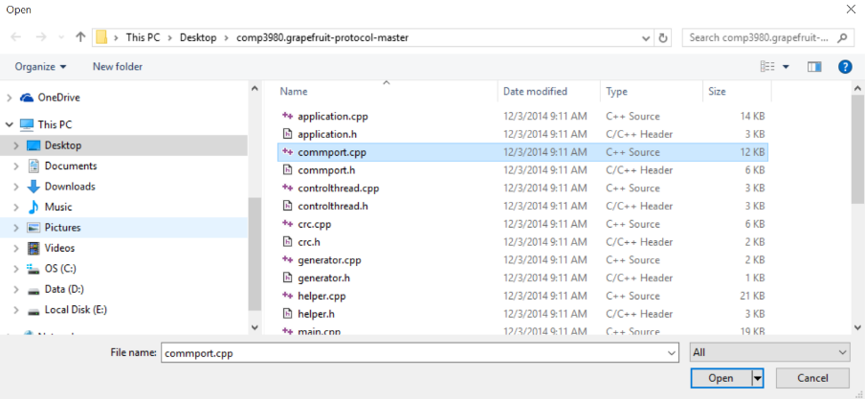An open file dialog appears and you are able to select a text file located in your directories.
2. Open the file and the content is displayed on the left window.
3. Once the file is done loading on the window, click the Send button to begin **sending**.

# Receiving a file

1. Assuming the communication settings is the same on both sides, once the sender clicks sends. The receiver side receives the packets one at a time and displays it on the right window.

# Statistics

1. Packet statistics are updated live in the Stats box. Check out the screenshot below.

