1. 資料庫中建立資料表  
   SQL語法：

USE MVCPracticeDB

GO

CREATE TABLE dbo.Products(

ProductID int PRIMARY KEY,

ProductName nvarchar(20) NULL,

Price int

)

1. 在Visual Studio中的MVCJob.Web專案  
   Models => Add => New Item  
   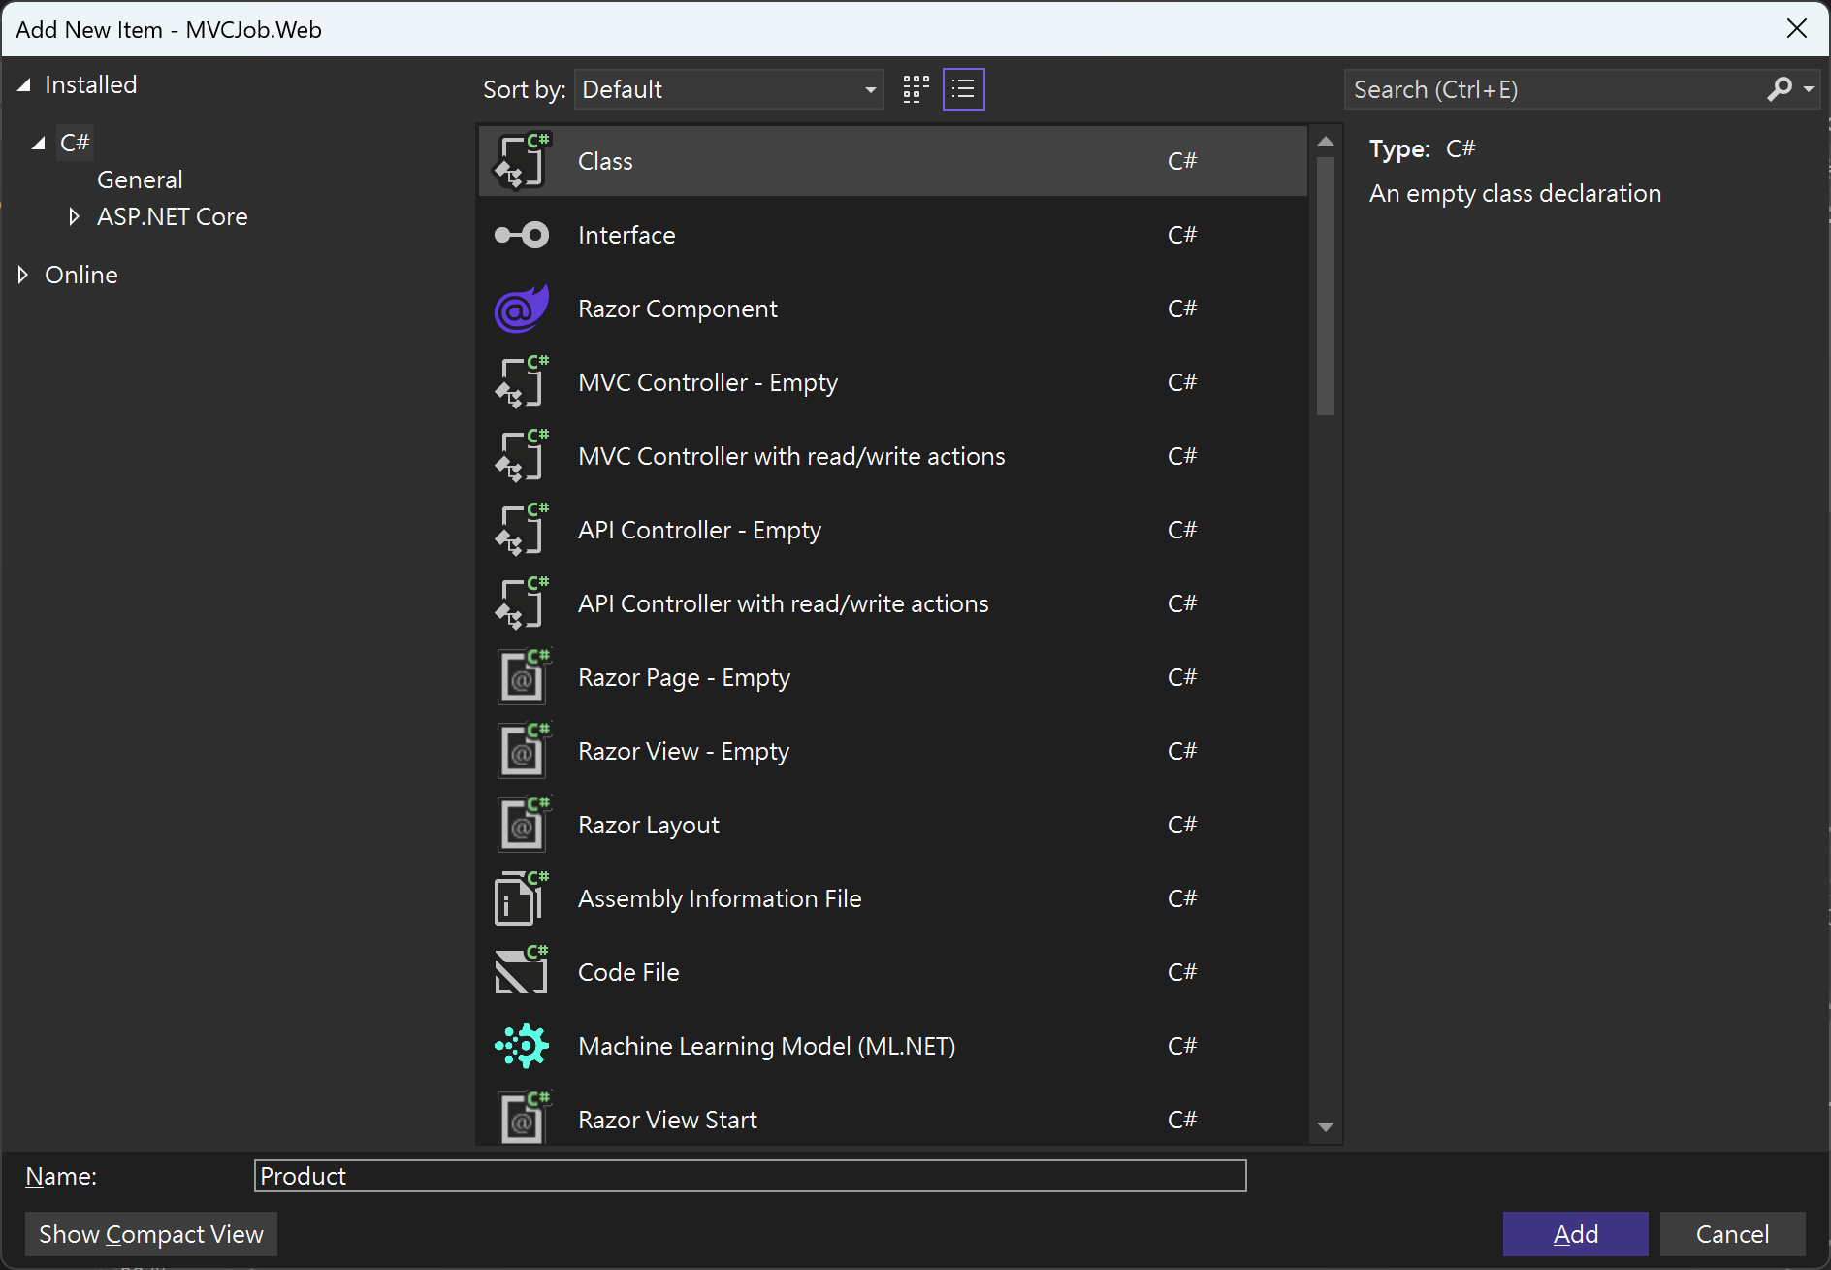

Class  
Name: **Product**

Product.cs

using System.ComponentModel.DataAnnotations;  
namespace MVCJob.Web.Models;  
public class Product  
{  
 [Key]  
 public int ProductId { get; set; }  
 [Required]  
 public required string ProductName { get; set; }

public int Price { get; set; }

}

1. 資料夾Data => ApplicationDbContext.cs

public DbSet<Category> Categories { get; set; }

protected override void OnModelCreating(ModelBuilder modelBuilder)

{

modelBuilder.Entity<Category>().HasData(

new Category { Id = 1, Name = "Action", DisplayOrder = 1 },

new Category { Id = 2, Name = "SciFi", DisplayOrder = 2 },

new Category { Id = 3, Name = "History", DisplayOrder = 3 });

}

public DbSet<Product> Products { get; set; }

}

加入紅色標示的程式碼。

1. 新增Controller: ProductController  
   Controllers => Add => MVC Controoler – Empty  
   一張含有 文字, 軟體, 螢幕擷取畫面, 多媒體軟體 的圖片

   AI 產生的內容可能不正確。

**Name:** **ProductController**.**cs**

Product Controller.cs的程式碼：

using Microsoft.AspNetCore.Mvc;

using MVCJob.Web.Data;

using MVCJob.Web.Models;

namespace MVCJob.Web.Controllers

{

public class ProductController : Controller

{

private readonly ApplicationDbContext _db;

public ProductController(ApplicationDbContext db)

{

_db = db;

}

public IActionResult Index()

{

List<Product> objProductList = _db.Products.ToList();

return View(objProductList);

}

}

}

1. 在ProductController.cs中

public IActionResult Index()  
{

}

位置上右鍵 => Add View…

一張含有 文字, 螢幕擷取畫面, 軟體, 多媒體軟體 的圖片

AI 產生的內容可能不正確。

5. 資料夾Views=>Products=Index.cshtml  
  
@model List<Product>

<h1>Product List</h1>

<table class="table table-border table-striped">

<thead>

<tr>

<th>Product ID</th>

<th>Product Name</th>

<th>Unit Price</th>

</tr>

</thdad>

<tbody>

@foreach (var obj in Model)

{

<tr>

<td>@obj.ProductId</td>

<td>@obj.ProductName</td>

<td>@obj.Price</td>

</tr>

}

</tbody>

</table>

1. 資料夾Views => Shared => _Layout.cshtml

<ul class="navbar-nav flex-grow-1">  
<li class="nav-item">

<**a** class="nav-link text-dark" **asp-area**=""   
**asp-controller**="Home" **asp-action**="Index">Home</**a**>

</li>

<li class="nav-item">

**controller**="Home" **asp-action**="Privacy">Privacy</**a**>

</li>

<li class="nav-item">

<**a** class="nav-link text-dark" **asp-area**=""

**asp-controller**="Category" **asp-action**="Index">Category</**a**>

</li>

**<li class="nav-item">**

**<a class="nav-link text-dark" asp-area=""   
asp-controller="Product" asp-action="Index">Product</a>**

**</li>**

</ul>

加入紅色標示的程式碼。