USE master;

DROP DATABASE IF EXISTS db01;

GO

CREATE DATABASE [db01]

CONTAINMENT = NONE

ON PRIMARY

( NAME = N'db01', FILENAME = N'C:\SQLData\db01.mdf' , SIZE = 8192KB , FILEGROWTH = 4096KB ),

FILEGROUP [YR_2006]

( NAME = N'db01_2006', FILENAME = N'C:\ SQLData \db01_2006.ndf' , SIZE = 8192KB , FILEGROWTH = 4096KB ),

FILEGROUP [YR_2007]

( NAME = N'db01_2007', FILENAME = N'C:\ SQLData \db01_2007.ndf' , SIZE = 8192KB , FILEGROWTH = 4096KB ),

FILEGROUP [YR_2008]

( NAME = N'db01_2008', FILENAME = N'C:\ SQLData \db01_2008.ndf' , SIZE = 8192KB , FILEGROWTH = 4096KB ),

FILEGROUP [YR_BEFORE]

( NAME = N'db01_before', FILENAME = N'C:\ SQLData \db01_before.ndf' , SIZE = 8192KB , FILEGROWTH = 4096KB )

LOG ON

( NAME = N'db01_log', FILENAME = N'C:\ SQLData \db01_log.ldf' , SIZE = 8192KB , FILEGROWTH = 4096KB )

GO

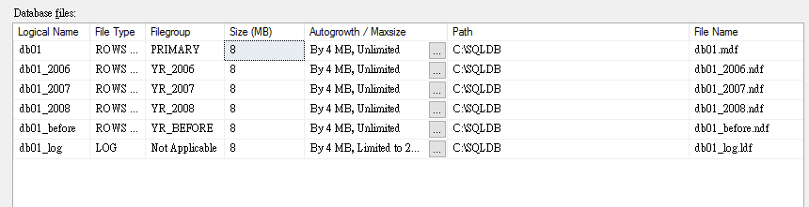

USE db01;

CREATE TABLE dbo.BigOrder

(

order_id int IDENTITY(1, 1),

order_date date,

big_data nchar(4000) DEFAULT '',

CONSTRAINT PK_BigOrder PRIMARY KEY(order_id, order_date)

);

