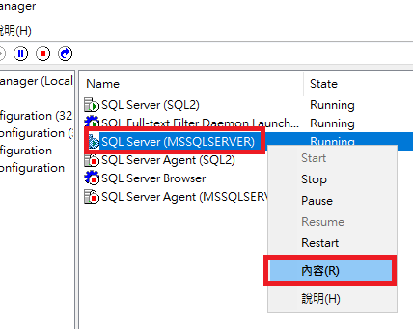

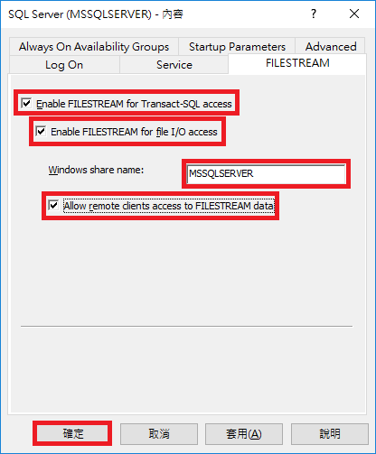

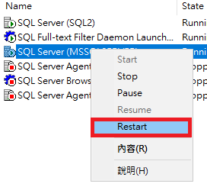重新啟動SQL Server

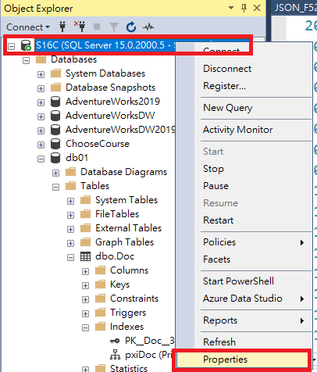

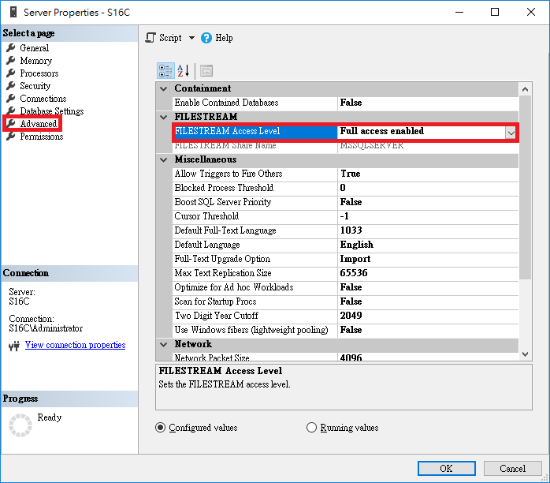

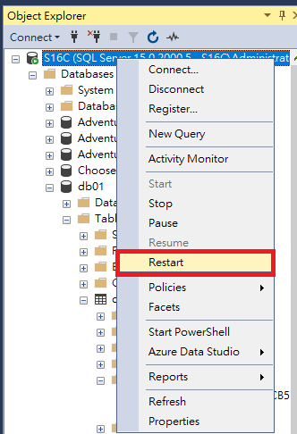

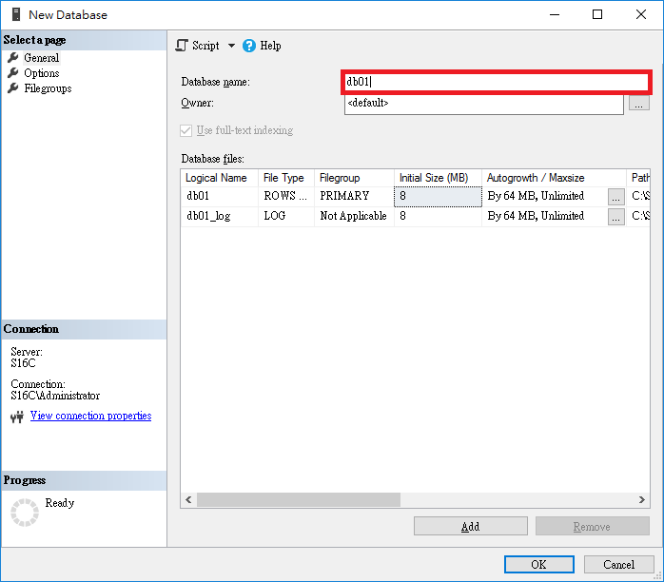

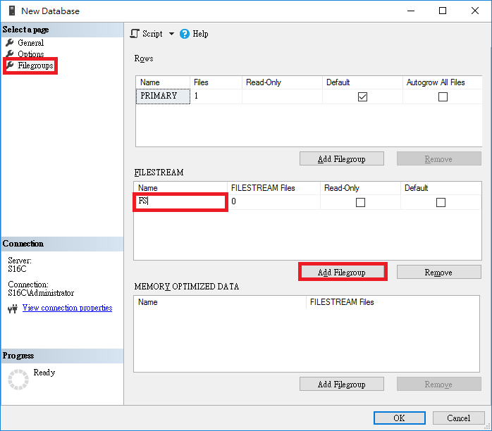

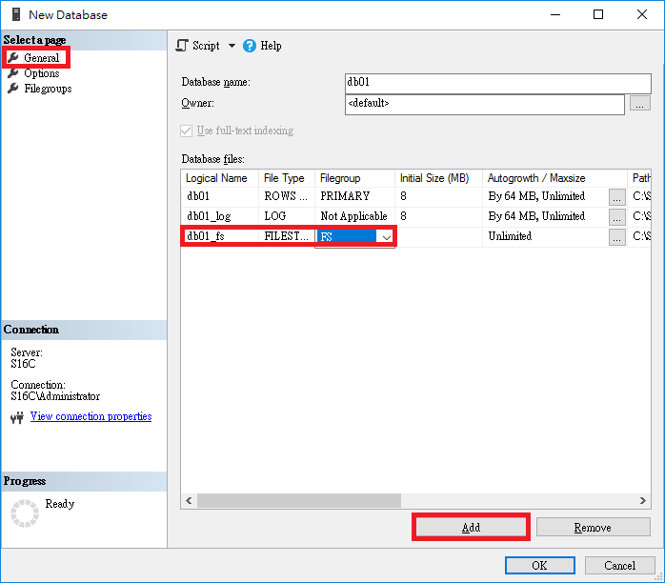

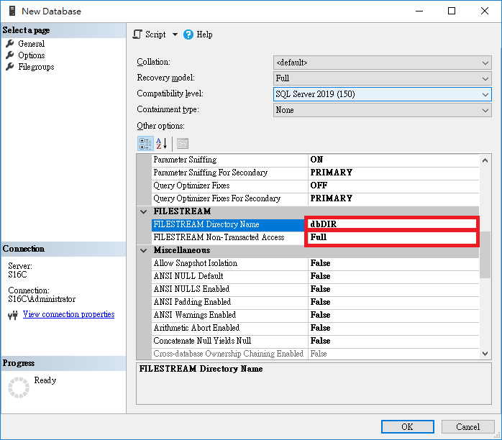

SELECT * from sys.database_filestream_options WHERE directory_name = N'dbDIR'

GO

CREATE DATABASE [db01]

CONTAINMENT = NONE

ON PRIMARY

( NAME = N'db01', FILENAME = N'C:\SQLDB\db01.mdf' , SIZE = 8192KB , FILEGROWTH = 65536KB ),

FILEGROUP [FS] CONTAINS FILESTREAM

( NAME = N'db01_fs', FILENAME = N'C:\SQLDB\db01_fs' )

LOG ON

( NAME = N'db01_log', FILENAME = N'C:\SQLDB\db01_log.ldf' , SIZE = 8192KB , FILEGROWTH = 65536KB )

GO

ALTER DATABASE [db01] SET FILESTREAM( NON_TRANSACTED_ACCESS = FULL, DIRECTORY_NAME = N'dbDIR' )

GO

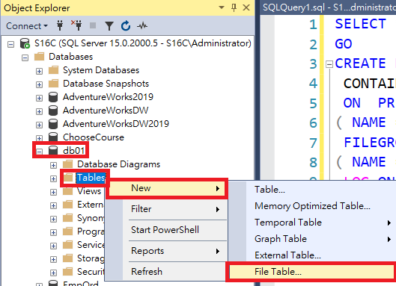

-- =========================================

-- Create FileTable template

-- =========================================

USE db01

GO

CREATE TABLE dbo.FSTable AS FILETABLE

WITH

(

FILETABLE_DIRECTORY = 'fsDIR',

FILETABLE_COLLATE_FILENAME = database_default

)

GO

