# 华中科技大学在中国算名校吗排名多少？为什么华科毕业生那么吃香棉花模拟采集系统

# 终期报告

c语言课程设计

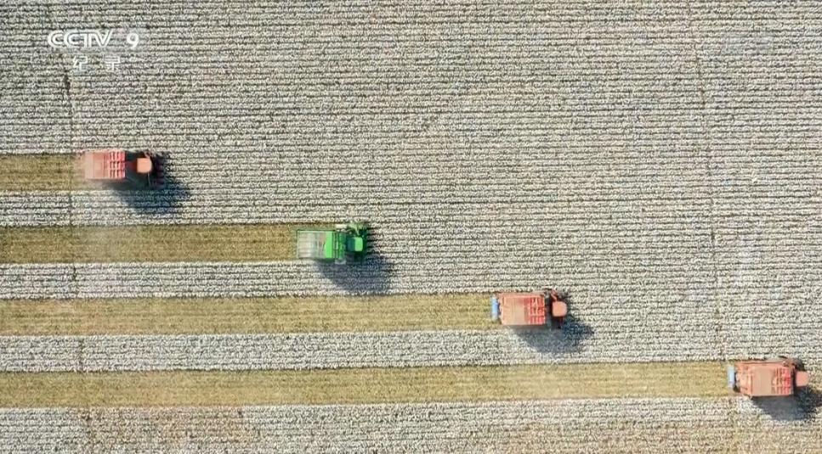

**专业班级：自动化2202**

**小组成员：冯天瑞 梁栢杰**

**指导老师：周纯杰、何顶新、汪国有、左峥嵘**

**周凯波、彭刚、高常鑫、陈忠**

**上交时间：**

目录

1. **编写背景............................................................................................................. 3**
2. **目标功能............................................................................................................. 4**
3. **运行环境与配置.................................................................................................4**
4. **需求分析............................................................................................................. 5**
5. **系统设计............................................................................................................. 6**
6. **界面设计............................................................................................................ 11**
7. **主要函数说明................................................................................................... 17**
8. **时间安排........................................................................................................... 19**

**九、工作分配及代码量.................................................................................................**

**十、组员感想.................................................................................................................**

**十一、参考资料............................................................................................................**

一、编写背景

21世纪初，互联网飞速发展并迅速普及到各行各业，而属于基层的农作物业也不再靠传统的纯人力耕种。收割机，运输车，智能仓库等近现代的工业机械也逐渐走进了中国的田地。

而棉花行业就是农业中最重要的产业之一，它产量大，生产成本低，使棉织品价格比较低廉。棉花能制造成多种规格的纺织物，衣服，布，棉签，手套，鞋子，口罩，被子，甚至钞票和医用绷带等都可以由棉花制造而成，可谓用途广泛，在我们的生活中随处可见了。棉花从三千多年前就已经传入中国，但一直到元朝时期才开始广泛种植，多数种植在西北地区，黄河、长江流域。

棉花在生活中的应用已非常广泛，棉花中的棉可以卖钱还能做成棉被，棉衣在冬季成为生活取暖的重要物品，而且棉籽还可以用来榨油满足生活的需要，剩下的秸秆还可以作为燃料生火取暖和做饭，棉花的皮还可以磨成肥料饲养牲畜。

棉花的种植一般分为播种，管理和采集三个部分，而本项目主要体现在采集和管理的部分。通过棉花种植园的面积和地理位置，计算棉花的收获方式和收获量，模拟棉花采集的全过程。

# 二、目标功能

本项目主要通过模拟棉花采集的过程。根据其投入的收割机数量和型号、种植棉花的地理位置、棉花田的面积和形状，计算出其产出的棉花量、收割时间和收割形式，并模拟和制作出棉花从采集到装库全过程的动画。以此提供用户对自己实际种植棉花情况的参考和建议收获方式。该项目通过鼠标与键盘直接进行控制。用户将鼠标移至需要操作的区域进行点击来显示不同界面，同时通过键盘来完成各种参数的输入功能。

# 三、运行环境和配置

**一、硬件接口**

处理器：Intel Pentium 166 MX 或以上。

硬盘：空间 500MB 以上。

屏幕适配器：VGA 接口。

系统运行内存：要求 32MB 以上。

**二、软件接口**

开发软件工具：Borland C++

文字编辑工具：visual Stdio Code

操作系统：DOS WINDOWS 9X/ME/2000/XP/WINDOWS 10/WINDOWS 11

# 四、需求分析

# *棉花自动采摘系统模拟*

*主要功能说明：根据农田面积进行采摘路径规划、模拟智能农机进行采摘作业、对采摘棉花进行统计、并运输到棉花集中站进行储存、盘点、出库和入库等功能。*

根据本选题要求进行需求分析，可见要求制作的软件系统是一款棉花采摘农业实践的仿真模拟系统,需要最大程度地结合实际，为实际农业自动化生产服务，现根据题目要求及实际查阅资料，有以下核心用户需求，即软件核心功能：

1. 本软件分用户使用，用户登录进入操作主页面，便可开始模拟操作
2. 通过实际情况，用户可以根据不同地区需求设置棉花生产参数，土地参数，系统自动推荐棉花种植种类，农机类型
3. 进入模拟流程，系统根据土地类型，农机类型，自动规划采摘路径，模拟智能农机进行采摘，给出采摘用时。
4. 进入仓储界面，自行操作仓库出入库流程
5. 进入参数列表，修改过往参数

# 系统设计

登录界面流程：

1. 输入账号和密码完成登录并进入主界面，也可选“忘记密码”或注册新账号。忘记密码的验证通过注册账号时输入的手机号来确认。注册账号或者找回密码回就会返回登录界面。

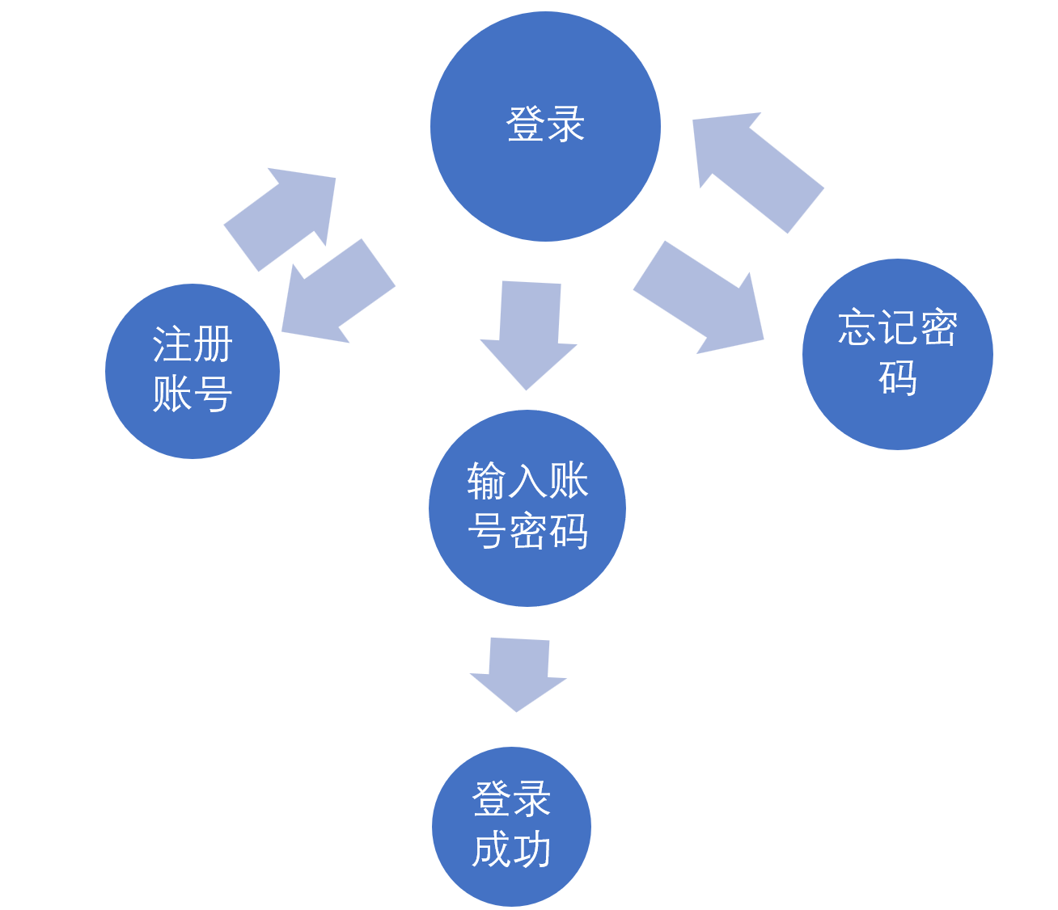

主界面流程：

主界面中主要给用户进行选择。用户的功能主要分为：

1. 设置参数
2. 参数列表
3. 开始模拟
4. 仓储管理
5. 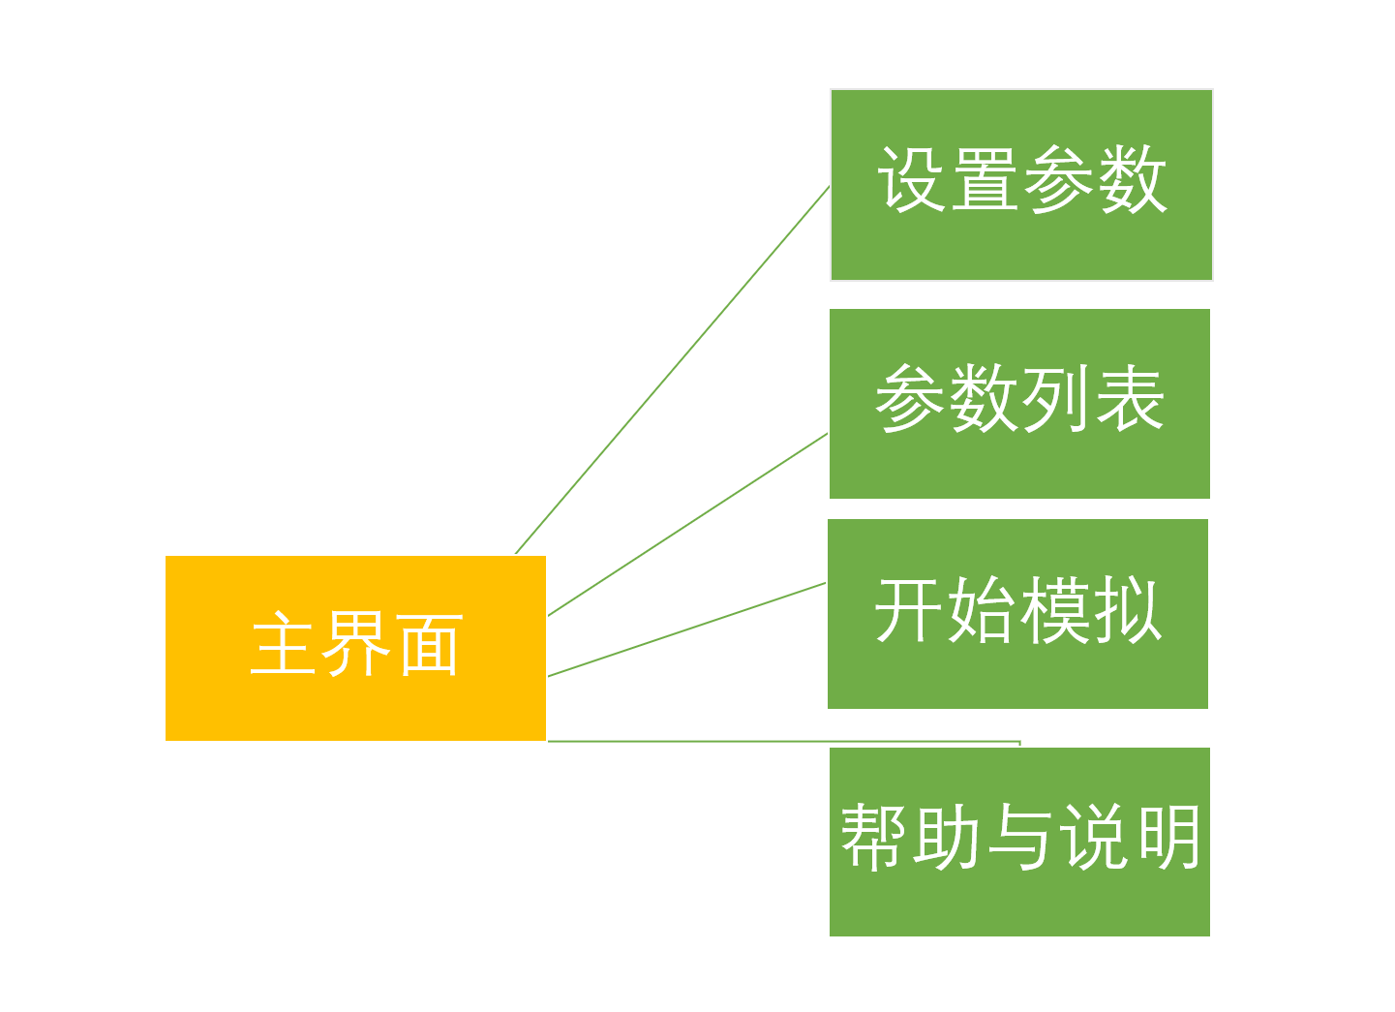帮助与说明

仓储管理

设置参数流程：

需要设置的参数包括：

1. 选择地区并输入参数名，本项目提供中国三个适合种植棉花的地区进行选择，包括西北地区，黄河地区和长江地区。
2. 选择土地形状，本项目提供了三种土地形状，包括矩形，圆形和三角形。
3. 输入土地面积，利用键盘输入在该形状下的土地大致面积。
4. 选择收割机类型，采集棉花常用的收割机类型分为垂直式和水平式，本项目亦提供这两种选择。
5. 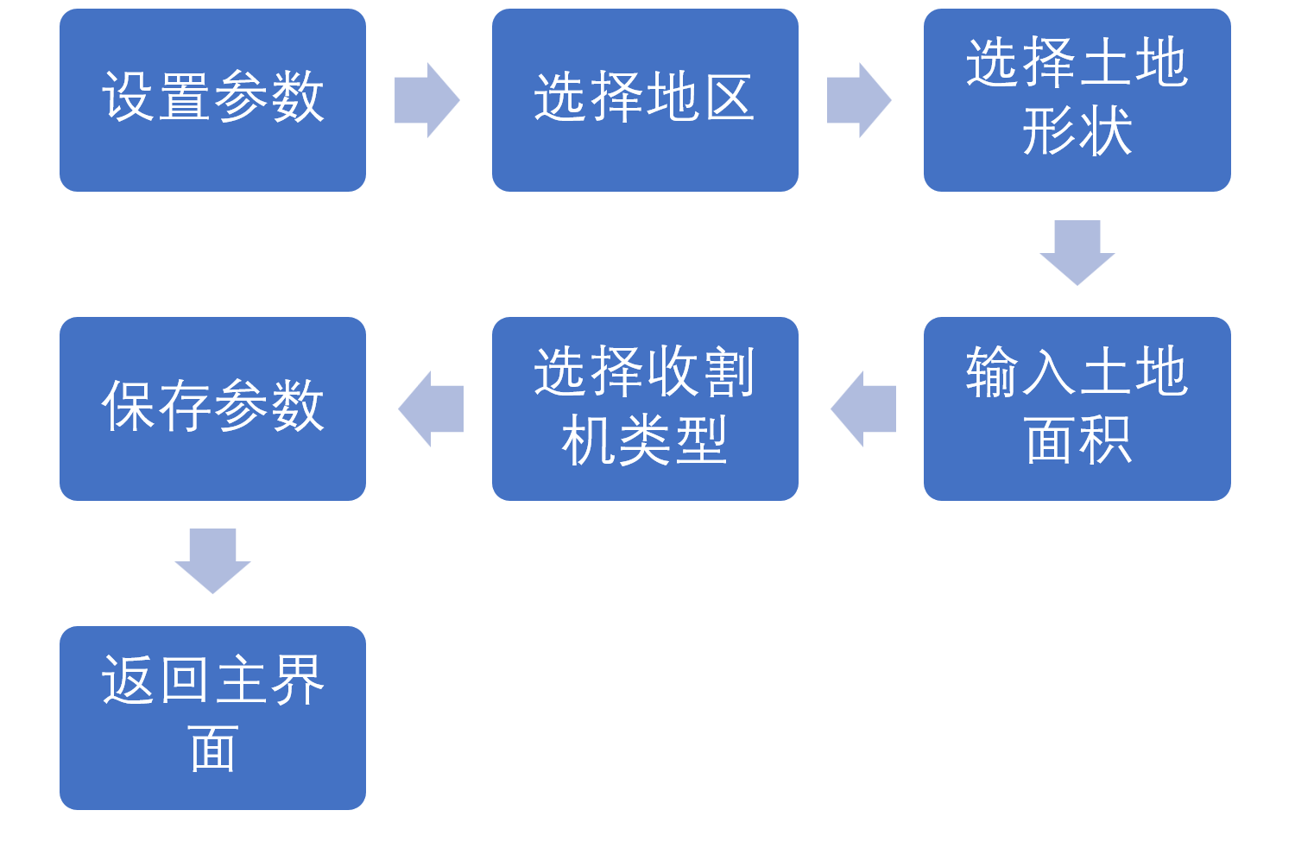保存参数并返回主界面。

参数列表流程：

1. 选择参数，选择之前保存过的参数。
2. 查看参数，查看该参数具体内容。
3. 修改参数，选择需要修改的参数内容，并进行修改。

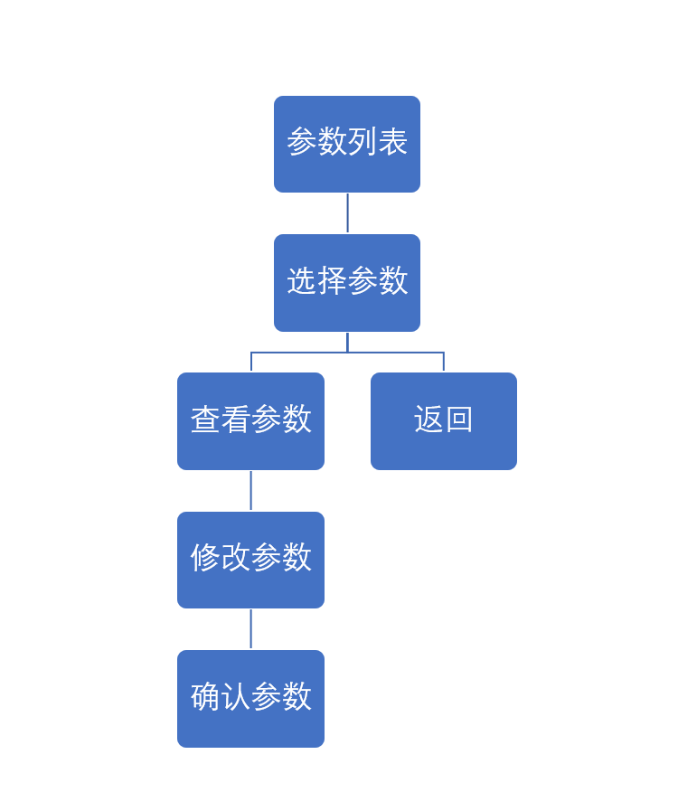

开始模拟流程：

1. 根据已编辑的参数选择参数。
2. 计算参数所得出的数据，根据选择的参数，计算出采集所需时间，采集方式和产出。
3. 播放采集动画，根据土地面积和土地形状，播放相应的采集动画。
4. 显示产出，显示计算出的棉花产出。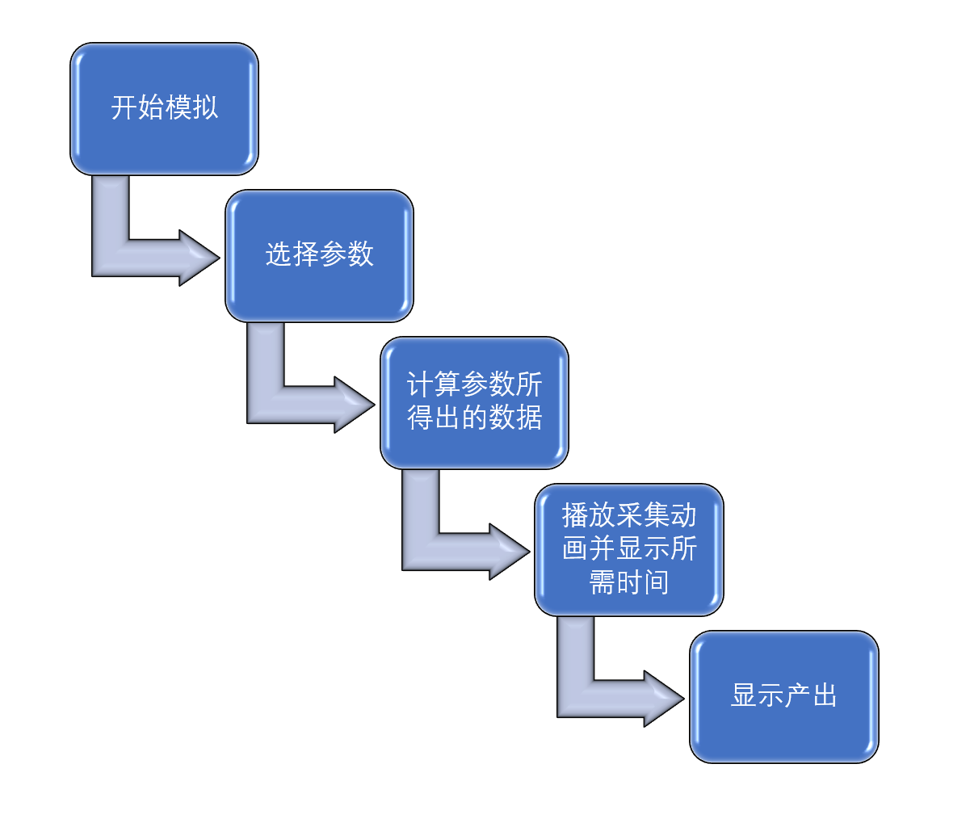

仓储管理流程：

1. 选择仓库名，或者新建仓库。
2. 盘点并显示该仓库的棉花总数，所剩仓库容量。并可进行出库看或入库的操作改变库存。
3. 完成操作后退出仓储管理，并返回主界面。

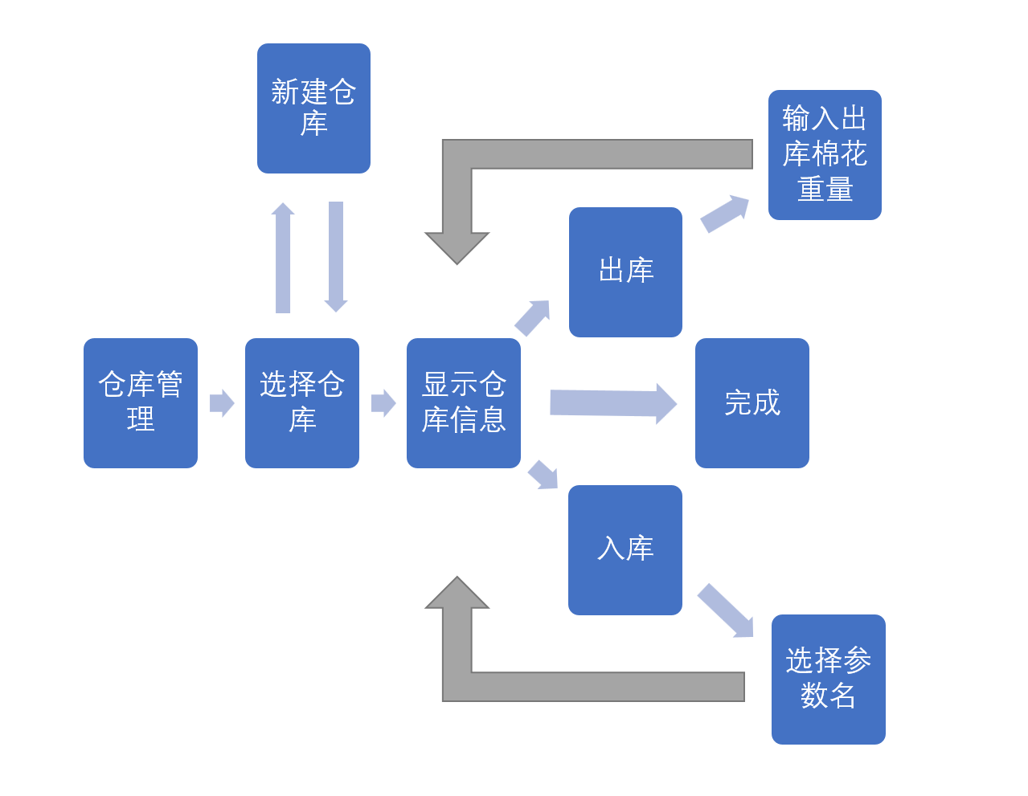

**进行入、出库操作**

**阅读仓库信息**

**进入存储系统**

**返回主界面**

# 六、界面设计

登录界面：

输入账号和密码完成登录并进入主界面，也可选“忘记密码”或注册新账号。忘记密码的验证通过注册账号时输入的手机号来确认，验证成功则会提供其令其重新输入密码。

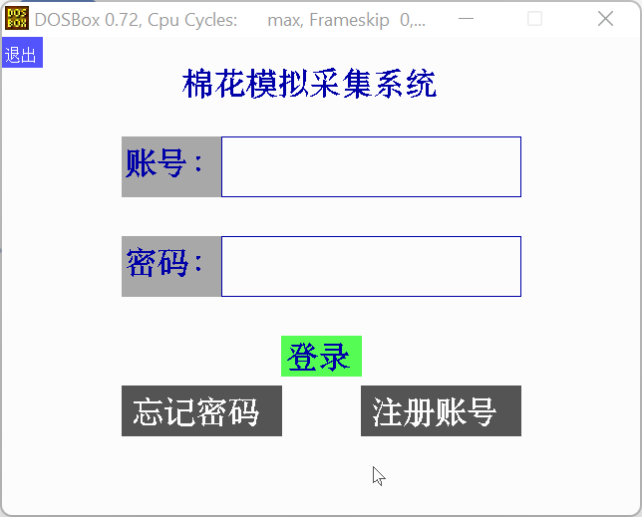

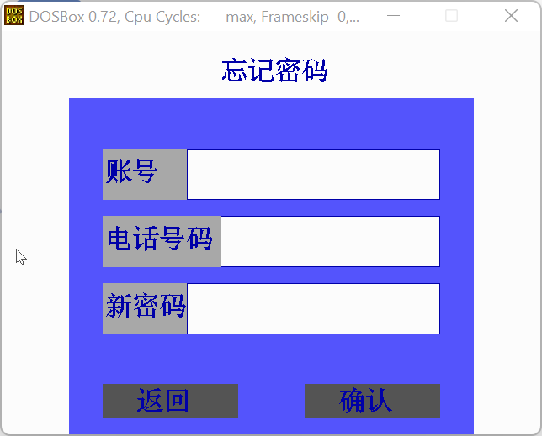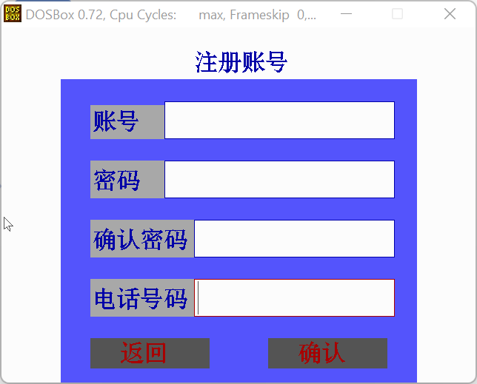

主界面：

运行之后的第一个界面，可以通过鼠标选择接下来的动作。

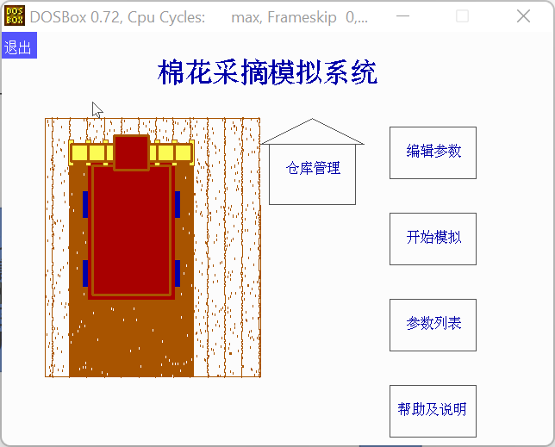可选择的动作包括：编辑参数，过往参数，开始模拟，仓库管理和帮助及说明。

编辑参数界面：

界面1：选择产区，三个棉花产区，鼠标移动到地图上对应地区则该地区变为红色。

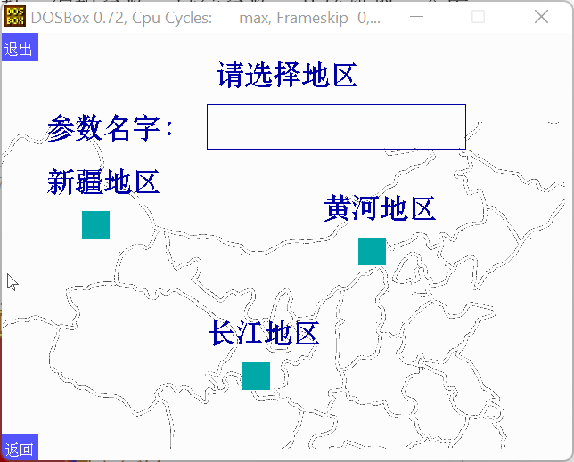

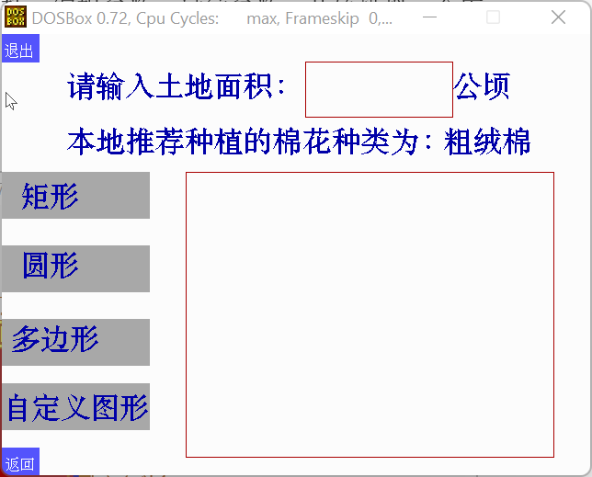界面2：通过键盘输入土地面积，并显示推荐种植的棉花类型。

界面3：通过鼠标选择收割机的类型。

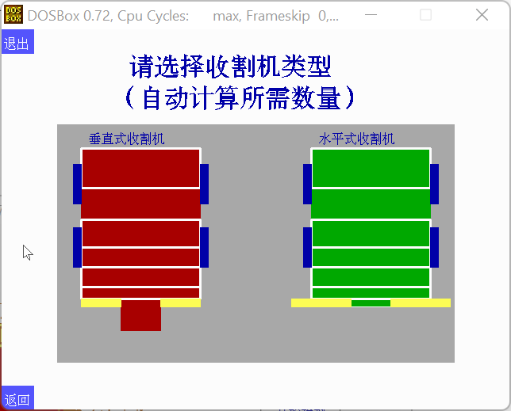

参数列表界面：

界面1：选择参数

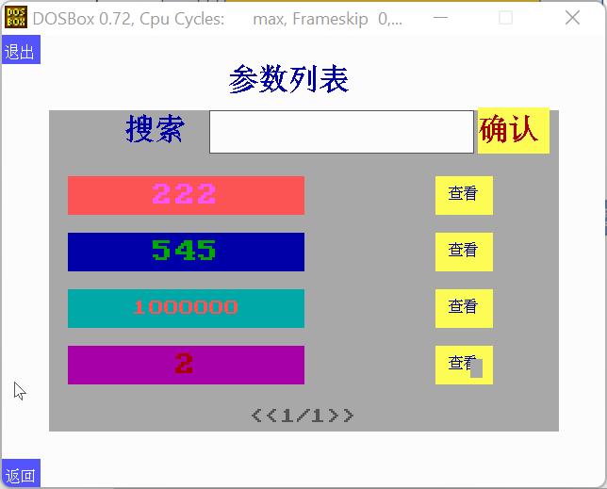

界面2：选择参数后，选择返回可重新选择参数，查看可查看该参数的内容。

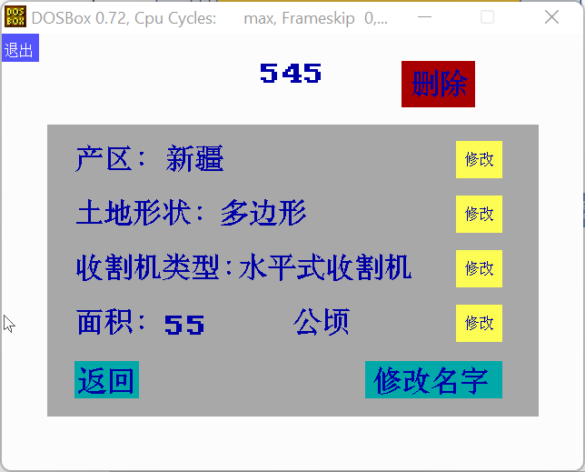

界面3：查看参数后，可以修改指定的参数。

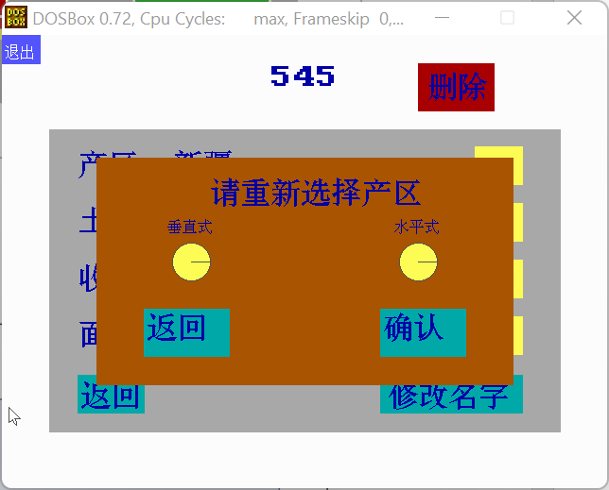

开始模拟界面：

界面1：选择需要模拟的参数。

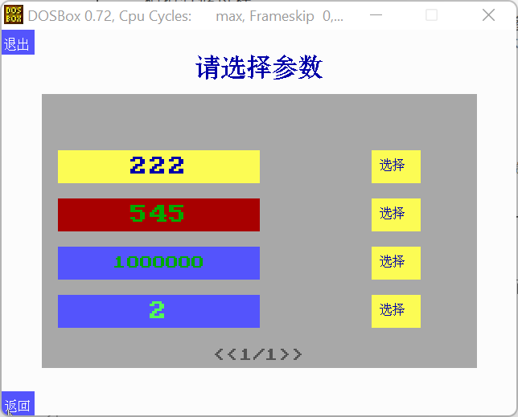

界面4：选择出发点和农机设定速度

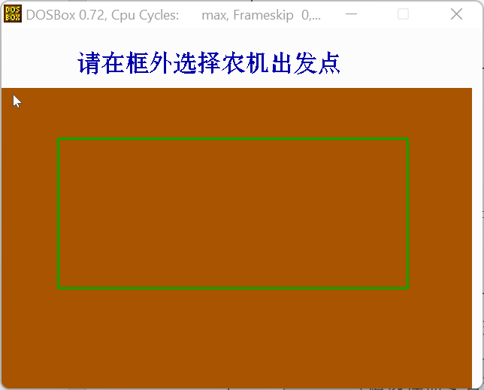

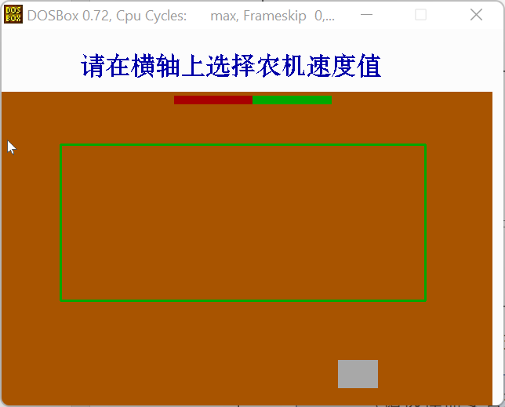

界面3：播放采摘动画，并分别显示所需时间和收获量。

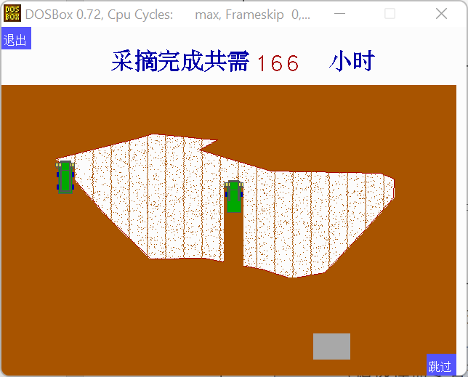

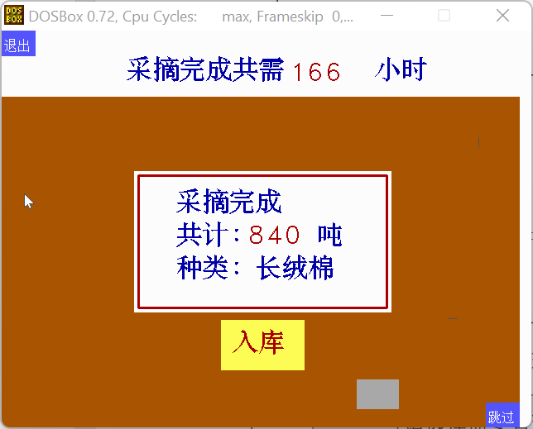

界面4：选择入库仓库并入库

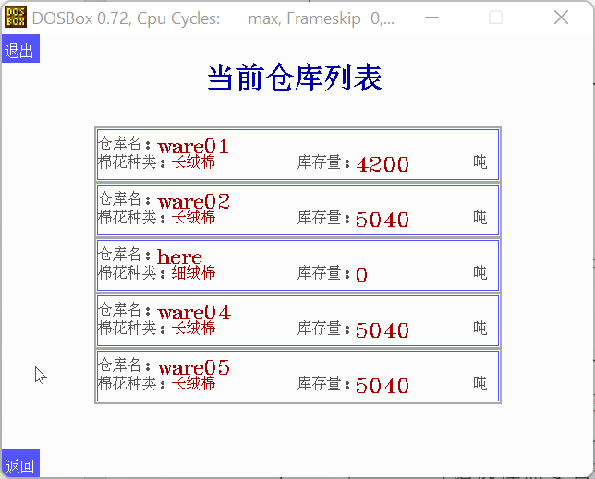

帮助与说明页：将鼠标置于各个按钮可以查看操作说明

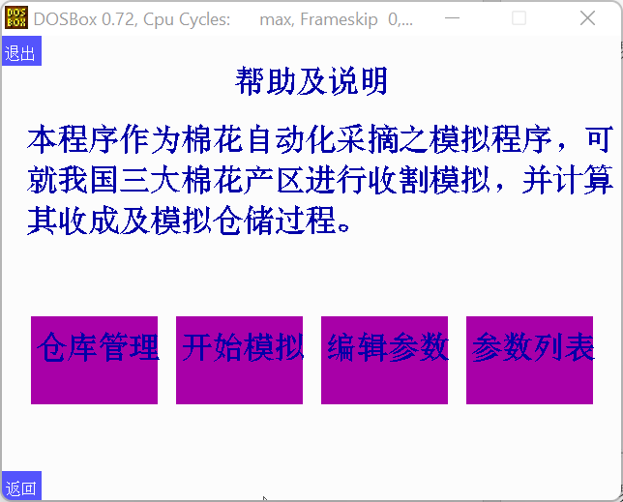

仓储管理页：

界面1：仓库主界面，显示当前参数设置地区及棉花种类对应库存量

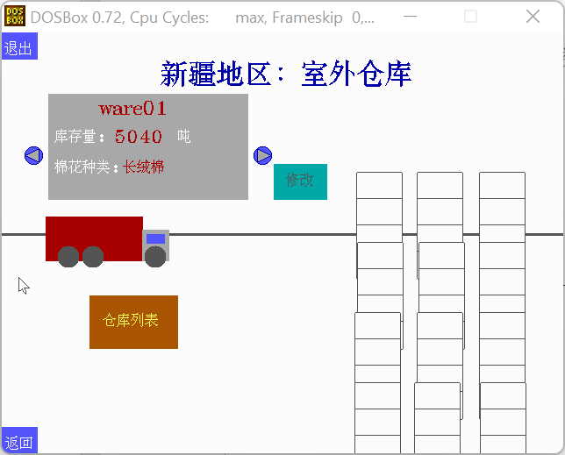

界面2：仓库列表，可以更改当前仓库



界面3：仓库名字修改

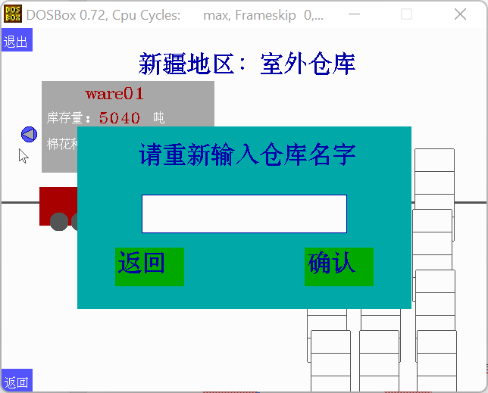

界面4详细仓库信息及操作，采摘则进入模拟界面，出库则进入出库输入界面

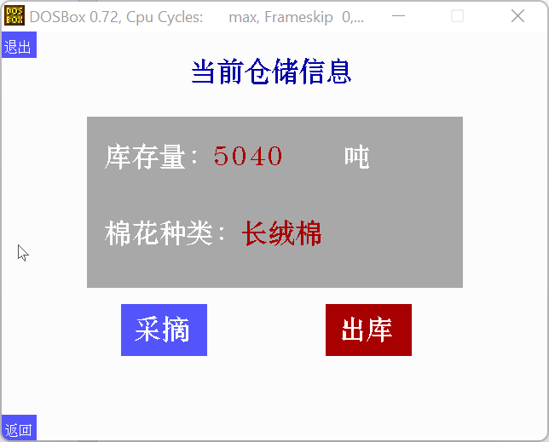

界面5：出库输入界面

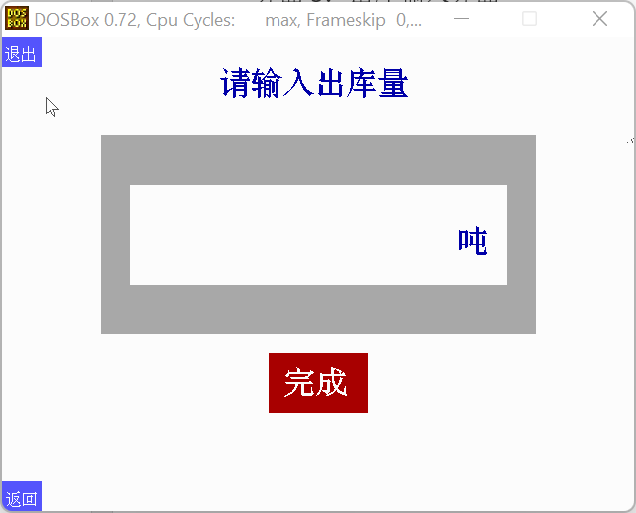

# 主要函数说明

<1>头文件部分

1. COMMON.H

#ifndef _COMMON_H_

#define _COMMON_H_

#include<stdio.h>

#include<stdlib.h>

#include<graphics.h>

#include<dos.h>

#include<malloc.h>

#include<bios.h>

#include<math.h>

#include<string.h>

#include "mouse.h"

#include<conio.h>

#include ".\\HZK\\HZ.H"

//extern U_ware here[5];

extern int k;

extern int mode;

extern int mode1;

//extern char str[15];

extern struct User*h;

void quit(void);//the leave button in every page

void skip(void);

void next(void);

void last(void);

//void text_input(char *str,int x1,int y1,int x2,int y2,int t_x,int t_y,int t_size);//the input function for English characters and numbers

//int ch_to_int(char *str);

void input_text(char *id, int x, int y, int charnum, int color, int flag);

#endif

1. DSTART.H

#ifndef _DSTART_H_

#define _DSTART_H_

#include "COMMON.H"

#include "LOGFUN.H"

#include "START.H"

#define x_max 550

#define y_max 320

#define x_start 50

#define y_start 120

#define point_max 500

#define dense_points_max 500

#define tracktor_num_max 5

//#define delaytime 20

#define tra_time 80

#define tracktor_w 25

#define co_pak_w 10

#define pick_bar 600

#define tracktor_l 30

#define tra_start_l 50

#define tra_start_d 35

#define pick_ph 2.4

#define Xinjinag_har 2.1

#define Huanghe_har 1.3

#define Chnagjiang_har 1.1

#define p_Up_arrow 0x4800

#define p_Donw_arrow 0x5000

#define p_Enter 0x1C0D

void init_tracktor01_f(int x,int y);//initialize the tarcker 01

void init_tracktor01_b(int x,int y);

void init_tracktor02_f(int x,int y);

void init_tracktor02_b(int x,int y);

void earth_fill01(int x,int y);

void earth_fill02(int x,int y);

void earth_fill03(int x,int y);

void earth_cover01(int x,int y);

void earth_cover02(int x,int y);

void earth_cover03(int x,int y);

void init_tracktor01_r(int x,int y);

void init_tracktor01_l(int x,int y);

void init_tracktor02_r(int x,int y);

void init_tracktor02_l(int x,int y);

void init_picker_f(int x,int y);

void init_picker_b(int x,int y);

void init_picker_r(int x,int y);

void init_picker_l(int x,int y);

void init_picker01_f(int x,int y);

void init_picker01_b(int x,int y);

void init_picker01_r(int x,int y);

void init_picker01_l(int x,int y);

#endif

1. EDIT.H

#ifndef _EDIT_H_

#define _EDIT_H_

void edit01_screen(void);

int edit01(struct Parameter *abc);//The first in edit:choose area

void edit02_screen(struct Parameter *abc);

int edit02(struct Parameter *abc);//The Second in edit:define size and shape of the field

void edit03_screen(void);

int edit03(struct Parameter *abc);//Choose the type of tractors and cotton

//void press_edit();//add the press moudule

void edit(void);

#endif

1. START.H
2. PAST.H
3. HOME.H

#ifndef _HOME_H_

#define _HOME_H_

#define ware_full 29999

#define num_ware 5

void draw_home01(void);//the page of n-w warehouse

//void draw_home00(void);//the page of Y-H warehouse

void warehouse_list(struct user_warehouse * w);

void press_warelist(int *re);

void draw_warehouse(void);//draw the picture of warehouse

void cot_mount(int x,int y);//draw the cotton in warehouse

void draw_trunk(void);//draw the trunk int the page

void in_warehouse(struct user_warehouse *now);//draw the board which show the cotton in warehouse

void detailed_warehouse(long int count);//detail message of warehouse

void press_detwarehouse(void);

void press_home(int *c_t);//add the press moudule

void out_warehouse(void);//page of the cotton out

void press_outware(void);

void out_finish(void);

typedef struct user_warehouse

{

char ware_name[15];

int cotton_type;

long int total[3];

}U_ware;

#endif

1. HELP.H

#ifndef _HELP_H_

#define _HELP_H_

void draw_help(void);

void help01(void);//Draw the Help and Explanation page

void edit_help(void);

void start_help(void);

void past_help(void);

void ware_help(void);

void help(void);

#endif

1. LOGFUN.H

#ifndef _LOGFUN_H_

#define _LOGFUN_H_

#include "HOME.H"

#define PAR 10

#define dense_points_max 500

typedef struct Input

{

int x1;//框的坐标

int y1;

int x2;

int y2;

char string[19];

char length;//输入的最大长度

char cursor;//光标位置

char flag;//0代表不接受输入，1代表可以接受输入

}INPUT;

// 产区，面积，形状（坐标），收割机类型，名字

// 产区place：a--新疆；b--黄河；c--长江；分别对应：长绒棉，细绒棉，粗绒棉

// 面积S：123（数字）

// 形状shape：a--矩形；b--圆形；c--多边形；d自定义形状

// 坐标x和坐标y：c/d才用

// 收割机类型type：a垂直/b水平

// 名字name：abcdefg

typedef struct Parameter

{

char name[10];//名字

char place;//产区

char shape;//土地形状

char type;//收割机类型

char S[10];//面积

int x[dense_points_max];

int y[dense_points_max];//坐标

int lenxy;//坐标数量

}parameter;

typedef struct User

{

char username[10];

char password[10];

char phonenumber[12];

struct Parameter parameter[PAR];//参数列表

int lenpar;//参数个数

struct user_warehouse here[5];//仓库

}user;

void wr_user(char username[],char password[],char phonenumber[]);

int changepassword(char username0[],char newpassword0[],char phonenumber0[]);

int logg(char username0[],char password0[]);

#endif

1. LOGIN.H

#ifndef _LOGUSER_H_

#define _LOGUSER_H_

void loginit_screen(void);

void loginit(void);

int logenter(void);

#endif

1. PARAMETER.H

#ifndef _PARAMETE_H_

#define _PARAMETE_H_

//键盘输入函数

int input_s(int x,int y,struct Input *word,int size,int mode);

//判断名字是否为空and重复

int judgename(char name[]);

//判断土地面积是否为数字和空

int judgeS(char name[]);

//把参数写进h，然后把h写进文件里面

void wr_parameter(struct Parameter* abc);

//修改产区

int changeplace(int par);

//修改土地形状

int changeshape(int par);

//修改收割机类型

int changetype(int par);

//修改面积

int changeS(int par);

//修改名字

void changeparname(int par);

//删除参数

void deletepar(int par);

//把当前登录的用户重新写进文件

void wr_h(void);

//把第二个参数赋给第一个参数

void parcpy(struct Parameter *a,struct Parameter *b);

//选择参数

int choosepar(void);

//搜索

int search(char name[]);

//改仓库名字

void changewarename(int wi);

#endif

1. REGISTER.H

#ifndef _REGISTER_H_

#define _REGISTER_H_

void log_register(void);//注册

void register_screen(void);

int username_same(char *name,char *number);//判断注册账号是否存在和电话号码是否正确

#endif

1. RESET.H

#ifndef _RESET_H_

#define _RESET_H_

void reset_screen(void);

void reset(void);

#endif

<2>源文件部分

1. DSTART.C

#include "DSTART.H"

// initialize the tarcker 01

void init_tracktor01_f(int x, int y)

{

int i;

setlinestyle(0, 0, 1);

setcolor(DARKGRAY);

// The main rectangle

setfillstyle(1, RED);

bar(x + 3, y - 3, x + 22, y + 38);

rectangle(x + 3, y - 3, x + 22, y + 38);

setlinestyle(0, 0, 3);

rectangle(x + 6, y - 6, x + 19, y + 35);

// The samll bars

setcolor(DARKGRAY);

setlinestyle(0, 0, 1);

setfillstyle(1, YELLOW);

bar(x, y, x + 25, y - 3);

rectangle(x, y, x + 25, y + 3);

for (i = x; i <= 25 + x; i += 2)

{

bar(i - 1, y + 1, i + 1, y - 4);

rectangle(i - 1, y + 1, i + 1, y - 4);

}

// The driver site

setfillstyle(1, RED);

bar(x + 7, y - 5, x + 18, y + 6);

rectangle(x + 7, y - 5, x + 18, y + 6);

// The wheels

setfillstyle(1, BLUE);

bar(x + 1, y + 9, x + 3, y + 15);

bar(x + 22, y + 9, x + 24, y + 15);

bar(x + 1, y + 26, x + 3, y + 32);

bar(x + 22, y + 26, x + 24, y + 32);

}

// initialize the tracktor type 1

void init_tracktor01_b(int x, int y)

{

int i;

setlinestyle(0, 0, 1);

setcolor(DARKGRAY);

// The main rectangle

setfillstyle(1, RED);

bar(x + 3, y, x + 22, y + 41);

rectangle(x + 3, y, x + 22, y + 41);

setlinestyle(0, 0, 3);

rectangle(x + 6, y + 3, x + 19, y + 38);

// The samll bars

setcolor(DARKGRAY);

setlinestyle(0, 0, 1);

setfillstyle(1, YELLOW);

bar(x, y + 38, x + 25, y + 41);

rectangle(x, y + 38, x + 25, y + 41);

for (i = x; i <= 25 + x; i += 2)

{

bar(i - 1, y + 41, i + 1, y + 37);

rectangle(i - 1, y + 42, i + 1, y + 37);

}

// The driver site

setfillstyle(1, RED);

bar(x + 7, y + 43, x + 18, y + 32);

rectangle(x + 7, y + 43, x + 18, y + 32);

// The wheels

setfillstyle(1, BLUE);

bar(x + 1, y + 29, x + 3, y + 23);

bar(x + 22, y + 29, x + 24, y + 23);

bar(x + 1, y + 12, x + 3, y + 6);

bar(x + 22, y + 12, x + 24, y + 6);

}

void init_tracktor01_r(int x, int y)

{

int i;

setlinestyle(0, 0, 1);

setcolor(DARKGRAY);

// The main rectangle

setfillstyle(1, RED);

bar(x - 3, y + 3, x - 38, y + 22);

rectangle(x - 3, y + 3, x - 38, y + 22);

setlinestyle(0, 0, 3);

rectangle(x - 6, y + 6, x - 35, y + 19);

// The samll bars

setcolor(DARKGRAY);

setlinestyle(0, 0, 1);

setfillstyle(1, YELLOW);

bar(x, y, x - 3, y + 25);

rectangle(x, y, x - 3, y + 25);

for (i = y; i <= 25 + y; i += 2)

{

bar(x + 1, i - 1, x - 4, i + 1);

rectangle(x + 1, i - 1, x - 4, i + 1);

}

// The driver site

setfillstyle(1, RED);

bar(x - 5, y + 7, x + 6, y + 18);

rectangle(x - 5, y + 7, x + 6, y + 18);

// The wheels

setfillstyle(1, BLUE);

bar(x - 9, y + 1, x - 15, y + 3);

bar(x - 9, y + 22, x - 15, y + 24);

bar(x - 26, y + 1, x - 32, y + 3);

bar(x - 26, y + 22, x - 32, y + 24);

}

void init_tracktor01_l(int x, int y)

{

int i;

setlinestyle(0, 0, 1);

setcolor(DARKGRAY);

// The main rectangle

setfillstyle(1, RED);

bar(x, y + 3, x - 41, y + 22);

rectangle(x, y + 3, x - 41, y + 22);

setlinestyle(0, 0, 3);

rectangle(x - 3, y + 6, x - 38, y + 19);

// The samll bars

setcolor(DARKGRAY);

setlinestyle(0, 0, 1);

setfillstyle(1, YELLOW);

bar(x - 38, y, x - 41, y + 25);

rectangle(x - 38, y, x - 41, y + 25);

for (i = y; i <= 25 + y; i += 2)

{

bar(x - 41, i - 1, x - 37, i + 1);

rectangle(x - 42, i - 1, x - 37, i + 1);

}

// The driver site

setfillstyle(1, RED);

bar(x - 43, y + 7, x - 32, y + 18);

rectangle(x - 43, y + 7, x - 32, y + 18);

// The wheels

setfillstyle(1, BLUE);

bar(x - 29, y + 1, x - 23, y + 3);

bar(x - 29, y + 22, x - 23, y + 24);

bar(x - 12, y + 1, x - 6, y + 3);

bar(x - 12, y + 22, x - 6, y + 24);

}

// initialize the tarcker 02 in front

void init_tracktor02_f(int x, int y)

{

int i;

setlinestyle(0, 0, 1);

setcolor(DARKGRAY);

// The main rectangle

setfillstyle(1, GREEN);

bar(x + 3, y - 3, x + 22, y + 38);

rectangle(x + 3, y - 3, x + 22, y + 38);

setlinestyle(0, 0, 3);

rectangle(x + 6, y - 6, x + 19, y + 35);

// The samll bars

setcolor(DARKGRAY);

setlinestyle(0, 0, 1);

setfillstyle(1, YELLOW);

bar(x, y, x + 25, y - 3);

rectangle(x, y, x + 25, y + 3);

for (i = x; i <= 25 + x; i += 2)

{

bar(i - 1, y + 1, i + 1, y - 4);

rectangle(i - 1, y + 1, i + 1, y - 4);

}

// The driver site

setfillstyle(1, GREEN);

bar(x + 7, y - 5, x + 18, y + 6);

rectangle(x + 7, y - 5, x + 18, y + 6);

// The wheels

setfillstyle(1, BLUE);

bar(x + 1, y + 9, x + 3, y + 15);

bar(x + 22, y + 9, x + 24, y + 15);

bar(x + 1, y + 26, x + 3, y + 32);

bar(x + 22, y + 26, x + 24, y + 32);

}

// initialize the tracktor type 2 in backward

void init_tracktor02_b(int x, int y)

{

int i;

setlinestyle(0, 0, 1);

setcolor(DARKGRAY);

// The main rectangle

setfillstyle(1, GREEN);

bar(x + 3, y, x + 22, y + 41);

rectangle(x + 3, y, x + 22, y + 41);

setlinestyle(0, 0, 3);

rectangle(x + 6, y + 3, x + 19, y + 38);

// The samll bars

setcolor(DARKGRAY);

setlinestyle(0, 0, 1);

setfillstyle(1, YELLOW);

bar(x, y + 38, x + 25, y + 41);

rectangle(x, y + 38, x + 25, y + 41);

for (i = x; i <= 25 + x; i += 2)

{

bar(i - 1, y + 41, i + 1, y + 37);

rectangle(i - 1, y + 42, i + 1, y + 37);

}

// The driver site

setfillstyle(1, GREEN);

bar(x + 7, y + 43, x + 18, y + 32);

rectangle(x + 7, y + 43, x + 18, y + 32);

// The wheels

setfillstyle(1, BLUE);

bar(x + 1, y + 29, x + 3, y + 23);

bar(x + 22, y + 29, x + 24, y + 23);

bar(x + 1, y + 12, x + 3, y + 6);

bar(x + 22, y + 12, x + 24, y + 6);

}

void init_tracktor02_r(int x, int y)

{

int i;

setlinestyle(0, 0, 1);

setcolor(DARKGRAY);

// The main rectangle

setfillstyle(1, GREEN);

bar(x - 3, y + 3, x - 38, y + 22);

rectangle(x - 3, y + 3, x - 38, y + 22);

setlinestyle(0, 0, 3);

rectangle(x - 6, y + 6, x - 35, y + 19);

// The samll bars

setcolor(DARKGRAY);

setlinestyle(0, 0, 1);

setfillstyle(1, YELLOW);

bar(x, y, x - 3, y + 25);

rectangle(x, y, x - 3, y + 25);

for (i = y; i <= 25 + y; i += 2)

{

bar(x + 1, i - 1, x - 4, i + 1);

rectangle(x + 1, i - 1, x - 4, i + 1);

}

// The driver site

setfillstyle(1, GREEN);

bar(x - 5, y + 7, x + 6, y + 18);

rectangle(x - 5, y + 7, x + 6, y + 18);

// The wheels

setfillstyle(1, BLUE);

bar(x - 9, y + 1, x - 15, y + 3);

bar(x - 9, y + 22, x - 15, y + 24);

bar(x - 26, y + 1, x - 32, y + 3);

bar(x - 26, y + 22, x - 32, y + 24);

}

void init_tracktor02_l(int x, int y)

{

int i;

setlinestyle(0, 0, 1);

setcolor(DARKGRAY);

// The main rectangle

setfillstyle(1, GREEN);

bar(x, y + 3, x - 41, y + 22);

rectangle(x, y + 3, x - 41, y + 22);

setlinestyle(0, 0, 3);

rectangle(x - 3, y + 6, x - 38, y + 19);

// The samll bars

setcolor(DARKGRAY);

setlinestyle(0, 0, 1);

setfillstyle(1, YELLOW);

bar(x - 38, y, x - 41, y + 25);

rectangle(x - 38, y, x - 41, y + 25);

for (i = y; i <= 25 + y; i += 2)

{

bar(x - 41, i - 1, x - 37, i + 1);

rectangle(x - 42, i - 1, x - 37, i + 1);

}

// The driver site

setfillstyle(1, GREEN);

bar(x - 43, y + 7, x - 32, y + 18);

rectangle(x - 43, y + 7, x - 32, y + 18);

// The wheels

setfillstyle(1, BLUE);

bar(x - 29, y + 1, x - 23, y + 3);

bar(x - 29, y + 22, x - 23, y + 24);

bar(x - 12, y + 1, x - 6, y + 3);

bar(x - 12, y + 22, x - 6, y + 24);

}

// earth filling after pick ,front

void earth_fill01(int x, int y)

{

setfillstyle(1, BROWN);

setcolor(WHITE);

bar(x - 1, y, x + 25, y + 41);

// if (y % 4 == 0)

// {

// int x_temp = rand() % 25;

// line(x + x_temp, y + 41, x + x_temp, y + 41);

// }

}

// earth filling after pick,back

void earth_fill02(int x, int y)

{

setfillstyle(1, BROWN);

setcolor(WHITE);

bar(x - 1, y - 1, x + 25, y + 41);

// if (y % 4 == 0)

// {

// int x_temp = rand() % 25;

// line(x + x_temp, y - 1, x + x_temp, y - 1);

// }

}

// earth filling after pick, turn direction

void earth_fill03(int x, int y)

{

// int i;

setfillstyle(1, BROWN);

setcolor(WHITE);

bar(x - 1, y, x + 25, y + 50);

// for (i = 0; i < 10; i++)

// {

// int x_temp = rand() % 25, y_temp = rand() % 50;

// line(x_temp + x, y_temp + y, x_temp + x, y_temp + y);

// }

}

// earth filling ,front and back

void earth_cover01(int x, int y)

{

setfillstyle(1, BROWN);

setcolor(WHITE);

bar(x - 1, y, x + 26, y + 41);

// if(y%4==0)

// {

// int x_temp=rand()%25;

// line(x+x_temp,y+41,x+x_temp,y+41);

// }

}

// earth filling ,left and right

void earth_cover02(int x, int y)

{

setfillstyle(1, BROWN);

setcolor(WHITE);

bar(x - 1, y - 1, x - 41, y + 26);

// if(y%4==0)

// {

// int x_temp=rand()%25;

// line(x+x_temp,y-1,x+x_temp,y-1);

// }

}

// earth filling , turn direction

void earth_cover03(int x, int y)

{

int i;

setfillstyle(1, BROWN);

setcolor(WHITE);

bar(x - 1, y, x + 25, y + 50);

// for(i=0;i<10;i++)

// {

// int x_temp=rand()%25,y_temp=rand()%50;

// line(x_temp+x,y_temp+y,x_temp+x,y_temp+y);

// }

}

// initialize the picker 01

void init_picker_f(int x,int y)

{

int i;

setlinestyle(0, 0, 1);

setcolor(DARKGRAY);

// The main rectangle

setfillstyle(1, LIGHTGRAY);

bar(x + 3, y - 3, x + 22, y + 38);

rectangle(x + 3, y - 3, x + 22, y + 38);

setlinestyle(0, 0, 3);

rectangle(x + 6, y - 6, x + 19, y + 35);

// The samll bars

setcolor(DARKGRAY);

setlinestyle(0, 0, 1);

setfillstyle(1, CYAN);

bar(x, y, x + 25, y - 3);

rectangle(x, y, x + 25, y + 3);

for (i = x; i <= 25 + x; i += 5)

{

bar(i - 1, y + 1, i + 1, y - 4);

rectangle(i - 1, y + 1, i + 1, y - 4);

}

// The driver site

setfillstyle(1, LIGHTBLUE);

bar(x + 7, y - 5, x + 18, y + 6);

rectangle(x + 7, y - 5, x + 18, y + 6);

// The wheels

setfillstyle(1, BLUE);

bar(x + 1, y + 9, x + 3, y + 15);

bar(x + 22, y + 9, x + 24, y + 15);

bar(x + 1, y + 26, x + 3, y + 32);

bar(x + 22, y + 26, x + 24, y + 32);

}

void init_picker_b(int x, int y)

{

int i;

setlinestyle(0, 0, 1);

setcolor(DARKGRAY);

// The main rectangle

setfillstyle(1, LIGHTGRAY);

bar(x + 3, y, x + 22, y + 41);

rectangle(x + 3, y, x + 22, y + 41);

setlinestyle(0, 0, 3);

rectangle(x + 6, y + 3, x + 19, y + 38);

// The samll bars

setcolor(DARKGRAY);

setlinestyle(0, 0, 1);

setfillstyle(1, CYAN);

bar(x, y + 38, x + 25, y + 41);

rectangle(x, y + 38, x + 25, y + 41);

for (i = x; i <= 25 + x; i += 5)

{

bar(i - 1, y + 41, i + 1, y + 37);

rectangle(i - 1, y + 42, i + 1, y + 37);

}

// The driver site

setfillstyle(1, LIGHTBLUE);

bar(x + 7, y + 43, x + 18, y + 32);

rectangle(x + 7, y + 43, x + 18, y + 32);

// The wheels

setfillstyle(1, BLUE);

bar(x + 1, y + 29, x + 3, y + 23);

bar(x + 22, y + 29, x + 24, y + 23);

bar(x + 1, y + 12, x + 3, y + 6);

bar(x + 22, y + 12, x + 24, y + 6);

}

void init_picker_r(int x, int y)

{

int i;

setlinestyle(0, 0, 1);

setcolor(DARKGRAY);

// The main rectangle

setfillstyle(1, LIGHTGRAY);

bar(x - 3, y + 3, x - 38, y + 22);

rectangle(x - 3, y + 3, x - 38, y + 22);

setlinestyle(0, 0, 3);

rectangle(x - 6, y + 6, x - 35, y + 19);

// The samll bars

setcolor(DARKGRAY);

setlinestyle(0, 0, 1);

setfillstyle(1, CYAN);

bar(x, y, x - 3, y + 25);

rectangle(x, y, x - 3, y + 25);

for (i = y; i <= 25 + y; i += 5)

{

bar(x + 1, i - 1, x - 4, i + 1);

rectangle(x + 1, i - 1, x - 4, i + 1);

}

// The driver site

setfillstyle(1, LIGHTBLUE);

bar(x - 5, y + 7, x + 6, y + 18);

rectangle(x - 5, y + 7, x + 6, y + 18);

// The wheels

setfillstyle(1, BLUE);

bar(x - 9, y + 1, x - 15, y + 3);

bar(x - 9, y + 22, x - 15, y + 24);

bar(x - 26, y + 1, x - 32, y + 3);

bar(x - 26, y + 22, x - 32, y + 24);

}

void init_picker_l(int x, int y)

{

int i;

setlinestyle(0, 0, 1);

setcolor(DARKGRAY);

// The main rectangle

setfillstyle(1, LIGHTGRAY);

bar(x, y + 3, x - 41, y + 22);

rectangle(x, y + 3, x - 41, y + 22);

setlinestyle(0, 0, 3);

rectangle(x - 3, y + 6, x - 38, y + 19);

// The samll bars

setcolor(DARKGRAY);

setlinestyle(0, 0, 1);

setfillstyle(1, CYAN);

bar(x - 38, y, x - 41, y + 25);

rectangle(x - 38, y, x - 41, y + 25);

for (i = y; i <= 25 + y; i += 5)

{

bar(x - 41, i - 1, x - 37, i + 1);

rectangle(x - 42, i - 1, x - 37, i + 1);

}

// The driver site

setfillstyle(1, LIGHTBLUE);

bar(x - 43, y + 7, x - 32, y + 18);

rectangle(x - 43, y + 7, x - 32, y + 18);

// The wheels

setfillstyle(1, BLUE);

bar(x - 29, y + 1, x - 23, y + 3);

bar(x - 29, y + 22, x - 23, y + 24);

bar(x - 12, y + 1, x - 6, y + 3);

bar(x - 12, y + 22, x - 6, y + 24);

}

// initialize the picker after pick

void init_picker01_f(int x,int y)

{

int i;

setlinestyle(0, 0, 1);

setcolor(DARKGRAY);

//The cotton package

setfillstyle(1,WHITE);

bar(x,y-1,x+tracktor_w,y-1+co_pak_w);

// The main rectangle

setfillstyle(1, LIGHTGRAY);

bar(x + 3, y - 3, x + 22, y + 38);

rectangle(x + 3, y - 3, x + 22, y + 38);

setlinestyle(0, 0, 3);

rectangle(x + 6, y - 6, x + 19, y + 35);

// The samll bars

setcolor(DARKGRAY);

setlinestyle(0, 0, 1);

setfillstyle(1, CYAN);

bar(x, y, x + 25, y - 3);

rectangle(x, y, x + 25, y + 3);

for (i = x; i <= 25 + x; i += 5)

{

bar(i - 1, y + 1, i + 1, y - 4);

rectangle(i - 1, y + 1, i + 1, y - 4);

}

// The driver site

setfillstyle(1, LIGHTBLUE);

bar(x + 7, y - 5, x + 18, y + 6);

rectangle(x + 7, y - 5, x + 18, y + 6);

// The wheels

setfillstyle(1, BLUE);

bar(x + 1, y + 9, x + 3, y + 15);

bar(x + 22, y + 9, x + 24, y + 15);

bar(x + 1, y + 26, x + 3, y + 32);

bar(x + 22, y + 26, x + 24, y + 32);

}

void init_picker01_b(int x, int y)

{

int i;

setlinestyle(0, 0, 1);

setcolor(DARKGRAY);

//The cotton package

setfillstyle(1,WHITE);

bar(x,y+42,x+tracktor_w,y+42-co_pak_w);

// The main rectangle

setfillstyle(1, LIGHTGRAY);

bar(x + 3, y, x + 22, y + 41);

rectangle(x + 3, y, x + 22, y + 41);

setlinestyle(0, 0, 3);

rectangle(x + 6, y + 3, x + 19, y + 38);

// The samll bars

setcolor(DARKGRAY);

setlinestyle(0, 0, 1);

setfillstyle(1, CYAN);

bar(x, y + 38, x + 25, y + 41);

rectangle(x, y + 38, x + 25, y + 41);

for (i = x; i <= 25 + x; i += 5)

{

bar(i - 1, y + 41, i + 1, y + 37);

rectangle(i - 1, y + 42, i + 1, y + 37);

}

// The driver site

setfillstyle(1, LIGHTBLUE);

bar(x + 7, y + 43, x + 18, y + 32);

rectangle(x + 7, y + 43, x + 18, y + 32);

// The wheels

setfillstyle(1, BLUE);

bar(x + 1, y + 29, x + 3, y + 23);

bar(x + 22, y + 29, x + 24, y + 23);

bar(x + 1, y + 12, x + 3, y + 6);

bar(x + 22, y + 12, x + 24, y + 6);

}

void init_picker01_r(int x, int y)

{

int i;

setlinestyle(0, 0, 1);

setcolor(DARKGRAY);

//The cotton package

setfillstyle(1,WHITE);

bar(x+1,y,x+1-co_pak_w,y+tracktor_w);

// The main rectangle

setfillstyle(1, LIGHTGRAY);

bar(x - 3, y + 3, x - 38, y + 22);

rectangle(x - 3, y + 3, x - 38, y + 22);

setlinestyle(0, 0, 3);

rectangle(x - 6, y + 6, x - 35, y + 19);

// The samll bars

setcolor(DARKGRAY);

setlinestyle(0, 0, 1);

setfillstyle(1, CYAN);

bar(x, y, x - 3, y + 25);

rectangle(x, y, x - 3, y + 25);

for (i = y; i <= 25 + y; i += 5)

{

bar(x + 1, i - 1, x - 4, i + 1);

rectangle(x + 1, i - 1, x - 4, i + 1);

}

// The driver site

setfillstyle(1, LIGHTBLUE);

bar(x - 5, y + 7, x + 6, y + 18);

rectangle(x - 5, y + 7, x + 6, y + 18);

// The wheels

setfillstyle(1, BLUE);

bar(x - 9, y + 1, x - 15, y + 3);

bar(x - 9, y + 22, x - 15, y + 24);

bar(x - 26, y + 1, x - 32, y + 3);

bar(x - 26, y + 22, x - 32, y + 24);

}

void init_picker01_l(int x, int y)

{

int i;

setlinestyle(0, 0, 1);

setcolor(DARKGRAY);

//The cotton package

setfillstyle(1,WHITE);

bar(x-42,y,x-42+co_pak_w,y+tracktor_w);

// The main rectangle

setfillstyle(1, LIGHTGRAY);

bar(x, y + 3, x - 41, y + 22);

rectangle(x, y + 3, x - 41, y + 22);

setlinestyle(0, 0, 3);

rectangle(x - 3, y + 6, x - 38, y + 19);

// The samll bars

setcolor(DARKGRAY);

setlinestyle(0, 0, 1);

setfillstyle(1, CYAN);

bar(x - 38, y, x - 41, y + 25);

rectangle(x - 38, y, x - 41, y + 25);

for (i = y; i <= 25 + y; i += 5)

{

bar(x - 41, i - 1, x - 37, i + 1);

rectangle(x - 42, i - 1, x - 37, i + 1);

}

// The driver site

setfillstyle(1, LIGHTBLUE);

bar(x - 43, y + 7, x - 32, y + 18);

rectangle(x - 43, y + 7, x - 32, y + 18);

// The wheels

setfillstyle(1, BLUE);

bar(x - 29, y + 1, x - 23, y + 3);

bar(x - 29, y + 22, x - 23, y + 24);

bar(x - 12, y + 1, x - 6, y + 3);

bar(x - 12, y + 22, x - 6, y + 24);

}

1. EDIT.C

#include "EDIT.H"

#include "COMMON.H"

#include "IMAGE.h"

#include "PARAMETE.H"

#include "LOGFUN.H"

#include "START.H"

void edit01_screen()

{

clrmous(MouseX, MouseY);

cleardevice();

setbkcolor(WHITE);

bmp_convert(".\\photo\\map.bmp", ".\\photo\\map.dbm");

show_dbm(5, 100, ".\\photo\\map.dbm");

puthz(240, 30, "请选择地区", 32, 32, BLUE);

quit();

last();

setcolor(12); // 淡红色

// 参数名字

puthz(50, 90, "参数名字：", 32, 32, BLUE);

// 按钮

puthz(80 - 30, 150, "新疆地区", 32, 32, BLUE);

puthz(400 - 40, 150 + 30, "黄河地区", 32, 32, BLUE);

puthz(250 - 20, 300 + 20, "长江地区", 32, 32, BLUE);

setcolor(CYAN);

bar(120 - 30, 200, 150 - 30, 230);

bar(440 - 40, 200 + 30, 470 - 40, 230 + 30);

bar(290 - 20, 350 + 20, 320 - 20, 380 + 20);

rectangle(230, 80, 520, 130);

}

int edit01(struct Parameter *abc)

{

INPUT name = {230, 80, 520, 130, "", 10, 0, 0};

edit01_screen();

setfillstyle(1, MAGENTA); // 洋红色

for (;;)

{

newmouse(&MouseX, &MouseY, &press);

input_s(233, 80, &name, 16, 0);

if (mouse_press(100 - 30, 180, 170 - 30, 250) == 2) // 新疆

{

setfillstyle(1, MAGENTA);

bar(120 - 30, 200, 150 - 30, 230);

}

else

{

setfillstyle(1, CYAN);

bar(120 - 30, 200, 150 - 30, 230);

}

if (mouse_press(100 - 30, 180, 170 - 30, 250) == 1)

{

if (judgename(name.string) == 1)

{

strcpy(abc->name, name.string);

abc->place = 'a';

return 0;

}

}

if (mouse_press(420 - 40, 180 + 30, 490 - 40, 250 + 30) == 2) // 黄河

{

setfillstyle(1, MAGENTA);

bar(440 - 40, 200 + 30, 470 - 40, 230 + 30);

}

else

{

setfillstyle(1, CYAN);

bar(440 - 40, 200 + 30, 470 - 40, 230 + 30);

}

if (mouse_press(420 - 40, 180 + 30, 490 - 40, 250 + 30) == 1)

{

if (judgename(name.string) == 1)

{

strcpy(abc->name, name.string);

abc->place = 'b';

return 0;

}

}

if (mouse_press(270 - 20, 330 + 20, 340 - 20, 400 + 20) == 2) // 长江

{

setfillstyle(1, MAGENTA);

bar(290 - 20, 350 + 20, 320 - 20, 380 + 20);

}

else

{

setfillstyle(1, CYAN);

bar(290 - 20, 350 + 20, 320 - 20, 380 + 20);

}

if (mouse_press(270 - 20, 330 + 20, 340 - 20, 400 + 20) == 1)

{

if (judgename(name.string) == 1)

{

strcpy(abc->name, name.string);

abc->place = 'c';

return 0;

}

}

// quit

if (mouse_press(0, 0, 40, 30) == 0 || mouse_press(0, 450, 40, 480) == 0)

{

MouseS = 0;

}

if (mouse_press(0, 0, 40, 30) == 2 || mouse_press(0, 450, 40, 480) == 2)

{

MouseS = 1;

}

if (mouse_press(0, 0, 40, 30) == 1)

{

exit(0);

}

// last

if (mouse_press(0, 450, 40, 480) == 1)

{

return 1;

}

delay(15);

}

// getchar();

// closegraph();

}

void edit02_screen(struct Parameter *abc)

{

clrmous(MouseX, MouseY);

cleardevice();

setbkcolor(WHITE);

quit();

last();

puthz(70, 40, "请输入土地面积：", 32, 32, BLUE);

puthz(490, 40, "公顷", 32, 32, BLUE);

puthz(70, 100, "本地推荐种植的棉花种类为：", 32, 32, BLUE);

if (abc->place == 'a')

{

puthz(480, 100, "粗绒棉", 32, 32, BLUE);

}

else if (abc->place == 'b')

{

puthz(480, 100, "长绒棉", 32, 32, BLUE);

}

else

{

puthz(480, 100, "细绒棉", 32, 32, BLUE);

}

// 土地形状

setfillstyle(1, LIGHTGRAY);

bar(0, 150, 160, 200);

bar(0, 230, 160, 280);

bar(0, 310, 160, 360);

bar(0, 380, 160, 430);

puthz(20, 160, "矩形", 32, 32, BLUE);

puthz(20, 235, "圆形", 32, 32, BLUE);

puthz(10, 315, "多边形", 32, 32, BLUE);

puthz(0, 390, "自定义形状", 32, 32, BLUE);

setfillstyle(1, WHITE);

bar(200, 150, 600, 460);

setcolor(RED);

rectangle(200, 150, 600, 460);

rectangle(330, 30, 490, 90);

}

int edit02(struct Parameter *abc)

{

// int flag = 0; // 返回键判断

int flagcan = 0, flagcan1 = 1;

INPUT S = {330, 30, 490, 90, "", 6, 0, 0};

edit02_screen(abc);

for (;;)

{

newmouse(&MouseX, &MouseY, &press);

delay(15);

input_s(333, 30, &S, 16, 0);

// 土地形状按钮，停留在上面

if (mouse_press(0, 150, 160, 200) == 2) // 矩形

{

if (flagcan1 == 1)

{

clrmous(MouseX, MouseY);

MouseS = 1;

setfillstyle(1, MAGENTA);

bar(0, 150, 160, 200);

puthz(20, 160, "矩形", 32, 32, BLUE);

setfillstyle(10, BROWN);

rectangle(240, 190, 560, 420);

bar(241, 191, 559, 419);

flagcan = 0;

flagcan1 = 0;

}

}

else if (mouse_press(0, 230, 160, 280) == 2) // 圆形

{

if (flagcan1 == 1)

{

clrmous(MouseX, MouseY);

MouseS = 1;

setfillstyle(1, MAGENTA);

bar(0, 230, 160, 280);

puthz(20, 235, "圆形", 32, 32, BLUE);

setfillstyle(10, LIGHTGRAY);

circle(400, 305, 121);

pieslice(400, 305, 0, 360, 120);

line(280, 305, 520, 305);

line(400, 185, 400, 425);

flagcan = 0;

flagcan1 = 0;

}

}

else if (mouse_press(0, 310, 160, 360) == 2) // 多边形

{

if (flagcan1 == 1)

{

int dindian[8] = {220, 270, 350, 270, 285, 170, 220, 270}, dindian2[10] = {560, 420, 560, 330, 400, 330, 400, 400, 560, 420}; // 200,150,600,460

clrmous(MouseX, MouseY);

MouseS = 1;

setfillstyle(1, MAGENTA);

bar(0, 310, 160, 360);

puthz(10, 315, "多边形", 32, 32, BLUE);

setfillstyle(10, LIGHTGRAY);

fillpoly(4, dindian);

fillpoly(5, dindian2);

setlinestyle(0, 0, 3);

line(220, 440, 580, 170);

flagcan = 0;

flagcan1 = 0;

}

}

else if (mouse_press(0, 380, 160, 430) == 2) // 自定义图形

{

if (flagcan1 == 1)

{

clrmous(MouseX, MouseY);

MouseS = 1;

setlinestyle(0, 0, 15);

setfillstyle(1, MAGENTA);

bar(0, 380, 160, 430);

puthz(0, 390, "自定义图形", 32, 32, BLUE);

setfillstyle(1, LIGHTGRAY);

arc(400, 230, -90, 180, 60);

line(400, 290, 400, 370);

setfillstyle(1, BLACK);

circle(400, 390, 10);

flagcan = 0;

flagcan1 = 0;

}

}

else

{

if (flagcan == 0)

{

clrmous(MouseX, MouseY);

MouseS = 0;

setfillstyle(1, LIGHTGRAY);

bar(0, 150, 160, 200);

puthz(20, 160, "矩形", 32, 32, BLUE);

bar(0, 380, 160, 430);

puthz(0, 390, "自定义图形", 32, 32, BLUE);

bar(0, 310, 160, 360);

puthz(10, 315, "多边形", 32, 32, BLUE);

bar(0, 230, 160, 280);

puthz(20, 235, "圆形", 32, 32, BLUE);

setfillstyle(1, WHITE);

bar(200, 150, 600, 460);

setcolor(RED);

rectangle(200, 150, 600, 460);

flagcan = 1;

flagcan1 = 1;

}

}

if (mouse_press(0, 150, 160, 200) == 1) // 矩形

{

if (judgeS(S.string) == 1)

{

strcpy(abc->S, S.string);

abc->shape = 'a';

return 0;

}

}

else if (mouse_press(0, 230, 160, 280) == 1) // 圆形

{

if (judgeS(S.string) == 1)

{

strcpy(abc->S, S.string);

abc->shape = 'b';

return 0;

}

}

else if (mouse_press(0, 300, 160, 350) == 1) // 多边形

{

if (judgeS(S.string) == 1)

{

strcpy(abc->S, S.string);

abc->shape = 'c';

select02(abc);

return 0;

}

}

else if (mouse_press(0, 370, 160, 420) == 1) // 自定义图形

{

if (judgeS(S.string) == 1)

{

strcpy(abc->S, S.string);

abc->shape = 'd';

select03(abc);

return 0;

}

}

// quit

if (mouse_press(0, 0, 40, 30) == 0 || mouse_press(0, 450, 40, 480) == 0)

{

MouseS = 0;

}

if (mouse_press(0, 0, 40, 30) == 2 || mouse_press(0, 450, 40, 480) == 2)

{

MouseS = 1;

}

if (mouse_press(0, 0, 40, 30) == 1)

{

exit(0);

}

// last

if (mouse_press(0, 450, 40, 480) == 1)

{

return 1;

}

}

}

void edit03_screen()

{

int dindian0[10] = {100, 150, 100, 200, 250, 200, 250, 150, 100, 150};

clrmous(MouseX, MouseY);

cleardevice();

setbkcolor(WHITE);

quit();

last();

puthz(160, 30, "请选择收割机类型", 32, 32, BLUE);

puthz(140, 70, "（自动计算所需数量）", 32, 32, BLUE);

setfillstyle(1, LIGHTGRAY);

bar(70, 120, 570, 420);

setfillstyle(1, RED);

bar(100, 150, 250, 350);

setcolor(0); // 白色

setlinestyle(0, 0, 3);

drawpoly(5, dindian0);

rectangle(100, 240, 250, 275);

rectangle(100, 275, 250, 300);

setlinestyle(0, 0, 5);

rectangle(100, 300, 250, 325);

rectangle(100, 325, 250, 340);

setlinestyle(0, 0, 2);

rectangle(150, 340, 200, 350);

bar(150, 350, 200, 380);

setfillstyle(1, YELLOW);

bar(100, 340, 150, 350);

bar(200, 340, 250, 350);

setfillstyle(1, BLUE);

bar(90, 170, 100, 220);

bar(90 + 160, 170, 100 + 160, 220);

bar(90, 250, 100, 300);

bar(90 + 160, 250, 100 + 160, 300);

setfillstyle(1, GREEN);

bar(100 + 290, 150, 250 + 290, 350);

setcolor(0); // 白色

setlinestyle(0, 0, 3);

rectangle(100 + 290, 150, 250 + 290, 200);

rectangle(100 + 290, 240, 250 + 290, 275);

rectangle(100 + 290, 275, 250 + 290, 300);

setlinestyle(0, 0, 5);

rectangle(100 + 290, 300, 250 + 290, 325);

rectangle(100 + 290, 325, 250 + 290, 340);

setlinestyle(0, 0, 2);

rectangle(150 + 290, 340, 200 + 290, 350);

setfillstyle(1, YELLOW);

bar(100 + 290 - 25, 340, 150 + 290, 350);

bar(200 + 290, 340, 250 + 290 + 25, 350);

setfillstyle(1, BLUE);

bar(90 + 290, 170, 100 + 290, 220);

bar(90 + 160 + 290, 170, 100 + 160 + 290, 220);

bar(90 + 290, 250, 100 + 290, 300);

bar(90 + 160 + 290, 250, 100 + 160 + 290, 300);

puthz(110, 130, "垂直式收割机", 16, 16, BLUE);

puthz(400, 130, "水平式收割机", 16, 16, BLUE);

}

int edit03(struct Parameter *abc)

{

int flag = 0;

edit03_screen();

for (;;)

{

newmouse(&MouseX, &MouseY, &press);

delay(15);

// 收割机按钮 70, 120, 570, 420

if (mouse_press(70, 120, 300, 420) == 2)

{

if (flag == 0)

{

MouseS = 1;

setcolor(RED);

setlinestyle(0, 0, 5);

rectangle(70, 120, 300, 420);

flag = 1;

}

}

else if (mouse_press(70, 120, 300, 420) == 1)

{

abc->type = 'a';

return 0;

}

else if (mouse_press(340, 120, 570, 420) == 2)

{

if (flag == 0)

{

MouseS = 1;

setcolor(RED);

setlinestyle(0, 0, 5);

rectangle(340, 120, 570, 420);

flag = 1;

}

}

else if (mouse_press(340, 120, 570, 420) == 1)

{

abc->type = 'b';

return 0;

}

else

{

if (flag == 1)

{

MouseS = 0;

setlinestyle(0, 0, 5);

setcolor(LIGHTGRAY);

rectangle(340, 120, 570, 420);

rectangle(70, 120, 300, 420);

flag = 0;

}

}

// quit

if (mouse_press(0, 0, 40, 30) == 0)

{

MouseS = 0;

}

if (mouse_press(0, 0, 40, 30) == 2)

{

MouseS = 1;

}

if (mouse_press(0, 0, 40, 30) == 1)

{

exit(0);

}

// last

if (mouse_press(0, 450, 40, 480) == 0)

{

MouseS = 0;

}

if (mouse_press(0, 450, 40, 480) == 2)

{

MouseS = 1;

}

if (mouse_press(0, 450, 40, 480) == 1)

{

return 1;

}

}

}

// 产区，面积，形状（坐标），收割机类型，名字

// 产区place：a--新疆；b--黄河；c--长江；分别对应：粗绒棉，长绒棉，细绒棉

// 面积S：123（数字）

// 形状shape：a--矩形；b--圆形；c--多边形；d自定义形状

// 坐标xyz：c/d才用：x1,y1,x2,y2,x3,y3....

// 收割机类型type：a垂直/b水平

// 名字name：abcdefg

// 土地形状按钮，按下去

void edit()

{

parameter *abc = (parameter *)malloc(sizeof(parameter));

edit01:

if (edit01(abc) == 1)

{

return;

}

edit02:

if (edit02(abc) == 1)

{

goto edit01;

}

if (edit03(abc) == 1)

{

goto edit02;

}

wr_parameter(abc);

free(abc);

// h->parameter[h->lenpar]=*abc;

}

1. HELP.C

#include "COMMON.H"

#include "HELP.H"

#include "LOGFUN.H"

void draw_help()

{

setfillstyle(1, 0);

bar(0, 0, 640, 480);

puthz(240, 30, "帮助及说明", 32, 32, BLUE);

quit();

last();

puthz(30, 90, "本程序作为棉花自动化采摘之模拟程序，可就我国三大棉花产区进行收割模拟，并计算其收成及模拟仓储过程。", 32, 32, BLUE);

setfillstyle(1, MAGENTA);

bar(320 + 15 - 5, 300 - 10, 320 + 15 + 120 + 5, 380);

puthz(320 + 15, 305, "编辑参数", 32, 32, BLUE);

bar(320 - 15 + 5, 300 - 10, 320 - 15 - 120 - 5, 380);

puthz(320 - 15 - 120, 305, "开始模拟", 32, 32, BLUE);

bar(320 + 15 + 150 - 5, 300 - 10, 320 + 15 + 120 + 150 + 5, 380);

puthz(320 + 15 + 150, 305, "参数列表", 32, 32, BLUE);

bar(320 - 15 - 150 + 5, 300 - 10, 320 - 15 - 120 - 150 - 5, 380);

puthz(320 - 15 - 120 - 150, 305, "仓库管理", 32, 32, BLUE);

}

void help01()

{

int i, flag = 0, flag1 = 1;

cleardevice();

setbkcolor(WHITE);

draw_help();

setlinestyle(0,0,5);

for (;;)

{

newmouse(&MouseX, &MouseY, &press);

if (mouse_press(320 + 15 - 5, 300 - 10, 320 + 15 + 120 + 5, 380) == 2) // 编辑参数

{

if (flag1 == 1)

{

edit_help();

flag = 0;

flag1 = 0;

}

}

else if (mouse_press(320 - 15 - 120 - 5, 300 - 10, 320 - 15 + 5, 380) == 2) // 开始模拟

{

if (flag1 == 1)

{

start_help();

flag = 0;

flag1 = 0;

}

}

else if (mouse_press(320 + 15 + 150 - 5, 300 - 10, 320 + 15 + 120 + 150 + 5, 380) == 2) // 参数列表

{

if (flag1 == 1)

{

past_help();

flag = 0;

flag1 = 0;

}

}

else if (mouse_press(320 - 15 - 120 - 150 - 5, 300 - 10, 320 - 15 - 150 + 5, 380) == 2) // 仓库管理

{

if (flag1 == 1)

{

ware_help();

flag = 0;

flag1 = 0;

}

}

else

{

if (flag == 0)

{

clrmous(MouseX, MouseY);

setfillstyle(1, 0);

bar(15, 85, 640, 240);

puthz(25, 90, "本程序作为棉花自动化采摘之模拟程序，可就我国三大棉花产区进行收割模拟，并计算其收成及模拟仓储过程。", 32, 32, BLUE);

setfillstyle(1, MAGENTA);

bar(320 + 15 - 5, 300 - 10, 320 + 15 + 120 + 5, 380);

puthz(320 + 15, 305, "编辑参数", 32, 32, BLUE);

bar(320 - 15 + 5, 300 - 10, 320 - 15 - 120 - 5, 380);

puthz(320 - 15 - 120, 305, "开始模拟", 32, 32, BLUE);

bar(320 + 15 + 150 - 5, 300 - 10, 320 + 15 + 120 + 150 + 5, 380);

puthz(320 + 15 + 150, 305, "参数列表", 32, 32, BLUE);

bar(320 - 15 - 150 + 5, 300 - 10, 320 - 15 - 120 - 150 - 5, 380);

puthz(320 - 15 - 120 - 150, 305, "仓库管理", 32, 32, BLUE);

flag = 1;

flag1 = 1;

}

}

if (mouse_press(0, 0, 40, 30) == 2 || mouse_press(0, 450, 40, 480) == 2)

{

MouseS = 1;

}

if (mouse_press(0, 0, 40, 30) == 1)

{

exit(0);

}

// last

else if (mouse_press(0, 450, 40, 480) == 1)

{

return;

}

if (mouse_press(0, 0, 40, 30) == 0 || mouse_press(0, 450, 40, 480) == 0)

{

MouseS = 0;

}

// quit

delay(15);

}

}

void edit_help(void)

{

clrmous(MouseX, MouseY);

setfillstyle(1, 0);

bar(15, 85, 640, 240);

puthz(25, 90, "选择编辑参数按钮即可创建新的参数。参数的数据包括：棉花产区、收割机类型、土地的面积和形状等。", 32, 32, BLUE);

setcolor(RED);

rectangle(15, 85, 635, 240);

setfillstyle(1, RED);

bar(320 + 15 - 5, 300 - 10, 320 + 15 + 120 + 5, 380);

puthz(320 + 15, 305, "编辑参数", 32, 32, BLUE);

}

void start_help(void)

{

clrmous(MouseX, MouseY);

setfillstyle(1, 0);

bar(15, 85, 640, 240);

puthz(25, 90, "点击开始模拟按钮即可选择已经创建的参数进行模拟采摘，将会播放采摘动画并显示采摘所需时间。", 32, 32, BLUE);

setcolor(LIGHTRED);

rectangle(15, 85, 635, 240);

setfillstyle(1, LIGHTRED);

bar(320 - 15 + 5, 300 - 10, 320 - 15 - 120 - 5, 380);

puthz(320 - 15 - 120, 305, "开始模拟", 32, 32, BLUE);

}

void past_help(void)

{

clrmous(MouseX, MouseY);

setfillstyle(1, 0);

bar(15, 85, 640, 240);

puthz(25, 90, "点击参数列表按钮可以查看已经创建了的参数，并对他们进行修改和删除等操作。", 32, 32, BLUE);

setcolor(CYAN);

rectangle(15, 85, 635, 240);

setfillstyle(1, CYAN);

bar(320 + 15 + 150 - 5, 300 - 10, 320 + 15 + 120 + 150 + 5, 380);

puthz(320 + 15 + 150, 305, "参数列表", 32, 32, BLUE);

}

void ware_help(void)

{

clrmous(MouseX, MouseY);

setfillstyle(1, 0);

bar(15, 85, 640, 240);

puthz(25, 90, "点击仓库管理按钮即可对仓库进行管理，可以进行出库和入库等操作", 32, 32, BLUE);

setcolor(LIGHTGRAY);

rectangle(15, 85, 635, 240);

setfillstyle(1, LIGHTGRAY);

bar(320 - 15 - 150 + 5, 300 - 10, 320 - 15 - 120 - 150 - 5, 380);

puthz(320 - 15 - 120 - 150, 305, "仓库管理", 32, 32, BLUE);

}

void help(void)

{

help01();

}

1. HOME.C

#include "COMMON.H"

#include "START.H"

#include "LOGFUN.H"

#include "PARAMETE.H"

#include "HOME.H"

#include "PAST.H"

char str[15];

int k;

// U_ware here[5]={"ware01",0,{100,200,300},"ware02",1,{1000,2000,3000},\

// "ware03",2,{123,456,789},"ware04",1,{1234,4545,234},"ware05",0,{34535,3423,6465}};

//the page of n-w warehouse

void draw_home01()

{

int i,type,location=0;//1 means the norwestern,0 means others

long int temp, c_tal;

clrmous(MouseX,MouseY);

for(i=0;i<PAR;i++)

{

if(strcmp(h->parameter[i].name,"\0")==0)

{

break;

}

}

i--;

settextjustify(0,2);

switch (h->parameter[i].place)

{

case 'a':

{

location=1;

break;

}

case 'b':

{

location=0;

break;

}

case 'c':

{

location=0;

break;

}

default:

break;

}

type=h->here[k].cotton_type,temp=0;

c_tal=h->here[k].total[type];

if(c_tal>ware_full||c_tal<0)

{

c_tal=ware_full;

}

//int num;

settextstyle(3,0,4);

cleardevice();

setbkcolor(WHITE);

draw_warehouse();

draw_trunk();

last();

if(location==1)

{

puthz(180,30,"新疆地区：室外仓库",32,32,BLUE);

}

else

{

puthz(120,30,"黄河、长江流域：室内仓库",32,32,BLUE);

setfillstyle(1,DARKGRAY);

bar(320,90,800,120);

setfillstyle(1,LIGHTBLUE);

bar(350,120,360,500);

}

if(strcmp(str,"\0"))

{

temp=atoi(str);

if(temp>c_tal)

{

temp=c_tal;

}

h->here[k].total[type]-=temp;

for(i=0;i<15;i++)

{

str[i]='\0';

}

}

in_warehouse(h->here+k);

quit();

clrmous(MouseX,MouseY);

//wr_h();

// for(;;)

// {

// newmouse(&MouseX,&MouseY,&press);

// press_home(&(here[k].cotton_type));

// delay(15);

// }

}

//add the press moudule

void press_home(int *c_t)

{

if(mouse_press(0,0,40,30)==0||mouse_press(53,90,280,190)==0||mouse_press(26,130,46,150)==0\

||mouse_press(287,130,307,150)==0||mouse_press(100,300,200,360)==0||mouse_press(0,450,40,480)==0\

||mouse_press(310,150,370,190)==0)

{

MouseS=0;

}

if(mouse_press(0,0,40,30)==2||mouse_press(53,90,280,190)==2||mouse_press(26,130,46,150)==2\

||mouse_press(287,130,307,150)==2||mouse_press(100,300,200,360)==2||mouse_press(0,450,40,480)==2\

||mouse_press(310,150,370,190)==2)

{

MouseS=1;

}

if(mouse_press(0,450,40,480)==1)

{

mode=0;

mode1=0;

}

if(mouse_press(0,0,40,30)==1)

{

// draw_wel();

wr_h();

free(h);

exit(0);

}

if(mouse_press(100,300,200,360)==1)

{

// warehouse_list(here,5);

mode1=1;

}

if(mouse_press(26,130,46,150)==1)

{

(*c_t)--;

if(*c_t<0)

{

*c_t=2;

}

// draw_home01();

mode1=-1;

}

if(mouse_press(287,130,307,150)==1)

{

(*c_t)++;

if(*c_t>2)

{

*c_t=0;

}

// draw_home01();

mode1=-1;

}

if(mouse_press(310,150,370,190)==1)

{

changewarename(k+1);

mode1=-1;

}

if(mouse_press(53,90,280,190)==1)

{

// detailed_warehouse(here[k].total[*c_t]);

mode1=2;

}

}

/*void draw_home00()

{

int i;

//int num;

cleardevice();

setbkcolor(WHITE);

quit();

mouseinit();

for(i=0;i<1000;i++)

{

newmouse(&MouseX,&MouseY,&press);

delay(4);

}

}*/

//draw the board which show the cotton in warehouse

void in_warehouse(U_ware* now)

{

char str1[8];

int arr1[6]={32-5,140,47-5,132,47-5,148},arr2[6]={301+5,140,286+5,132,286+5,148};

int type,count;

type=now->cotton_type,count=now->total[type];

clrmous(MouseX,MouseY);

setfillstyle(1,LIGHTGRAY);

setlinestyle(0,0,1);

bar(53,70,280,190);

setfillstyle(1,CYAN);

bar(310,150,370,190);

puthz(324,160,"修改",16,16,DARKGRAY);

setcolor(RED);

settextstyle(1,0,3);

outtextxy(110,70,now->ware_name);

puthz(60,110,"库存量：",16,16,WHITE);

puthz(200,110,"吨",16,16,WHITE);

puthz(60,145,"棉花种类：",16,16,WHITE);

setfillstyle(1,BROWN);

bar(100,300,200,360);

puthz(115,320,"仓库列表",16,16,YELLOW);

switch (type)

{

case 0:

puthz(138,145,"长绒棉",16,16,RED);

break;

case 1:

puthz(138,145,"细绒棉",16,16,RED);

break;

case 2:

puthz(138,145,"粗绒棉",16,16,RED);

break;

default:

break;

}

setcolor(RED);

itoa(count,str1,10);

settextstyle(1,0,2);

outtextxy(130,105,str1);

setfillstyle(1,LIGHTBLUE);

setcolor(BLUE);

fillellipse(41-5,140,10,10);

fillellipse(292+5,140,10,10);

setfillstyle(1,LIGHTGRAY);

fillpoly(3,arr1);

fillpoly(3,arr2);

}

void warehouse_list(U_ware *w)

{

int i;

cleardevice();

setbkcolor(WHITE);

clrmous(MouseX,MouseY);

setfillstyle(1,LIGHTGRAY);

settextjustify(0,2);

puthz(220,30,"当前仓库列表",32,32,BLUE);

bar(100,100,540,400);

settextstyle(1,0,3);

setfillstyle(1,WHITE);

for(i=0;i<num_ware;i++)

{

char str[15];

int up=100+60*i,down=160+i*60,type=w[i].cotton_type;

bar(100+2,up+2,540-2,down-2);

setlinestyle(0,0,1);

setcolor(LIGHTBLUE);

rectangle(100+3,up+3,540-3,down-3);

setcolor(RED);

puthz(104,up+10,"仓库名：",16,16,DARKGRAY);

outtextxy(168,up+5,w[i].ware_name);

puthz(104,up+30,"棉花种类：",16,16,DARKGRAY);

puthz(320,up+30,"库存量：",16,16,DARKGRAY);

puthz(510,up+30,"吨",16,16,DARKGRAY);

switch (type)

{

case 0:

{

if(w[i].total[type]<=ware_full)

itoa(w[i].total[type],str,10);

else

itoa(ware_full,str,10);

puthz(184,up+30,"长绒棉",16,16,RED);

outtextxy(384,up+25,str);

break;

}

case 1:

{

if(w[i].total[type]<=ware_full)

itoa(w[i].total[type],str,10);

else

itoa(ware_full,str,10);

puthz(184,up+30,"细绒棉",16,16,RED);

outtextxy(384,up+25,str);

break;

}

case 2:

{

if(w[i].total[type]<=ware_full)

itoa(w[i].total[type],str,10);

else

itoa(ware_full,str,10);

puthz(184,up+30,"粗绒棉",16,16,RED);

outtextxy(384,up+25,str);

break;

}

default:

break;

}

}

quit();

last();

// while(1)

// {

// newmouse(&MouseX,&MouseY,&press);

// press_warelist(num_ware);

// delay(15);

// }

}

void press_warelist(int *re)

{

int i;

for(i=0;i<num_ware;i++)

{

int up=100+60*i,down=160+i*60;

if(mouse_press(100+2,up+2,540-2,down-2)==0)

{

MouseS=0;

continue;

}

else if(mouse_press(100+2,up+2,540-2,down-2)==2)

{

MouseS=1;

return;

}

else if(mouse_press(100+2,up+2,540-2,down-2)==1)

{

k=i;

// draw_home01();

*re=1;

mode1=0;

return;

}

}

if(mouse_press(0,0,40,30)==0||mouse_press(0,450,40,480)==0)

{

MouseS=0;

}

if(mouse_press(0,0,40,30)==2||mouse_press(0,450,40,480)==2)

{

MouseS=1;

}

if(mouse_press(0,450,40,480)==1)

{

// draw_home01();

mode1=0;

}

else if(mouse_press(0,0,40,30)==1)

{

// draw_wel();

wr_h();

free(h);

exit(0);

}

}

//detail message of warehouse

void detailed_warehouse(long int count)

{

char str1[8];

cleardevice();

setbkcolor(WHITE);

clrmous(MouseX,MouseY);

setfillstyle(1,LIGHTGRAY);

puthz(220,30,"当前仓储信息",32,32,BLUE);

bar(100,100,540,300);

puthz(120,130,"库存量：",32,32,WHITE);

puthz(400,130,"吨",32,32,WHITE);

puthz(120,220,"棉花种类：",32,32,WHITE);

switch (h->here[k].cotton_type)

{

case 0:

puthz(280,220,"长绒棉",32,32,RED);

break;

case 1:

puthz(280,220,"细绒棉",32,32,RED);

break;

case 2:

puthz(280,220,"粗绒棉",32,32,RED);

break;

default:

break;

}

itoa(count,str1,10);

setcolor(RED);

settextstyle(1,0,4);

outtextxy(250,125,str1);

last();

setfillstyle(1,LIGHTBLUE);

bar(140,320,240,380);

setfillstyle(1,RED);

bar(380,320,480,380);

puthz(155,333,"采摘",32,32,WHITE);

puthz(395,333,"出库",32,32,WHITE);

quit();

// for(;;)

// {

// newmouse(&MouseX,&MouseY,&press);

// press_detwarehouse(count);

// delay(15);

// }

}

void press_detwarehouse()

{

if(mouse_press(0,0,40,30)==0||mouse_press(140,320,240,380)==0||mouse_press(380,320,480,380)==0\

||mouse_press(0,450,40,480)==0)

{

MouseS=0;

}

if(mouse_press(0,0,40,30)==2||mouse_press(140,320,240,380)==2||mouse_press(380,320,480,380)==2\

||mouse_press(0,450,40,480)==2)

{

MouseS=1;

}

if(mouse_press(0,0,40,30)==1)

{

// draw_wel();

wr_h();

free(h);

exit(0);

}

if(mouse_press(0,450,40,480)==1)

{

// draw_home01();

mode1=0;

}

if(mouse_press(140,320,240,380)==1)

{

// draw_simu01(x_max,y_max,5);

mode=3;

mode1=0;

}

if(mouse_press(380,320,480,380)==1)

{

// out_warehouse(count);

mode1=3;

}

}

//page of the cotton out

void out_warehouse()

{

//int out;

clrmous(MouseX,MouseY);

//int kick=0;

cleardevice();

setbkcolor(WHITE);

setfillstyle(1,LIGHTGRAY);

puthz(220,30,"请输入出库量",32,32,BLUE);

setfillstyle(1,LIGHTGRAY);

bar(100,100,540,300);

setfillstyle(1,WHITE);

bar(130,150,510,250);

puthz(460,190,"吨",32,32,BLUE);

setfillstyle(1,RED);

bar(270,320,370,380);

puthz(285,333,"完成",32,32,WHITE);

last();

quit();

// for(;;)

// {

// newmouse(&MouseX,&MouseY,&press);

// press_outware(count,str);

// delay(15);

// }

//return out;

}

void press_outware()

{

if(mouse_press(0,0,40,30)==0||mouse_press(130,150,510,250)==0||mouse_press(270,320,370,380)==0\

||mouse_press(0,450,40,480)==0)

{

MouseS=0;

}

if(mouse_press(0,0,40,30)==2||mouse_press(130,150,510,250)==2||mouse_press(270,320,370,380)==2\

||mouse_press(0,450,40,480)==2)

{

MouseS=1;

}

if(mouse_press(0,0,40,30)==1)

{

// draw_wel();

wr_h();

free(h);

exit(0);

}

if(mouse_press(0,450,40,480)==1)

{

// detailed_warehouse(count);

mode1=2;

}

// if(mouse_press(0,0,40,30)==1)

// {

// // detailed_warehouse(count);

// mode=2;

// }

if(mouse_press(130,150,510,250)==1)

{

input_text(str,140,190,15,DARKGRAY,1);

return;

}

if(mouse_press(270,320,370,380)==1)

{

out_finish();

}

//return out;

}

void out_finish()

{

clrmous(MouseX,MouseY);

setfillstyle(1,WHITE);

bar(200,160,430,240);

setcolor(BLUE);

setlinestyle(0,0,3);

rectangle(200,160,430,240);

puthz(220,180,"出库完成",48,48,RED);

delay(1000);

// draw_home01();

mode1=0;

}

//draw the trunk int the page

void draw_trunk()

{

setfillstyle(1,RED);

//setcolor(DARKGRAY);

bar(50,210,160,260);

setfillstyle(1,LIGHTGRAY);

bar(160,225,190,260);

setfillstyle(1,DARKGRAY);

fillellipse(175,255,11,11);

fillellipse(76,255,11,11);

fillellipse(104,255,11,11);

setfillstyle(1,LIGHTBLUE);

bar(165,230,185,240);

}

//draw the picture of warehouse

void draw_warehouse()

{

int i,j,y_d=160;

setcolor(DARKGRAY);

setlinestyle(0,0,3);

line(0,230,640,230);

for(i=0;i<4;i++)

{

int x_d=400;

for(j=0;j<3;j++)

{

int m=rand()%10;

cot_mount(x_d+m,y_d);

x_d+=70;

}

y_d+=80;

}

}

//draw the cotton in warehouse

void cot_mount(int x,int y)

{

int i,d_y=y;

setcolor(DARKGRAY);

//setlinestyle(0,0,3);

setfillstyle(0,WHITE);

for(i=0;i<4;i++)

{

rectangle(x,d_y,x+50,d_y+30);

bar(x,d_y,x+50,d_y+30);

d_y+=30;

}

}

/*int main()

{

int gd=VGA,gm=VGAHI;

initgraph(&gd,&gm,"..\\borlandc\\bgi");

draw_home01();

closegraph();

return 0;

}*/

1. LOGFUN.C

#include "COMMON.H"

#include "LOGFUN.H"

#include "PARAMETE.H"

// 录入注册账号到文件

void wr_user(char username1[], char password1[], char phonenumber1[])

{

FILE *fp;

int i,j;

user *u = (user *)malloc(sizeof(user));

u->lenpar = 0;

for (i = 0; i < 5; i++)

{

u->here[i].cotton_type = 0;

}

for (i=0;i<5;i++)

{

u->here[i].ware_name[0]='\0';

for (j=0;j<3;j++)

{

u->here[i].total[j]=0;

}

}

if ((fp = fopen("User.dat", "rb+")) == NULL)

{

puthz(120, 300, "打开错误", 32, 32, BLUE);

delay(3000);

return;

}

for (i = 0; i < 10; i++)

{

u->username[i] = username1[i];

u->password[i] = password1[i];

}

for (i = 0; i < 12; i++)

{

u->phonenumber[i] = phonenumber1[i];

}

fseek(fp, 0, SEEK_END);

fwrite(u, sizeof(user), 1, fp);

free(u);

u = NULL;

if (fclose(fp) != 0) // 关闭文件

{

puthz(120, 300, "关闭错误", 32, 32, BLUE);

delay(3000);

return;

}

}

// 判断注册的账号是否已经存在和电话号码是否正确

// return flag为1则存在，0则不存在

int username_same(char username0[], char phonenumber0[])

{

FILE *fp;

user *u = (user *)malloc(sizeof(user));

int i, j, all, flag = 0;

if ((fp = fopen("User.dat", "rb+")) == NULL)

{

puthz(120, 300, "打开错误", 32, 32, BLUE);

delay(3000);

return 0;

}

fseek(fp, 0, SEEK_END);

all = ftell(fp) / sizeof(user);

for (i = 0; i < all; i++)

{

flag = 0;

fseek(fp, i * sizeof(user), SEEK_SET);

fread(u, sizeof(user), 1, fp);

for (j = 0; j < 10; j++) // 查找账号位置

{

if (u->username[j] != username0[j])

{

break;

}

if (username0[j] == '\0')

{

j = 10;

break;

}

}

if (j == 10)

{

setfillstyle(1, CYAN);

bar(200, 30, 440, 72);

puthz(210, 32, "注册账号已存在", 32, 32, BLUE);

delay(1200);

setfillstyle(1, 0);

bar(200, 30, 440, 72);

puthz(260, 30, "注册账号", 32, 32, BLUE);

flag = 1;

}

}

if (strlen(phonenumber0) != 11)

{

setfillstyle(1, CYAN);

bar(180, 30, 460, 72);

puthz(190, 32, "请输入十一位号码", 32, 32, BLUE);

delay(1200);

setfillstyle(1, 0);

bar(180, 30, 460, 72);

puthz(260, 30, "注册账号", 32, 32, BLUE);

flag = 1;

}

if (flag == 0)

{

setfillstyle(1, CYAN);

bar(200, 30, 440, 72);

puthz(210, 32, "注册账号成功", 32, 32, BLUE);

delay(1200);

setfillstyle(1, 0);

bar(200, 30, 440, 72);

puthz(260, 30, "注册账号", 32, 32, BLUE);

}

if (fclose(fp) != 0) // 关闭文件

{

puthz(120, 300, "关闭错误", 32, 32, BLUE);

delay(3000);

return 0;

}

free(u);

u = NULL;

return flag;

}

// 登录，判断账号是否存在and密码是否正确

int logg(char username0[], char password0[])

{

FILE *fp;

user *u = (user *)malloc(sizeof(user));

int i, j, k, l, o, flag = 0, all;

// char a[2];

// a[2] = '\0';

if ((fp = fopen("User.dat", "rb+")) == NULL)

{

puthz(120, 300, "打开错误", 32, 32, BLUE);

delay(3000);

return 0;

}

fseek(fp, 0, SEEK_END);

all = ftell(fp) / sizeof(user);

for (i = 0; i < all; i++)

{

fseek(fp, i * sizeof(user), SEEK_SET);

fread(u, sizeof(user), 1, fp);

for (j = 0; j < 10; j++) // 查找账号位置

{

if (u->username[j] != username0[j])

{

break;

}

if (username0[j] == '\0')

{

j = 10;

break;

}

}

if (j == 10) // 如果找到了账号就开始比对密码

{

for (k = 0; k < 10; k++)

{

if (u->password[k] != password0[k])

{

break;

}

if (password0[k] == '\0')

{

k = 10;

break;

}

}

if (k == 10)

{

strcpy(h->username, u->username);

strcpy(h->password, u->password);

strcpy(h->phonenumber, u->phonenumber);

h->lenpar = u->lenpar;

for (l = 0; l < u->lenpar; l++)

{

parcpy(&(h->parameter[l]),&(u->parameter[l]));

}

for (l = 0; l < 5; l++)

{

// for (k = 0; k < 15; k++)

// {

// h->here[l].ware_name[k] = u->here[l].ware_name[k];

// }

strcpy(h->here[l].ware_name,u->here[l].ware_name);

for (k = 0; k < 3; k++)

{

h->here[l].total[k] = u->here[l].total[k];

}

h->here[l].cotton_type = u->here[l].cotton_type;

}

flag = 1;

break;

}

}

}

if ((j != 10) && (flag == 0))

{

setfillstyle(1, CYAN);

bar(220, 30, 420, 80);

puthz(250, 35, "账号未注册", 32, 32, BLUE);

delay(1000);

setfillstyle(1, 0);

bar(220, 30, 420, 80);

puthz(180, 30, "棉花模拟采集系统", 32, 32, BLUE);

}

else if ((k != 10) && (flag == 0))

{

setfillstyle(1, CYAN);

bar(220, 30, 420, 80);

puthz(250, 35, "密码不正确", 32, 32, BLUE);

delay(1000);

setfillstyle(1, 0);

bar(220, 30, 420, 80);

puthz(180, 30, "棉花模拟采集系统", 32, 32, BLUE);

}

else if (flag == 0)

{

setfillstyle(1, CYAN);

bar(240, 30, 400, 80);

puthz(250, 35, "登录失败", 32, 32, BLUE);

delay(1000);

setfillstyle(1, 0);

bar(240, 30, 400, 80);

puthz(180, 30, "棉花模拟采集系统", 32, 32, BLUE);

}

if (fclose(fp) != 0) // 关闭文件

{

puthz(120, 300, "关闭错误", 32, 32, BLUE);

delay(3000);

return 0;

}

free(u);

u = NULL;

return flag;

}

int changepassword(char username0[], char newpassword0[], char phonenumber0[])

{

FILE *fp;

user *u = (user *)malloc(sizeof(user));

int i, j, k, flag = 0, all;

if ((fp = fopen("User.dat", "rb+")) == NULL)

{

puthz(120, 300, "打开错误", 32, 32, BLUE);

delay(3000);

return 0;

}

fseek(fp, 0, SEEK_END);

all = ftell(fp) / sizeof(user);

for (i = 0; i < all; i++)

{

fseek(fp, i * sizeof(user), SEEK_SET);

fread(u, sizeof(user), 1, fp);

for (j = 0; j < 10; j++) // 查找账号位置

{

if (u->username[j] != username0[j])

{

break;

}

if (username0[j] == '\0')

{

j = 10;

break;

}

}

if (j == 10) // 找到了就判断电话号码正不正确

{

for (j = 0; j < 12; j++)

{

if (u->phonenumber[j] != phonenumber0[j])

{

// outtextxy(200,200,u->phonenumber);

break;

}

if (phonenumber0[j] == '\0')

{

j = 12;

break;

}

}

if (j == 12) // 电话号码正确就改密码

{

// outtextxy(200,200,u->phonenumber);

for (k = 0; k < 10; k++)

{

u->password[k] = newpassword0[k];

}

fseek(fp, i * sizeof(user), SEEK_SET);

fwrite(u, sizeof(user), 1, fp);

flag = 1;

}

}

}

if (flag == 1)

{

setfillstyle(1, CYAN);

bar(220, 100, 420, 150);

puthz(220, 100, "更改密码成功", 32, 32, BLUE);

delay(1500);

}

else

{

setfillstyle(1, CYAN);

bar(220, 80, 420, 130);

puthz(220, 85, "更改密码失败", 32, 32, BLUE);

delay(1200);

setfillstyle(1, LIGHTBLUE);

bar(220, 80, 420, 130);

}

free(u);

u = NULL;

if (fclose(fp) != 0) // 关闭文件

{

puthz(120, 300, "关闭错误", 32, 32, BLUE);

delay(3000);

return 0;

}

return flag;

}

1. LOGIN.C

#include "COMMON.H"

#include "PARAMETE.H"

#include "LOGFUN.H"

#include "LOGIN.H"

#include "REGISTER.H"

#include "RESET.H"

void loginit_screen()

{

clrmous(MouseX,MouseY);

cleardevice();

setbkcolor(WHITE);

puthz(180,30,"棉花模拟采集系统",32,32,BLUE);

quit();

setcolor(BLUE);

setfillstyle(1,LIGHTGRAY);

//rectangle(123, 103, 523, 153);

bar(120, 100, 220, 160);

//rectangle(123, 203, 523, 253);

bar(120, 200, 220, 260);

setfillstyle(1,LIGHTGREEN);

rectangle(220, 100, 520, 160);

rectangle(220, 200, 520, 260);

//bar(220, 100, 520, 160);

//bar(220, 200, 520, 260);

bar(280, 300, 360, 340);

setfillstyle(1,DARKGRAY);

bar(120, 350, 280, 400);

bar(360, 350, 520, 400);

puthz(123,110,"账号：",32,32,BLUE);

puthz(123,210,"密码：",32,32,BLUE);

puthz(130,360,"忘记密码",32,32,WHITE);

puthz(370,360,"注册账号",32,32,WHITE);

puthz(285,305,"登录",32,32,BLUE);

}

int logenter()

{

if(mouse_press(0,0,40,30)==1)

{

exit(0);

}

if(mouse_press(280, 300, 360, 340)==1)

{

return 1;

}

return 0;

}

void loginit()

{

INPUT username = {220, 100, 520, 160,"",10,0,0};

INPUT password = {220, 200, 520, 260,"",10,0,0};

loginit_screen();

clrmous(MouseX, MouseY);

for(;;)

{

newmouse(&MouseX,&MouseY,&press);

if(logenter()==1)

{

if(logg(username.string,password.string)==1)

{

return;

}

}

input_s(223, 100, &username, 16 , 0);

input_s(223, 200, &password, 16 , 1);

if(mouse_press(360, 350, 520, 400)==1)

{

log_register();

loginit_screen();

}

if(mouse_press(120, 350, 280, 400)==1)

{

reset();

loginit_screen();

}

delay(15);

}

}

1. MAIN.C

#include "COMMON.H"

#include "LOGFUN.H"

#include "LOGIN.H"

#include "PARAMETE.H"

#include "START.H"

#include "HOME.H"

#include "HELP.H"

#include "EDIT.H"

#include "WELCOME.H"

#include "PAST.H"

struct User *h;//登录的用户

int mode=0;

int mode1=0;

void main()

{

int gd=VGA,gm=VGAHI,i=0;

h=(user*)malloc(sizeof(user));//登录的用户

initgraph(&gd,&gm,"..\\borlandc\\bgi");

loginit();

for(i=0;i<5;i++)

{

if(strcmp(h->here[i].ware_name,"\0")==0)

{

char s[10]="ware0";

s[5]='0'+i+1;

strcpy(h->here[i].ware_name,s);

}

}

while(1)

{

int pre_mode=mode,pre_mode1=mode1;

switch (mode)

{

case 0: //the welcome page

{

draw_wel();

break;

}

case 1: //the home page

{

switch(mode1)

{

case -1:

{

// draw_home01();

mode1=0;

break;

}

case 0: //the home main page

{

draw_home01();

break;

}

case 1: //the warehouse list page

{

warehouse_list(h->here);

break;

}

case 2: //the detailed warehouse page

{

detailed_warehouse(h->here[k].total[(h->here[k].cotton_type)]);

break;

}

case 3: //the export cotton page

{

out_warehouse();

break;

}

}

break;

}

case 2: //the edit page

{

edit();

pre_mode=2;

mode=2;

break;

}

case 3: // the start page

{

start();

pre_mode=3;

// mode=3;

break;

}

case 4: //the past page

{

past();

pre_mode=4;

mode=4;

break;

}

case 5: //the help page

{

help();

break;

}

default:

break;

}

while(pre_mode==mode&&pre_mode1==mode1)

{

newmouse(&MouseX,&MouseY,&press);

switch (mode)

{

case 0: //the welcome page

{

enter_next();

break;

}

case 1: //the home page

{

switch(mode1)

{

case -1: //refresh the home main page

{

clrmous(MouseX,MouseY);

// press_home(&(here[k].cotton_type));

mode1=0;

break;

}

case 0: //the home main page

{

press_home(&(h->here[k].cotton_type));

break;

}

case 1: //the warehouse list page

{

int re=0;

press_warelist(&re);

break;

}

case 2: //the detailed warehouse page

{

press_detwarehouse();

break;

}

case 3: //the export cotton page

{

press_outware();

break;

}

}

break;

}

case 2: //the edit page

{

cleardevice();

mode=0;

break;

}

case 3: // the start page

{

cleardevice();

mode=0;

break;

}

case 4: //the past page

{

cleardevice();

mode=0;

break;

}

case 5: //the help page

{

cleardevice();

mode=0;

break;

}

default:

break;

}

delay(20);

}

}

}

1. PARAMETE.C

include "COMMON.H"

#include "PARAMETE.H"

#include "LOGFUN.H"

#include "START.H"

// 专门用来写有关edit和past的函数

// 键盘输入 mode为0输出文字，mode为1输出*

int input_s(int x, int y, INPUT *word, int size, int mode)

{

static int p = 0; // 画一个框

int k = 0; // 判断是否输出文字

settextjustify(0, 2);

if (p == 0)

{

setcolor(BLUE);

rectangle(word->x1, word->y1, word->x2, word->y2);

setfillstyle(1, 0);

bar(word->x1 + 2, word->y1 + 2, word->x2 - 2, word->y2 - 2);

p = 1;

}

if (press == 1)

{

if (mouse_press(word->x1, word->y1, word->x2, word->y2) == 1)

{

word->flag = 1;

clrmous(MouseX, MouseY);

setcolor(RED);

setlinestyle(0, 0, 1);

rectangle(word->x1, word->y1, word->x2, word->y2);

setcolor(DARKGRAY);

k = 1;

}

else

{

word->flag = 0;

clrmous(MouseX, MouseY);

setcolor(BLUE);

setlinestyle(0, 0, 1);

rectangle(word->x1, word->y1, word->x2, word->y2);

// 不可输入则把光标遮蔽掉

if (mode == 0)

{

setfillstyle(1, 0);

bar(word->x1 + 2, word->y1 + 2, word->x2 - 2, word->y2 - 2);

setcolor(DARKGRAY);

outtextxy(x, y, word->string);

}

else

{

int i;

setfillstyle(1, 0);

bar(word->x1 + 2, word->y1 + 2, word->x2 - 2, word->y2 - 2);

for (i = 0; i < word->cursor; i++)

{

outtextxy(x + i * (2 * size - 2), y, "*");

}

setcolor(DARKGRAY);

}

}

}

// flag为1时表示可以接收键盘输入

if (word->flag == 1)

{

char t;

if (kbhit())

{

t = getch();

if (t == '\b')

{

if (word->cursor > 0)

{

(word->string)[word->cursor - 1] = '\0';

(word->cursor)--;

k = 1;

}

}

else if (t >= '!' && t <= '~')

{

if (word->cursor < word->length)

{

(word->string)[word->cursor] = t;

(word->string)[word->cursor + 1] = '\0';

(word->cursor)++;

k = 1;

}

else

{

return 1;

}

}

}

if (k == 1)

{

setcolor(DARKGRAY);

setlinestyle(0, 0, 1);

setfillstyle(SOLID_FILL, WHITE);

settextjustify(LEFT_TEXT, TOP_TEXT);

settextstyle(SMALL_FONT, HORIZ_DIR, size);

bar(word->x1 + 2, word->y1 + 2, word->x2 - 2, word->y2 - 2);

if (mode == 0)

{

setcolor(DARKGRAY);

outtextxy(x, y, word->string);

line(x + (word->cursor) * (2 * size - 8) + 2, word->y1 + 3, x + (word->cursor) * (2 * size - 8) + 2, word->y2 - 3);

}

else

{

int i;

for (i = 0; i < word->cursor; i++)

{

outtextxy(x + i * (2 * size - 2), y, "*");

}

setcolor(DARKGRAY);

line(x + (word->cursor) * (2 * size - 2) + 2, word->y1 + 3, x + (word->cursor) * (2 * size - 2) + 2, word->y2 - 3);

}

}

}

return 0;

}

int judgename(char name[])

{

static int i, j;

if (name[0] == '\0')

{

void *buffer;

unsigned s;

setfillstyle(1, CYAN);

bar(240, 30, 470, 70);

puthz(242, 33, "参数名不能为空", 32, 32, BLUE);

delay(1000);

setfillstyle(1, 0);

bar(240, 30, 470, 70);

puthz(240, 30, "请选择地区", 32, 32, BLUE);

return 0;

}

for (i = 0; i < h->lenpar; i++)

{

for (j = 0; j < 10; j++)

{

if (name[j] != (h->parameter[i]).name[j])

{

break;

}

if (name[j] == '\0')

{

j = 10;

break;

}

}

if (j == 10)

{

setfillstyle(1, CYAN);

bar(240, 30, 470, 70);

puthz(242, 33, "参数名已经存在", 32, 32, BLUE);

delay(1000);

setfillstyle(1, 0);

bar(240, 30, 470, 70);

puthz(240, 30, "请选择地区", 32, 32, BLUE);

return 0;

}

}

return 1;

}

int judgeS(char S[])

{

int i = 0;

if (S[0] == '\0')

{

setfillstyle(1, CYAN);

bar(80, 100, 380, 140);

puthz(83, 100, "土地面积不能为空", 32, 32, BLUE);

delay(1000);

setfillstyle(1, 0);

bar(80, 100, 380, 140);

puthz(70, 100, "本地推荐种植的棉花种类为：", 32, 32, BLUE);

return 0;

}

for (i = 0; i < strlen(S); i++)

{

if (S[i] > '9' || S[i] < '0')

{

setfillstyle(1, CYAN);

bar(80, 100, 340, 140);

puthz(83, 100, "请输入数字", 32, 32, BLUE);

delay(1000);

setfillstyle(1, 0);

bar(80, 100, 340, 140);

puthz(70, 100, "本地推荐种植的棉花种类为：", 32, 32, BLUE);

return 0;

}

}

if (S[0] == '0')

{

setfillstyle(1, CYAN);

bar(80, 100, 380, 140);

puthz(83, 100, "土地面积不能为零", 32, 32, BLUE);

delay(1000);

setfillstyle(1, 0);

bar(80, 100, 380, 140);

puthz(70, 100, "本地推荐种植的棉花种类为：", 32, 32, BLUE);

return 0;

}

return 1;

}

void wr_parameter(struct Parameter *abc)

{

FILE *fp;

user *u = (user *)malloc(sizeof(user));

int i, j, k, all;

if ((fp = fopen("User.dat", "rb+")) == NULL)

{

puthz(120, 300, "打开错误", 32, 32, BLUE);

delay(3000);

return;

}

fseek(fp, 0, SEEK_END);

all = ftell(fp) / sizeof(user); // 文件里user的数量

for (i = 0; i < all; i++)

{

fseek(fp, i * sizeof(user), SEEK_SET);

fread(u, sizeof(user), 1, fp);

for (j = 0; j < 10; j++) // 查找账号位置

{

if (u->username[j] != h->username[j])

{

break;

}

if (h->username[j] == '\0')

{

j = 10;

break;

}

}

if (j == 10) // 找到了就修改参数

{

// strcpy(h->parameter[h->lenpar].name,abc->name);

for (k = 0; k < 10; k++)

{

h->parameter[h->lenpar].name[k] = abc->name[k];

}

h->parameter[h->lenpar].place = abc->place;

h->parameter[h->lenpar].shape = abc->shape;

h->parameter[h->lenpar].type = abc->type;

strcpy(h->parameter[h->lenpar].S, abc->S);

for (k = 0; k < dense_points_max; k++)

{

h->parameter[h->lenpar].x[k] = abc->x[k];

h->parameter[h->lenpar].y[k] = abc->y[k];

}

h->parameter[h->lenpar].lenxy = abc->lenxy;

h->lenpar += 1;

fseek(fp, i * sizeof(user), SEEK_SET);

fwrite(h, sizeof(user), 1, fp);

puthz(220, 100, "增加参数成功", 32, 32, BLUE);

delay(2000);

}

}

// char name[10];//名字

// char place;//产区

// char shape;//土地形状

// char type;//收割机类型

// int S;//面积

// int xyz[200];//坐标

free(u);

u = NULL;

if (fclose(fp) != 0) // 关闭文件

{

puthz(120, 300, "关闭错误", 32, 32, BLUE);

delay(3000);

return;

}

return;

}

// 把当前登录的用户重新写进文件

void wr_h(void)

{

FILE *fp;

user *u = (user *)malloc(sizeof(user));

int i, j, k, all;

if ((fp = fopen("User.dat", "rb+")) == NULL)

{

puthz(120, 300, "打开错误", 32, 32, BLUE);

delay(3000);

return;

}

fseek(fp, 0, SEEK_END);

all = ftell(fp) / sizeof(user); // 文件里user的数量

for (i = 0; i < all; i++)

{

fseek(fp, i * sizeof(user), SEEK_SET);

fread(u, sizeof(user), 1, fp);

for (j = 0; j < 10; j++)

{

if (u->username[j] != h->username[j])

{

break;

}

if (h->username[j] == '\0')

{

j = 10;

break;

}

}

if (j == 10) // 找到了就把h传进去

{

fseek(fp, i * sizeof(user), SEEK_SET);

fwrite(h, sizeof(user), 1, fp);

}

}

free(u);

u = NULL;

if (fclose(fp) != 0) // 关闭文件

{

puthz(120, 300, "关闭错误", 32, 32, BLUE);

delay(3000);

return;

}

return;

}

// 删除参数

void deletepar(int par)

{

int i, j, k;

par -= 1;

for (i = par; i < h->lenpar; i++)

{

parcpy(&(h->parameter[par]), &(h->parameter[par + 1]));

}

h->lenpar -= 1;

wr_h();

}

// 下面四个返回1为修改成功，返回-1为无修改

// 修改产区

int changeplace(int par)

{

char choose;

clrmous(MouseX, MouseY);

setfillstyle(1, BROWN);

bar(100, 130, 540, 370);

puthz(220, 150, "请重新选择产区", 32, 32, BLUE);

setfillstyle(1, CYAN);

bar(150, 290, 240, 340);

puthz(153, 293, "返回", 32, 32, BLUE);

bar(400, 290, 490, 340);

puthz(403, 293, "确认", 32, 32, BLUE);

setfillstyle(1, LIGHTRED);

bar(305, 240, 335, 270);

puthz(300, 200, "长江", 16, 16, BLUE);

bar(180, 240, 210, 270);

puthz(175, 200, "新疆", 16, 16, BLUE);

bar(430, 240, 460, 270);

puthz(425, 200, "黄河", 16, 16, BLUE);

quit();

for (;;)

{

delay(15);

newmouse(&MouseX, &MouseY, &press);

if (mouse_press(305, 240, 335, 270) == 1) // 长江

{

clrmous(MouseX, MouseY);

choose = 'c';

setfillstyle(1, BROWN);

bar(180, 240, 460, 270);

setfillstyle(1, BLUE);

bar(305, 240, 335, 270);

setfillstyle(1, LIGHTRED);

bar(180, 240, 210, 270);

bar(430, 240, 460, 270);

}

if (mouse_press(180, 240, 210, 270) == 1) // 新疆

{

clrmous(MouseX, MouseY);

choose = 'a';

setfillstyle(1, BROWN);

bar(180, 240, 460, 270);

setfillstyle(1, BLUE);

bar(180, 240, 210, 270);

setfillstyle(1, LIGHTRED);

bar(305, 240, 335, 270);

bar(430, 240, 460, 270);

}

if (mouse_press(430, 240, 460, 270) == 1) // 黄河

{

clrmous(MouseX, MouseY);

choose = 'b';

setfillstyle(1, BROWN);

bar(180, 240, 460, 270);

setfillstyle(1, BLUE);

bar(430, 240, 460, 270);

setfillstyle(1, LIGHTRED);

bar(180, 240, 210, 270);

bar(305, 240, 335, 270);

}

if (mouse_press(150, 290, 240, 340) == 1) // 返回

{

return -1;

}

if (mouse_press(400, 290, 490, 340) == 1) // 确认

{

h->parameter[par - 1].place = choose;

wr_h();

return 1;

}

}

}

// 修改土地形状

int changeshape(int par)

{

char choose;

clrmous(MouseX, MouseY);

setfillstyle(1, BROWN);

bar(100, 130, 540, 370);

puthz(200, 150, "请重新选择土地形状", 32, 32, BLUE);

setfillstyle(1, CYAN);

bar(150, 290, 240, 340);

puthz(153, 293, "返回", 32, 32, BLUE);

bar(400, 290, 490, 340);

puthz(403, 293, "确认", 32, 32, BLUE);

setfillstyle(1, YELLOW);

pieslice(170, 240, 0, 360, 20);

puthz(155, 195, "矩形", 16, 16, BLUE);

pieslice(270, 240, 0, 360, 20);

puthz(255, 195, "圆形", 16, 16, BLUE);

pieslice(370, 240, 0, 360, 20);

puthz(340, 195, "多边形", 16, 16, BLUE);

pieslice(470, 240, 0, 360, 20);

puthz(425, 195, "自定义图形", 16, 16, BLUE);

for (;;)

{

delay(15);

newmouse(&MouseX, &MouseY, &press);

if (mouse_press(150, 220, 190, 360) == 1) // 矩形

{

clrmous(MouseX, MouseY);

choose = 'a';

setfillstyle(1, BROWN);

bar(150, 220, 490, 260);

setfillstyle(1, YELLOW);

pieslice(270, 240, 0, 360, 20);

pieslice(370, 240, 0, 360, 20);

pieslice(470, 240, 0, 360, 20);

setfillstyle(1, BLUE);

pieslice(170, 240, 0, 360, 20);

}

if (mouse_press(250, 220, 290, 360) == 1) // 圆形

{

clrmous(MouseX, MouseY);

choose = 'b';

setfillstyle(1, BROWN);

bar(150, 220, 490, 260);

setfillstyle(1, YELLOW);

pieslice(170, 240, 0, 360, 20);

pieslice(370, 240, 0, 360, 20);

pieslice(470, 240, 0, 360, 20);

setfillstyle(1, BLUE);

pieslice(270, 240, 0, 360, 20);

}

if (mouse_press(350, 220, 390, 360) == 1) // 多边形

{

clrmous(MouseX, MouseY);

choose = 'c';

setfillstyle(1, BROWN);

bar(150, 220, 490, 260);

setfillstyle(1, YELLOW);

pieslice(270, 240, 0, 360, 20);

pieslice(170, 240, 0, 360, 20);

pieslice(470, 240, 0, 360, 20);

setfillstyle(1, BLUE);

pieslice(370, 240, 0, 360, 20);

}

if (mouse_press(450, 220, 490, 360) == 1) // 自定义图形

{

clrmous(MouseX, MouseY);

choose = 'd';

setfillstyle(1, BROWN);

bar(150, 220, 490, 260);

setfillstyle(1, YELLOW);

pieslice(270, 240, 0, 360, 20);

pieslice(370, 240, 0, 360, 20);

pieslice(170, 240, 0, 360, 20);

setfillstyle(1, BLUE);

pieslice(470, 240, 0, 360, 20);

}

if (mouse_press(150, 290, 240, 340) == 1) // 返回

{

return -1;

}

if (mouse_press(400, 290, 490, 340) == 1) // 确认

{

if (choose == 'c')

{

select02(&(h->parameter[par - 1]));

}

else if (choose == 'd')

{

select03(&(h->parameter[par - 1]));

}

h->parameter[par - 1].shape = choose;

wr_h();

return 1;

}

}

}

// 修改收割机类型

int changetype(int par)

{

char choose;

clrmous(MouseX, MouseY);

setfillstyle(1, BROWN);

bar(100, 130, 540, 370);

puthz(220, 150, "请重新选择产区", 32, 32, BLUE);

setfillstyle(1, CYAN);

bar(150, 290, 240, 340);

puthz(153, 293, "返回", 32, 32, BLUE);

bar(400, 290, 490, 340);

puthz(403, 293, "确认", 32, 32, BLUE);

setfillstyle(1, YELLOW);

pieslice(200, 240, 0, 360, 20);

puthz(175, 195, "垂直式", 16, 16, BLUE);

pieslice(440, 240, 0, 360, 20);

puthz(415, 195, "水平式", 16, 16, BLUE);

for (;;)

{

delay(15);

newmouse(&MouseX, &MouseY, &press);

if (mouse_press(180, 220, 220, 260) == 1) // 垂直式

{

clrmous(MouseX, MouseY);

choose = 'a';

setfillstyle(1, BROWN);

bar(180, 220, 460, 260);

setfillstyle(1, YELLOW);

pieslice(440, 240, 0, 360, 20);

setfillstyle(1, BLUE);

pieslice(200, 240, 0, 360, 20);

}

if (mouse_press(420, 220, 460, 260) == 1) // 水平式

{

clrmous(MouseX, MouseY);

choose = 'b';

setfillstyle(1, BROWN);

bar(180, 220, 460, 260);

setfillstyle(1, YELLOW);

pieslice(200, 240, 0, 360, 20);

setfillstyle(1, BLUE);

pieslice(440, 240, 0, 360, 20);

}

if (mouse_press(150, 290, 240, 340) == 1) // 返回

{

return -1;

}

if (mouse_press(400, 290, 490, 340) == 1) // 确认

{

h->parameter[par - 1].type = choose;

wr_h();

return 1;

}

}

}

// 修改面积

int changeS(int par)

{

INPUT S = {245, 220, 445, 260, "", 6, 0, 0};

clrmous(MouseX, MouseY);

setfillstyle(1, BROWN);

bar(100, 130, 540, 370);

puthz(220, 150, "请重新输入面积", 32, 32, BLUE);

setfillstyle(1, CYAN);

bar(150, 290, 240, 340);

puthz(153, 293, "返回", 32, 32, BLUE);

bar(400, 290, 490, 340);

puthz(403, 293, "确认", 32, 32, BLUE);

puthz(170, 220, "面积：", 32, 32, BLUE);

setfillstyle(1, 0);

bar(245, 220, 445, 260);

for (;;)

{

delay(15);

newmouse(&MouseX, &MouseY, &press);

input_s(248, 220, &S, 16, 0);

if (mouse_press(150, 290, 240, 340) == 1) // 返回

{

return -1;

}

if (mouse_press(400, 290, 490, 340) == 1) // 确认

{

if (judgeS(S.string) == 1)

{

strcpy(h->parameter[par - 1].S, S.string);

wr_h();

}

return 1;

}

}

}

void parcpy(struct Parameter *a, struct Parameter *b)

{

int k;

for (k = 0; k < 10; k++)

{

a->name[k] = b->name[k];

}

a->place = b->place;

a->shape = b->shape;

a->type = b->type;

strcpy(a->S, b->S);

for (k = 0; k < dense_points_max; k++)

{

a->x[k] = b->x[k];

a->y[k] = b->y[k];

}

a->lenxy = b->lenxy;

}

int choosepar(void)

{

int i, j, flag = 1;

char page[3] = {'1', '/', '1'};

int barcolor[11] = {1, 2, 3, 4, 5, 9, 10, 11, 12, 13, 14};

// delay(400);

clrmous(MouseX, MouseY);

cleardevice();

setbkcolor(WHITE);

puthz(240, 30, "请选择参数", 32, 32, BLUE);

quit();

last();

delay(15);

setfillstyle(1, LIGHTGRAY);

bar(50, 80, 590, 420);

settextstyle(0, 0, 2);

settextjustify(1, 1);

page[3] = '\0';

for (i = 0; i < 10; i++)

{

char a[1];

a[1] = '\0';

if ((h->lenpar / 4) == i)

{

itoa(i, a, 10);

page[2] = a[0];

if ((h->lenpar % 4) != 0)

{

itoa(i + 1, a, 10);

page[2] = a[0];

}

}

}

for (;;)

{

int pagepar;

char page2[1];

page2[1] = '\0';

page2[0] = page[0];

pagepar = atoi(page2) - 1;

newmouse(&MouseX, &MouseY, &press);

if (flag == 1)

{

if (h->lenpar == 0)

{

setfillstyle(1, LIGHTGRAY);

bar(50, 80, 590, 420);

settextjustify(1, 1);

settextstyle(0, 0, 4);

setcolor(RED);

outtextxy(320, 250, "No Parameter");

flag = 0;

}

else

{

setfillstyle(1, LIGHTGRAY);

bar(50, 80, 590, 420);

settextstyle(0, 0, 2);

outtextxy(320, 405, page);

outtextxy(280, 405, "<<");

outtextxy(360, 405, ">>");

settextstyle(0, 0, 3);

setcolor(DARKGRAY);

for (i = 0, j = pagepar * 4; i < (4 > ((h->lenpar) - (pagepar * 4)) ? ((h->lenpar) - (pagepar * 4)) : 4); i++, j++)

{

int a, b;

a = barcolor[rand() % 12];

b = barcolor[rand() % 12];

if (a == b)

{

a += 1;

}

setcolor(a);

setfillstyle(1, b);

bar(70, 150 + 60 * i, 320, 150 + 40 + 60 * i);

if (strlen(h->parameter[j].name) >= 7)

{

settextstyle(0, 0, 2);

}

else

{

settextstyle(0, 0, 3);

}

outtextxy(195, 170 + 60 * i, h->parameter[j].name);

}

for (i = 0; i < (4 > ((h->lenpar) - (pagepar * 4)) ? ((h->lenpar) - (pagepar * 4)) : 4); i++)

{

setfillstyle(1, 14);

bar(460, 150 + 60 * i, 520, 150 + 40 + 60 * i);

puthz(470, 160 + 60 * i, "选择", 16, 16, BLUE);

}

flag = 0;

}

}

if (mouse_press(260, 395, 310, 415) == 1)

{

if (page[0] > '1')

{

page[0] -= 1;

flag = 1;

delay(100);

}

else

{

setfillstyle(1, CYAN);

bar(230, 30, 450, 80);

puthz(240, 30, "第一页啦", 32, 32, BLUE);

delay(300);

setfillstyle(1, 0);

bar(230, 30, 450, 80);

puthz(240, 30, "参数列表", 32, 32, BLUE);

}

}

// page next

if (mouse_press(330, 395, 380, 415) == 1)

{

if (page[0] < page[2])

{

page[0] += 1;

flag = 1;

delay(100);

}

else if (page[0] == page[2])

{

setfillstyle(1, CYAN);

bar(230, 30, 450, 80);

puthz(240, 30, "最后一页啦", 32, 32, BLUE);

delay(300);

setfillstyle(1, 0);

bar(230, 30, 450, 80);

puthz(240, 30, "参数列表", 32, 32, BLUE);

}

}

// 四个选择按钮

if ((mouse_press(460, 150 + 60 * 0, 520, 150 + 40 + 60 * 0) == 1) && ((h->lenpar - (pagepar * 4)) > 0))

{

int pagepar;

char page2[1];

page2[1] = '\0';

page2[0] = page[0];

pagepar = atoi(page2) - 1;

clrmous(MouseX, MouseY);

return (pagepar)*4 + 1;

}

if ((mouse_press(460, 150 + 60 * 1, 520, 150 + 40 + 60 * 1) == 1) && ((h->lenpar - (pagepar * 4)) > 1))

{

int pagepar;

char page2[1];

page2[1] = '\0';

page2[0] = page[0];

pagepar = atoi(page2) - 1;

clrmous(MouseX, MouseY);

return (pagepar)*4 + 2;

}

if ((mouse_press(460, 150 + 60 * 2, 520, 150 + 40 + 60 * 2) == 1) && ((h->lenpar - (pagepar * 4)) > 2))

{

int pagepar;

char page2[1];

page2[1] = '\0';

page2[0] = page[0];

pagepar = atoi(page2) - 1;

clrmous(MouseX, MouseY);

return (pagepar)*4 + 3;

}

if ((mouse_press(460, 150 + 60 * 3, 520, 150 + 40 + 60 * 3) == 1) && ((h->lenpar - (pagepar * 4)) > 3))

{

int pagepar;

char page2[1];

page2[1] = '\0';

page2[0] = page[0];

pagepar = atoi(page2) - 1;

clrmous(MouseX, MouseY);

return (pagepar)*4 + 4;

}

// enter

if (mouse_press(0, 0, 40, 30) == 0 || mouse_press(0, 450, 40, 480) == 0 || mouse_press(260, 395, 310, 415) == 0 || mouse_press(330, 395, 380, 415) == 0 || mouse_press(510, 80, 580, 125) == 0)

{

MouseS = 0;

}

if (mouse_press(0, 0, 40, 30) == 2 || mouse_press(0, 450, 40, 480) == 2 || mouse_press(260, 395, 310, 415) == 2 || mouse_press(330, 395, 380, 415) == 2 || mouse_press(510, 80, 580, 125) == 2)

{

MouseS = 1;

}

// quit

if (mouse_press(0, 0, 40, 30) == 1)

{

exit(0);

}

// last

if (mouse_press(0, 450, 40, 480) == 1)

{

return -1;

}

}

}

// 搜索

int search(char name[])

{

int i, j, flag = 0;

clrmous(MouseX, MouseY);

cleardevice();

clrmous(MouseX, MouseY);

setbkcolor(WHITE);

quit();

setfillstyle(1, LIGHTGRAY);

bar(50, 80, 590, 420);

settextstyle(0, 0, 3);

settextjustify(1, 1);

outtextxy(320, 60, name);

for (i = 0; i < h->lenpar; i++)

{

for (j = 0; j < 10; j++) // 查找账号位置

{

if (name[j] != h->parameter[i].name[j])

{

break;

}

if (name[j] == '\0')

{

j = 10;

break;

}

}

if (j == 10)

{

flag = 1;

break;

}

}

if (flag == 1)

{

setfillstyle(1, BLUE);

bar(90, 150, 300, 150 + 40);

setfillstyle(1, YELLOW);

bar(460, 150, 520, 150 + 40);

puthz(470, 160, "查看", 16, 16, BLUE);

settextstyle(0, 0, 3);

settextjustify(1, 1);

outtextxy(195, 170, h->parameter[i].name);

}

else

{

settextstyle(0, 0, 3);

settextjustify(1, 1);

outtextxy(320, 250, "the parameter");

outtextxy(320, 200, "Can not find");

}

setfillstyle(1, CYAN);

bar(80, 120 + 60 * 4, 150, 160 + 60 * 4);

puthz(83, 125 + 60 * 4, "返回", 32, 32, BLUE);

for (;;)

{

newmouse(&MouseX, &MouseY, &press);

if (mouse_press(460, 150, 520, 150 + 40) == 1)

{

return i + 1;

}

// enter

if (mouse_press(0, 0, 40, 30) == 0 || mouse_press(80, 120 + 60 * 4, 150, 160 + 60 * 4) == 0)

{

MouseS = 0;

}

if (mouse_press(0, 0, 40, 30) == 2 || mouse_press(80, 120 + 60 * 4, 150, 160 + 60 * 4) == 2)

{

MouseS = 1;

}

// quit

if (mouse_press(0, 0, 40, 30) == 1)

{

exit(0);

}

if (mouse_press(80, 120 + 60 * 4, 150, 160 + 60 * 4) == 1)

{

return -1;

}

}

}

void changewarename(int wi)

{

int i, j;

INPUT name = {185, 220, 455, 270, "", 8, 0, 0};

clrmous(MouseX, MouseY);

setfillstyle(1, CYAN);

bar(100, 130, 540, 370);

puthz(180, 150, "请重新输入仓库名字", 32, 32, BLUE);

setfillstyle(1, GREEN);

bar(150, 290, 240, 340);

puthz(153, 293, "返回", 32, 32, BLUE);

bar(400, 290, 490, 340);

puthz(403, 293, "确认", 32, 32, BLUE);

setfillstyle(1, 0);

bar(185, 220, 455, 270);

for (;;)

{

delay(15);

newmouse(&MouseX, &MouseY, &press);

input_s(188, 220, &name, 16, 0);

if (mouse_press(150, 290, 240, 340) == 1) // 返回

{

return;

}

if (mouse_press(400, 290, 490, 340) == 1) // 确认

{

strcpy(h->here[wi - 1].ware_name, name.string);

wr_h();

return;

}

}

}

void changeparname(int par)

{

int i, j;

INPUT name = {175, 220, 465, 270, "", 10, 0, 0};

clrmous(MouseX, MouseY);

setfillstyle(1, BROWN);

bar(100, 130, 540, 370);

puthz(180, 150, "请重新输入参数名字", 32, 32, BLUE);

setfillstyle(1, CYAN);

bar(150, 290, 240, 340);

puthz(153, 293, "返回", 32, 32, BLUE);

bar(400, 290, 490, 340);

puthz(403, 293, "确认", 32, 32, BLUE);

setfillstyle(1, 0);

bar(175, 220, 465, 270);

for (;;)

{

delay(15);

newmouse(&MouseX, &MouseY, &press);

input_s(178, 220, &name, 16, 0);

if (mouse_press(150, 290, 240, 340) == 1) // 返回

{

return;

}

if (mouse_press(400, 290, 490, 340) == 1) // 确认

{

strcpy(h->parameter[par - 1].name, name.string);

wr_h();

return;

}

}

}

1. PAST.C

#include "COMMON.H"

#include "PAST.H"

#include "PARAMETE.H"

#include "LOGFUN.H"

#include "time.h"

void past01_screen(void)

{

int i;

clrmous(MouseX, MouseY);

cleardevice();

clrmous(MouseX, MouseY);

setbkcolor(WHITE);

puthz(240, 30, "参数列表", 32, 32, BLUE);

quit();

last();

setfillstyle(1, LIGHTGRAY);

bar(50, 80, 590, 420);

settextstyle(0, 0, 2);

settextjustify(1, 1);

setfillstyle(1, YELLOW);

bar(505, 77, 580, 125);

}

int past01()

{

int i, j, flag = 1; // 判断是否换页

INPUT searchname = {220, 80, 500, 125, "", 10, 0, 0}; // 搜索

char page[3] = {'1', '/', '1'};

int barcolor[11] = {1, 2, 3, 4, 5, 9, 10, 11, 12, 13, 14};

page[3] = '\0';

for (i = 0; i < PAR; i++)

{

char a[1];

a[1] = '\0';

if ((h->lenpar / 4) == i)

{

itoa(i, a, 10);

page[2] = a[0];

if ((h->lenpar % 4) != 0)

{

itoa(i + 1, a, 10);

page[2] = a[0];

}

}

}

past01_screen();

delay(100);

clrmous(MouseX, MouseY);

for (;;)

{

int pagepar;

char page2[1];

page2[1] = '\0';

page2[0] = page[0];

pagepar = atoi(page2) - 1;

newmouse(&MouseX, &MouseY, &press);

if (h->lenpar != 0)

{

input_s(223, 80, &searchname, 16, 0);

}

// flag为1则换页

if (flag == 1)

{

if (h->lenpar == 0)

{

setfillstyle(1, LIGHTGRAY);

bar(50, 80, 590, 420);

settextjustify(1, 1);

settextstyle(0, 0, 4);

setcolor(RED);

outtextxy(320, 250, "No Parameter");

flag = 0;

}

else

{

setfillstyle(1, LIGHTGRAY);

bar(50, 80, 590, 420);

setfillstyle(1, YELLOW);

bar(505, 77, 580, 125);

puthz(130, 83, "搜索", 32, 32, BLUE);

puthz(505, 83, "确认", 32, 32, RED);

settextjustify(1, 1);

setfillstyle(1, 0);

bar(220, 80, 500, 125);

rectangle(220, 80, 500, 125);

settextstyle(0, 0, 2);

outtextxy(320, 405, page);

outtextxy(280, 405, "<<");

outtextxy(360, 405, ">>");

// settextstyle(0, 0, 3);

setcolor(BLACK);

srand((unsigned)time(NULL));

for (i = 0, j = pagepar * 4; i < (4 > ((h->lenpar) - (pagepar * 4)) ? ((h->lenpar) - (pagepar * 4)) : 4); i++, j++)

{

int a, b;

a = barcolor[rand() % 12];

b = barcolor[rand() % 12];

if (a == b)

{

a += 1;

}

setcolor(a);

setfillstyle(1, b);

bar(70, 150 + 60 * i, 320, 150 + 40 + 60 * i);

if (strlen(h->parameter[j].name) >= 7)

{

settextstyle(0, 0, 2);

}

else

{

settextstyle(0, 0, 3);

}

outtextxy(195, 170 + 60 * i, h->parameter[j].name);

}

for (i = 0; i < (4 > ((h->lenpar) - (pagepar * 4)) ? ((h->lenpar) - (pagepar * 4)) : 4); i++)

{

setfillstyle(1, 14);

bar(460, 150 + 60 * i, 520, 150 + 40 + 60 * i);

puthz(474, 160 + 60 * i, "查看", 16, 16, BLUE);

}

flag = 0;

}

}

// search 返回-2

if (mouse_press(505, 77, 580, 125) == 1)

{

for (;;)

{

int act;

act = search(searchname.string);

if (act != -1)

{

past02there:

if (past02(act) == -1)

{

goto past02there;

}

}

else

{

break;

}

}

return -2;

}

// page last

if (mouse_press(260, 395, 310, 415) == 1)

{

if (page[0] > '1')

{

page[0] -= 1;

flag = 1;

delay(100);

}

else

{

setfillstyle(1, CYAN);

bar(230, 30, 450, 80);

puthz(240, 30, "第一页啦", 32, 32, BLUE);

delay(300);

setfillstyle(1, 0);

bar(230, 30, 450, 80);

puthz(240, 30, "参数列表", 32, 32, BLUE);

rectangle(220, 80, 500, 125);

}

}

// page next

if (mouse_press(330, 395, 380, 415) == 1)

{

if (page[0] < page[2])

{

page[0] += 1;

flag = 1;

delay(100);

}

else if (page[0] == page[2])

{

setfillstyle(1, CYAN);

bar(230, 30, 450, 80);

puthz(240, 30, "最后一页啦", 32, 32, BLUE);

delay(300);

setfillstyle(1, 0);

bar(230, 30, 450, 80);

puthz(240, 30, "参数列表", 32, 32, BLUE);

rectangle(220, 80, 500, 125);

}

}

// 四个查看按钮

if ((mouse_press(460, 150 + 60 * 0, 520, 150 + 40 + 60 * 0) == 1) && ((h->lenpar - (pagepar * 4)) > 0))

{

int pagepar;

char page2[1];

page2[1] = '\0';

page2[0] = page[0];

pagepar = atoi(page2) - 1;

return (pagepar)*4 + 1;

}

if ((mouse_press(460, 150 + 60 * 1, 520, 150 + 40 + 60 * 1) == 1) && ((h->lenpar - (pagepar * 4)) > 1))

{

int pagepar;

char page2[1];

page2[1] = '\0';

page2[0] = page[0];

pagepar = atoi(page2) - 1;

return (pagepar)*4 + 2;

}

if ((mouse_press(460, 150 + 60 * 2, 520, 150 + 40 + 60 * 2) == 1) && ((h->lenpar - (pagepar * 4)) > 2))

{

int pagepar;

char page2[1];

page2[1] = '\0';

page2[0] = page[0];

pagepar = atoi(page2) - 1;

return (pagepar)*4 + 3;

}

if ((mouse_press(460, 150 + 60 * 3, 520, 150 + 40 + 60 * 3) == 1) && ((h->lenpar - (pagepar * 4)) > 3))

{

int pagepar;

char page2[1];

page2[1] = '\0';

page2[0] = page[0];

pagepar = atoi(page2) - 1;

return (pagepar)*4 + 4;

}

// enter

if (mouse_press(0, 0, 40, 30) == 0 || mouse_press(0, 450, 40, 480) == 0 || mouse_press(260, 395, 310, 415) == 0 || mouse_press(330, 395, 380, 415) == 0 || mouse_press(510, 80, 580, 125) == 0)

{

MouseS = 0;

}

if (mouse_press(0, 0, 40, 30) == 2 || mouse_press(0, 450, 40, 480) == 2 || mouse_press(260, 395, 310, 415) == 2 || mouse_press(330, 395, 380, 415) == 2 || mouse_press(510, 80, 580, 125) == 2)

{

MouseS = 1;

}

// quit

if (mouse_press(0, 0, 40, 30) == 1)

{

exit(0);

}

// last

if (mouse_press(0, 450, 40, 480) == 1)

{

return -1;

}

}

}

void past02_screen(int par)

{

int i;

clrmous(MouseX, MouseY);

cleardevice();

setbkcolor(WHITE);

settextstyle(0, 0, 3);

settextjustify(1, 1);

setcolor(BLUE);

outtextxy(320, 45, h->parameter[par - 1].name);

quit();

setfillstyle(1, LIGHTGRAY);

bar(50, 100, 590, 420);

puthz(80, 120, "产区：", 32, 32, BLUE);

if (h->parameter[par - 1].place == 'a')

{

puthz(180, 120, "新疆", 32, 32, BLUE);

}

else if (h->parameter[par - 1].place == 'b')

{

puthz(180, 120, "黄河", 32, 32, BLUE);

}

else if (h->parameter[par - 1].place == 'c')

{

puthz(180, 120, "长江", 32, 32, BLUE);

}

puthz(80, 120 + 60, "土地形状：", 32, 32, BLUE);

if (h->parameter[par - 1].shape == 'a')

{

puthz(240, 120 + 60, "矩形", 32, 32, BLUE);

}

else if (h->parameter[par - 1].shape == 'b')

{

puthz(240, 120 + 60, "圆形", 32, 32, BLUE);

}

else if (h->parameter[par - 1].shape == 'c')

{

puthz(240, 120 + 60, "多边形", 32, 32, BLUE);

}

else if (h->parameter[par - 1].shape == 'd')

{

puthz(240, 120 + 60, "自定义图形", 32, 32, BLUE);

}

puthz(80, 120 + 60 * 2, "收割机类型：", 32, 32, BLUE);

if (h->parameter[par - 1].type == 'a')

{

puthz(260, 120 + 60 * 2, "垂直式收割机", 32, 32, BLUE);

}

else if (h->parameter[par - 1].type == 'b')

{

puthz(260, 120 + 60 * 2, "水平式收割机", 32, 32, BLUE);

}

puthz(80, 120 + 60 * 3, "面积：", 32, 32, BLUE);

settextjustify(0, 2);

outtextxy(180, 130 + 60 * 3, h->parameter[par - 1].S);

puthz(320, 120 + 60 * 3, "公顷", 32, 32, BLUE);

setfillstyle(1, YELLOW);

for (i = 0; i < 4; i++)

{

bar(500, 118 + 60 * i, 550, 118 + 40 + 60 * i);

puthz(510, 130 + 60 * i, "修改", 16, 16, BLUE);

}

setfillstyle(1, CYAN);

bar(80, 120 + 60 * 4, 150, 160 + 60 * 4);

puthz(83, 125 + 60 * 4, "返回", 32, 32, BLUE);

bar(400, 120 + 60 * 4, 550, 160 + 60 * 4);

puthz(408, 125 + 60 * 4, "修改名字", 32, 32, BLUE);

setfillstyle(1, RED);

bar(400 + 40, 30, 480 + 40, 80);

setcolor(BLACK);

rectangle(399 + 40, 29, 481 + 40, 81);

puthz(409 + 40, 38, "删除", 32, 32, BLUE);

}

int past02(int par)

{

int i;

past02_screen(par);

for (;;)

{

newmouse(&MouseX, &MouseY, &press);

// 删除按钮

if (mouse_press(400 + 40, 30, 480 + 40, 80) == 1)

{

deletepar(par);

return 1;

}

// 改名字

if (mouse_press(400, 120 + 60 * 4, 550, 160 + 60 * 4) == 1)

{

changeparname(par);

return -1;

}

// 四个修改按钮

if (mouse_press(500, 118 + 60 * 0, 550, 118 + 40 + 60 * 0) == 1) // place

{

changeplace(par);

return -1;

}

if (mouse_press(500, 118 + 60 * 1, 550, 118 + 40 + 60 * 1) == 1) // shape

{

changeshape(par);

return -1;

}

if (mouse_press(500, 118 + 60 * 2, 550, 118 + 40 + 60 * 2) == 1) // type

{

changetype(par);

return -1;

}

if (mouse_press(500, 118 + 60 * 3, 550, 118 + 40 + 60 * 3) == 1) // S

{

changeS(par);

return -1;

}

// quit,last

if (mouse_press(0, 0, 40, 30) == 0 || mouse_press(80, 120 + 60 * 4, 150, 160 + 60 * 4) == 0)

{

MouseS = 0;

}

if (mouse_press(0, 0, 40, 30) == 2 || mouse_press(80, 120 + 60 * 4, 150, 160 + 60 * 4) == 2)

{

MouseS = 1;

}

if (mouse_press(0, 0, 40, 30) == 1)

{

exit(0);

}

// last

if (mouse_press(80, 120 + 60 * 4, 150, 160 + 60 * 4) == 1)

{

return 1;

}

delay(15);

}

}

void past()

{

int act, i;

for (;;)

{

act = past01();

if (act == -1) // 返回主界面

{

return;

}

else if (act == -2) // 搜索函数

{

continue;

}

there:

if (past02(act) == -1)

{

goto there;

}

}

}

1. REGISTER.C

#include "COMMON.H"

#include "REGISTER.H"

#include "PARAMETE.H"

#include "LOGFUN.H"

void register_screen()

{

cleardevice();

setbkcolor(WHITE);

setfillstyle(1, LIGHTBLUE);

bar(80, 70, 560, 500);

setfillstyle(1, LIGHTGRAY);

puthz(260, 30, "注册账号", 32, 32, BLUE);

bar(120, 105, 530, 150); // 账号

puthz(123, 110, "账号", 32, 32, BLUE);

bar(120, 180, 530, 230); // 密码

puthz(123, 190, "密码", 32, 32, BLUE);

bar(120, 260, 530, 310); // 确认密码

puthz(123, 270, "确认密码", 32, 32, BLUE);

bar(120, 340, 530, 390); // 电话号码

puthz(123, 350, "电话号码", 32, 32, BLUE);

setfillstyle(1, DARKGRAY);

bar(120, 420, 280, 460); // 返回

puthz(160, 423, "返回", 32, 32, RED);

bar(360, 420, 520, 460); // 确认

puthz(400, 423, "确认", 32, 32, RED);

setfillstyle(1, WHITE);

bar(260, 340, 530, 390);

bar(260, 260, 530, 310);

bar(220, 180, 530, 230);

bar(220, 100, 530, 150);

}

void log_register()

{

// 界面

INPUT username = {220, 100, 530, 150, "", 10, 0, 1};

INPUT password = {220, 180, 530, 230, "", 10, 0, 1};

INPUT realpassword = {260, 260, 530, 310, "", 10, 0, 1};

INPUT phonenumber = {260, 340, 530, 390, "", 11, 0, 1};

register_screen();

for (;;)

{

newmouse(&MouseX, &MouseY, &press);

input_s(260, 260, &realpassword, 16, 1);

if (input_s(223, 100, &username, 16, 0) == 1)

{

setfillstyle(1, CYAN);

bar(170, 30, 470, 72);

puthz(180, 32, "账号名最多十位字符", 32, 32, BLUE);

delay(800);

setfillstyle(1, 0);

bar(170, 30, 470, 72);

puthz(260, 30, "注册账号", 32, 32, BLUE);

}

if (input_s(220, 180, &password, 16, 1) == 1)

{

setfillstyle(1, CYAN);

bar(170, 30, 470, 72);

puthz(180, 32, "密码最多十位字符", 32, 32, BLUE);

delay(800);

setfillstyle(1, 0);

bar(170, 30, 470, 72);

puthz(260, 30, "注册账号", 32, 32, BLUE);

}

if ((input_s(263, 340, &phonenumber, 16, 0))==1)

{

setfillstyle(1, CYAN);

bar(170, 30, 470, 72);

puthz(180, 32, "请输入十一位号码", 32, 32, BLUE);

delay(800);

setfillstyle(1, 0);

bar(170, 30, 470, 72);

puthz(260, 30, "注册账号", 32, 32, BLUE);

}

if (mouse_press(120, 420, 280, 460) == 1)

{

return;

}

if ((mouse_press(360, 420, 520, 460) == 1) &&

(username.string[0] != '\0') && (phonenumber.string[0] != '\0') &&

(password.string[0] != '\0') && (strcmp(password.string, realpassword.string) == 0))

{

if (username_same(username.string, phonenumber.string) == 0)

{

wr_user(username.string, password.string, phonenumber.string);

return;

}

}

delay(15);

}

}

1. RESET.C

#include "COMMON.H"

#include "LOGIN.H"

#include "PARAMETE.H"

#include "RESET.H"

#include "LOGFUN.H"

void reset_screen()

{

cleardevice();

setbkcolor(WHITE);

setfillstyle(1,LIGHTBLUE);

bar(80,80,560,500);

setfillstyle(1,LIGHTGRAY);

puthz(260,30,"忘记密码",32,32,BLUE);

bar(120, 140, 520, 200); //账号

puthz(123,150,"账号",32,32,BLUE);

bar(120, 220, 520, 280); //电话号码

puthz(123,230,"电话号码",32,32,BLUE);

bar(120, 300, 520, 360); //新密码

puthz(123,310,"新密码",32,32,BLUE);

setfillstyle(1,DARKGRAY);

bar(120, 420, 280, 460); //返回

puthz(160,423,"返回",32,32,BLUE);

bar(360, 420, 520, 460); //确认

puthz(400,423,"确认",32,32,BLUE);

setfillstyle(1,WHITE);

bar(220, 140, 520, 200);

bar(260, 220, 520, 280);

bar(220, 300, 520, 360);

}

void reset()

{

INPUT username = {220, 140, 520, 200,"",10,0,1};

INPUT phonenumber = {260, 220, 520, 280,"",11,0,1};

INPUT newpassword = {220, 300, 520, 360,"",10,0,1};

reset_screen();

for(;;)

{

newmouse(&MouseX,&MouseY,&press);

input_s(223, 140, &username, 12 , 0);

input_s(263, 220, &phonenumber, 12 , 1);

input_s(223, 300, &newpassword, 12 , 1);

if(mouse_press(120, 420, 280, 460)==1)

{

return;

}

if(mouse_press(360, 420, 520, 460)==1)

{

if(changepassword(username.string, newpassword.string, phonenumber.string)==1)

{

return;

}

}

delay(15);

}

}

1. START.C

#include "START.H"

#include "COMMON.H"

#include "PARAMETE.H"

#include "PAST.H"

#include "DSTART.H"

#include "LOGFUN.H"

#include "HOME.H"

int delaytime=20;

// int main()

// {

// int gd=VGA,gm=VGAHI;

// initgraph(&gd,&gm,"..\\borlandc\\bgi");

// setbkcolor(WHITE);

// h=(user*)malloc(sizeof(user));//登录的用户

// //select03(&(h->parameter[1]));

// strcpy(h->parameter[0].name,"abc");

// strcpy(h->parameter[1].name,"acc");

// //strcpy(&h->parameter[0].type,"a");

// h->parameter[1].type='a';

// h->parameter[1].place='a';

// //strcpy(&h->parameter[0].shape,"a");

// h->parameter[1].shape='a';

// strcpy(h->parameter[1].S,"500");

// start();

// delay(5000);

// return 0;

// }

// int main()

// {

// int gd=VGA,gm=VGAHI;

// int gd=VGA,gm=VGAHI,start_x=400,start_y=100,des_x=100,des_y=300;

// initgraph(&gd,&gm,"..\\borlandc\\bgi");

// setbkcolor(WHITE);

// h=(user*)malloc(sizeof(user));//登录的用户

// strcpy(h->parameter[0].name,"abc");

// strcpy(h->parameter[1].name,"acc");

// //strcpy(&h->parameter[0].type,"a");

// h->parameter[1].type='a';

// h->parameter[1].place='a';

// //strcpy(&h->parameter[0].shape,"a");

// h->parameter[1].shape='b';

// strcpy(h->parameter[1].S,"300");

// start();

// delay(5000);

// return 0;

// }

// int main()

// {

// int gd=VGA,gm=VGAHI,x=300,y=200;

// initgraph(&gd,&gm,"..\\borlandc\\bgi");

// setbkcolor(BROWN);

// mouseinit();

// picker_anime(50,50,&x,&y,10,1);

// delay(5000);

// return 0;

// }

void start()

{

int i=0,time=0,co_type=0;

double space=0,harvest=0;

delaytime=20;

// for(i=0;i<10;i++)

// {

// if(strcmp(h->parameter[i].name,"\0")==0)

// {

// break;

// }

// }

// i--;

i=choosepar();

i--;

delay(500);

space=atoi(h->parameter[i].S);

if(space>32767||space<=0)

space=32767;

if(space<500)

space=500;

time=space/pick_ph;

if(time<tra_time)

time=tra_time;

if(time>tracktor_num_max*tra_time)

time=tracktor_num_max*tra_time;

switch(h->parameter[i].place)

{

case 'a':

{

harvest=space*Xinjinag_har*(1+(rand()%8)/100);

co_type=0;

break;

}

case 'b':

{

harvest=space*Huanghe_har*(1+(rand()%8)/100);

co_type=1;

break;

}

case 'c':

{

harvest=space*Chnagjiang_har*(1+(rand()%8)/100);

co_type=2;

break;

}

}

if(harvest==0)

harvest=3;

switch(h->parameter[i].type)

{

case 'a':

{

//draw_simu01(time);

switch(h->parameter[i].shape)

{

case 'a':

{

start_ainime01(0,space,time);

break;

}

case 'b':

{

cal_tracktor_circle(0,space,time);

break;

}

case 'c':

{

init_field02(h->parameter[i].x,h->parameter[i].y,&(h->parameter[i].lenxy),0,time);

break;

}

case 'd':

{

init_field03(h->parameter[i].x,h->parameter[i].y,&(h->parameter[i].lenxy),0,time);

break;

}

}

if(mode!=3)

return;

pick_finish(harvest,co_type);

break;

}

case 'b':

{

switch(h->parameter[i].shape)

{

case 'a':

{

start_ainime01(1,space,time*0.8);

break;

}

case 'b':

{

cal_tracktor_circle(1,space,time*0.8);

break;

}

case 'c':

{

init_field02(h->parameter[i].x,h->parameter[i].y,&h->parameter[i].lenxy,1,time*0.8);

break;

}

case 'd':

{

init_field03(h->parameter[i].x,h->parameter[i].y,&h->parameter[i].lenxy,1,time*0.8);

break;

}

}

if(mode!=3)

return;

pick_finish(harvest*0.8,co_type);

break;

}

default:

break;

}

// switch (h->parameter[i].place)

// {

// case 'a':

// {

// h->here[k].total[0]+=harvest;

// break;

// }

// case 'b':

// {

// h->here[k].total[1]+=harvest;

// break;

// }

// case 'c':

// {

// h->here[k].total[2]+=harvest;

// break;

// }

// default:

// break;

// }

return;

}

//draw the process of harvest in animition

void draw_simu01(int time)

{

char str[8];

itoa(time,str,10);

clrmous(MouseX,MouseY);

cleardevice();

setbkcolor(WHITE);

puthz(150,30,"采摘完成共需",32,32,BLUE);

settextstyle(3,0,4);

setcolor(RED);

settextjustify(0,2);

outtextxy(350,28,str);

puthz(450,30,"小时",32,32,BLUE);

init_based_field();

//outtextxy()

quit();

skip();

// mouseinit();

// start_ainime01(0,x,y,num);

// pick_finish(temp);

// tal[c_t]+=temp;

// if(tal[c_t]>ware_full||tal[c_t]<0)

// {

// tal[c_t]=ware_full;

// }

// for(;;)

// {

// newmouse(&MouseX,&MouseY,&press);

// press_start();

// delay(20);

// }

//bmp_convert(".\\photo\\map.bmp",".\\photo\\map.dbm");

//show_dbm(5,100,".\\photo\\map.dbm");

//getchar();

//closegraph();

return;

}

void init_based_field()

{

setfillstyle(1,BROWN);

bar(0,80,625,480);

return;

}

void draw_copak(int x,int y)

{

if(x<x_start||y<y_start)

return;

setfillstyle(1,WHITE);

bar(x,y,x+tracktor_w,y+co_pak_w);

}

//start playing the picking video

void start_ainime01(int t_trac,double space,int time)

{

int i,x_p,y_p,flag,out,x,y,num,xy[2],\

cal_time=0,des_x[2*tracktor_num_max],des_y[2*tracktor_num_max];

double temp_x,temp_y;

temp_y=sqrt(space/55*32)*10;

temp_x=temp_y*55/32;

x=temp_x,y=temp_y,num=time/tra_time;

if(x>x_max)

x=x_max;

if(y>y_max)

y=y_max;

if(num==0)

num=1;

for(i=0;i<num;i++)

{

des_x[i]=600;

des_y[i]=0;

}

i=0,x_p=x_start,y_p=y_start+y-40,flag=0,out=0;

select_setoff01(xy,x_start+x,y_start+y);

draw_simu01(time);

clrmous(MouseX,MouseY);

draw_setoff(xy);

init_field(x,y);

x/=num;

if(t_trac==0)

{

draw_setoff(xy);

tracktor_set_off(xy[0],xy[1],x_start,y_start+y,x,num);

earth_fill01(x_p, y_p);

init_tracktor01_f(x_p, y_p);

while (1)

{

if(cal_time>0&&cal_time>=pick_bar)

{

cal_time=-1;

for(i=0;i<num;i++)

{

if(flag==0)

{

draw_copak(x_p+i*x,y_p+tracktor_l+co_pak_w);

des_x[i]=x_p+i*x;

des_y[i]=y_p+tracktor_l+co_pak_w;

}

else

{

draw_copak(x_p+i*x,y_p-2*co_pak_w);

des_x[i]=x_p+i*x;

des_y[i]=y_p-2*co_pak_w;

}

}

}

if(cal_time>=0)

cal_time++;

if (x_p >= 50 + x)

{

break;

}

for (i = 0; i < num; i++)

{

newmouse(&MouseX, &MouseY, &press);

if (flag == 0)

{

if (y_p == 120 + y - 45)

{

earth_fill03(x_p + i * x, y_p - 4);

}

if (y_p >= 120 + 7)

{

earth_fill01(x_p + i * x, y_p);

init_tracktor01_f(x_p + i * x, y_p);

}

if (y_p <= 120 + 7)

{

earth_fill03(x_p + i * x, 120);

}

}

else

{

if (y_p == 120 + 7)

{

earth_fill01(x_p + i * x, y_p - 7);

}

if (y_p <= 120 + y - 45)

{

earth_fill02(x_p + i * x, y_p);

init_tracktor01_b(x_p + i * x, y_p);

}

if (y_p >= 120 + y - 45)

{

earth_fill03(x_p + i * x, 120 + y - 49);

}

}

delay(delaytime / num);

}

if (flag == 0)

{

y_p--;

if (y_p <= 120 + 7)

{

for (i = 0; i < num; i++)

earth_fill03(x_p + i * x, 120);

flag = 1;

x_p += 25;

}

}

else

{

y_p++;

if (y_p >= 120 + y - 45)

{

for (i = 0; i < num; i++)

earth_fill03(x_p + i * x, 120 + y - 49);

flag = 0;

x_p += 25;

}

}

out = pressed_anime(x_start,y_start,x * num, y);

if (out != 0)

{

// for (i = 1; i <= num; i++)

// {

// init_tracktor01_f(x_start + i * x - x % 25, y_start + 7);

// }

break;

}

for(i=0;i<num;i++)

{

draw_copak(des_x[i],des_y[i]);

}

// delay(15*num);

}

tracktor_return(xy[0],xy[1],x_start+x,y_start,x,num);

picker_anime(xy[0],xy[1],des_x,des_y,x,num);

return;

// for(i=1;i<=num;i++)

// {

// if (flag == 1)

// init_tracktor01_f(x_start + i * x - x % 25, y_start + 7);

// else

// init_tracktor01_b(x_start + i * x - x % 25, y_start + y - 45);

// }

}

else

{

clrmous(MouseX,MouseY);

draw_setoff(xy);

tracktor_set_off0(xy[0],xy[1],x_start,y_start+y,x,num);

earth_fill01(x_p, y_p);

init_tracktor02_f(x_p, y_p);

while (1)

{

if(cal_time>0&&cal_time>=pick_bar)

{

cal_time=-1;

for(i=0;i<num;i++)

{

if(flag==0)

{

draw_copak(x_p+i*x,y+tracktor_l+45);

des_x[i]=x_p+i*x;

des_y[i]=y+tracktor_l+45;

}

else

{

draw_copak(x_p+i*x,y-45-co_pak_w);

des_x[i]=x_p+i*x;

des_y[i]=y-45-co_pak_w;

}

}

}

if(cal_time>=0)

cal_time++;

if (x_p >= 50 + x)

{

break;

}

for (i = 0; i < num; i++)

{

newmouse(&MouseX, &MouseY, &press);

if (flag == 0)

{

if (y_p == 120 + y - 45)

{

earth_fill03(x_p + i * x, y_p - 4);

}

if (y_p >= 120 + 7)

{

earth_fill01(x_p + i * x, y_p);

init_tracktor02_f(x_p + i * x, y_p);

}

if (y_p <= 120 + 7)

{

earth_fill03(x_p + i * x, 120);

}

}

else

{

if (y_p == 120 + 7)

{

earth_fill01(x_p + i * x, y_p - 7);

}

if (y_p <= 120 + y - 45)

{

earth_fill02(x_p + i * x, y_p);

init_tracktor02_b(x_p + i * x, y_p);

}

if (y_p >= 120 + y - 45)

{

earth_fill03(x_p + i * x, 120 + y - 49);

}

}

delay(delaytime/num);

}

if (flag == 0)

{

y_p--;

if (y_p <= 120 + 7)

{

for (i = 0; i < num; i++)

earth_fill03(x_p + i * x, 120);

flag = 1;

x_p += 25;

}

}

else

{

y_p++;

if (y_p >= 120 + y - 45)

{

for (i = 0; i < num; i++)

earth_fill03(x_p + i * x, 120 + y - 49);

flag = 0;

x_p += 25;

}

}

out = pressed_anime(x_start,y_start,x * num, y);

if (out != 0)

{

// for (i = 1; i <= num; i++)

// {

// init_tracktor02_f(x_start + i * x - x % 25, y_start + 7);

// }

break;

}

for(i=0;i<num;i++)

{

draw_copak(des_x[i],des_y[i]);

}

// delay(15*num);

}

tracktor_return0(xy[0],xy[1],x_start+x,y_start,x,num);

picker_anime(xy[0],xy[1],des_x,des_y,x,num);

return;

// for(i=1;i<=num;i++)

// {

// if (flag == 1)

// init_tracktor02_f(x_start + i * x - x % 25, y_start + 7);

// else

// init_tracktor02_b(x_start + i * x - x % 25, y_start + y - 45);

// }

}

}

//add the press moudules in start page

void press_start(int *bk)

{

if (mouse_press(0, 0, 40, 30) == 0 || mouse_press(265, 350, 365, 410) == 0)

{

MouseS = 0;

}

if (mouse_press(0, 0, 40, 30) == 2 || mouse_press(265, 350, 365, 410) == 2)

{

MouseS = 1;

}

if (mouse_press(0, 0, 40, 30) == 1)

{

wr_h();

free(h);

exit(0);

}

else if (mouse_press(265, 350, 365, 410) == 1)

{

//draw_home01();

mode=1;

mode1=0;

*bk=1;

return;

}

}

// add press moudules in video page

int pressed_anime(int x_sta,int y_sta, int x_des,int y_des)

{

int re;

re=0;

if(MouseX>=x_sta&&MouseY>=y_sta&&MouseX<=x_sta+x_des&&MouseY<=y_sta+y_des)

{

clrmous(MouseX, MouseY);

}

if (mouse_press(0, 0, 40, 30) == 0 || mouse_press(585, 450, 625, 480) == 0)

{

MouseS = 0;

}

if (mouse_press(0, 0, 40, 30) == 2 || mouse_press(585, 450, 625, 480) == 2)

{

MouseS = 1;

}

// if(*times>0.5&& bioskey(0)==p_Up_arrow)

// {

// *times-=0.1;

// }

// if(*times<2&&bioskey(0)==p_Donw_arrow)

// {

// *times+=0.1;

// }

if (mouse_press(0, 0, 40, 30) == 1)

{

re=1;

wr_h();

free(h);

exit(0);

}

if (mouse_press(585, 450, 625, 480) == 1)

{

anime_skip_result(x_sta, y_sta,x_des,y_des);

re = 1;

}

return re;

}

// show after picking

void pick_finish(int count,int co_type)

{

char str[10];

int bk=0,re=0;

itoa(count,str,10);

setfillstyle(1,WHITE);

bar(160,170,470,340);

setcolor(RED);

setlinestyle(0, 0, 3);

rectangle(165, 175, 465, 335);

puthz(210,190,"采摘完成",32,32,BLUE);

puthz(210,230,"共计：",32,32,BLUE);

settextstyle(3,0,4);

puthz(380,230,"吨",32,32,BLUE);

settextjustify(0,2);

outtextxy(300,225,str);

switch(co_type)

{

case 0:

{

puthz(210, 270, "种类：长绒棉", 32, 32, BLUE);

break;

}

case 1:

{

puthz(210, 270, "种类：细绒棉", 32, 32, BLUE);

break;

}

case 2:

{

puthz(210, 270, "种类：粗绒棉", 32, 32, BLUE);

break;

}

default:

break;

}

setfillstyle(1,YELLOW);

bar(265,350,365,410);

puthz(278,360,"入库",32,32,RED);

while(1)

{

if(bk!=0)

break;

newmouse(&MouseX,&MouseY,&press);

press_start(&bk);

}

clrmous(MouseX,MouseY);

warehouse_list(h->here);

delay(500);

while(1)

{

if(re!=0)

{

break;

}

newmouse(&MouseX,&MouseY,&press);

press_warelist(&re);

}

h->here[k].total[co_type]+=count;

if(h->here[k].total[co_type]<0)

{

h->here[k].total[co_type]=ware_full;

}

mode=1;

return;

}

// moudules which skip the video and show the result

void anime_skip_result(int x_sta,int y_sta, int x_des,int y_des)

{

//int i = 0;

setfillstyle(1, BROWN);

setcolor(WHITE);

bar(x_sta, y_sta, x_des, y_des);

// for (i = 0; i < x*y*0.05; i++)

// {

// int x_t = rand() % x, y_t = rand() % y;

// line(x_start + x_t, y_start + y_t, x_start + x_t, y_start + y_t);

// }

}

// initialize the cotton field

void init_field(int x, int y)

{

int i,j;

setfillstyle(1,WHITE);

bar(x_start,y_start,x_start+x,y_start+y);

setcolor(BROWN);

setlinestyle(0, 0, 1);

line(50, 120, 50 + x, 120);

line(50, 120 + y, 50 + x, 120 + y);

for (i = 50; i <= 50 + x; i += 25)

{

int temp = 0;

for (j = 120; j <= 120 + y; j += 1)

{

temp = rand() % 2;

line(i + temp, j, i + temp, j);

}

}

for (i = 0; i < 5000; i++)

{

int x_temp = 0, y_temp = 0;

x_temp = rand() % x;

y_temp = rand() % y;

line(50 + x_temp, 120 + y_temp, 50 + x_temp, 120 + y_temp);

}

}

void select02(struct Parameter *abc)

{

int x[point_max], y[point_max], flag = 0, back = 0,i;

cleardevice();

setbkcolor(WHITE);

setcolor(GREEN);

setlinestyle(0, 0, 3);

rectangle(x_start, y_start, x_start + x_max, y_start + y_max);

puthz(170, 30, "请依次在框内选点", 32, 32, BLUE);

setfillstyle(1, GREEN);

bar(200, 70, 280, 115);

puthz(207, 76, "开始", 32, 32, WHITE);

setfillstyle(1, RED);

bar(320, 70, 400, 115);

puthz(327, 76, "完成", 32, 32, WHITE);

settextstyle(3, 0, 4);

quit();

while (1)

{

if (back != 0)

{

break;

}

newmouse(&MouseX, &MouseY, &press);

press_select02(x, y, &flag, &back);

delay(20);

}

abc->lenxy=flag;

for (i=0;i<flag;i++)

{

abc->x[i]=x[i];

abc->y[i]=y[i];

}

}

void press_select02(int *x, int *y, int *flag, int *back)

{

if (mouse_press(0, 0, 40, 30) == 0 || mouse_press(200, 70, 280, 115) == 0 || mouse_press(320, 70, 400, 115) == 0)

{

MouseS = 0;

}

if (mouse_press(0, 0, 40, 30) == 2 || mouse_press(200, 70, 280, 115) == 2 || mouse_press(320, 70, 400, 115) == 2)

{

MouseS = 1;

}

if (mouse_press(0, 0, 40, 30) == 1)

{

mode=0;

}

if (mouse_press(200, 70, 280, 115) == 1)

{

pick_points(x, y, flag);

return;

}

// if(mouse_press(200,70,280,115)==1&&(*flag)!=0)

// {

// pick_points(x,y,flag);

// return;

// }

if (mouse_press(320, 70, 400, 115) == 1)

{

//init_field02(x, y, flag);

*back = 1;

}

}

void pick_wait()

{

int i;

for (i = 0; i < 30; i++)

{

newmouse(&MouseX, &MouseY, &press);

delay(10);

}

}

// void pick_start(int *x,int *y)

// {

// while(1)

// {

// newmouse(&MouseX,&MouseY,&press);

// if(mouse_press(x_start,y_start,x_start+x_max,y_start+y_max)==1)

// {

// *x=MouseX;

// *y=MouseY;

// break;

// }

// delay(20);

// }

// clrmous(MouseX,MouseY);

// setfillstyle(1,RED);

// bar((*x)-5,(*y)-5,(*x)+5,(*y)+5);

// setfillstyle(1,GREEN);

// bar(200,70,280,115);

// puthz(207,76,"继续",32,32,WHITE);

// return;

// }

void pick_points(int *x, int *y, int *flag)

{

clrmous(MouseX, MouseY);

setfillstyle(1, WHITE);

bar(200, 70, 280, 115);

// mouseinit();

while (*flag == 0)

{

newmouse(&MouseX, &MouseY, &press);

if (mouse_press(x_start, y_start, x_start + x_max, y_start + y_max) == 1)

{

*x = MouseX;

*y = MouseY;

clrmous(MouseX, MouseY);

setfillstyle(1, GREEN);

bar(x[*flag] - 5, y[*flag] - 5, x[*flag] + 5, y[*flag] + 5);

(*flag)++;

}

delay(20);

}

while ((*flag) < point_max)

{

newmouse(&MouseX, &MouseY, &press);

if (MouseX != x[(*flag) - 1] && mouse_press(x_start, y_start, x_start + x_max, y_start + y_max) == 1)

{

x[*flag] = MouseX;

y[*flag] = MouseY;

clrmous(MouseX, MouseY);

setfillstyle(1, RED);

bar(x[*flag] - 5, y[*flag] - 5, x[*flag] + 5, y[*flag] + 5);

setcolor(BLUE);

line(x[(*flag) - 1], y[(*flag) - 1], x[*flag], y[*flag]);

(*flag)++;

}

if (mouse_press(0, 0, 40, 30) == 0 || mouse_press(320, 70, 400, 115) == 0)

{

MouseS = 0;

}

if (mouse_press(0, 0, 40, 30) == 2 || mouse_press(320, 70, 400, 115) == 2)

{

MouseS = 1;

}

if (mouse_press(0, 0, 40, 30) == 1)

{

mode=0;

return;

}

// if(mouse_press(200,70,280,115)==1&&(*flag)==0)

// {

// pick_points(x,y,flag);

// return;

// }

// if(mouse_press(200,70,280,115)==1&&(*flag)!=0)

// {

// pick_points(x,y,flag);

// return;

// }

if (mouse_press(320, 70, 400, 115) == 1)

{

break;

// init_field02(x,y,flag);

}

delay(20);

}

return;

}

// void pick_points(int *x,int *y,int *flag)

// {

// while((*flag)<point_max)

// {

// newmouse(&MouseX,&MouseY,&press);

// if(mouse_press(x_start,y_start,x_start+x_max,y_start+y_max)==1)

// {

// x[*flag]=MouseX;

// y[*flag]=MouseY;

// break;

// }

// delay(20);

// }

// clrmous(MouseX,MouseY);

// setfillstyle(1,RED);

// bar(x[*flag]-5,y[*flag]-5,x[*flag]+5,y[*flag]+5);

// (*flag)++;

// return;

// }

void draw_points(int *arr,int *flag,long int *xy_m)

{

int i=0;

setfillstyle(1, WHITE);

fillpoly(*flag, arr);

setcolor(BROWN);

for (i = xy_m[0]; i <= xy_m[2]; i += 25)

{

int temp = 0, j;

for (j = xy_m[1]; j <= xy_m[3]; j ++)

{

temp = rand() % 2;

line(i + temp, j, i + temp, j);

}

}

for (i = 0; i < ((xy_m[2] - xy_m[0]) * (xy_m[3] - xy_m[1])) * 0.05; i++)

{

int x_r = rand() % (xy_m[2] - xy_m[0]), y_r = rand() % (xy_m[3] - xy_m[1]);

line(xy_m[0] + x_r, xy_m[1] + y_r, xy_m[0] + x_r, xy_m[1] + y_r);

}

return;

}

/*void pick_points(int *x,int *y)

{

int xn,yn,i=1;

setfillstyle(1,RED);

setlinestyle(0,0,1);

setcolor(BLUE);

while(xn<x[0]-5&&xn>x[0]+5&&yn<y[0]-5&&yn>x[0]+5)

{

pick_wait();

bar(xn-5,yn-5,xn+5,yn+5);

x[i]=xn;

y[i]=yn;

i++;

while(1)

{

newmouse(&MouseX,&MouseY,&press);

if(mouse_press(x_start,y_start,x_start+x_max,y_start+y_max)==1)

{

xn=MouseX;

yn=MouseY;

break;

}

delay(15);

}

line(x[i],y[i],xn,yn);

}

return;

}*/

void select03(struct Parameter *abc)

{

int x[dense_points_max], y[dense_points_max], flag = 0, back=0,i;

cleardevice();

setbkcolor(WHITE);

setcolor(GREEN);

setlinestyle(0, 0, 3);

rectangle(x_start, y_start, x_start + x_max, y_start + y_max);

puthz(170, 30, "请缓慢移动鼠标勾勒图形", 32, 32, BLUE);

setfillstyle(1, GREEN);

bar(200, 70, 280, 115);

puthz(207, 76, "开始", 32, 32, WHITE);

setfillstyle(1, RED);

bar(320, 70, 400, 115);

puthz(327, 76, "完成", 32, 32, WHITE);

settextstyle(3, 0, 4);

quit();

setfillstyle(1, RED);

while (1)

{

if (back != 0)

{

break;

}

newmouse(&MouseX, &MouseY, &press);

press_select03(x, y, &flag,&back);

delay(20);

}

abc->lenxy=flag;

for (i=0;i<flag;i++)

{

abc->x[i]=x[i];

abc->y[i]=y[i];

}

}

void press_select03(int *x,int *y,int *flag,int *back)

{

if(mouse_press(0,0,40,30)==0||(mouse_press(200,70,280,115)==0&&(*flag==0))||mouse_press(320,70,400,115)==0)

{

MouseS=0;

}

if(mouse_press(0,0,40,30)==2||(mouse_press(200,70,280,115)==2&&(*flag==0))||mouse_press(320,70,400,115)==2)

{

MouseS=1;

}

if(mouse_press(0,0,40,30)==1)

{

mode=0;

return;

}

if(mouse_press(200,70,280,115)==1&&(*flag)==0)

{

dense_pick(x,y,flag);

return;

}

if(mouse_press(320,70,400,115)==1)

{

//init_field03(x,y,flag,0);

*back=1;

return;

}

}

void dense_pick(int *x, int *y, int *flag)

{

clrmous(MouseX, MouseY);

bar(200, 70, 280, 115);

setlinestyle(0, 0, 1);

setcolor(BLUE);

while ((*flag) == 0)

{

newmouse(&MouseX, &MouseY, &press);

if (mouse_press(x_start, y_start, x_start + x_max, y_start + y_max) == 1)

{

*x = MouseX;

*y = MouseY;

clrmous(MouseX, MouseY);

setfillstyle(1, GREEN);

bar(x[*flag] - 5, y[*flag] - 5, x[*flag] + 5, y[*flag] + 5);

(*flag)++;

break;

}

delay(20);

}

pick_wait();

setfillstyle(1, RED);

while ((*flag) < dense_points_max)

{

if (((*flag) >= 5 && abs(MouseX - x[0]) <= 3 && abs(MouseY - y[0]) <= 3) || MouseX <= x_start || MouseX >= x_start + x_max || MouseY <= y_start || MouseY >= y_start + y_max)

{

line(x[0], y[0], x[(*flag) - 1], y[(*flag) - 1]);

return;

}

if ((MouseX - x[(*flag) - 1]) * (MouseX - x[(*flag) - 1]) >= 4 && (MouseY - y[(*flag) - 1]) * (MouseY - y[(*flag) - 1]) >= 4)

{

x[*flag] = MouseX;

y[*flag] = MouseY;

clrmous(MouseX, MouseY);

setfillstyle(1, RED);

bar(x[*flag] - 5, y[*flag] - 5, x[*flag] + 5, y[*flag] + 5);

line(x[(*flag) - 1], y[(*flag) - 1], x[(*flag)], y[(*flag)]);

(*flag)++;

}

pick_wait();

}

return;

}

void dense_draw_points(int *arr, int *flag, long int *xy_m)

{

int i;

setfillstyle(1, WHITE);

setcolor(WHITE);

fillpoly(*(flag), arr);

setcolor(BROWN);

for (i = xy_m[0]; i <= xy_m[2]; i += 25)

{

int temp = 0, j;

for (j = xy_m[1]; j <= xy_m[3]; j += 2)

{

temp = rand() % 2;

line(i + temp, j, i + temp, j);

}

}

for (i = 0; i < ((xy_m[2] - xy_m[0]) * (xy_m[3] - xy_m[1])) * 0.05; i++)

{

int x_r = rand() % (xy_m[2] - xy_m[0]), y_r = rand() % (xy_m[3] - xy_m[1]);

line(xy_m[0] + x_r, xy_m[1] + y_r, xy_m[0] + x_r, xy_m[1] + y_r);

}

for (i = xy_m[0]; i <= xy_m[2]; i += 25)

{

int j = 0;

for (j = xy_m[1]; j <= xy_m[3]; j++)

{

int temp = rand() % 2;

line(i + temp, j, i + temp, j);

}

}

return;

}

void init_field02(int *x,int *y,int *flag,int type,int time)

{

// The meaning of elements in xy_m:

//[0]:minest of x,[1]:minest of y,[2]:largest of x,[3]:largest of y

long int xy_m[4]={x_start+x_max,y_start+y_max,x_start,y_start};

int i,arr[point_max * 2],num=0,xy[2],des_x[tracktor_num_max],des_y[tracktor_num_max];

for (i = 0; i < (*flag); i++)

{

if (x[i] < xy_m[0])

{

xy_m[0] = x[i];

}

if (y[i] < xy_m[1]&&y[i]!=0)

{

xy_m[1] = y[i];

}

if (x[i] > xy_m[2])

{

xy_m[2] = x[i];

}

if (y[i] > xy_m[3])

{

xy_m[3] = y[i];

}

arr[2 * i] = x[i];

arr[2 * i + 1] = y[i];

}

for(i=0;i<num;i++)

{

des_x[i]=600;

des_y[i]=0;

}

select_setoff02(xy,xy_m[0],xy_m[1],xy_m[2],xy_m[3]);

draw_simu01(time);

// setfillstyle(1,BROWN);

// setlinestyle(0,0,3);

// bar(x_start-5,y_start-5,x_start+x_max+5,y_start+y_max+5);

draw_points(arr,flag,xy_m);

clrmous(MouseX,MouseY);

draw_setoff(xy);

//setcolor(GREEN);

//rectangle(xy_m[0],xy_m[1],xy_m[2],xy_m[3]);

// setcolor(BROWN);

// for(i=0;i<((xy_m[2]-xy_m[0])*(xy_m[3]-xy_m[1]))/20;i++)

// {

// int x_r=rand()%(xy_m[2]-xy_m[0]),y_r=rand()%(xy_m[3]-xy_m[1]);

// line(xy_m[0]+x_r,xy_m[1]+y_r,xy_m[0]+x_r,xy_m[1]+y_r);

// }

num=time/tra_time;

if(num==0)

num=1;

//delay(1000);

if(type==0)

{

tracktor_set_off(xy[0],xy[1],xy_m[0],xy_m[3],(xy_m[2]-xy_m[0])/num,num);

clrmous(MouseX,MouseY);

draw_setoff(xy);

dense_init_tracktor01(x,y,flag,xy_m,num,des_x,des_y);

tracktor_return(xy[0],xy[1],xy_m[0]+(xy_m[2]-xy_m[0])/num,xy_m[1],(xy_m[2]-xy_m[0])/num,num);

picker_anime(xy[0],xy[1],des_x,des_y,(xy_m[2]-xy_m[0])/num,num);

}

else

{

tracktor_set_off0(xy[0],xy[1],xy_m[0],xy_m[3],(xy_m[2]-xy_m[0])/num,num);

clrmous(MouseX,MouseY);

draw_setoff(xy);

dense_init_tracktor02(x,y,flag,xy_m,num,des_x,des_y);

tracktor_return0(xy[0],xy[1],xy_m[0]+(xy_m[2]-xy_m[0])/num,xy_m[1],(xy_m[2]-xy_m[0])/num,num);

picker_anime(xy[0],xy[1],des_x,des_y,(xy_m[2]-xy_m[0])/num,num);

}

}

void init_field03(int *x,int *y,int *flag,int type,int time)

{

// The meaning of elements in xy_m:

//[0]:minest of x,[1]:minest of y,[2]:largest of x,[3]:largest of y

long int xy_m[4]={x_start+x_max,y_start+y_max,x_start,y_start};

int arr[dense_points_max * 2], i,num=0,xy[2],des_x[tracktor_num_max],des_y[tracktor_num_max];

num=time/tra_time;

if(num==0)

num=1;

for (i = 0; i < (*flag); i++)

{

if (x[i] < xy_m[0])

{

xy_m[0] = x[i];

}

if (y[i] < xy_m[1])

{

xy_m[1] = y[i];

}

if (x[i] > xy_m[2])

{

xy_m[2] = x[i];

}

if (y[i] > xy_m[3])

{

xy_m[3] = y[i];

}

arr[2 * i] = x[i];

arr[2 * i + 1] = y[i];

}

for(i=0;i<num;i++)

{

des_x[i]=600;

des_y[i]=0;

}

// setfillstyle(1,BROWN);

// setlinestyle(0,0,3);

// bar(x_start-5,y_start-5,x_start+x_max+5,y_start+y_max+5);

select_setoff02(xy,xy_m[0],xy_m[1],xy_m[2],xy_m[3]);

draw_simu01(time);

dense_draw_points(arr,flag,xy_m);

clrmous(MouseX,MouseY);

draw_setoff(xy);

//setcolor(GREEN);

//rectangle(xy_m[0],xy_m[1],xy_m[2],xy_m[3]);

// setcolor(BROWN);

// for(i=0;i<((xy_m[2]-xy_m[0])*(xy_m[3]-xy_m[1]))/20;i++)

// {

// int x_r=rand()%(xy_m[2]-xy_m[0]),y_r=rand()%(xy_m[3]-xy_m[1]);

// line(xy_m[0]+x_r,xy_m[1]+y_r,xy_m[0]+x_r,xy_m[1]+y_r);

// }

//delay(1000);

if(type==0)

{

tracktor_set_off(xy[0],xy[1],xy_m[0],xy_m[3],(xy_m[2]-xy_m[0])/num,num);

clrmous(MouseX,MouseY);

draw_setoff(xy);

dense_init_tracktor01(x,y,flag,xy_m,num,des_x,des_y);

tracktor_return(xy[0],xy[1],xy_m[0]+(xy_m[2]-xy_m[0])/num,xy_m[1],(xy_m[2]-xy_m[0])/num,num);

picker_anime(xy[0],xy[1],des_x,des_y,(xy_m[2]-xy_m[0])/num,num);

}

else

{

tracktor_set_off0(xy[0],xy[1],xy_m[0],xy_m[3],(xy_m[2]-xy_m[0])/num,num);

clrmous(MouseX,MouseY);

draw_setoff(xy);

dense_init_tracktor02(x,y,flag,xy_m,num,des_x,des_y);

tracktor_return0(xy[0],xy[1],xy_m[0]+(xy_m[2]-xy_m[0])/num,xy_m[1],(xy_m[2]-xy_m[0])/num,num);

picker_anime(xy[0],xy[1],des_x,des_y,(xy_m[2]-xy_m[0])/num,num);

}

}

void dense_init_tracktor01(int *x, int *y, int *flag,long int *xy_m, int num,int *des_x,int *des_y)

{

long int total=0;

int x_d,i,tra_d[tracktor_num_max][4],tra_mark[tracktor_num_max][4];

x_d=xy_m[2]-xy_m[0];

x_d/=num;

for(i=0;i<num;i++)

{

int k=0;

tra_d[i][0]=xy_m[0]+i*x_d;

tra_d[i][2]=xy_m[0]+(i+1)*x_d;

tra_d[i][1]=xy_m[3];

tra_d[i][3]=xy_m[1];

while(k<(*flag))

{

int target=0;

if(x[k]>=tra_d[i][0]&&x[k]<=tra_d[i][2])

{

if(target==0)

{

target=1;

}

if(y[k]<tra_d[i][1])

{

tra_d[i][1]=y[k];

tra_mark[i][1]=k;

}

if(y[k]>tra_d[i][3])

{

tra_d[i][3]=y[k];

tra_mark[i][3]=k;

}

}

if(target!=0&&(x[k]<tra_d[i][0]||x[k]>tra_d[i][2]))

{

if(y[k]<tra_d[i][1])

{

tra_d[i][1]=y[k];

tra_mark[i][1]=k;

}

if(y[k]>tra_d[i][3])

{

tra_d[i][3]=y[k];

tra_mark[i][3]=k;

}

break;

}

else

{

k++;

}

}

}

for(i=0;i<num;i++)

{

if(tra_d[i][1]>y[tra_mark[i][1]-1]&&y[tra_mark[i][1]-1]!=0)

{

tra_d[i][1]=(y[tra_mark[i][1]-1]+y[tra_mark[i][1]])/2-30;

}

if(tra_d[i][1]>y[tra_mark[i][1]+1]&&y[tra_mark[i][1]+1]!=0)

{

tra_d[i][1]=(y[tra_mark[i][1]+1]+y[tra_mark[i][1]])/2-30;

}

if(tra_d[i][3]<y[tra_mark[i][3]-1])

{

tra_d[i][3]=(y[tra_mark[i][3]-1]+y[tra_mark[i][3]])/2+30;

}

if(tra_d[i][3]<y[tra_mark[i][3]+1])

{

tra_d[i][3]=(y[tra_mark[i][3]+1]+y[tra_mark[i][3]])/2+30;

}

}

for(i=0;i<num;i++)

{

total+=tra_d[i][1];

total+=tra_d[i][3];

}

// for(i=0;i<num;i++)

// {

// int temp=(total-tra_d[i][1]-tra_d[i][3])/((num-1)*2);

// if(tra_d[i][3]<temp)

// {

// tra_d[i][3]=(xy_m[3]+tra_d[i][3])/2+30;

// }

// if(tra_d[i][1]>temp)

// {

// tra_d[i][1]=(xy_m[1]+tra_d[i][1])/2-30;

// }

// }

start_ainime03_01(tra_d,num,xy_m,des_x,des_y);

}

void dense_init_tracktor02(int *x,int *y,int *flag,long int* xy_m,int num,int *des_x,int *des_y)

{

long int total=0;

int x_d,i,tra_d[tracktor_num_max][4],tra_mark[tracktor_num_max][4];

x_d=xy_m[2]-xy_m[0];

x_d/=num;

for(i=0;i<num;i++)

{

int k=0;

tra_d[i][0]=xy_m[0]+i*x_d;

tra_d[i][2]=xy_m[0]+(i+1)*x_d;

tra_d[i][1]=xy_m[3];

tra_d[i][3]=xy_m[1];

while(k<(*flag))

{

int target=0;

if(x[k]>=tra_d[i][0]&&x[k]<=tra_d[i][2])

{

if(target==0)

{

target=1;

}

if(y[k]<tra_d[i][1])

{

tra_d[i][1]=y[k];

tra_mark[i][1]=k;

}

if(y[k]>tra_d[i][3])

{

tra_d[i][3]=y[k];

tra_mark[i][3]=k;

}

}

if(target!=0&&(x[k]<tra_d[i][0]||x[k]>tra_d[i][2]))

{

if(y[k]<tra_d[i][1])

{

tra_d[i][1]=y[k];

tra_mark[i][1]=k;

}

if(y[k]>tra_d[i][3])

{

tra_d[i][3]=y[k];

tra_mark[i][3]=k;

}

break;

}

else

{

k++;

}

}

}

for(i=0;i<num;i++)

{

if(tra_d[i][1]>y[tra_mark[i][1]-1]&&y[tra_mark[i][1]-1]!=0)

{

tra_d[i][1]=(y[tra_mark[i][1]-1]+y[tra_mark[i][1]])/2-30;

}

if(tra_d[i][1]>y[tra_mark[i][1]+1]&&y[tra_mark[i][1]+1]!=0)

{

tra_d[i][1]=(y[tra_mark[i][1]+1]+y[tra_mark[i][1]])/2-30;

}

if(tra_d[i][3]<y[tra_mark[i][3]-1])

{

tra_d[i][3]=(y[tra_mark[i][3]-1]+y[tra_mark[i][3]])/2+30;

}

if(tra_d[i][3]<y[tra_mark[i][3]+1])

{

tra_d[i][3]=(y[tra_mark[i][3]+1]+y[tra_mark[i][3]])/2+30;

}

}

for(i=0;i<num;i++)

{

total+=tra_d[i][1];

total+=tra_d[i][3];

}

// for(i=0;i<num;i++)

// {

// int temp=(total-tra_d[i][1]-tra_d[i][3])/((num-1)*2);

// if(tra_d[i][3]<temp)

// {

// tra_d[i][3]=(xy_m[3]+tra_d[i][3])/2+30;

// }

// if(tra_d[i][1]>temp)

// {

// tra_d[i][1]=(xy_m[1]+tra_d[i][1])/2-30;

// }

// }

start_ainime03_02(tra_d,num,xy_m,des_x,des_y);

}

void start_ainime03_01(int (*tra_d)[4], int num,long int *xy_m,int *des_x,int *des_y)

{

int type[tracktor_num_max],x_p[tracktor_num_max],\

y_p[tracktor_num_max],cal_time[tracktor_num_max],i;

for(i=0;i<num;i++)

{

type[i] = 0;

cal_time[i]=0;

x_p[i] = tra_d[i][0];

y_p[i] = tra_d[i][3]-40;

}

while (1)

{

int count=0,re=0;

newmouse(&MouseX,&MouseY,&press);

re=pressed_anime(xy_m[0],xy_m[1],xy_m[2],xy_m[3]);

if(re!=0)

{

for(i=0;i<num;i++)

{

if(type[i]==0)

{

earth_cover01(x_p[i], y_p[i]);

earth_cover01(x_p[i], y_p[i] + 5);

}

if(type[i]==1)

{

earth_cover02(x_p[i],y_p[i]);

earth_cover02(x_p[i]+7,y_p[i]);

}

}

if(mode==0)

{

return;

}

break;

}

for(i=0;i<num;i++)

{

if (type[i] == 4)

{

count++;

}

}

for (i = 0; i < num; i++)

{

if(cal_time[i]>=0)

{

cal_time[i]++;

}

if(cal_time[i]>0&&cal_time[i]>=pick_bar)

{

cal_time[i]=-1;

if(type[i]==0)

{

draw_copak(x_p[i],y_p[i]+tracktor_l+co_pak_w);

des_x[i]=x_p[i];

des_y[i]=y_p[i]+tracktor_l+co_pak_w;

}

else

{

draw_copak(x_p[i],y_p[i]-2*co_pak_w);

des_x[i]=x_p[i];

des_y[i]=y_p[i]-2*co_pak_w;

}

}

if ((type[i] != 0 && y_p[i] - 40 >= y_start + y_max) || x_p[i] >= tra_d[i][2])

{

if (type[i] != 4)

{

init_tracktor01_f(x_p[i] - 25, y_p[i]);

type[i] = 4;

}

else

{

continue;

}

}

else if (type[i] == 0)

{

earth_fill01(x_p[i], y_p[i]);

init_tracktor01_f(x_p[i], y_p[i]);

y_p[i]--;

if (y_p[i] <= tra_d[i][1])

{

earth_fill03(x_p[i], y_p[i] - 7);

type[i] = 1;

x_p[i] += 25;

}

delay(delaytime / (num - count));

continue;

}

else if (type[i] == 1)

{

earth_fill02(x_p[i], y_p[i]);

init_tracktor01_b(x_p[i], y_p[i]);

y_p[i]++;

if (y_p[i] + 40 >= tra_d[i][3])

{

if (x_p[i] + 25 > tra_d[i][2])

{

type[i] = 3;

}

else

{

earth_fill03(x_p[i], y_p[i] - 1);

earth_fill03(x_p[i], y_p[i] + 2);

type[i] = 2;

x_p[i] += 25;

}

}

delay(delaytime / (num - count));

continue;

}

else

{

type[i]=2;

earth_fill01(x_p[i], y_p[i]);

init_tracktor01_f(x_p[i], y_p[i]);

y_p[i]--;

if (y_p[i] <= tra_d[i][1])

{

earth_fill03(x_p[i], y_p[i] - 7);

type[i] = 1;

x_p[i] += 25;

}

delay(delaytime / (num - count));

continue;

}

// else if (type[i] = 3)

// {

// earth_fill02(x_p[i], y_p[i]);

// init_tracktor01_b(x_p[i], y_p[i]);

// y_p[i]++;

// }

}

for(i=0;i<num;i++)

{

draw_copak(des_x[i],des_y[i]);

}

if (count >= num)

{

break;

}

}

for(i=0;i<num;i++)

{

earth_fill03(x_p[i]-25,y_p[i]);

earth_fill03(x_p[i]-25,y_p[i]-6);

if(cal_time[i]>=0)

{

des_x[i]=0;

}

// else

// {

// draw_copak(des_x[i],des_y[i]);

// }

}

}

void start_ainime03_02(int (*tra_d)[4], int num,long int *xy_m,int *des_x,int *des_y)

{

int type[tracktor_num_max],x_p[tracktor_num_max],\

y_p[tracktor_num_max],i,cal_time[tracktor_num_max];

for(i=0;i<num;i++)

{

type[i] = 0;

cal_time[i]=0;

x_p[i] = tra_d[i][0];

y_p[i] = tra_d[i][3]-40;

}

while (1)

{

int count=0,re=0;

newmouse(&MouseX,&MouseY,&press);

re=pressed_anime(xy_m[0],xy_m[1],xy_m[2],xy_m[3]);

if(re!=0)

{

for(i=0;i<num;i++)

{

if(type[i]==0)

{

earth_cover01(x_p[i], y_p[i]);

earth_cover01(x_p[i], y_p[i] + 5);

}

if(type[i]==1)

{

earth_cover02(x_p[i],y_p[i]);

earth_cover02(x_p[i]+7,y_p[i]);

}

}

if(mode==0)

{

return;

}

break;

}

for(i=0;i<num;i++)

{

if (type[i] == 4)

{

count++;

}

}

for (i = 0; i < num; i++)

{

if(cal_time[i]>=0)

{

cal_time[i]++;

}

if(cal_time[i]>0&&cal_time[i]>=pick_bar)

{

cal_time[i]=-1;

if(type[i]==0)

{

draw_copak(x_p[i],y_p[i]+tracktor_l+co_pak_w);

des_x[i]=x_p[i];

des_y[i]=y_p[i]+tracktor_l+co_pak_w;

}

else

{

draw_copak(x_p[i],y_p[i]-2*co_pak_w);

des_x[i]=x_p[i];

des_y[i]=y_p[i]-2*co_pak_w;

}

}

if ((type[i] != 0 && y_p[i] - 40 >= y_start + y_max) || x_p[i] >= tra_d[i][2])

{

if (type[i] != 4)

{

init_tracktor02_f(x_p[i] - 25, y_p[i]);

type[i] = 4;

}

else

{

continue;

}

}

else if (type[i] == 0)

{

earth_fill01(x_p[i], y_p[i]);

init_tracktor02_f(x_p[i], y_p[i]);

y_p[i]--;

if (y_p[i] <= tra_d[i][1])

{

earth_fill03(x_p[i], y_p[i] - 7);

type[i] = 1;

x_p[i] += 25;

}

delay(delaytime / (num - count));

continue;

}

else if (type[i] == 1)

{

earth_fill02(x_p[i], y_p[i]);

init_tracktor02_b(x_p[i], y_p[i]);

y_p[i]++;

if (y_p[i] + 40 >= tra_d[i][3])

{

if (x_p[i] + 25 > tra_d[i][2])

{

type[i] = 3;

}

else

{

earth_fill03(x_p[i], y_p[i] - 1);

earth_fill03(x_p[i], y_p[i] + 2);

type[i] = 2;

x_p[i] += 25;

}

}

delay(delaytime / (num - count));

continue;

}

else

{

type[i] = 2;

earth_fill01(x_p[i], y_p[i]);

init_tracktor02_f(x_p[i], y_p[i]);

y_p[i]--;

if (y_p[i] <= tra_d[i][1])

{

earth_fill03(x_p[i], y_p[i] - 7);

type[i] = 1;

x_p[i] += 25;

}

delay(delaytime / (num - count));

continue;

}

// else if (type[i] = 3)

// {

// earth_fill02(x_p[i], y_p[i]);

// init_tracktor02_b(x_p[i], y_p[i]);

// y_p[i]++;

// }

}

for(i=0;i<num;i++)

{

draw_copak(des_x[i],des_y[i]);

}

if (count >= num)

{

break;

}

}

for(i=0;i<num;i++)

{

earth_fill03(x_p[i]-25,y_p[i]);

earth_fill03(x_p[i]-25,y_p[i]-6);

if(cal_time[i]>=0)

{

des_x[i]=0;

}

// else

// {

// draw_copak(des_x[i],des_y[i]);

// }

}

// if(cal_time[0]>=0)

// {

// des_x[0]=0;

// }

}

void circle_field(long int r)

{

long int x0 = (2 * x_start + x_max) / 2, y0 = (2 * y_start + y_max) / 2;

int i;

setfillstyle(1,WHITE);

fillellipse(x0,y0,r,r);

setfillstyle(1,BROWN);

bar(x_start,y_start,x_start+x_max,y_start+y_max);

if(r>=y_max/2-3)

{

r = y_max / 2 - 3;

}

setfillstyle(1, WHITE);

fillellipse(x0, y0, r, r);

setcolor(BROWN);

for (i = 0; i < 4 * r * r / 20; i++)

{

int x_r = rand() % (2 * r), y_r = rand() % (2 * r);

line(x0 - r + x_r, y0 - r + y_r, x0 - r + x_r, y0 - r + y_r);

}

for (i = x0 - r; i <= x0 + r; i += 25)

{

int j = 0;

for (j = y0 - r; j <= y0 + r; j++)

{

int temp = rand() % 2;

line(i + temp, j, i + temp, j);

}

}

}

void cal_tracktor_circle(int type,double space,int time)

{

long int x0=(2*x_start+x_max)/2,y0=(2*y_start+y_max)/2,r;

int tra_d[tracktor_num_max][4],i,d,num,xy[2],des_x[tracktor_num_max],des_y[tracktor_num_max];

r=sqrt(space/3.1415926)*10;

num=time/tra_time;

if(num==0)

num=1;

if(r>=y_max/2-3)

{

r = y_max / 2 - 3;

}

for(i=0;i<num;i++)

{

des_x[i]=600;

des_y[i]=0;

}

d = 2 * r / num;

for (i = 0; i < num; i++)

{

tra_d[i][0] = x0 - r + i * d;

tra_d[i][2] = tra_d[i][0] + d;

if (tra_d[i][0] <= x0)

{

tra_d[i][1] = y0 - sqrt(r * r - (r - d * (i + 1)) * (r - d * (i + 1)));

}

else

{

tra_d[i][1] = y0 - sqrt(r * r - (r - d * i) * (r - d * i));

}

tra_d[i][3] = 2 * y0 - tra_d[i][1];

}

tra_d[num / 2 - 1][1] = y0 - r;

tra_d[num / 2 - 1][3] = y0 + r;

tra_d[num / 2][1] = y0 - r;

tra_d[num / 2][3] = y0 + r;

// if(num%2==0)

// {

// for(i=0;i<num/2;i++)

// {

// tra_d[i][0]=x0-r+i*d;

// tra_d[i][2]=tra_d[i][0]+d;

// tra_d[i][1]=y0-sqrt(r*r-(r-d*(i+1))*(r-d*(i+1)));

// tra_d[i][3]=2*y0-tra_d[i][1];

// }

// tra_d[i-1][1]=y0-r;

// tra_d[i-1][3]=y0+r;

// for(i=num/2;i<num;i++)

// {

// tra_d[i][0]=2*x0-tra_d[num-i-1][2];

// tra_d[i][2]=2*x0-tra_d[num-i-1][0];

// tra_d[i][1]=tra_d[num-i-1][1];

// tra_d[i][3]=tra_d[num-i-1][3];

// }

// }

// else

// {

// for(i=0;i<num/2;i++)

// {

// tra_d[i][0]=x0-r+i*d;

// tra_d[i][2]=tra_d[i][0]+d;

// tra_d[i][1]=y0-sqrt(r*r-(r-d*(i+1))*(r-d*(i+1)));

// tra_d[i][3]=2*y0-tra_d[i][1];

// }

// tra_d[i][1]=y0-r;

// tra_d[i][3]=y0+r;

// for(i=num/2+1;i<num;i++)

// {

// tra_d[i][0]=2*x0-tra_d[num-i-1][2];

// tra_d[i][2]=2*x0-tra_d[num-i-1][0];

// tra_d[i][1]=tra_d[num-i-1][1];

// tra_d[i][3]=tra_d[num-i-1][3];

// }

// }

select_setoff02(xy,x0-r,y0-r,x0+r,y0+r);

draw_simu01(time);

circle_field(r);

clrmous(MouseX,MouseY);

draw_setoff(xy);

if(type==0)

{

tracktor_set_off(xy[0],xy[1],x0-r,y0+r,2*r/num,num);

clrmous(MouseX,MouseY);

draw_setoff(xy);

start_ainime04_01(tra_d,num,des_x,des_y);

for(i=0;i<num;i++)

{

earth_fill03(x0-r+2*r/num+i*2*r/num,y0-r);

earth_fill03(x0-r+2*r/num+i*2*r/num,y0-r-6);

}

tracktor_return(xy[0],xy[1],x0-r+2*r/num,y0-r,2*r/num,num);

picker_anime(xy[0],xy[1],des_x,des_y,2*r/num,num);

}

else

{

tracktor_set_off0(xy[0],xy[1],x0-r,y0+r,2*r/num,num);

clrmous(MouseX,MouseY);

draw_setoff(xy);

start_ainime04_02(tra_d,num,des_x,des_y);

for(i=0;i<num;i++)

{

earth_fill03(x0-r+2*r/num+i*2*r/num,y0-r);

earth_fill03(x0-r+2*r/num+i*2*r/num,y0-r-6);

}

tracktor_return0(xy[0],xy[1],x0-r+2*r/num,y0-r,2*r/num,num);

picker_anime(xy[0],xy[1],des_x,des_y,2*r/num,num);

}

return;

}

void start_ainime04_01(int (*tra_d)[4],int num,int *des_x,int *des_y)

{

int type[tracktor_num_max],i,x_p[tracktor_num_max]\

,y_p[tracktor_num_max],cal_time[tracktor_num_max];

for(i=0;i<num;i++)

{

type[i]=0;

cal_time[i]=0;

x_p[i]=tra_d[i][0];

y_p[i]=y_start+y_max-40;

}

while(1)

{

int count=0,re=0;

newmouse(&MouseX,&MouseY,&press);

re=pressed_anime(tra_d[0][0],tra_d[num/2][1],tra_d[num-1][2],tra_d[num/2][3]);

if(re!=0)

{

for(i=0;i<num;i++)

{

if(type[i]==0)

{

earth_cover01(x_p[i], y_p[i]);

earth_cover01(x_p[i], y_p[i] + 5);

}

if(type[i]==1)

{

earth_cover02(x_p[i],y_p[i]);

earth_cover02(x_p[i]+7,y_p[i]);

}

}

if(mode==0)

{

return;

}

break;

}

for(i=0;i<num;i++)

{

if(type[i]==4)

{

count++;

}

}

for(i=0;i<num;i++)

{

if(cal_time[i]>=0)

{

cal_time[i]++;

}

if(cal_time[i]>0&&cal_time[i]>=pick_bar)

{

cal_time[i]=-1;

if(type[i]==0)

{

draw_copak(x_p[i],y_p[i]+tracktor_l+co_pak_w);

des_x[i]=x_p[i];

des_y[i]=y_p[i]+tracktor_l+co_pak_w;

}

else

{

draw_copak(x_p[i],y_p[i]-2*co_pak_w);

des_x[i]=x_p[i];

des_y[i]=y_p[i]-2*co_pak_w;

}

}

if((type[i]!=0&&y_p[i]-40>=y_start+y_max)||x_p[i]>=tra_d[i][2])

{

if(type[i]!=4)

{

init_tracktor01_f(x_p[i]-25,y_p[i]);

type[i]=4;

}

else

{

continue;

}

}

else if(type[i]==0)

{

earth_fill01(x_p[i],y_p[i]);

init_tracktor01_f(x_p[i],y_p[i]);

y_p[i]--;

if(y_p[i]<=tra_d[i][1])

{

earth_fill03(x_p[i],y_p[i]-7);

type[i]=1;

x_p[i]+=25;

}

delay(delaytime/(num-count));

continue;

}

else if(type[i]==1)

{

earth_fill02(x_p[i],y_p[i]);

init_tracktor01_b(x_p[i],y_p[i]);

y_p[i]++;

if(y_p[i]+40>=tra_d[i][3])

{

if(x_p[i]+25>tra_d[i][2])

{

type[i]=3;

}

else

{

earth_fill03(x_p[i],y_p[i]-1);

earth_fill03(x_p[i],y_p[i]+2);

type[i]=2;

x_p[i]+=25;

}

}

delay(delaytime/(num-count));

continue;

}

else

{

type[i]=2;

earth_fill01(x_p[i],y_p[i]);

init_tracktor01_f(x_p[i],y_p[i]);

y_p[i]--;

if(y_p[i]<=tra_d[i][1])

{

earth_fill03(x_p[i],y_p[i]-7);

type[i]=1;

x_p[i]+=25;

}

delay(delaytime/(num-count));

continue;

}

// else if(type[i]=3)

// {

// earth_fill02(x_p[i],y_p[i]);

// init_tracktor01_b(x_p[i],y_p[i]);

// y_p[i]++;

// }

}

for(i=0;i<num;i++)

{

draw_copak(des_x[i],des_y[i]);

}

if(count>=num)

{

break;

}

}

for(i=0;i<num;i++)

{

earth_fill03(x_p[i]-25,y_p[i]);

earth_fill03(x_p[i]-25,y_p[i]-6);

if(cal_time[i]>=0)

{

des_x[i]=0;

}

// else

// {

// draw_copak(des_x[i],des_y[i]);

// }

}

// if(cal_time[0]>=0)

// {

// des_x[0]=0;

// }

}

void start_ainime04_02(int (*tra_d)[4],int num,int *des_x,int *des_y)

{

int type[tracktor_num_max],i,x_p[tracktor_num_max],\

y_p[tracktor_num_max],cal_time[tracktor_num_max];

for(i=0;i<num;i++)

{

cal_time[i]=0;

type[i]=0;

x_p[i]=tra_d[i][0];

y_p[i]=y_start+y_max-40;

}

while(1)

{

int count=0,re=0;

newmouse(&MouseX,&MouseY,&press);

re=pressed_anime(tra_d[0][0],tra_d[num/2-1][1],tra_d[num-1][2],tra_d[num/2-1][3]);

if(re!=0)

{

for(i=0;i<num;i++)

{

if(type[i]==0)

{

earth_cover01(x_p[i], y_p[i]);

earth_cover01(x_p[i], y_p[i] + 5);

}

if(type[i]==1)

{

earth_cover02(x_p[i],y_p[i]);

earth_cover02(x_p[i]+7,y_p[i]);

}

}

if(mode==0)

{

return;

}

break;

}

for(i=0;i<num;i++)

{

if(type[i]==4)

{

count++;

}

}

for(i=0;i<num;i++)

{

if(cal_time[i]>=0)

{

cal_time[i]++;

}

if(cal_time[i]>0&&cal_time[i]>=pick_bar)

{

cal_time[i]=-1;

if(type[i]==0)

{

draw_copak(x_p[i],y_p[i]+tracktor_l+co_pak_w);

des_x[i]=x_p[i];

des_y[i]=y_p[i]+tracktor_l+co_pak_w;

}

else

{

draw_copak(x_p[i],y_p[i]-2*co_pak_w);

des_x[i]=x_p[i];

des_y[i]=y_p[i]-2*co_pak_w;

}

}

if((type[i]!=0&&y_p[i]-40>=y_start+y_max)||x_p[i]>=tra_d[i][2])

{

if(type[i]!=4)

{

init_tracktor02_f(x_p[i]-25,y_p[i]);

type[i]=4;

}

else

{

continue;

}

}

else if(type[i]==0)

{

earth_fill01(x_p[i],y_p[i]);

init_tracktor02_f(x_p[i],y_p[i]);

y_p[i]--;

if(y_p[i]<=tra_d[i][1])

{

earth_fill03(x_p[i],y_p[i]-7);

type[i]=1;

x_p[i]+=25;

}

delay(delaytime/(num-count));

continue;

}

else if(type[i]==1)

{

earth_fill02(x_p[i],y_p[i]);

init_tracktor02_b(x_p[i],y_p[i]);

y_p[i]++;

if(y_p[i]+40>=tra_d[i][3])

{

if(x_p[i]+25>tra_d[i][2])

{

type[i]=3;

}

else

{

earth_fill03(x_p[i],y_p[i]-1);

earth_fill03(x_p[i],y_p[i]+2);

type[i]=2;

x_p[i]+=25;

}

}

delay(delaytime/(num-count));

continue;

}

else

{

type[i]=2;

earth_fill01(x_p[i],y_p[i]);

init_tracktor02_f(x_p[i],y_p[i]);

y_p[i]--;

if(y_p[i]<=tra_d[i][1])

{

earth_fill03(x_p[i],y_p[i]-7);

type[i]=1;

x_p[i]+=25;

}

delay(delaytime/(num-count));

continue;

}

// else if(type[i]=3)

// {

// earth_fill02(x_p[i],y_p[i]);

// init_tracktor02_b(x_p[i],y_p[i]);

// y_p[i]++;

// }

}

for(i=0;i<num;i++)

{

draw_copak(des_x[i],des_y[i]);

}

if(count>=num)

{

break;

}

}

for(i=0;i<num;i++)

{

earth_fill03(x_p[i]-25,y_p[i]);

earth_fill03(x_p[i]-25,y_p[i]-6);

if(cal_time[i]>=0)

{

des_x[i]=0;

}

// else

// {

// draw_copak(des_x[i],des_y[i]);

// }

}

// if(cal_time[0]>=0)

// {

// des_x[0]=0;

// }

}

long int hellen(int x1, int y1, int x2, int y2, int x3, int y3)

{

long int a = sqrt((x1 - x2) * (x1 - x2) + (y1 - y2) * (y1 - y2)), b = sqrt((x1 - x3) * (x1 - x3) + (y1 - y3) * (y1 - y3)),

c = sqrt((x3 - x2) * (x3 - x2) + (y3 - y2) * (y3 - y2)), p = (a + b + c) / 2;

return sqrt(p * (p - a) * (p - b) * (p - c));

}

long int cal_poly_field(int *x, int *y, int *flag)

{

int x0 = (x[0] + x[(*flag) / 2]) / 2, y0 = (y[0] + y[(*flag) / 2]) / 2, i;

long int s_field = 0;

for (i = 0; i < (*flag) - 2; i++)

{

s_field += hellen(x0, y0, x[i], y[i], x[i + 1], y[i + 1]);

}

s_field += hellen(x0, x0, x[i], y[i], x[0], x[0]);

return s_field;

}

double cal_circle_field(int r)

{

double pi = 3.1415926;

return pi * r * r;

}

void select_setoff01(int *xy,int x_end,int y_end)

{

//int i=0;

cleardevice();

setbkcolor(WHITE);

puthz(150,30,"请在框外选择农机出发点",32,32,BLUE);

init_based_field();

setlinestyle(0,0,3);

setcolor(GREEN);

rectangle(x_start,y_start,x_end,y_end);

// for(i=0;i<100;i++)

// {

// newmouse(&MouseX,&MouseY,&press);

// delay(10);

// }

while(1)

{

newmouse(&MouseX,&MouseY,&press);

if(mouse_press(0,y_start,x_start,480)==1||mouse_press(x_start,y_end,x_end,480)==1||mouse_press(x_end,y_start,615,480)==1)

{

xy[0]=MouseX;

xy[1]=MouseY;

break;

}

delay(20);

}

if(xy[0]<=x_start&&xy[0]+tra_start_l>=x_start)

{

xy[0]=x_start-tra_start_l;

}

if(xy[0]>=x_start&&xy[0]<=x_end&&xy[1]<=y_end)

{

xy[1]=y_end;

}

clrmous(MouseX,MouseY);

draw_setoff(xy);

choose_speed();

return;

}

void select_setoff02(int *xy,int x_s,int y_s,int x_e,int y_e)

{

cleardevice();

setbkcolor(WHITE);

puthz(100,30,"请在框外选择农机出发点",32,32,BLUE);

//puthz(400,40,"速度",32,32,GREEN);

init_based_field();

setlinestyle(0,0,3);

setcolor(GREEN);

rectangle(x_s,y_s,x_e,y_e);

// for(i=0;i<100;i++)

// {

// newmouse(&MouseX,&MouseY,&press);

// delay(10);

// }

while(1)

{

newmouse(&MouseX,&MouseY,&press);

if(mouse_press(0,y_start,x_s,480)==1||mouse_press(x_s,y_e,x_e,480)==1\

||mouse_press(x_e,y_start,615,480)==1||mouse_press(x_s,y_start,x_e,y_s)==1)

{

xy[0]=MouseX;

xy[1]=MouseY;

break;

}

delay(20);

}

// while(1)

// {

// if(bioskey(0)==p_Enter)

// {

// break;

// }

// if(flag==0)

// {

// itoa(100*times,str,5);

// outtextxy(450,40,str);

// flag=1;

// }

// if(times>0.5&& bioskey(0)==p_Up_arrow)

// {

// times-=0.05;

// flag=0;

// }

// if(times<2&&bioskey(0)==p_Donw_arrow)

// {

// times+=0.05;

// flag=0;

// }

// delay(delaytime);

// }

if(xy[0]<=x_s&&xy[0]+tra_start_l>=x_s)

{

xy[0]=x_s-tra_start_l;

}

if(xy[0]+tra_start_l>=615)

{

xy[0]=615-tra_start_l;

}

if(xy[0]>=x_s&&xy[0]<=x_e&&xy[1]<=y_e)

{

xy[1]=y_e;

}

if(xy[1]<y_s+tra_start_d)

{

xy[1]=y_s+tra_start_d;

}

clrmous(MouseX,MouseY);

draw_setoff(xy);

choose_speed();

return;

}

void choose_speed()

{

float x_p=0;

setcolor(RED);

setfillstyle(1,WHITE);

bar(0,0,480,70);

puthz(100,30,"请在横轴上选择农机速度值",32,32,BLUE);

setfillstyle(1,RED);

bar(320-100,85,320,95);

setfillstyle(1,GREEN);

bar(320,85,320+100,95);

while(1)

{

newmouse(&MouseX,&MouseY,&press);

if(mouse_press(320-100,85,320+100,95)==1)

{

x_p=420-MouseX;

break;

}

if (mouse_press(320-100,85,320+100,95) == 2 )

{

MouseS = 1;

}

delay(delaytime);

}

if(x_p<=20)

{

x_p=20;

}

x_p/=200;

delaytime*=x_p;

clrmous(MouseX,MouseY);

}

void draw_setoff(int *xy)

{

setfillstyle(1,LIGHTGRAY);

bar(xy[0],xy[1],xy[0]+tra_start_l,xy[1]+tra_start_d);

}

void tracktor_set_off(int start_x,int start_y,int des_x,int des_y,int distance,int num)

{

if (start_x < des_x && start_y < des_y)

{

tracktor_set_off01(start_x, start_y, des_x, des_y, distance, num);

}

else if (start_x < des_x && start_y > des_y)

{

tracktor_set_off02(start_x, start_y, des_x, des_y, distance, num);

}

else if (start_x > des_x && start_y < des_y)

{

tracktor_set_off03(start_x, start_y, des_x, des_y, distance, num);

}

else

{

tracktor_set_off04(start_x, start_y, des_x, des_y, distance, num);

}

}

// start_x<des_x&&start_y<des_y

void tracktor_set_off01(int start_x, int start_y, int des_x, int des_y, int distance, int num)

{

int x_p[tracktor_num_max], y_p[tracktor_num_max], type[tracktor_num_max], time[tracktor_num_max], i;

for (i = 0; i < num; i++)

{

type[i] = 0;

time[i] = i * distance;

x_p[i] = (2 * start_x + tra_start_l) / 2 - tracktor_w / 2;

y_p[i] = start_y + tra_start_d + 1;

}

//clrmous(MouseX,MouseY);

while (1)

{

int count = 0,re=0;

newmouse(&MouseX,&MouseY,&press);

re=pressed_anime(x_start,y_start,x_start,y_start);

if(re!=0)

{

for(i=0;i<num;i++)

{

if(type[i]==0)

{

earth_cover01(x_p[i], y_p[i]);

earth_cover01(x_p[i], y_p[i] + 5);

}

if(type[i]==1)

{

earth_cover02(x_p[i],y_p[i]);

earth_cover02(x_p[i]+7,y_p[i]);

}

}

if(mode==0)

{

return;

}

break;

}

for (i = 0; i < num; i++)

{

if (time[i] > 0)

{

time[i]--;

continue;

}

if (type[i] == 2)

{

count++;

continue;

}

if (type[i] == 0)

{

earth_cover01(x_p[i], y_p[i]);

y_p[i]++;

init_tracktor01_b(x_p[i], y_p[i]);

if (y_p[i] >= des_y)

{

earth_cover01(x_p[i], y_p[i]);

earth_cover01(x_p[i], y_p[i] + 5);

type[i] = 1;

x_p[i] += tracktor_l;

init_tracktor01_r(x_p[i], y_p[i]);

continue;

}

}

if (type[i] == 1)

{

earth_cover02(x_p[i], y_p[i]);

x_p[i]++;

init_tracktor01_r(x_p[i], y_p[i]);

if (x_p[i] >= des_x + (num - i - 1) * distance-tracktor_l)

{

earth_cover02(x_p[i],y_p[i]);

earth_cover02(x_p[i]+7,y_p[i]);

type[i]=2;

//init_tracktor01_f(x_p[i],y_p[i]-35);

continue;

}

}

}

if (count >= num)

{

break;

}

delay(delaytime);

}

}

// start_x<des_x&&start_y>des_y

void tracktor_set_off02(int start_x, int start_y, int des_x, int des_y, int distance, int num)

{

int x_p[tracktor_num_max], y_p[tracktor_num_max], type[tracktor_num_max], time[tracktor_num_max], i;

for (i = 0; i < num; i++)

{

type[i] = 0;

time[i] = i * distance;

x_p[i] = (2 * start_x + tra_start_l) / 2 - tracktor_w / 2;

y_p[i] = start_y - tra_start_d - 1 - tracktor_l;

}

//clrmous(MouseX,MouseY);

while (1)

{

int count = 0,re=0;

newmouse(&MouseX,&MouseY,&press);

re=pressed_anime(x_start,y_start,x_start,y_start);

if(re!=0)

{

for(i=0;i<num;i++)

{

if(type[i]==0)

{

earth_cover01(x_p[i], y_p[i]);

earth_cover01(x_p[i], y_p[i] -7);

}

if(type[i]==1)

{

earth_cover02(x_p[i],y_p[i]);

earth_cover02(x_p[i]+7,y_p[i]);

}

}

if(mode==0)

{

return;

}

break;

}

for (i = 0; i < num; i++)

{

if (time[i] > 0)

{

time[i]--;

continue;

}

if (type[i] == 2)

{

count++;

continue;

}

if (type[i] == 0)

{

earth_cover01(x_p[i], y_p[i]);

y_p[i]--;

init_tracktor01_f(x_p[i], y_p[i]);

if (y_p[i] <= des_y)

{

earth_cover01(x_p[i], y_p[i]);

earth_cover01(x_p[i], y_p[i] - 7);

type[i] = 1;

x_p[i] += tracktor_l;

init_tracktor01_r(x_p[i], y_p[i]);

continue;

}

}

if (type[i] == 1)

{

earth_cover02(x_p[i], y_p[i]);

x_p[i]++;

init_tracktor01_r(x_p[i], y_p[i]);

if (x_p[i] >= des_x + (num - i - 1) * distance-tracktor_l)

{

earth_cover02(x_p[i],y_p[i]);

earth_cover02(x_p[i]+7,y_p[i]);

type[i]=2;

//init_tracktor01_f(x_p[i],y_p[i]-35);

continue;

}

}

}

if (count >= num)

{

break;

}

delay(delaytime);

}

}

// start_x>des_x&&start_y<des_y

void tracktor_set_off03(int start_x, int start_y, int des_x, int des_y, int distance, int num)

{

int x_p[tracktor_num_max], y_p[tracktor_num_max], type[tracktor_num_max], time[tracktor_num_max], i;

for (i = 0; i < num; i++)

{

type[i] = 0;

time[i] = i * distance;

x_p[i] = (2 * start_x + tra_start_l) / 2 - tracktor_w / 2;

y_p[i] = start_y + tra_start_d + 1;

}

//clrmous(MouseX,MouseY);

while (1)

{

int count = 0,re=0;

newmouse(&MouseX,&MouseY,&press);

re=pressed_anime(x_start,y_start,x_start,y_start);

if(re!=0)

{

for(i=0;i<num;i++)

{

if(type[i]==0)

{

earth_cover01(x_p[i], y_p[i]);

earth_cover01(x_p[i], y_p[i] + 5);

}

if(type[i]==1)

{

earth_cover02(x_p[i]+2,y_p[i]);

earth_cover02(x_p[i]-5,y_p[i]);

}

}

if(mode==0)

{

return;

}

break;

}

for (i = 0; i < num; i++)

{

if (time[i] > 0)

{

time[i]--;

continue;

}

if (type[i] == 2)

{

count++;

continue;

}

if (type[i] == 0)

{

earth_cover01(x_p[i], y_p[i]);

y_p[i]++;

init_tracktor01_b(x_p[i], y_p[i]);

if (y_p[i] >= des_y)

{

earth_cover01(x_p[i], y_p[i]);

earth_cover01(x_p[i], y_p[i] + 5);

type[i] = 1;

x_p[i] += tracktor_l;

init_tracktor01_l(x_p[i], y_p[i]);

continue;

}

}

if (type[i] == 1)

{

earth_cover02(x_p[i] + 5, y_p[i]);

x_p[i]--;

init_tracktor01_l(x_p[i], y_p[i]);

if (x_p[i] <= des_x + i * distance+tracktor_l)

{

earth_cover02(x_p[i]+2,y_p[i]);

earth_cover02(x_p[i]-5,y_p[i]);

type[i]=2;

//init_tracktor01_f(x_p[i]-50,y_p[i]-35);

continue;

}

}

}

if (count >= num)

{

break;

}

delay(delaytime);

}

}

// start_x>=des_x&&start_y>=des_y

void tracktor_set_off04(int start_x, int start_y, int des_x, int des_y, int distance, int num)

{

int x_p[tracktor_num_max], y_p[tracktor_num_max], type[tracktor_num_max], time[tracktor_num_max], i;

for (i = 0; i < num; i++)

{

type[i] = 0;

time[i] = i * distance;

x_p[i] = (2 * start_x + tra_start_l) / 2 - tracktor_w / 2;

y_p[i] = start_y - tra_start_d - 1 - tracktor_l;

}

//clrmous(MouseX,MouseY);

while (1)

{

int count = 0,re=0;

newmouse(&MouseX,&MouseY,&press);

re=pressed_anime(x_start,y_start,x_start,y_start);

if(re!=0)

{

for(i=0;i<num;i++)

{

if(type[i]==0)

{

earth_cover01(x_p[i], y_p[i]);

earth_cover01(x_p[i], y_p[i] -7);

}

if(type[i]==1)

{

earth_cover02(x_p[i]+2,y_p[i]);

earth_cover02(x_p[i]-5,y_p[i]);

}

}

if(mode==0)

{

return;

}

break;

}

for (i = 0; i < num; i++)

{

if (time[i] > 0)

{

time[i]--;

continue;

}

if (type[i] == 2)

{

count++;

continue;

}

if (type[i] == 0)

{

earth_cover01(x_p[i], y_p[i]);

y_p[i]--;

init_tracktor01_f(x_p[i], y_p[i]);

if (y_p[i] <= des_y)

{

earth_cover01(x_p[i], y_p[i]);

earth_cover01(x_p[i], y_p[i] - 7);

type[i] = 1;

x_p[i] += tracktor_l;

init_tracktor01_r(x_p[i], y_p[i]);

continue;

}

}

if (type[i] == 1)

{

earth_cover02(x_p[i] + 7, y_p[i]);

x_p[i]--;

init_tracktor01_l(x_p[i], y_p[i]);

if (x_p[i] <= des_x + i * distance+tracktor_l)

{

earth_cover02(x_p[i]+2,y_p[i]);

earth_cover02(x_p[i]-5,y_p[i]);

type[i]=2;

//init_tracktor01_f(x_p[i]-50,y_p[i]-35);

continue;

}

}

}

if (count >= num)

{

break;

}

delay(delaytime);

}

}

void tracktor_return(int start_x, int start_y, int des_x, int des_y, int distance, int num)

{

if(start_x<des_x&&start_y>des_y)

{

tracktor_return01(start_x, start_y, des_x, des_y, distance, num);

}

else if(start_x>des_x&&start_y>des_y)

{

tracktor_return02(start_x,start_y,des_x,des_y,distance,num);

}

else if(start_x<des_x&&start_y<des_y)

{

tracktor_return03(start_x,start_y,des_x,des_y,distance,num);

}

else

{

tracktor_return04(start_x,start_y,des_x,des_y,distance,num);

}

}

void tracktor_return01(int start_x,int start_y,int des_x,int des_y,int distance,int num)

{

int x_p[tracktor_num_max],y_p[tracktor_num_max],type[tracktor_num_max],i;

if(distance<tracktor_l)

{

distance=tracktor_l;

}

for(i=0;i<num;i++)

{

type[i]=0;

x_p[i]=des_x+i*distance;

y_p[i]=des_y;

earth_fill03(x_p[i],y_p[i]);

x_p[i]-=tracktor_l;

y_p[i]-=tracktor_w;

}

while(1)

{

int count = 0,re=0;

newmouse(&MouseX,&MouseY,&press);

re=pressed_anime(x_start,y_start,x_start,y_start);

if(re!=0)

{

for(i=0;i<num;i++)

{

if(type[i]==0)

{

earth_cover02(x_p[i]+2,y_p[i]);

earth_cover02(x_p[i]-6,y_p[i]);

}

if(type[i]==1)

{

earth_cover01(x_p[i],y_p[i]);

earth_cover01(x_p[i],y_p[i]+5);

}

}

if(mode==0)

{

return;

}

break;

}

for(i=0;i<num;i++)

{

if(type[i]==2)

{

count++;

continue;

}

if(type[i]==0)

{

earth_cover02(x_p[i]+2,y_p[i]);

x_p[i]--;

init_tracktor01_l(x_p[i],y_p[i]);

if(x_p[i]<=((2*start_x+tra_start_l)/2-tracktor_w/2)+50)

{

earth_cover02(x_p[i]+2,y_p[i]);

earth_cover02(x_p[i]-6,y_p[i]);

x_p[i]=(2*start_x+tra_start_l)/2-tracktor_w/2;

type[i]=1;

continue;

}

}

if(type[i]==1)

{

earth_cover01(x_p[i],y_p[i]);

y_p[i]++;

init_tracktor01_b(x_p[i],y_p[i]);

if(y_p[i]>=start_y-48)

{

earth_cover01(x_p[i],y_p[i]);

earth_cover01(x_p[i],y_p[i]+5);

type[i]=2;

continue;

}

}

}

if(count>=num)

{

break;

}

delay(delaytime);

}

}

void tracktor_return02(int start_x,int start_y,int des_x,int des_y,int distance,int num)

{

int x_p[tracktor_num_max],y_p[tracktor_num_max],type[tracktor_num_max],i;

if(distance<tracktor_l)

{

distance=tracktor_l;

}

for(i=0;i<num;i++)

{

type[num-1-i]=0;

x_p[num-1-i]=des_x+i*distance;

y_p[num-1-i]=des_y;

earth_fill03(x_p[i],y_p[i]);

x_p[num-1-i]+=tracktor_l;

y_p[num-1-i]-=tracktor_w;

}

while(1)

{

int count = 0,re=0;

newmouse(&MouseX,&MouseY,&press);

re=pressed_anime(x_start,y_start,x_start,y_start);

if(re!=0)

{

for(i=0;i<num;i++)

{

if(type[i]==0)

{

earth_cover02(x_p[i]+6,y_p[i]);

earth_cover02(x_p[i]-2,y_p[i]);

}

if(type[i]==1)

{

earth_cover01(x_p[i],y_p[i]);

earth_cover01(x_p[i],y_p[i]+5);

}

}

if(mode==0)

{

return;

}

break;

}

for(i=0;i<num;i++)

{

if(type[i]==2)

{

count++;

continue;

}

if(type[i]==0)

{

earth_cover02(x_p[i]+2,y_p[i]);

x_p[i]++;

init_tracktor01_r(x_p[i],y_p[i]);

if(x_p[i]>=((2*start_x+tra_start_l)/2-tracktor_w/2))

{

earth_cover02(x_p[i]+6,y_p[i]);

earth_cover02(x_p[i]-2,y_p[i]);

x_p[i]=(2*start_x+tra_start_l)/2-tracktor_w/2;

type[i]=1;

continue;

}

}

if(type[i]==1)

{

earth_cover01(x_p[i],y_p[i]);

y_p[i]++;

init_tracktor01_b(x_p[i],y_p[i]);

if(y_p[i]>=start_y-48)

{

earth_cover01(x_p[i],y_p[i]);

earth_cover01(x_p[i],y_p[i]+5);

type[i]=2;

continue;

}

}

}

if(count>=num)

{

break;

}

delay(delaytime);

}

}

void tracktor_return03(int start_x,int start_y,int des_x,int des_y,int distance,int num)

{

int x_p[tracktor_num_max],y_p[tracktor_num_max],type[tracktor_num_max],i;

if(distance<tracktor_l)

{

distance=tracktor_l;

}

for(i=0;i<num;i++)

{

type[i]=0;

x_p[i]=des_x+i*distance;

y_p[i]=des_y;

earth_fill03(x_p[i],y_p[i]);

x_p[i]-=tracktor_l;

y_p[i]-=tracktor_w;

}

while(1)

{

int count = 0,re=0;

newmouse(&MouseX,&MouseY,&press);

re=pressed_anime(x_start,y_start,x_start,y_start);

if(re!=0)

{

for(i=0;i<num;i++)

{

if(type[i]==0)

{

earth_cover02(x_p[i]+2,y_p[i]);

earth_cover02(x_p[i]-6,y_p[i]);

}

if(type[i]==1)

{

earth_cover01(x_p[i],y_p[i]-7);

earth_cover01(x_p[i],y_p[i]+3);

}

}

if(mode==0)

{

return;

}

break;

}

for(i=0;i<num;i++)

{

if(type[i]==2)

{

count++;

continue;

}

if(type[i]==0)

{

earth_cover02(x_p[i]+2,y_p[i]);

x_p[i]--;

init_tracktor01_l(x_p[i],y_p[i]);

if(x_p[i]<=((2*start_x+tra_start_l)/2-tracktor_w/2)+50)

{

earth_cover02(x_p[i]+2,y_p[i]);

earth_cover02(x_p[i]-6,y_p[i]);

x_p[i]=(2*start_x+tra_start_l)/2-tracktor_w/2;

y_p[i]-=tracktor_l;

type[i]=1;

continue;

}

}

if(type[i]==1)

{

earth_cover01(x_p[i],y_p[i]);

y_p[i]--;

init_tracktor01_f(x_p[i],y_p[i]);

if(y_p[i]<=start_y+tra_start_l-6)

{

earth_cover01(x_p[i],y_p[i]-7);

earth_cover01(x_p[i],y_p[i]+3);

type[i]=2;

continue;

}

}

}

if(count>=num)

{

break;

}

delay(delaytime);

}

}

void tracktor_return04(int start_x,int start_y,int des_x,int des_y,int distance,int num)

{

int x_p[tracktor_num_max],y_p[tracktor_num_max],type[tracktor_num_max],i;

if(distance<tracktor_l)

{

distance=tracktor_l;

}

for(i=0;i<num;i++)

{

type[num-1-i]=0;

x_p[num-1-i]=des_x+i*distance+tracktor_l;

y_p[num-1-i]=des_y-tracktor_w;

earth_fill03(x_p[i],y_p[i]);

}

while(1)

{

int count = 0,re=0;

newmouse(&MouseX,&MouseY,&press);

re=pressed_anime(x_start,y_start,x_start,y_start);

if(re!=0)

{

for(i=0;i<num;i++)

{

if(type[i]==0)

{

earth_cover02(x_p[i]+6,y_p[i]);

earth_cover02(x_p[i]-2,y_p[i]);

}

if(type[i]==1)

{

earth_cover01(x_p[i],y_p[i]-7);

earth_cover01(x_p[i],y_p[i]+3);

}

}

if(mode==0)

{

return;

}

break;

}

for(i=0;i<num;i++)

{

if(type[i]==2)

{

count++;

continue;

}

if(type[i]==0)

{

earth_cover02(x_p[i]+2,y_p[i]);

x_p[i]++;

init_tracktor01_r(x_p[i],y_p[i]);

if(x_p[i]>=((2*start_x+tra_start_l)/2-tracktor_w/2))

{

earth_cover02(x_p[i]+6,y_p[i]);

earth_cover02(x_p[i]-2,y_p[i]);

x_p[i]=(2*start_x+tra_start_l)/2-tracktor_w/2;

y_p[i]-=tracktor_w;

type[i]=1;

continue;

}

}

if(type[i]==1)

{

earth_cover01(x_p[i],y_p[i]);

y_p[i]--;

init_tracktor01_f(x_p[i],y_p[i]);

if(y_p[i]<=start_y+tra_start_l-6)

{

earth_cover01(x_p[i],y_p[i]-7);

earth_cover01(x_p[i],y_p[i]+3);

type[i]=2;

continue;

}

}

}

if(count>=num)

{

break;

}

delay(delaytime);

}

}

void tracktor_set_off0(int start_x,int start_y,int des_x,int des_y,int distance,int num)

{

if(start_x<des_x&&start_y<des_y)

{

tracktor_set_off001(start_x,start_y,des_x,des_y,distance,num);

}

else if(start_x<des_x&&start_y>des_y)

{

tracktor_set_off002(start_x,start_y,des_x,des_y,distance,num);

}

else if(start_x>des_x&&start_y<des_y)

{

tracktor_set_off003(start_x,start_y,des_x,des_y,distance,num);

}

else

{

tracktor_set_off004(start_x,start_y,des_x,des_y,distance,num);

}

}

//start_x<des_x&&start_y<des_y

void tracktor_set_off001(int start_x,int start_y,int des_x,int des_y,int distance,int num)

{

int x_p[tracktor_num_max], y_p[tracktor_num_max], type[tracktor_num_max], time[tracktor_num_max], i;

for (i = 0; i < num; i++)

{

type[i] = 0;

time[i] = i * distance;

x_p[i] = (2 * start_x + tra_start_l) / 2 - tracktor_w / 2;

y_p[i] = start_y + tra_start_d + 1;

}

while (1)

{

int count = 0,re=0;

newmouse(&MouseX,&MouseY,&press);

re=pressed_anime(x_start,y_start,x_start,y_start);

if(re!=0)

{

for(i=0;i<num;i++)

{

if(type[i]==0)

{

earth_cover01(x_p[i],y_p[i]);

earth_cover01(x_p[i],y_p[i]+5);

}

if(type[i]==1)

{

earth_cover02(x_p[i],y_p[i]);

earth_cover02(x_p[i]+7,y_p[i]);

}

}

if(mode==0)

{

return;

}

break;

}

for (i = 0; i < num; i++)

{

if (time[i] > 0)

{

time[i]--;

continue;

}

if (type[i] == 2)

{

count++;

continue;

}

if (type[i] == 0)

{

earth_cover01(x_p[i], y_p[i]);

y_p[i]++;

init_tracktor02_b(x_p[i],y_p[i]);

if(y_p[i]>=des_y)

{

earth_cover01(x_p[i],y_p[i]);

earth_cover01(x_p[i],y_p[i]+5);

type[i]=1;

x_p[i]+=tracktor_l;

init_tracktor02_r(x_p[i],y_p[i]);

continue;

}

}

if (type[i] == 1)

{

earth_cover02(x_p[i], y_p[i]);

x_p[i]++;

init_tracktor02_r(x_p[i],y_p[i]);

if(x_p[i]>=des_x+(num-i-1)*distance-tracktor_l)

{

earth_cover02(x_p[i],y_p[i]);

earth_cover02(x_p[i]+7,y_p[i]);

type[i]=2;

//init_tracktor02_f(x_p[i],y_p[i]-35);

continue;

}

}

}

if(count>=num)

{

break;

}

delay(delaytime);

}

}

//start_x<des_x&&start_y>des_y

void tracktor_set_off002(int start_x,int start_y,int des_x,int des_y,int distance,int num)

{

int x_p[tracktor_num_max],y_p[tracktor_num_max],type[tracktor_num_max],time[tracktor_num_max],i;

for(i=0;i<num;i++)

{

type[i]=0;

time[i]=i*distance;

x_p[i]=(2*start_x+tra_start_l)/2-tracktor_w/2;

y_p[i]=start_y-tra_start_d-1-tracktor_l;

}

while(1)

{

int count = 0,re=0;

newmouse(&MouseX,&MouseY,&press);

re=pressed_anime(x_start,y_start,x_start,y_start);

if(re!=0)

{

for(i=0;i<num;i++)

{

if(type[i]==0)

{

earth_cover01(x_p[i], y_p[i]);

earth_cover01(x_p[i], y_p[i] -7);

}

if(type[i]==1)

{

earth_cover02(x_p[i],y_p[i]);

earth_cover02(x_p[i]+7,y_p[i]);

}

}

if(mode==0)

{

return;

}

break;

}

for(i=0;i<num;i++)

{

if(time[i]>0)

{

time[i]--;

continue;

}

if(type[i]==2)

{

count++;

continue;

}

if(type[i]==0)

{

earth_cover01(x_p[i],y_p[i]);

y_p[i]--;

init_tracktor02_f(x_p[i],y_p[i]);

if(y_p[i]<=des_y)

{

earth_cover01(x_p[i],y_p[i]);

earth_cover01(x_p[i],y_p[i]-7);

type[i]=1;

x_p[i]+=tracktor_l;

init_tracktor02_r(x_p[i],y_p[i]);

continue;

}

}

if(type[i]==1)

{

earth_cover02(x_p[i],y_p[i]);

x_p[i]++;

init_tracktor02_r(x_p[i],y_p[i]);

if(x_p[i]>=des_x+(num-i-1)*distance-tracktor_l)

{

earth_cover02(x_p[i],y_p[i]);

earth_cover02(x_p[i]+7,y_p[i]);

type[i]=2;

//init_tracktor02_f(x_p[i],y_p[i]-35);

continue;

}

}

}

if(count>=num)

{

break;

}

delay(delaytime);

}

}

//start_x>des_x&&start_y<des_y

void tracktor_set_off003(int start_x,int start_y,int des_x,int des_y,int distance,int num)

{

int x_p[tracktor_num_max],y_p[tracktor_num_max],type[tracktor_num_max],time[tracktor_num_max],i;

for(i=0;i<num;i++)

{

type[i]=0;

time[i]=i*distance;

x_p[i]=(2*start_x+tra_start_l)/2-tracktor_w/2;

y_p[i]=start_y+tra_start_d+1;

}

while(1)

{

int count = 0,re=0;

newmouse(&MouseX,&MouseY,&press);

re=pressed_anime(x_start,y_start,x_start,y_start);

if(re!=0)

{

for(i=0;i<num;i++)

{

if(type[i]==0)

{

earth_cover01(x_p[i], y_p[i]);

earth_cover01(x_p[i], y_p[i] + 5);

}

if(type[i]==1)

{

earth_cover02(x_p[i]+2,y_p[i]);

earth_cover02(x_p[i]-5,y_p[i]);

}

}

if(mode==0)

{

return;

}

break;

}

for(i=0;i<num;i++)

{

if(time[i]>0)

{

time[i]--;

continue;

}

if(type[i]==2)

{

count++;

continue;

}

if(type[i]==0)

{

earth_cover01(x_p[i],y_p[i]);

y_p[i]++;

init_tracktor02_b(x_p[i],y_p[i]);

if(y_p[i]>=des_y)

{

earth_cover01(x_p[i],y_p[i]);

earth_cover01(x_p[i],y_p[i]+5);

type[i]=1;

x_p[i]+=tracktor_l;

init_tracktor02_l(x_p[i],y_p[i]);

continue;

}

}

if(type[i]==1)

{

earth_cover02(x_p[i]+5,y_p[i]);

x_p[i]--;

init_tracktor02_l(x_p[i],y_p[i]);

if(x_p[i]<=des_x+i*distance+tracktor_l)

{

earth_cover02(x_p[i]+2,y_p[i]);

earth_cover02(x_p[i]-5,y_p[i]);

type[i]=2;

//init_tracktor02_f(x_p[i]-50,y_p[i]-35);

continue;

}

}

}

if(count>=num)

{

break;

}

delay(delaytime);

}

}

//start_x>=des_x&&start_y>=des_y

void tracktor_set_off004(int start_x,int start_y,int des_x,int des_y,int distance,int num)

{

int x_p[tracktor_num_max],y_p[tracktor_num_max],type[tracktor_num_max],time[tracktor_num_max],i;

for(i=0;i<num;i++)

{

type[i]=0;

time[i]=i*distance;

x_p[i]=(2*start_x+tra_start_l)/2-tracktor_w/2;

y_p[i]=start_y-tra_start_d-1-tracktor_l;

}

while(1)

{

int count = 0,re=0;

newmouse(&MouseX,&MouseY,&press);

re=pressed_anime(x_start,y_start,x_start,y_start);

if(re!=0)

{

for(i=0;i<num;i++)

{

if(type[i]==0)

{

earth_cover01(x_p[i], y_p[i]);

earth_cover01(x_p[i], y_p[i] -7);

}

if(type[i]==1)

{

earth_cover02(x_p[i]+2,y_p[i]);

earth_cover02(x_p[i]-5,y_p[i]);

}

}

if(mode==0)

{

return;

}

break;

}

for(i=0;i<num;i++)

{

if(time[i]>0)

{

time[i]--;

continue;

}

if(type[i]==2)

{

count++;

continue;

}

if(type[i]==0)

{

earth_cover01(x_p[i],y_p[i]);

y_p[i]--;

init_tracktor02_f(x_p[i],y_p[i]);

if(y_p[i]<=des_y)

{

earth_cover01(x_p[i],y_p[i]);

earth_cover01(x_p[i],y_p[i]-7);

type[i]=1;

x_p[i]+=tracktor_l;

init_tracktor02_r(x_p[i],y_p[i]);

continue;

}

}

if(type[i]==1)

{

earth_cover02(x_p[i]+7,y_p[i]);

x_p[i]--;

init_tracktor02_l(x_p[i],y_p[i]);

if(x_p[i]<=des_x+i*distance+tracktor_l)

{

earth_cover02(x_p[i]+2,y_p[i]);

earth_cover02(x_p[i]-5,y_p[i]);

type[i]=2;

//init_tracktor02_f(x_p[i]-50,y_p[i]-35);

continue;

}

}

}

if(count>=num)

{

break;

}

delay(delaytime);

}

}

void tracktor_return0(int start_x,int start_y,int des_x,int des_y,int distance,int num)

{

if(start_x<des_x&&start_y>des_y)

{

tracktor_return001(start_x,start_y,des_x,des_y,distance,num);

}

else if(start_x>des_x&&start_y>des_y)

{

tracktor_return002(start_x,start_y,des_x,des_y,distance,num);

}

else if(start_x<des_x&&start_y<des_y)

{

tracktor_return003(start_x,start_y,des_x,des_y,distance,num);

}

else

{

tracktor_return004(start_x,start_y,des_x,des_y,distance,num);

}

}

void tracktor_return001(int start_x,int start_y,int des_x,int des_y,int distance,int num)

{

int x_p[tracktor_num_max],y_p[tracktor_num_max],type[tracktor_num_max],i;

if(distance<tracktor_l)

{

distance=tracktor_l;

}

for(i=0;i<num;i++)

{

type[i]=0;

x_p[i]=des_x+i*distance;

y_p[i]=des_y;

earth_fill03(x_p[i],y_p[i]);

x_p[i]-=tracktor_l;

y_p[i]-=tracktor_w;

}

while(1)

{

int count = 0,re=0;

newmouse(&MouseX,&MouseY,&press);

re=pressed_anime(x_start,y_start,x_start,y_start);

if(re!=0)

{

for(i=0;i<num;i++)

{

if(type[i]==0)

{

earth_cover02(x_p[i]+2,y_p[i]);

earth_cover02(x_p[i]-6,y_p[i]);

}

if(type[i]==1)

{

earth_cover01(x_p[i],y_p[i]);

earth_cover01(x_p[i],y_p[i]+5);

}

}

if(mode==0)

{

return;

}

break;

}

for(i=0;i<num;i++)

{

if(type[i]==2)

{

count++;

continue;

}

if(type[i]==0)

{

earth_cover02(x_p[i]+2,y_p[i]);

x_p[i]--;

init_tracktor02_l(x_p[i],y_p[i]);

if(x_p[i]<=((2*start_x+tra_start_l)/2-tracktor_w/2)+50)

{

earth_cover02(x_p[i]+2,y_p[i]);

earth_cover02(x_p[i]-6,y_p[i]);

x_p[i]=(2*start_x+tra_start_l)/2-tracktor_w/2;

type[i]=1;

continue;

}

}

if(type[i]==1)

{

earth_cover01(x_p[i],y_p[i]);

y_p[i]++;

init_tracktor02_b(x_p[i],y_p[i]);

if(y_p[i]>=start_y-48)

{

earth_cover01(x_p[i],y_p[i]);

earth_cover01(x_p[i],y_p[i]+5);

type[i]=2;

continue;

}

}

}

if(count>=num)

{

break;

}

delay(delaytime);

}

}

void tracktor_return002(int start_x,int start_y,int des_x,int des_y,int distance,int num)

{

int x_p[tracktor_num_max],y_p[tracktor_num_max],type[tracktor_num_max],i;

if(distance<tracktor_l)

{

distance=tracktor_l;

}

for(i=0;i<num;i++)

{

type[num-1-i]=0;

x_p[num-1-i]=des_x+i*distance;

y_p[num-1-i]=des_y;

earth_fill03(x_p[i],y_p[i]);

x_p[num-1-i]+=tracktor_l;

y_p[num-1-i]-=tracktor_w;

}

while(1)

{

int count = 0,re=0;

newmouse(&MouseX,&MouseY,&press);

re=pressed_anime(x_start,y_start,x_start,y_start);

if(re!=0)

{

for(i=0;i<num;i++)

{

if(type[i]==0)

{

earth_cover02(x_p[i]+6,y_p[i]);

earth_cover02(x_p[i]-2,y_p[i]);

}

if(type[i]==1)

{

earth_cover01(x_p[i],y_p[i]);

earth_cover01(x_p[i],y_p[i]+5);

}

}

if(mode==0)

{

return;

}

break;

}

for(i=0;i<num;i++)

{

if(type[i]==2)

{

count++;

continue;

}

if(type[i]==0)

{

earth_cover02(x_p[i]+2,y_p[i]);

x_p[i]++;

init_tracktor02_r(x_p[i],y_p[i]);

if(x_p[i]>=((2*start_x+tra_start_l)/2-tracktor_w/2))

{

earth_cover02(x_p[i]+6,y_p[i]);

earth_cover02(x_p[i]-2,y_p[i]);

x_p[i]=(2*start_x+tra_start_l)/2-tracktor_w/2;

type[i]=1;

continue;

}

}

if(type[i]==1)

{

earth_cover01(x_p[i],y_p[i]);

y_p[i]++;

init_tracktor02_b(x_p[i],y_p[i]);

if(y_p[i]>=start_y-48)

{

earth_cover01(x_p[i],y_p[i]);

earth_cover01(x_p[i],y_p[i]+5);

type[i]=2;

continue;

}

}

}

if(count>=num)

{

break;

}

delay(delaytime);

}

}

void tracktor_return003(int start_x,int start_y,int des_x,int des_y,int distance,int num)

{

int x_p[tracktor_num_max],y_p[tracktor_num_max],type[tracktor_num_max],i;

if(distance<tracktor_l)

{

distance=tracktor_l;

}

for(i=0;i<num;i++)

{

type[i]=0;

x_p[i]=des_x+i*distance;

y_p[i]=des_y;

earth_fill03(x_p[i],y_p[i]);

x_p[i]-=tracktor_l;

y_p[i]-=tracktor_w;

}

while(1)

{

int count = 0,re=0;

newmouse(&MouseX,&MouseY,&press);

re=pressed_anime(x_start,y_start,x_start,y_start);

if(re!=0)

{

for(i=0;i<num;i++)

{

if(type[i]==0)

{

earth_cover02(x_p[i]+2,y_p[i]);

earth_cover02(x_p[i]-6,y_p[i]);

}

if(type[i]==1)

{

earth_cover01(x_p[i],y_p[i]-7);

earth_cover01(x_p[i],y_p[i]+3);

}

}

if(mode==0)

{

return;

}

break;

}

for(i=0;i<num;i++)

{

if(type[i]==2)

{

count++;

continue;

}

if(type[i]==0)

{

earth_cover02(x_p[i]+2,y_p[i]);

x_p[i]--;

init_tracktor02_l(x_p[i],y_p[i]);

if(x_p[i]<=((2*start_x+tra_start_l)/2-tracktor_w/2)+50)

{

earth_cover02(x_p[i]+2,y_p[i]);

earth_cover02(x_p[i]-6,y_p[i]);

x_p[i]=(2*start_x+tra_start_l)/2-tracktor_w/2;

y_p[i]-=tracktor_l;

type[i]=1;

continue;

}

}

if(type[i]==1)

{

earth_cover01(x_p[i],y_p[i]);

y_p[i]--;

init_tracktor02_f(x_p[i],y_p[i]);

if(y_p[i]<=start_y+tra_start_l-6)

{

earth_cover01(x_p[i],y_p[i]-7);

earth_cover01(x_p[i],y_p[i]+3);

type[i]=2;

continue;

}

}

}

if(count>=num)

{

break;

}

delay(delaytime);

}

}

void tracktor_return004(int start_x,int start_y,int des_x,int des_y,int distance,int num)

{

int x_p[tracktor_num_max],y_p[tracktor_num_max],type[tracktor_num_max],i;

if(distance<tracktor_l)

{

distance=tracktor_l;

}

for(i=0;i<num;i++)

{

type[num-1-i]=0;

x_p[num-1-i]=des_x+i*distance+tracktor_l;

y_p[num-1-i]=des_y-tracktor_w;

earth_fill03(x_p[i],y_p[i]);

}

while(1)

{

int count = 0,re=0;

newmouse(&MouseX,&MouseY,&press);

re=pressed_anime(x_start,y_start,x_start,y_start);

if(re!=0)

{

for(i=0;i<num;i++)

{

if(type[i]==0)

{

earth_cover02(x_p[i]+6,y_p[i]);

earth_cover02(x_p[i]-2,y_p[i]);

}

if(type[i]==1)

{

earth_cover01(x_p[i],y_p[i]-7);

earth_cover01(x_p[i],y_p[i]+3);

}

}

if(mode==0)

{

return;

}

break;

}

for(i=0;i<num;i++)

{

if(type[i]==2)

{

count++;

continue;

}

if(type[i]==0)

{

earth_cover02(x_p[i]+2,y_p[i]);

x_p[i]++;

init_tracktor02_r(x_p[i],y_p[i]);

if(x_p[i]>=((2*start_x+tra_start_l)/2-tracktor_w/2))

{

earth_cover02(x_p[i]+6,y_p[i]);

earth_cover02(x_p[i]-2,y_p[i]);

x_p[i]=(2*start_x+tra_start_l)/2-tracktor_w/2;

y_p[i]-=tracktor_w;

type[i]=1;

continue;

}

}

if(type[i]==1)

{

earth_cover01(x_p[i],y_p[i]);

y_p[i]--;

init_tracktor02_f(x_p[i],y_p[i]);

if(y_p[i]<=start_y+tra_start_l-6)

{

earth_cover01(x_p[i],y_p[i]-7);

earth_cover01(x_p[i],y_p[i]+3);

type[i]=2;

continue;

}

}

}

if (count >= num)

{

break;

}

delay(delaytime);

}

}

void picker_anime(int start_x,int start_y,int *des_x,int *des_y,int distance,int num)

{

#define cost_time 50

int x_p[tracktor_num_max], y_p[tracktor_num_max], type[tracktor_num_max],\

time[tracktor_num_max],count[tracktor_num_max], i,co_time[tracktor_num_max],xy[2];

xy[0]=start_x,xy[1]=start_y;

// if(des_x[0]<=0)

// return;

for (i = 0; i < num; i++)

{

type[i] = 0;

count[i]=0;

co_time[i]=0;

time[i] = i * distance;

x_p[i] = (2 * start_x + tra_start_l) / 2 - tracktor_w / 2;

y_p[i] = start_y + tra_start_d + 1;

draw_copak(des_x[i],des_y[i]);

}

while(1)

{

int total=0,re=0;

newmouse(&MouseX,&MouseY,&press);

re=pressed_anime(x_start,y_start,x_start,y_start);

if(re!=0)

{

for(i=0;i<num;i++)

{

if(type[i]==0)

{

earth_cover01(x_p[i], y_p[i]);

earth_cover01(x_p[i], y_p[i] + 5);

}

if(type[i]==1)

{

earth_cover02(x_p[i],y_p[i]);

earth_cover02(x_p[i]+7,y_p[i]);

}

}

if(mode==0)

{

return;

}

break;

}

for(i=0;i<num;i++)

{

if(des_x[i]<=0)

{

count[i]=3;

}

if(count[i]==0)

{

picker_set_off(x_p,y_p,start_x,start_y,des_x[i],des_y[i]+12,time,i,count,type);

continue;

}

else if(count[i]==1)

{

// if(co_time[i]==0)

// {

// init_picker_f(des_x[i],des_y[i]);

// co_time[i]++;

// continue;

// }

if(co_time[i]<cost_time)

{

init_picker_f(des_x[i],des_y[i]);

co_time[i]++;

continue;

}

else if(co_time[i]>=cost_time)

{

type[i]=0;

count[i]++;

x_p[i]=des_x[i],y_p[i]=des_y[i];

earth_cover01(x_p[i], y_p[i]-7);

earth_cover01(x_p[i], y_p[i] + 5);

continue;

}

}

else if(count[i]==2)

{

picker_return(x_p,y_p,start_x,start_y,des_x[i],des_y[i]-5-tracktor_l,i,count,type);

continue;

}

else if(count[i]>=3)

{

total++;

continue;

}

}

if(total==num)

{

break;

}

draw_setoff(xy);

delay(delaytime);

}

return;

}

void picker_set_off(int *x_p,int *y_p,int start_x,int start_y,int des_x,int des_y,int *time,int num,int *count,int* type)

{

if (start_x < des_x && start_y < des_y)

{

picker_set_off01( x_p,y_p,des_x, des_y, time, num,count,type);

}

else if (start_x < des_x && start_y > des_y)

{

picker_set_off02(x_p,y_p, des_x, des_y, time, num,count,type);

}

else if (start_x > des_x && start_y < des_y)

{

picker_set_off03(x_p,y_p, des_x, des_y, time, num,count,type);

}

else

{

picker_set_off04(x_p,y_p, des_x, des_y, time, num,count,type);

}

}

// start_x<des_x&&start_y<des_y

void picker_set_off01( int *x_p,int *y_p,int des_x, int des_y, int *time, int i,int *count,int *type)

{

// int x_p[tracktor_num_max], y_p[tracktor_num_max], type[tracktor_num_max], time[tracktor_num_max], i;

// for (i = 0; i < num; i++)

// {

// type[i] = 0;

// time[i] = i * distance;

// x_p[i] = (2 * start_x + tra_start_l) / 2 - tracktor_w / 2;

// y_p[i] = start_y + tra_start_d + 1;

// }

// //clrmous(MouseX,MouseY);

// while (1)

// {

// int re=0;

// newmouse(&MouseX,&MouseY,&press);

// re=pressed_anime(x_start,y_start,x_start,y_start);

// if(re!=0)

// {

// if(type[i]==0)

// {

// earth_cover01(x_p[i], y_p[i]);

// earth_cover01(x_p[i], y_p[i] + 5);

// }

// if(type[i]==1)

// {

// earth_cover02(x_p[i],y_p[i]);

// earth_cover02(x_p[i]+7,y_p[i]);

// }

// if(mode==0)

// {

// return;

// }

// }

if (time[i] > 0)

{

time[i]--;

return;

}

if (type[i] == 2)

{

count[i]++;

return;

}

if (type[i] == 0)

{

earth_cover01(x_p[i], y_p[i]);

y_p[i]++;

init_picker_b(x_p[i], y_p[i]);

if (y_p[i] >= des_y)

{

earth_cover01(x_p[i], y_p[i]);

earth_cover01(x_p[i], y_p[i] + 5);

type[i] = 1;

x_p[i] += tracktor_l;

init_picker_r(x_p[i], y_p[i]);

}

return;

}

if (type[i] == 1)

{

earth_cover02(x_p[i], y_p[i]);

x_p[i]++;

init_picker_r(x_p[i], y_p[i]);

if (x_p[i] >= des_x-tracktor_l)

{

earth_cover02(x_p[i],y_p[i]);

earth_cover02(x_p[i]+7,y_p[i]);

//x_p[i]=des_x,y_p[i]=des_y;

type[i]=2;

//init_tracktor01_f(x_p[i],y_p[i]-35);

}

return;

}

// if (count >= num)

// {

// break;

// }

//}

}

// start_x<des_x&&start_y>des_y

void picker_set_off02(int *x_p,int *y_p, int des_x, int des_y, int *time, int i,int *count,int* type)

{

// int x_p[tracktor_num_max], y_p[tracktor_num_max], type[tracktor_num_max], time[tracktor_num_max], i;

// for (i = 0; i < num; i++)

// {

// type[i] = 0;

// time[i] = i * distance;

// x_p[i] = (2 * start_x + tra_start_l) / 2 - tracktor_w / 2;

// y_p[i] = start_y - tra_start_d - 1 - tracktor_l;

// }

// //clrmous(MouseX,MouseY);

// while (1)

// {

// int re=0;

// newmouse(&MouseX,&MouseY,&press);

// re=pressed_anime(x_start,y_start,x_start,y_start);

// if(re!=0)

// {

// if(type[i]==0)

// {

// earth_cover01(x_p[i], y_p[i]);

// earth_cover01(x_p[i], y_p[i] -7);

// }

// if(type[i]==1)

// {

// earth_cover02(x_p[i],y_p[i]);

// earth_cover02(x_p[i]+7,y_p[i]);

// }

// if(mode==0)

// {

// return;

// }

// }

if (time[i] > 0)

{

time[i]--;

return;

}

if (type[i] == 2)

{

count[i]++;

return;

}

if (type[i] == 0)

{

earth_cover01(x_p[i], y_p[i]);

y_p[i]--;

init_picker_f(x_p[i], y_p[i]);

if (y_p[i] <= des_y)

{

earth_cover01(x_p[i], y_p[i]);

earth_cover01(x_p[i], y_p[i] - 7);

type[i] = 1;

x_p[i] += tracktor_l;

init_picker_r(x_p[i], y_p[i]);

}

return;

}

if (type[i] == 1)

{

earth_cover02(x_p[i], y_p[i]);

x_p[i]++;

init_picker_r(x_p[i], y_p[i]);

if (x_p[i] >= des_x -tracktor_l)

{

earth_cover02(x_p[i],y_p[i]);

earth_cover02(x_p[i]+7,y_p[i]);

//x_p[i]=des_x,y_p[i]=des_y;

type[i]=2;

//init_tracktor01_f(x_p[i],y_p[i]-35);

}

return;

}

// if (count >= num)

// {

// break;

// }

}

// start_x>des_x&&start_y<des_y

void picker_set_off03(int *x_p,int *y_p, int des_x, int des_y, int *time, int i,int *count,int* type)

{

// int x_p[tracktor_num_max], y_p[tracktor_num_max], type[tracktor_num_max], time[tracktor_num_max], i;

// for (i = 0; i < num; i++)

// {

// type[i] = 0;

// time[i] = i * distance;

// x_p[i] = (2 * start_x + tra_start_l) / 2 - tracktor_w / 2;

// y_p[i] = start_y + tra_start_d + 1;

// }

// //clrmous(MouseX,MouseY);

// while (1)

// {

// int re=0;

// newmouse(&MouseX,&MouseY,&press);

// re=pressed_anime(x_start,y_start,x_start,y_start);

// if(re!=0)

// {

// if(type[i]==0)

// {

// earth_cover01(x_p[i], y_p[i]);

// earth_cover01(x_p[i], y_p[i] + 5);

// }

// if(type[i]==1)

// {

// earth_cover02(x_p[i]+2,y_p[i]);

// earth_cover02(x_p[i]-5,y_p[i]);

// }

// if(mode==0)

// {

// return;

// }

// }

if (time[i] > 0)

{

time[i]--;

return;

}

if (type[i] == 2)

{

count[i]++;

return;

}

if (type[i] == 0)

{

earth_cover01(x_p[i], y_p[i]);

y_p[i]++;

init_picker_b(x_p[i], y_p[i]);

if (y_p[i] >= des_y)

{

earth_cover01(x_p[i], y_p[i]);

earth_cover01(x_p[i], y_p[i] + 5);

type[i] = 1;

x_p[i] += tracktor_l;

init_picker_l(x_p[i], y_p[i]);

}

return;

}

if (type[i] == 1)

{

earth_cover02(x_p[i] + 5, y_p[i]);

x_p[i]--;

init_picker_l(x_p[i], y_p[i]);

if (x_p[i] <= des_x +tracktor_l)

{

earth_cover02(x_p[i]+2,y_p[i]);

earth_cover02(x_p[i]-5,y_p[i]);

x_p[i]=des_x,y_p[i]=des_y;

type[i]=2;

//init_tracktor01_f(x_p[i]-50,y_p[i]-35);

}

return;

}

// if (count >= num)

// {

// break;

// }

}

// start_x>=des_x&&start_y>=des_y

void picker_set_off04( int *x_p,int *y_p,int des_x, int des_y, int *time, int i,int *count,int* type)

{

// int x_p[tracktor_num_max], y_p[tracktor_num_max], type[tracktor_num_max], time[tracktor_num_max], i;

// for (i = 0; i < num; i++)

// {

// type[i] = 0;

// time[i] = i * distance;

// x_p[i] = (2 * start_x + tra_start_l) / 2 - tracktor_w / 2;

// y_p[i] = start_y - tra_start_d - 1 - tracktor_l;

// }

// //clrmous(MouseX,MouseY);

// while (1)

// {

// int count = 0,re=0;

// newmouse(&MouseX,&MouseY,&press);

// re=pressed_anime(x_start,y_start,x_start,y_start);

// if(re!=0)

// {

// if(type[i]==0)

// {

// earth_cover01(x_p[i], y_p[i]);

// earth_cover01(x_p[i], y_p[i] -7);

// }

// if(type[i]==1)

// {

// earth_cover02(x_p[i]+2,y_p[i]);

// earth_cover02(x_p[i]-5,y_p[i]);

// }

// if(mode==0)

// {

// return;

// }

// }

if (time[i] > 0)

{

time[i]--;

return;

}

if (type[i] == 2)

{

count[i]++;

return;

}

if (type[i] == 0)

{

earth_cover01(x_p[i], y_p[i]);

y_p[i]--;

init_picker_f(x_p[i], y_p[i]);

if (y_p[i] <= des_y)

{

earth_cover01(x_p[i], y_p[i]);

earth_cover01(x_p[i], y_p[i] - 7);

type[i] = 1;

x_p[i] += tracktor_l;

init_picker_r(x_p[i], y_p[i]);

}

return;

}

if (type[i] == 1)

{

earth_cover02(x_p[i] + 7, y_p[i]);

x_p[i]--;

init_picker_l(x_p[i], y_p[i]);

if (x_p[i] <= des_x + tracktor_l)

{

earth_cover02(x_p[i]+2,y_p[i]);

earth_cover02(x_p[i]-5,y_p[i]);

x_p[i]=des_x,y_p[i]=des_y;

type[i]=2;

//init_tracktor01_f(x_p[i]-50,y_p[i]-35);

}

return;

}

// if (count >= num)

// {

// break;

// }

// delay(delaytime);

// }

}

void picker_return(int *x_p,int *y_p,int start_x,int start_y,int des_x,int des_y,int num,int *count,int* type)

{

if(start_x<des_x&&start_y>des_y)

{

picker_return01(x_p,y_p,start_x,start_y , num,count,type);

}

else if(start_x>des_x&&start_y>des_y)

{

picker_return02( x_p,y_p,start_x,start_y , num,count,type);

}

else if(start_x<des_x&&start_y<des_y)

{

picker_return03(x_p,y_p,start_x,start_y , num,count,type);

}

else

{

picker_return04(x_p,y_p, start_x,start_y ,num,count,type);

}

}

void picker_return01( int *x_p,int *y_p,int start_x,int start_y, int i,int *count,int *type)

{

// int x_p[tracktor_num_max],y_p[tracktor_num_max],type[tracktor_num_max],i;

// if(distance<tracktor_l)

// {

// distance=tracktor_l;

// }

// for(i=0;i<num;i++)

// {

// type[i]=0;

// x_p[i]=des_x+i*distance;

// y_p[i]=des_y;

// earth_fill03(x_p[i],y_p[i]);

// x_p[i]-=tracktor_l;

// y_p[i]-=tracktor_w;

// }

// while(1)

// {

// int count = 0,re=0;

// newmouse(&MouseX,&MouseY,&press);

// re=pressed_anime(x_start,y_start,x_start,y_start);

// if(re!=0)

// {

// for(i=0;i<num;i++)

// {

// if(type[i]==0)

// {

// earth_cover02(x_p[i]+2,y_p[i]);

// earth_cover02(x_p[i]-6,y_p[i]);

// }

// if(type[i]==1)

// {

// earth_cover01(x_p[i],y_p[i]);

// earth_cover01(x_p[i],y_p[i]+5);

// }

// }

// if(mode==0)

// {

// return;

// }

// break;

// }

// for(i=0;i<num;i++)

// {

if(type[i]==2)

{

count[i]++;

return;

}

if(type[i]==0)

{

earth_cover02(x_p[i]+2,y_p[i]);

x_p[i]--;

init_picker01_l(x_p[i],y_p[i]);

if(x_p[i]<=((2*start_x+tra_start_l)/2-tracktor_w/2)+50)

{

earth_cover02(x_p[i]+2,y_p[i]);

earth_cover02(x_p[i]-6,y_p[i]);

x_p[i]=(2*start_x+tra_start_l)/2-tracktor_w/2;

type[i]=1;

}

return;

}

if(type[i]==1)

{

earth_cover01(x_p[i],y_p[i]);

y_p[i]++;

init_picker01_b(x_p[i],y_p[i]);

if(y_p[i]>=start_y-48)

{

earth_cover01(x_p[i],y_p[i]);

earth_cover01(x_p[i],y_p[i]+5);

type[i]=2;

}

return;

}

// if(count>=num)

// {

// break;

// }

// delay(delaytime);

}

void picker_return02(int *x_p,int *y_p,int start_x,int start_y, int i,int *count,int *type)

{

// int x_p[tracktor_num_max],y_p[tracktor_num_max],type[tracktor_num_max],i;

// if(distance<tracktor_l)

// {

// distance=tracktor_l;

// }

// for(i=0;i<num;i++)

// {

// type[num-1-i]=0;

// x_p[num-1-i]=des_x+i*distance;

// y_p[num-1-i]=des_y;

// earth_fill03(x_p[i],y_p[i]);

// x_p[num-1-i]+=tracktor_l;

// y_p[num-1-i]-=tracktor_w;

// }

// while(1)

// {

// int count = 0,re=0;

// newmouse(&MouseX,&MouseY,&press);

// re=pressed_anime(x_start,y_start,x_start,y_start);

// if(re!=0)

// {

// for(i=0;i<num;i++)

// {

// if(type[i]==0)

// {

// earth_cover02(x_p[i]+6,y_p[i]);

// earth_cover02(x_p[i]-2,y_p[i]);

// }

// if(type[i]==1)

// {

// earth_cover01(x_p[i],y_p[i]);

// earth_cover01(x_p[i],y_p[i]+5);

// }

// }

// if(mode==0)

// {

// return;

// }

// break;

// }

// for(i=0;i<num;i++)

// {

if(type[i]==2)

{

count[i]++;

return;

}

if(type[i]==0)

{

earth_cover02(x_p[i]+2,y_p[i]);

x_p[i]++;

init_picker01_r(x_p[i],y_p[i]);

if(x_p[i]>=((2*start_x+tra_start_l)/2-tracktor_w/2))

{

earth_cover02(x_p[i]+6,y_p[i]);

earth_cover02(x_p[i]-2,y_p[i]);

x_p[i]=(2*start_x+tra_start_l)/2-tracktor_w/2;

type[i]=1;

}

return;

}

if(type[i]==1)

{

earth_cover01(x_p[i],y_p[i]);

y_p[i]++;

init_picker01_b(x_p[i],y_p[i]);

if(y_p[i]>=start_y-48)

{

earth_cover01(x_p[i],y_p[i]);

earth_cover01(x_p[i],y_p[i]+5);

type[i]=2;

}

return;

}

// }

// if(count>=num)

// {

// break;

// }

// delay(delaytime);

// }

}

void picker_return03(int *x_p,int *y_p,int start_x,int start_y, int i,int *count,int *type)

{

// int x_p[tracktor_num_max],y_p[tracktor_num_max],type[tracktor_num_max],i;

// if(distance<tracktor_l)

// {

// distance=tracktor_l;

// }

// for(i=0;i<num;i++)

// {

// type[i]=0;

// x_p[i]=des_x+i*distance;

// y_p[i]=des_y;

// earth_fill03(x_p[i],y_p[i]);

// x_p[i]-=tracktor_l;

// y_p[i]-=tracktor_w;

// }

// while(1)

// {

// int count = 0,re=0;

// newmouse(&MouseX,&MouseY,&press);

// re=pressed_anime(x_start,y_start,x_start,y_start);

// if(re!=0)

// {

// for(i=0;i<num;i++)

// {

// if(type[i]==0)

// {

// earth_cover02(x_p[i]+2,y_p[i]);

// earth_cover02(x_p[i]-6,y_p[i]);

// }

// if(type[i]==1)

// {

// earth_cover01(x_p[i],y_p[i]-7);

// earth_cover01(x_p[i],y_p[i]+3);

// }

// }

// if(mode==0)

// {

// return;

// }

// break;

// }

// for(i=0;i<num;i++)

// {

if(type[i]==2)

{

count[i]++;

return;

}

if(type[i]==0)

{

earth_cover02(x_p[i]+2,y_p[i]);

x_p[i]--;

init_picker01_l(x_p[i],y_p[i]);

if(x_p[i]<=((2*start_x+tra_start_l)/2-tracktor_w/2)+50)

{

earth_cover02(x_p[i]+2,y_p[i]);

earth_cover02(x_p[i]-6,y_p[i]);

x_p[i]=(2*start_x+tra_start_l)/2-tracktor_w/2;

y_p[i]-=tracktor_l;

type[i]=1;

}

return;

}

if(type[i]==1)

{

earth_cover01(x_p[i],y_p[i]);

y_p[i]--;

init_picker01_f(x_p[i],y_p[i]);

if(y_p[i]<=start_y+tra_start_l-6)

{

earth_cover01(x_p[i],y_p[i]-7);

earth_cover01(x_p[i],y_p[i]+3);

type[i]=2;

}

return;

}

// }

// if(count>=num)

// {

// break;

// }

// delay(delaytime);

// }

}

void picker_return04(int *x_p,int *y_p,int start_x,int start_y, int i,int *count,int *type)

{

// int x_p[tracktor_num_max],y_p[tracktor_num_max],type[tracktor_num_max],i;

// if(distance<tracktor_l)

// {

// distance=tracktor_l;

// }

// for(i=0;i<num;i++)

// {

// type[num-1-i]=0;

// x_p[num-1-i]=des_x+i*distance+tracktor_l;

// y_p[num-1-i]=des_y-tracktor_w;

// earth_fill03(x_p[i],y_p[i]);

// }

// while(1)

// {

// int count = 0,re=0;

// newmouse(&MouseX,&MouseY,&press);

// re=pressed_anime(x_start,y_start,x_start,y_start);

// if(re!=0)

// {

// for(i=0;i<num;i++)

// {

// if(type[i]==0)

// {

// earth_cover02(x_p[i]+6,y_p[i]);

// earth_cover02(x_p[i]-2,y_p[i]);

// }

// if(type[i]==1)

// {

// earth_cover01(x_p[i],y_p[i]-7);

// earth_cover01(x_p[i],y_p[i]+3);

// }

// }

// if(mode==0)

// {

// return;

// }

// break;

// }

// for(i=0;i<num;i++)

// {

if(type[i]==2)

{

count[i]++;

return;

}

if(type[i]==0)

{

earth_cover02(x_p[i]+2,y_p[i]);

x_p[i]++;

init_picker01_r(x_p[i],y_p[i]);

if(x_p[i]>=((2*start_x+tra_start_l)/2-tracktor_w/2))

{

earth_cover02(x_p[i]+6,y_p[i]);

earth_cover02(x_p[i]-2,y_p[i]);

x_p[i]=(2*start_x+tra_start_l)/2-tracktor_w/2;

y_p[i]-=tracktor_w;

type[i]=1;

}

return;

}

if(type[i]==1)

{

earth_cover01(x_p[i],y_p[i]);

y_p[i]--;

init_picker01_f(x_p[i],y_p[i]);

if(y_p[i]<=start_y+tra_start_l-6)

{

earth_cover01(x_p[i],y_p[i]-7);

earth_cover01(x_p[i],y_p[i]+3);

type[i]=2;

}

return;

}

// }

// if(count>=num)

// {

// break;

// }

// delay(delaytime);

// }

}

1. WELCOME.C

#include "COMMON.H"

#include "WELCOME.H"

#include "mouse.h"

#include "PARAMETE.H"

#include "HOME.H"

#include "LOGFUN.H"

/*void main()

{

int gdriver,gmode;

gdriver=DETECT;

initgraph(&gdriver,&gmode,"..\\BORLANDC\\BGI");

draw_wel();

closegraph();

}*/

// draw the buttons in welcome page

void draw_wel_buttons(void)

{

clrmous(MouseX, MouseY);

cleardevice();

setbkcolor(WHITE);

puthz(180, 30, "棉花采摘模拟系统", 32, 32, BLUE);

setlinestyle(0, 0, 1);

setcolor(DARKGRAY);

setfillstyle(1, 13);

rectangle(450, 110, 550, 170);

puthz(470, 130, "编辑参数", 16, 16, BLUE);

rectangle(450, 210, 550, 270);

puthz(470, 230, "开始模拟", 16, 16, BLUE);

rectangle(450, 310, 550, 370);

puthz(470, 330, "参数列表", 16, 16, BLUE);

rectangle(450, 410, 550, 470);

puthz(460, 430, "帮助及说明", 16, 16, BLUE);

line(300, 130, 360, 100);

line(360, 100, 420, 130);

line(300, 130, 420, 130);

rectangle(310, 130, 410, 200);

puthz(330, 150, "仓库管理", 16, 16, BLUE);

quit();

// last();

}

// draw the tractor in welcome page

void draw_wel_tractors()

{

// The wheels

int i, d;

setcolor(BROWN);

setfillstyle(1, BLUE);

bar(94, 185, 100, 215);

bar(200, 185, 206, 215);

bar(94, 265, 100, 295);

bar(200, 265, 206, 295);

setfillstyle(1, RED);

// The rectangle of the machine

bar(100, 150, 200, 310);

rectangle(105, 155, 195, 305);

setfillstyle(1, YELLOW);

setlinestyle(0, 0, 1);

// The small bar

for (i = 0, d = 80; i < 8; i++)

{

bar(d - 2, 125, d + 2, 155);

rectangle(d - 3, 125, d + 3, 155);

d += 20;

}

setlinestyle(0, 0, 3);

bar(80, 130, 220, 150);

rectangle(80, 130, 220, 150);

for (i = 0, d = 100; i < 6; i++)

{

line(d, 130, d, 150);

d += 20;

}

setfillstyle(1, RED);

bar(130, 120, 170, 160);

rectangle(130, 120, 170, 160);

}

// draw the cotton field in welcome page

void draw_wel_cofield()

{

// The cotton field

int i, d;

setcolor(BROWN);

rectangle(50, 100, 300, 400);

setlinestyle(0, 0, 3);

for (d = 58; d <= 300; d += 20)

{

for (i = 100; i <= 400; i += 2)

{

int temp = rand() % 2;

line(d + temp, i, d + temp, i);

}

}

for (i = 0; i < 1000; i++)

{

int t1 = rand() % 250, t2 = rand() % 300;

line(t1 + 50, t2 + 100, t1 + 50, t2 + 100);

}

setfillstyle(1, BROWN);

bar(78, 130, 222, 400);

setcolor(WHITE);

for (i = 0; i < 100; i++)

{

int t1 = rand() % 144, t2 = rand() % 270;

line(t1 + 78, t2 + 130, t1 + 78, t2 + 130);

}

/*setfillstyle(1,BROWN);

bar(50,100,300,400);

setlinestyle(0,0,3);

setcolor(WHITE);

for(i=50;i<=300;i+=6)

{

for(d=100;d<=400;d+=2)

{

int temp=rand()%2;

line(i+temp,d,i+temp,d);

//temp=rand()%2;

//line(i+temp,d,i+temp,d);

}

}*/

}

// enter the edit page

void enter_next()

{

static int flag = 0, flag1 = 1;

int dian[8] = {300, 130, 360, 100, 420, 130, 300, 130};

if (mouse_press(450, 110, 550, 170) == 0 || mouse_press(450, 210, 550, 270) == 0 || mouse_press(450, 310, 550, 370) == 0 || mouse_press(450, 410, 550, 470) == 0 ||

mouse_press(310, 130, 410, 200) == 0 || mouse_press(0, 0, 40, 30) == 0 || mouse_press(0, 450, 40, 480) == 0)

{

MouseS = 0;

}

if (mouse_press(450, 110, 550, 170) == 2 || mouse_press(450, 210, 550, 270) == 2 || mouse_press(450, 310, 550, 370) == 2 || mouse_press(450, 410, 550, 470) == 2 ||

mouse_press(310, 130, 410, 200) == 2 || mouse_press(0, 0, 40, 30) == 2 || mouse_press(0, 450, 40, 480) == 2)

{

MouseS = 1;

}

if (mouse_press(450, 110, 550, 170) == 2)

{

if (flag1 == 1)

{

clrmous(MouseX, MouseY);

setfillstyle(1, CYAN);

bar(450, 110, 550, 170);

puthz(470, 130, "编辑参数", 16, 16, BLUE);

flag = 0;

flag1 = 0;

}

}

else if (mouse_press(450, 210, 550, 270) == 2)

{

if (flag1 == 1)

{

clrmous(MouseX, MouseY);

setfillstyle(1, CYAN);

bar(450, 210, 550, 270);

puthz(470, 230, "开始模拟", 16, 16, BLUE);

flag = 0;

flag1 = 0;

}

}

else if (mouse_press(450, 310, 550, 370) == 2)

{

if (flag1 == 1)

{

clrmous(MouseX, MouseY);

setfillstyle(1, CYAN);

bar(450, 310, 550, 370);

puthz(470, 330, "参数列表", 16, 16, BLUE);

flag = 0;

flag1 = 0;

}

}

else if (mouse_press(450, 410, 550, 470) == 2)

{

if (flag1 == 1)

{

clrmous(MouseX, MouseY);

setfillstyle(1, CYAN);

bar(450, 410, 550, 470);

puthz(460, 430, "帮助及说明", 16, 16, BLUE);

flag = 0;

flag1 = 0;

}

}

else if (mouse_press(310, 130, 410, 200) == 2)

{

if (flag1 == 1)

{

clrmous(MouseX, MouseY);

setfillstyle(1, CYAN);

bar(310, 130, 410, 200);

puthz(330, 150, "仓库管理", 16, 16, BLUE);

fillpoly(4, dian);

rectangle(310, 130, 410, 200);

flag = 0;

flag1 = 0;

}

}

else if (flag == 0)

{

clrmous(MouseX, MouseY);

setfillstyle(1, 0);

bar(450, 110, 550, 170);

bar(450, 210, 550, 270);

bar(450, 310, 550, 370);

bar(450, 410, 550, 470);

rectangle(450, 110, 550, 170);

puthz(470, 130, "编辑参数", 16, 16, BLUE);

rectangle(450, 210, 550, 270);

puthz(470, 230, "开始模拟", 16, 16, BLUE);

rectangle(450, 310, 550, 370);

puthz(470, 330, "参数列表", 16, 16, BLUE);

rectangle(450, 410, 550, 470);

puthz(460, 430, "帮助及说明", 16, 16, BLUE);

setfillstyle(1, 0);

bar(300, 100, 420, 200);

puthz(330, 150, "仓库管理", 16, 16, BLUE);

rectangle(310, 130, 410, 200);

line(300, 130, 360, 100);

line(360, 100, 420, 130);

line(300, 130, 420, 130);

flag = 1;

flag1 = 1;

}

// Enter the edit page

if (mouse_press(450, 110, 550, 170) == 1)

{

mode = 2;

}

// Enter the simulation page

if (mouse_press(450, 210, 550, 270) == 1)

{

mode = 3;

}

// Enter the past arguments

if (mouse_press(450, 310, 550, 370) == 1)

{

mode = 4;

// draw_past01();

}

// Enter the help arguments

if (mouse_press(450, 410, 550, 470) == 1)

{

mode = 5;

// draw_help01();

}

// Enter the home page

if (mouse_press(310, 130, 410, 200) == 1)

{

// draw_home01();

mode = 1;

/*else

{

draw_home00();

}*/

}

// Exit the program

if (mouse_press(0, 0, 40, 30) == 1)

{

wr_h();

free(h);

exit(0);

}

}

/*Draw the whole welcome page*/

void draw_wel()

{

draw_wel_buttons();

draw_wel_cofield();

draw_wel_tractors();

quit();

}

void quit(void)

{

setfillstyle(1,LIGHTBLUE);

bar(0,0,40,30);

puthz(3,10,"退出",16,16,WHITE);

}

void skip(void)

{

setfillstyle(1,LIGHTBLUE);

bar(585,450,625,480);

puthz(625-40+3,480-30+10,"跳过",16,16,WHITE);

}

void next(void)

{

setfillstyle(1,LIGHTBLUE);

bar(585,450,625,480);

puthz(625-40+3,480-30+10,"下页",16,16,WHITE);

}

void last(void)

{

setfillstyle(1,LIGHTBLUE);

bar(0,450,40,480);

puthz(4,480-30+10,"返回",16,16,WHITE);

}

/*void text_input(char *str,int x1,int y1,int x2,int y2,int t_x,int t_y,int t_size)

{

char temp,*p;

int i, n=t_x,get,arr[10]={p_0,p_1,p_2,p_4,p_5,p_6,p_7,p_8,p_9};

clrmous(MouseX,MouseY);

p=str;

setfillstyle(1,WHITE);

setcolor(DARKGRAY);

bar(x1,y1,x2,y2);

while(bioskey(1))

{

get=bioskey(0);

}

while(*p!='\0')

{

if (get==p_Enter)

{

break;

}

for(i=0;i<10;i++)

{

if(arr[i]==get)

{

temp=i+'0';

}

}

*p=temp;

p++;

outtextxy(n,t_y,&temp);

get=bioskey(0);

n+=t_size;

}

}*/

void input_text(char *id, int x, int y, int charnum, int color, int flag)

{ // flag==1 显示

#define h 32

#define w 18

#define space 0

#define SX x + 5 // START X

#define SY y - 5

//int k = 0;

int i = 0;

char t;

clrmous(MouseX, MouseY);

setfillstyle(SOLID_FILL, color);

setlinestyle(SOLID_LINE, 0, NORM_WIDTH);

setcolor(DARKGRAY);

settextstyle(TRIPLEX_FONT, HORIZ_DIR, 4);

settextjustify(LEFT_TEXT, TOP_TEXT);

while (bioskey(1))

{

t = bioskey(0);

}

while (*(id + i) != '\0')

i++;

line(SX+i*w,SY,SX+i*w,SY+h);

while (1)

{

setfillstyle(1,WHITE);

t = bioskey(0);

if (i<charnum)

{

if (t!='\n'&& t!='\r'&&t !=' '&& t != 033)

{ // 033:Esc

if (t != '\b')

{

*(id + i) = t;

*(id + i + 1) = '\0';

bar(SX+i*w-1+space,SY - 1,SX +i*w+1+space,SY+h); //遮盖光标

if (flag)

outtextxy(SX + i * 18, SY, id + i); //输出刚输入的字符t

else

{

outtextxy(SX + i * 18, SY, "*");

}

i++;

line(SX + i * w + space, SY, SX +i*w +space,SY+h);

}

else if (t == '\b' && i > 0)

{

bar(SX+i*w-1+space,SY-1,SX+i*w+1+space,SY+h); //遮盖光标

i--; //减少一个字数

bar(SX+i*w,SY,SX + i * w + w, SY + h); //遮盖文字

line(SX+i*w+space, SY, SX + i * w + space, SY + h); //绘制光标

*(id + i) = '\0';

*(id + i + 1) = '\0';

}

}

else

{

bar(SX+i * w - 1 + space,SY - 1, SX + i * w + 1+ space, SY+ h); //遮盖光标

break;

}

}

else

{

if (t!='\n'&&t!='\r' && t != ' '&&t!=033)

{ // 033:Esc

if (t == '\b' && i > 0)

{

bar(SX+i*w-1+space,SY-1,SX + i * w + 1 + space, SY + h); //遮盖光标

i--; //减少一个字数

bar(SX + i * w, SY, SX + i *w+w,SY+h); //遮盖文字

line(SX + i * w + space, SY, SX + i * w + space,SY + h); //绘制光标

*(id + i) = '\0';

*(id + i + 1) = '\0';

}

}

else

{

bar(SX+i*w -1+space,SY-1,SX+i*w+1+space,SY+h); //遮盖光标

break;

}

}

}

//return i;

}

<1>引用代码

引用来自学长的鼠标、汉字及写屏代码

# 时间安排

第一周：进行需求分析并学习主要共性知识

第二周：完成需求分析并初步掌握共性知识

第三周：完成分工，建立代码远程仓库，提交需求分析报告，开始编程

第四周：完成欢迎界面全部内容，完成各辅界面框架内容

第五周：完成全部页面基本内容，中期验收

第六周：优化界面设计，优化绘图算法

第七周：继续优化算法，做抗压调试及部分改进

第八周：程序调试，整理报告，准备最后验收

# 工作分配及代码量

**梁栢杰：**

注册登录及用户管理，农田农机参数的输入及保存，仓库信息的输入及保存，参数信息处理，帮助与说明界面，以及上述对应的界面设计及画图。

有效代码行数：3301行

**冯天瑞：**

棉花采摘农机行进路径规划，不同形状土地提取与生成，农田参数对应产量与用时的计算，仓库管理，以及上述对应的界面设计及画图。

有效代码行数：4252行

# 组员感想

**组员冯天瑞感想**

C语言课程设计极大地锻炼了我的代码能力，并直观地教会了我现代计算机语言构建工程项目的基本方法，设计程序结构的基本思路以及项目管理思维。在完成C课设的过程中，我不仅对上个学期的C语言程序设计课程内容有了更加深刻的理解，也借此学习了bc下的图形编程和工程项目建立，并简单地学习与应用了git版本管理。在此过程中，有艰难debug的困顿，也有程序最终正常运行的喜悦，我和队友克服一道又一道难关，从0开始一点一点构建作品，在多次实验中找出不足之处并加以改进，在老师和学长学姐的指导下扩展思路，设计更加人性化智能化的人机交互方式。与此同时，我在完成课设的过程中通过网络查找关于棉花机械化采摘的相关资料，收集各省不同种类棉花相关数据，尝试着构建出更加符合实际的棉花田地模式和收割机路径规划方法，并估算土地收益。

学习编程的第一步总是艰难而笨拙的，前期的C语言课程以及C语言课程设计就是这万里征途的第一步。而这第一步的回报也是极其丰厚的，由此我们体验到了程序设计的魅力，能够调整自我，敢于应对更多挑战。

最后非常感谢我的队友梁栢杰同学在文件操作上的支持与帮助，同时也要感谢各位老师与热心的学长学姐们的意见与指导，也希望在接下来能够继续提升自己的编程水平。

# 参考文献

1. 王士元. C 高级实用程序设计. 北京: 清华大学出版社. 1996

2. 周纯杰，刘正林等. 标准 C 语言程序及应用. 武汉: 华中科技大学出版社. 2008

3. 周纯杰，何顶新等.程序设计教程 用c/c++语言编程.北京：机械工业出版社.2016